**Date Submitted: 10/22/19**

**Task 00:**

**#include**<stdint.h>

**#include**<stdbool.h>

**#include**"inc/hw_memmap.h"

**#include**"inc/hw_types.h"

**#include**"driverlib/debug.h"

**#include**"driverlib/sysctl.h"

**#include**"driverlib/adc.h"

**int** **main**(**void**)

{

uint32_t ui32ADC0Value[4]; //sequencer 1 with depth of 4

//volatile so that each variable cannot be optimized out by the compiler

**volatile** uint32_t ui32TempAvg;

**volatile** uint32_t ui32TempValueC;

**volatile** uint32_t ui32TempValueF;

//Have clock run at 40MHz

**SysCtlClockSet**(SYSCTL_SYSDIV_5|SYSCTL_USE_PLL|SYSCTL_OSC_MAIN|SYSCTL_XTAL_16MHZ);

//Enable ADC0 peripheral

**SysCtlPeripheralEnable**(SYSCTL_PERIPH_ADC0);

**ADCHardwareOversampleConfigure**(ADC0_BASE, 64);

//ADC will run at default rate of 1Msps

//Configure ADC sequencer 1

//want the processor to trigger the sequence and use highest priority

**ADCSequenceConfigure**(ADC0_BASE, 1, ADC_TRIGGER_PROCESSOR, 0);

//Configure all four steps of ADC sequencer

//temp sensor = ADC_CTL_TS

**ADCSequenceStepConfigure**(ADC0_BASE, 1, 0, ADC_CTL_TS);

**ADCSequenceStepConfigure**(ADC0_BASE, 1, 1, ADC_CTL_TS);

**ADCSequenceStepConfigure**(ADC0_BASE, 1, 2, ADC_CTL_TS);

//Configure interrupt flag = ADC_CTL_IE

//Tell ADC logic that this is the last conversion on sequencer 1 = ADC_CTL_END

**ADCSequenceStepConfigure**(ADC0_BASE,1,3,ADC_CTL_TS|ADC_CTL_IE|ADC_CTL_END);

**ADCSequenceEnable**(ADC0_BASE, 1); //Enable ADC sequencer 1

//read the value of the temperature sensor and calculate the temperature endlessly

**while**(1)

{

**ADCIntClear**(ADC0_BASE, 1); //clear interrupt flag

**ADCProcessorTrigger**(ADC0_BASE, 1); //trigger ADC conversion with software

//wait for conversion

**while**(!**ADCIntStatus**(ADC0_BASE, 1, false))

{

}

//get data from a buffer in memory

**ADCSequenceDataGet**(ADC0_BASE, 1, ui32ADC0Value);

//Calculate average of the temperature sensor

ui32TempAvg = (ui32ADC0Value[0] + ui32ADC0Value[1] + ui32ADC0Value[2] + ui32ADC0Value[3] + 2)/4;

//Calculate Celsius

ui32TempValueC = (1475 - ((2475 * ui32TempAvg)) / 4096)/10;

//Calculate Fahrenheit

ui32TempValueF = ((ui32TempValueC * 9) + 160) / 5;

}

}

**Youtube Link:**

<https://www.youtube.com/watch?v=qUxirbQrL-M>

**------------------------------------------------------------------------------------**

**Task 01:**

In this task, I will change the ADC sequencer to SS2(4 sequences). Once, the temperature is greater than 72 degreesF LED PF2 will turn on else PF1 is ON. I will be using the internal temperature sensor and displaying temperature on the built-in graph tool. In my code I had to do at 70 degrees due to internal temp. sensor.

Youtube Link:

<https://www.youtube.com/watch?v=O4vN-P4HWEs>

**Modified Schematic (if applicable):**

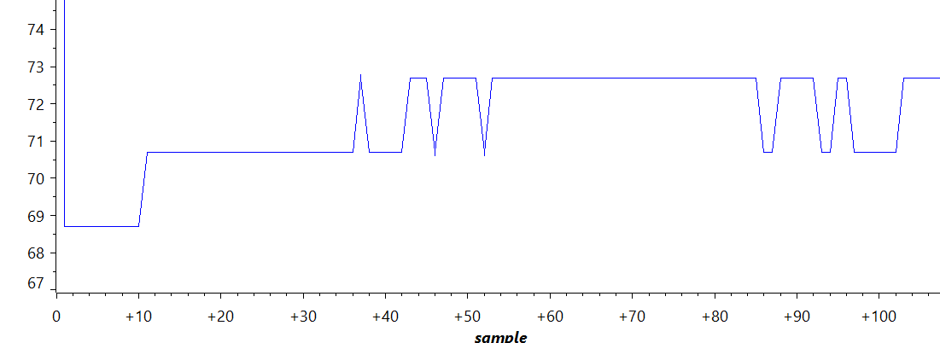

**Modified Code:**

**#include**<stdint.h>

**#include**<stdbool.h>

**#include**"inc/hw_memmap.h"

**#include**"inc/hw_types.h"

**#include**"driverlib/debug.h"

**#include**"driverlib/sysctl.h"

**#include**"driverlib/adc.h"

**#include** "driverlib/gpio.h"

**int** **main**(**void**)

{

uint32_t ui32ADC0Value[4]; //sequencer 2 with depth of 4

//volatile so that each variable cannot be optimized out by the compiler

**volatile** uint32_t ui32TempAvg;

**volatile** uint32_t ui32TempValueC;

**volatile** uint32_t ui32TempValueF;

//Have clock run at 40MHz

**SysCtlClockSet**(SYSCTL_SYSDIV_5|SYSCTL_USE_PLL|SYSCTL_OSC_MAIN|SYSCTL_XTAL_16MHZ);

//Enable ADC0 peripheral

**SysCtlPeripheralEnable**(SYSCTL_PERIPH_ADC0);

ADCHardwareOversampleConfigure(ADC0_BASE, 64);

//ADC will run at default rate of 1Msps

//Configure ADC sequencer 2

//want the processor to trigger the sequence and use highest priority

**ADCSequenceConfigure**(ADC0_BASE, 2, ADC_TRIGGER_PROCESSOR, 0);

//Configure all four steps of ADC sequencer

//temp sensor = ADC_CTL_TS

**ADCSequenceStepConfigure**(ADC0_BASE, 2, 0, ADC_CTL_TS);

**ADCSequenceStepConfigure**(ADC0_BASE, 2, 1, ADC_CTL_TS);

**ADCSequenceStepConfigure**(ADC0_BASE, 2, 2, ADC_CTL_TS);

//Configure interrupt flag = ADC_CTL_IE

//Tell ADC logic that this is the last conversion on sequencer 2 = ADC_CTL_END

**ADCSequenceStepConfigure**(ADC0_BASE,2,3,ADC_CTL_TS|ADC_CTL_IE|ADC_CTL_END);

**ADCSequenceEnable**(ADC0_BASE, 2); //Enable ADC sequencer 2

//Enable PortF and all 3 LEDs

**SysCtlPeripheralEnable**(SYSCTL_PERIPH_GPIOF);

**GPIOPinTypeGPIOOutput**(GPIO_PORTF_BASE, GPIO_PIN_1|GPIO_PIN_2|GPIO_PIN_3);

//read the value of the temperature sensor and calculate the temperature endlessly

**while**(1)

{

**ADCIntClear**(ADC0_BASE, 2); //clear interrupt flag

**ADCProcessorTrigger**(ADC0_BASE, 2); //trigger ADC conversion with software

//wait for conversion

**while**(!**ADCIntStatus**(ADC0_BASE, 2, false))

{

}

//get data from a buffer in memory

**ADCSequenceDataGet**(ADC0_BASE, 2, ui32ADC0Value);

//Calculate average of the temperature sensor

ui32TempAvg = (ui32ADC0Value[0] + ui32ADC0Value[1] + ui32ADC0Value[2] + ui32ADC0Value[3] + 2)/4;

//Calculate Celsius

ui32TempValueC = (1475 - ((2475 * ui32TempAvg)) / 4096)/10;

//Calculate Fahrenheit

ui32TempValueF = ((ui32TempValueC * 9) + 160) / 5;

**if**(ui32TempValueF >= 70)

{

**GPIOPinWrite**(GPIO_PORTF_BASE, GPIO_PIN_1, 0);

**GPIOPinWrite**(GPIO_PORTF_BASE, GPIO_PIN_2, 4);

}

**else**

{

**GPIOPinWrite**(GPIO_PORTF_BASE, GPIO_PIN_2, 0);

**GPIOPinWrite**(GPIO_PORTF_BASE, GPIO_PIN_1, 2);

}

}

}

**------------------------------------------------------------------------------------**

**Task 02:**

In this task I was to set the hardware averaging to 32 and have the interrupt to occur every 0.5 sec.

Youtube Link:

<https://www.youtube.com/watch?v=sQUfnzrPhIc>

**Modified Schematic (if applicable):**

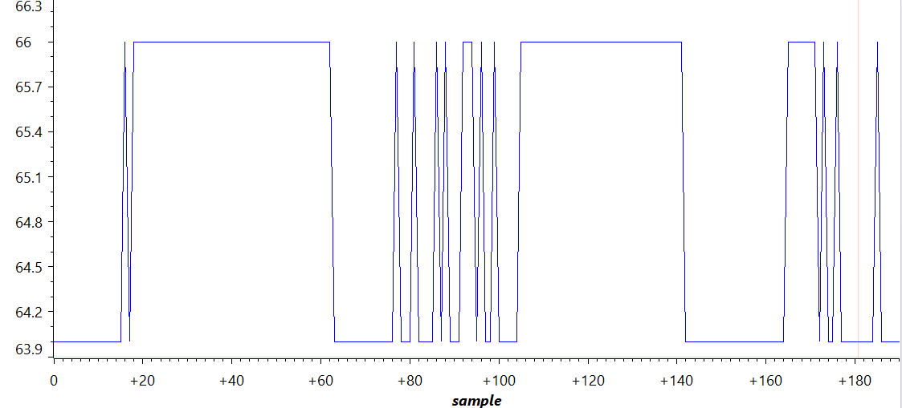

**Modified Code:**

**#include**<stdint.h>

**#include**<stdbool.h>

**#include** "inc/hw_memmap.h"

**#include** "inc/hw_types.h"

**#include** "driverlib/debug.h"

**#include** "driverlib/sysctl.h"

**#include** "driverlib/adc.h"

**#include** "driverlib/gpio.h"

**#include** "inc/tm4c123gh6pm.h"

**#include** "driverlib/timer.h"

**#include** "driverlib/interrupt.h"

uint32_t ui32ADC0Value[4]; //sequencer 2 with depth of 4

//volatile so that each variable cannot be optimized out by the compiler

**volatile** uint32_t ui32TempAvg;

**volatile** uint32_t ui32TempValueC;

**volatile** uint32_t ui32TempValueF;

uint32_t ui32Period;

**int** **main**(**void**)

{

//Have clock run at 40MHz

**SysCtlClockSet**(SYSCTL_SYSDIV_5|SYSCTL_USE_PLL|SYSCTL_OSC_MAIN|SYSCTL_XTAL_16MHZ);

//Enable ADC0 peripheral

**SysCtlPeripheralEnable**(SYSCTL_PERIPH_ADC0);

**ADCHardwareOversampleConfigure**(ADC0_BASE, 32); //hardware average of 32

//ADC will run at default rate of 1Msps

//Configure ADC sequencer 2

//want the processor to trigger the sequence and use highest priority

**ADCSequenceConfigure**(ADC0_BASE, 2, ADC_TRIGGER_PROCESSOR, 0);

//Configure all four steps of ADC sequencer

//temp sensor = ADC_CTL_TS

**ADCSequenceStepConfigure**(ADC0_BASE, 2, 0, ADC_CTL_TS);

**ADCSequenceStepConfigure**(ADC0_BASE, 2, 1, ADC_CTL_TS);

**ADCSequenceStepConfigure**(ADC0_BASE, 2, 2, ADC_CTL_TS);

//Configure interrupt flag = ADC_CTL_IE

//Tell ADC logic that this is the last conversion on sequencer 2 = ADC_CTL_END

**ADCSequenceStepConfigure**(ADC0_BASE,2,3,ADC_CTL_TS|ADC_CTL_IE|ADC_CTL_END);

**ADCSequenceEnable**(ADC0_BASE, 2); //Enable ADC sequencer 2

//Enable PortF and all 3 LEDs

**SysCtlPeripheralEnable**(SYSCTL_PERIPH_GPIOF);

**GPIOPinTypeGPIOOutput**(GPIO_PORTF_BASE, GPIO_PIN_1|GPIO_PIN_2|GPIO_PIN_3);

**SysCtlPeripheralEnable**(SYSCTL_PERIPH_TIMER1);

**TimerConfigure**(TIMER1_BASE, TIMER_CFG_PERIODIC);

ui32Period = (**SysCtlClockGet**() / 10) / 2;//10Hz and 50% DC

**TimerLoadSet**(TIMER1_BASE, TIMER_A, ui32Period -1);

//Enabling Interrupt

**IntEnable**(INT_TIMER1A);

**TimerIntEnable**(TIMER1_BASE, TIMER_TIMA_TIMEOUT);

**IntMasterEnable**();

//Will start the timer and interrupts will begin triggering on the timeouts

**TimerEnable**(TIMER1_BASE, TIMER_A);

//Enable ADC interrupt

**ADCIntEnable**(ADC0_BASE, 3);

//The toggling of the GPIO will happen in the interrupt service routine

**while**(1)

{

}

}

**void** **Timer1IntHandler**(**void**)

{

**TimerIntClear**(TIMER1_BASE,TIMER_A);

//read the value of the temperature sensor and calculate the temperature endlessly

**ADCIntClear**(ADC0_BASE, 2); //clear interrupt flag

**ADCProcessorTrigger**(ADC0_BASE, 2); //trigger ADC conversion with software

//wait for conversion

**while**(!**ADCIntStatus**(ADC0_BASE, 2, false))

{

}

//get data from a buffer in memory

**ADCSequenceDataGet**(ADC0_BASE, 2, ui32ADC0Value);

//Calculate average of the temperature sensor

ui32TempAvg = (ui32ADC0Value[0] + ui32ADC0Value[1] + ui32ADC0Value[2] + ui32ADC0Value[3] + 2)/4;

//Calculate Celsius

ui32TempValueC = (1475 - ((2475 * ui32TempAvg)) / 4096)/10;

//Calculate Fahrenheit

ui32TempValueF = ((ui32TempValueC * 9) + 160) / 5;

**if**(ui32TempValueF >= 66)

{

**GPIOPinWrite**(GPIO_PORTF_BASE, GPIO_PIN_1, 0);

**GPIOPinWrite**(GPIO_PORTF_BASE, GPIO_PIN_2, 4);

}

**else**

{

**GPIOPinWrite**(GPIO_PORTF_BASE, GPIO_PIN_2, 0);

**GPIOPinWrite**(GPIO_PORTF_BASE, GPIO_PIN_1, 2);

}

}

**------------------------------------------------------------------------------------**