CPE301 – SPRING 2019

Design Assignment 5

Student Name: Itzel Becerril

Student #: 2000478001

Student Email: becerri2@unlv.nevada.edu

Primary Github address: Hadidbuilds

Directory: DA5

1. **COMPONENTS LIST AND CONNECTION BLOCK DIAGRAM w/ PINS**

List of Components used

* Atmega328P
* Micro USB
* Xplained mini
* Male/female wires
* LM 34
* Nrf24l01

Block diagram with pins used in the Atmega328P

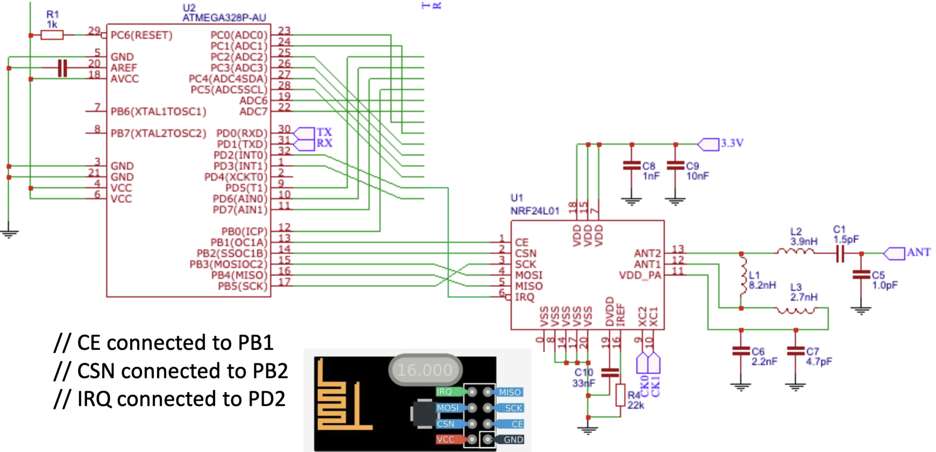

1. **DEVELOPED CODE**

This is the main file, some of the functions are in the other files which are included at the top. However, it is a lot so I did not add them here but can be found on my github.

**#ifndef *F_CPU***

**#define *F_CPU* 16000000UL**

**#endif**

**#include <avr/io.h>**

**#include <util/delay.h>**

**#include <avr/interrupt.h>**

**#include <stdbool.h>**

**#include <stdio.h>**

**#include <string.h>**

**// Set up UART for printf();**

**#ifndef BAUD**

**#define BAUD 9600**

**#endif**

**#include "inc/STDIO_UART.h"**

**// Include nRF24L01+ library**

**#include "inc/nrf24l01.h"**

**#include "inc/nrf24l01-mnemonics.h"**

**#include "inc/spi.h"**

**void print_config(void);**

**void read_adc(void); // Function Declarations**

**void adc_init(void);**

**volatile unsigned int adc_temp;**

**char outs[20];**

**// Used in IRQ ISR**

**volatile bool message_received = false;**

**volatile bool status = false;**

**int main(void)**

**{**

**// Initialize UART**

**uart_init();**

**adc_init();**

**// Initialize nRF24L01+ and print configuration info**

**nrf24_init();**

**print_config();**

**// Start listening** to incoming messages

nrf24_start_listening();

while (1)

{

read_adc(); //read ADC

adc_temp = (adc_temp*500)/1023 + 20; //conversion of temp

*snprintf*(outs,sizeof(outs),"%3d\r\n", adc_temp); // print it

*strcpy*(tx_message,outs); // Copy string into array

nrf24_send_message(tx_message);

*_delay_ms*(1500);

if (message_received)

{

// Message received, print it

message_received = false;

*printf*("Received message: %s\n",nrf24_read_message());

// Send message as response

*_delay_ms*(500);

status = nrf24_send_message(tx_message);

if (status == true) *printf*("Message sent successfully\n");

}

}

}

// Interrupt on IRQ pin

ISR(INT0_vect)

{

message_received = true;

}

void print_config(void)

{

*uint8_t* data;

*printf*("Startup successful\n\n nRF24L01+ configured as:\n");

*printf*("-------------------------------------------\n");

nrf24_read(CONFIG,&data,1);

*printf*("CONFIG 0x%02X\n",data);

nrf24_read(EN_AA,&data,1);

*printf*("EN_AA 0x%02X\n",data);

nrf24_read(EN_RXADDR,&data,1);

*printf*("EN_RXADDR 0x%02X\n",data);

nrf24_read(SETUP_RETR,&data,1);

*printf*("SETUP_RETR 0x%02X\n",data);

nrf24_read(RF_CH,&data,1);

*printf*("RF_CH 0x%02X\n",data);

nrf24_read(RF_SETUP,&data,1);

*printf*("RF_SETUP 0x%02X\n",data);

nrf24_read(STATUS,&data,1);

*printf*("STATUS 0x%02X\n",data);

nrf24_read(FEATURE,&data,1);

*printf*("FEATURE 0x%02X\n",data);

*printf*("-------------------------------------------\n\n");

}

/* INIT ADC */

void adc_init(void)

{

/** Setup and enable ADC **/

ADMUX = (0<<REFS1)| // Reference Selection Bits

(1<<REFS0)| // AVcc - external cap at AREF

(0<<ADLAR)| // ADC Left Adjust Result

(1<<MUX2)| // Analog Channel Selection Bits

(0<<MUX1)| // ADC4 (PC4 PIN27)

(0<<MUX0);

ADCSRA = (1<<ADEN)| // ADC ENable

(0<<ADSC)| // ADC Start Conversion

(0<<ADATE)| // ADC Auto Trigger Enable

(0<<ADIF)| // ADC Interrupt Flag

(0<<ADIE)| // ADC Interrupt Enable

(1<<ADPS2)| // ADC Prescaler Select Bits

(0<<ADPS1)|

(1<<ADPS0);

}

/* READ ADC PINS */

void read_adc(void)

{

unsigned char i = 4;

adc_temp = 0;

while (i--)

{

ADCSRA |= (1<<ADSC);

while(ADCSRA & (1<<ADSC));

adc_temp+= ADC;

*_delay_ms*(50);

}

adc_temp = adc_temp / 4; // Average a few samples

}

These are the addresses we used to receive and transmit:

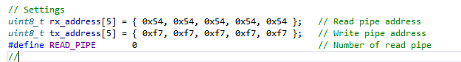

1. **SCHEMATICS**

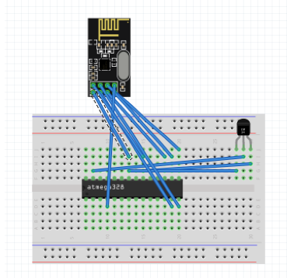

1. **SCREENSHOTS OF EACH TASK OUTPUT (ATMEL STUDIO OUTPUT)**

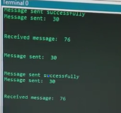

1. **SCREENSHOT OF EACH DEMO (BOARD SETUP)**

Before: After:

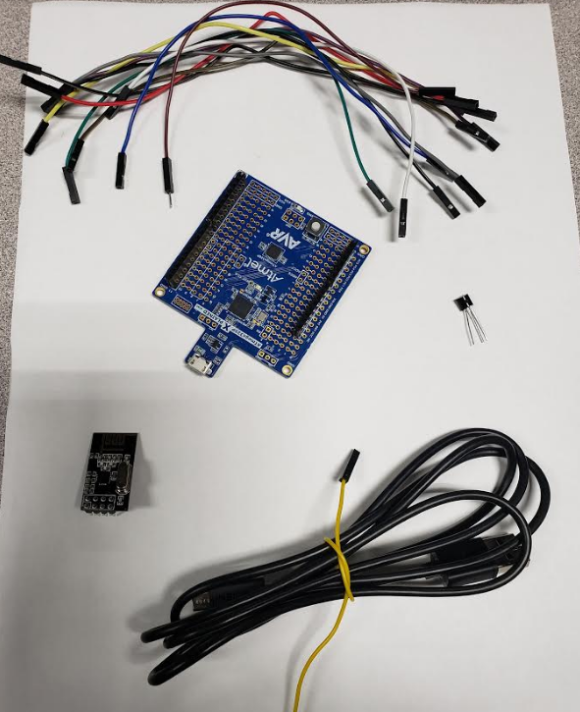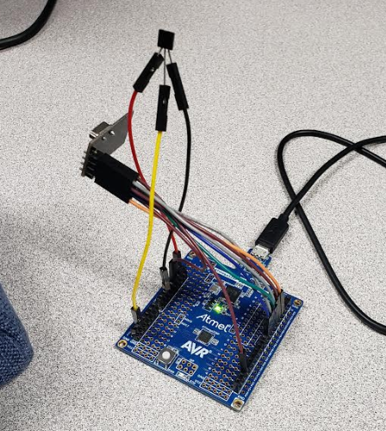

1. **VIDEO LINKS OF EACH DEMO**

<https://www.youtube.com/watch?v=XYlI3REwjdo>

1. **GITHUB LINK OF THIS DA**

<https://github.com/HadidBuilds/hw_sub_da1>

**Student Academic Misconduct Policy**

<http://studentconduct.unlv.edu/misconduct/policy.html>

“This assignment submission is my own, original work”.

Itzel Becerril