**Description**

This web portal will help providing musical contents for its users who are registered in it; they can upload music files, information about it, see what they uploaded and what the other users uploaded.

User will register to it by filling a form with his name, email, password, phone number and bank account number, and then he/she can log in to start uploading music or listen to uploaded music.

**Installation**

-To run this application you need to have visual studio and Microsoft SQL Server Management Studio to be installed to your device.

**1. The Data Base Attachment**

-You will find in the project files a file name “MusicalContent.mdf”

-First you need to connect to a server in your Microsoft SQL Server Management

-When you start the MSqlserver it will open a window you should enter the server name you choosed while installing the tool.

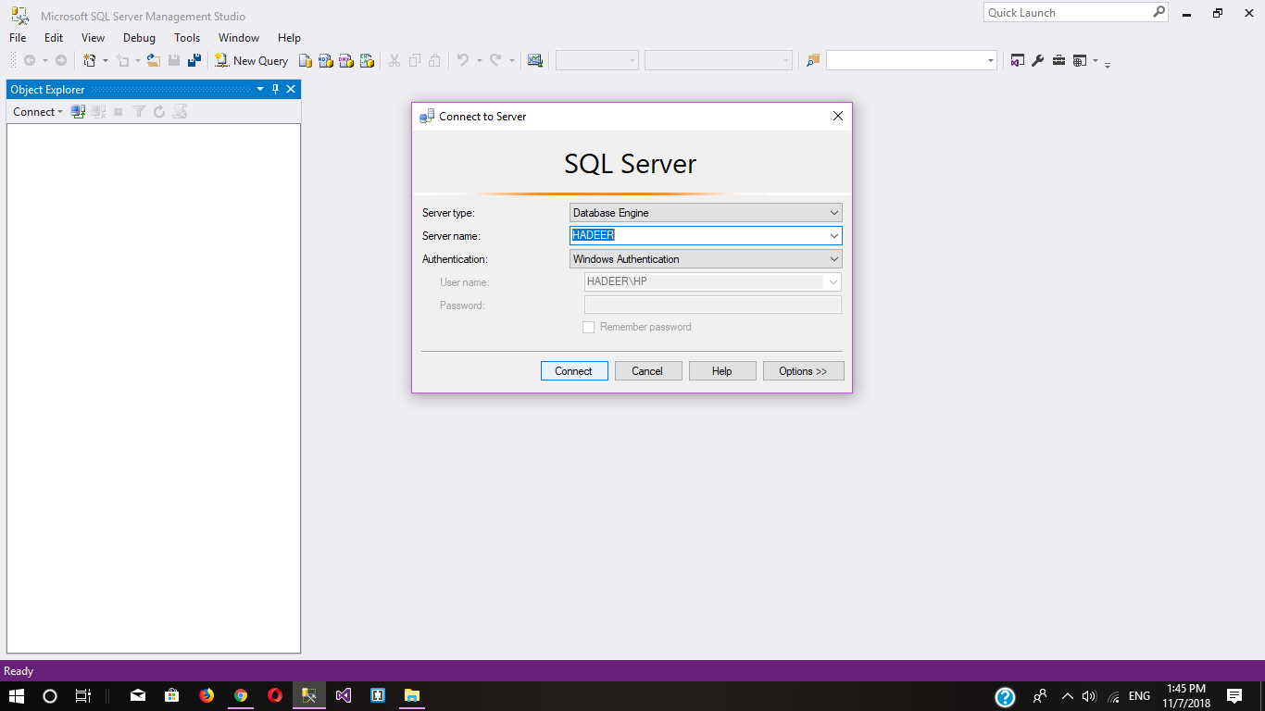

Fig(1): connecting to server

Now you need to Attach the data base :-

-Copy the “MusicalContent.mdf” and” MusicalContent.sql” to the path that you installed the tool(The path that the tool save the databases created with it to ) in it looks something like that:-

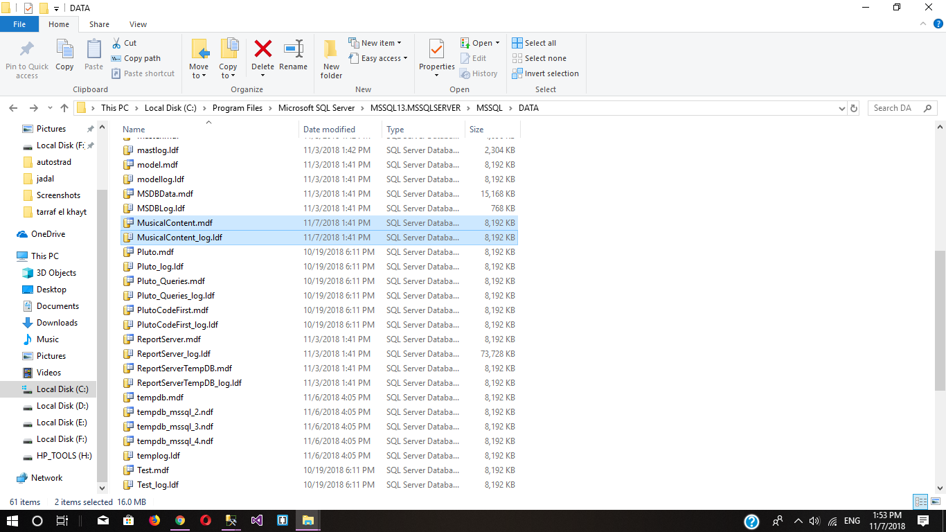

-Then from The Sql Server Management Studio right click on DataBases -> Attach

-Then select the .mdf file you just added

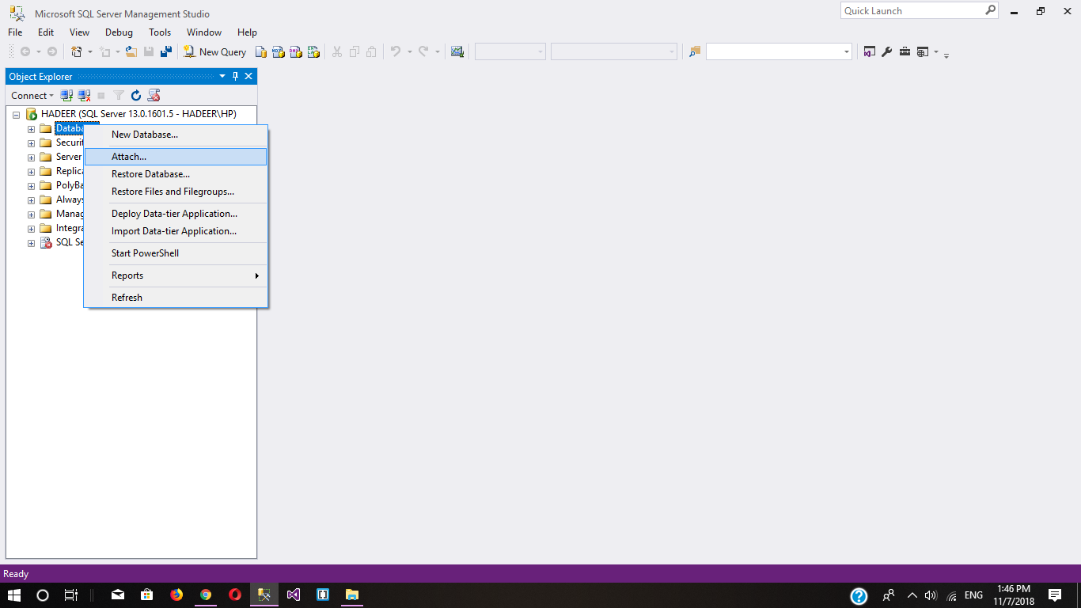 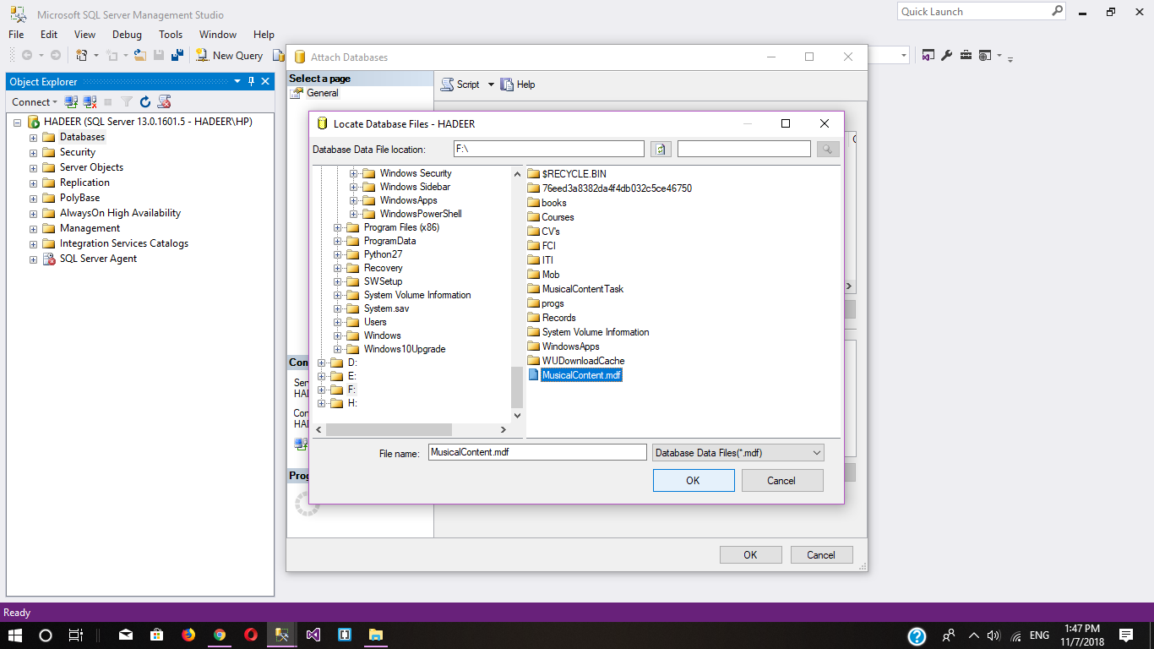

Fig(2,3,4): Attatching the database

-Now the Database is attached

-If you have any problem with the previous attachment method you can simply in Microsoft sql server click on File->open file the select The “MusicalContent.sql” that file contains a script that will generate the database

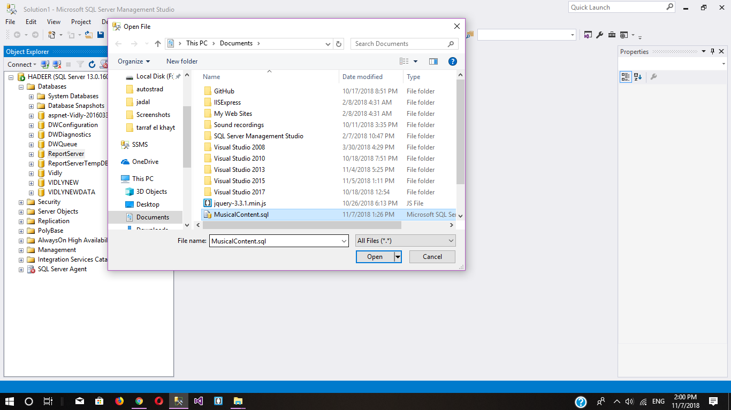

-After its opened in Msqlserver you click execute that will create the data base

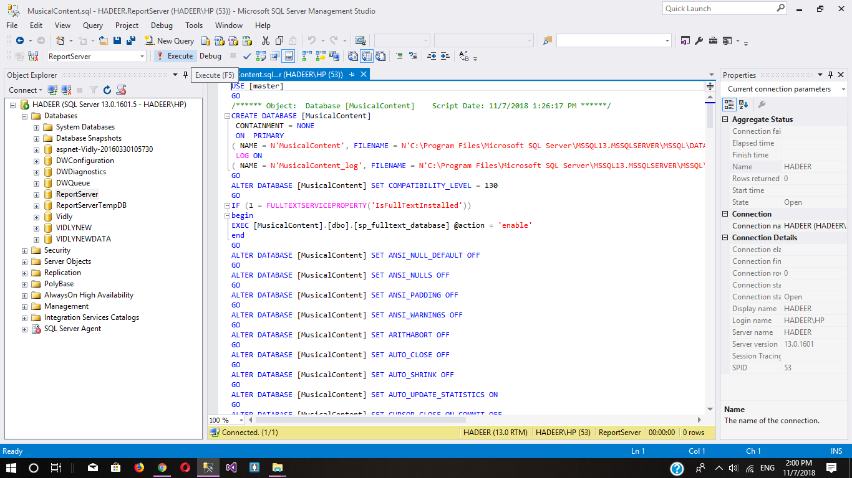

Fig(5,6): Generating the database from a script file

-That is all with the database files.

**2.Solution files in visual studio**

-After starting the visual studio click on file ->open->Project/solution , the select the “MusicalContentTask.sln” that exists in “MusicalContentTask” file

You need to make one change before running the project:-

-Change the server name in connection string tag in web.config file to the server you are connected to in Sql server management studio.

-open Web.config file go to solution explorer you will find it

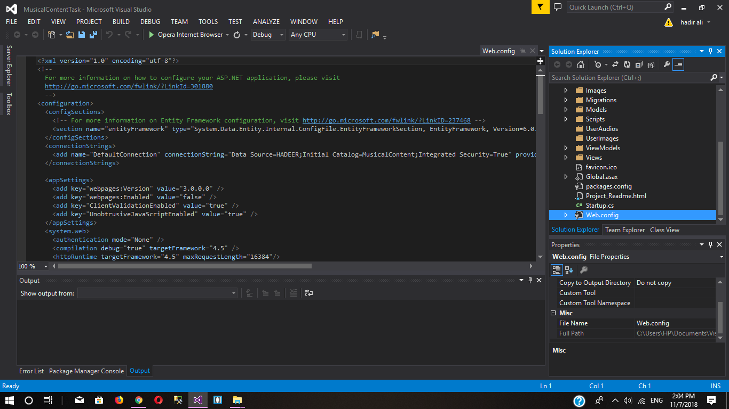

-then in the Connection string tag in Data Source=”” part you need to provide the server name of Sql server management studio Like Data Source=”YOUR SERVER NAME”

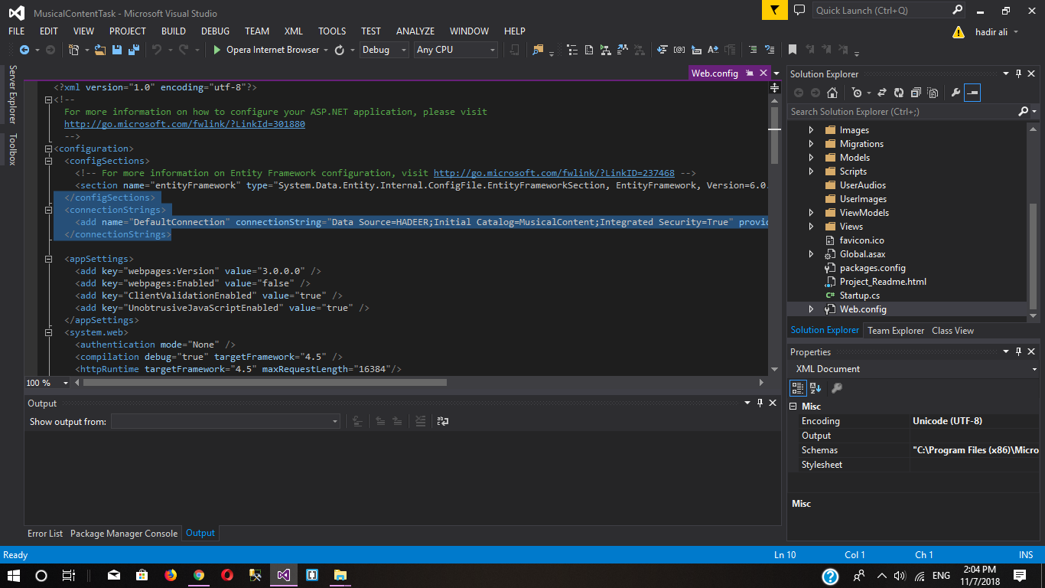

Fig(7,8): Modifying connection string

-Now a final step is to chose the browser you want to run the solution with

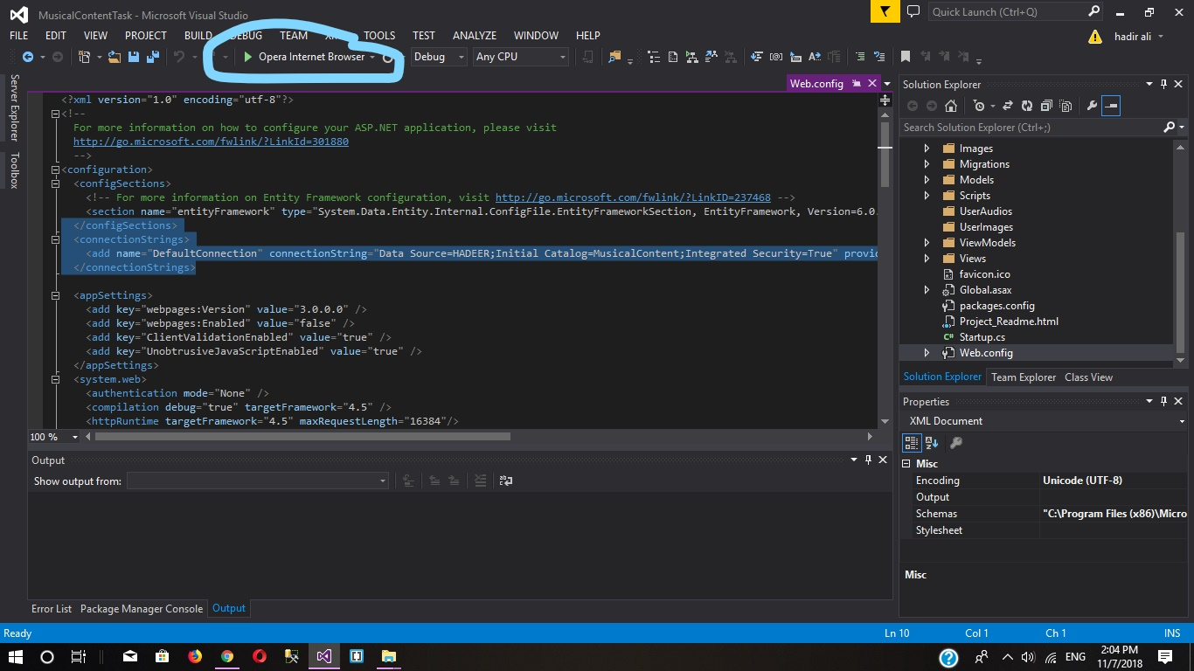

Fig(9): Running the solution

**3-The application**

-when you click o register tab you will find a registration form fil it with your information to be registered .

-also you will find a log in form to log in if you already have an account.

-after that you will have three choices to upload music , see your uploaded music , see all users uploaded music.

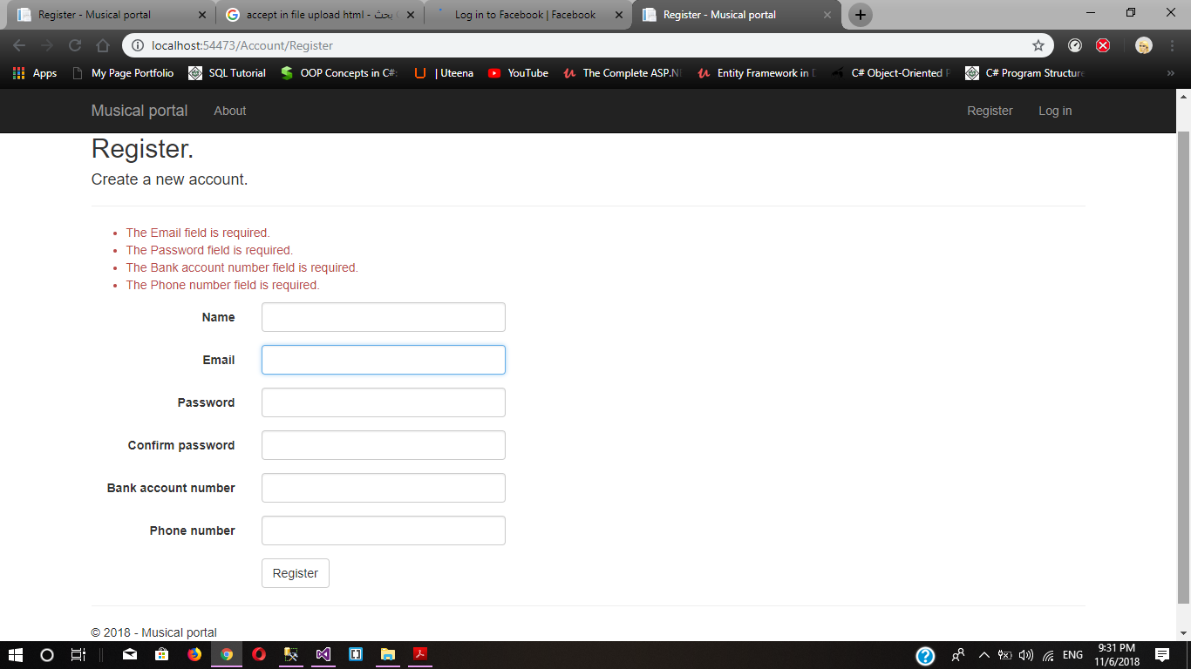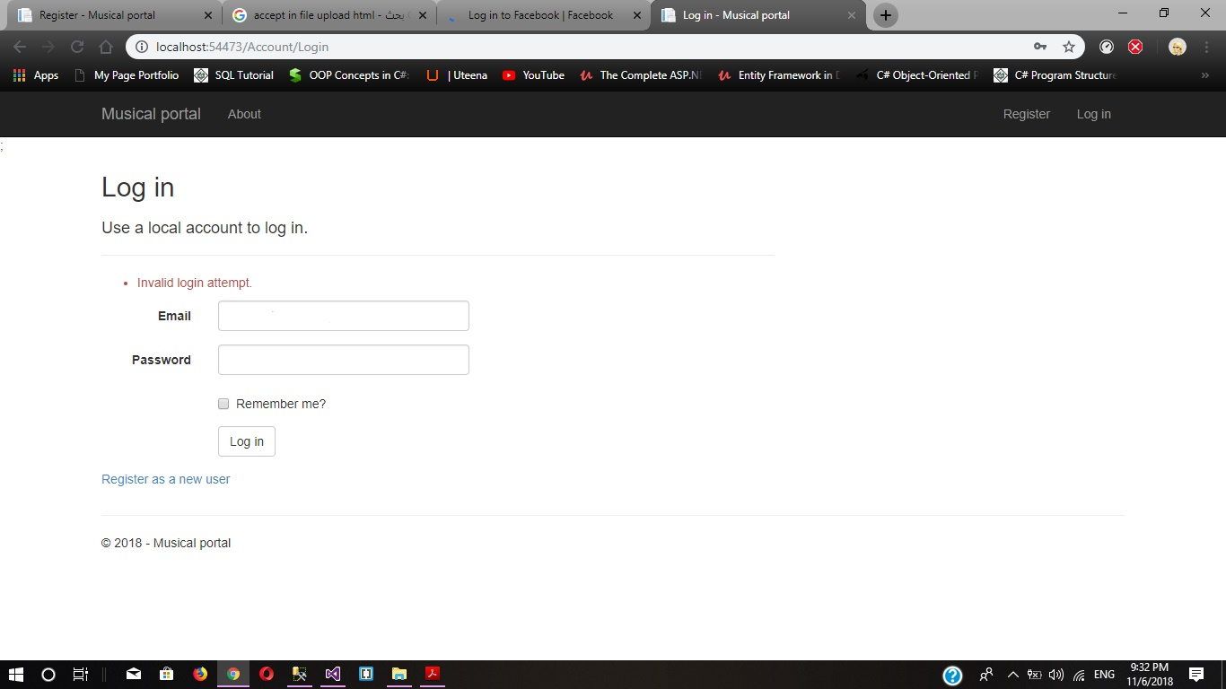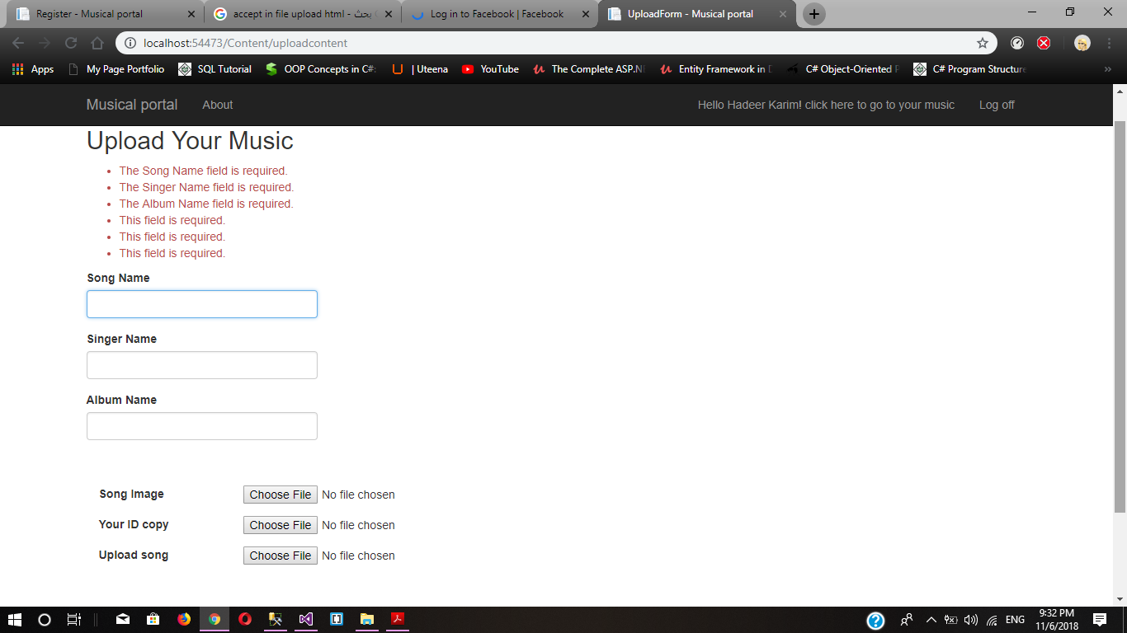

Fig(10,11,12): Register , login and uploading music forms.

**Support**

-If you are Having any issue please let us know.

-contact us : [hadeerkarim60@yahoo.com](mailto:hadeerkarim60@yahoo.com)