SSH-EC2

As mentioned before I will be using one control machine and a target machine. To start with installation, perform the steps as shown below in both the machines.

1. Create a common id on both the machines, for **Example**, **ansible**with SUDO privileges. This id will be used for communicating across all the machines involved for automation of tasks.

**# useradd ansible**

**# passwd ansible ---- give your password**

**b)** Edit the**/etc/ssh/sshd_config**file on the **control machine** and uncomment out the lines for**PasswordAuthentication and PermitRootLogin**

[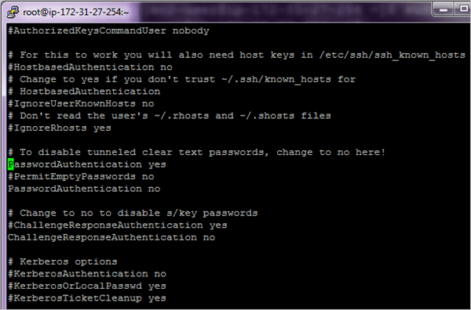](https://www.softwaretestinghelp.com/wp-content/qa/uploads/2018/07/2.Edit-the-sshd_config-file.png)

[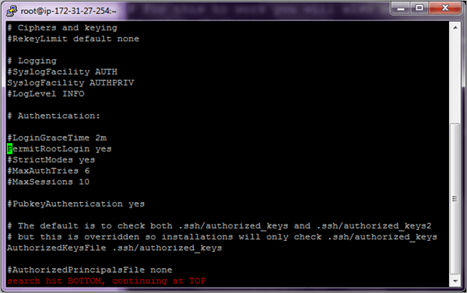](https://www.softwaretestinghelp.com/wp-content/qa/uploads/2018/07/3.Edit-config-file.png)

Perform the above steps on both the machines. Once completed, restart the **sshd** service on both the machines.

**# systemctl restart sshd**

**c)** For complete automation of tasks, we will need passwordless SSH authentication else the whole process will not be used if you have to key in the password every time.

So post the changes done above if we run the command ssh <target machine> and ssh <control machine> we will need to key in the password every time which is not the right procedure to execute Ansible tasks.

**d)** To enable passwordless authentication to perform the steps shown below. Firstly add the user **ansible**to the **/etc/sudoers** file on both the machines which will enable the user **ansible**to run any command which requires root privileges.

[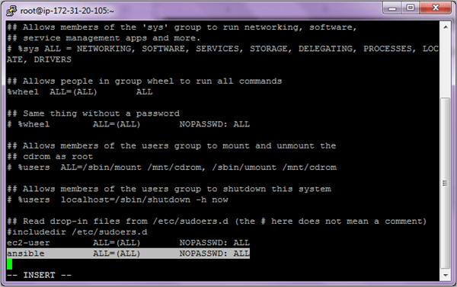](https://www.softwaretestinghelp.com/wp-content/qa/uploads/2018/07/4.add-the-user-ansible.png)

Save and exit the file after adding the user.

**e)** Going forward we will use the user **ansible**to perform all the steps. So switch to the user **ansible.**

**Control Machine su – ansible AND Target Machine su – ansible**

[5.user ansible](https://www.softwaretestinghelp.com/wp-content/qa/uploads/2018/07/5.user-ansible.png)

**Control Machine ssh-keygen**

[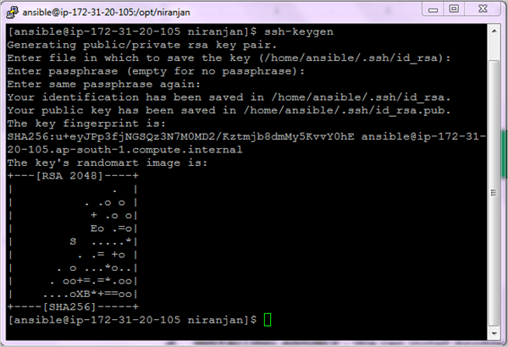](https://www.softwaretestinghelp.com/wp-content/qa/uploads/2018/07/6.Control-Machine-ssh-keygen.png)

**Target Machine ssh-keygen**

[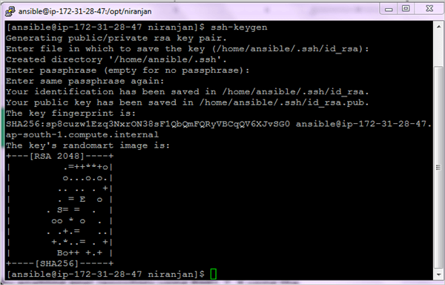](https://cdn.softwaretestinghelp.com/wp-content/qa/uploads/2018/07/6.Target-Machine-ssh-keygen.png)

Copy the ssh key to the target machine and vice versa.

**Control Machine ssh-copy-id <IP-Address-Host-Machine>**

[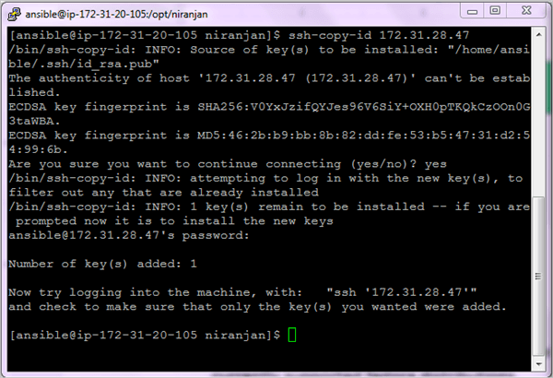](https://www.softwaretestinghelp.com/wp-content/qa/uploads/2018/07/7.Control-Machine-ssh-copy-id.png)

**Target Machine ssh-copy-id <IP-Address-Control-Machine>**

[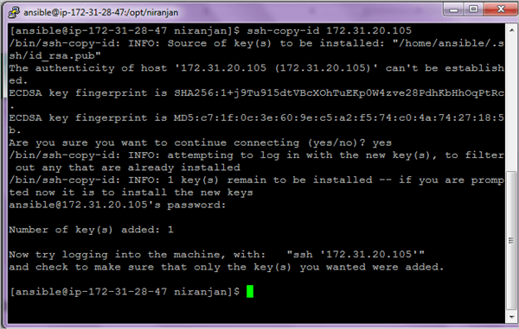](https://cdn.softwaretestinghelp.com/wp-content/qa/uploads/2018/07/7.Target-Machine-ssh-copy-id.png)

We are now able to log in without entering the password. After the check out of the ssh connectivity on both the machines and be logged in as ansible user.

**Control Machine: ssh ansible@<IP-Address-Host-Machine**

[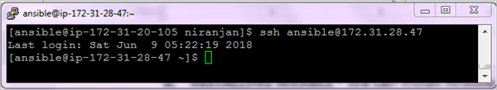](https://www.softwaretestinghelp.com/wp-content/qa/uploads/2018/07/8.Control-Machine-login-without-pwd.png)

**Target Machine: ssh ansible@<IP-Address-Control-Machine>**

[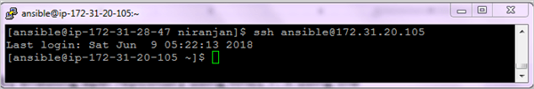](https://cdn.softwaretestinghelp.com/wp-content/qa/uploads/2018/07/8.Target-machine-login-without-pwd.png)

Install Ansible on Master :

yum update

yum install wget

wget https://dl.fedoraproject.org/pub/epel/epel-release-latest-7.noarch.rpm

yum install ./epel-release-latest-*.noarch.rpm

yum install ansible

