AI-Powered Smart Health Prediction System

A Machine Learning and RAG-Based Healthcare Analysis and Recommendation Platform

Prepared By: Kashan Baig (CT-24178), Hadiya Kashif (CT-22008), Hassan Shakil (CT-24185)

Department of Computer Science, NED University

Table Of Contents

Problem Statement 3

Objectives 3

Importance 3

Significance 3

Tech Stack Used 3

Limitations 4

Front-End Interface 5

Front-End Components: 5

Data Files 9

X_train.csv & X_test.csv 9

y_train.csv & y_test.csv 9

cleaned_health_data.csv 9

enhanced_health_data.csv 9

complete_processed_dataset.csv 9

processed_features.csv & processed_target.csv 10

Source Code Modules 11

data_ingestion.py 11

data_cleaning.py 11

data_transformation.py 11

model_training.py 11

model_evaluation.py 12

rag_integration.py 12

Model Artifacts 13

Deployment Components 13

Jupyter Notebook Artifacts 13

ML Pipeline Overview 14

Requirements 15

Conclusion 15

# Problem Statement

Build a transparent health risk service that predicts health risk from vitals and lifestyle data, explains results, suggests next actions, finds nearby doctors, and sends email alerts for high risk.

# Objectives

• Ingest, clean, and transform health data reproducibly.  
• Train multiple classifiers and compare their performance.  
• Serve predictions through a simple Flask API.  
• Generate RAG-based explanations and next steps.  
• Notify high-risk users via email.

# Importance

Early detection enables timely intervention. The project builds user trust through explanations and demonstrates practical use of AI in healthcare.

# Significance

A practical ML + RAG system for healthcare analytics with reproducibility and small footprint. Ideal for educational and prototype environments.

# Tech Stack Used

| **Category** | **Technologies Used** |
| --- | --- |
| **Data & ML** | pandas, numpy, scikit-learn, CatBoost, XGBoost, joblib |
| **API & Deployment** | Flask, flask-cors, python-dotenv, requests, SMTP |
| **RAG (Retrieval)** | LangChain, sentence-transformers, ChromaDB, FAISS CPU, transformers |
| **Visualization** | seaborn, matplotlib, BeautifulSoup (bs4), email-validator |

# Limitations

• **Prototype**; not validated for clinical use.  
• Overpass API may timeout.  
• Distance approximations only.  
• RAG quality depends on indexed content.  
• Some hard-coded paths.

# Front-End Interface

The Smart Health Prediction System provides an intuitive and responsive user interface that allows users to input   
their health-related information, view AI-generated predictions, and access recommendations through RAG integration.

## Front-End Components:

• Dashboard:

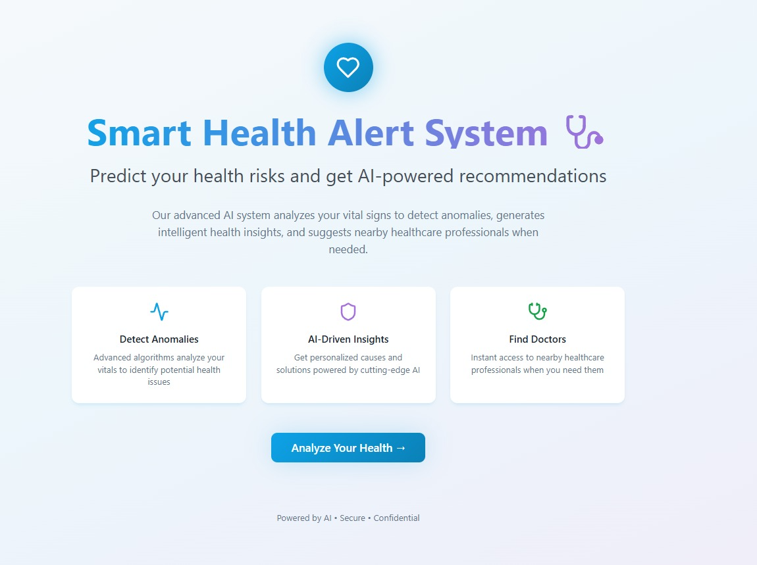

• Information Input: 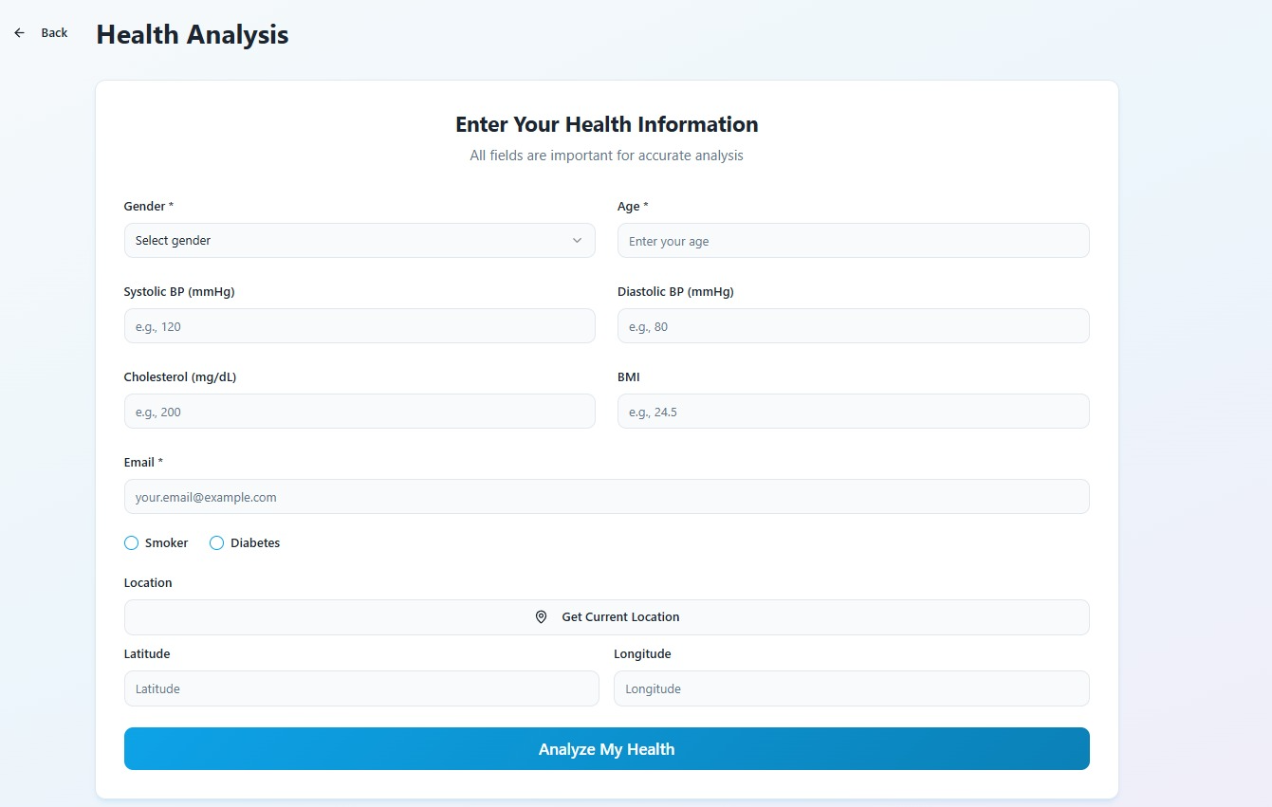

• Processing Page: 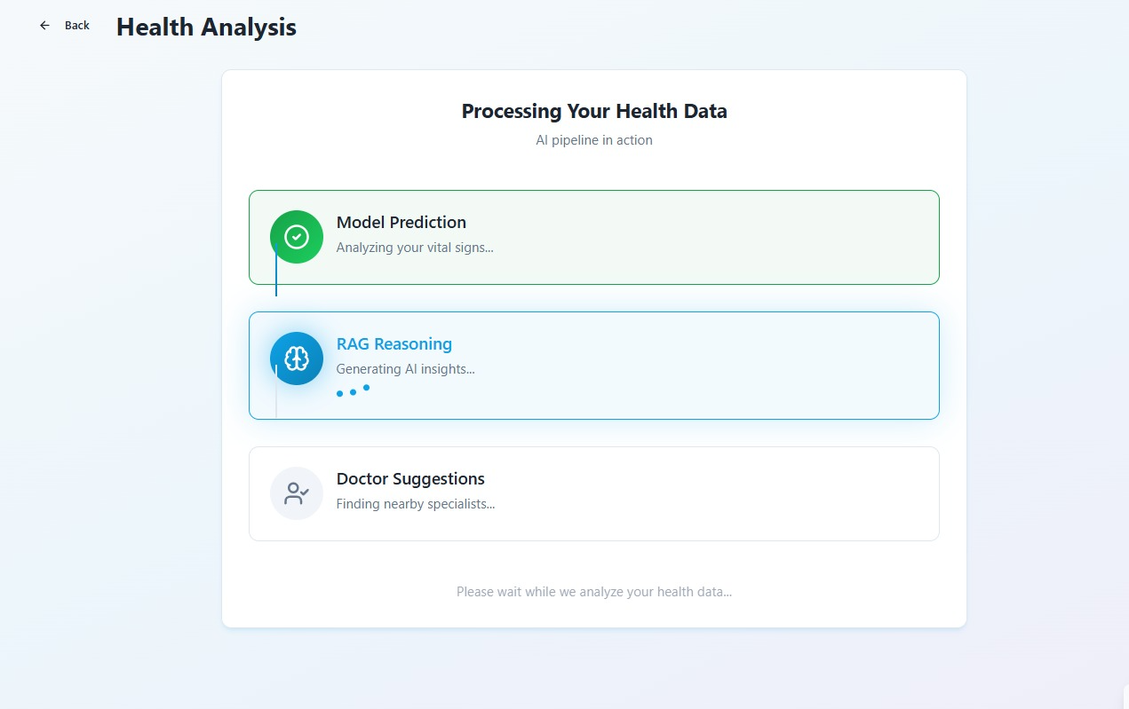

• Results Page: 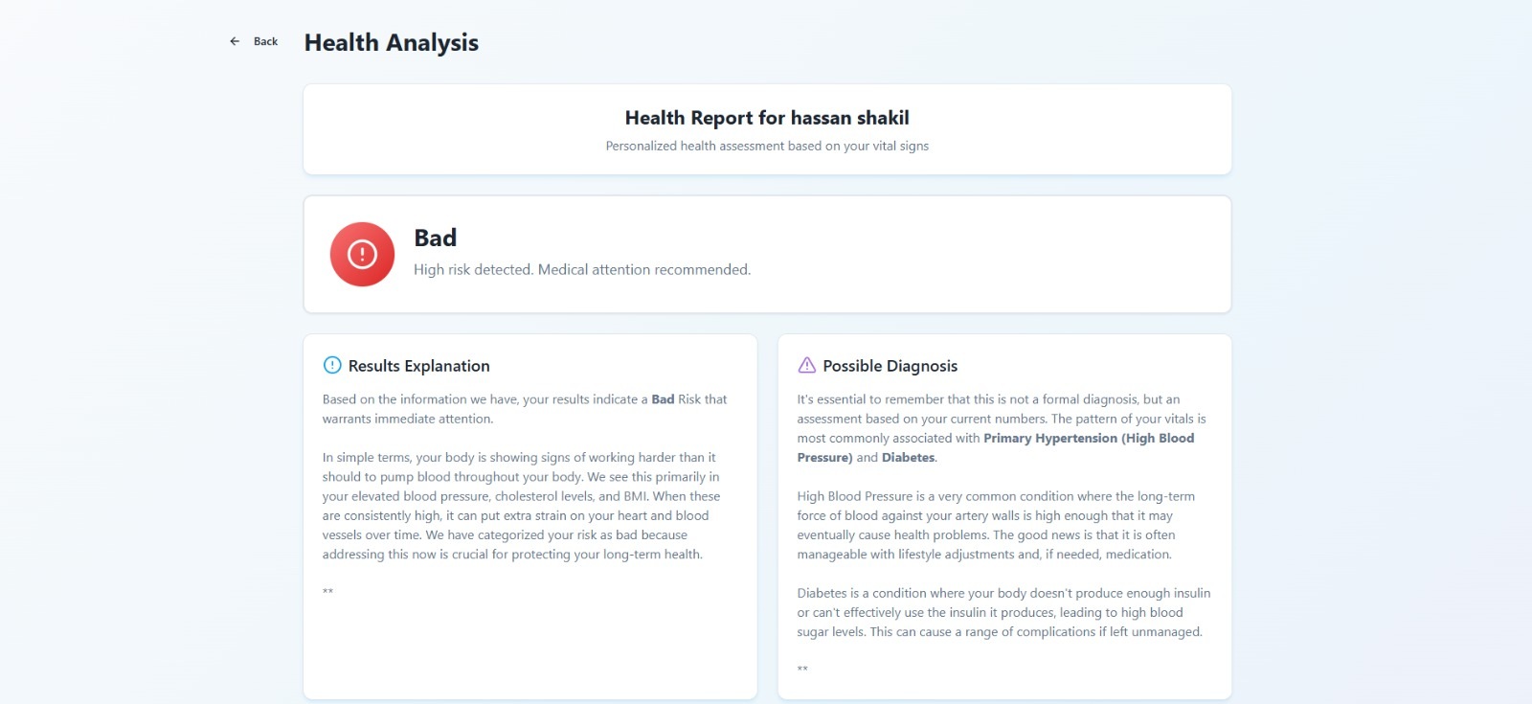

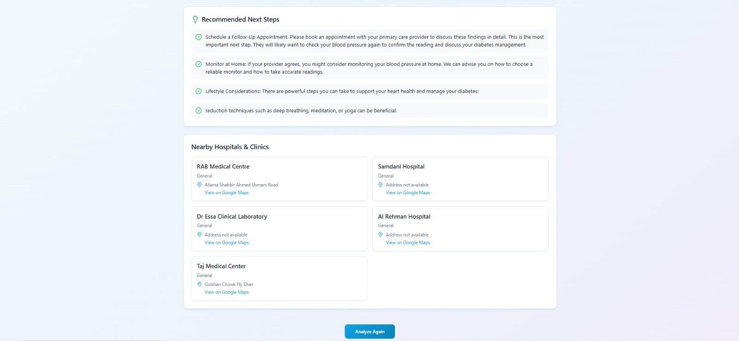

# Data Files

The Data directory houses both raw and processed datasets in CSV format, serving as inputs and outputs throughout the ML pipeline.

## X_train.csv & X_test.csv

These files contain the feature matrices for model training and evaluation.  
• Generated by split_data() in Src_Code/data_transformation.py.  
• Used as inputs by model_training.py and model_evaluation.py.  
• Columns correspond to encoded vitals and lifestyle factors (e.g., Gender, Age, BMI).

## y_train.csv & y_test.csv

These files store the target labels (Health risk categories) aligned with X_train.csv and X_test.csv.  
• Produced alongside feature splits by data_transformation.py.  
• Loaded in model_evaluation.py for reporting accuracy and per-class metrics.

## cleaned_health_data.csv

A cleaned version of the raw dataset, with missing values handled, unnecessary columns dropped, and outliers addressed.  
• Created by Src_Code/data_cleaning.py via DataCleaner methods.  
• Serves as input to data_transformation.py.

## enhanced_health_data.csv

An enriched raw dataset containing engineered features (e.g., precomputed BMI) and original fields like patient coordinates and email.  
• Loaded by Src_Code/data_ingestion.py for quality checks.  
• Feeds into the cleaning pipeline.

## complete_processed_dataset.csv

A fully encoded dataset (all categorical → numeric) combining features and target.  
• Saved by save_complete_processed_dataset() in data_transformation.py.  
• Useful for external analyses or retraining.

## processed_features.csv & processed_target.csv

• processed_features.csv: Contains numeric feature matrix after encoding Gender, Smoker, Diabetes.  
• processed_target.csv: Column of raw target labels.  
• Produced by prepare_features_target() in data_transformation.py.

# Source Code Modules

The Src_Code folder implements the end-to-end pipeline: ingestion → cleaning → transformation → training → evaluation → RAG integration.

## data_ingestion.py

Loads and inspects the raw enhanced dataset; reports missing values, data types, duplicates, and unique counts.  
• Functions: load_and_explore_data(), check_data_quality()  
• Entry point: main()

## data_cleaning.py

Encapsulates cleaning steps in DataCleaner:  
• remove_unnecessary_columns() (drops Name, redundant height/weight)  
• handle_missing_values() (fills numerics with mean, categoricals with mode)  
• standardize_categorical_data() (lowercases, strips whitespace)  
• detect_and_handle_outliers() (clips extreme vitals and visualizes via boxplots)  
• validate_data_cleaning() returns final DataFrame.

## data_transformation.py

Prepares data for modeling:  
1. load_and_preprocess_data() reads cleaned CSV.  
2. save_complete_processed_dataset() encodes all columns and writes full dataset.  
3. prepare_features_target() splits features/target and saves processed_features.csv and processed_target.csv.  
4. split_data() stratifies and creates train/test CSVs.  
5. main() orchestrates the pipeline and returns splits plus feature names.

## model_training.py

Defines ModelTrainer to train three classifiers:  
• Decision Tree (train_decision_tree())  
• Random Forest (train_random_forest())  
• CatBoost (train_catboost())  
Also supports prediction (predict_all()), evaluation per model (evaluate_model()), and saving (save_all_models()).

## model_evaluation.py

Implements ModelEvaluator for comprehensive assessment:  
• load_model() and load_test_data()  
• comprehensive_evaluation() computes accuracy, precision, recall, F1, confusion matrix, and classification report.  
• save_metrics_to_json() writes a structured evaluation_metrics.json.  
• print_model_comparison() outputs sorted accuracy table.

## rag_integration.py

Builds or loads a Chroma vector database of health guidelines from WHO/CDC websites using LangChain.  
• init_rag() fetches pages, embeds text, and prepares a retriever.  
• query_rag() accepts vitals + predicted risk to return human-readable causes, diagnosis, and suggestions.

# Model Artifacts

Models folder contains serialized classifiers and evaluation metrics.  
• decision_tree_model.pkl: Pickled DecisionTreeClassifier.  
• random_forest_model.pkl: Pickled RandomForestClassifier.  
• catboost_model.pkl: Pickled CatBoostClassifier (300 iterations, depth 8).  
• evaluation_metrics.json: Per-model accuracy and ranking report.

# Deployment Components

The Flask-based API enables deployment of the model as a RESTful service.  
Endpoints:  
• GET / : Health check.  
• POST /analyze : Accepts JSON input, predicts risk, triggers RAG explanations, fetches nearby doctors, and sends alert emails.

# Jupyter Notebook Artifacts

The notebook directory demonstrates exploratory analysis and interactive training.  
• eda.ipynb: Visual analysis of raw data.  
• model_training_evaluation.ipynb: Inline model training and comparison.

# ML Pipeline Overview

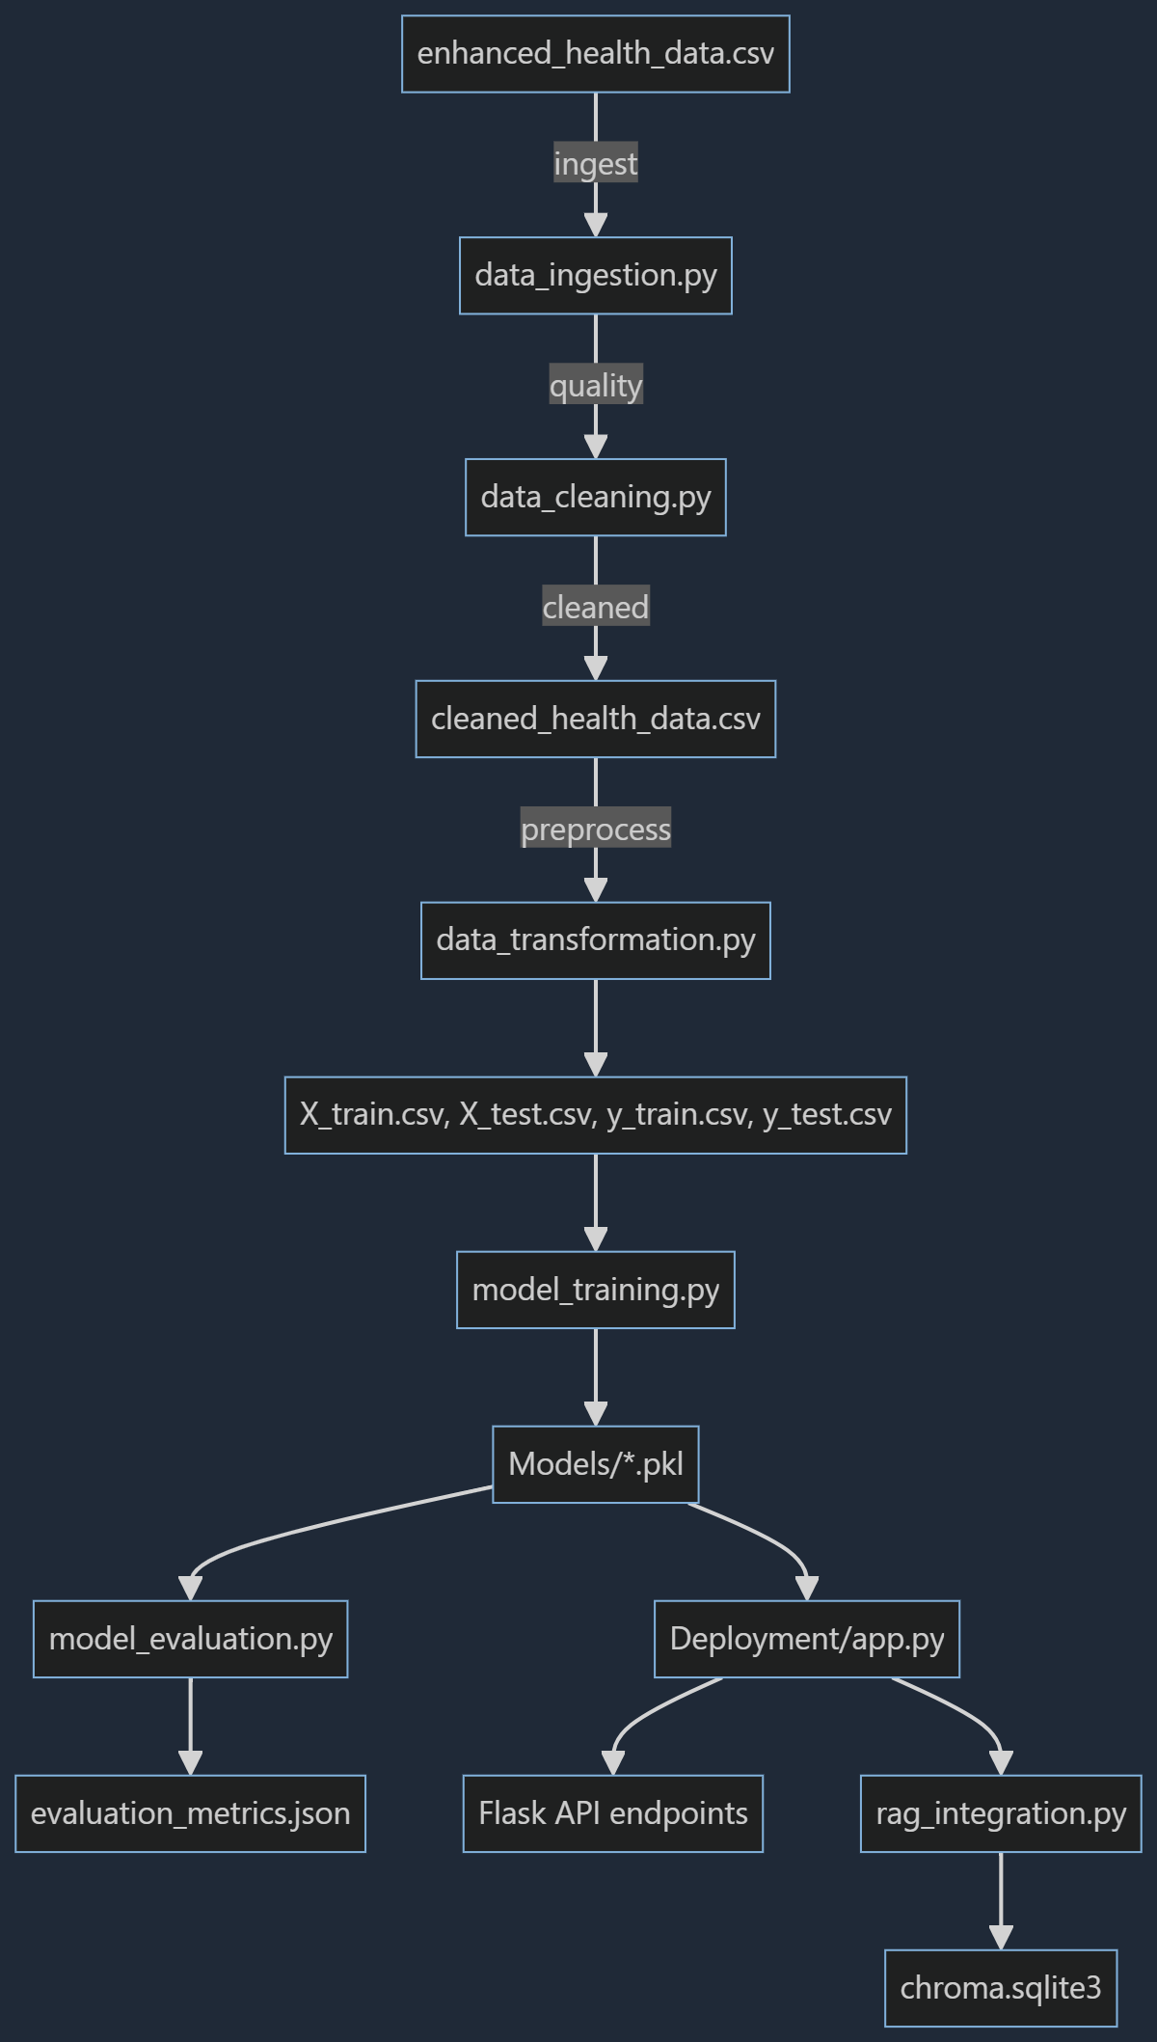

# Requirements

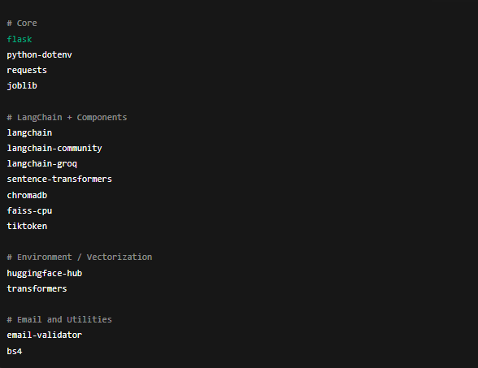

# Conclusion

The AI-Powered Smart Health Prediction System integrates machine learning and retrieval-augmented generation for interpretable, actionable health insights. It offers transparency, simplicity, and a base for future extensions such as fairness checks and calibration.