Breeze Board v2.0
Specifications
1) Introduction
Breeze is an autopilot system for UAV. Our goal is to provide innovative features to small aerial vehicule in order to improve takeoff, flying and landing capabilities. An UAV system relies on both the on-board electronic device and the ground station.
In this document we focused on the board. A previous version called Breeze Board v1.0 has been developed based on Atmega 2560 processor which runned at 16Mhz. This solution allows us to test our basic function such as flight stabilization. However since our needs in CPU are getting bigger with new features, we need more power to ensures such capabilities.

Our goal is to provide a much better version while keeping its size and weight around 20 grams.
Below a screenshot of our first board :

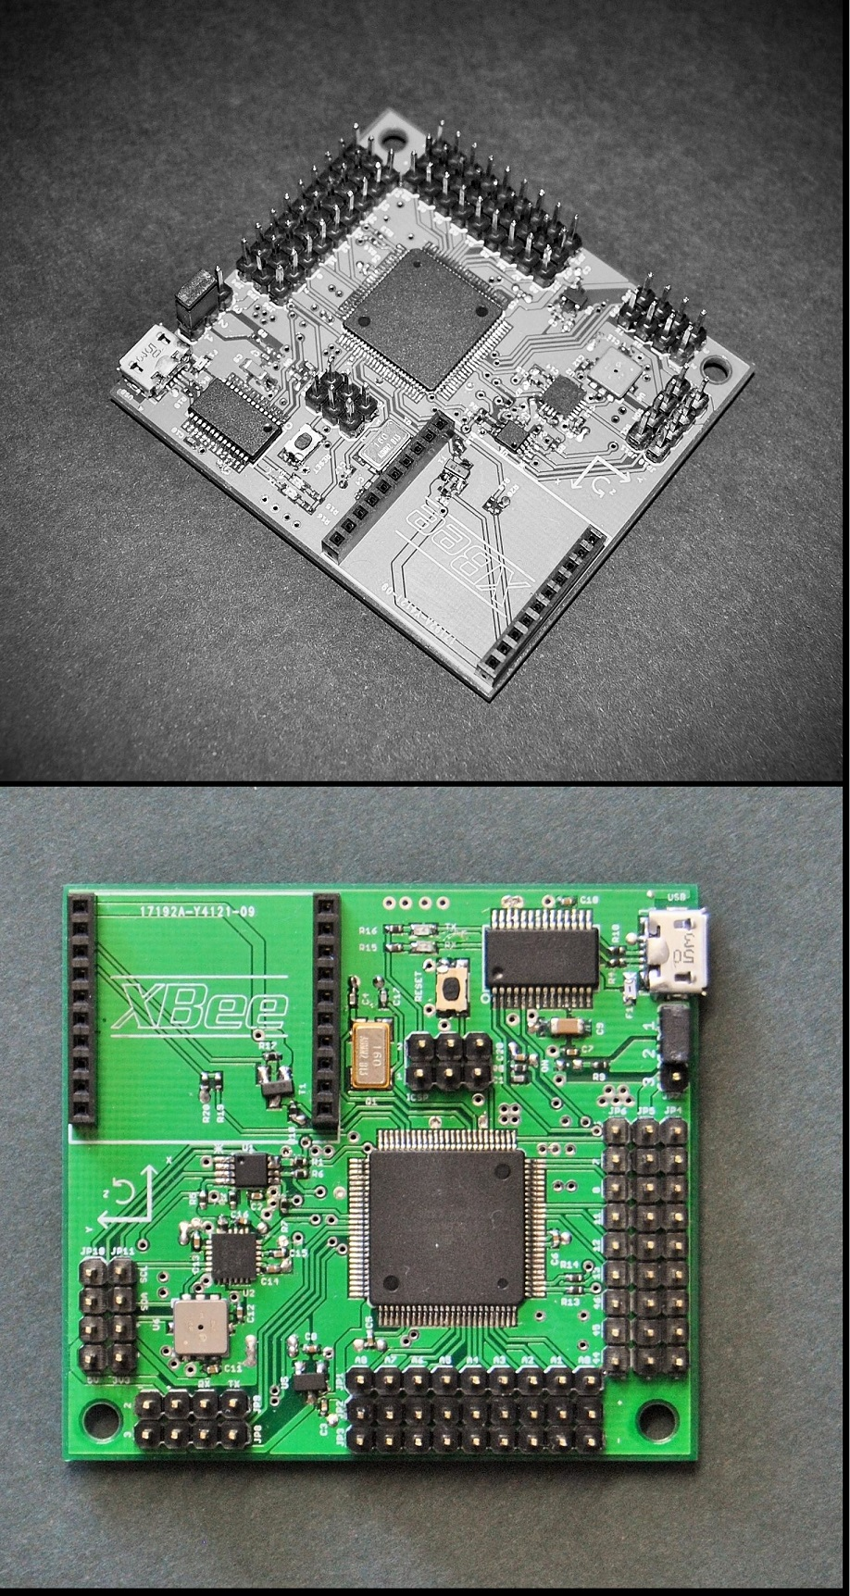

2) Changes from v1.0
The cornerstone of the v2.0 concerns its processor : ARM Cortex M4. In fact such processor keeps power consumption low while providing more than 150Mhz. We also want to improve our prototyping method by finding reliable companies which produce PCB board and assemble them in a good manner.
3) Risks
Type | Description | Solution
Production & Factory | Ability to find a reliable and cheap company to produce and assemble board
ARM Cortex code | Difficulty to adapt the Atmega2560 code into ARM Cortex (see library libopencm3 on github) | See library http://www.libopencm3.org/wiki/Main_Page
Voltage | Providing the right voltage +3.3v and +5v where its needed (ARM runned at 3.3v, while PWM needs 5v)
Magnetic & RF interference | Magnetic or RF perturbation between magnometer and Xbee

4) Performance requirements
Type | Description | Ensured
Clockspeed | Over 100Mhz
Size | Keep it under 5x5cm  Any benefit with 4 layers instead of 2?  Make two design : one in stick, one square to compare the benefits

4) Specifications

4.1- Components

Type | Name | Notes
MCU | ARM Cortex M4 | ﻿Is it ST STM32F4 ? Choose the best one compatible with libopencm3 and with enough UART, PWM, .. ports
IMU | MPU9150 6 axis | Interest to have 2 IMU instead of one to combine data (see chapter 6)
Barometer | BMP085
SBUS on board signal inverter |  | Resistance and transistors
Port | Mini/micro usb port (the same as current board) | To power and upload program on the board

4.2- Pins
Type | Number | Notes
Analog | 2
SDA/SCL | 4 pins with +3.3v, ground, sda, sdl  4 pins with +5v, ground, sda, sdl (for LIDAR Lite laser)
PWM 3 pins-header (signal +5v ground) related to ARM Cortex timers | at least 9 row of 3-pins-header
SBUS on board signal inverter | tx ; rx ; +5v ; ground | On serial2
GPS (Ublox LEA-6) Serial 3 pins | tx; rx ; +5v ; ground | On serial3
+/- pin for LED in series | 1 positive negative pin header | In order to light 1,2,3... and more LEDs using this port.
Xbee mount | Power, rx/tx and RSSI strength | Same as v1.0

4.3- Electrical and others services

- On board inverter logic for Futaba SBUS port (Only three pins (signal, +5v, ground) on the Rx)
- On board indiction with pin number / IMU orientation (x, y and z to the top) / “Breeze board v2.0” on the bottom
5) Work packages

Design

Name | Description | Earnings (€)
Review specs | Answering questions in chapter 6 “To be defined” | 20
Design the board, produce eagle and gerber file | - Produce multiple quick design to be able to estimate size for various model (stick, square, xbee over components, ..) | 80
Price estimation | Prediction of the board components and productions pricing (for one or multiples boards) | 20

Production

Name | Description | Earnings
Find company reliable for printing PCB and assembling the board | Making quote and companies reviews | 20
Listing components and ordering them |  | Price of the components
Producing and assemble the PCB board |  | Price of the production and shipment
Assemble and test the board |  | 80

Total earnings : 220€
Total cost : 220 + 180 (printing, assemble, components, shipping)
This amount must be reviewed as soon as we choose the company for printing and assembly.

6) To be defined

- How many timers are available on ARM cortex, TBD each timer used on Breeze for motors ?

- How many PWM ports are available ? (for ESC motors and servos)

- How many UARTs ports are available on ARM Cortex

- Xbee signal strength, which pin is needed on the ARM to have RSSI data ?

- Is it interesting to embed two IMU such as MPU9150 and combine the data, and in this case how to read/write on two components having same BUS addresses ?

- Which ARM Cortex to choose ? (Look library libopencm3 to see ARM available for this lib)

- Is there any solution for ESC/usb power without jumper ? While still be able to power the board from usb or from ESC BEC

- Is it possible to make a board where components are under the xbee to minimize size ?

