
Contents
Project Overview
Project: CardPOV
Date: 10/06/2011
1.0. Project Description 1
2.0. Project Roadmap 1
3.0. Legal Analysis 2
3.1. Regulatory Analysis and Compliance 2
3.2. Patent Analysis 2
4.0. Competitor Analysis 2
4.1. Open Source Project Analysis 2
4.1.1. Dangerous Prototypes USB POV Toy 2
4.1.2. uPOV POV Keychain 3
4.1.3. Business Card POV 4

1.0. Project Description
CardPOV is a project which applies the persistence of vision (POV) concept to a business card pocketable form factor. Using persistence of vision, the device can write out text as it is waved through the air. CardPOV differs from other conventional POV devices in that it is optimized to be in a slim form factor.
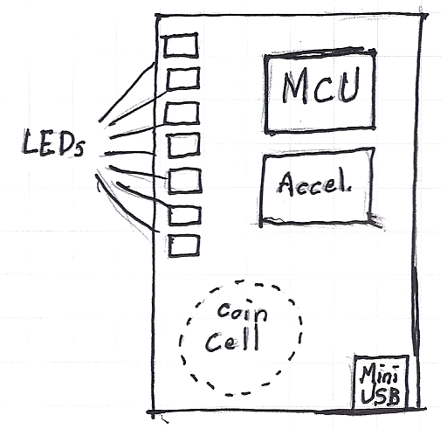
Fig. 1.1. Concept Sketch

2.0. Project Roadmap
The following phases are proposed for this project:
- Version 1: Open-loop POV
CardPOV v1 will utilize open-loop POV control (no feedback to adjust led blinking rate), and will provide all of the basic features of a functional POV device.
- Version 2: Closed-loop POV
CardPOV v2 will add support for an accelerometer to provide closed-loop control of the POV device (text output will be invariant of the speed at which the device is moved).
- Version 3: USB POV
CardPOV v3 will include an onboard USB port and bootloader which will allow users to perform firmware upgrades and upload customized text strings (without the need for a firmware reprogram). In addition, the coin cell will be replaced by a rechargeable coin cell or supercapacitor and allow the device to be recharged over the onboard USB port.
- Version 4: Global POV
CardPOV v4 will increase the number of onboard LEDs, adding in support for non-latin character sets such as arabic or japanese.
- Version 5: Touch POV
CardPOV v5 will take the POV concept a step further, doing away with tactile switches in favor of utilizing capactive or resistive touch sensing.
- Version 6: Color POV
CardPOV v6 will replace the onboard LEDs with RGB leds and implement RGB color mixing for custom display signs.

3.0. Legal Analysis

3.1. Regulatory Analysis and Compliance
- FCC: CardPOV features no antennas or other appreciable radiation emitting devices, so FCC regulatory issues are not expected.
- Medical: CardPOV does not perform any useful function in relation to medical devices or life-saving equipment, so medical device regulations are not expected.
- ITAR: CardPOV does not have any useful defense or military applications, so ITAR regulatory issues are not expected.
- Other: CardPOV does feature blinking, flashing lights that, when used in a car or other road vehicle, could violate street legal criterion in some states. CardPOV is not intended for this use, and a simple disclaimer should mitigate any regulations of this kind.

3.2. Patent Analysis
CardPOV is based upon the persistence of vision effect, whose earliest known demonstration in electronic devices was done by Bob Blick in 1996. This POV demonstration was released to the public domain, so patent infringement is not anticipated in this project.

4.0. Competitor Analysis
Persistence of vision devices are popular among hobbyists but thus far have fairly limited commercial exposure. In spite of similar projects, there is considerable room for improvement and CardPOV could be made a compelling project and product.

4.1. Open Source Project Analysis

4.1.1. Dangerous Prototypes USB POV Toy

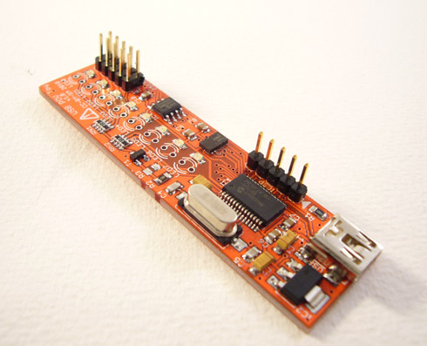
Fig. 4.1.1. Dangerous Prototypes USB POV Toy
Open source hardware community Dangerous Prototypes has had a persistence of vision device in development since late 2010. The device features onboard USB and an accelerometer for closed-loop control. It does not currently appear to feature battery power or multiple string support, although these would be trivial extensions of the device. At the time of this writing, the device has not undergone active development in many months, with the latest source files for the project having been dated May 2011 (4 months ago), and POV development at Dangerous Prototypes does not appear to be a priority.

4.1.2. uPOV POV Keychain
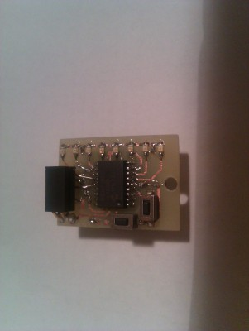
Fig. 4.1.2. uPOV Keychain
Dangerous Prototypes user exapod developed the uPOV persistence of vision keychain. Similar to CardPOV, the device utilizes a coin cell battery and PIC microcontroller to achieve the persistence of vision effect. The device uses very small SMD parts, and is much smaller than the CardPOV. Closed-loop control is achieved through the use of onboard tilt switches, and a video of the device in action suggests this method is capable of achieving good results.
The device is a simple one-off project, and as such the microcontroller is programmed directly via a PICKit interface. Additionally, the device lacks user control or programmability, with features such as multiple string support, included in the CardPOV project.

4.1.3. Business Card POV
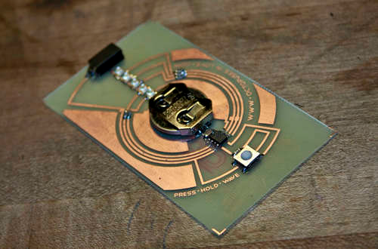
Fig. 4.1.3. Business Card POV
Instructables user sponges developed a business card POV device similar in many respects to version 1 of the CardPOV project. Particularly noteworthy about the device is the beautiful, catchy polar circuit design on the board. The device features a coin cell battery, extremely lightweight PIC16 series microcontroller, and tilt sensor for closed-loop control. A video of the device in action shows performance to be quite similar to CardPOV v1 (decent performance on camera, somewhat difficult to read in live situations).
Programming is extremely user unfriendly, requiring wires to be soldered to the physical board for programming. Additionally, The device appears to feature only 5 leds, making it extremely difficult to accurately display the standard latin character set (7 or 8 leds is typically recommended).

4.2. Commercial Product Analysis


4.1.1. Adafruit Industries MiniPOV v3
Fig. 4.2.1. MiniPOV v3
Arguably the most established POV device, the Adafruit Industries MiniPOV v3 is the latest in the MiniPOV line. At the time of this writing, MiniPOV hasn't seen appreciable development in years, and development of this project is not believed to be a priority for Adafruit Industries. Major advantages of the MiniPOV device are that it is commercially available and user programmable without the need for a microcontroller programmer.
The MiniPOV features an external AA battery pack connected to the main board via a pair of wires. While this lends itself to superior battery life, it results in an overly large form factor and is awkward to hold in one's hand. While the device doesn't require a microcontroller programmer, it still requires the use of a costly, cumbersome, and often out of stock USB/Serial converter. Additionally, the device is still fairly nontrivial to program (from a PC-side software perspective), and lacks certain useful user interface features (such as multiple string support). For these reasons, CardPOV could be made into a considerably better product than MiniPOV v3.

