Date: October 19th, 2009
Author: George Hadley
Project: Business Card POV
Description: Business Card POV Design Overview

Summary:
The Business Card POV is a project which applies the persistence of vision (POV) concept to a business card form factor. Using persistence of vision, the card can write out text as it is waved through the air. The Business Card POV differs from other conventional POV devices in that it is optimized to be in a slim form factor.

Concept Sketch:
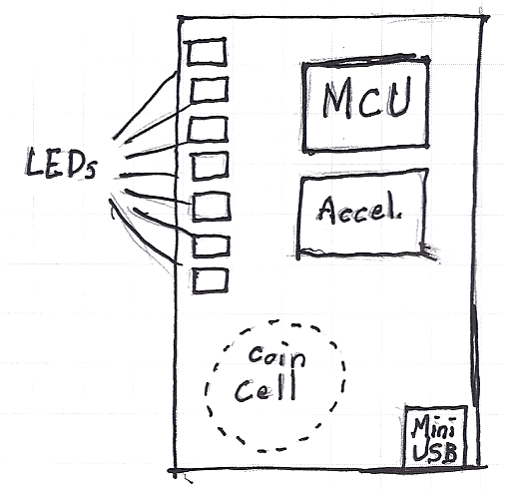

Versions:
The following phases are planned for this project:
Version 1: Open-loop POV
POV v1 will utilize open-loop POV control (no feedback to adjust led blinking rate), and will provide all the base features of a functional POV device.
Version 2: Closed-loop POV
POV v2 will implement an accelerometer to provide closed-loop control of the POV device (text output will be invariant of speed at which device is moved)
Version 3: MiniUSB POV
POV v3 will include a miniUSB port and bootloader which will allow users to perform firmware updates and upload customized text strings (without the need for a firmware reprogram).
Version 4: Touch POV
POV v4 will take the POV concept a step further, doing away with tactile switches in favor of utilizing capacitive or resistive touch sensing.
Version 5: Recharge POV
POV v5 will replace the standard coin cell battery with a rechargable coin cell and allow the device to be recharged over the POV's miniUSB port.

Hardware:
The following hardware is specified for this project:
Version 1:
-Microcontroller
-External Oscillator (may be required)
-Surface mount LEDs (x7)
-CR2032 coin cell battery
-Voltage regulation circuitry
-Tactile switches
Version 2:
-Add accelerometer
Version 3:
-Add miniUSB port
Version 4:
-Replace tactile switches with touch sensing planes
Version 5:
-Add charging circuitry

Software:
The following software is required for this project:
Version 1:
-General startup code
-POV table
-POV code
Version 2:
-Accelerometer code
Version 3:
-PC Application
-USB Bootloader
Version 4:
-Capacitive touch sensing code
Version 5:
-Battery charging code (?)

