
Contents
Project Overview
Project: RGBSaber
Date: 10-13-2011
1.0. Project Description 2
2.0. Project Roadmap 2
3.0. Legal Analysis 2
3.1. Regulatory Analysis and Compliance 2
3.2. Patent Analysis 2
3.2.1. Patent 1 2
3.2.2. Patent 2 2
3.2.3. Patent 3 2
4.0. Competitor Analysis 2
4.1. Open Source Project Analysis 2
4.1.1. Open Source Project 1 2
4.1.2. Open Source Project 2 2
4.1.3. Open Source Project 3 2
4.2. Commercial Product Analysis 2
4.2.1. Commercial Product 1 2
4.2.2. Commercial Product 2 2
4.2.3. Commercial Product 3 2
5.0. Sources Cited 2

1.0. Project Description
RGBSaber is an open-source, single-channel high power LED driver. The device is capable of implementing complete digital color control on a single high-intensity LED via pulse width modulation (PWM). In this way, the color of a lightsaber blade can be changed to any color in the RGB color spectrum.

2.0. Project Roadmap
The following versions are considered for the RGBSaber project:
RGBSaber_Control:
- Version 1: Basic digital color control, user saveable/selectable colors, sleep mode
- Version 2: Improved connectors, modular daughterboard system, SOUND, integrated accelerometer
- Version 3: User programmability, configurable peripheral interface
RGBSaber_Periph:
- Version 1: Basic user interface
- Version 2: Capacitive touch interface
Sound Driver (supported with RGBSaber_Control v2.0 and later):
- Version 1: Basic operational model
- Version 2: Support for sound fonts, microSD card support
Transistor Driver Boards:
- 3W RGB Transistor driver
- 5W WRGB Transistor driver
- 10W WRGB Transistor driver
RGBSaber_Chassis:
- Version 1.0: Basic operational model

3.0. Legal Analysis

3.1. Regulatory Analysis and Compliance
As with other active NBitWonder projects at the time of this writing, RGBSaber has no useful defense or medical applications, does not emit appreciable radiation at any radio frequencies, and is incapable of flight. Therefore, ITAR, medical device, FCC, and FAA regulatory compliance is assumed, and regulatory issues are not expected.

3.2. Patent Analysis
At the time of this writing, RGBSaber utilizes extremely simple PWM color mixing techniques. These techniques are trivial and well documented in the public domain, so patent infringement and related issues are not expected.

4.0. Competitor Analysis

4.1. Open Source Project Analysis
At the time of this writing, no other known open source RGB lightsaber systems are known to exist. That said, there are a few noteworthy open source projects capable of doing RGB color mixing.

4.1.1. Dangerous Prototypes USB RGB Color Changer
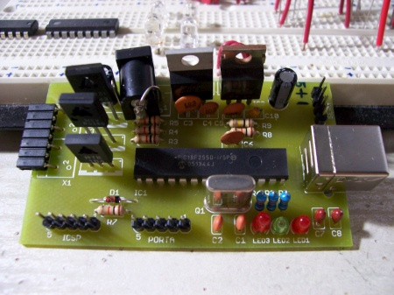
Fig. 1. Dangerous Prototypes USB Color Changer
Dangerous Prototypes produced a USB RGB color changer some time ago. This design was only ever in the prototype stage, was never produced, and is no longer actively developed. Additionally, the boardsare far too large to fit into a lightsaber form factor and use through-hole parts. As such, this design is not seen as a strong competitor to the RGB Lightsaber design.

4.1.2. MaceTech ShiftBrite Project
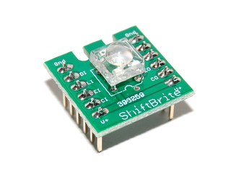
Fig. 2. MaceTech ShiftBrite Module
Open source company MaceTech developed and manufactures an RGB color mixing system known as the ShiftBrite. The ShiftBrite RGB system is theoretically small enough to fit inside of a lightsaber hilt environment. However, the LEDs and associated driving circuitry for the ShiftBrite system are not bright and powerful enough to see use in a practical lightsaber system, and no focusing optics for narrowing the ShiftBrite beam to an acceptably narrow width are known to exist.

4.2. Commercial Product Analysis

4.2.1. Sparkfun Electronics RGB Triple Play
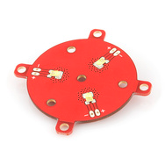
Fig. 3. Sparkfun RGB Triple Play
In late 2010, Sparkfun Electronics released the RGB Triple Play and associated drive circuitry. Coupled with a tri-LED optical lens, these products certainly hit closer to the RGBSaber system than most competitors. However, at the time of this writing, these products are still too bulky to see effective use inside of a lightsaber hilt, and are also vastly overpriced (costing approximately 70 dollars for the LED and drivers alone, without any control electronics). As such, Sparkfun's products are not seen as strong competitors to the RGBSaber project.

4.2.2. Plecter Labs Crystal Focus System
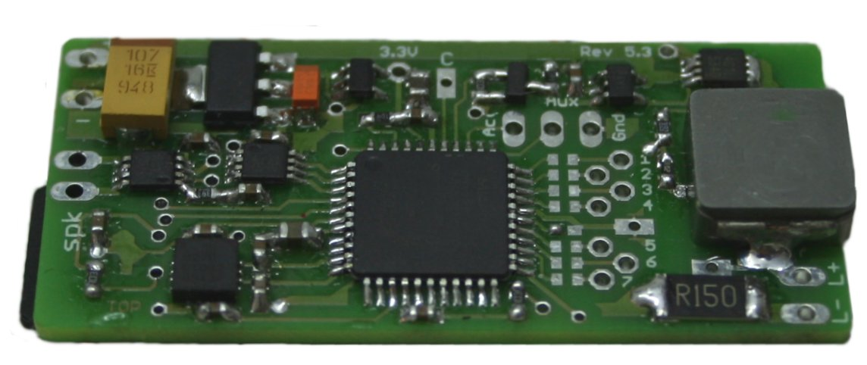
Fig. 4. Plecter Labs Crystal Focus System
Lightsaber company Plecter Labs produces a set of lightsaber electronics known as Crystal Focus, which is seen as the primary competitor to the RGBSaber project. The board is the most advanced set of lightsaber electronics known, and includes many advanced features, such as sound and swing/clash detection. The board is not capable of RGB color control at the present time, and only supports a single channel. Nonetheless, the system could be modified to support RGB color without too much effort. The system is decidedly a high-end system at the present time (costing approximately USD 200 per board), so a slightly less featured but cheaper board could be a prominent competitor to this system.

