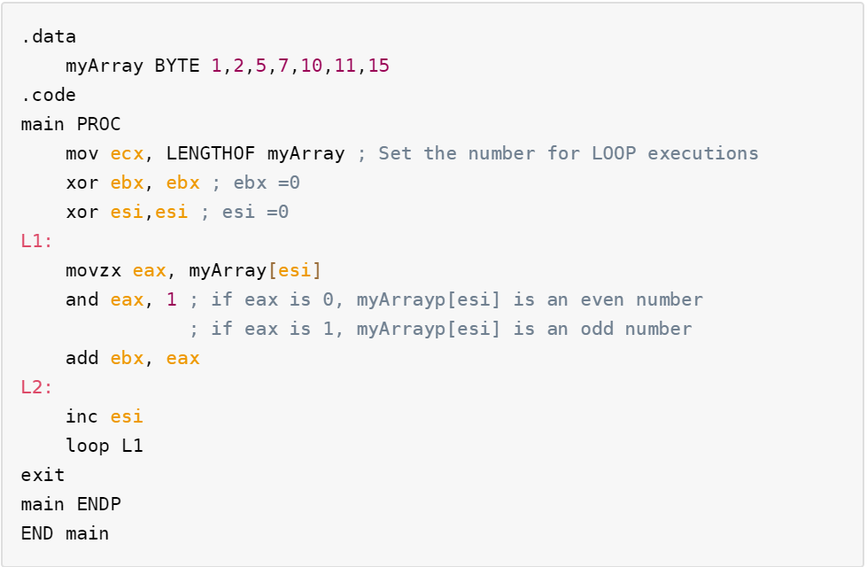

|  |  |  |
| --- | --- | --- |
|  | EAX | EBX |
| 0 | 00000000h | 00000000h |
| 1 | 00000001h | 00000001h |
| 2 | 00000000h | 00000001h |
| 3 | 00000001h | 00000010h |
| 4 | 00000001h | 00000011h |
| 5 | 00000000h | 00000011h |
| 6 | 00000001h | 00000100h |
| 7 | 00000001h | 00000101h |

Assume that the 0 th row shows the value of registers when the program executes to L1, and fills the value of the registers in the i-th row of the table when the “loop L1” is executed to the L2.

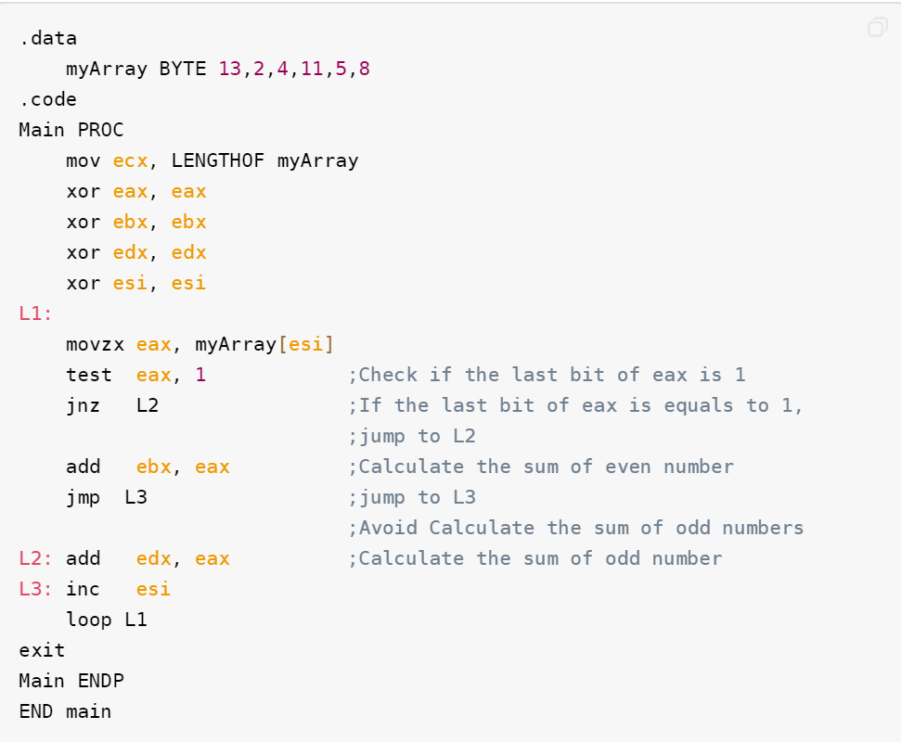

|  |  |  |  |  |
| --- | --- | --- | --- | --- |
|  | EAX | ZF | EBX | EDX |
| 0 | 00000000h | 0 | 00000000h | 00000000h |
| 1 | 0000000Dh | 0 | 00000000h | 0000000Dh |
| 2 | 00000002h | 1 | 00000002h | 0000000Dh |
| 3 | 00000004h | 1 | 00000006h | 0000000Dh |
| 4 | 0000000Bh | 0 | 00000006h | 00000018h |
| 5 | 00000005h | 0 | 00000006h | 0000001Dh |
| 6 | 00000008h | 1 | 0000000Eh | 0000001Dh |