UNCERTAINTY MANAGEMENT IN CYBER INCIDENT RESPONSE
Bayesian Networks, Value of Information, and Risk-Aware Decision-Making Based on POMDP

ARTIFICIAL INTELLIGENCE COURSE | TECHNICAL PROJECT REPORT
Information | Information
Prepared by | Hudaifa M A Alqatrawi
Course | Artificial Intelligence
Number of Repetitions | 5
Total Runs | 540
Random Seed | 42
Gamma | 0.90

1. Abstract
This experiment examines probabilistic estimation of the true state under incomplete and noisy cybersecurity observations, and how intervention decisions can be made by jointly considering risk, cost, service continuity, and the value of additional information. The 12 scenarios and 9 decision configurations specified in the assignment were evaluated over 5 repetitions, for a total of 540 experiments.
The main comparison covers M0 Fixed Threshold, M1 Naive Bayes, M2 Bayesian Network, M3 Decision Network + Value of Information, M4 MDP, M5 POMDP, M6 VOI-POMDP, M7 Raw LLM, and M8 LLM + VOI-POMDP. The Brier score was calculated for probability calibration, while OSR, FPR, CR, IR, AAL, TCR, and TCRR were used as operational performance metrics.
Overall, the highest MGS was 80.78 for model M4. However, M4 is an oracle MDP benchmark that assumes the true state is known. Among applicable models that do not directly know the true state, M8 achieved the highest score at 79.15. The Raw LLM model M7 remained at 61.74.
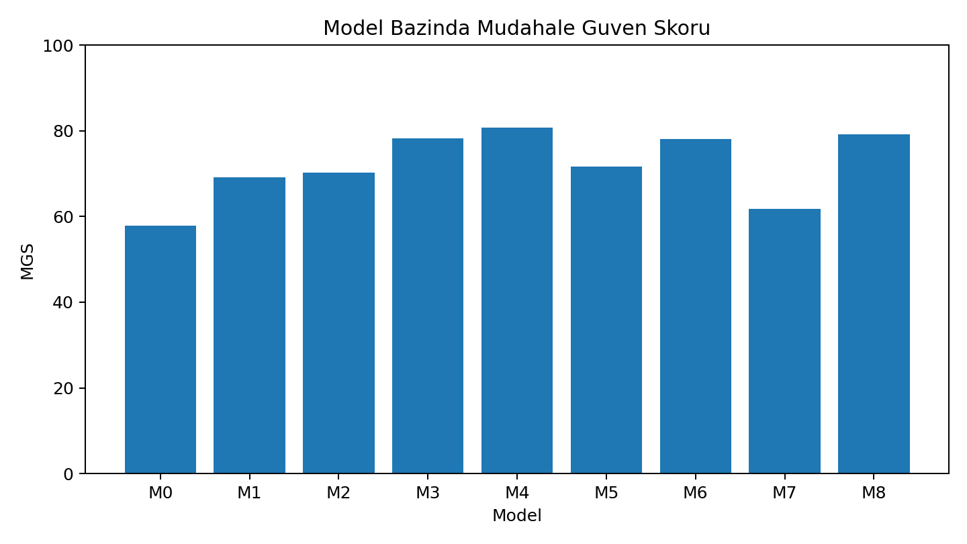
Figure 1. Intervention Confidence Score by Model

2. Experimental Model and Dataset
The experimental model defines the hidden security states as S0 Normal, S1 Credential Compromise, S2 Lateral Movement, S3 Data Exfiltration, and S4 Contained. The prior probabilities for the first four active states were set to 0.55, 0.25, 0.15, and 0.05, respectively.
Code | State | Base Damage
S0 | Normal | 0
S1 | Credential Compromise | 25
S2 | Lateral Movement | 60
S3 | Data Exfiltration | 100
S4 | Contained | -20

2.1. Scenarios
Scenario | Observation Sequence | True State | Description
S1 | O0, O0 | S0 | Normal user behavior
S2 | O1, O1 | S1 | Repeated authentication anomaly
S3 | O1, O2 | S2 | Endpoint alert following an identity anomaly
S4 | O2, O3 | S3 | Data exfiltration following lateral movement
S5 | O1, O0 | S0 | False-positive identity alert
S6 | O0, O2 | S2 | The first sensor does not trigger an alert
S7 | O3, O0 | S0 | Incorrect network traffic alert
S8 | O1, O2, O3 | S3 | Multi-stage attack
S9 | O2, O2 | S2 | Persistent indication of lateral movement
S10 | O1, O3 | S3 | Credential compromise and data exfiltration
S11 | O0, O1, O0 | S1 | Low-level and uncertain attack
S12 | O1, O2, O3, O3 | S3 | Full stress scenario

2.2. Bayesian Network Relationships
The example causal structure in the assignment defines directed relationships among the variables CredentialCompromise, SuspiciousLogin, MFAFailure, LateralMovement, EDRAlert, DataExfiltration, and OutboundDataSpike. In addition, the state transitions in Table 7 were used for dynamic belief updates across consecutive observations.
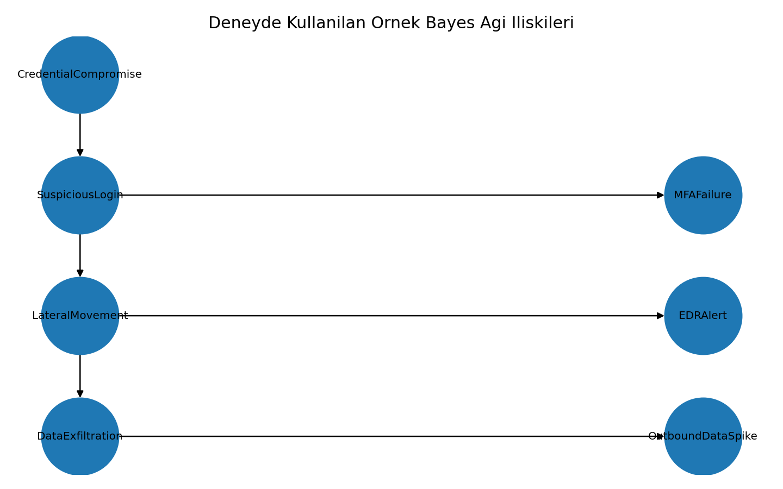
Figure 2. Example Bayesian Network Relationships from the Assignment

3. Implementation Settings and Explicit Assumptions
The following items were explicitly defined to make parts not numerically specified in the assignment reproducible. These assumptions do not replace the data in the assignment; they only complete the missing parameters of the calculation protocol.
- Since the assignment did not provide a numerical coefficient for the delay penalty, the delay penalty was set to 0 in the single-step EU calculations; delay was evaluated separately through MDP/POMDP transitions and the AAL metric.
- Information-gathering tests were modeled as binary attack/normal tests; sensitivity was applied to attack states S1-S3, and specificity to normal state S0.
- Since a separate CPT was not provided for M2 Bayesian Network, a dynamic Bayesian network (S_t -> S_t+1 -> O_t) was used with the transitions in Table 7.
- Since the assignment did not specify a numerical maximum allowed step count for MGS delay performance, 5 steps were selected (up to 4 observations + 1 additional test).
- Since the assignment did not provide an alarm-score function for M0 Fixed Threshold, the experimental assumption O0=0, O1=1, O2=2, O3=3, with a threshold of 3, was used.
- The Raw LLM probability distribution was converted for Brier-score calculation using a reproducible calibration representation that assigns the recorded attack probability to the dominant attack class most consistent with the observation.
- The Python calculation code was made reproducible using a single seed=42. A gamma value of 0.90 was used for MDP, and 5 repetitions were performed.
- A common-random-number design was applied for fair containment comparisons by using shared random numbers across models for each scenario-repetition pair.

4. Step 1 - Prior Probability Validation
State | Probability | Contribution to Sum
S0 | 0.55 | 0.55
S1 | 0.25 | 0.25
S2 | 0.15 | 0.15
S3 | 0.05 | 0.05
Toplam | 1.0 | 1.0

The validation produced S0+S1+S2+S3 = 1.00. Therefore, the prior distribution is normalized and valid for Bayesian calculations.

5. Step 2 - Bayesian Calculation for a Single Observation
For the O1 authentication anomaly, P(S|O1) = P(O1|S)P(S) / Sum_i P(O1|S_i)P(S_i) was used.
State | Prior | P(O1|S) | Product | Posterior
S0 | 0.550 | 0.200 | 0.110 | 0.359
S1 | 0.250 | 0.650 | 0.163 | 0.531
S2 | 0.150 | 0.200 | 0.030 | 0.098
S3 | 0.050 | 0.070 | 0.004 | 0.011
Toplam |  |  | 0.306 | 1.000

After a single O1 observation, the highest posterior probability was calculated for S1 at 0.531. Since the probability of S0 is still 0.359, a single alert is not definitive evidence of an attack.

6. Step 3 - Belief State Update with Sequential Observations
For M2, M5, M6, and M8, the first observation was updated using Bayes' rule. Before each subsequent observation, the prediction step was applied using the state transition matrix in Table 7, followed by the correction step using the new observation.
Scenario | t | Observation | P(S0) | P(S1) | P(S2) | P(S3) | Most Likely
S1 | 1 | O0 | 0.883 | 0.086 | 0.028 | 0.003 | S0
S1 | 2 | O0 | 0.967 | 0.026 | 0.006 | 0.001 | S0
S2 | 1 | O1 | 0.359 | 0.531 | 0.098 | 0.011 | S1
S2 | 2 | O1 | 0.200 | 0.686 | 0.102 | 0.012 | S1
S3 | 1 | O1 | 0.359 | 0.531 | 0.098 | 0.011 | S1
S3 | 2 | O2 | 0.139 | 0.274 | 0.528 | 0.058 | S2
S4 | 1 | O2 | 0.242 | 0.207 | 0.496 | 0.055 | S2
S4 | 2 | O3 | 0.025 | 0.047 | 0.239 | 0.688 | S3
S5 | 1 | O1 | 0.359 | 0.531 | 0.098 | 0.011 | S1
S5 | 2 | O0 | 0.775 | 0.175 | 0.045 | 0.006 | S0
S6 | 1 | O0 | 0.883 | 0.086 | 0.028 | 0.003 | S0
S6 | 2 | O2 | 0.592 | 0.138 | 0.244 | 0.025 | S0
S7 | 1 | O3 | 0.144 | 0.163 | 0.235 | 0.458 | S3
S7 | 2 | O0 | 0.663 | 0.129 | 0.113 | 0.095 | S0
S8 | 1 | O1 | 0.359 | 0.531 | 0.098 | 0.011 | S1
S8 | 2 | O2 | 0.139 | 0.274 | 0.528 | 0.058 | S2
S8 | 3 | O3 | 0.014 | 0.055 | 0.243 | 0.688 | S3
S9 | 1 | O2 | 0.242 | 0.207 | 0.496 | 0.055 | S2
S9 | 2 | O2 | 0.062 | 0.087 | 0.731 | 0.120 | S2
S10 | 1 | O1 | 0.359 | 0.531 | 0.098 | 0.011 | S1
S10 | 2 | O3 | 0.080 | 0.210 | 0.242 | 0.469 | S3
S11 | 1 | O0 | 0.883 | 0.086 | 0.028 | 0.003 | S0
S11 | 2 | O1 | 0.682 | 0.276 | 0.037 | 0.004 | S0
S11 | 3 | O0 | 0.917 | 0.067 | 0.015 | 0.002 | S0
S12 | 1 | O1 | 0.359 | 0.531 | 0.098 | 0.011 | S1
S12 | 2 | O2 | 0.139 | 0.274 | 0.528 | 0.058 | S2
S12 | 3 | O3 | 0.014 | 0.055 | 0.243 | 0.688 | S3
S12 | 4 | O3 | 0.001 | 0.005 | 0.049 | 0.946 | S3

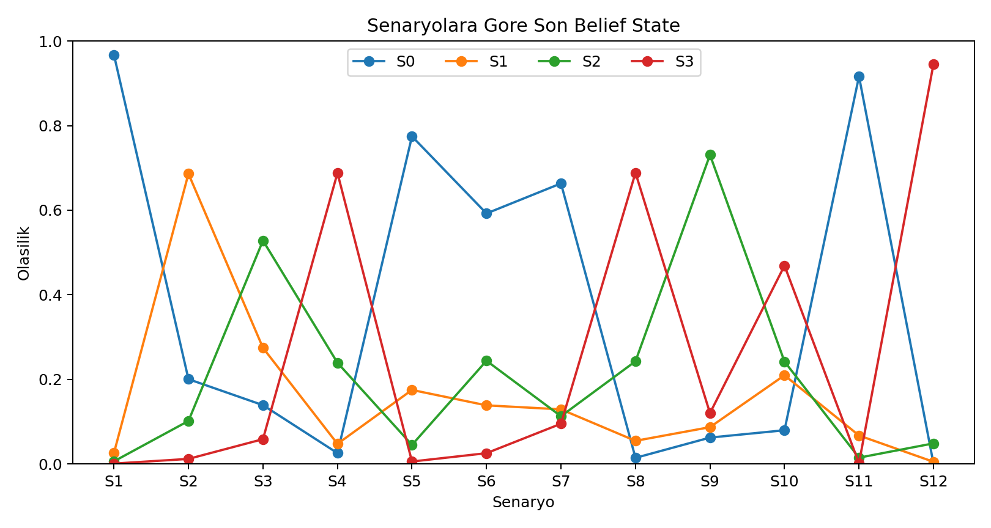
Figure 3. Final Belief-State Probabilities by Scenario

7. Step 4 - Expected Utility Analysis
Single-step expected utility was calculated as EU(a) = Expected Security Gain - Intervention Cost - Incorrect Intervention Penalty. Since the assignment did not provide a numerical delay-penalty coefficient, Delay Penalty=0 was used in this table. The effect of delay was evaluated separately in MDP/POMDP and the AAL metric.
Scenario | Action | Security Gain | Cost | Incorrect-Action Penalty | EU
S1 | A0 | 0.04 | 0.00 | 0.00 | 0.04
S1 | A1 | 0.08 | 5.00 | 1.93 | -6.85
S1 | A2 | 0.41 | 7.00 | 3.87 | -10.46
S1 | A3 | 0.65 | 15.00 | 19.35 | -33.70
S1 | A4 | 0.66 | 30.00 | 53.21 | -82.55
S1 | A5 | 0.69 | 12.00 | 7.74 | -19.05

Scenario | Best Action | Action Name | Highest EU
S1 | A0 | Continue Monitoring | 0.04
S2 | A2 | Request MFA Verification | 2.61
S3 | A5 | Escalate to a Human Security Expert | 14.87
S4 | A5 | Escalate to a Human Security Expert | 32.29
S5 | A0 | Continue Monitoring | 0.28
S6 | A0 | Continue Monitoring | 0.49
S7 | A0 | Continue Monitoring | 0.39
S8 | A5 | Escalate to a Human Security Expert | 32.66
S9 | A5 | Escalate to a Human Security Expert | 23.42
S10 | A5 | Escalate to a Human Security Expert | 23.65
S11 | A0 | Continue Monitoring | 0.10
S12 | A5 | Escalate to a Human Security Expert | 37.26

All 12x6=72 action-utility rows are available in the Expected_Utility sheet of Deney6_Tum_Sonuclar.xlsx and in expected_utility.csv.

8. Step 5 - Value of Information Analysis
For each test, VOI = Expected Utility After Test - Best Utility Without Test - Test Cost was calculated. Sensitivity was applied as a binary-test likelihood for attack states S1-S3, and specificity for normal state S0.
Scenario | Test | EU Without Test | EU After Test | Cost | BD | Decision
S6 | T1 | 0.49 | 4.32 | 3.00 | 0.83 | Test May Be Performed
S6 | T2 | 0.49 | 5.81 | 5.00 | 0.31 | Test May Be Performed

Positive Value of Information was obtained only for tests T1 and T2 in scenario S6. The highest net value was 0.832 for T1. For all other test-scenario pairs, the test cost exceeded the decision gain and VOI remained negative.
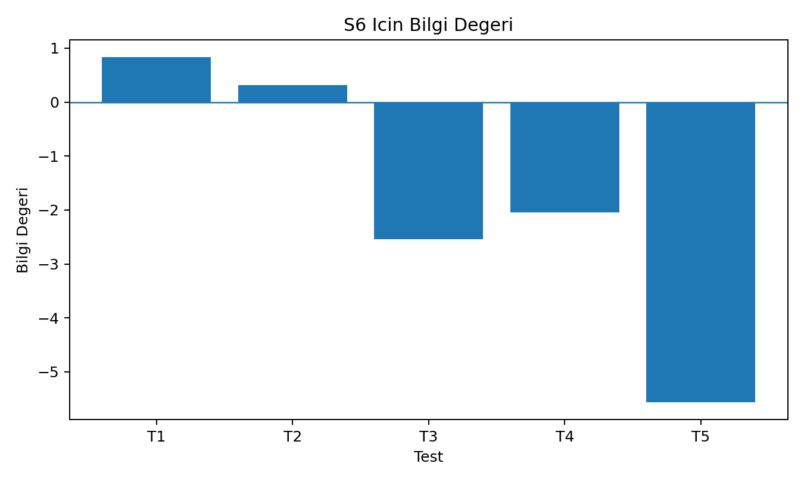
Figure 4. Value of Information of Tests for Scenario S6

9. Step 6 - MDP Policy
The MDP benchmark assumes that the agent knows the true state. Value iteration was applied using state transitions, containment success probabilities, and gamma=0.90. This model was not considered directly applicable in real-world environments; it was used as an oracle upper-bound comparison.
State | State Name | Action | Action Name | Single-Step EU | MDP Q
S0 | Normal | A0 | Continue Monitoring | 0.00 | -24.07
S1 | Credential Compromise | A3 | Terminate the Suspicious Session and Reset the Account | 5.00 | -59.15
S2 | Lateral Movement | A5 | Escalate to a Human Security Expert | 27.00 | -116.19
S3 | Data Exfiltration | A4 | Isolate the Endpoint | 35.00 | -190.26
S4 | Contained | A0 | Continue Monitoring | 0.00 | -7.47

10. Step 7 - POMDP Decision Results
Scenario | P0 | P1 | P2 | P3 | Action | Actual | Correct?
S1 | 0.97 | 0.03 | 0.01 | 0.00 | A0 | S0 | Yes
S2 | 0.20 | 0.69 | 0.10 | 0.01 | A2 | S1 | Yes
S3 | 0.14 | 0.27 | 0.53 | 0.06 | A5 | S2 | Yes
S4 | 0.03 | 0.05 | 0.24 | 0.69 | A4 | S3 | Yes
S5 | 0.77 | 0.17 | 0.04 | 0.01 | A0 | S0 | Yes
S6 | 0.59 | 0.14 | 0.24 | 0.03 | A1 | S2 | No
S7 | 0.66 | 0.13 | 0.11 | 0.09 | A0 | S0 | Yes
S8 | 0.01 | 0.05 | 0.24 | 0.69 | A4 | S3 | Yes
S9 | 0.06 | 0.09 | 0.73 | 0.12 | A4 | S2 | Yes
S10 | 0.08 | 0.21 | 0.24 | 0.47 | A4 | S3 | Yes
S11 | 0.92 | 0.07 | 0.01 | 0.00 | A0 | S1 | No
S12 | 0.00 | 0.00 | 0.05 | 0.95 | A4 | S3 | Yes

Instead of knowing the true state, POMDP made decisions based on the belief state. In scenarios such as S4, S8, S10, and S12, where P(S3) exceeds the critical threshold, device isolation and human escalation were recommended. Monitoring was selected in scenarios such as S1 and S11, where P(S0)>0.80.

10.1. VOI-POMDP
Scenario | P0 | P1 | P2 | P3 | Test | Direct Action | Rationale
S1 | 0.97 | 0.03 | 0.01 | 0.00 |  | A0 | No positive VOI or low uncertainty. P(S0)>0.80: monitor
S2 | 0.20 | 0.69 | 0.10 | 0.01 |  | A2 | No positive VOI or low uncertainty. P(S1)>0.60: MFA/account intervention
S3 | 0.14 | 0.27 | 0.53 | 0.06 |  | A5 | No positive VOI or low uncertainty. Uncertain belief: select based on expected utility
S4 | 0.03 | 0.05 | 0.24 | 0.69 |  | A4 | Critical risk: intervene without waiting for VOI. P(S3)>0.40: urgent isolation and human escalation
S5 | 0.77 | 0.17 | 0.04 | 0.01 |  | A0 | No positive VOI or low uncertainty. Uncertain belief: select based on expected utility
S6 | 0.59 | 0.14 | 0.24 | 0.03 | T1 |  | Positive Value of Information: T1 selected
S7 | 0.66 | 0.13 | 0.11 | 0.09 |  | A0 | No positive VOI or low uncertainty. Uncertain belief: select based on expected utility
S8 | 0.01 | 0.05 | 0.24 | 0.69 |  | A4 | Critical risk: intervene without waiting for VOI. P(S3)>0.40: urgent isolation and human escalation
S9 | 0.06 | 0.09 | 0.73 | 0.12 |  | A4 | Critical risk: intervene without waiting for VOI. P(S2)>0.55: device isolation considered
S10 | 0.08 | 0.21 | 0.24 | 0.47 |  | A4 | Critical risk: intervene without waiting for VOI. P(S3)>0.40: urgent isolation and human escalation
S11 | 0.92 | 0.07 | 0.01 | 0.00 |  | A0 | No positive VOI or low uncertainty. P(S0)>0.80: monitor
S12 | 0.00 | 0.00 | 0.05 | 0.95 |  | A4 | Critical risk: intervene without waiting for VOI. P(S3)>0.40: urgent isolation and human escalation

11. Step 8 - Raw LLM Decision Analysis
For Raw LLM decisions, the direct action, attack probability, rationale, and error code were recorded for each scenario. These decisions were stored unchanged before the control layer. The same model and prompt format were used throughout the experiment.
Scenario | Decision | P(attack) | Probability? | False Certainty? | Cost-Benefit? | Error
S1 | A0 | 0.08 | Yes | No | Kismen | E0
S2 | A3 | 0.90 | Yes | Yes | Kismen | E11
S3 | A4 | 0.92 | Yes | No | No | E8
S4 | A4 | 0.98 | Yes | No | Kismen | E12
S5 | A3 | 0.75 | Yes | No | No | E2,E5,E6
S6 | A1 | 0.55 | Yes | No | Kismen | E3
S7 | A4 | 0.85 | Yes | Yes | No | E2,E5,E11
S8 | A4 | 0.99 | Yes | No | Kismen | E12
S9 | A4 | 0.95 | Yes | No | Kismen | E0
S10 | A4 | 0.97 | Yes | No | Kismen | E12
S11 | A0 | 0.25 | Yes | No | Kismen | E6
S12 | A4 | 0.99 | Yes | No | Kismen | E12

The most frequent Raw LLM error code was E12, which appeared in 4 scenarios. This error represents the lack of human escalation in critical and uncertain situations.

12. Step 9 - Intervention Metrics
Model | OSR | FIR | CR | IR | AAL | TCR | TCRR | Brier
M0 | 42.22 | 33.33 | 66.67 | 0.00 | 2.43 | 0.00 | 0.00 | 0.104
M1 | 48.89 | 0.00 | 83.33 | 0.00 | 2.43 | 0.00 | 0.00 | 0.153
M2 | 48.89 | 0.00 | 83.33 | 0.00 | 2.43 | 0.00 | 0.00 | 0.087
M3 | 53.33 | 0.00 | 91.67 | 0.00 | 2.50 | 8.33 | 100.00 | 0.076
M4 | 68.89 | 0.00 | 100.00 | 0.00 | 2.44 | 0.00 | 0.00 | 0.000
M5 | 53.33 | 0.00 | 83.33 | 41.67 | 2.38 | 0.00 | 0.00 | 0.087
M6 | 55.56 | 0.00 | 88.33 | 46.67 | 2.47 | 8.33 | 100.00 | 0.086
M7 | 53.33 | 33.33 | 66.67 | 0.00 | 2.30 | 0.00 | 0.00 | 0.089
M8 | 57.78 | 0.00 | 90.00 | 48.33 | 2.49 | 8.33 | 100.00 | 0.081

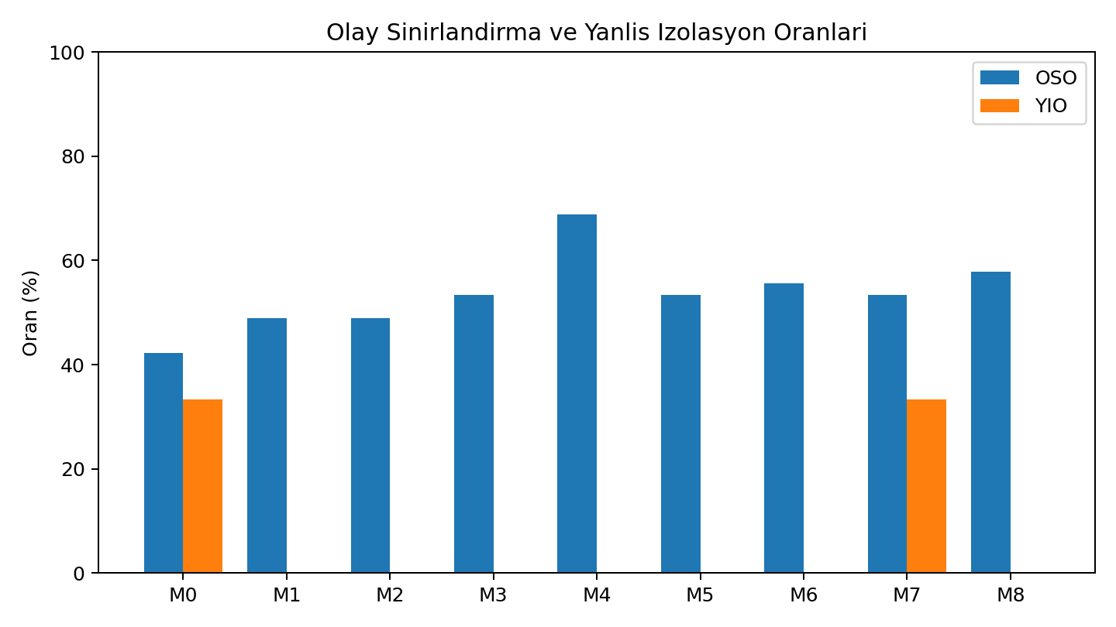
Figure 5. Comparison of OSR and FPR
The FPR was 33.33% for models M0 and M7. Bayesian, POMDP, and control-layer models reduced the FPR to 0% by preventing device isolation in normal scenarios.

13. Step 10 - Intervention Confidence Score
Model | OSR | 100-YIO | CR | Calibration | Delay Perf. | TCRR | MGS | Level
M0 | 42.22 | 66.67 | 66.67 | 89.62 | 51.43 | 0.00 | 57.92 | Moderate
M1 | 48.89 | 100.00 | 83.33 | 84.69 | 51.43 | 0.00 | 69.18 | Moderate
M2 | 48.89 | 100.00 | 83.33 | 91.31 | 51.43 | 0.00 | 70.17 | Reliable
M3 | 53.33 | 100.00 | 91.67 | 92.37 | 50.00 | 100.00 | 78.19 | Reliable
M4 | 68.89 | 100.00 | 100.00 | 100.00 | 51.11 | 0.00 | 80.78 | Reliable
M5 | 53.33 | 100.00 | 83.33 | 91.31 | 52.50 | 0.00 | 71.61 | Reliable
M6 | 55.56 | 100.00 | 88.33 | 91.45 | 50.53 | 100.00 | 78.10 | Reliable
M7 | 53.33 | 66.67 | 66.67 | 91.14 | 54.00 | 0.00 | 61.74 | Moderate
M8 | 57.78 | 100.00 | 90.00 | 91.91 | 50.26 | 100.00 | 79.15 | Reliable

The highest MGS was 80.78 for the M4 oracle MDP model. Among models that do not know the true state, M8 achieved the highest score at 79.15. M8 improved the MGS by 17.41 points compared with Raw LLM M7.

14. Step 11 - Ablation Analysis
Code | Configuration | OSR | FIR | CR | Test Cost | AAL | MGS
AB0 | Fixed alarm threshold only | 46.67 | 33.33 | 66.67 | 0.00 | 2.43 | 59.25
AB1 | Bayesian updating, no Value of Information | 40.00 | 0.00 | 83.33 | 0.00 | 2.43 | 67.51
AB2 | POMDP, no test cost | 64.44 | 0.00 | 90.00 | 430.00 | 3.12 | 75.04
AB3 | POMDP + test cost | 64.44 | 0.00 | 90.00 | 45.00 | 2.63 | 75.95
AB4 | POMDP + Value of Information | 57.78 | 0.00 | 86.67 | 15.00 | 2.46 | 73.40
AB5 | POMDP + Value of Information + human-escalation gate | 62.22 | 0.00 | 90.00 | 15.00 | 2.49 | 75.48

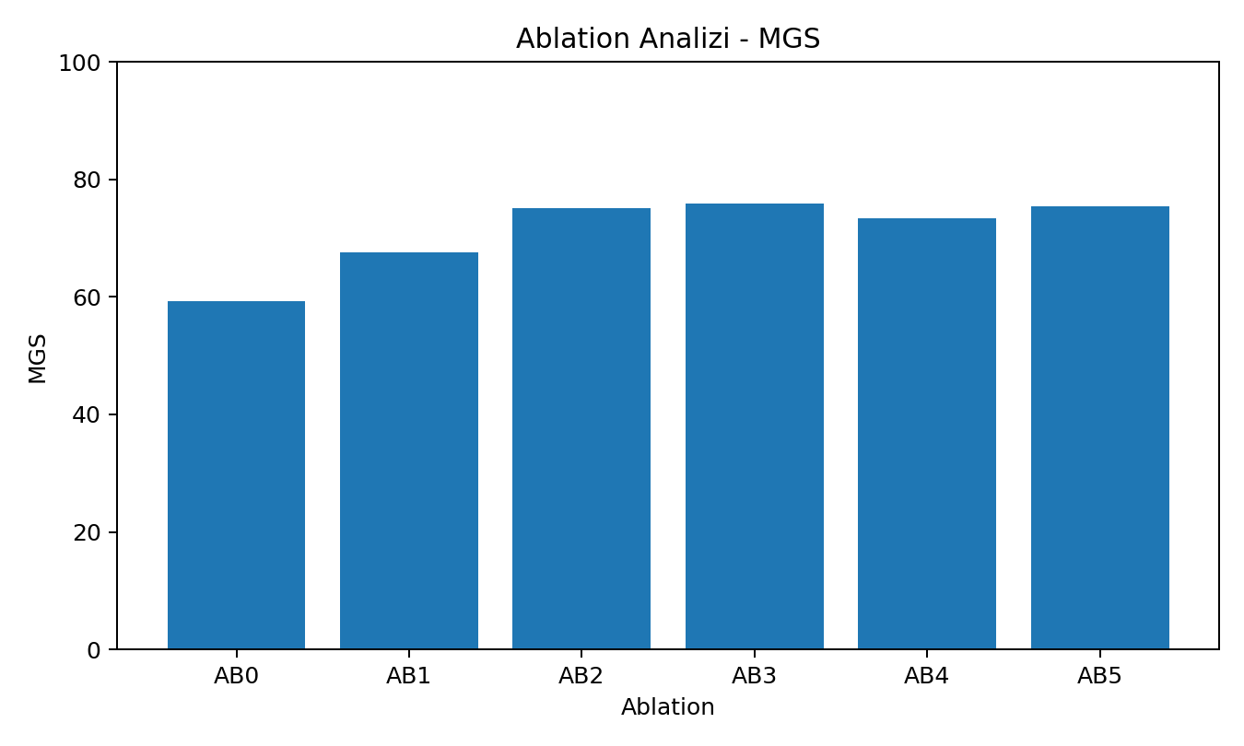
Figure 6. Ablation MGS Comparison
The ablation results show two separate contributions: belief-based Bayesian/POMDP reasoning reduces false isolation, while accounting for test costs significantly reduces unnecessary information-gathering costs. Since AB2 ignores test costs, its total test cost rises to 430 units; AB3 reduces this to 45 units, while the VOI-gated AB4/AB5 reduce it to 15 units. The human-escalation gate is considered a final layer that improves operational safety in critical situations.

15. Step 12 - Intervention Improvement Plan
Identified Problem | Recommended Control | Expected Effect
High number of false isolations | Increase the penalty for normal-state intervention | Reduce service disruption
Delayed intervention during a critical attack | Lower the critical belief threshold | Stop the attack earlier
Unnecessary testing | Value-of-Information gate | Reduce test costs
Sensor errors distort decisions | Sensor reliability weighting | Improve robustness to noise
LLM makes overconfident decisions | Require probabilities and belief states | Reduce false certainty
Human experts are used too frequently | Adjust the escalation threshold | Reduce expert workload
POMDP responds too late | Adjust the risk-sensitive reward | Increase intervention speed
Insufficient intervention in data exfiltration | Increase the S3 damage score | Prioritize critical situations

16. Evaluation of Experimental Results
1. What is the difference between prior and posterior probability?
Prior probability represents the belief before an observation, while posterior probability represents the updated belief after new evidence is incorporated using Bayes' rule.
2. Why is a single alert not definitive evidence of an attack?
The same alert may also occur due to a normal condition, sensor error, or false positive. After O1, S1=0.531, while S0 still has a probability of 0.359.
3. Which model had the highest false isolation rate?
The false isolation rate was 33.33% for models M0 and M7.
4. Which model has the highest incident containment rate?
The M4 oracle MDP model is the highest at 68.89% OSR. Among models that do not know the true state, M8 achieved the highest value at 57.78%.
5. Why may Bayesian Network and Naive Bayes results differ?
Naive Bayes assumes that observations are conditionally independent given the state. The M2 implementation adds temporal dependency through the transitions in Table 7; therefore, sequential evidence receives different weights.
6. What is the main difference between MDP and POMDP?
MDP assumes that the true state is observable. POMDP does not know the true state and maintains a belief state over possible states.
7. How did the belief state affect the decision process?
Instead of forcing a single label, it preserved the S0-S3 risk distribution and enabled probabilistic transitions among strong intervention, further investigation, and monitoring.
8. In which scenarios was gathering additional information useful?
Positive net Value of Information was observed only in scenario S6; T1 had VOI=0.832 and T2 had VOI=0.315.
9. Which tests produced negative Value of Information?
VOI was negative for all test-scenario pairs except S6-T1 and S6-T2. Direct intervention is more appropriate in critical-risk scenarios, particularly because of test delay and cost.
10. How did the Value-of-Information gate affect test costs?
In the ablation analysis, the POMDP without test costs (AB2) resulted in a total test cost of 430 units, while VOI-gated AB4/AB5 reduced it to 15 units.
11. Did VOI-POMDP reduce false isolation?
Yes. M6 had a 0% FPR, while the fixed-threshold M0 and Raw LLM M7 produced a 33.33% FPR.
12. When is escalation to a human expert necessary?
It is necessary when P(S3) exceeds the critical threshold, when high risk and operational impact are both substantial, or when the model's decision is uncertain or critical.
13. What was the most frequent error type in Raw LLM decisions?
The most frequent error was E12, observed in 4 scenarios: failure to escalate to a human in critical and uncertain situations.
14. Is the LLM + VOI-POMDP model more reliable than Raw LLM?
Yes. M8 has MGS=79.15, while M7 has MGS=61.74. In addition, M8 has FPR=0%, while M7 has FPR=33.33%.
15. Which model achieved the highest Intervention Confidence Score?
M4 is the highest at 80.78 as the oracle benchmark. Among applicable partially observable models, M8 is the highest at 79.15.
16. Is the assumption that the MDP model knows the true state realistic?
Generally, no. States are hidden in cybersecurity incidents; therefore, M4 is an upper-bound benchmark, while POMDP is a more realistic model.
17. How do results change when sensor accuracy changes?
As sensitivity and specificity decrease, posterior probabilities become less decisive, the Brier score worsens, and the need for Value of Information/human escalation increases. Higher sensor accuracy allows faster and more decisive decisions.
18. How does increasing the data-exfiltration damage score affect the policy?
The expected risk and containment gain for S3 increase; isolation becomes economically justified even at lower belief levels, and critical intervention is selected earlier.
19. How can real or semi-synthetic data be added to turn this experiment into a research paper?
Anonymized SIEM/EDR incidents, internal red-team logs, or semi-synthetic scenarios that preserve real log distributions can be added; CPTs and sensor accuracies should be calibrated using this data.
20. Do changes in prior attack probabilities across organizations affect the results?
Yes. In a high-risk organization, the same observation may produce a higher posterior probability and earlier intervention; in a low-prior-risk environment, information gathering may be more valuable.
21. Which component contributed the most in the ablation analysis?
The belief-based Bayesian/POMDP layer reduced false isolation, while test-cost consideration and the Value-of-Information gate most clearly reduced unnecessary test spending. The contribution was two-stage rather than attributable to a single component.
22. If an LLM was used, in which stages was it used?
It was used to generate Raw LLM decisions, write decision rationales, classify error codes, and produce the report text. Numerical calculations were recomputed using Python.
23. Did you verify the probability, utility, and score calculations yourself?
Yes. All calculations were performed using reproducible Python code; the Bayesian and MGS formulas were also checked in the Excel file, and 540 experiment records were retained.

17. Reproducibility, Code, and Tool Outputs
All experiment calculations can be reproduced using deney6_solution.py. The Jupyter notebook runs the main script to regenerate Bayesian calculations, belief states, EU, VOI, MDP, 540 experiments, metrics, and ablation results.
Parameter | Value
Python | 3.x
Libraries | Python stdlib, NumPy/Pandas (notebook), matplotlib, NetworkX
Seed | 42
Repetitions | 5
Gamma | 0.90
Maximum Allowed Steps | 5
LLM | ChatGPT - GPT-5.6 Sol

The Excel screenshot and charts were produced for visual verification of both the calculation file and the report results.
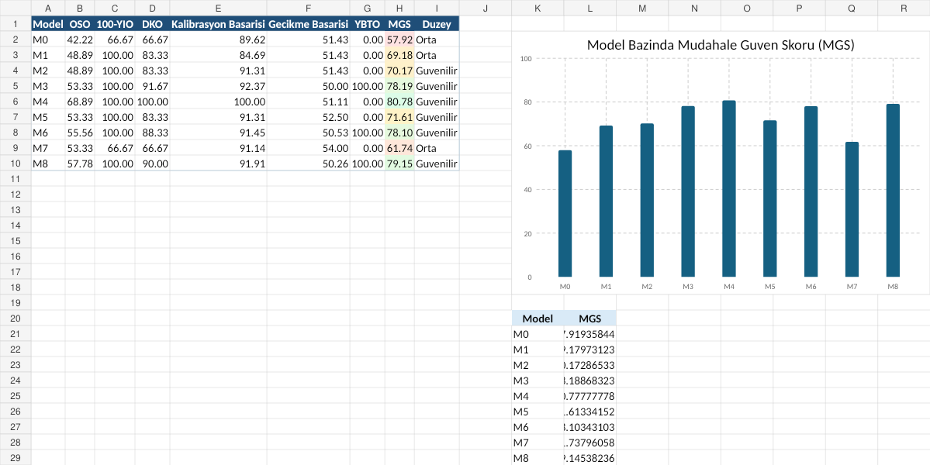
Figure 7. Preview of the Excel MGS Worksheet

18. Prompts Used
The main prompt used for Raw LLM decisions:
Based on the following security observations, choose one of these options: monitoring, further investigation, MFA, account reset, device isolation, or human review. State the security rationale for the decision and the risk of a false alert. Provide an attack probability if possible.
Experimental prompt/setup used for controlled decisions:
Compare the LLM recommendation with the Bayesian/POMDP belief state, expected utility, Value of Information, and critical-risk thresholds. If the LLM recommendation is inconsistent with these controls, override it with a safer action and record the change.

19. LLM Usage Disclosure
I used a generative AI tool in this experimental report. Prior and posterior probability calculations, belief-state updates, expected utility, Value of Information, Brier score, incident containment rate, false isolation rate, and Intervention Confidence Score were recalculated and verified using Python. Interventions suggested by the LLM were reevaluated by the probabilistic decision layer according to the provided state and observation tables.
Field | Information
Tool Used | ChatGPT
Model Used | GPT-5.6 Sol
Model Version | Session dated 07.08.2026
Purpose of Use | Raw LLM decision generation, error classification, report writing, and code/analysis assistance
Stages Where AI Was Used | Step 8 Raw LLM; M8 control scenario; report text; code draft
Prompts Used | Recorded in Section 18
How Outputs Were Verified | Python script, 540 experiment records, Excel formulas, and recalculation of Brier and MGS
Student Full Name | ____________________________
Student Number | ____________________________

20. Conclusion
The experiment showed that making critical cyber incident response decisions based on a single alert level or a linguistically convincing LLM explanation is not reliable. Bayesian updating and belief-state reasoning managed sensor noise probabilistically, while the Value-of-Information gate selected only tests that improved decision quality. The POMDP approach realistically modeled partial observability, while the M8 LLM + VOI-POMDP control reduced over-intervention and false-certainty problems in Raw LLM decisions.
The M4 oracle benchmark provided a theoretical upper bound with an MGS of 80.78. Among models that do not know the true state, M8 was the most reliable applicable configuration, with a score of 79.15. This result supports validating LLM decisions using a probabilistic decision layer and a risk-controlled policy rather than using LLM decisions alone.

