CS202-Lab1 – Report

Hunter Adomitis
Iftikhar Kalanther
Joseph D’Angelo

We created and tested the sysinfo and procinfo syscalls as instructed in the lab1 document. The entire XV6 source code with our modifications is available in the GitHub repository (https://github.com/Hadom-515/CS202-lab.git). The video demo for this lab1 assignment is available at https://github.com/Hadom-515/CS202-lab/tree/riscv.

- Modified files:

The following files were modified to create and make sysinfo and procinfo syscalls.

kernel folder:
- defs.h
- kalloc.c
- proc.c
- proc.h
- syscall.c
- syscall.h
- sysproc.c

user folder:
- lab1_test.c (new file. Delete old test.c)
- user.h
- usys.pl

CS202-lab:
1. Makefile

- Changes and screenshots:

- kernel/syscall.h:

syscall.h was modified to define new numbers for the syscalls - sysinfo(23) and -procinfo(24) - as shown in the screenshot below.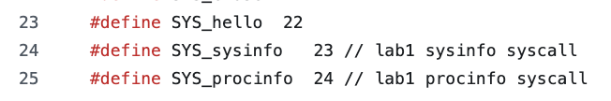
- kernel/syscall.c:

  - Declared sysinfo and procinfo.

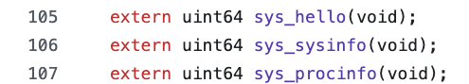

  - Updated the system call table (pointer array) *syscalls[] with sysinfo and procinfo system calls.

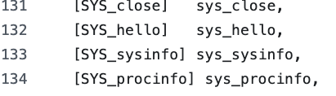

  - Updated the syscall(void) function to get the total number of syscalls made by sysinfo (excluding the first call) and procinfo.
  - A global variable, ‘total_Sys_calls’, was declared and initialized to zero, which can be accessed from the SYS_sysinfo function in sysproc.c.
  - Similarly, to get the number of ‘syscalls’ made by ‘procinfo’, a variable ‘syscall_count’ was defined in the ‘proc’ struct in proc.c.
  - The first sysinfo call made was subtracted from the total syscalls by defining and setting a flag (first_sysinfo_deducted).

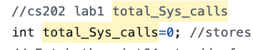
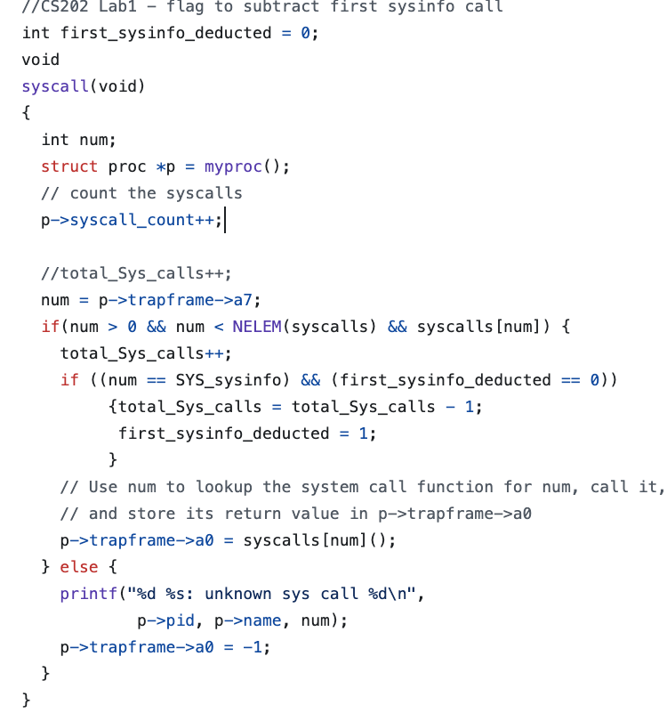
- kernel/sysproc.c (sys_sysinfo):

  - Defined syscall function ‘sys_sysinfo’
  - total_Sys_calls variable containing total number of system calls made (excluding first sysinfo call) is declared as an external variable.
  - sys_sysinfo function calls argint function to get the parameters passed by the user space.
  - if the parameter passed is
    - equal to 0, the function procCount() is called which returns active processes count.
    - equal to 1, the total number of system calls made is returned from the global variable total_Sys_calls.
    - equal to 2, the function freePageCount() is called which returns the number of free pages.
    - not 0,1, and 2, -1 is returned.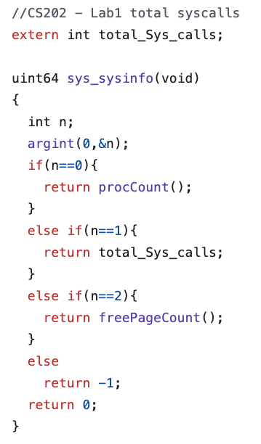

- kernel/sysproc.c (sys_procinfo):

  - Defined syscall function ‘sys_procinfo’.
  - The current process information is retrieved by defining a pointer to proc structure and calling the function myproc(), which returns the current process’s proc structure pointer.
  - The address of the user space buffer, where the current process info needs to be copied into, is retrieved by calling argadd function.
  - Defined proc_info structure in kernel space similar to the one in user space.
  - Updated the proc_info struct with parent process id, syscall count (after subtracting the first syscall) and the page usage from proc structure pointed by myproc().
  - If the page usage is not divisible by page size, page usage is incremented by 1 to accommodate this partial usage.
  - This updated proc information in the kernel space proc_info struct is copied into the user space kernel using the address provided by argadd function and by calling the function copyout.
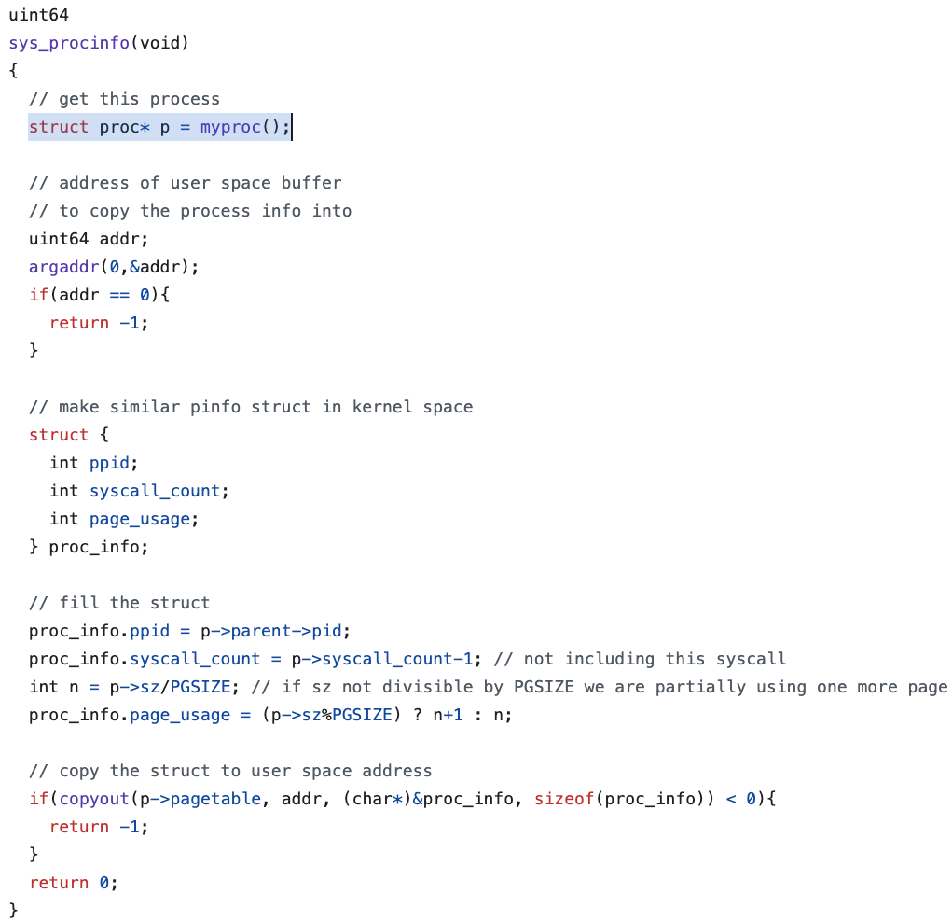
- kernel/proc.h:

  - The proc struct definition in proc.h is updated to include the syscall_count variable to get the number of system calls made by each process.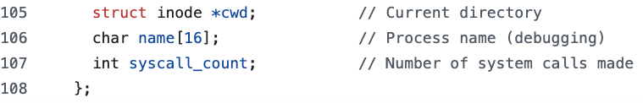

- kernel/proc.c:
  - Defined an integer function procCount, which returns the total number of active processes (runnable, running, waiting, and zombie).
  - The pointer to the proc struct is retrieved and iterated for all the processes.
  - The processes in ‘UNUSED’ and ‘USED’ states are excluded from the count to get the total number of active processes.
  - The proc struct was locked while reading.
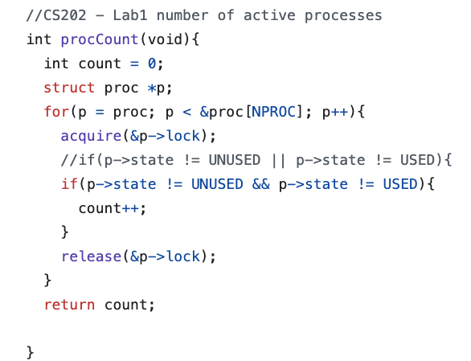
  - The syscall_count in the proc struct is initialized to zero in allocproc() function.
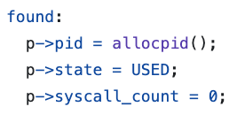
- kernel/kalloc.c:
  - Defined an integer function freepageCount, which returns the total number of free pages.
  - The pointer to the head of the free pages linked list is obtained and iterated for all the free pages in the list.
  - At each iteration step, the free pages count is incremented to get the total number of free pages.
  - The kmem struct was locked while reading.
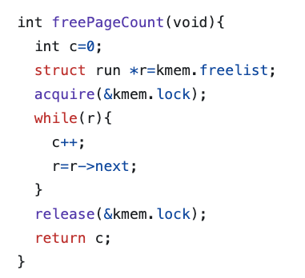

- kernel/def.h:

  - Declared the freePageCount function in the kalloc.c section.
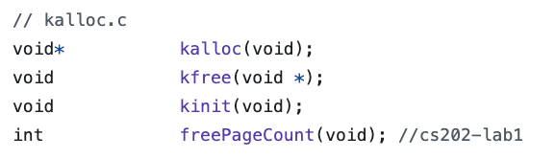
  - ProcCount function was declared in the proc.c section.
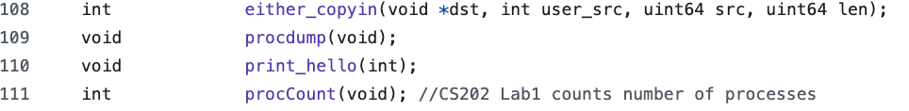

- user/usys.pl:

  - The user space syscall interface is updated by creating entries for syscalls ‘sysinfo’ and ‘procinfo’ in usys.pl
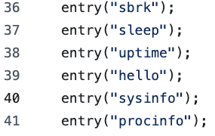

- user/user.h:

  - User system calls (sysinfo and procinfo) are updated in the user-space system call interface user.h.
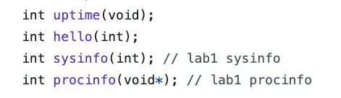
- user/lab1_test.c:

  - This file provided in the lab1 instruction contains the code to test the sysinfo and procinfo system calls.

- Makefile:
  - Makefile is updated by appending “$U/_lab1_test\” to UPROGS.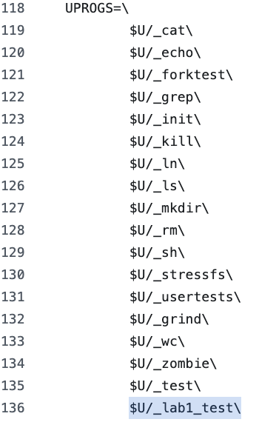

3. system call process:

sysinfo:
When the user space is making the sysinfo system call, a trap is generated that transfers the control from user mode to kernel mode. The wrapper in usys.pl invokes ‘ecall,’ which is a kernel trap. The syscall number is passed through the a7 register. The registers a0-a5 hold system arguments. The arguments passed by the sysinfo syscall are stored in the a0 register. The trap handler trap.c contains the usertrap() function, which calls the syscall() function in syscall.c that we modified to get the total number of system calls. The syscall() function calls the Sys_sysinfo function based on the sysinfo syscall number 23 and returns the outcome of the function through the a0 register.

We get the total number of system calls (after subtracting 1 for the initial sysinfo call), when the parameter passed is 1, through the global variable total_Sys_calls, which is returned by the sys_sysinfo function in sysproc.c. For parameters 0 and 2, the total number of active processes and free pages count are returned. The returned values are returned by the usertrapret() function in trap.c, which switches from kernel-trap to user-trap using the kerneltrap() and usertrap() functions. The usertrap() function in trap.c is called from the assembly program trampoline.S, which handles interrupts, exceptions, and system calls from the user space.

procinfo:

Similarly, when the user space is making the procinfo system call, a trap is generated that transfers the control from user mode to kernel mode. The wrapper in usys.pl invokes ‘ecall,’ which is a kernel trap. The syscall number is passed through the a7 register. The address of the pinfo struct passed by the procinfo syscall, where the process information from kernel space is to be copied into, is stored in the a0 register. The trap handler trap.c contains the usertrap() function, which calls the syscall() function in syscall.c that we modified to get the total number of system calls made by the process. The syscall() function calls the Sys_procinfo function based on the sysinfo syscall number 24 and returns the per-process data through the a0 register, which contains the address where the per-process data is to be copied into.
The total number of syscalls from kernel space is subtracted by 1 before copying into the user space struct using the copyout function. Also, the page_usage variable is updated with the current process’s memory size in pages. If the page_usage is not divisible by page size, it is incremented by 1 to accommodate partial page usage. The per-process values are returned by the usertrapret() function in trap.c, which switches from kernel-trap to user-trap using the kerneltrap() and usertrap() functions.

Testing:

The sysinfo and procinfo system calls are tested using lab1_testc by allocating memory (65536 and 65000 bytes) and by passing the number of child processes to be created. Following the screenshot of the output from the QEMU emulator.
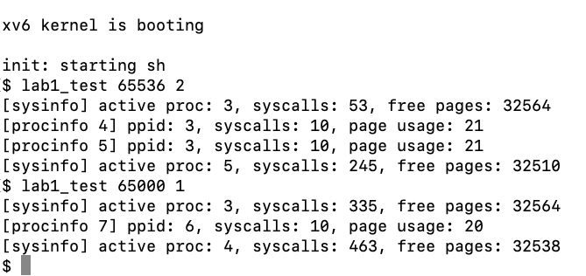

Joey’s branch:
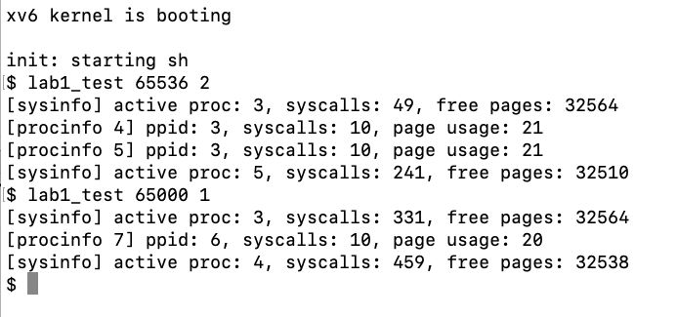

4. Contributions:

The team discussed the high-level approach and decided to do the following by each individual.

1. Hunter Adomitis: sysinfo (total number of active processes and free pages). Review both system calls (sysinfo and procinfo)
2. Iftikhar Kalanther: sysinfo (total number of system calls). Review both system calls (sysinfo and procinfo).
3. Joseph D’Angelo: procinfo. Review both system calls (sysinfo and procinfo)

The team collaborated to create the final report, which was reviewed by each team member before submission.

