CS202-Lab2 – Report

Hunter Adomitis(hadom001)
Iftikhar Kalanther (ikala005)
Joseph D’Angelo(jdan003)

We created and tested the system calls (sched_statistics and sched_tickets), lottery scheduling, and stride scheduling as instructed in the lab2 document. The entire XV6 source code with our modifications is available in the GitHub repository (https://github.com/Hadom-515/CS202-lab.git). The video demo for this lab2 assignment is available at https://drive.google.com/file/d/19_zNlfY98tSqShfSG3qgoSm-_zl2KKgz/view?usp=drive_link

- Modified files:

The following files were modified to create and make sched_statistics and sched_tickets syscalls.

kernel folder:
- defs.h
- proc.c
- proc.h
- syscall.c
- syscall.h
- sysproc.c

user folder:
- lab2.c
- user.h
- usys.pl

CS202-lab:
1. Makefile

- Changes and screenshots:

- kernel/syscall.h:

syscall.h was modified to define new numbers for the syscalls – sched_statistics(25) and sched_tickets(26) - as shown in the screenshot below.

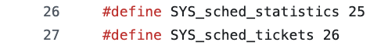
- kernel/syscall.c:

  - Declared sched_statistics and sched_tickets.

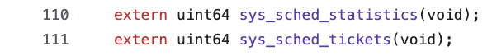

  - Updated the system call table (pointer array) *syscalls[] with sched_statistics and sched_tickets system calls.

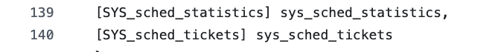

- kernel/sysproc.c (sys_sched_statistics):

  - Defined syscall function ‘sys_sched_statistics’. This function calls print_statistics() defined in kernel/proc.c, which will print the PID, Name, ticket value and total number of times called for scheduling for each process.

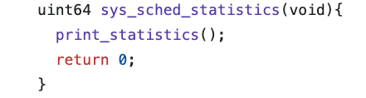

- kernel/sysproc.c (sys_sched_tickets):

  - Defined syscall function ‘sys_sched_tickets’.
  - The current process information is retrieved by defining a pointer to proc structure and calling the function myproc(), which returns the current process’s proc structure pointer.
  - This syscall function validates the number of tickets passed by the user. If it is less than or equal to 10,000, the same will be allocated to the respective process. If more than 10,000, then the process will be allocated only 10,000 as the number of tickets allocated cannot exceed 10,000.
  - If the number of tickets to be allocated is less than zero, this syscall will return -1.
  - The stride value is calculated by divding 10,000 (given K value) by the number of tickets allocated to each process and the pass value is initialized with this stride value.
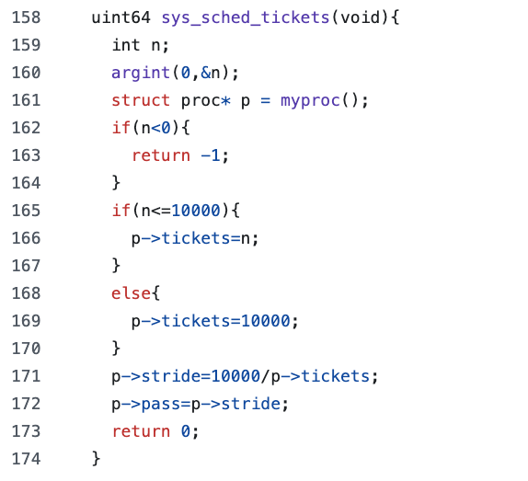
- kernel/proc.h:

  - The proc struct definition in proc.h is updated to include 4 variables – tickets, stride, pass and ticks. ‘tickets’ will store the number of tickets allocated to this process. ‘ticks’ will hold the number of times the process is scheduled to run. The stride and pass values are stored in stride and pass respectively.
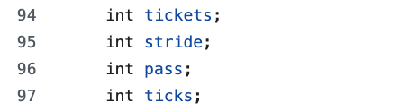

- kernel/proc.c:

  - The allocproc() function is modified to initialize the above 4 variables. tickets is initialized to 10,000 and stride to 10,000(K) by tickets and pass is initialized to stride value. ‘ticks’ is initialized to 0.

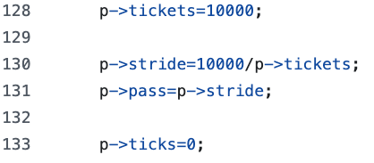

  - Scheduler() function is modified to include lottery and stride scheduling based on the preprocessor directives.

  - Lottery scheduling:

    - If the preprocessor directive is ‘LOTTERY’, then this section will be executed by the scheduler function.
    - Lottery scheduling is based on the random number (lottery) drawn. The process holding the drawn number will be selected for scheduling.
    - First, we need to get the total number of tickets held by all the processes. This is needed so that number drawn is not exceeding this total. This is obtained by adding the tickets held by each process which is in ‘RUNNABLE’ state.
    - Second, we used the rand() function to get the random number, which is used to draw a random winning number. If we divide any number by maximum number of tickets, then the reminder will be always less than maximum number of tickets. Hence, by dividing the random number generated by rand() function by maximum number of tickets will always give a reminder, which is less than the maximum number of tickets. This reminder is the winning number used to select the process to be scheduled. Since we are dividing by maximum number of tickets, we need to ensure that maximum number of tickets is not equal to zero to avoid ‘divide by zero’ error.
    - To select the process holding the winning number, a running_total, which is a cumulative total, is obtained by adding the number of tickets held by the runnable processes up until the running point. If this running total is greater than the random winning number, then that process is the winner and will be scheduled. If not, the next process will be selected to check for winning ticket, until the end of all the available runnable processes.
    - The ‘ticks’ count is incremented whenever a process is selected for scheduling.
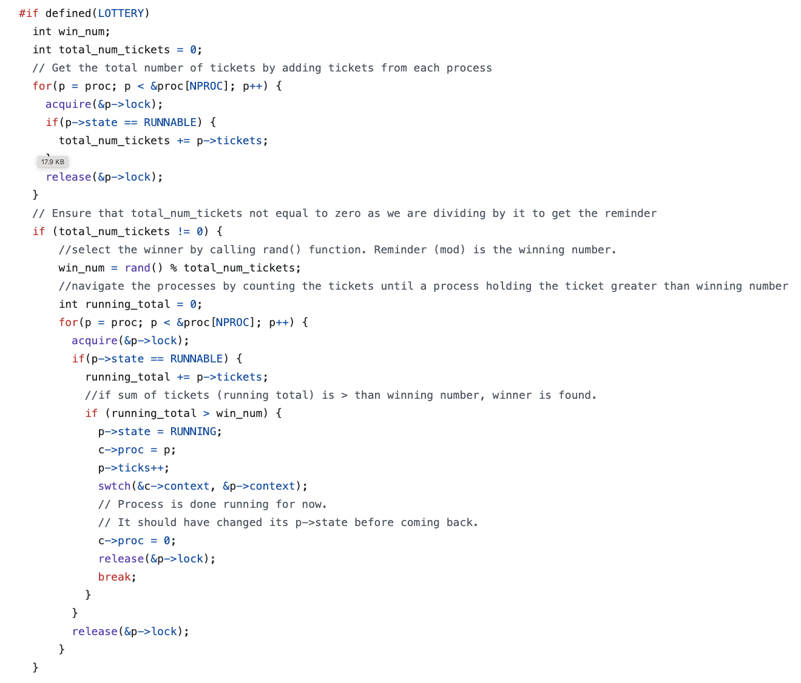
  - Stride scheduling:

    - If the preprocessor directive is ‘STRIDE’, then this section will be executed by the scheduler function.
    - First, get the minimum pass value by iterating through each ‘RUNNABLE’ process.
    - Then, find the ‘RUNNABLE’ process with that minimum pass value and select it for scheduling. Once selected, increment its pass value by the stride value and increment its ‘ticks’ count.

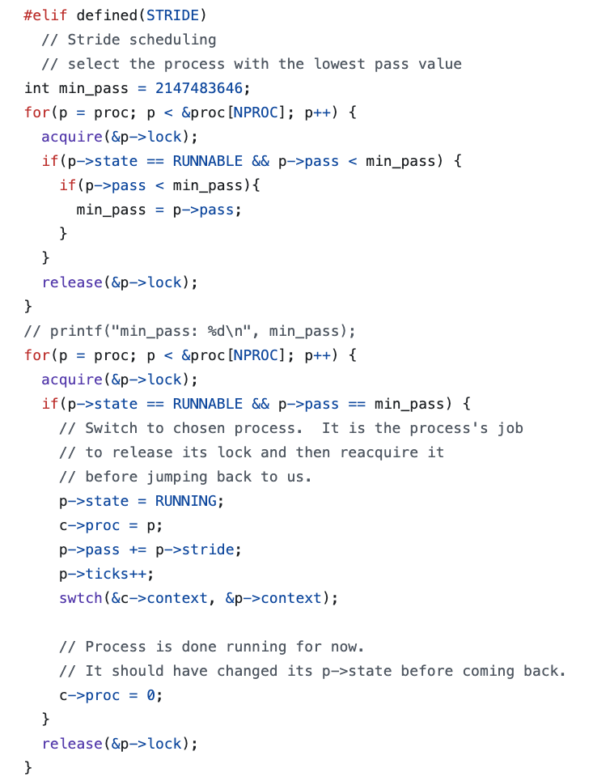
  - Round Robbin:
    - If the preprocessor directive is neither ‘LOTTERY’ nor ‘STRIDE’ the default scheduler (Round Robbin) will run.
    - Increment the ‘ticks’ count, each time a process is scheduled to run.

  - print_statistics() function was created, which will print the statistics of the schedules (PID, name, tickets, and ticks) in the format requested.

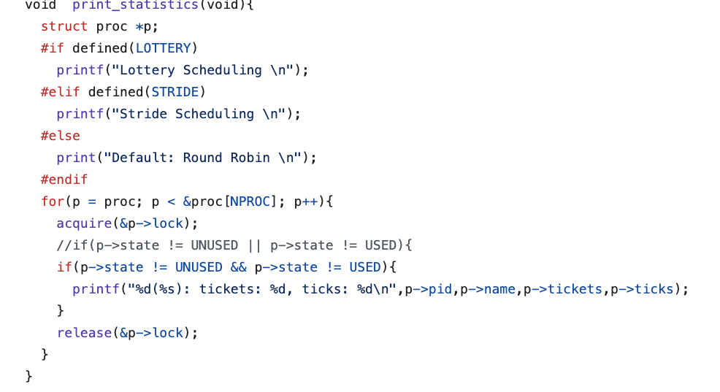
  - rand() function ((https://stackoverflow.com/a/7603688) was created as given in Lab2 instructions, which returns an unsigned random number in the short range when called.

- kernel/defs.h:

  - print_statistics() and rand() functions were declared in the proc.c section.

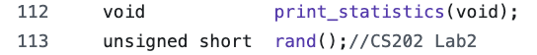

- user/usys.pl:

  - The user space syscall interface is updated by creating entries for syscalls ‘sched_statistics’ and ‘sched_tickets’ in usys.pl
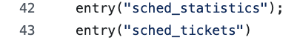

- user/user.h:

  - User system calls (sched_statistics and sched_tickets) are updated in the user-space system call interface user.h.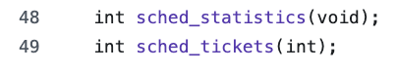

- user/lab2.c:

  - This file provided in the lab2 instruction contains the code to test the sched_statistics, sched_tickets system calls and test the LOTTERY, STRIDE and Round Robbing scheduling.

- Makefile:

  - Makefile is updated by appending “$U/_lab2\” to UPROGS.

  - This file is also updated to include the preprocessor directives.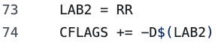

Testing:

The system calls (sched_statistics and sched_tickets) and schedules (LOTTERY, STRIDE, and Round Robbin) were tested using lab2.c. To test LOTTERY, the code was compiled with preprocessor directive using ‘make clean;make lab2=LOTTERY’. To test STRIDE, the code was compiled with preprocessor directive using ‘make clean;make lab2=STRIDE’. To test Round Robbin (default), the code was compiled with preprocessor directive using ‘make clean;make’.

Lottery scheduling output:
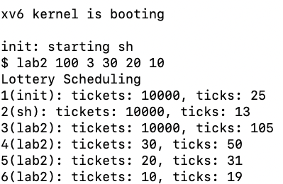

Stride scheduling output:
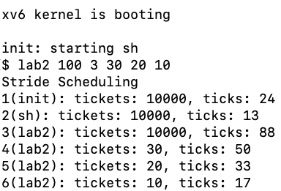

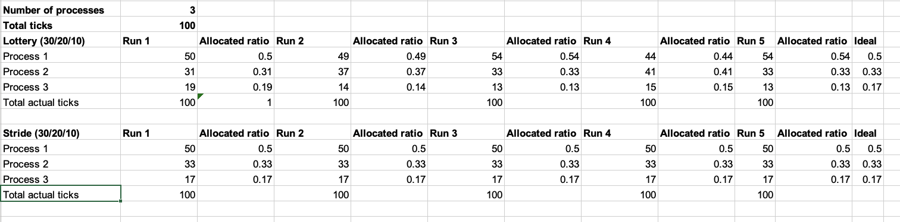

As we can see that, for LOTTERY scheduling, the allocated ratio for each process varies for each run. For the 5 runs, for process 1, allocated ratio varies from 0.44 to 0.54. For process 2, it varies from 0.31 to 0.41 and for process 3, it varies from 0.13 to 0.19. Ideally, the allocated ratio should be 0.5,0.33, and 0.17 for process 1, process 2, and process 3 in each run. This implies that LOTTERY scheduling is non-deterministic, and fairness is not achieved completely. This is due to the random function used to select the winner.

On the other hand, for STRIDE scheduling, the allocated ratio for each process remains the same for each run. For the 5 runs, the allocated ratio for process 1, process2, and process 3 was 0.5, 0.33, and 0.17 respectively, which is equal to the expected ideal allocation. This implies that STRIDE scheduling is deterministic, and fairness is achieved completely. This is due to the stride and the pass values. The stride value will be smaller for higher priority tasks with larger number of tickets than the ones with lower priority The pass value, which gets incremented by stride value for each tick, is like a virtual clock and it increases slowly for the process with higher priority (tickets) and faster for lower priority (tickets). The helps in achieving the fairness and getting the deterministic allocations.

Part3 - Experiment:

We conducted the experiment for the lottery and stride scheduling as instructed. For 4 processes with 8/4/2/1 allocation, we ran for 5 different quanta (20,40,60,80, and 100). For each quantum, we ran for minimum 5 times to get the average. The screenshot below shows the same for lottery and stride scheduling.

8/4/2/1 data for different runs to get average – lottery scheduling:

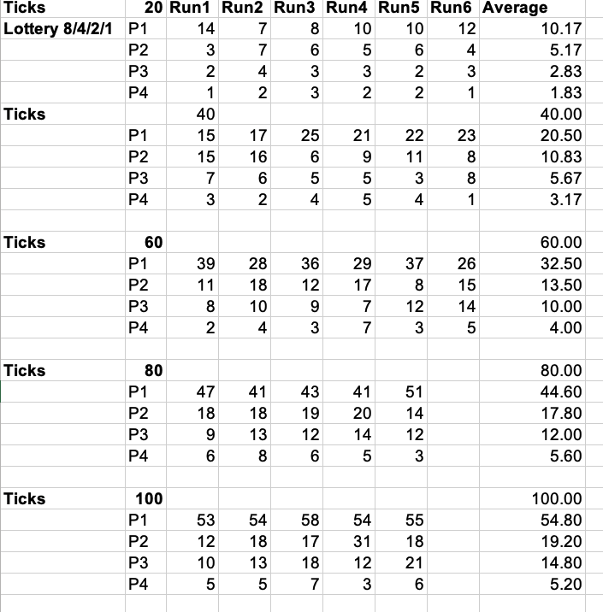

8/4/2/1 data for different runs to get average – Stride scheduling: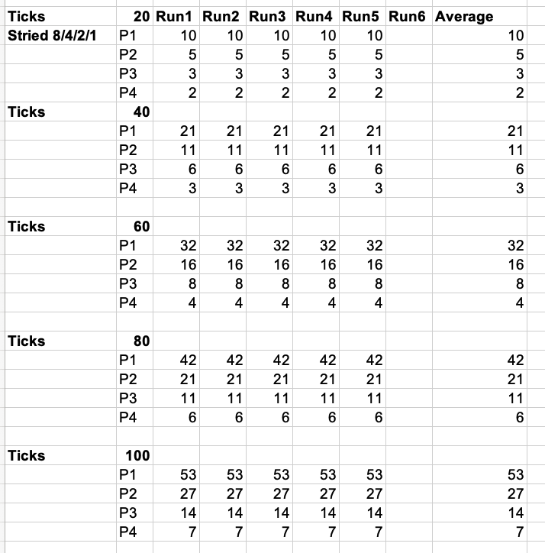

Similarly, for 4 processes with 1/1/1/1 allocation, we ran for 5 different quanta (20,40,60,80, and 100). For each quantum, we ran for minimum 5 times to get the average. The screenshot below shows the same for lottery and stride scheduling.

1/1/1/1 data for different runs to get average – lottery scheduling:

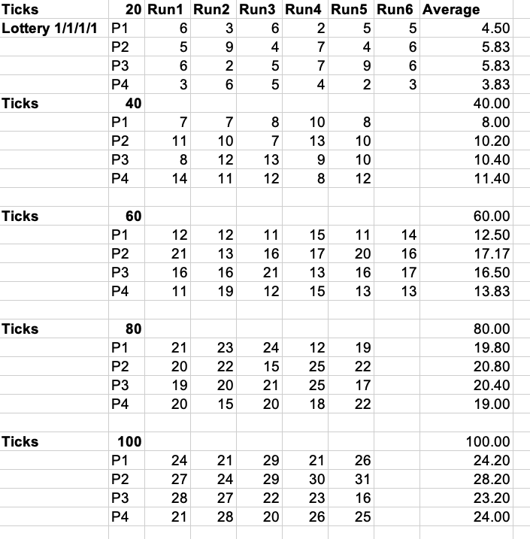

1/1/1/1 data for different runs to get average – stride scheduling:
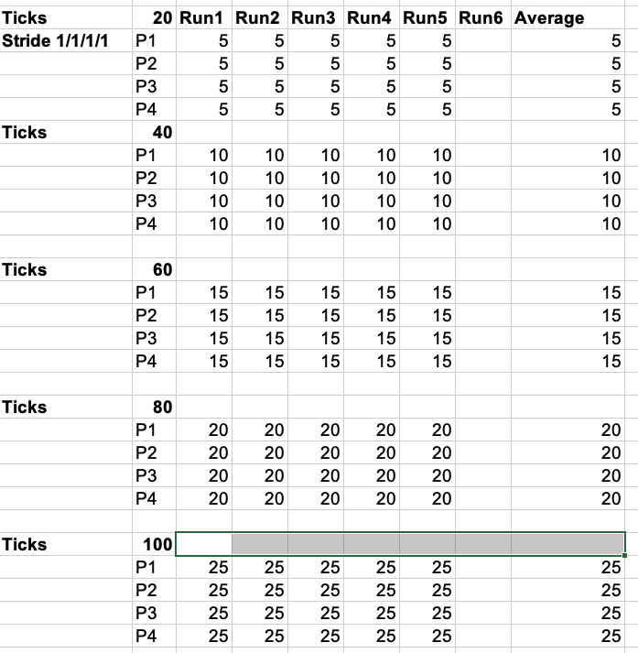

We plotted time(quanta) vs cumulative quanta for each process and created 4 different charts, which are shown below (C1,C2,C3, and C4 are ideal values with dotted lines and P1, P2, P3, and P4 are 4 processes).

8/4/2/1 Lottery:

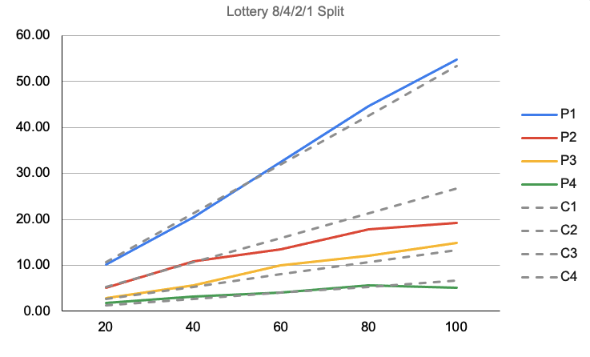
1/1/1/1 Lottery:

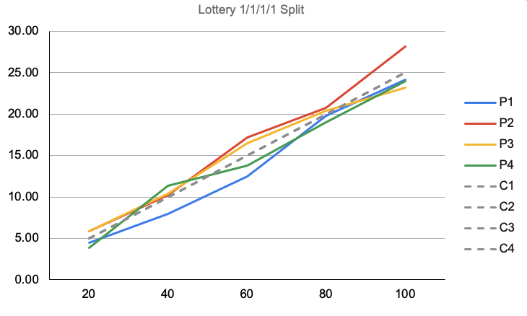

As we can see in the charts for 8/4/2/1 and 1/1/1/1 allocations above, lottery scheduling is not having expected allocation for each process. Process 1 is not having much of a problem with 8/4/2/1 allocation. The 8/4/2/1 chart shows that at the lower quanta (like 20, and 40), each process has almost the ideal allocation as there is not much deviation. However, for process 2, it is getting lower allocation than the ideal value after 40 quanta. Process 4 is also having near ideal values allocated. For 1/1/1/1 allocation, we can see the deviation from ideal values for each process and it is random. As explained above, this implies that LOTTERY scheduling is non-deterministic, and fairness is not achieved completely. This is due to the random function used to select the winner.

8/4/2/1 Stride:
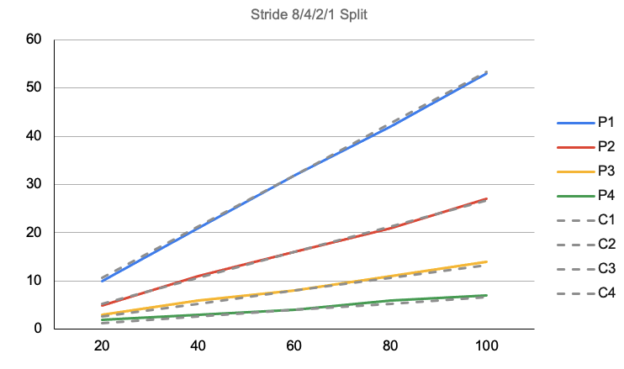

1/1/1/1 Stride:

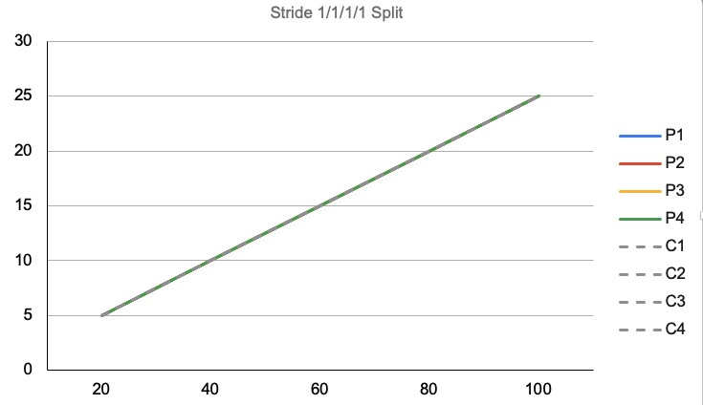

On the other hand, STRIDE scheduling is deterministic and fair, which can see from the charts shown. For both 8/4/2/1 and 1/1/1/1 allocations, the cumulative quanta is matching with the ideal values for all the processes. As explained above, the stride scheduling is more deterministic and fairer. This is due to the stride and the pass values. The stride value will be smaller for higher priority tasks with larger number of tickets than the ones with lower priority The pass value, which gets incremented by stride value for each tick, is like a virtual clock and it increases slowly for the process with higher priority (tickets) and faster for lower priority (tickets). The helps in achieving the fairness and getting the deterministic allocations.

Contributions:

The team discussed the high-level approach and decided to do the following by everyone.

1. Hunter Adomitis: sched_statistics and sched_tickets. Review both system calls (sched_statistics and sched_tickets), lottery, stride, and RR scheduling.

2. Iftikhar Kalanther: LOTTERY scheduling. Review both system calls (sched_statistics and sched_tickets), lottery, stride, and RR scheduling

3. Joseph D’Angelo: STRIDE scheduling Review both system calls (sched_statistics and sched_tickets), lottery, stride, and RR scheduling.

All 3 members ran Part-3 experiment. The team collaborated to create the final report, which was reviewed by each team member before submission.

