Network Design for StocksUK.

Hadi Khan
2369533
2025

Contents
Abstract 2
Introduction 2
Aim and Objectives 2
Network Design 2
Network Verification or Configuration Test Error! Bookmark not defined.
Network Evaluation and Discussion 20
Conclusion 20
References 21
Appendix A: 21

Abstract
This project presented the design and implementation of a secure, scalable, and cost-effective WAN for StocksUK, supporting multiple sites in Manchester and London with both wired and wireless connectivity.

A redundant mesh topology was implemented to improve fault tolerance, with OSPF providing efficient and dynamic routing.

LANs were segmented using VLANs to enhance security, reduce broadcast traffic, and improve performance.

Centralised on-premises services, including DHCP and DNS, were deployed to simplify management and reduce operational costs, while SSH secured administrative access.

Overall, the network met the organisation’s requirements and fulfilled all project objectives.

Introduction

StocksUK is a trading company that analyses and stores market data and requires a secure, cost-effective network to support locations in Manchester and London. Each city has two offices, each containing ten workspaces. A factory in the Manchester region will also be used for crypto mining.

Each workspace provides both wired and wireless connectivity. The Manchester factory follows the same design for consistency, with wired connections used by default for improved security. Wireless connectivity can be enabled if required.

Aim and Objectives
Aim:
To design a functional WAN that enables communication between all locations and sites. A mesh topology is planned to provide core redundancy while remaining cost-effective. The design will use a maximum of four routers for the mesh WAN, with each office sharing VLAN connections from Layer 3 switches, limited to two of these switches in total.

Objectives:
- Develop an IP addressing plan using CIDR.
- Develop routing table for WAN.
- Develop password plan for network devices.
- Configure SSH for each core network device.
- Create suitable VLAN connections.
- Enable DNS for company site.
- Configure OSPF routing.
- Configure DHCP for each location.

Network Design

Network Plan

Network Equipment Plan:
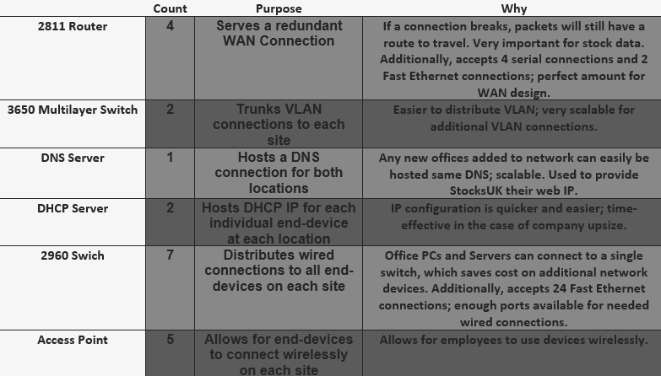
Figure 1: Network Equipment Plan
This network plan defines the entire WAN and all LANs.
Servers are hosted on-premises rather than through the cloud to avoid unnecessary recurring costs associated with cloud services. Since the servers only provide internal services such as DHCP and DNS, cloud or internet-based hosting is not required. Hosting these services locally is therefore the most efficient and cost-effective solution for this network design.

Please refer to Figure 8 to see network equipment.

Client Equipment Plan:
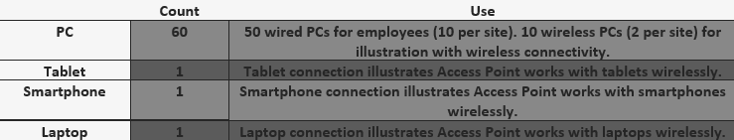
Figure 2: Client Equipment Plan
Client equipment was kept consistent across all sites while meeting StocksUK’s requirements. Multiple devices were shown connected to the access point to demonstrate correct functionality. Figure 3 illustrates a typical office layout, where each desk would realistically include at least one portable device capable of wireless connection.
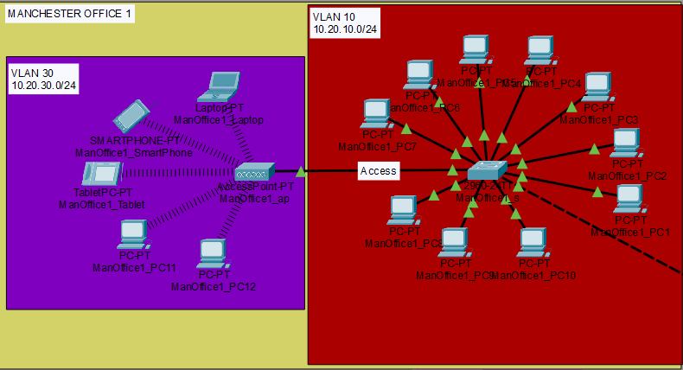
Figure 3:Client Design

IP Addressing plan:

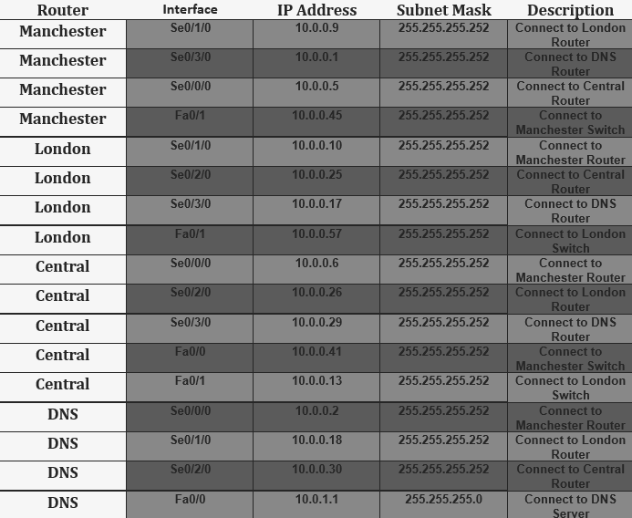
Figure 4: IP Addressing Plan for WAN Routers

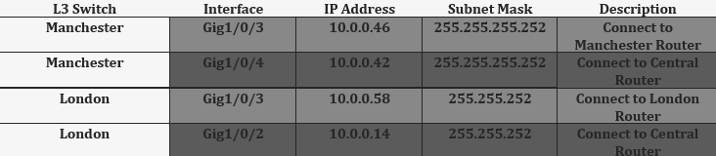
Figure 5: IP Addressing Plan for WAN L3 Switches

CIDR /30 subnets were used for all point-to-point connections, as each link only required two host addresses. This improves WAN scalability by increasing available network bits and enhances efficiency and security by fully utilising all available host addresses.

VLAN addressing plan:
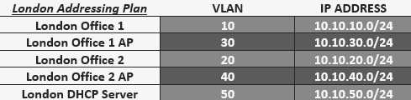
Figure 6: London VLAN Addressing Plan
In the London network, five VLANs are configured within the 10.10.0.0 subnet. Each VLAN uses a /24 (Class C) CIDR subnet, which is more than required for the number of employees.

I considered using a /28 subnet to better match the user count and increase the number of available networks per location. However, I chose to keep the VLAN addressing scheme simple and instead used the DHCP server to limit each VLAN to 20 users. If StocksUK expands and requires network growth, transitioning to a /28 subnet would be a straightforward upgrade.

NOTE: I chose a limit of 20 for users on each VLAN to account for possible company upsize.

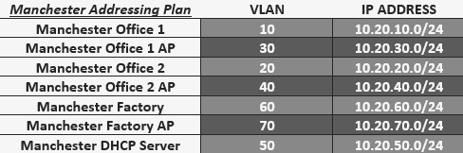
Figure 7: Manchester VLAN Addressing Plan

I used the same approach for the Manchester sites as London, but on the 10.20.0.0 subnet. This also accounts for the factory, which adds two additional VLANs to the Manchester branch. As with London, each VLAN supports a maximum of 20 users.

DHCP was chosen to enable dynamic IP addressing and to limit the number of users per VLAN. Connecting the server to the Layer 3 switch allows it to be located independently from the sites while remaining accessible on the network and enables easy distribution of VLAN connections.

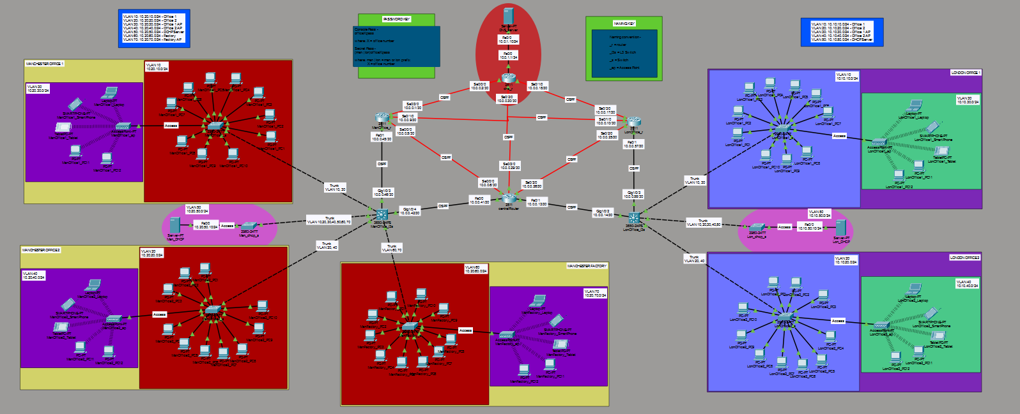
Figure 8: Complete Network Design
Figure 8 presents the complete network design for StocksUK, featuring a redundant WAN that allows packets to reroute if a router fails. This ensures reliable data delivery, which is critical for StocksUK. TCP is used to guarantee data integrity, as packets are reassembled using sequence numbers and retransmitted if lost, unlike UDP.

The design includes five sites; each divided into wired and wireless VLANs. Each site shares a DHCP server that dynamically assigns IP addresses, with the third octet segmented by VLAN. A central DNS server serves all locations by broadcasting a web IP, enabling web access across the network. The router connected to the DHCP server uses a /24 CIDR interface to support high traffic volumes and many hosts.

Network Configuration

DHCP Configuration

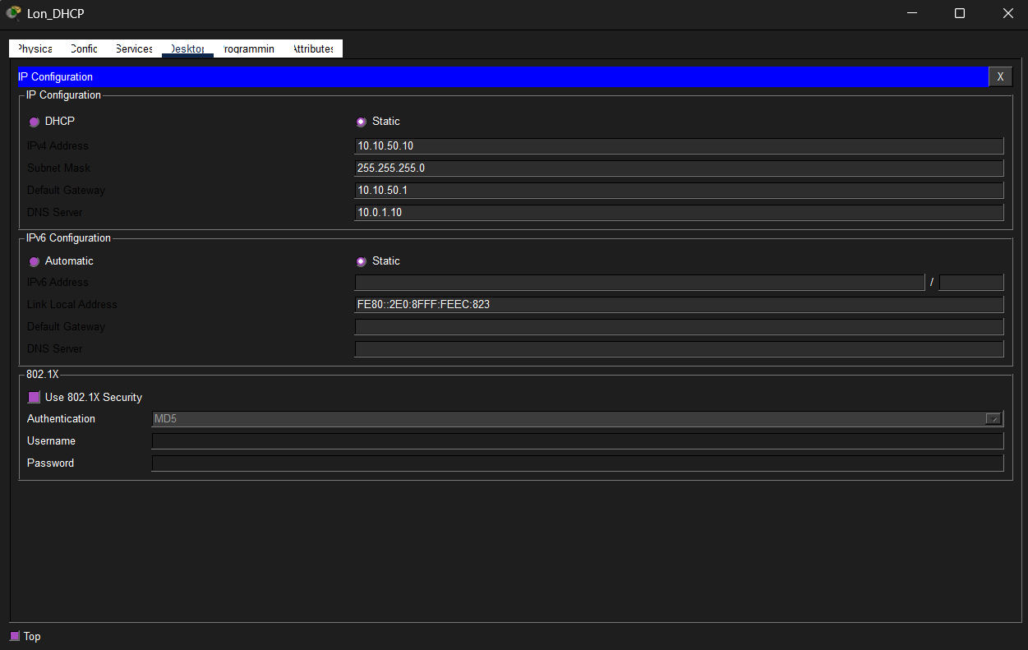
Figure 9: London DHCP IP Configuration
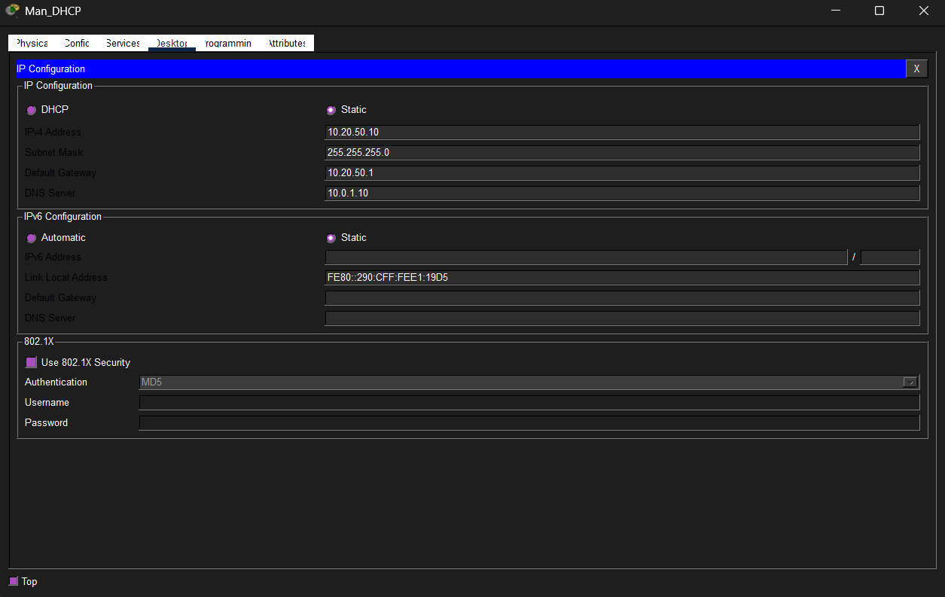
Figure 10: Manchester DHCP IP Configuration
Figure 9 shows the static IP configuration of 10.10.50.10 for London’s DHCP server. The address is structured as follows:
- First octet (10): Identifies the WAN
- Second octet (10): Identifies the London sites
- Third octet (50): Identifies the DHCP server VLAN
- Fourth octet (10): Identifies the server host address

Also shown in Figure 9, London uses the DNS server, which it accesses by specifying the gateway to the DNS server: 10.0.1.10.
Finally, end-devices in London access this DHCP server by accessing its default gateway, which I have specified to be: 10.10.50.1.

Figure 10 shows the exact same configuration as done on the London DHCP server, however for the second octet in its IP it uses 20, which specifies the Manchester area.

Figure 11: London DHCP Services
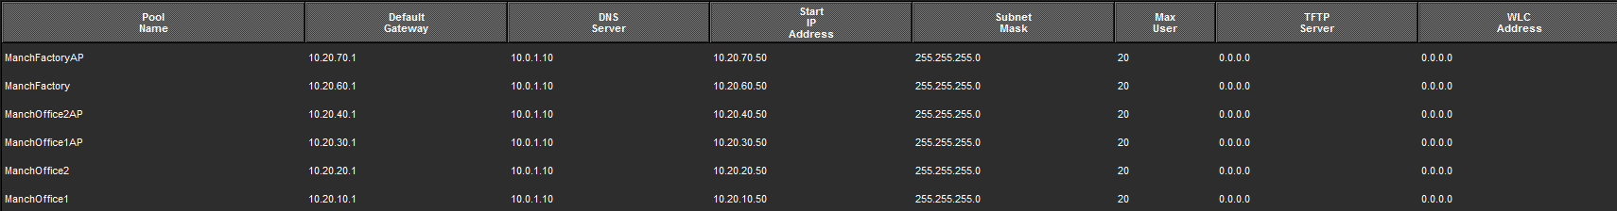
Figure 12: Manchester DHCP Services
Figure 11 and Figure 12 show how I created services in each DHCP server to dynamically host a different IP address based on the VLAN the area would be connected to. I did this by matching the third octet of the hosted IP to the VLAN number in the location.

E.g. Manchester Factory has VLAN of 60, DHCP hosts IP 10.20.60.1 to this service, and starts at the 50th address, because that’s what I specified.

The above figures also show how I configured the max users to be 20 for each service.

DNS Configuration
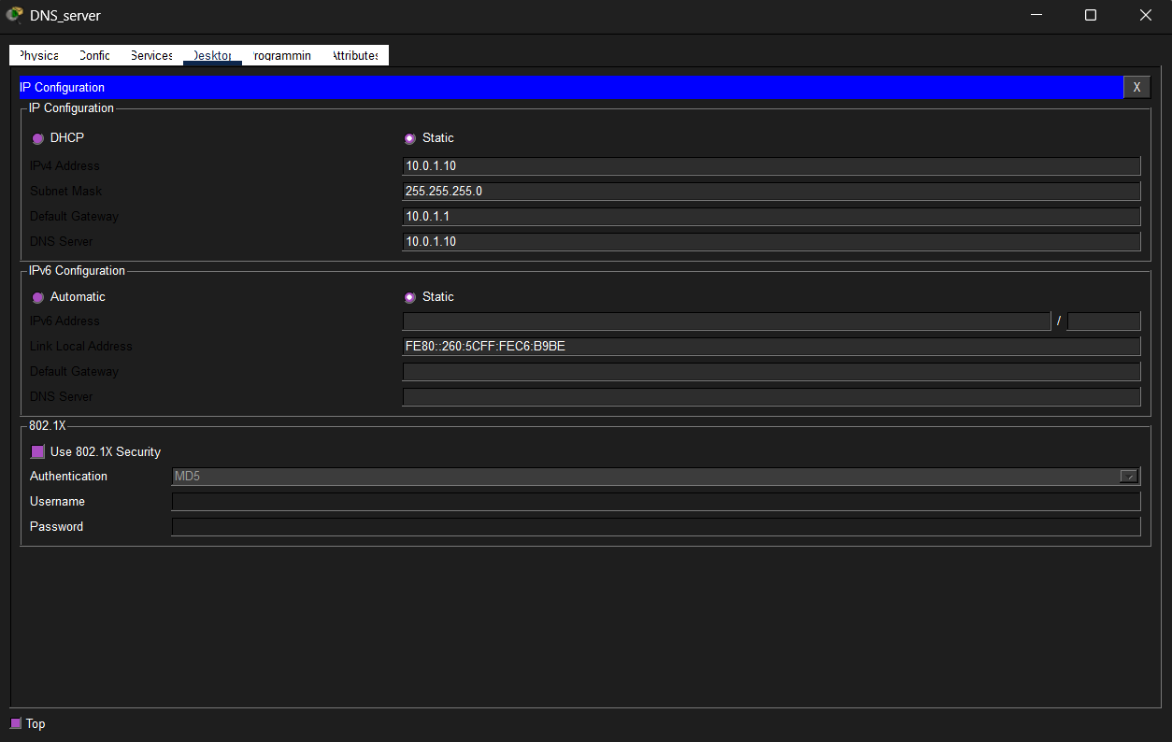
Figure 13: DNS IP Configuration

Figure 14: DNS Services
I configured a service in the DNS server which generates an A record DNS ‘stocksuk.com’, which uses the IP address 10.0.1.10 under-the-hood. See Figure 14. I referred to: https://medium.com/@z6157881/configure-dns-server-on-cisco-packet tracer-e7c412b3b3dd, to correctly implement DNS.

I also configured the gateway which accepts data from the connected routers interface 10.0.1.1.

VLAN Configuration

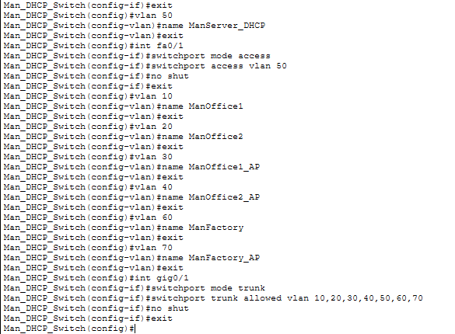
Figure 15: Configuring VLAN on Manchester DHCP switch
I had to transfer the DHCP VLAN from the DHCP server to the DHCP switch via access port and then use a trunk port to send all VLAN data to the Manchester L3 switch. This allowed the L3 switch to access all DHCP data from every VLAN.

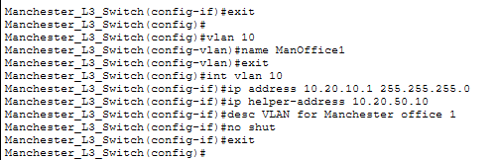
Figure 16: Manchester VLAN 10 configuration
In Figure 16, VLAN 10 (ManOffice1) is created on the Manchester Layer 3 switch and stored in the VLAN database for trunking to other sites. The VLAN is configured with the IP address 10.20.10.1 and a /24 subnet mask, providing 255 host addresses including the network and broadcast addresses.

A helper IP address is also configured, pointing to the Manchester DHCP server. This forwards DHCP requests from the Office 1 subnet to the DHCP server subnet, enabling centralized IP address management across multiple networks.

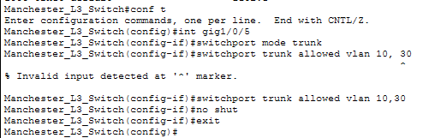
Figure 17: Manchester Trunk configuration
Figure 17 shows how I configure the trunk to office 1 in Manchester. I allow VLAN’s 10 and 30, since VLAN 10 is for office 1 devices, and VLAN 30 is for the access point in office 1.

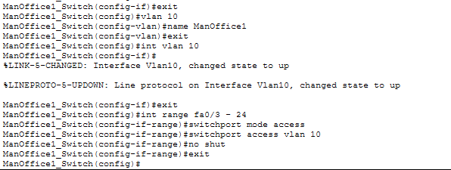
Figure 18: Manchester Office 1 Switch VLAN 10 Configuration
Figure 18 shows I create the VLAN 10 to store in the switch’s database, which is then used to distribute to all Fast Ethernet ports which would be occupied by PCs. These distributions are made across access ports.

For VLAN IP addressing and VLAN commands, I reference: https://diadenkov.medium.com/cisco-layer-3-switch-intervlan-routing-without-router-8e04f2315a56.

OSPF Configuration
OSPF (Open Shortest Path First) is a routing protocol that uses a link-state routing algorithm, specifically Dijkstra’s algorithm, to calculate the shortest path based on path cost.

I chose OSPF for WAN routing instead of RIP because RIP has a 15-hop limit, while OSPF has no hop limit, making it more scalable for large networks. OSPF also uses bandwidth as a metric for more efficient path selection, whereas RIP relies only on hop count. Additionally, OSPF’s use of Dijkstra’s algorithm allows it to calculate optimal paths more efficiently than RIP’s Bellman-Ford algorithm, resulting in faster convergence. Referenced from: https://www.auvik.com/franklyit/blog/ospf-protocol-explained/

Figure 19: OSPF Configuration to DNS server
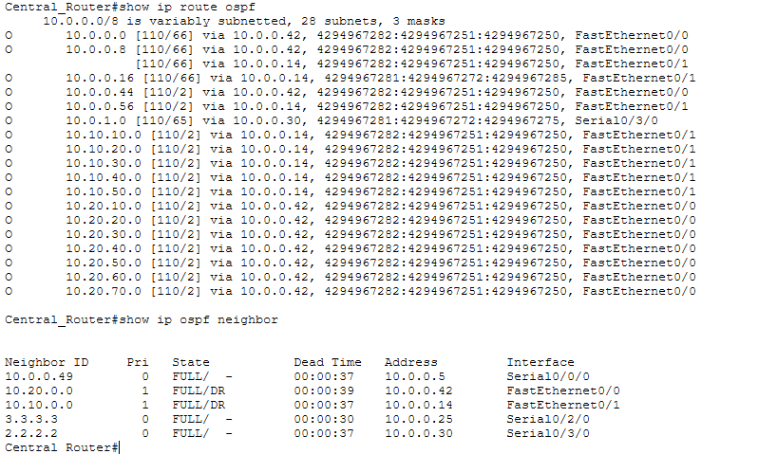
Figure 20: OSPF Routing in Central Router
I suggest referring to Figure 8 when analysing Figure 20.
Figure 20 shows the IP addresses which pass through the Central Router, and which port they come from.

View Appendix A - Additional OSPF Configuration to see more OSPF configuration and routing.

SSH Configuration
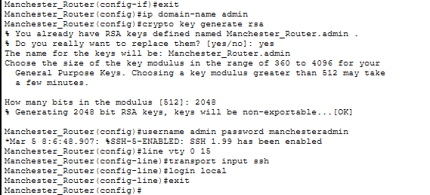
Figure 21: Configure SSH on Manchester Router
SSH was configured on all network devices to enable secure administrative access to routers and Layer 3 switches. A 2048-bit RSA key encrypts authentication data, protecting management traffic from packet sniffing, which is critical for StocksUK due to the transmission of sensitive data such as cryptocurrency transactions.

SSH was chosen over Telnet because Telnet transmits data in plaintext, creating a significant security vulnerability that allows attackers to intercept sensitive information.

(Configuration and description both reference: https://moodle.mmu.ac.uk/pluginfile.php/8409946/mod_resource/content/1/Net_Wk9_Lab.pdf &
https://computernetworking747640215.wordpress.com/2018/07/05/secure-shell-ssh-configuration-on-a-switch-and-router-in-packet-tracer/).

View Appendix A - Additional SSH Configuration to see more SSH configuration on different network devices.

Network Configuration Tests

DHCP Tests
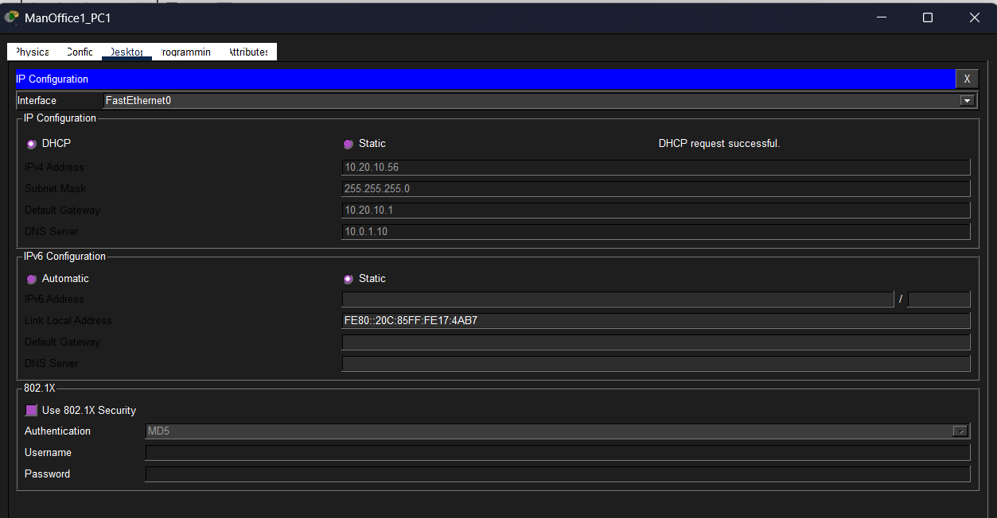
Figure 22: Manchester PC successful DHCP connection
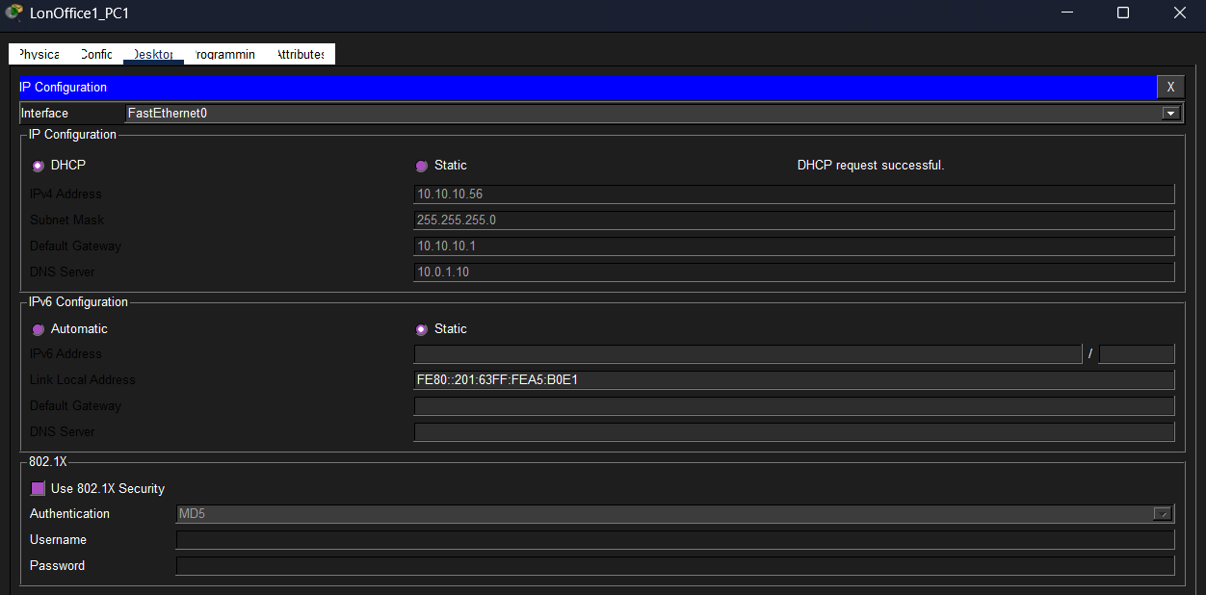
Figure 23: London PC successful DHCP connection
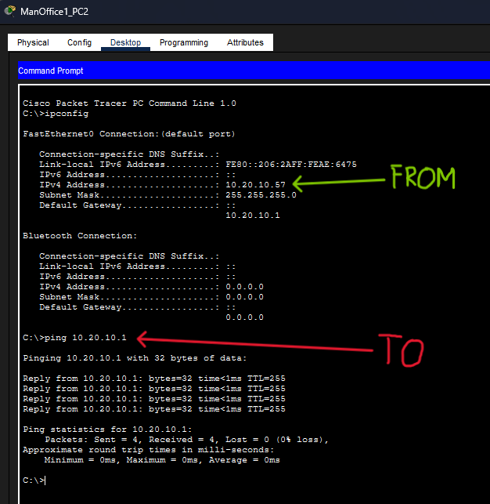
Figure 24: Manchester PC ping Manchester DHCP server

For Manchester’s DHCP server, Figure 22 shows a successful DHCP connection to an office PC, and Figure 24 shows a successful ping to the Manchester DHCP server.
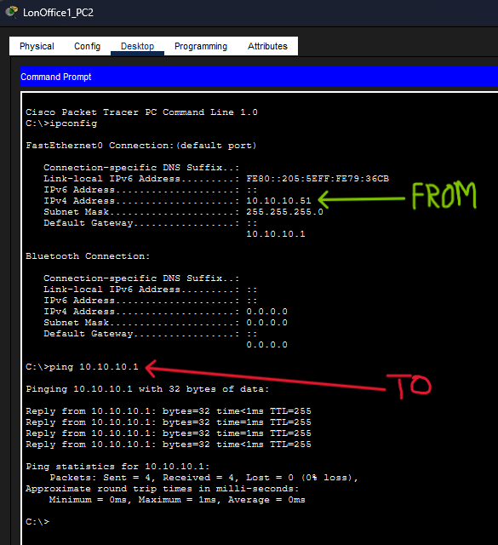
Figure 25: London PC ping London DHCP server
For London’s DHCP server, Figure 23 shows a successful DHCP connection to an office PC, and Figure 25 shows a successful ping to the London DHCP server.

These tests complete objective 8.

DNS Tests
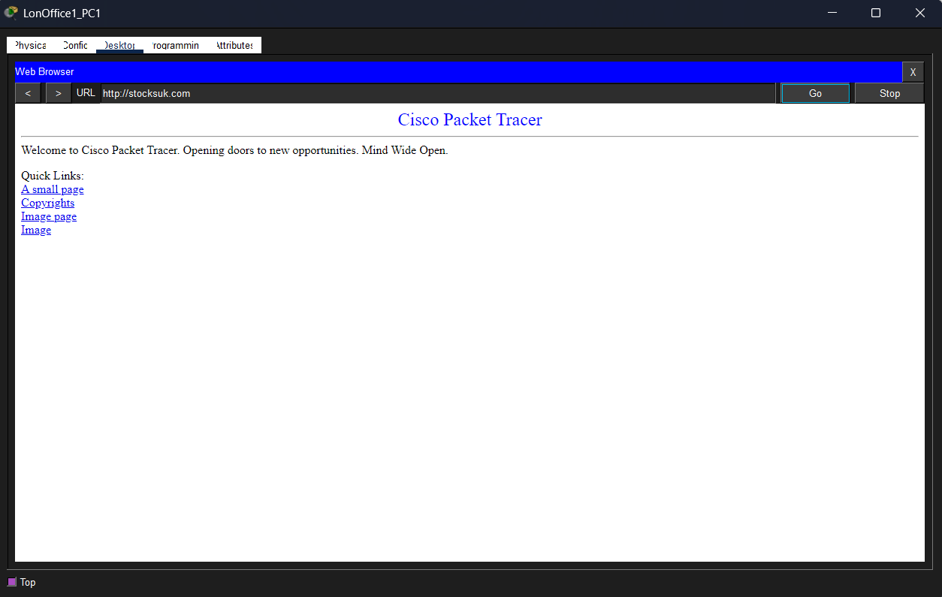
Figure 26: London PC connect to DNS webpage
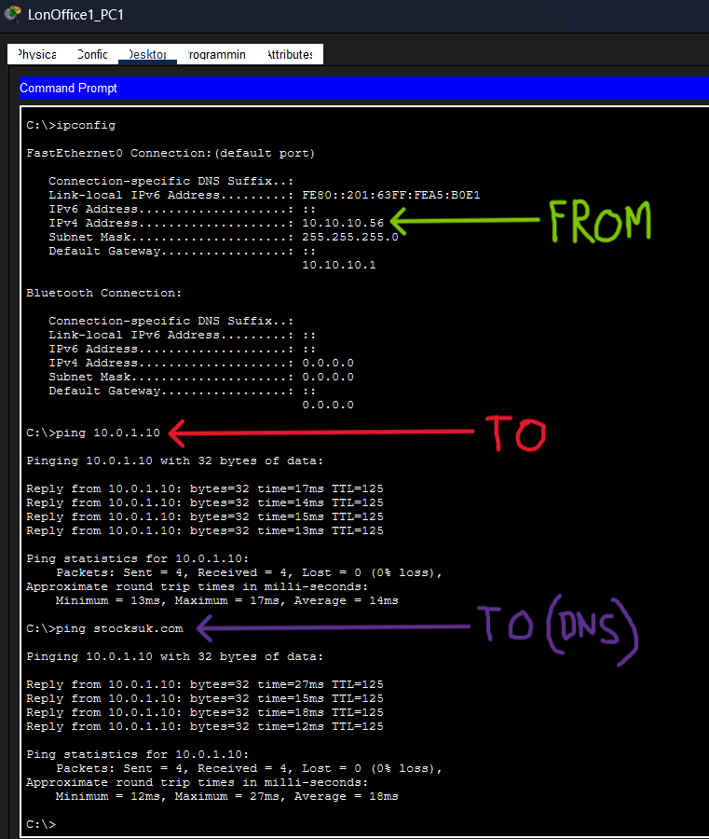
Figure 27: London PC pinging DNS Server
Figure 27 demonstrates a ping request from a PC in London office 1 to the DNS and its underlying IP address. It shows packets being received and sent back from the DNS server, showing the DNS works.

Furthermore, Figure 26 shows the same office PC connecting to the DNS through a web browser.
This confirms completion of objective 6.

VLAN Tests
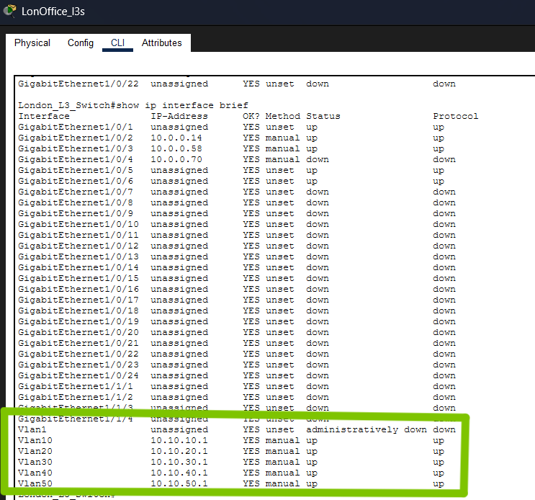
Figure 28: London VLAN IP proof
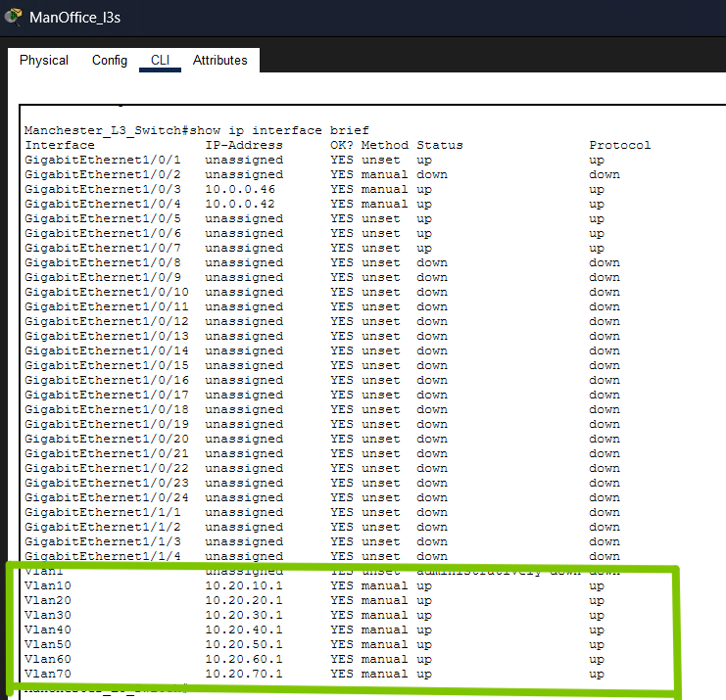
Figure 29: Manchester VLAN IP proof
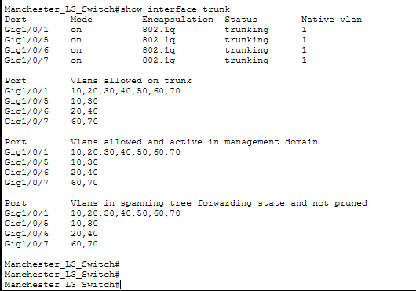
Figure 30: Manchester Trunk information
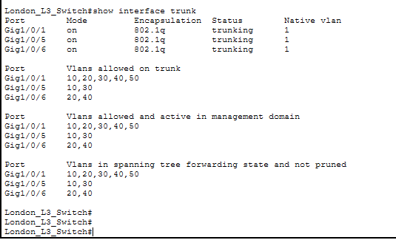
Figure 31: London Trunk information
Figure 28 and Figure 29 prove active VLAN’s inside of Manchester and London’s L3 switch.
Figure 30 and Figure 31 show the trunked interfaces on the L3 switches, and what VLAN’s they carry.

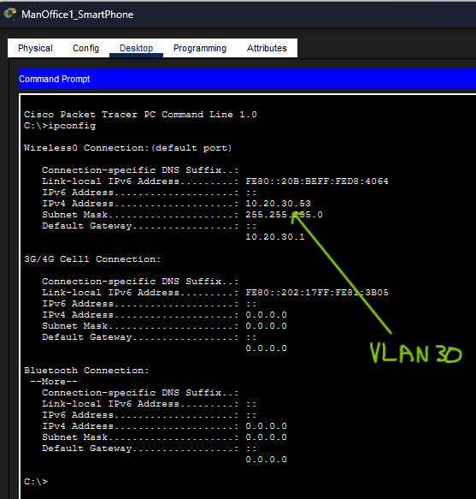
Figure 32: Manchester Phone on VLAN 30
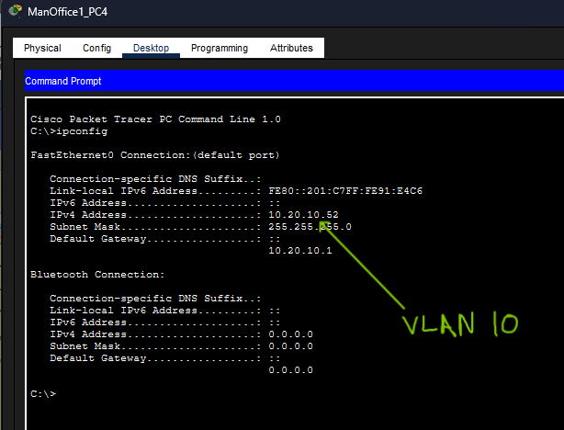
Figure 33: Manchester PC on VLAN 10
Figure 32 shows how the VLAN has made the third octet in the IP to 30 on a smartphone on the access point of office 1 in Manchester.
Figure 33 shows how the VLAN has made the third octet in the IP to 10 on a PC in office 1 in Manchester.
This marks objective 5 complete.

Routing Tests
These tests will be held in office 1 in London, more tests from Manchester office 1 will be displayed in Appendix A - Manchester Office 1 Ping Tests.

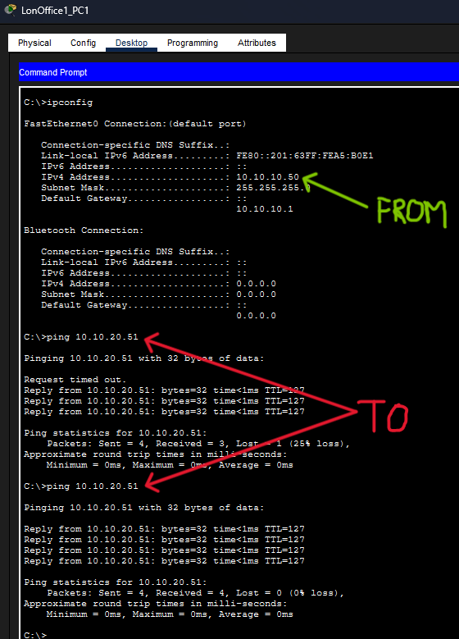
Figure 34: Ping from London office 1 to London office 2
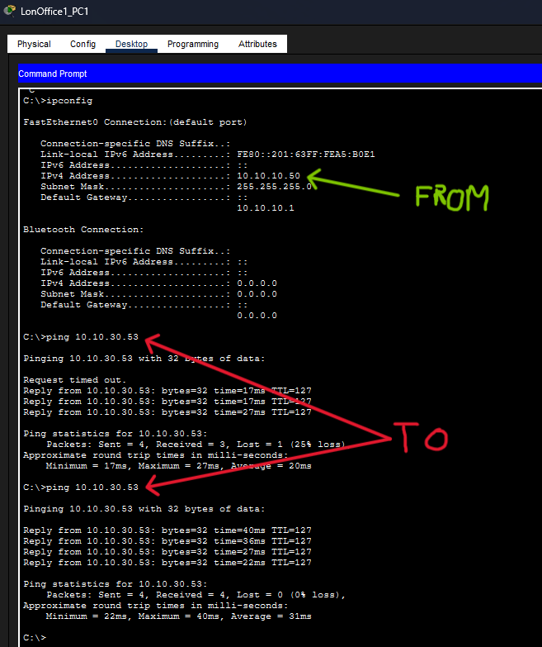
Figure 35: Ping from London Office 1 to London Office 1 Access Point
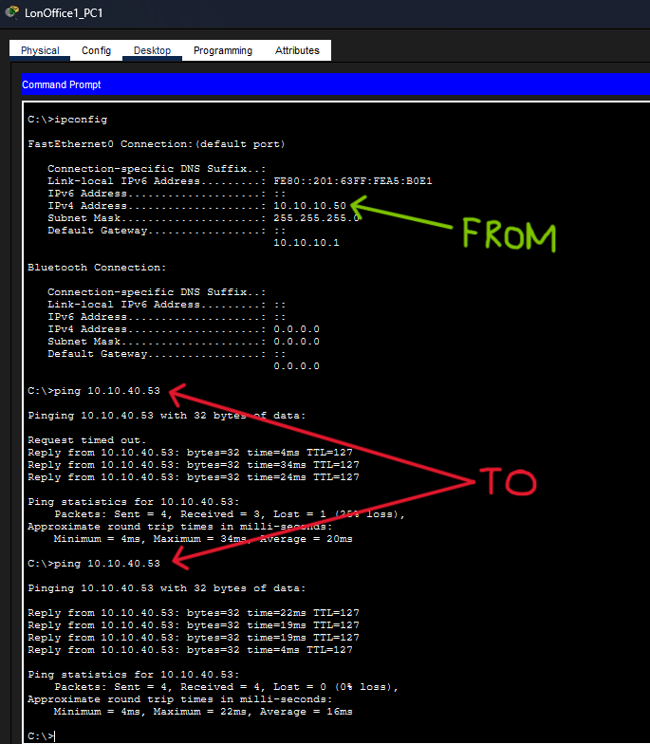
Figure 36: Ping from London Office 1 to London Office 2 Access Point
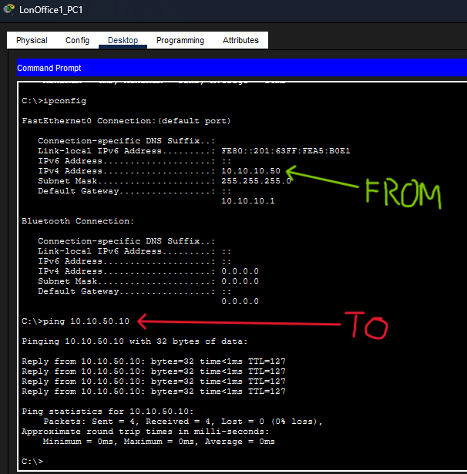
Figure 37: Ping from London Office 1 to London DHCP server
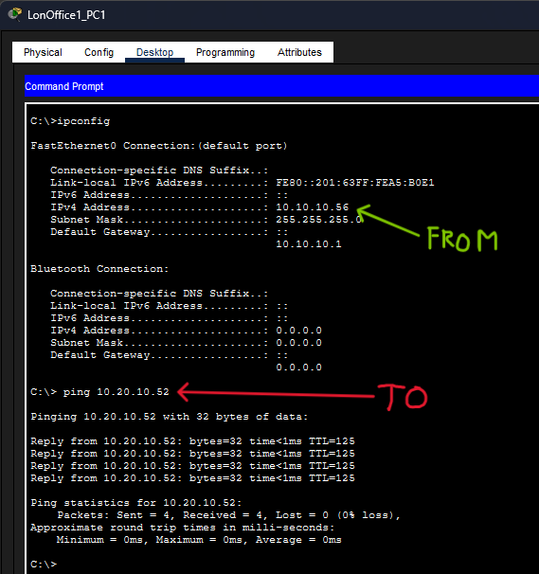
Figure 38: Ping from London Office 1 to Manchester Office 1
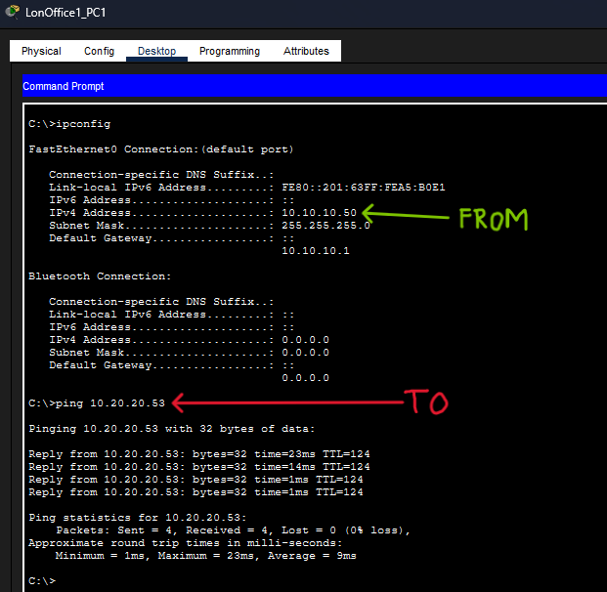
Figure 39: Ping from London Office 1 to Manchester Office 2
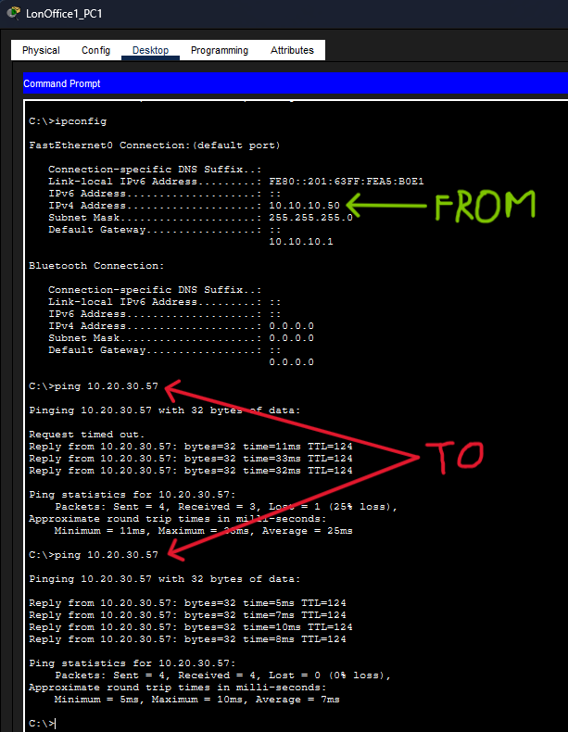
Figure 40: Ping from London Office 1 to Manchester Office 1 Access Point
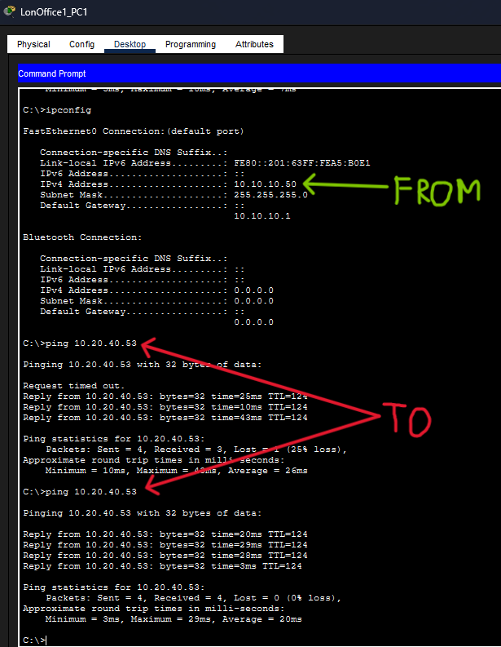
Figure 41: Ping from London Office 1 to Manchester Office 2 Access Point
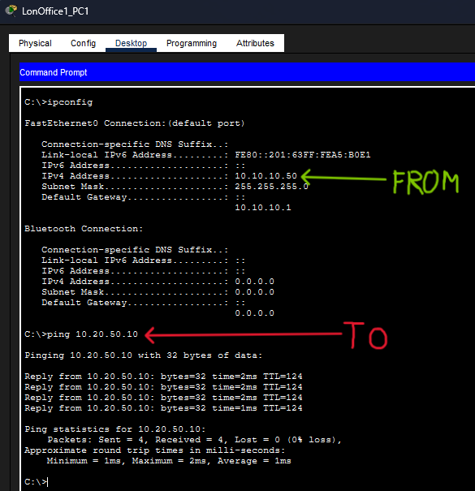
Figure 42: Ping from London Office 1 to Manchester DHCP server
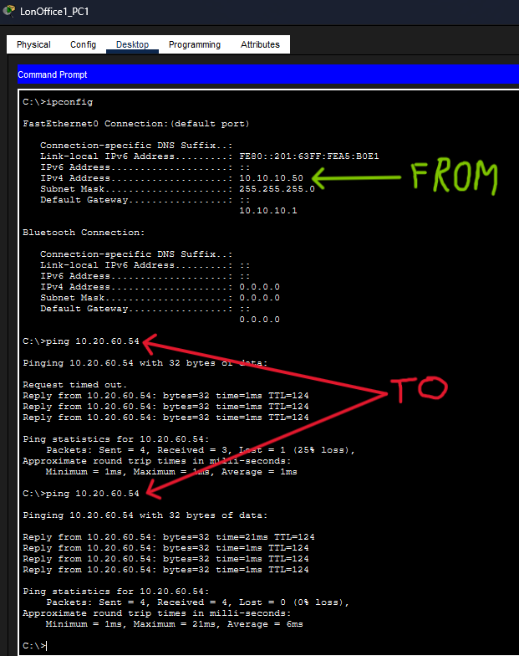
Figure 43: Ping from London Office 1 to Manchester Factory
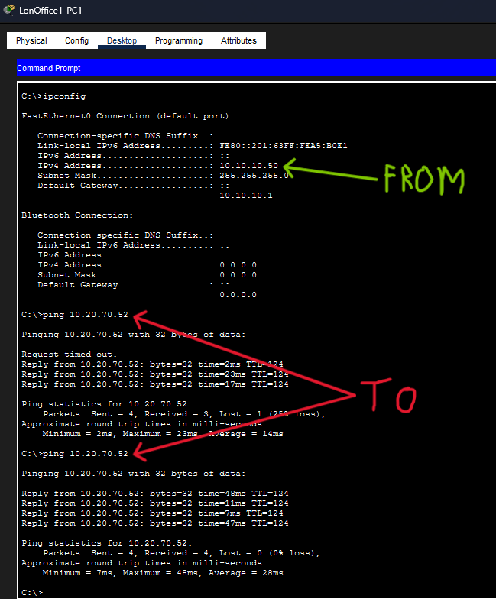
Figure 44: Ping from London Office 1 to Manchester Factory Access Point
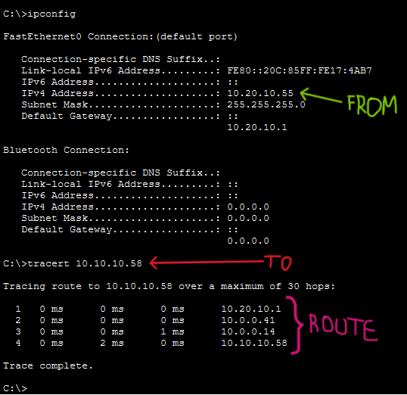
Figure 45: Tracert command from Manchester Office 1 to London Office 1
These figures above prove that each route to every location/VLAN works as expected.
Figure 45 directly shows the route taken from the VLAN in Manchester office 1 to the PC in London’s office. References from: https://medium.com/@minwork/tracert-or-traceroute-command-54d5f031ee9b

See Figure 27 to see successful DNS server ping.
This completes objective 7.

SSH Tests
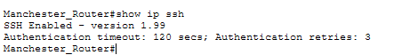
Figure 46: Testing SSH on Manchester Router

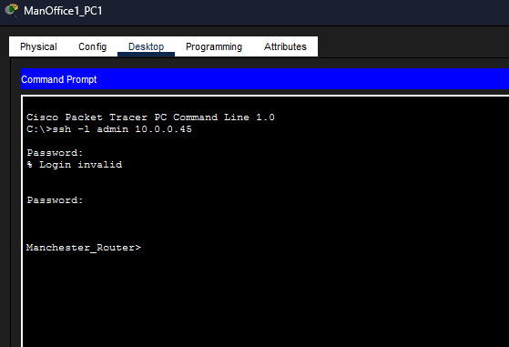
Figure 47: Entering SSH on Manchester office 1 PC
Figure 45 shows SSH correctly configured on the Manchester router. Figure 46 further shows a PC in Manchester office 1 entering the SSH of the Manchester router.

SSH checks for all network devices can be found in Appendix A - Additional SSH Tests, which completes objective 4.

Network Evaluation and Discussion
Referring to Figure 8 , the WAN consists of four core routers connected to Layer 3 switches, each representing a location. The design is scalable, as an additional router and L3 switch can be introduced to distribute VLANs. DNS is already integrated into the WAN and would only require configuration on a new DHCP server, while subnet isolation further supports scalability.
The WAN is also redundant, reducing downtime by allowing traffic to reroute during router failures. However, this redundancy increases cost and network complexity.

Despite this, routing efficiency remains high due to the use of OSPF, which applies Dijkstra’s algorithm to ensure optimal path selection. The design could be simplified by removing the dedicated DNS router to reduce costs, as future expansion would naturally increase redundancy. Overall, the network effectively meets the project requirements.

Conclusion
StocksUK now operates a secure, reliable, and scalable network supporting employees across four distributed sites. Each site provides wired and wireless connectivity within isolated VLANs, improving security, reducing broadcast traffic, and enhancing performance.

OSPF enables efficient WAN routing, ensuring optimal path selection and high availability through redundancy. Centralised services such as DHCP and DNS simplify network management, while SSH secures administrative access to WAN devices.

Although the redundant WAN design increases cost and complexity, this trade-off is justified by improved fault tolerance, reduced downtime, and support for business-critical data. The modular architecture also allows future expansion with minimal reconfiguration.

Overall, the network design meets StocksUK’s requirements and provides a robust solution for current operations and future growth.

References
- Banks, E. (2014). Open Shortest Path First OSPF Protocol Explained. [online] Auvik Networks Inc. Available at: https://www.auvik.com/franklyit/blog/ospf-protocol-explained/.
- Kimanzi, S. (2018). Secure Shell (SSH) configuration on a switch and router in Packet Tracer. [online] Computer Networking Highlights. Available at: https://computernetworking747640215.wordpress.com/2018/07/05/secure-shell-ssh-configuration-on-a-switch-and-router-in-packet-tracer/.
- Anshika (2024). Configure DNS Server On Cisco Packet Tracer. [online] Medium. Available at: https://medium.com/@z6157881/configure-dns-server-on-cisco-packet tracer-e7c412b3b3dd.
- Jones, M. (2025). DHCP, Redundancy, SSH [online] Mmu.ac.uk. Available at: https://moodle.mmu.ac.uk/pluginfile.php/8409946/mod_resource/content/1/Net_Wk9_Lab.pdf.
- Vladyslav Diadenko (2021). Cisco Layer 3 Switch Inter-VLAN Routing. [online] Medium. Available at: https://diadenkov.medium.com/cisco-layer-3-switch-intervlan-routing-without-router-8e04f2315a56.
- Adhikari, M. (2024). traceroute command. [online] Medium. Available at: https://medium.com/@minwork/tracert-or-traceroute-command-54d5f031ee9b.

‌

Appendix A

Manchester Office 1 Ping Tests

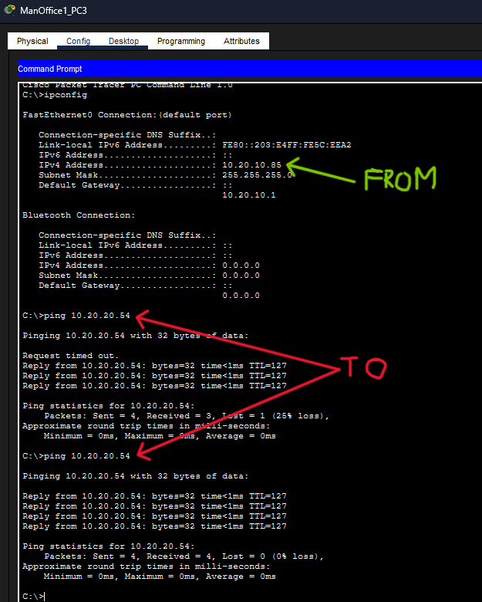
Figure 48: To Manchester Office 2

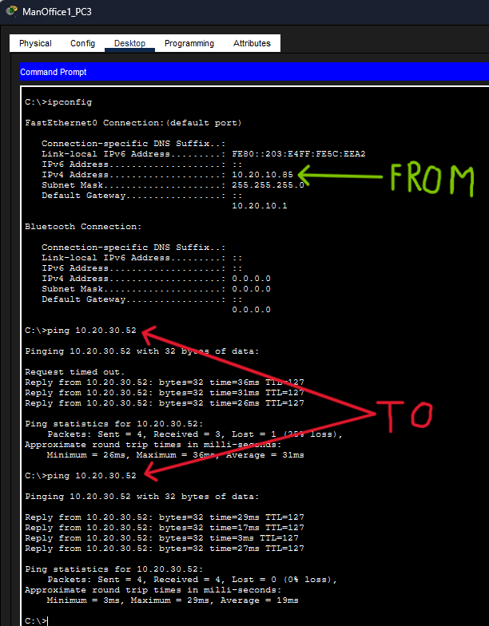
Figure 49: To Manchester Office 1 AP

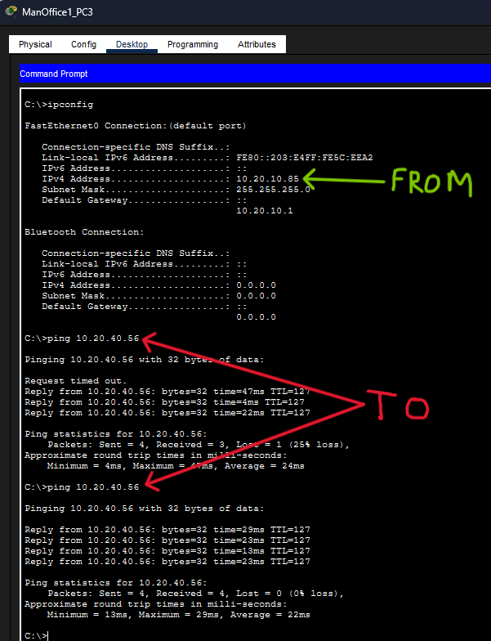
Figure 50: To Manchester Office 2 AP

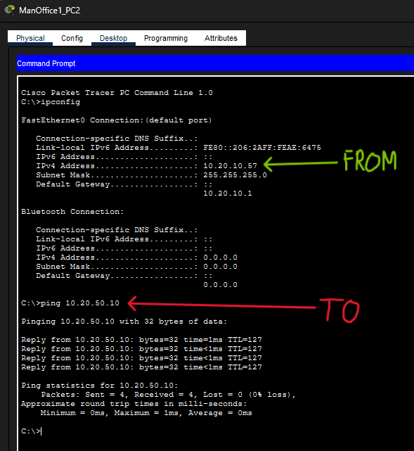
Figure 51: To Manchester DNS

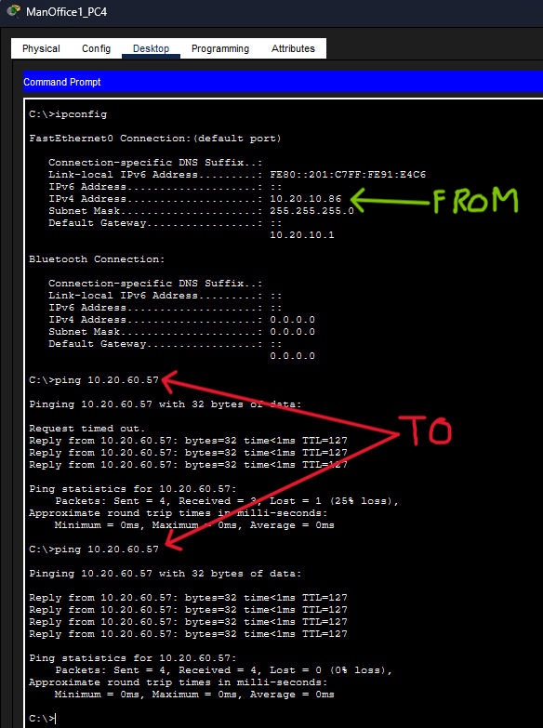
Figure 52: To Manchester Factory

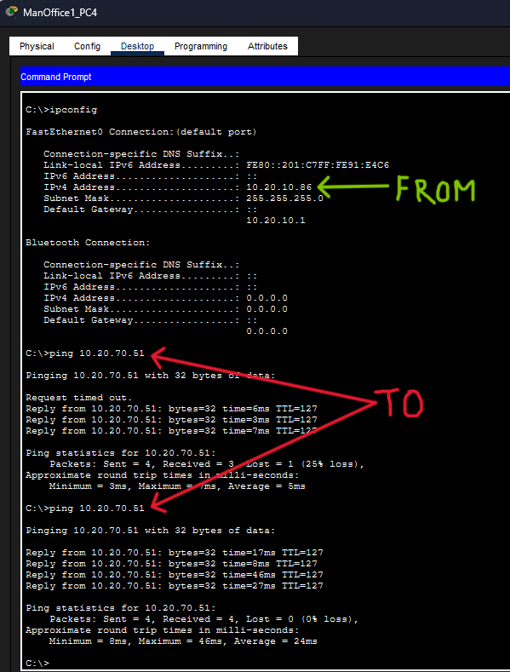
Figure 53: To Manchester Factory AP

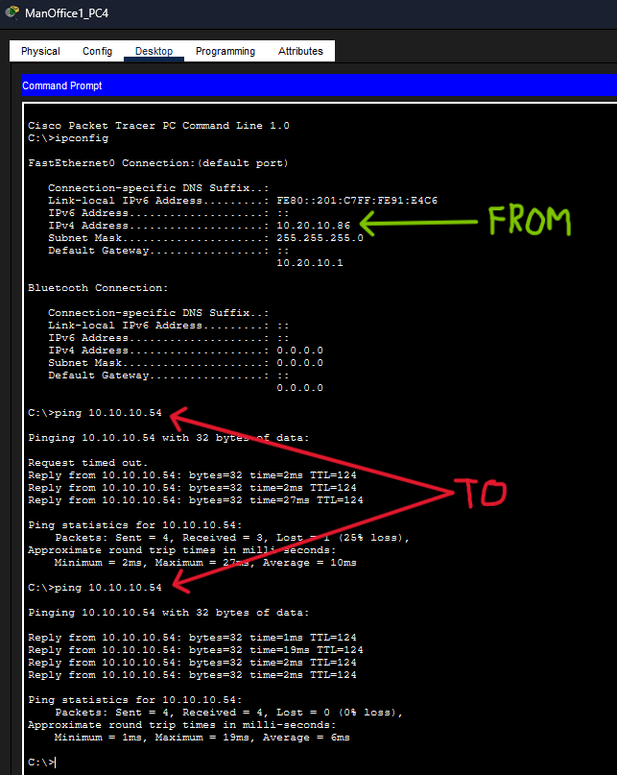
Figure 54: To London Office 1

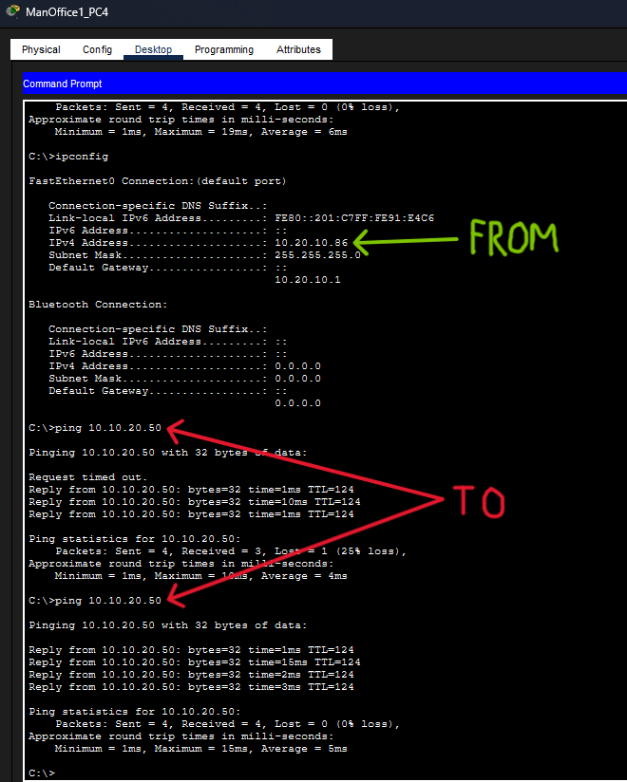
Figure 55: To London Office 1

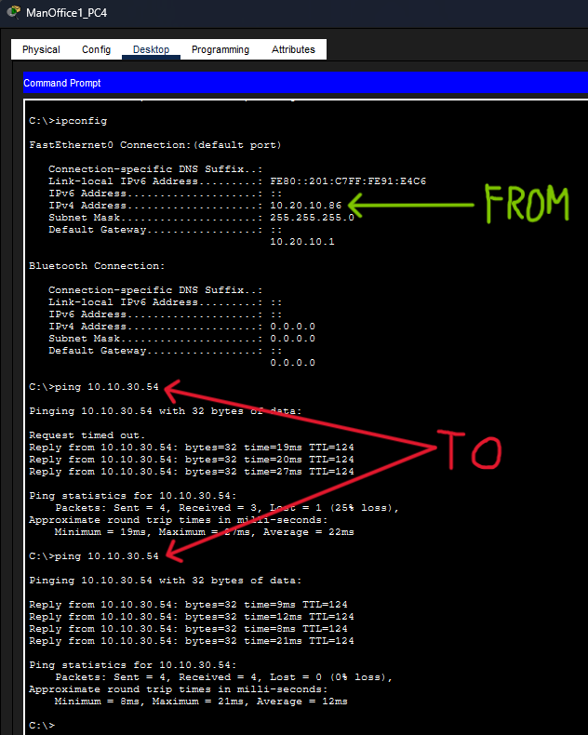
Figure 56: To London Office 1 AP

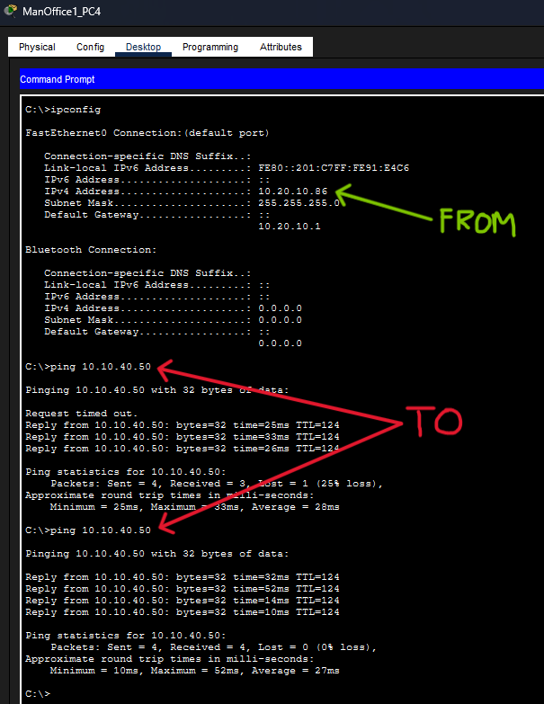
Figure 57: To London Office 2 AP

Figure 58: To London DNS

Additional OSPF Configuration
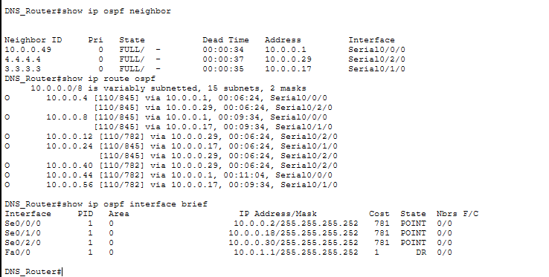
Figure 59: DNS Router

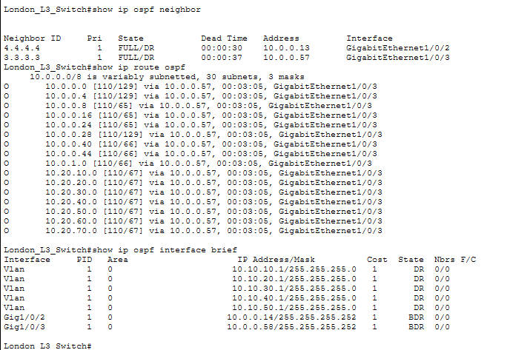
Figure 60: London L3 Switch

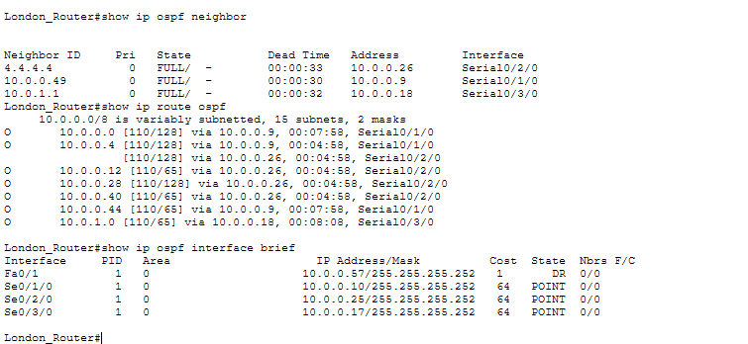
Figure 61: London Router

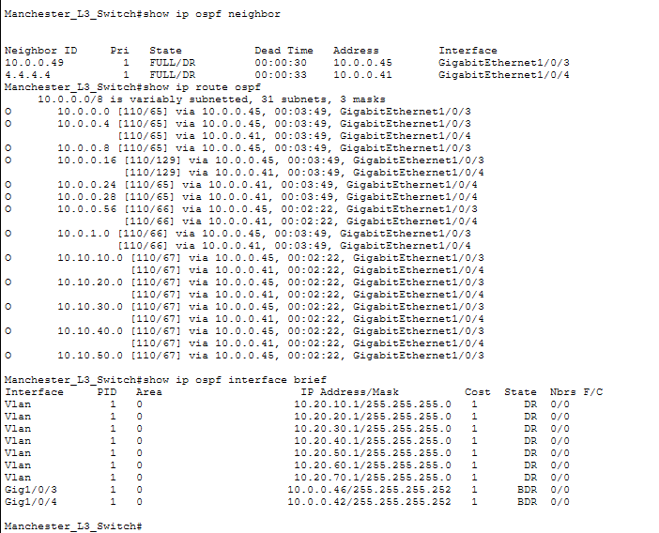
Figure 62: Manchester L3 Switch

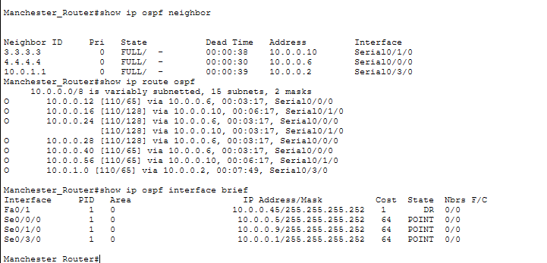
Figure 63: Manchester Router

Additional SSH Configuration
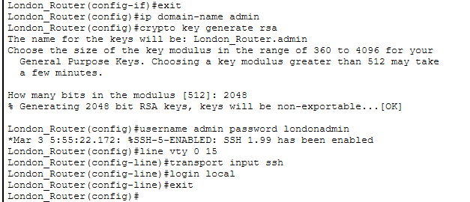
Figure 64: London Router
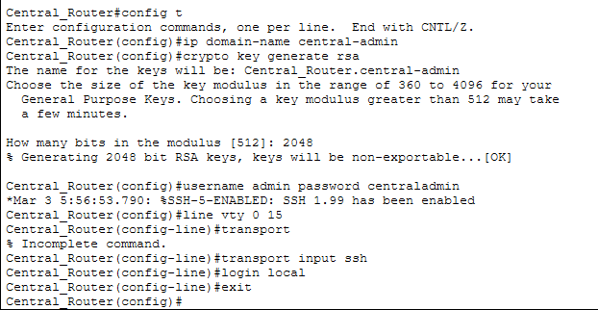
Figure 65: Central Router
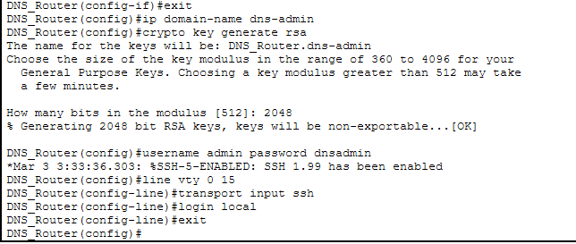
Figure 66: DNS Router
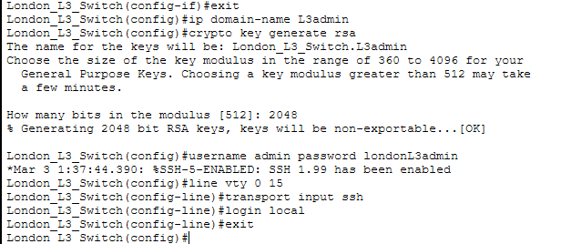
Figure 67: London L3 Switch
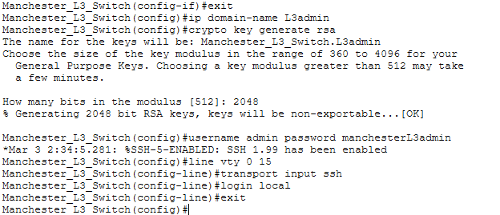
Figure 68: Manchester L3 Switch

Additional SSH Tests
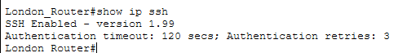
Figure 69: London Router
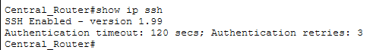
Figure 70: Central Router
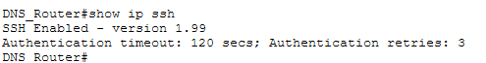
Figure 71: DNS Router
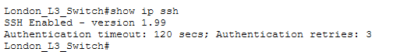
Figure 72: London L3 Switch
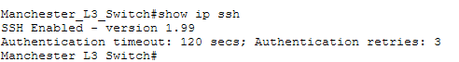
Figure 73: Manchester L3 Switch

