**CS TASK 3**

**1. Create Database**

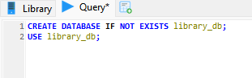

**Result:**

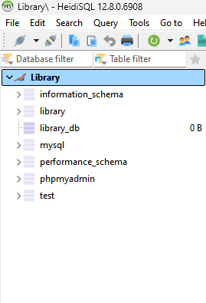

**2. Create Table**

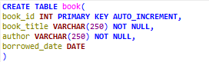

**Result:**



**3. Inserting Books**

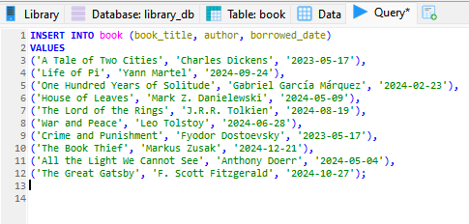

**Result:**

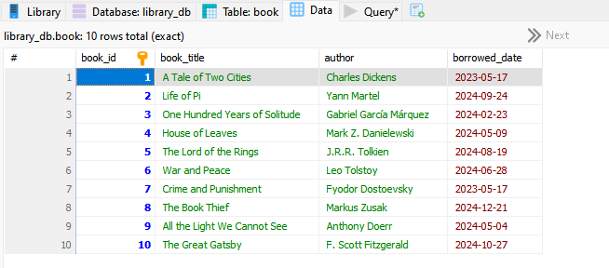

**4. Listing all books**



**Result:**

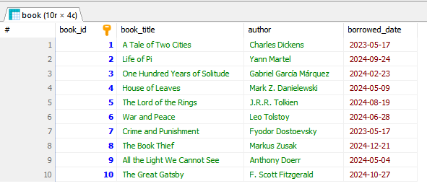

**5. Finding books by author**



**Result:**

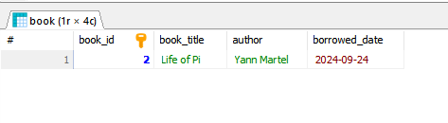

**6. Finding by specific date**



**Result:**

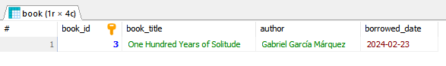

**7. Finding books after specific date**



**Result:**

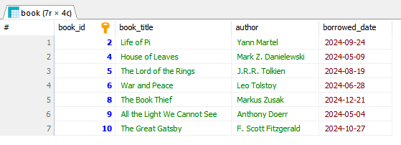

**8. Update a borrowed date**



**Result:**

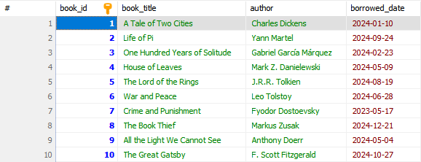

**9. Delete a book**

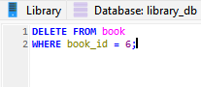

**Result:**

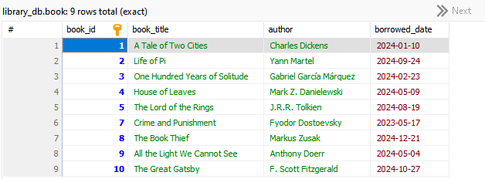

**10. Re-adding a book**

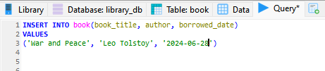

**Result:**

