The webpage for HoriSEOn Digital Marketing has not only been refactored to be more accessible (and therefore more likely to rank higher on a search engine’s results) but also more streamlined. Many unnecessary classes and ids were removed and multiple lines of repeated code were consolidated. As can be seen below in the screenshot portion of this debrief, minimal -if any- changes have been made to the actual layout and presentation of the website aside from adding a descriptive title.



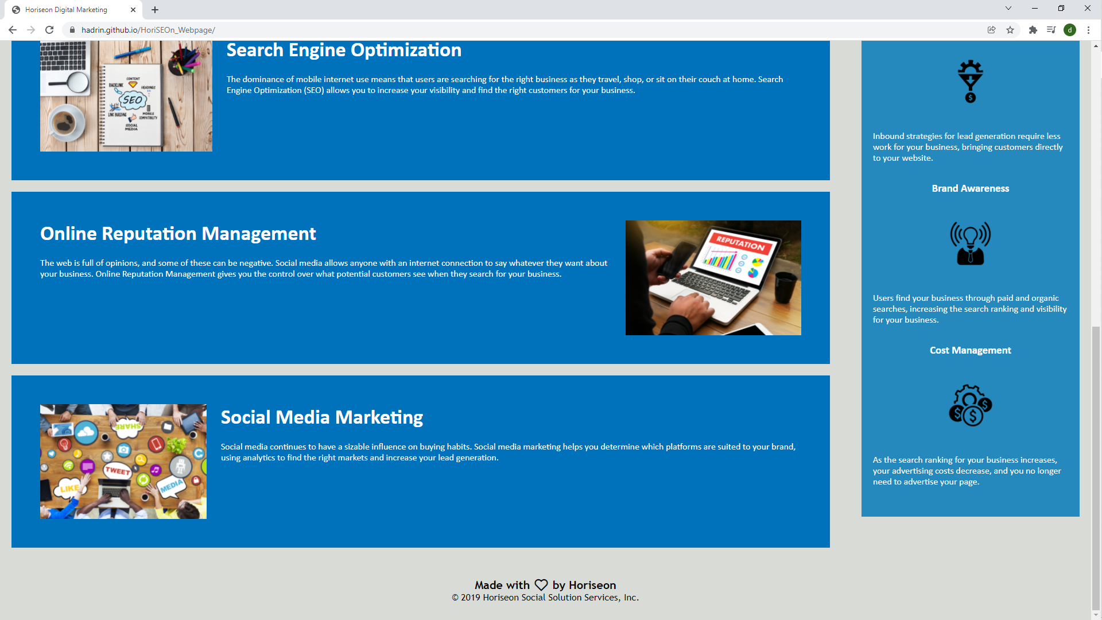

A live version of the updated site can be accessed at <https://hadrin.github.io/HoriSEOn_Webpage/>