Individual log item | Your answer
Name | HADSHEN THAVASEELAN
Student ID | 16247806
GitHub username | Hads44
What I worked on today | Prototype build plan report  Game developing with leader
Tool I used | HTML, JS & CSS
File/prototype part I created or edited | Prototype build plan
Commit message or evidence | 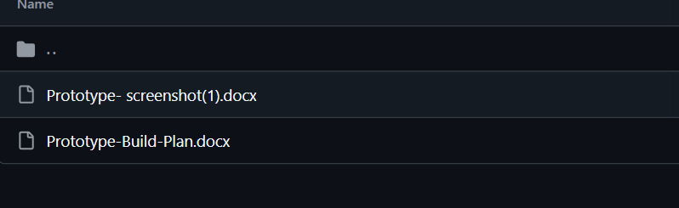  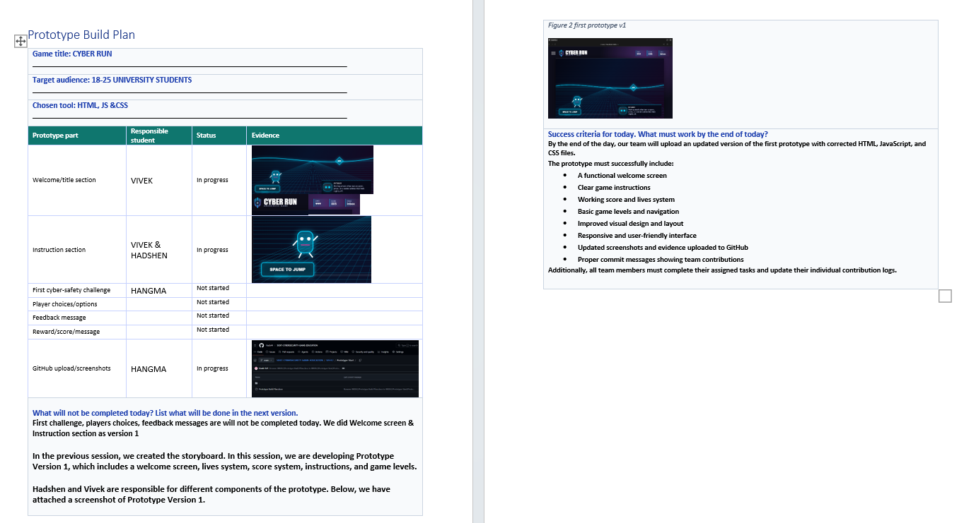
What I learned | How to translate a game concept canvas into a working prototype, Importance of linking learning objectives (cyber safety) to gameplay mechanics  How feedback systems (safe vs unsafe actions) can be used in educational games
What I need to do next | Improve cyber safety learning interactions (real scenario choices),Test accessibility such as readability, controls, difficulty balance.  Push final prototype version to GitHub with proper commits

