Prototype Build Plan
Game title: CYBER RUN
_____________________________________________________________________________________
Target audience: 18-25 UNIVERSITY STUDENTS
_____________________________________________________________________________________
Chosen tool: HTML, JS &CSS
_____________________________________________________________________________________
Prototype part | Responsible student | Status | Evidence
Welcome/title section | VIVEK | In progress | 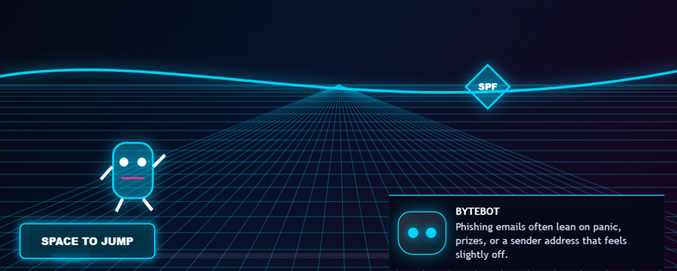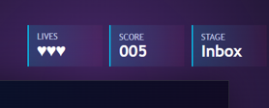
Instruction section | VIVEK & HADSHEN | In progress | 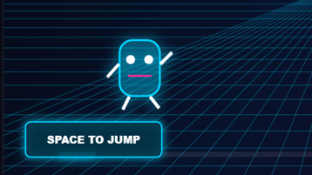
First cyber-safety challenge | HANGMA | Not started
Player choices/options |  | Not started
Feedback message |  | Not started
Reward/score/message |  | Not started
GitHub upload/screenshots | HANGMA | In progress | 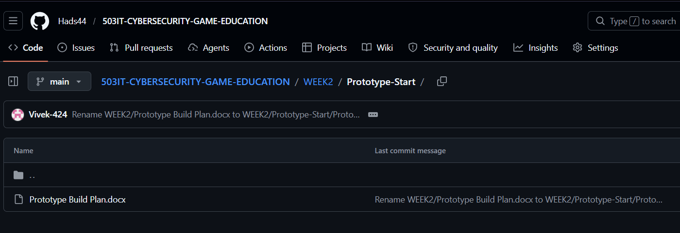
What will not be completed today? List what will be done in the next version.
First challenge, players choices, feedback messages are will not be completed today. We did Welcome screen & Instruction section as version 1

In the previous session, we created the storyboard. In this session, we are developing Prototype Version 1, which includes a welcome screen, lives system, score system, instructions, and game levels.

Hadshen and Vivek are responsible for different components of the prototype. Below, we have attached a screenshot of Prototype Version 1.

Figure 2 first prototype v1
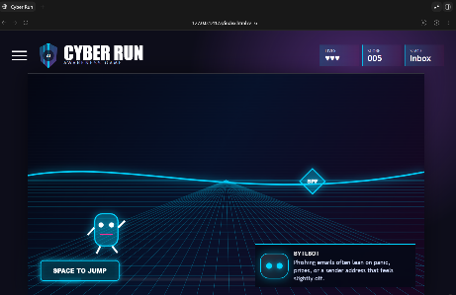

Success criteria for today. What must work by the end of today?
By the end of the day, our team will upload an updated version of the first prototype with corrected HTML, JavaScript, and CSS files.
The prototype must successfully include:
- A functional welcome screen
- Clear game instructions
- Working score and lives system
- Basic game levels and navigation
- Improved visual design and layout
- Responsive and user-friendly interface
- Updated screenshots and evidence uploaded to GitHub
- Proper commit messages showing team contributions
Additionally, all team members must complete their assigned tasks and update their individual contribution logs.

