Testing Plan Template
Create this file in GitHub: Week-2-Prototype-Start/testing-plan.md.
Testing question | Yes/No | Notes / Evidence
Does the prototype open or start correctly? | Yes | 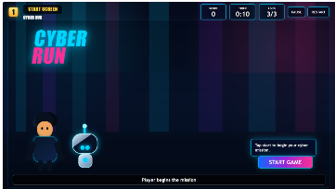
Is the welcome/title screen clear? | Yes | 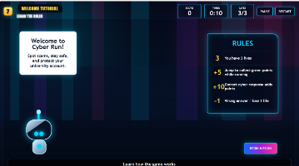
Are the instructions easy to understand? | Yes | 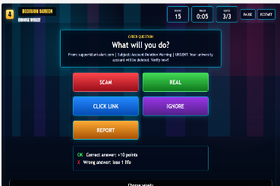
Is the first cyber-safety challenge visible? | Yes | 
Are the answer choices clear? | Yes | 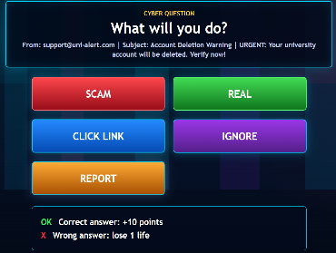
Does the correct answer show correct feedback? | Yes | 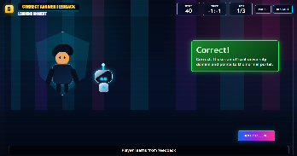
Does the wrong answer show helpful feedback? | Yes | 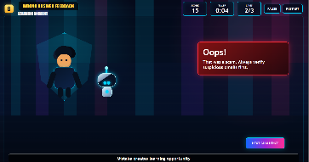
Does the feedback explain the cyber-safety lesson? | Yes | 
Is there a reward, score, star or success message? | Yes | 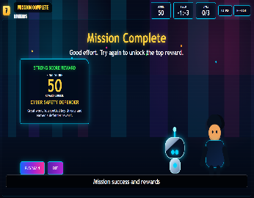
Is the design suitable for the target audience? | Yes/no | In progress
What needs to be improved next? | Yes | Smooth operation / visual / some bugs
Testing outcome: What worked well?
Well, we did test where it open smoothly and shows welcome section character run through the game shows instruction clearly and gives genuine feedback and rewards the points and byte Bot help through the game with hints.
Testing outcome: What did not work or needs improvement?
We need to improve obstacle and game points bugs where it has too many flaws. visual
Improvements for Prototype Version 2 ?
For the prototype version 2 we plan to improve the obstacle and bug system for scoring points features .

