Individual Contribution Log:
Individual log item |  | Your answer
Name |  | Swastika Sundas Suyal
Student ID |  | 15728966
GitHub username |  | syanasyana170-sys
What I worked on today |  | Today, I contributed to the development documentation and evidence preparation for our game prototype. I organized and worked on documenting prototype Version 1 and Version 2 by adding the explanations, screenshots, and figure captions to show the development progress of the game, and also, I helped to present the improvements made between both versions, including the welcome screen, instructions, lives system, score system, game challenges, and educational feedback screens. Also, I contributed to improve the visual presentation and structure of the prototype evidence for the project portfolio and Github documentation.
Tools I used |  | HTML / JS/ CSS
File/prototype part I created or edited |  | I created and organized the Evidence for prototype, documentation section, also I added screenshots and figure labels for prototype version 1 and version 2, and contributed to explaining gameplay improvements including the welcome screen, instructions, challenges for the player, score system, lives system, and also educational feedback screens.
Commit message or evidence | 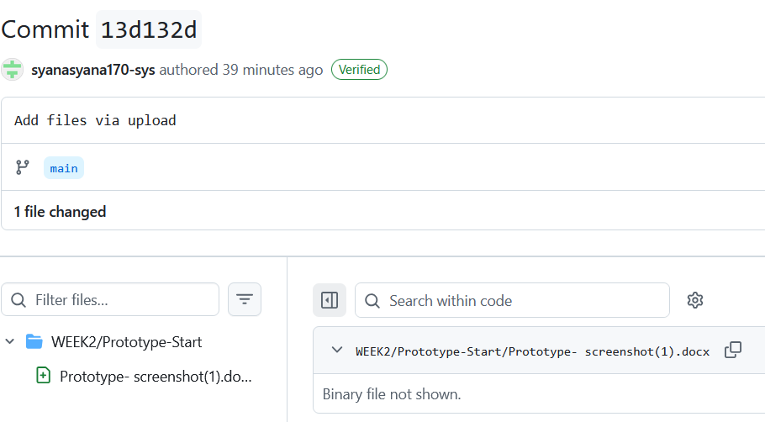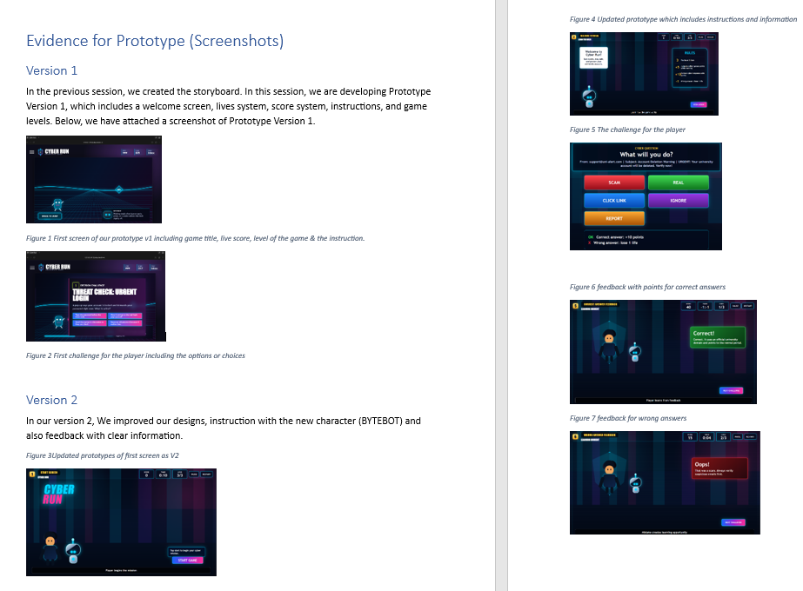
What I learned | I learned how a game prototype is developed step by step and how improvements are made between different the versions. I also learned how to organize screenshots, figures, and explanations properly to show evidence of our project development. Not only that but also, I learned how adding clear instructions, feedback, score systems, lives, and characters can make the game more interactive and easier for users to understand, also I gained a better understanding of how educational games can be used to teach phishing awareness and online safety through interactive gameplay.
What I need to do next |  | Next, I need to continue supporting the development of the “HTML/JS/CSS”, prototype, contribute gameplay refinement and phishing scenario design, upload additional evidences in the GitHub and assist with the presentation preparation and explanation of the prototype development process.

