11. Task 7 - Start Individual Portfolio / Report Planning
Important
The individual portfolio is not a group report. Each student must write their own report and explain their own contribution, reflection, evidence and professional development. Start planning now.

Portfolio section | What to write | Evidence to link
Introduction | Briefly introduce the project, game topic, group role and aim.  - Cyber Security awareness(Phishing awareness)  - Building such an interactive game that helps youths to learn and enjoy at the same time  - Cyber Run is the game topic  - My role is to develop the game and perform all the testing | 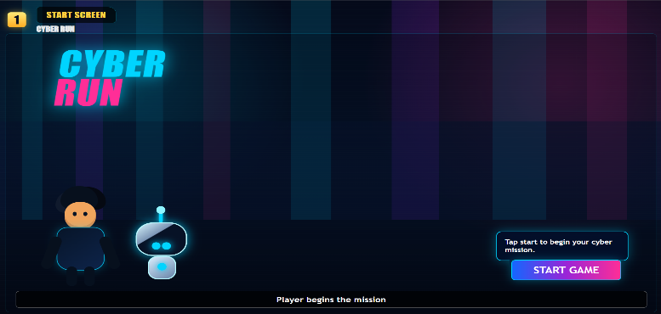  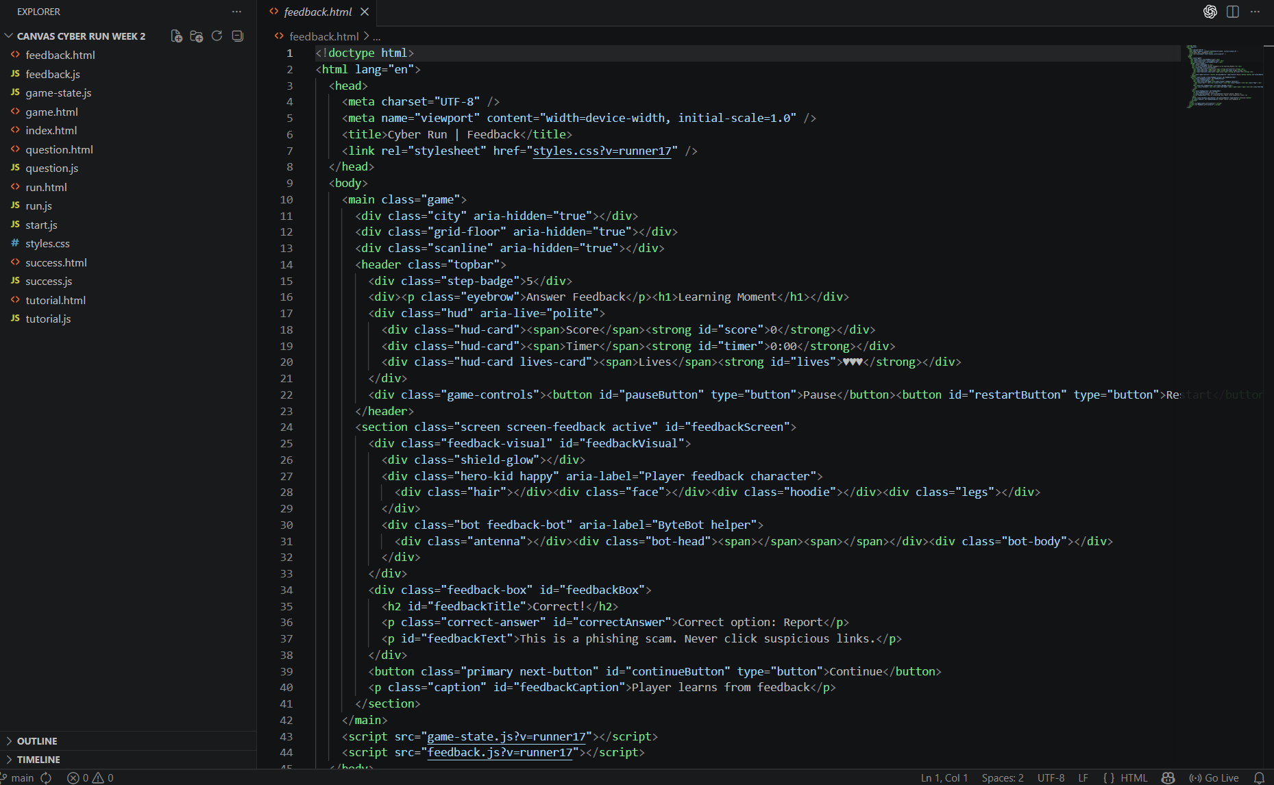
Project planning and teamwork | Explain meetings, role allocation and how the team organized work.  - Once meeting is held weekly  - And roles are allocated to every member where they perform according to it  - My team organizes each of their roles with full responsibility and we also discuss all the quires with each other solving every problem arises during our tasks | 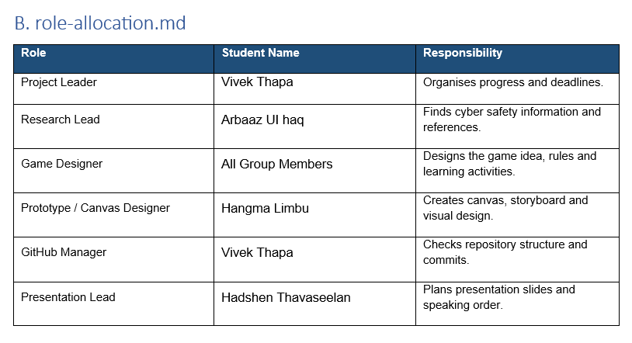
Personal contribution | Explain exactly what you personally did.  So, I was responsible for handling group as a group leader and I took the responsibility to develop the game using different tools where I used vs code and other AI tools to look into different problems and queries  I also performed all the tasks assigned by tutor in each week | 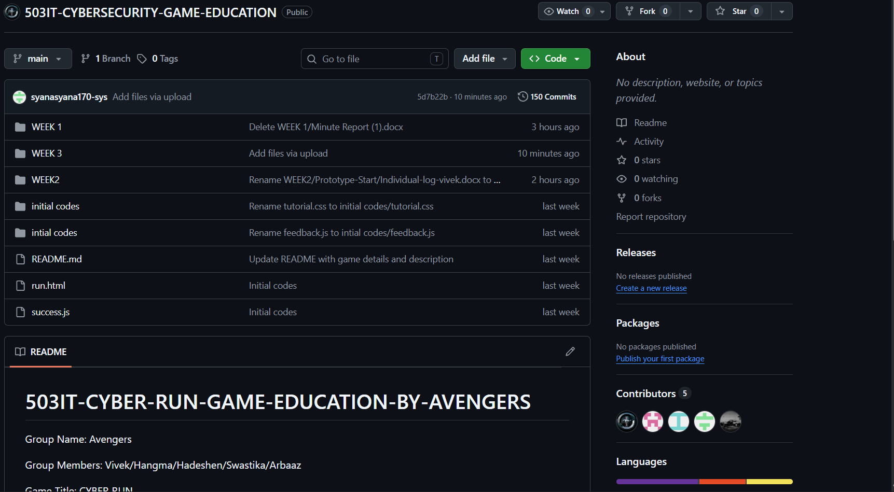
Prototype development | Explain how the game/prototype developed over time.  So, in first week we made an outline of our idea where how our game is going to look and how engaging it needs to be. Then gradually from second week we started developing the game and started testing the game, finding different bugs and flaws of the game. So, everything is going smoothly where different ideas are generated with time and we are making different changes to make it more engaging and reliable for target group. We expect it to be much better with time where we will go through different more changes according to time | 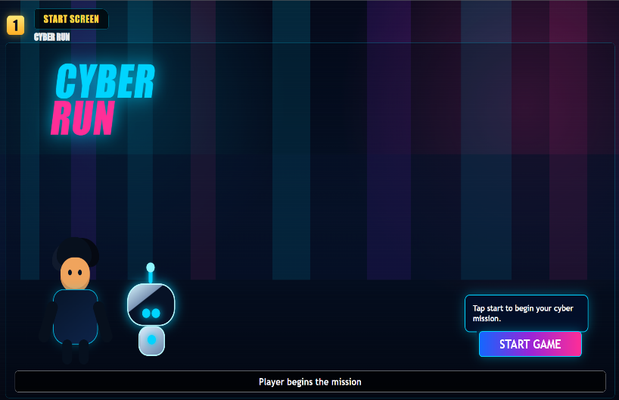  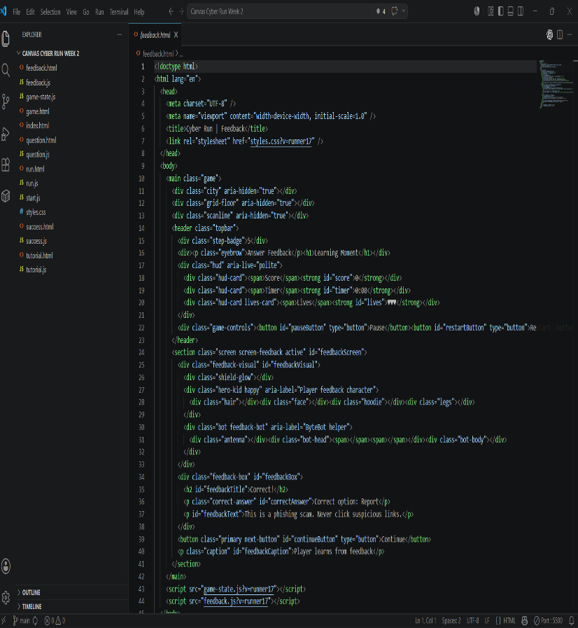
Communication and collaboration reflection | Reflect on teamwork, communication, conflict, feedback and improvement.  - Everybody was assigned with one specific task  - Gane development was done with teamwork  - Many updates were made in GitHub by each group members  - Game prototypes were evaluated by everybody  - Feedback and improvement suggestions were taken from each group member | 
Professional development | Explain what you learned for future professional practice.  So in this secession I learned the importance of team and teamwork where anything is possible to perform with good engaging team  - I learned about GitHub  - Learned how GitHub works  - Got familiar with codes  - Learned some more about programming language | 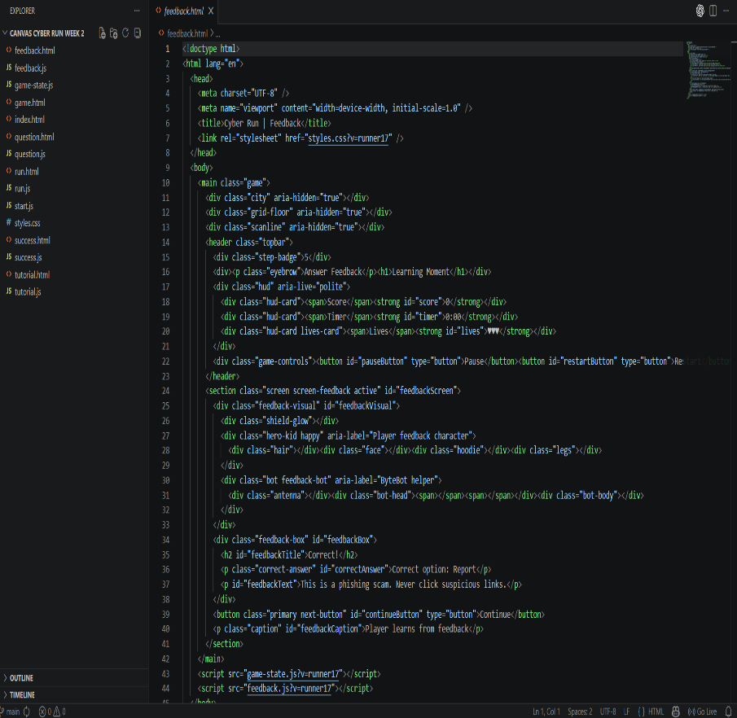  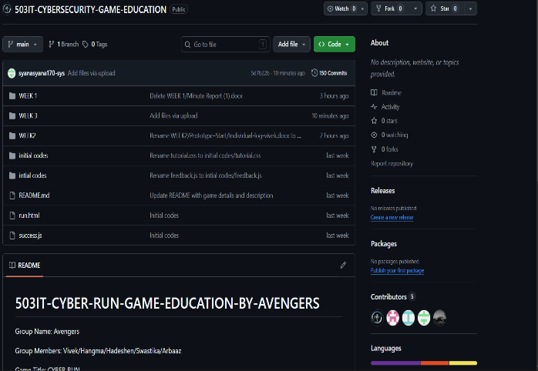
AI use statement | Declare how AI was or was not used.  AI Tools Used:  - Chat GPT, Codex, Canva  Chat GPT was used to understand the queries raised during development and codex for finding bugs and improving codes. Canva was used to develop different templets for game using different ideas raised during discussion
Appendices | Include supporting evidence in labelled appendix sections. | Appendix evidence map  