7. Task 3 - Test the Prototype and Record Evidence
What testing means this week
Testing does not mean the final game is complete. Testing means checking the current prototype to see whether it opens, works, is understandable, teaches the learning point, and is suitable for the target audience. Test what you have built so far.

Testing Instructions by Tool
Tool route | How to test | Evidence to upload
Scratch | Click the green flag. Test the start, instructions, challenge, answer choices, feedback, and score/reward. Ask another group to try it. | Scratch link, screenshots of start/challenge/feedback, testing-results.md
HTML / VS Code | Open the HTML file in a browser or with Live Server. Test every button/interaction. Check correct and wrong answers. Confirm feedback appears. | HTML file(s), screenshot of browser, screenshot of feedback working, testing-results.md
Canva / PowerPoint | Run the presentation/clickable prototype from the beginning. Ask another group to follow the screens and explain what they think the player should do. | Exported PDF/PPT, screenshots, testing notes, peer review notes
Other tool | Run the prototype using the tool’s preview/play mode. Check whether a new user can understand and interact with it. | Tool link/file, screenshots, testing notes

Testing Checklist
Testing question | Yes/No | Evidence or notes
Does the prototype open/start correctly? | Yes | 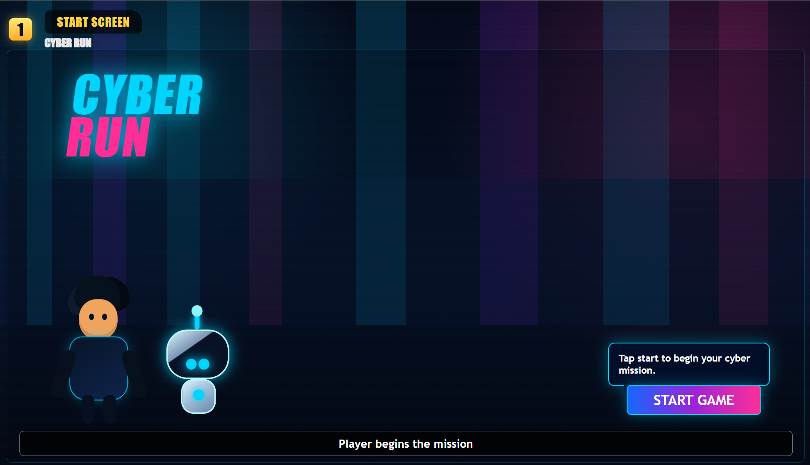
Is the welcome/title screen clear? | Yes | 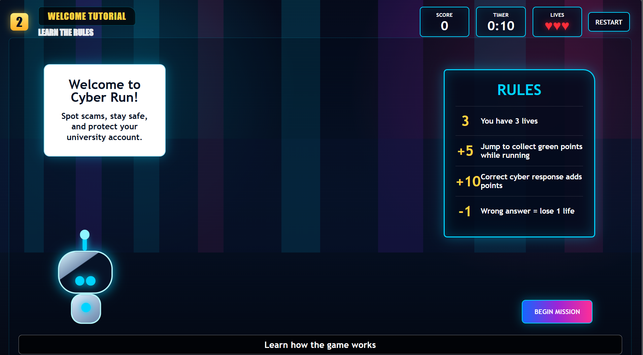
Are the instructions easy to understand? | Yes | 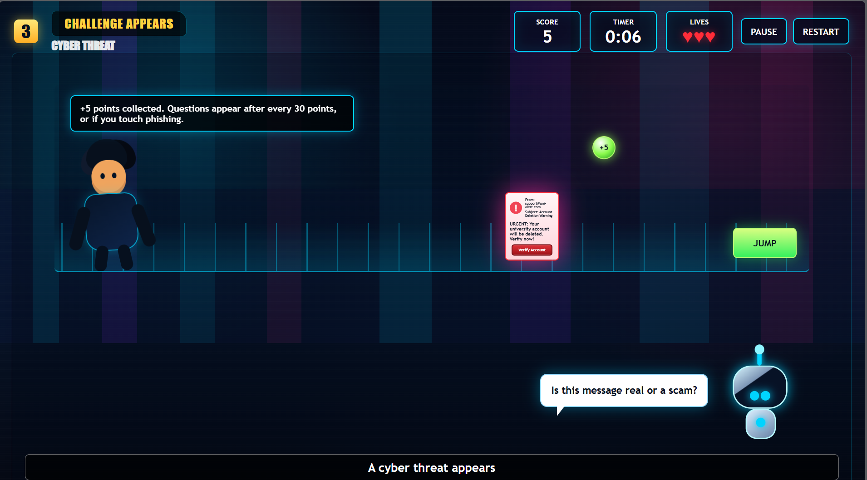
Can the player identify what to click/do? | Yes | 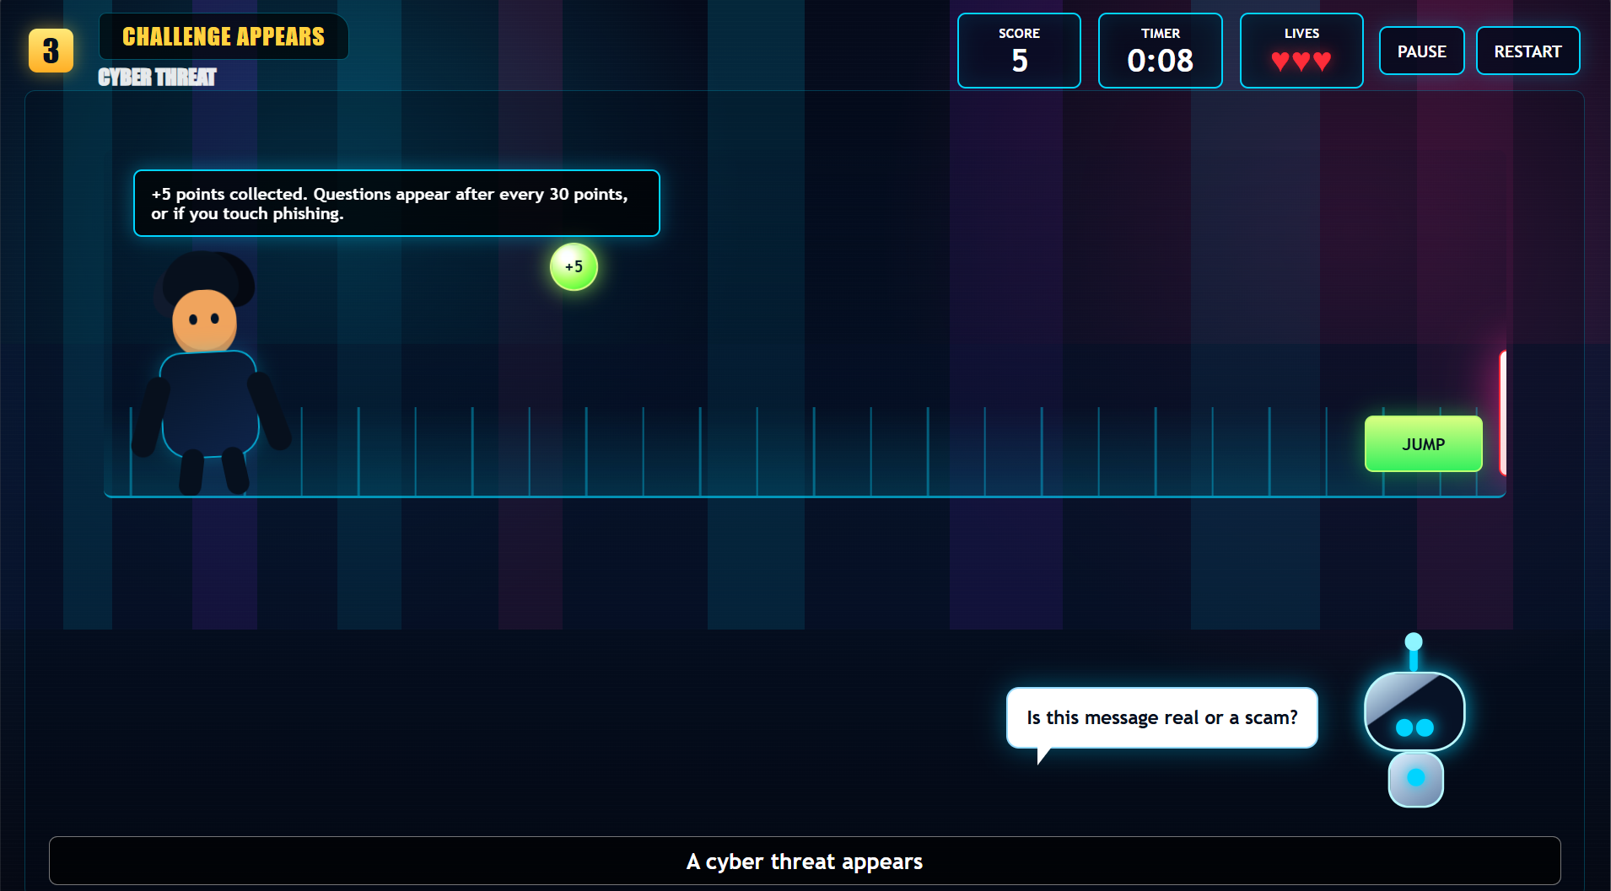
Does the first cyber-safety challenge work? | Yes | 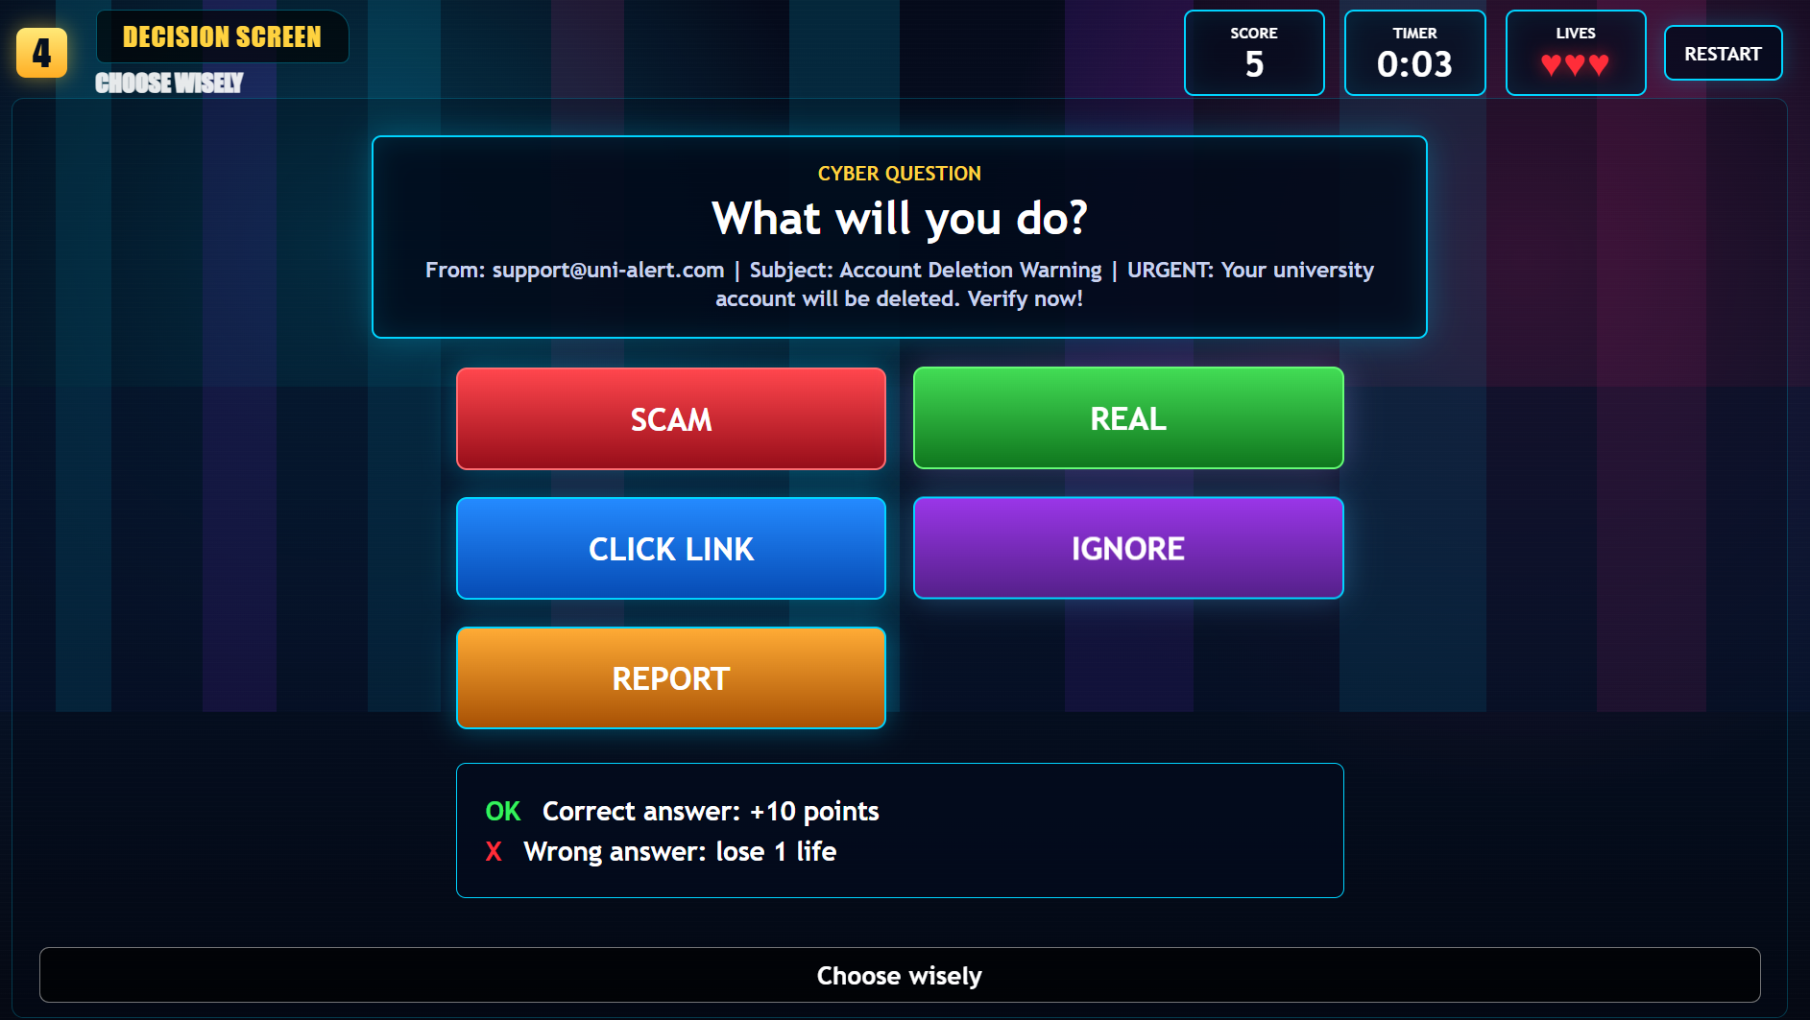
Does any new challenge/interaction work? | Yes | 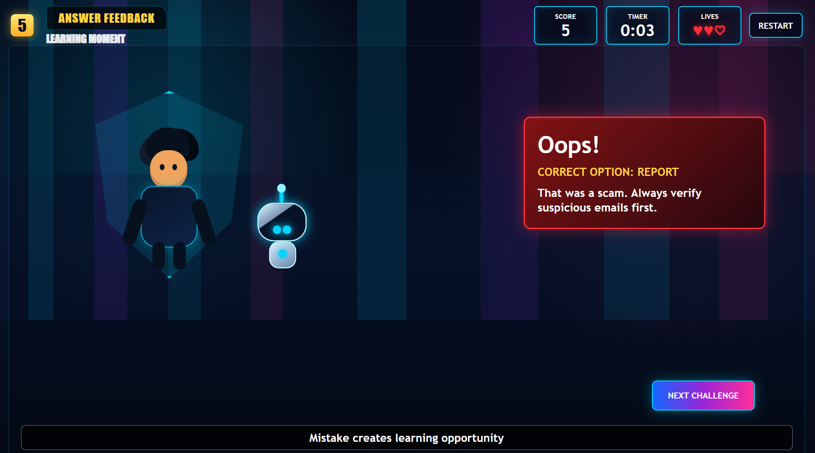
Does the correct answer show useful feedback? | Yes | 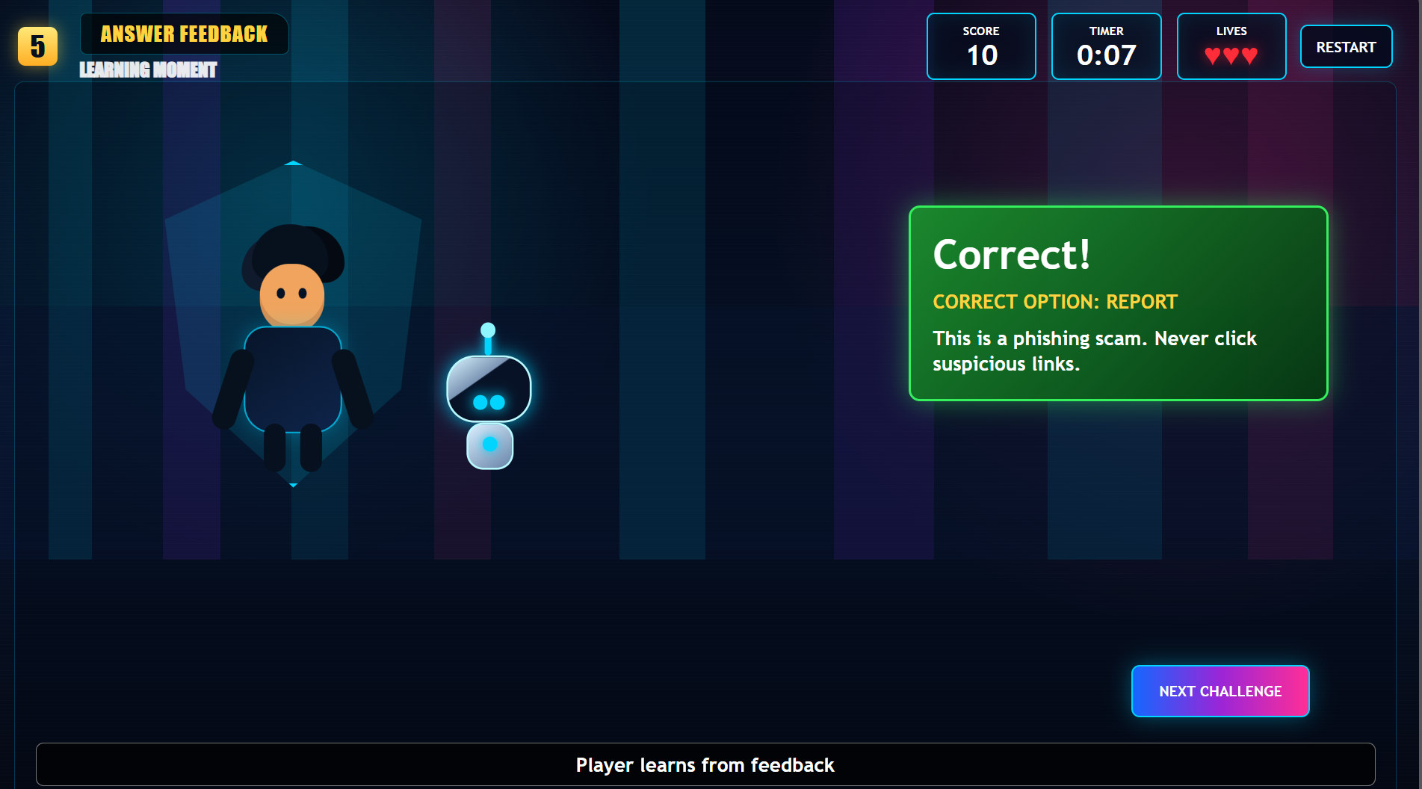
Does the wrong answer show helpful feedback? | Yes | 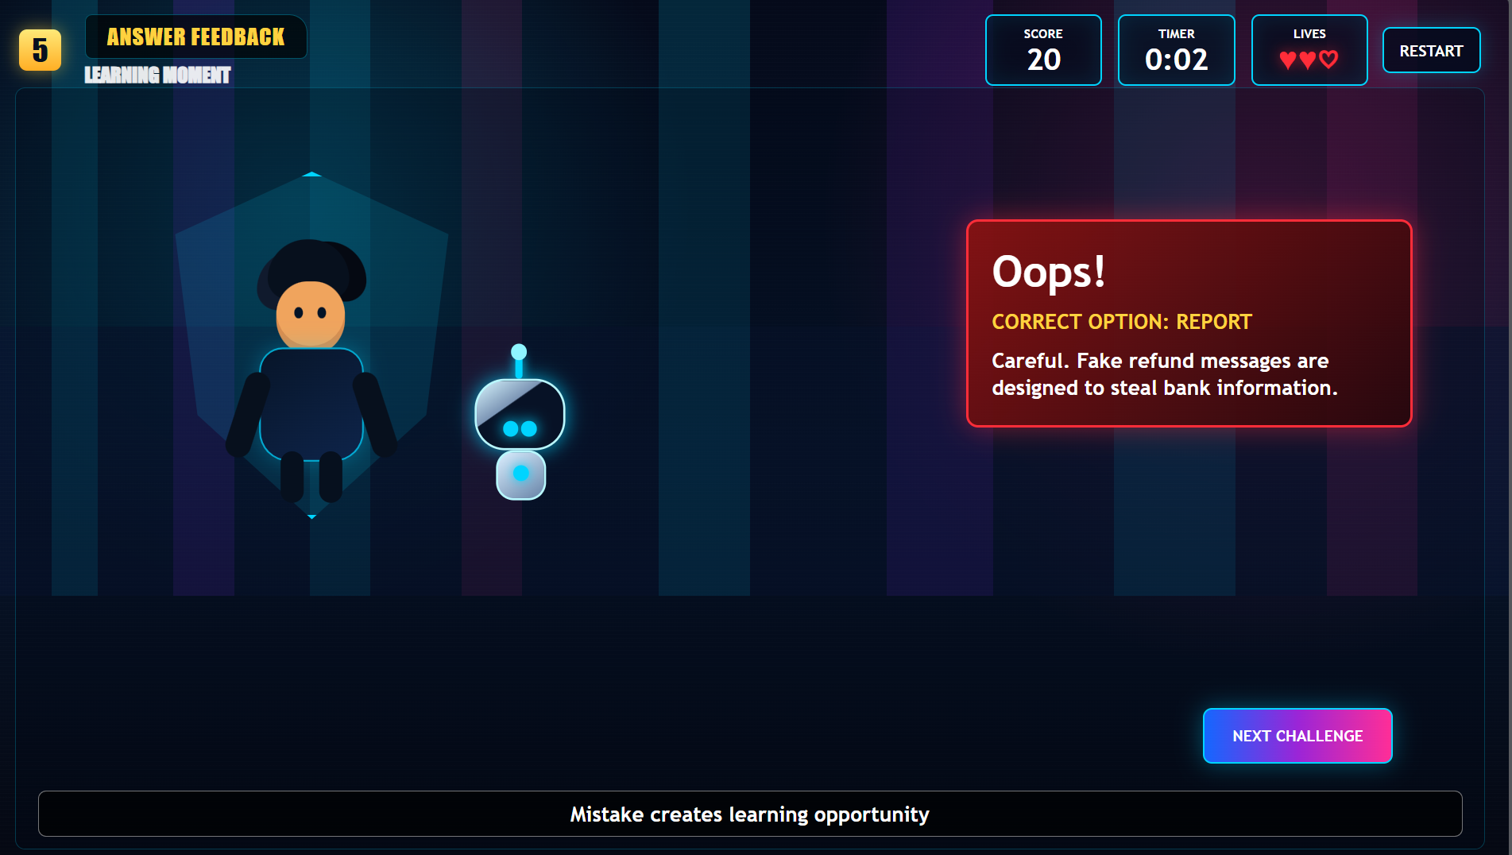
Does the feedback teach a cyber-safety lesson? | Yes | 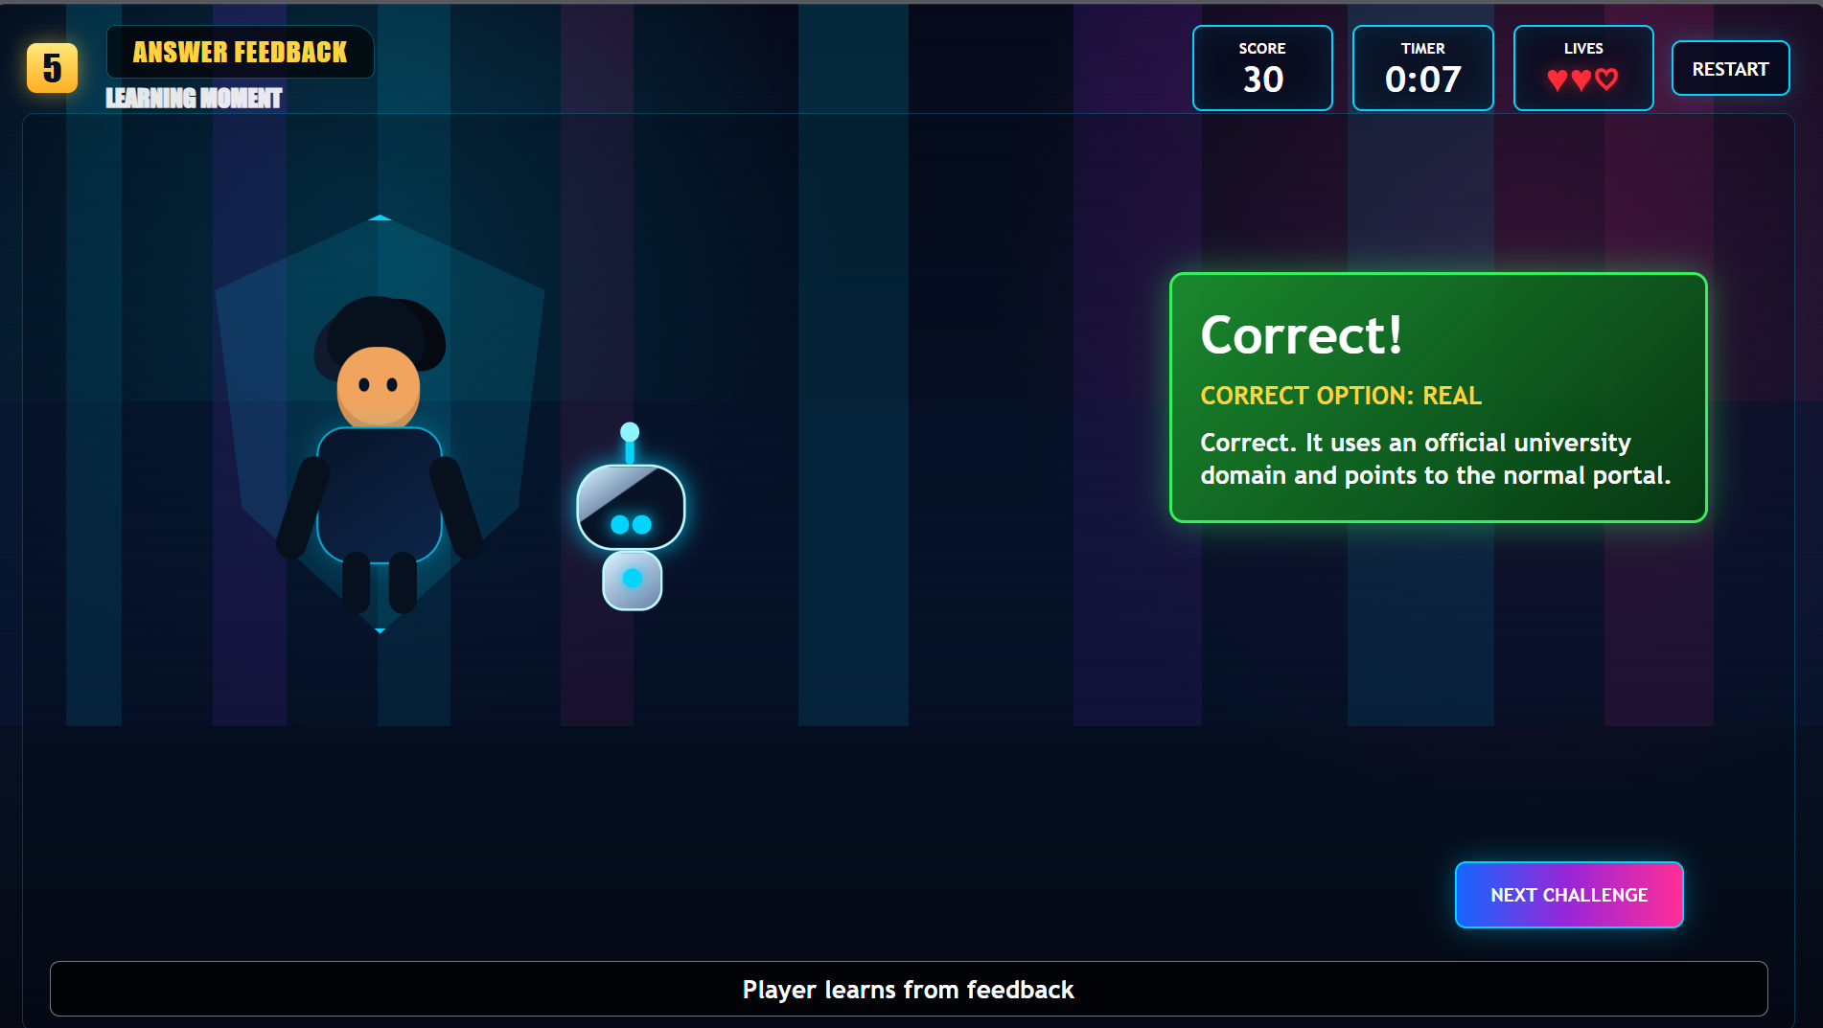
Is there a reward, score, star, badge or progress message? | Yes | 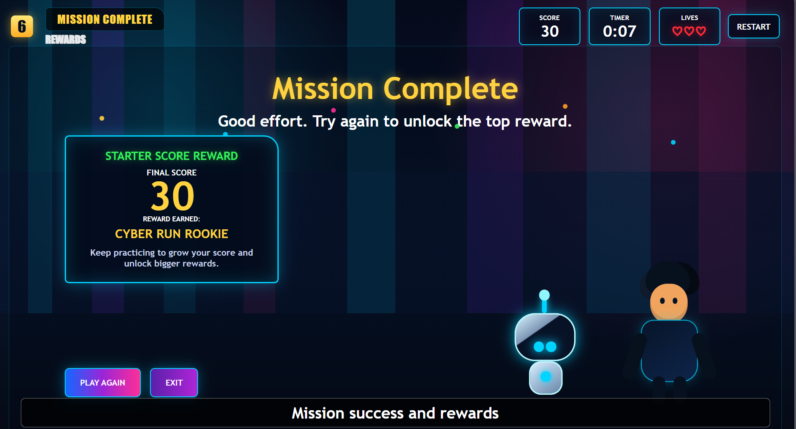
Is the prototype suitable for the target audience? | Yes | Its Engaging and fun which helps students enjoy and learn at the same time 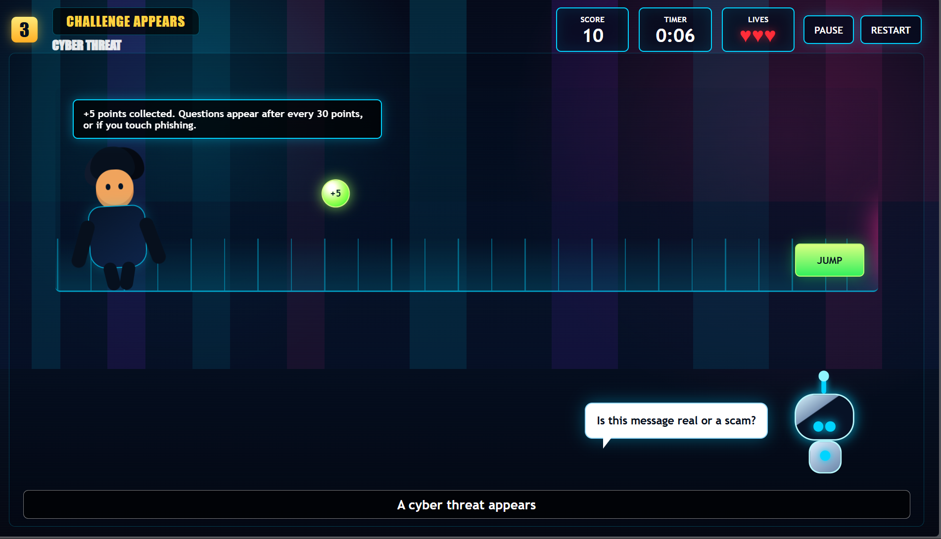
What must be improved before next week? | More engagement things needed to be added and some more improvement in graphical representation | Working on it !!

