13. Individual Contribution Log
Every student must update their own file in the Individual-Contribution-Logs folder. This is important because your individual portfolio will need evidence of your own contribution.
Individual log item | Your answer
Name | Vivek Thapa
Student ID | 15845159
GitHub username | Vivek-424
What I worked on today | Prototype built started and testing going on
Tool, I used | HTML / VS Code / GitHub / Other
File/prototype part I created or edited | 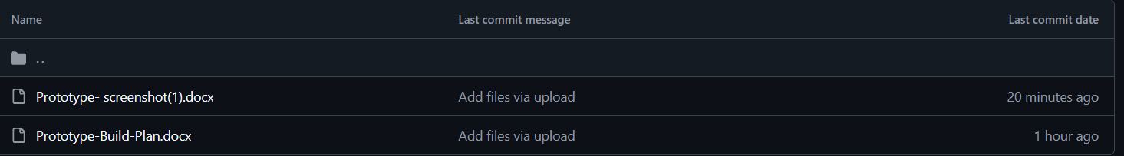
Commit message or evidence | 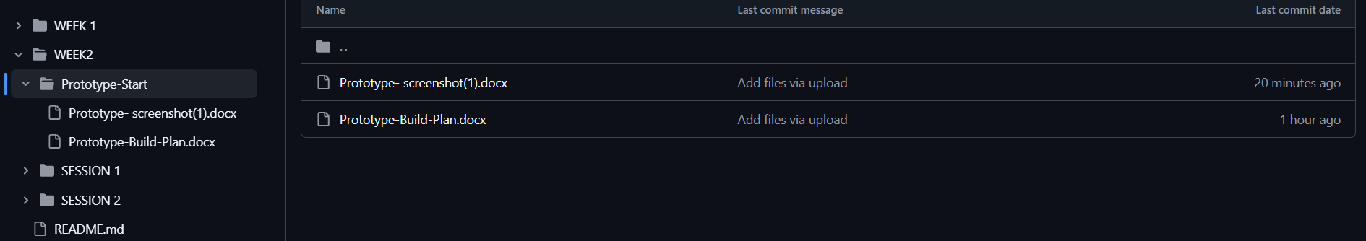
What I learned | HTML/CSS/JS/Using GitHub and more
What I need to do next | Develop prototype fully and make it smoothly run.

