13. Individual Contribution Log
Every student must update their own file in the Individual-Contribution-Logs folder. This is important because your individual portfolio will need evidence of your own contribution.
Individual log item | Your answer
Name | Hangma Limbu
Student ID | 15209959
GitHub username | Hangma16
What I worked on today | Report and helped in building prototype plan
Tool, I used | HTML / VS Code / GitHub / Other
File/prototype part I created or edited | 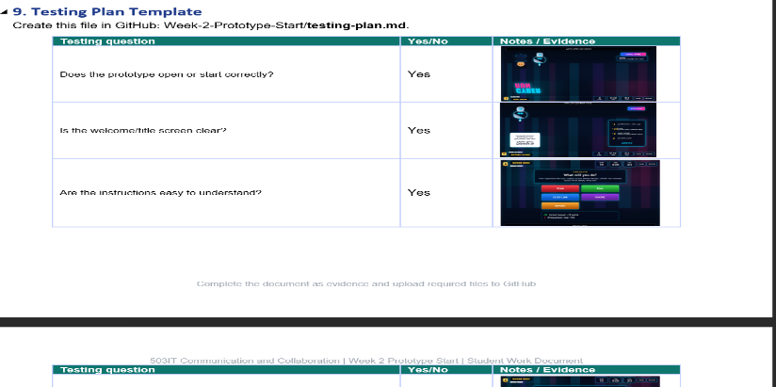
Commit message or evidence | 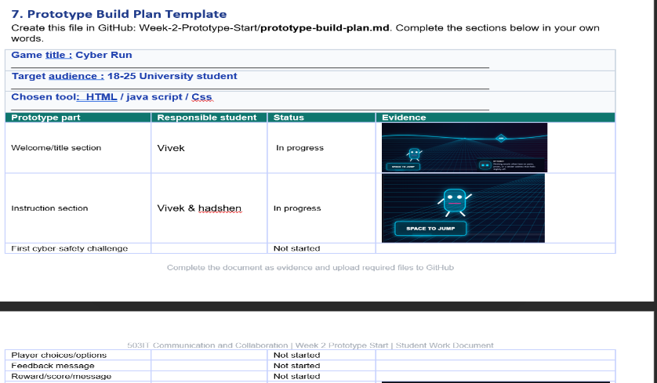
What I learned | Learned about HTML/CSS/JS/Using GitHub and more
What I need to do next | Develop prototype version challenges and communicated with member

