Individual Contribution Log
Individual log item | Your answer
Name | Arbaaz ul haq Qureshi
Student ID | 16200513
GitHub username | arbaazulhaqqqsfj-web
What I worked on today | Today I worked on testing and improving our cyber-safety game prototype. I tested different parts of the game including the welcome screen, instructions, challenge questions, feedback messages, rewards system, and gameplay flow. I also checked whether the game opened correctly and if the cyber-safety lessons were clear for users. During testing, I identified bugs in the obstacle system and issues with the scoring/points feature that affected smooth gameplay.
Tool I used | HTML / VS Code /CSS
File/prototype part I created or edited | Testing Plan document and prototype gameplay testing
Commit message or evidence | 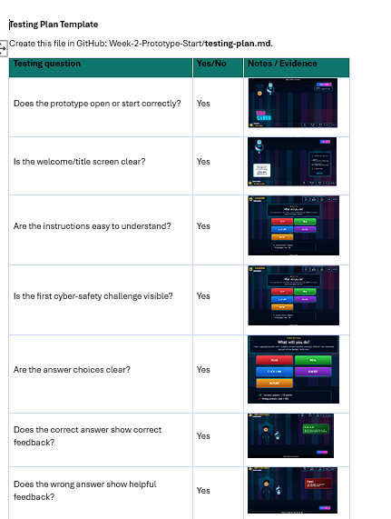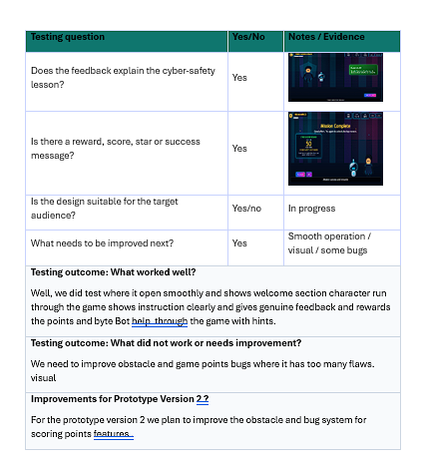
What I learned | I learned how important user testing is when developing a game prototype. Testing helped me understand how feedback, rewards, and instructions improve the player experience. I also learned how bugs in gameplay systems, such as obstacles and scoring, can affect the overall quality of the game and need careful debugging.
What I need to do next | Next, I need to improve the obstacle system, fix bugs in the scoring and points feature, and make the gameplay smoother. I also want to improve the visuals and make the game more engaging and user-friendly for Prototype Version 2.

