Pharamacy_DB

Our Database is including 5 tables :

Company, Employee, Medicine ,Bill , MedBill

This system for Pharamacy mangement system

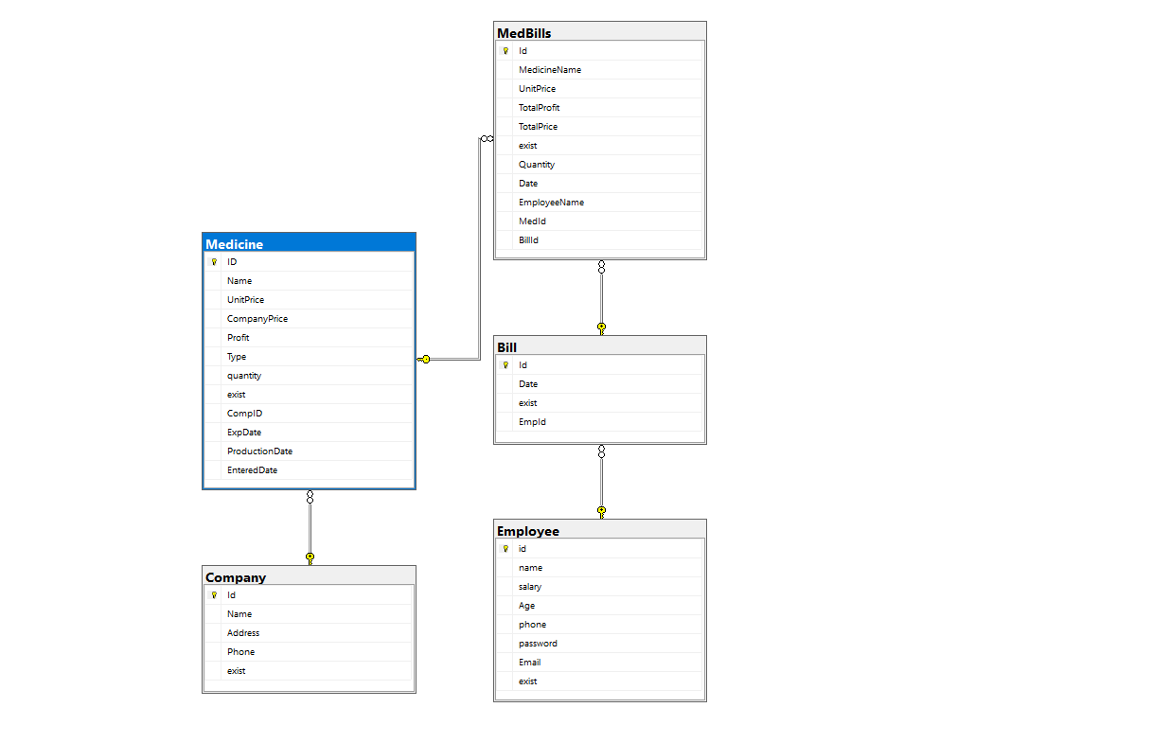

The Admin insert , update, delete data , add bill , return bill

Employee can add bill , return bill only