# Cyber Security and Ethical Hacking

## VMware Workstation 16 Player

Link: <https://www.vmware.com/content/vmware/vmware-published-sites/us/products/workstation-player/workstation-player-evaluation.html.html>

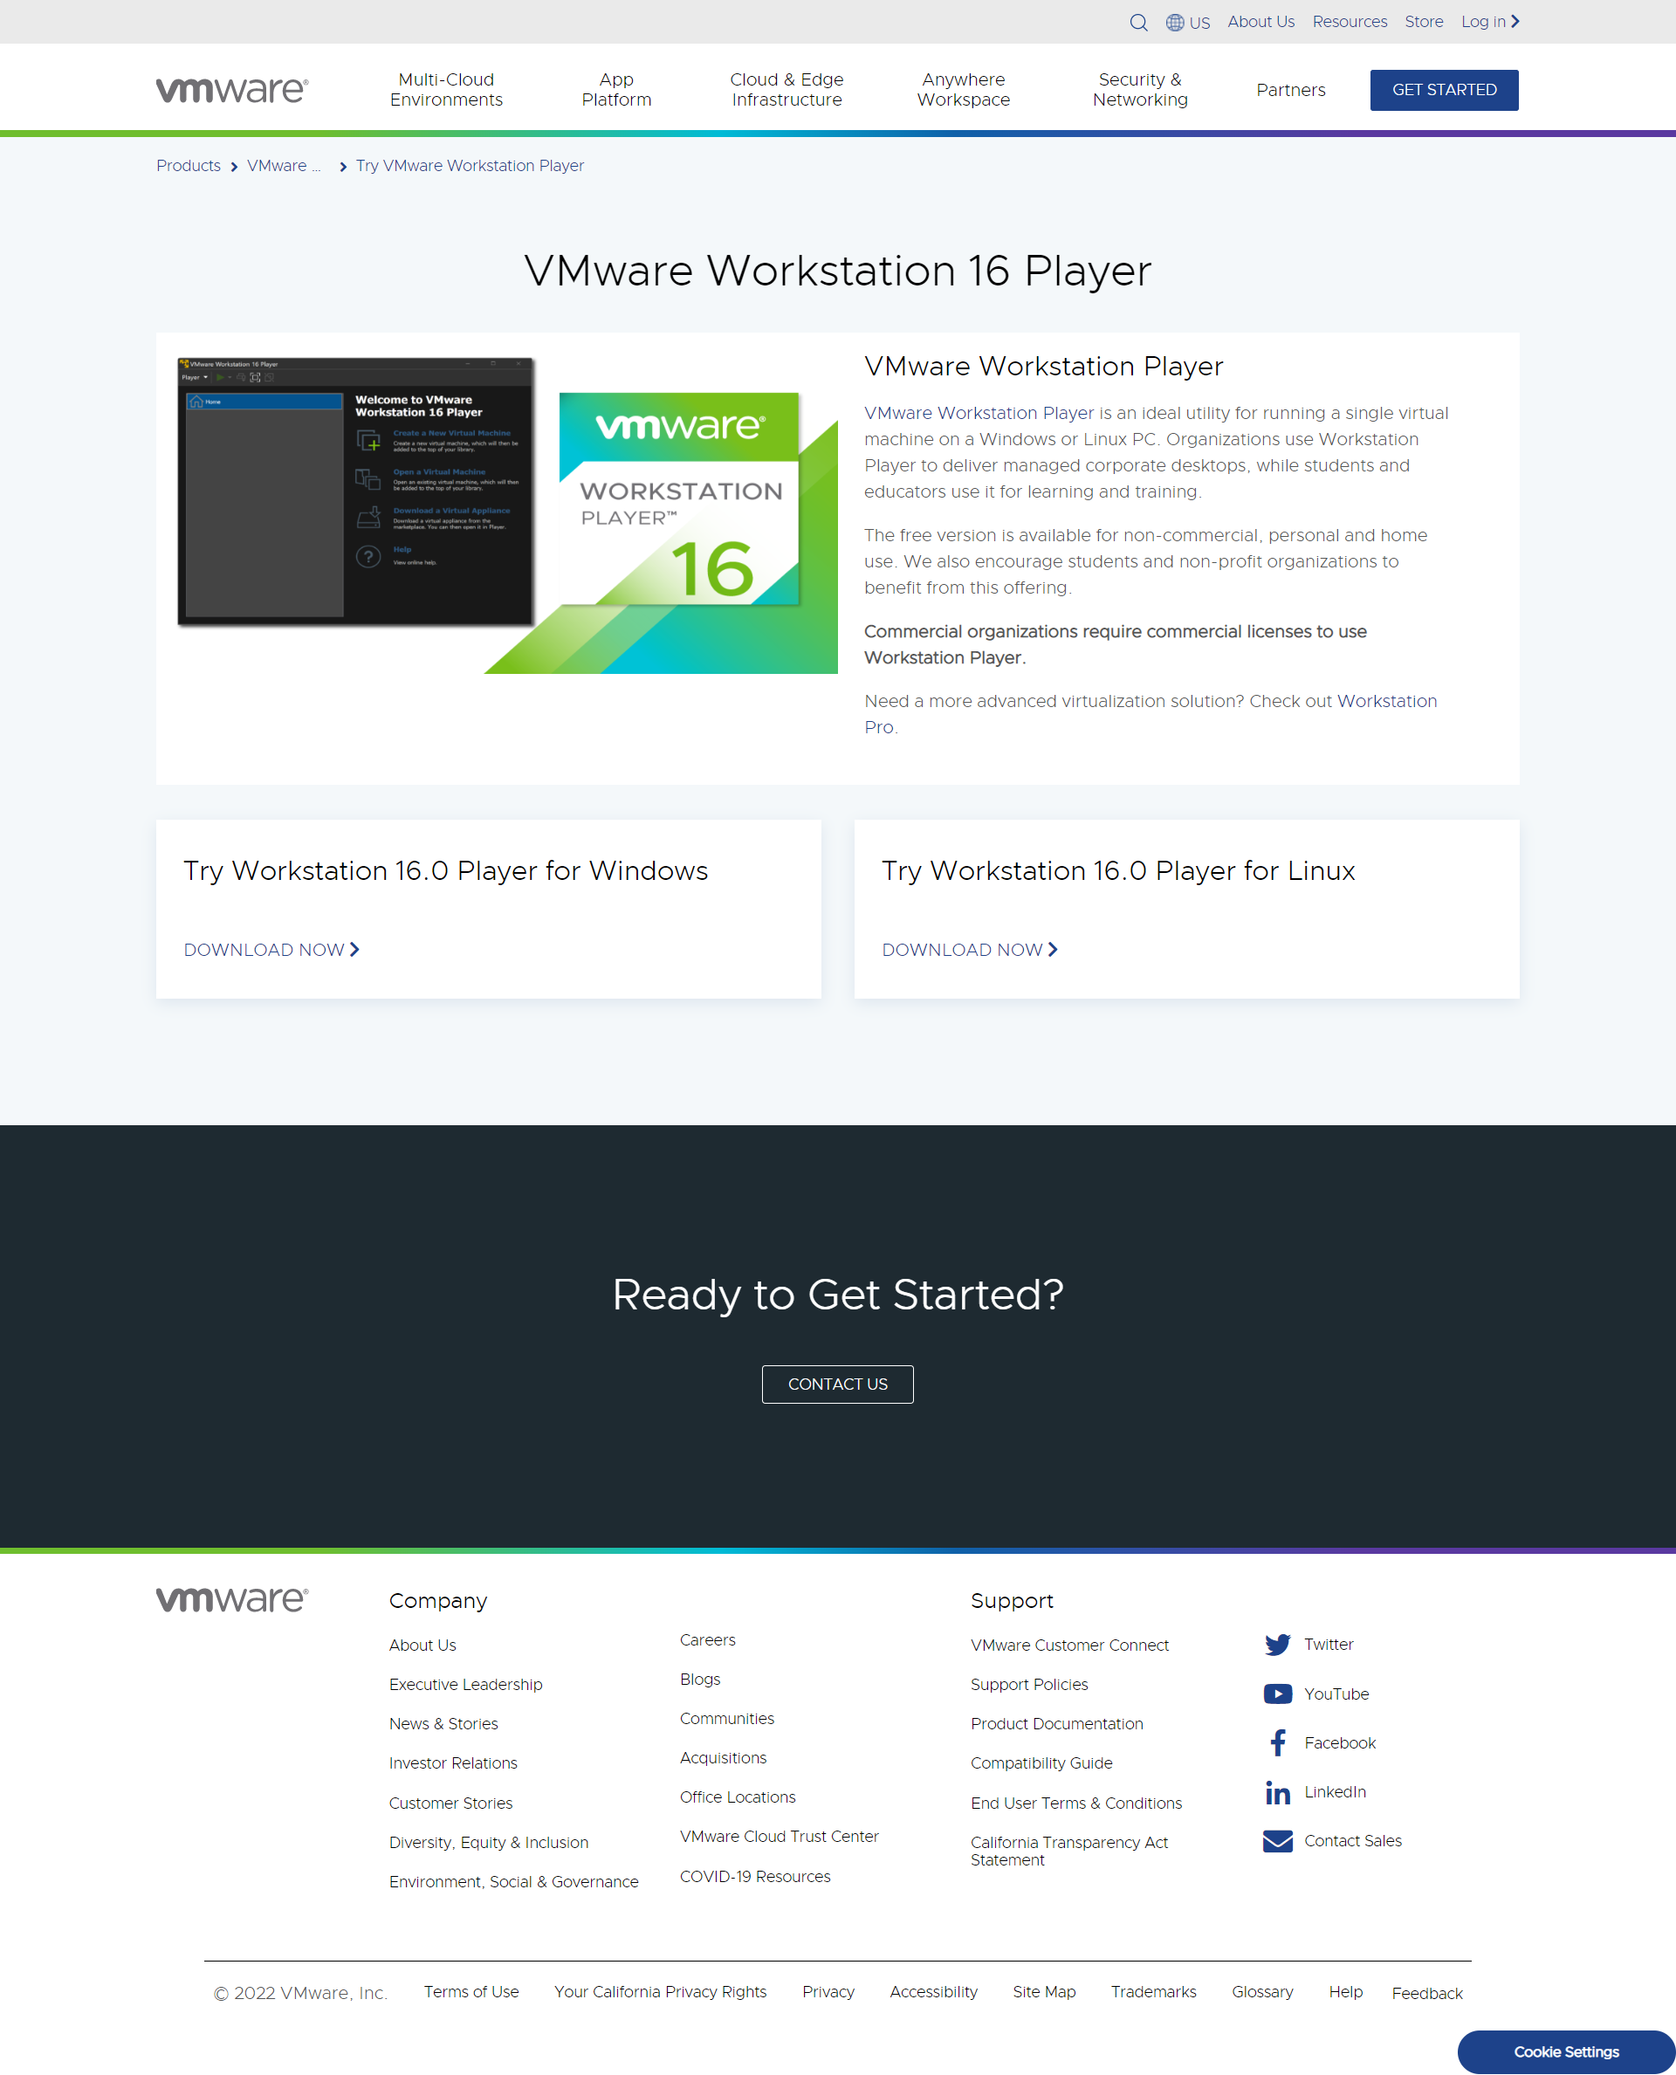

## Kali **Linux** VMware & VirtualBox

Link: <https://www.kali.org/get-kali/#kali-virtual-machines>

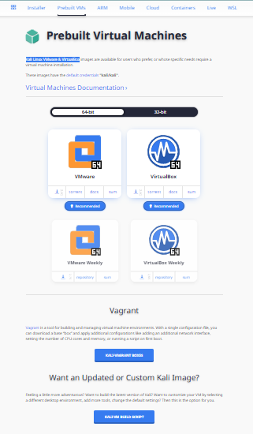

## Get Ubuntu Server

Link: <https://ubuntu.com/download/server>

