Angular Regular Exam - 18 December 2022

Individual Project Assignment

This is a Individual Project Assignment for the Angular Course @ SoftUni.

Landware is a property management solution that automates your rental management process. Allows users to manage the properties they rent. Every registered user has access to a dashboard where they can track their expenses and income from any property they have uploaded. The expenses section allows users to store data about each expense they had. Also any user can create custom leases and store them easily.

1. Routes

Landing Section (Available for unauthorized users)

http://localhost:4200/ homepage
http://localhost:4200/main/pricing pricing page
http://localhost:4200/main/resources resources page
http://localhost:4200/auth/register register page
http://localhost:4200/auth/register login page

Dashboard Section (Available ONLY for authorized users)

* Main
http://localhost:4200/dashboard dashboard home
http://localhost:4200/resources resources page
http://localhost:4200/auth/profile user profile page

* Properties
http://localhost:4200/properties user properties list page
http://localhost:4200/properties/add add new property
http://localhost:4200/properties/maintenance user properties under
maintenance list page

* Expenses
http://localhost:4200/expenses user expenses list page
http://localhost:4200/expenses/add add new expense

* Leases
http://localhost:4200/leases user leases list page
http://localhost:4200/leases/add add new lease

2. Pages

Landing page
When the user is not authenticated he will be able to see the landing page
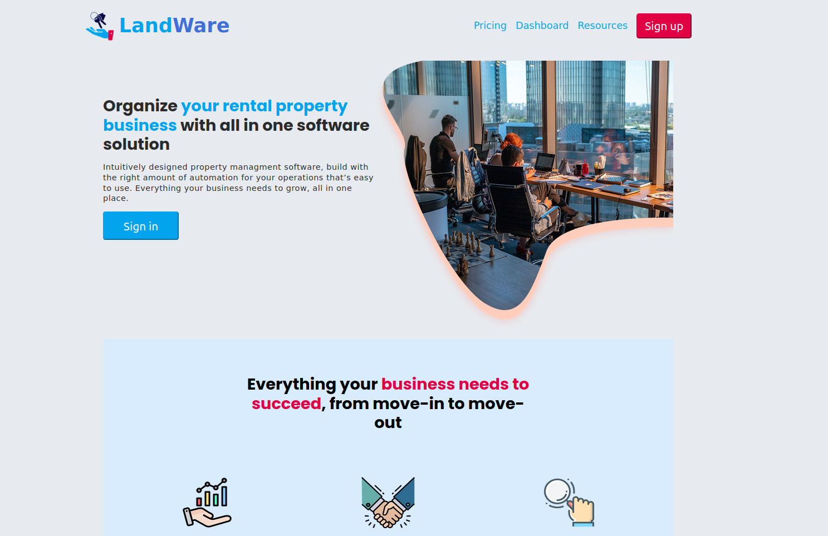
With a navigation bar for other available pages.

Pricing page
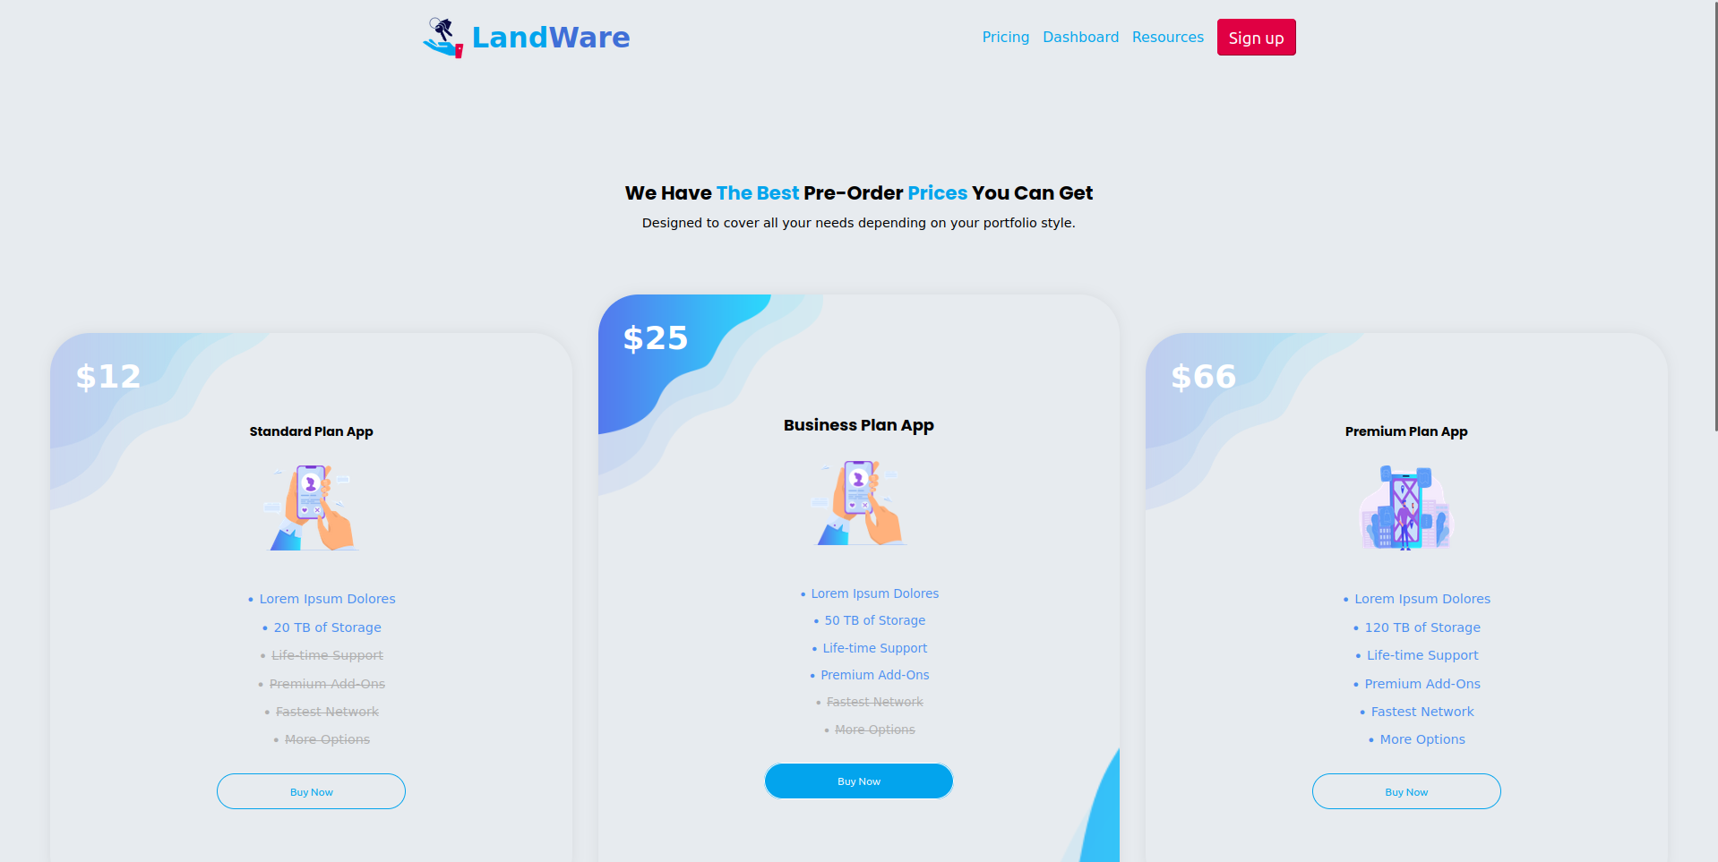
Contains the application pricing plans that are available

Resources Page
Contains a free for use resources for any visitor of the site.

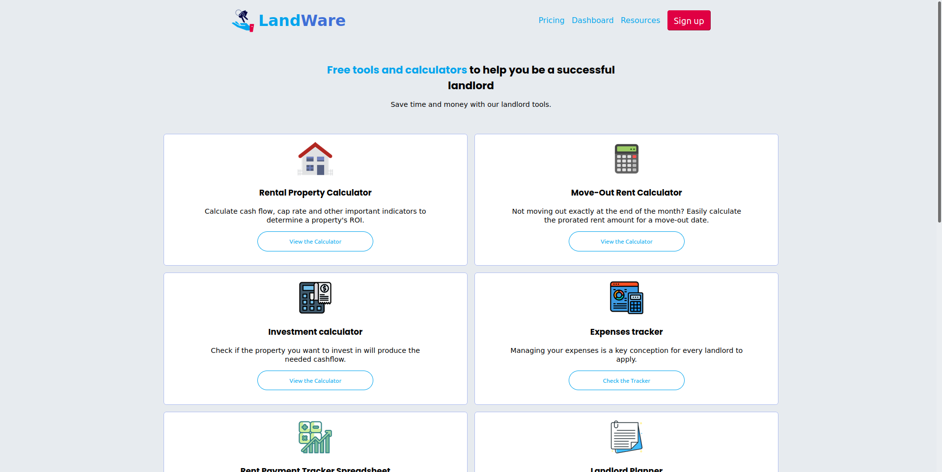

Register page
The user can register using email and password and using google authentication as well.
All form fields are required. The password field and email field has custom validation. Also the password field must match with the rePassword field.

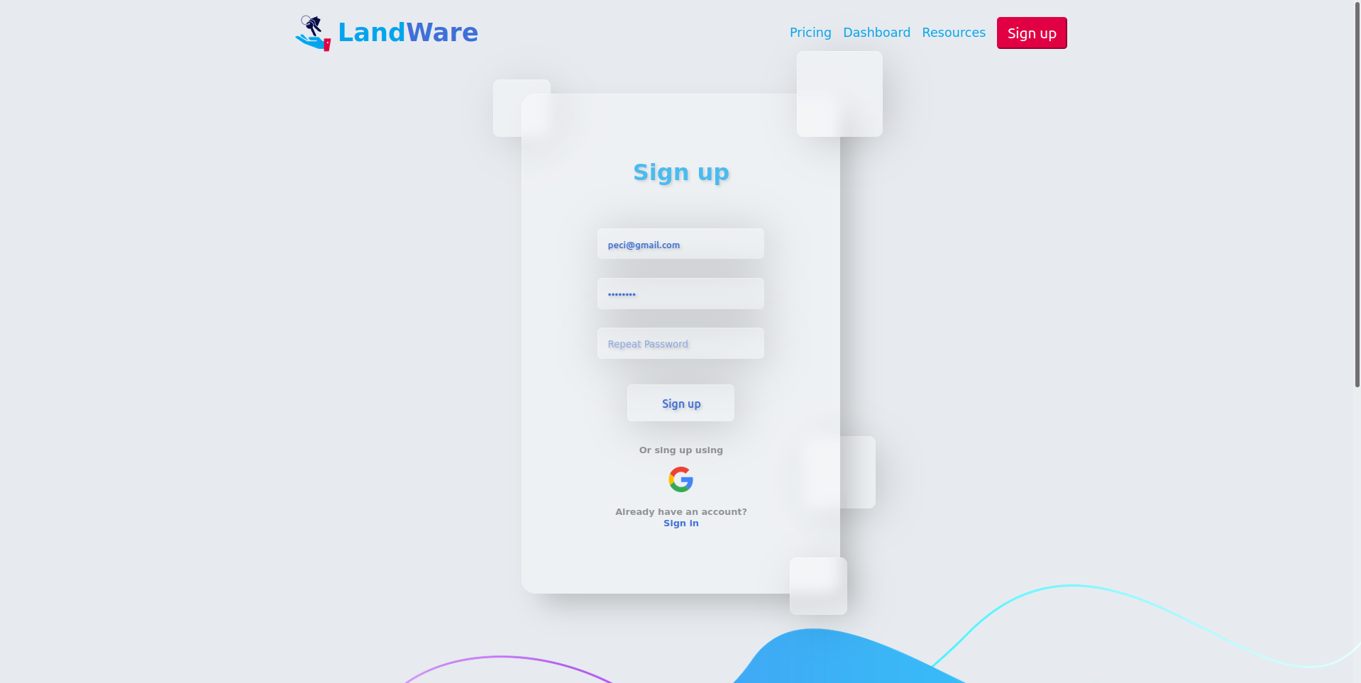

Login page
The user can login using email and password or using google authentication.
All form fields are required.

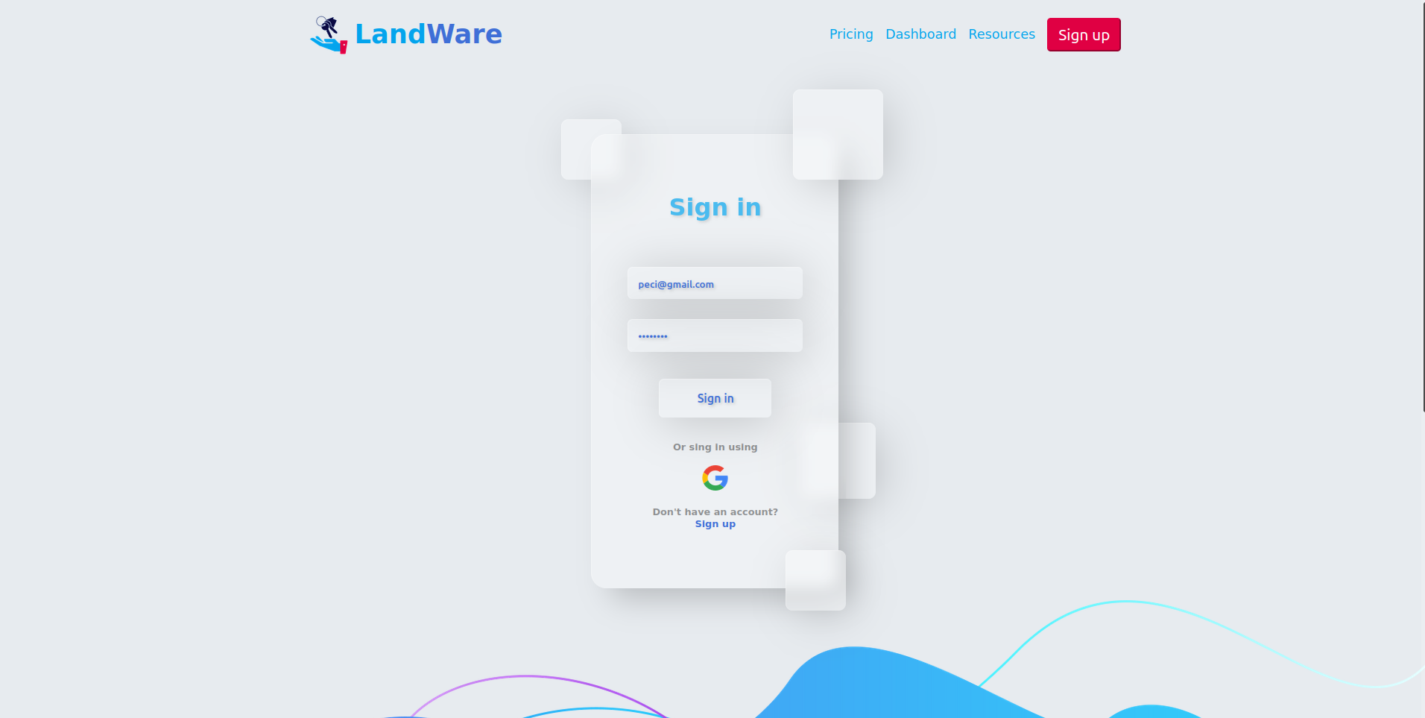

Dashboard page
When the user is authenticated he will be redirected to the dashboard page, where
A data for all activities will be shown. And instead of header navigation the user will be able to navigate trough the application using aside with all available routes

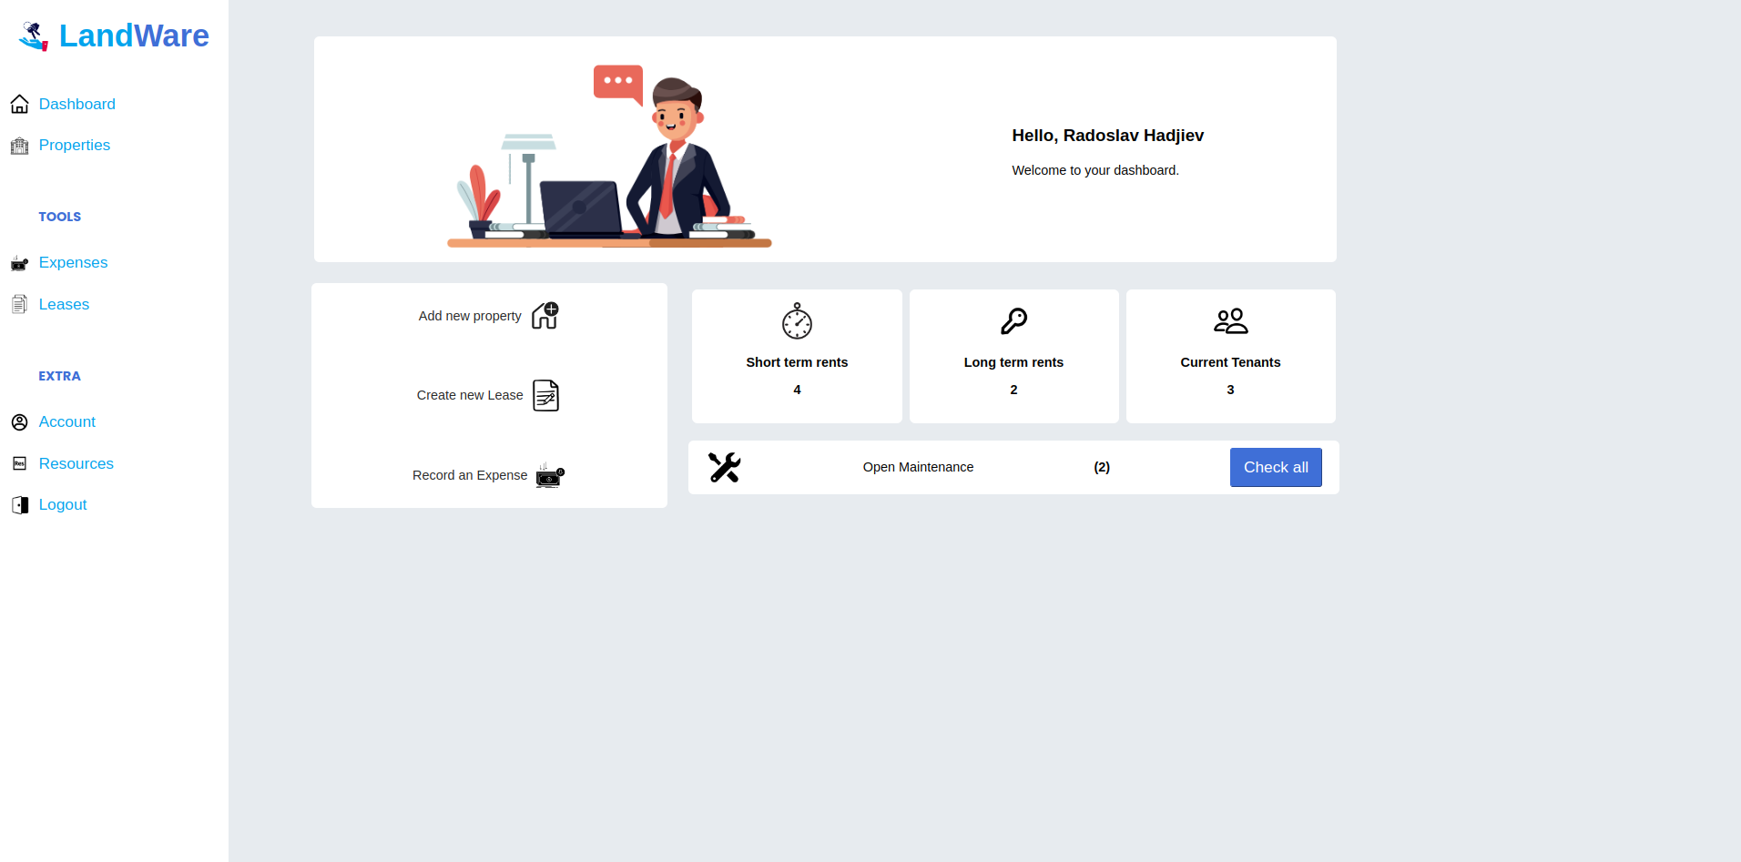

Properties list page
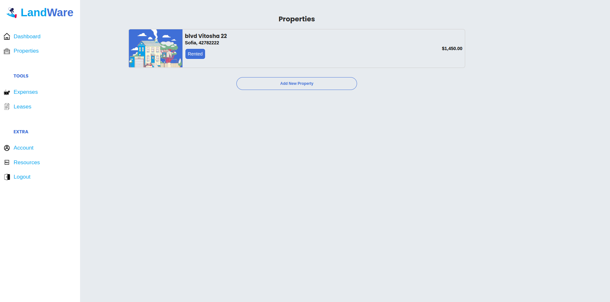
This page contains all the properties that are uploaded by the current user

If no properties

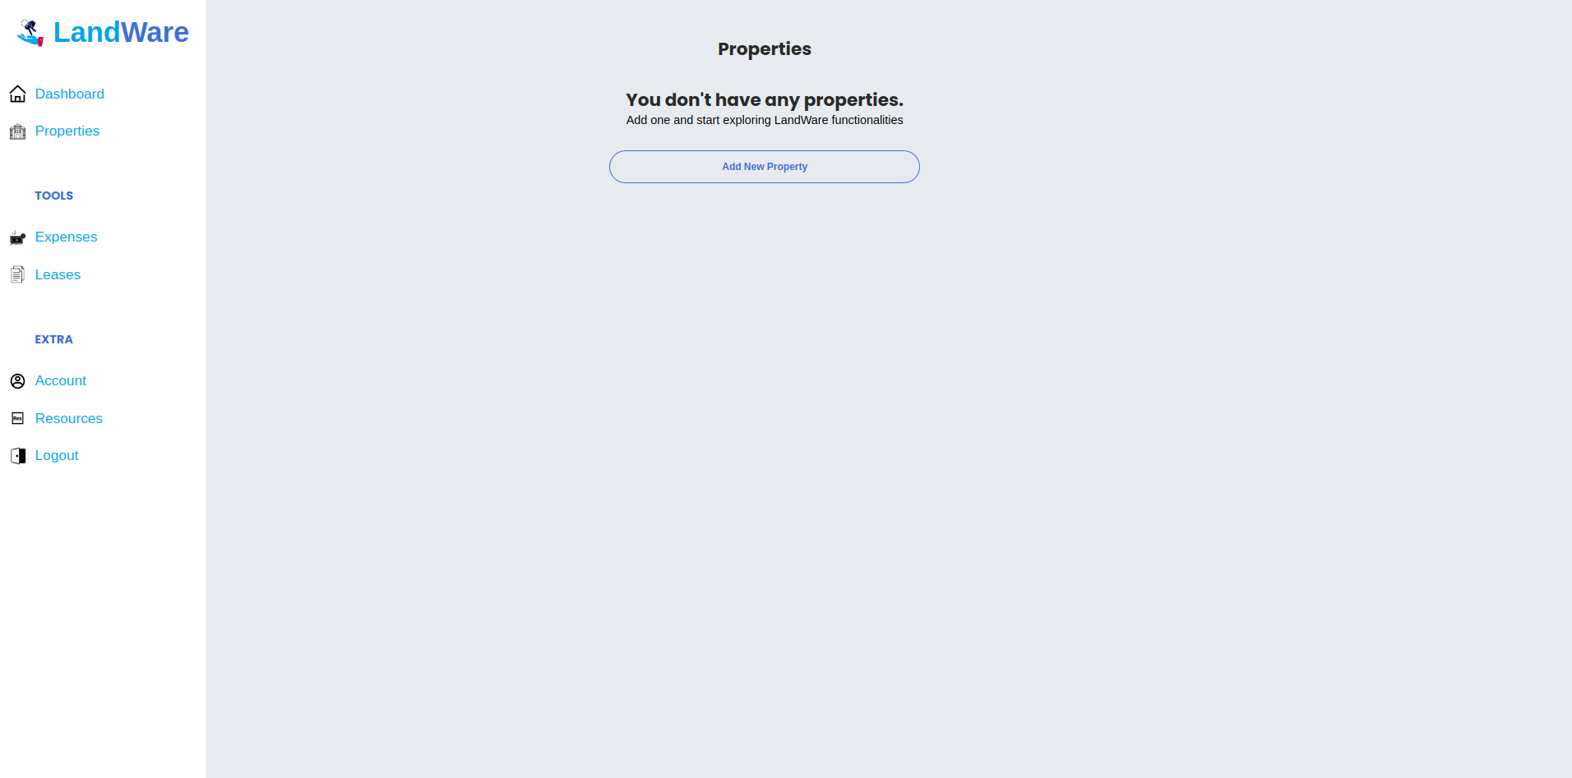

When the user clicks on any property he will be able to see the details for the current property.
Also can easily change the property statuses from “rented” to “not rented” and “under maintenance” to “maintenance” using the toggle buttons.

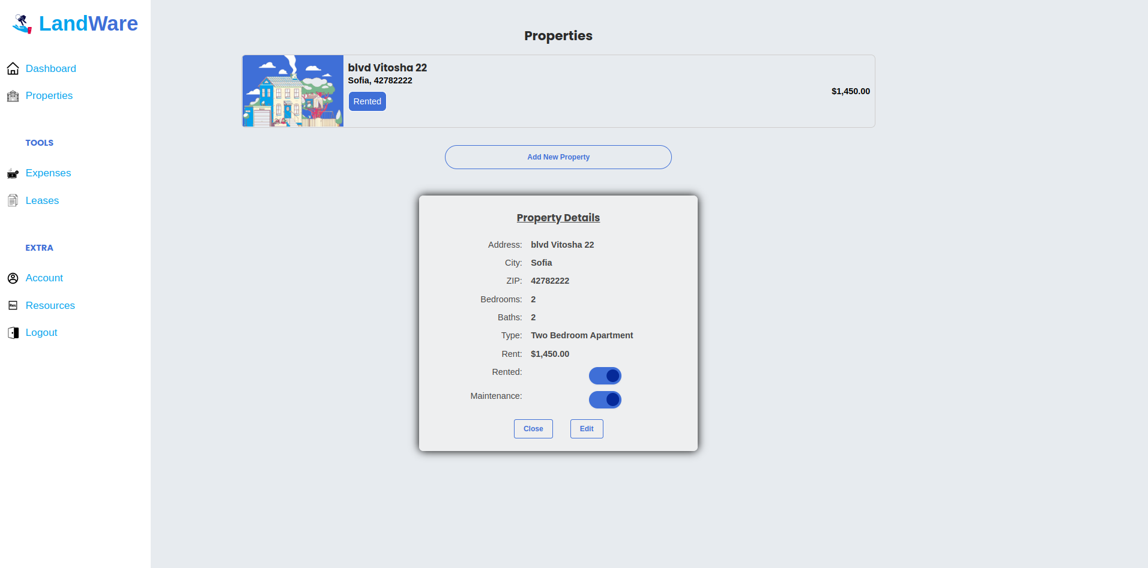

Any property details section contains two more buttons “cancel” and “edit”. The cancel button will close the property details section. The edit button will change the section appearance to a form where the user will be able to edit or delete current property. If the cancel button is clicked the form will be replaced by property details section again.

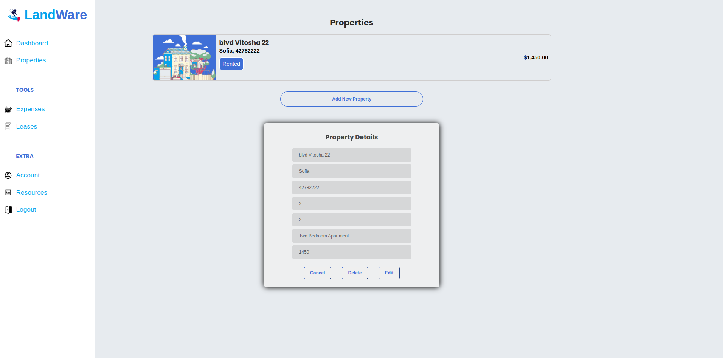

The properties list page also contains a “Add new property” button. When this button is clicked the user will be redirected to a add property form where he can upload new properties. All fields are required. All text type fields have min length validation as well. “Cancel” button will redirect the user back to the properties list page, and “Add” button will create new property object if form is valid, if not the button will be disabled.
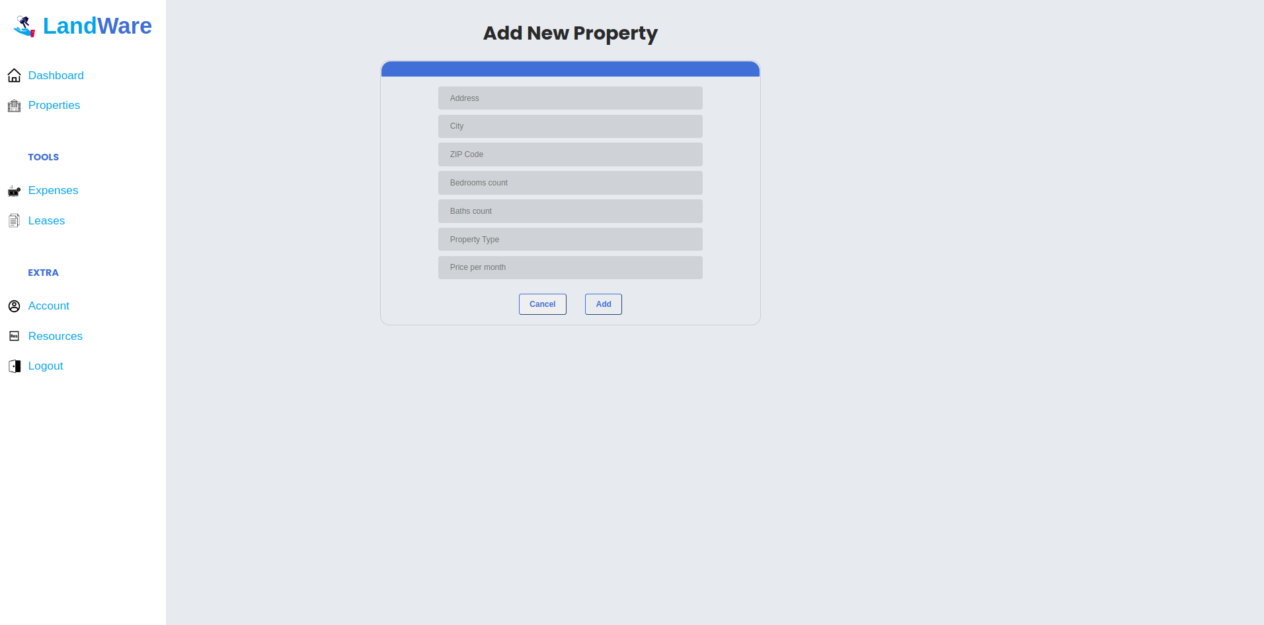

Expenses list page
Contains all the expenses added by current user.

If no expenses

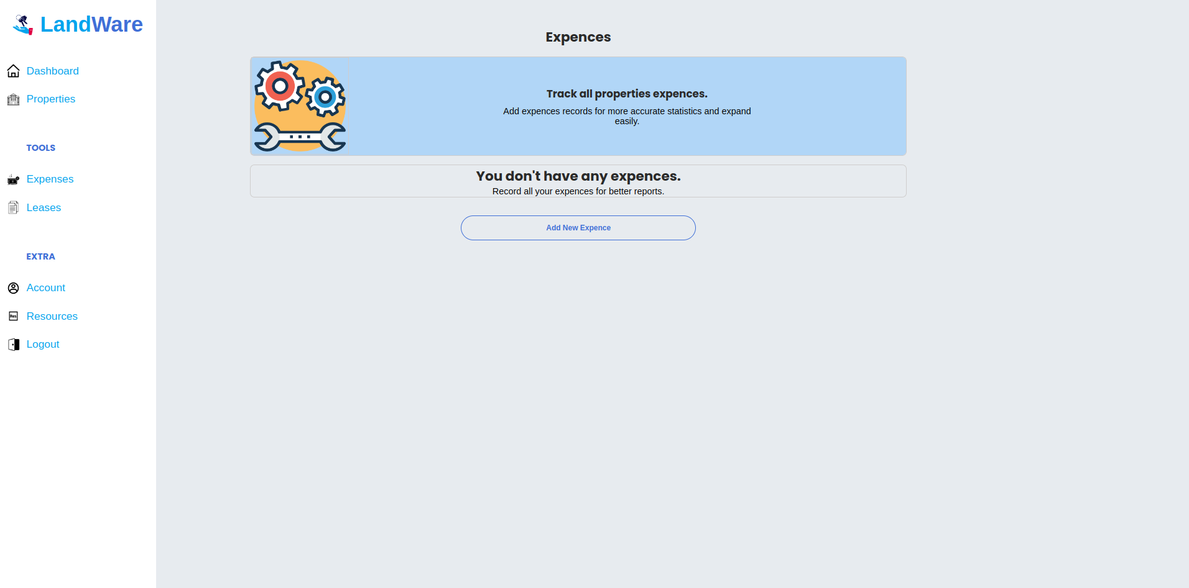

If expenses: The user can easily deletes expenses just by clicking on them.

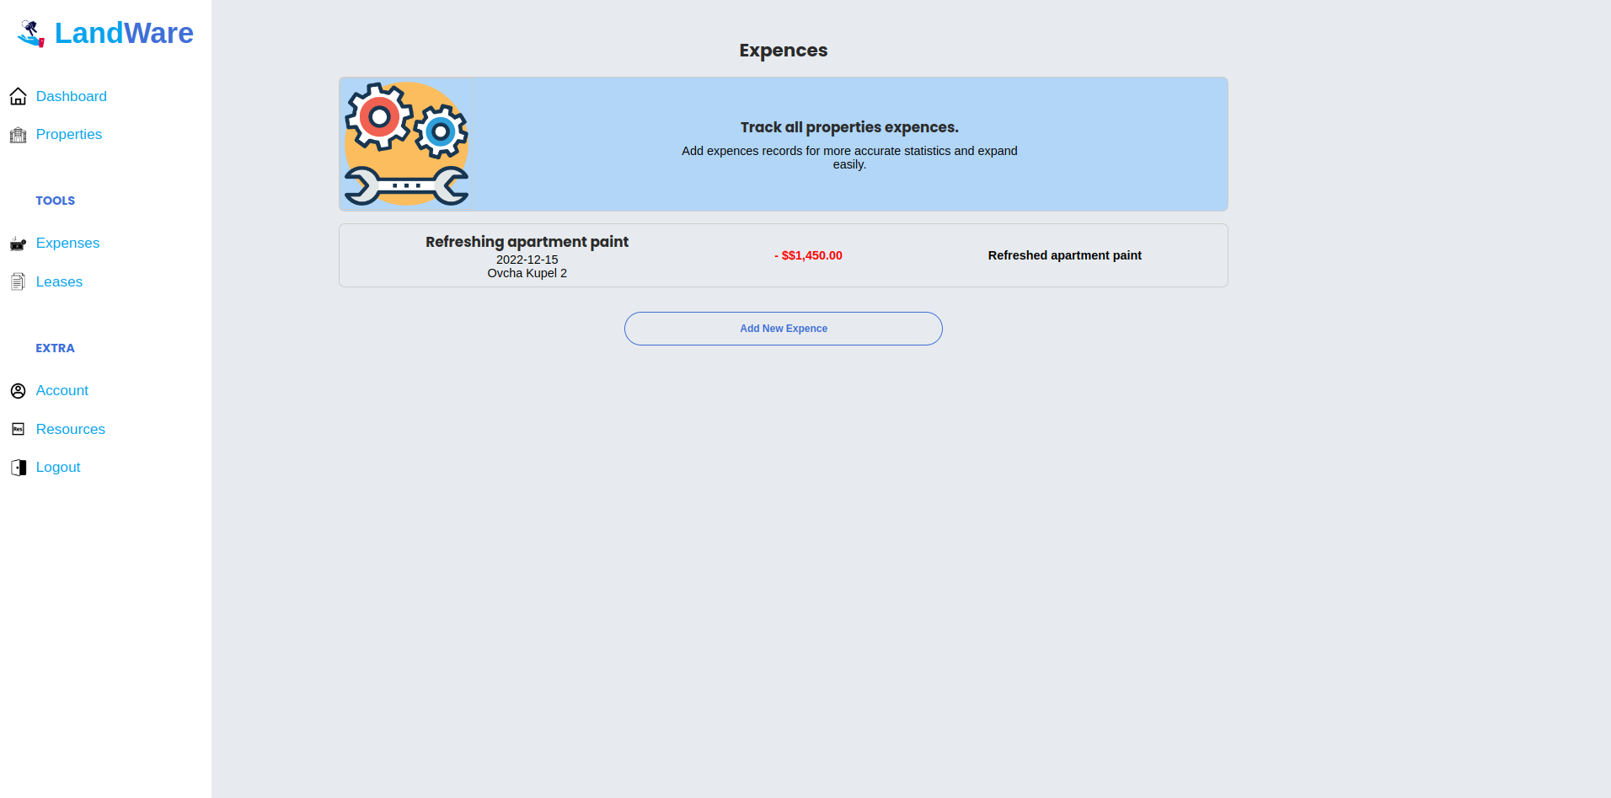

When “Add new expense” button is clicked the user will be redirected to a add expense form where he can add new expenses. All fields are required. All text type fields have min length validation as well. “Cancel” button will redirect the user back to the expenses list page, and “Add” button will create new expense object if form is valid, if not the button will be disabled.

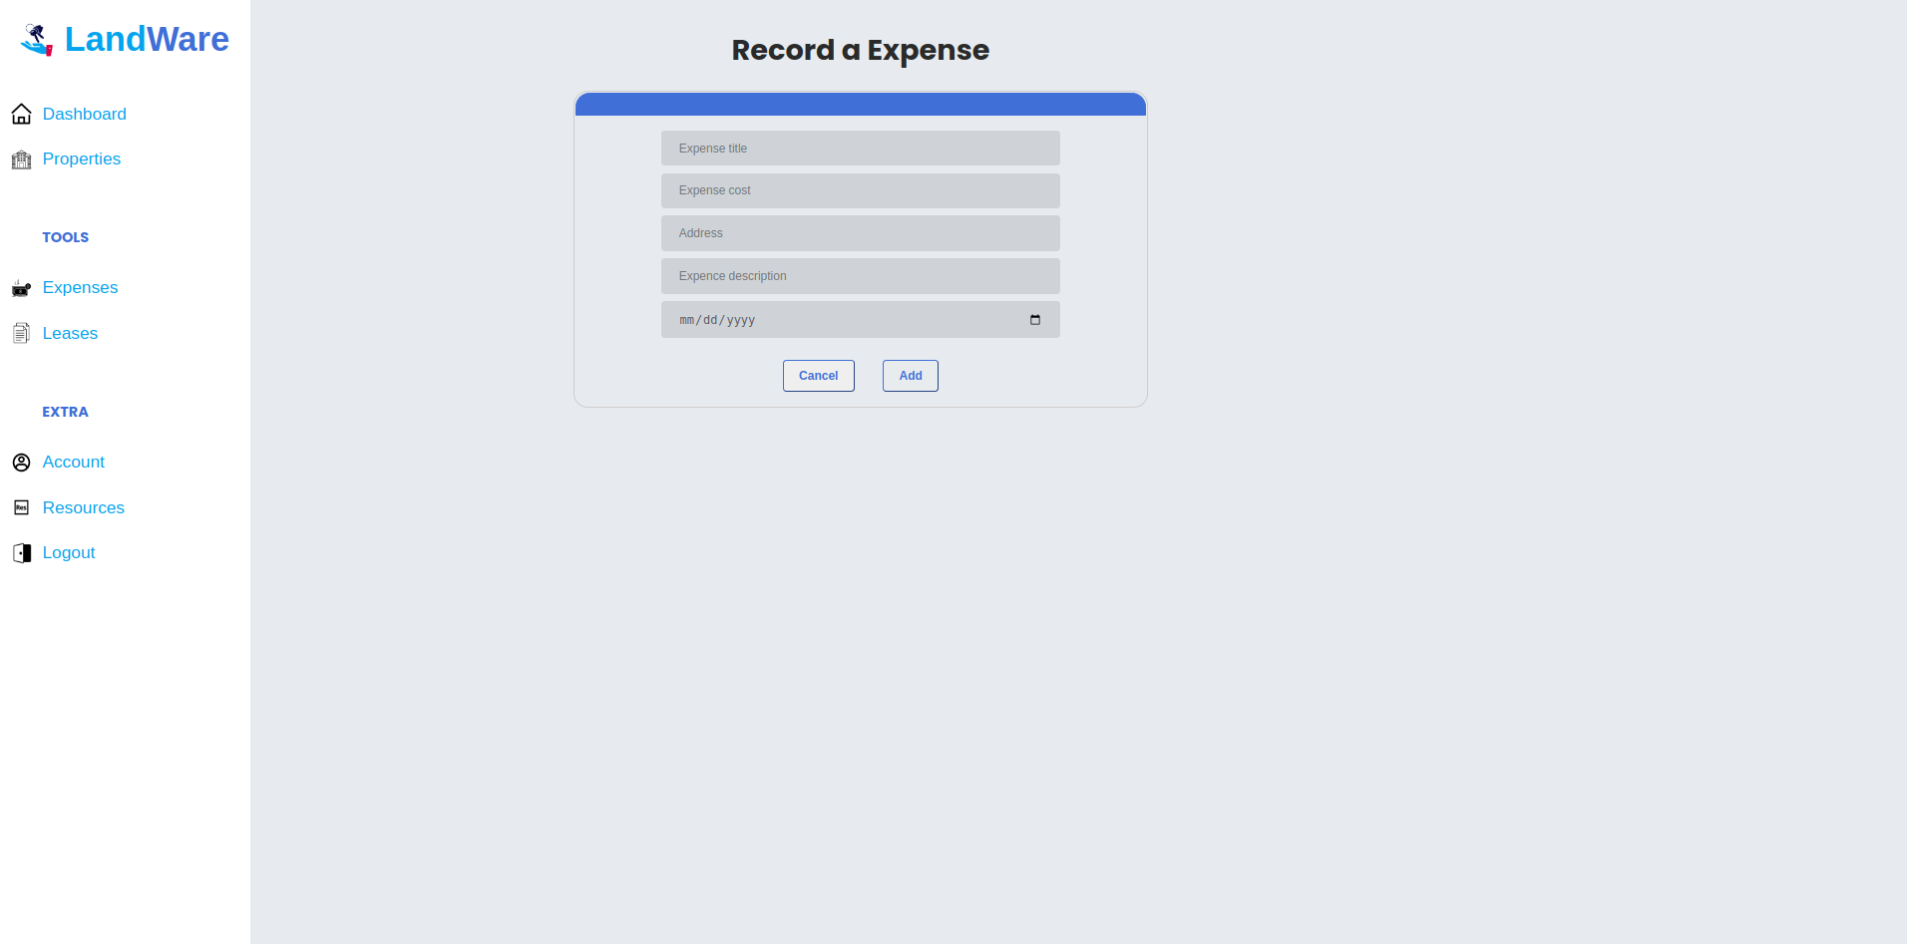

Leases list page
Contains all the leases added by current user.

If no leases

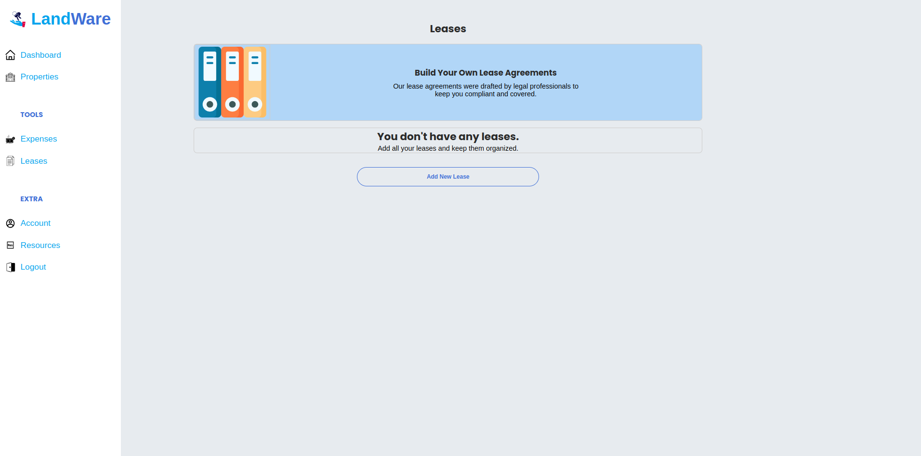

If leases: The user can easily deletes leases just by clicking on them.

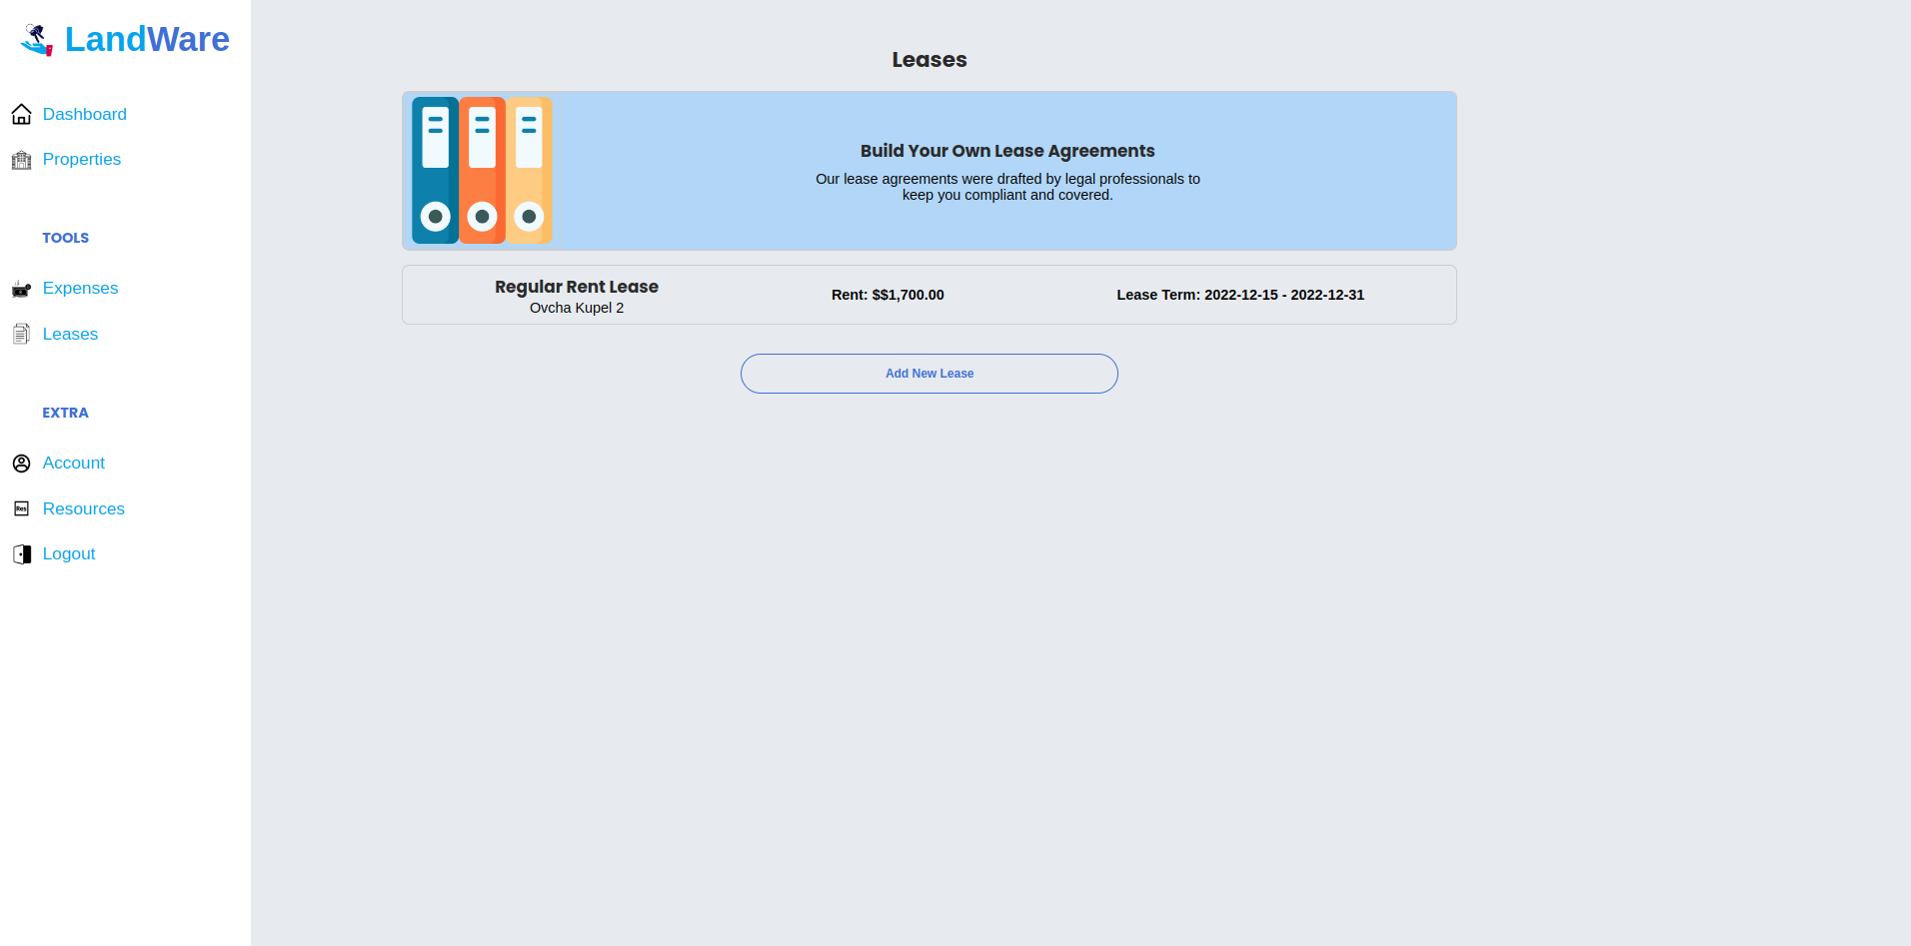

When “Add new lease” button is clicked the user will be redirected to a add lease form where he can add new lease. All fields are required. All text type fields have min length validation as well. “Cancel” button will redirect the user back to the leases list page, and “Add” button will create new lease object if form is valid, if not the button will be disabled.

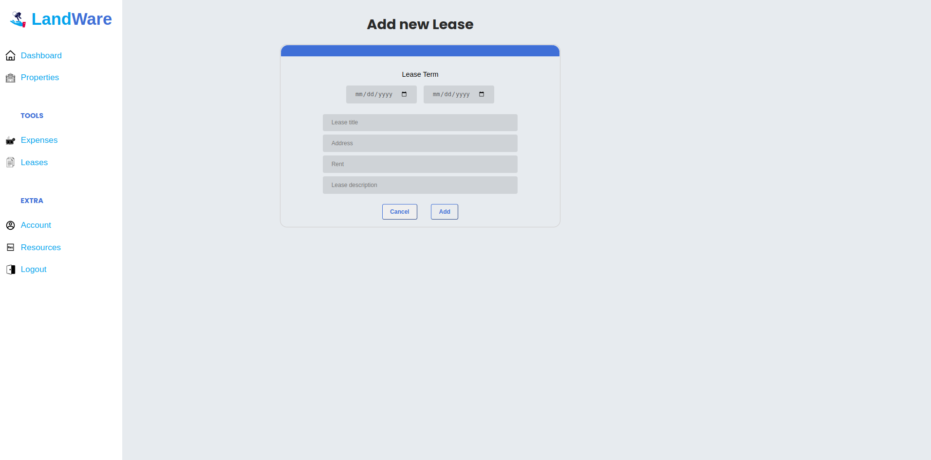

Profile page

Contains a data about current user

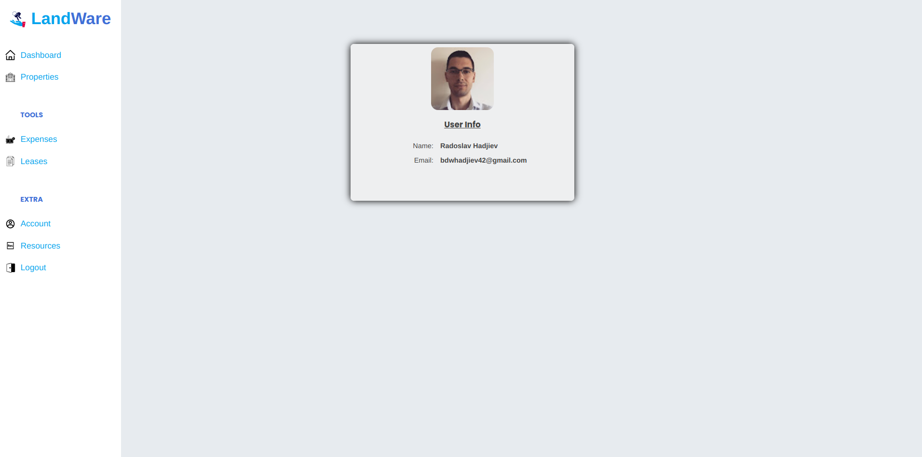

Resources page

Contains a grid with all resources for authorized users.

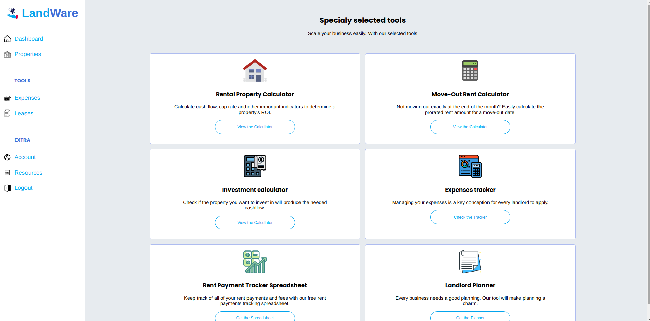

Maintenance page
Contains a list of all the properties with status maintenance: true.

