Python Web Framework Regular Exam - 16 April 2022

Individual Project Assignment

This is a Individual Project Assignment for the Python Web Framework Course @ SoftUni.

DjangoEstates is a real estate app where we can see the latest offers tested and offered by brokers. The blog section of the application allows us to be always informed about the latest market trends and useful tips for everyone who is in the real estate market.

1. Database
User Models:
- User
  - username- Character field with max length of 30 characters.
  - date_joined – auto_now_add=True.
  - is_staff – default=False.

- Profile
  - first_name - Character field with min length of 2 and max length of 30 characters. Must contains only letters.

  - last_name - Character field with min length of 2 and max length of 30 characters. Must contains only letters.

  - image – Url field. Can be empty.
  - description - Text field. Can be empty.
  - email- Email field, Required.
  - phone_number- Character field. Can be empty. Must start with “08..” or “+000..”. Up to 15 digits allowed.

  - Broker – Boolean Field. Accessible only for superusers.
  - is_complete – Boolean Field. False by default.
  - user- relation with the User model.

Blog Models:
- Category
  - title- Character field with max length of 30 characters.

- Post
  - title- Character field with max length of 200 characters.
  - category – relation with the Category model.
  - slug - Slug field with max length of 200 characters.
  - author- relation with the User model.
  - image – URL Field.
  - updated_on – Date field.
  - content – Text field.
  - created_on – Date field.
  - status – Choice field. The choices are “Draft” and “Publish”.

- Comment
  - text - Text field.
  - published – DateTime field.
  - post - relation with the Post model.
  - author- relation with the User model.

Estate Models:

- Estate
  - title - Character field with max length of 150 characters.
  - type – Choices Field. The choices are “One bedroom apartment”, “Two bedrooms apartment”, “Three bedrooms apartment”, “Maisonette”, “Single Family House”, “Duplex”, “Vacation Home”, “Office”, “Hotel”, “Special Purpose”, “Industrial”, “Land”.

  - location – Character field with max length of 150 characters.
  - floor – Choices Field.
  - heating_type– Choices Field.
  - area – Float Field.
  - exposition - Choices Field.
  - price – Float Field.
  - type_of_transaction – Choices Field. The choices are “For Rent”, “For Sale”.
  - description – Text Field.
  - amenities – Character field. All amenities should be separated with “, “.
  - favourites – relation with the User model.
  - main_image – Image field.
  - publication_date – Date field.
  - user - relation with the User model.

- EstateImages
  - estate – relation with the Estate Model.
  - image – Image field.

Newsletter Models:

- Subscribers
  - email- Email field.
  - date- Date field.

- Subscribers
  - title- Character field with max length of 100 characters.
  - message – Text Field.

2. Routes

Accounts Section

http://localhost:8000/accounts/login login
http://localhost:8000/accounts/logout logout
http://localhost:8000/accounts/register register
http://localhost:8000/accounts/change-password change password
http://localhost:8000/accounts/password_change_done change password redirect
http://localhost:8000/accounts/profile-details/<int:pk> profile details
http://localhost:8000/accounts/profile-edit/<int:pk> profile edit
http://localhost:8000/accounts/profile-delete/<int:pk> profile delete
http://localhost:8000/accounts/profile-complete profile complete
http://localhost:8000/accounts/favourites/<int:pk> add to favourites
http://localhost:8000/accounts/favourites user favourites page

Blog Section
http://localhost:8000/blog/ blog page
http://localhost:8000/blog/<slug:slug> post details
http://localhost:8000/blog/comment/<slug:slug> comment post
http://localhost:8000/blog/delete-comment/<int:pk> delete comment

Main Section

http://localhost:8000/ homepage
http://localhost:8000/estates estates page
http://localhost:8000/agents agents page
http://localhost:8000/about about page
http://localhost:8000/add-estate add estate page
http://localhost:8000/add-images add estate images page
http://localhost:8000/edit-estate/<int:pk> edit estate page
http://localhost:8000/delete-estate/<int:pk> delete estate page
http://localhost:8000/estate-details/<int:pk> estate details page

Main Section

http://localhost:8000/ homepage
http://localhost:8000/estates estates page

Newsletter Section
http://localhost:8000/newsletter subscribe page
http://localhost:8000/newsletter/mail_letter send emails to subs page

3. Groups
This app has 3 main groups.

- Users – every registered user is in this group by default
  - can view estates.
  - can view agents.
  - can view blog posts.
  - can add a comment to the posts.
  - can delete comment.
  - can add/ remove estates to favourites list.

- Brokers – users can be added to this group only by superuser
  - can view estates.
  - can view agents.
  - can view blog posts.
  - can upload/edit/delete a estate.
  - can add estate images.
  - is visible in the agents page.
  - can ‘t add/delete a comment to the posts.
  - can add/ remove estates to favourites list.

- Content Creators – users can be added to this group only by superuser
  - can view estates.
  - can view agents.
  - can view blog posts.
  - can upload/edit/delete a blog posts.(Only from django admin page)
  - can add a category.(Only from django admin page)
  - can’t add/ remove estates to favourites list.
  - can send emails to subscribers.
  - can delete all the comments from the users.

4. Pages

Homepage
If the user is not logged in: When the user is not registered in the header he will see a Login and Register buttons.


If the user is logged in: All the registered users will have a Favourites section in the header and a user panel as shown in the photo.

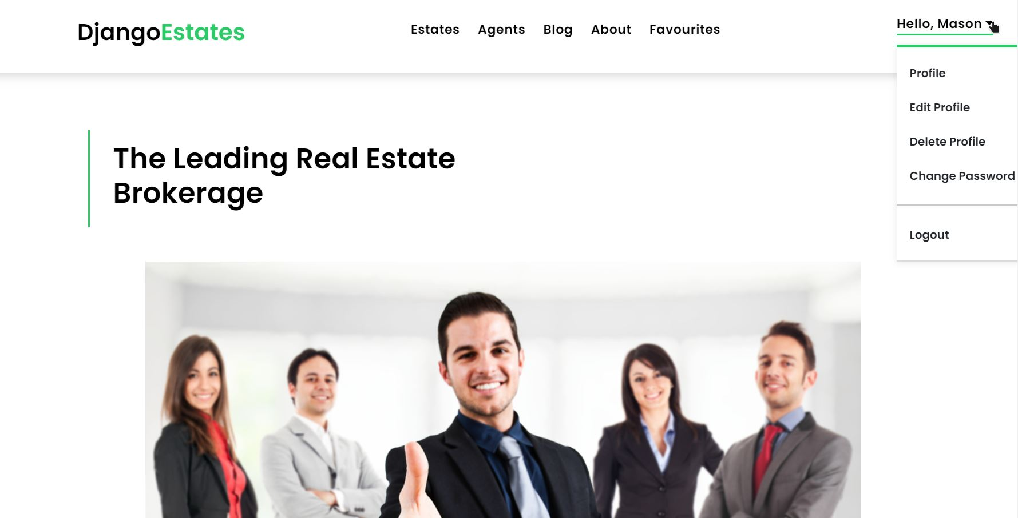


If the user is logged in and in content creators group: All the registered users will have a Favourites section in the header and a user panel as shown in the photo.

Estates page
All the estates, uploaded by the users which are in Brokers group. The estates are filtered by their type of transaction: For sale, For rent.
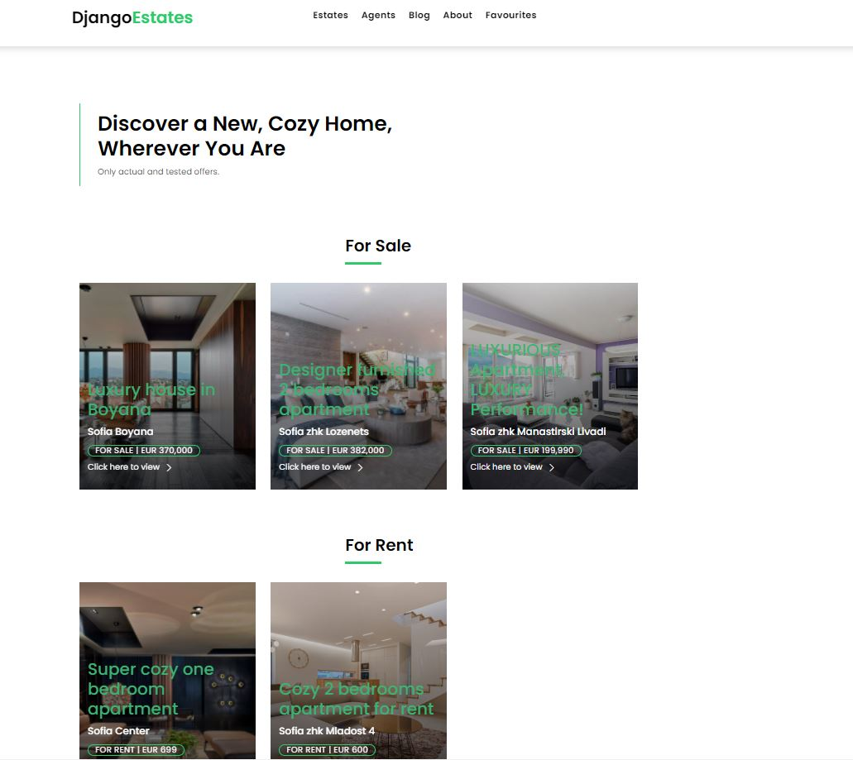

When a user clicks on “click here t view” button he will be redirected to the estate details page. If the user is broker he will be able to edit/delete the current estate. Otherwise he will see an information about the broker.
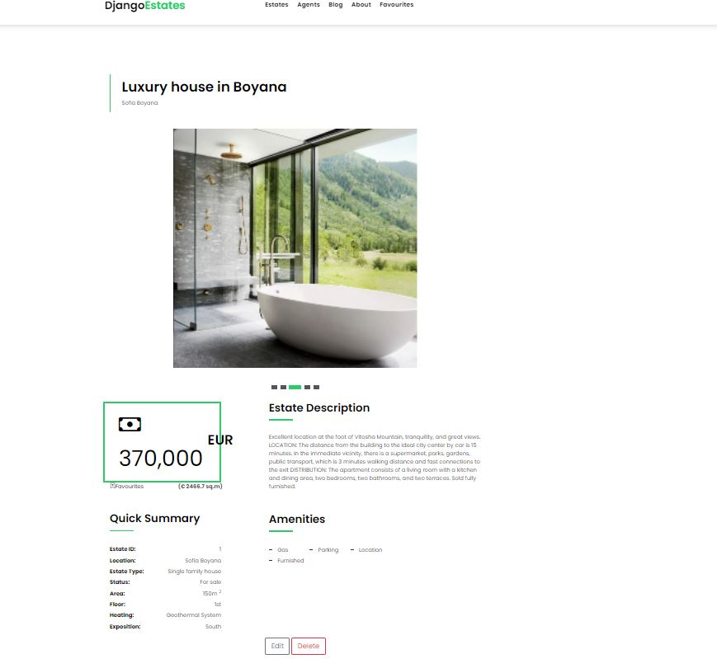

Agents page
All the users, from the Brokers group. If user “broker=True”, he will be visible in this page.
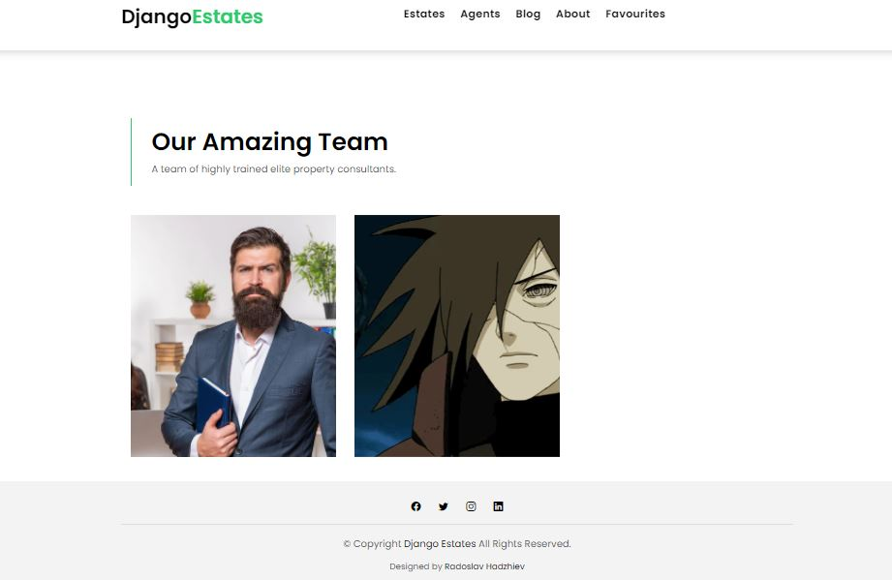

When a user clicks on the broker profile he will be redirected to the broker profile where he can find all the information regarding the current broker and also all the brokers estates.
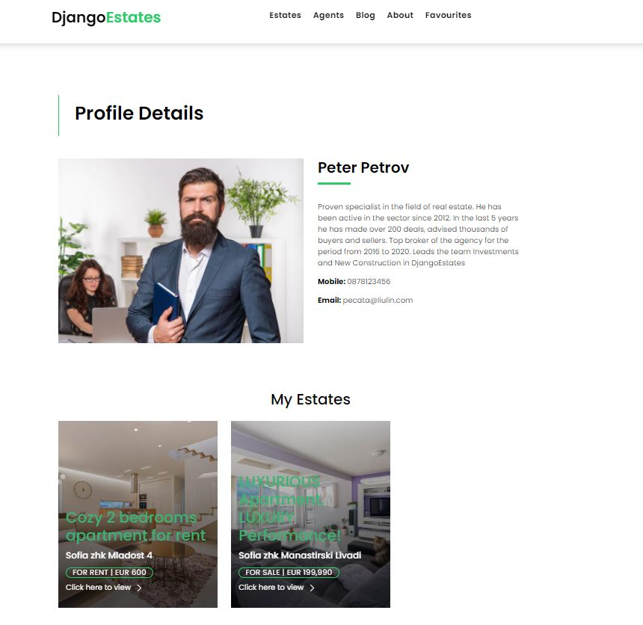

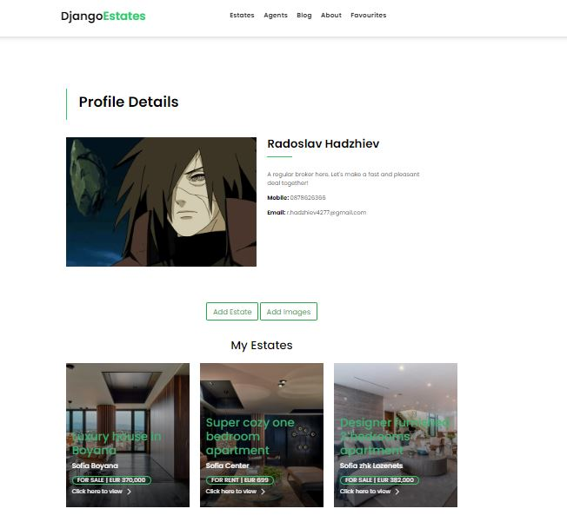
If the user is broker and this is his personal profile, he will be able to upload an Estate and Estate Images as shown below.

Add estate form:
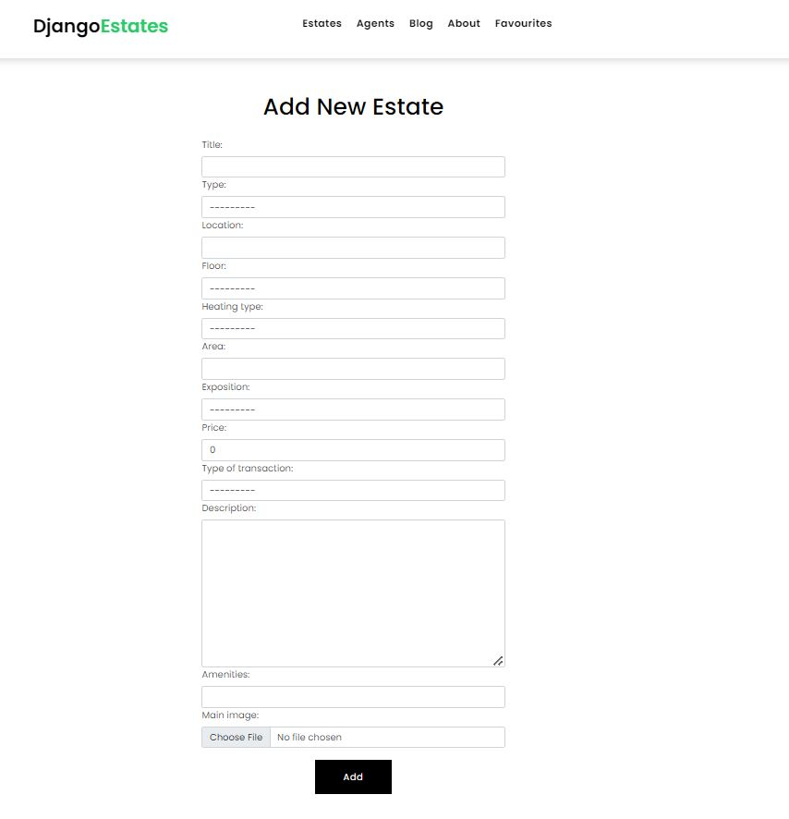

Add estate images form:
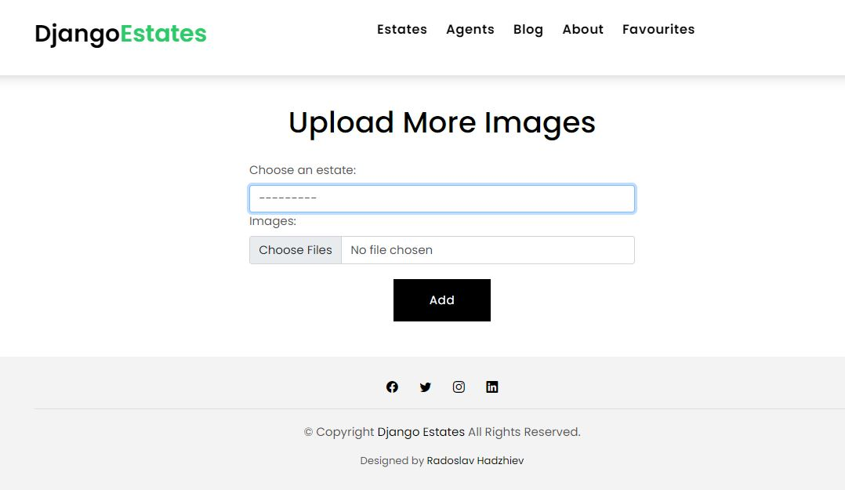

If user group is “Users” the profile details page will show only his information.. image, name, phone, email. Also If the user profile is incomplete he will see a message, telling him to complete his profile and a link where he can do that.

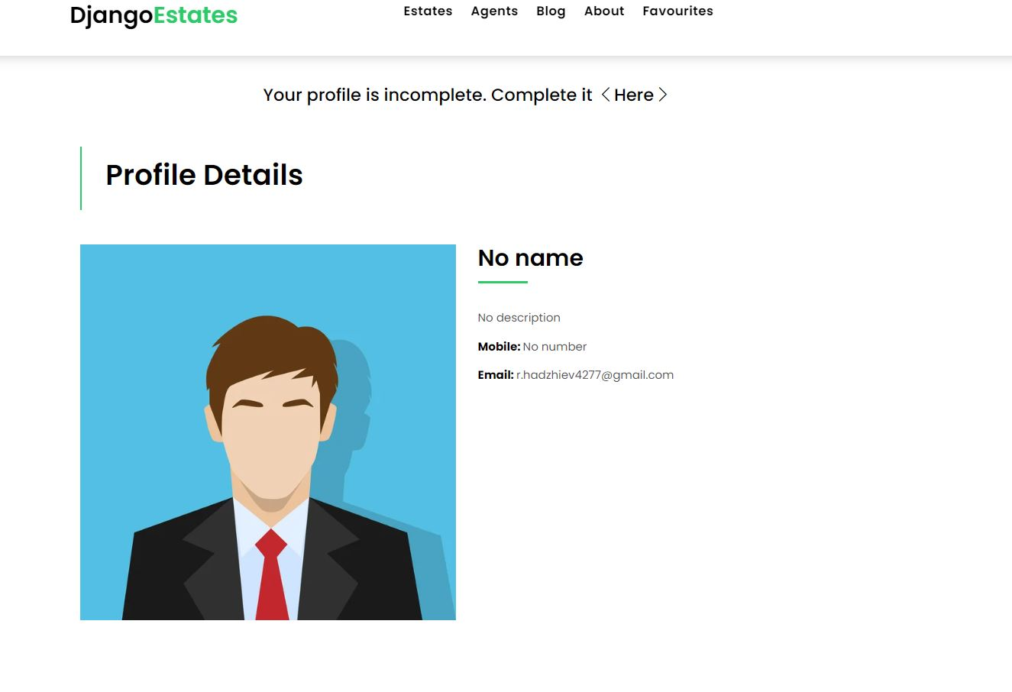

Profile complete form:
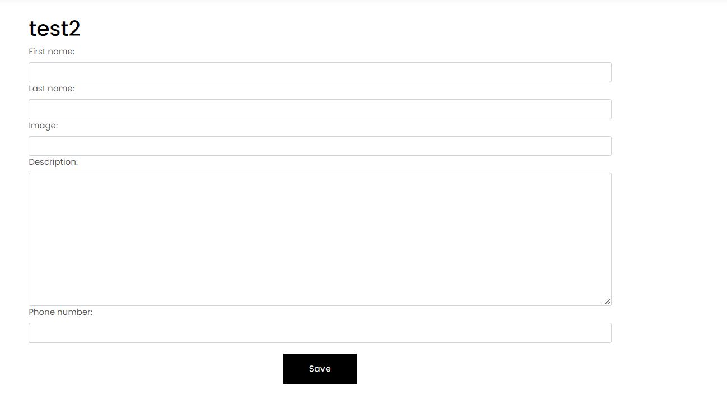

Blog page
All the post, paginated to be shown 4 per page.

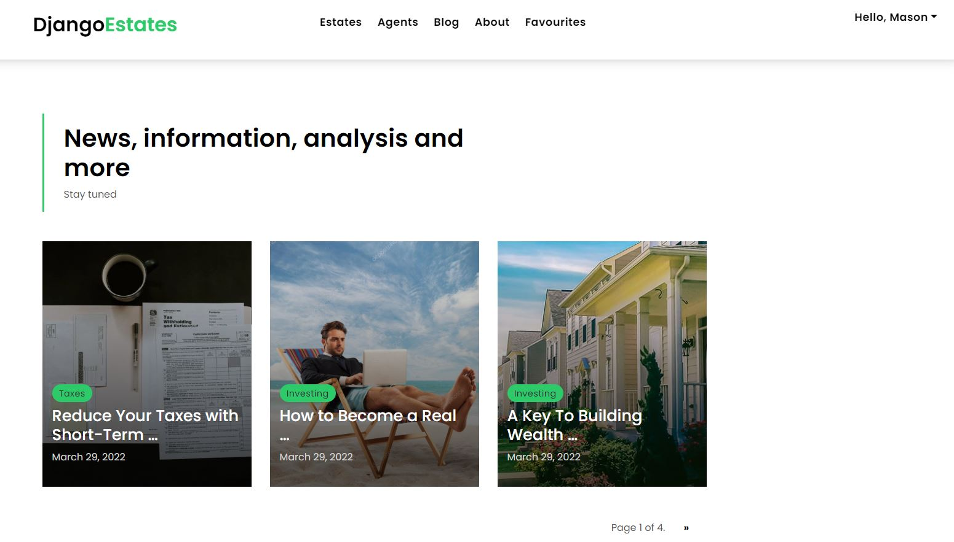

When the user clicks on some post he will be redirected to the post details page. After the post content he will find a comments section where he can add/ delete comments.
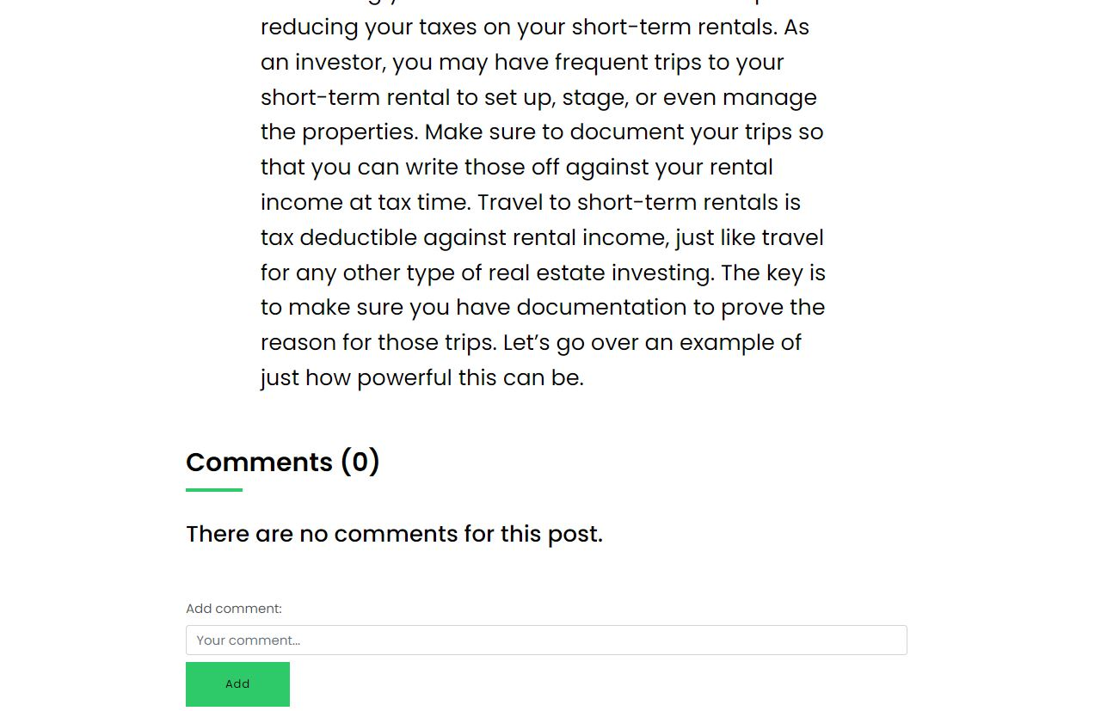

Delete comment.
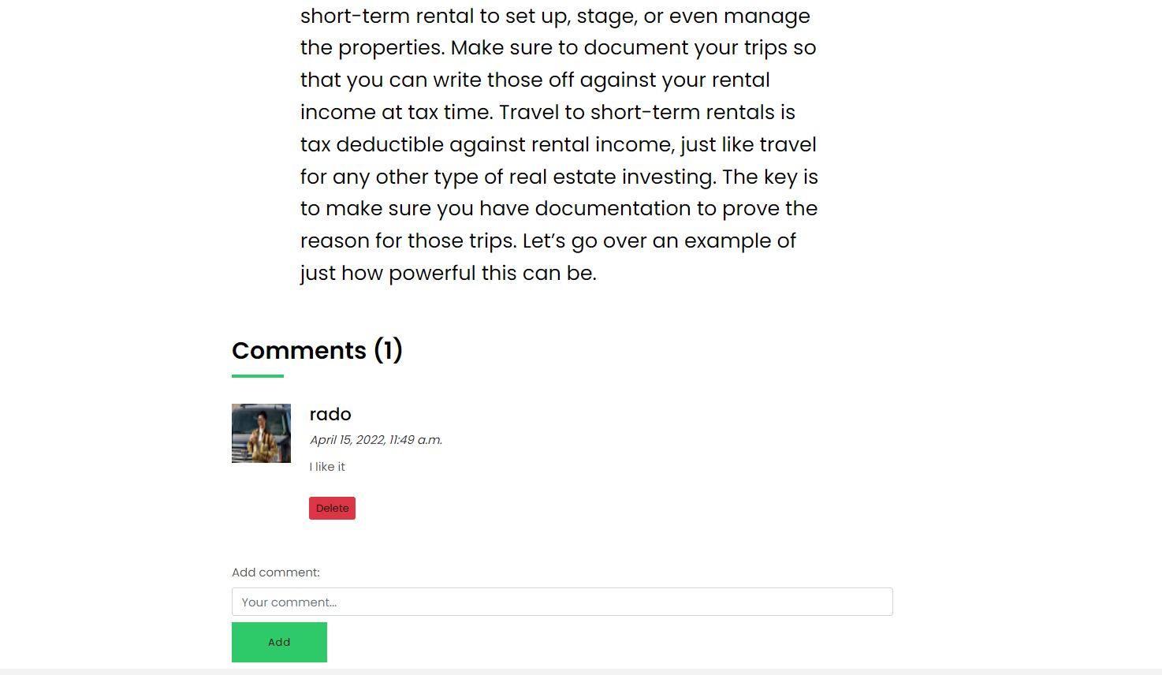

If the user is broker he won’t be able to add comments, only to see the left comments.

About page
Newsletter section, contact info.

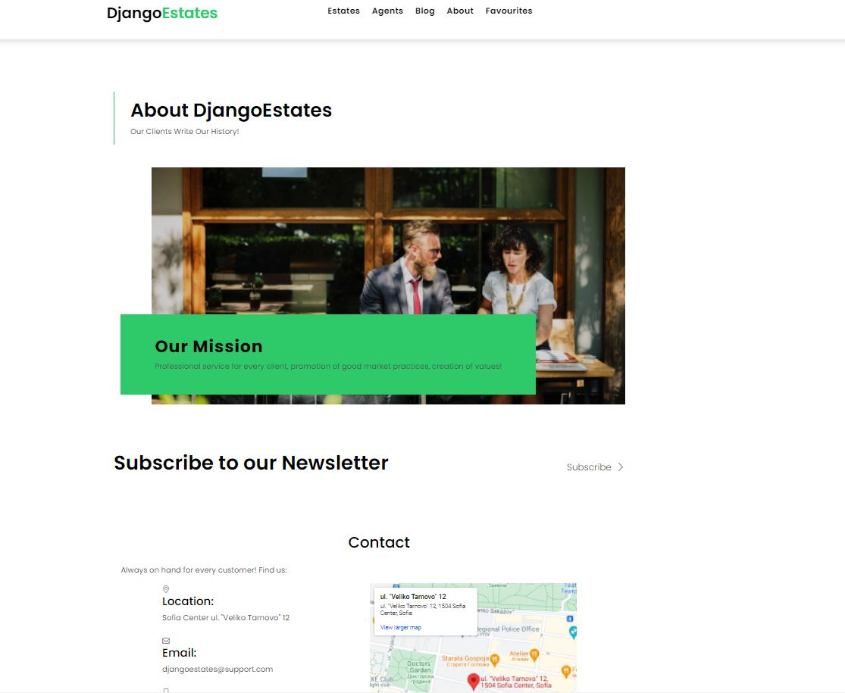

When a user clicks on the “Subscribe” button he will be redirected to a subscribe form where he can add an email.
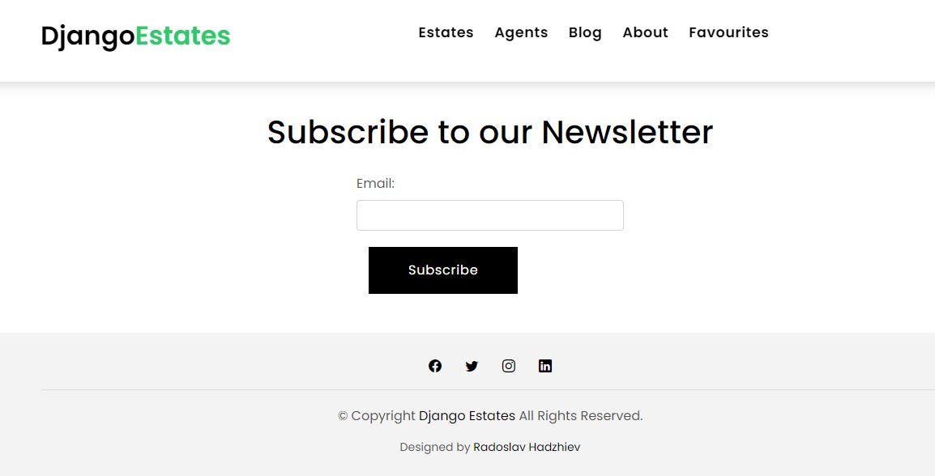

If the user belongs to the “Content creators” group he will be able to delete all the comments left by any user and to send an emails to all the subscribed users.
Send emails form:
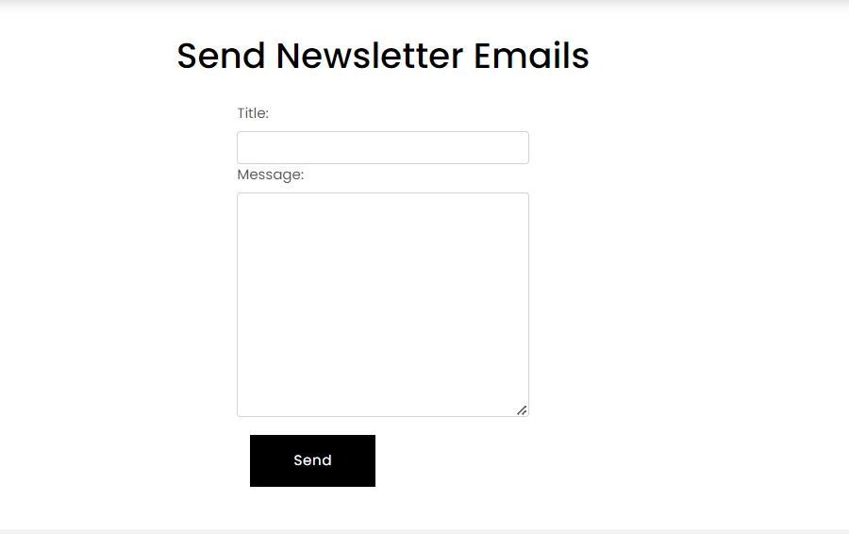

Favourites page
If empty:
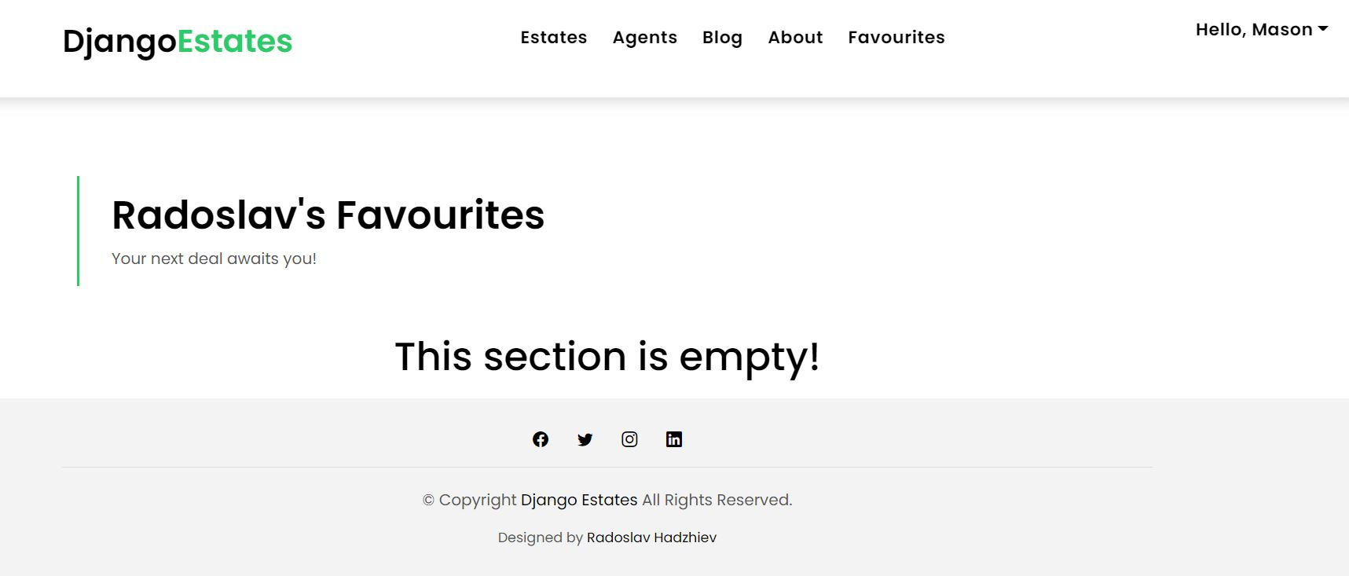

Edit estate form
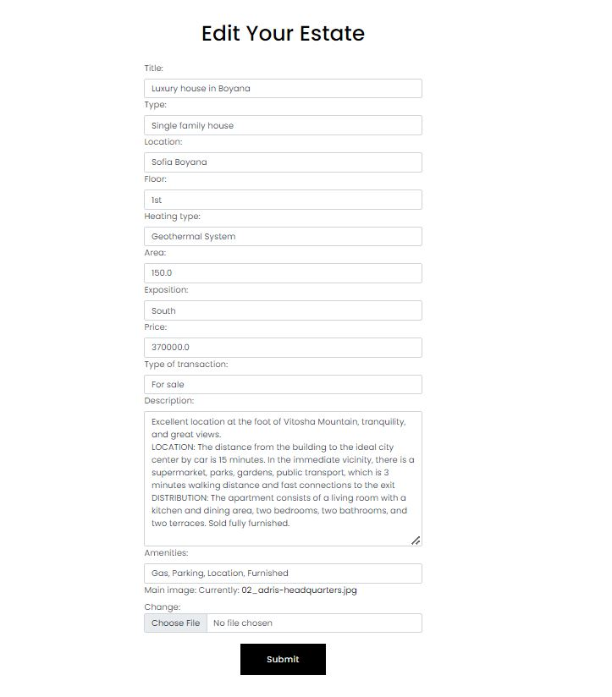

Delete estate form:
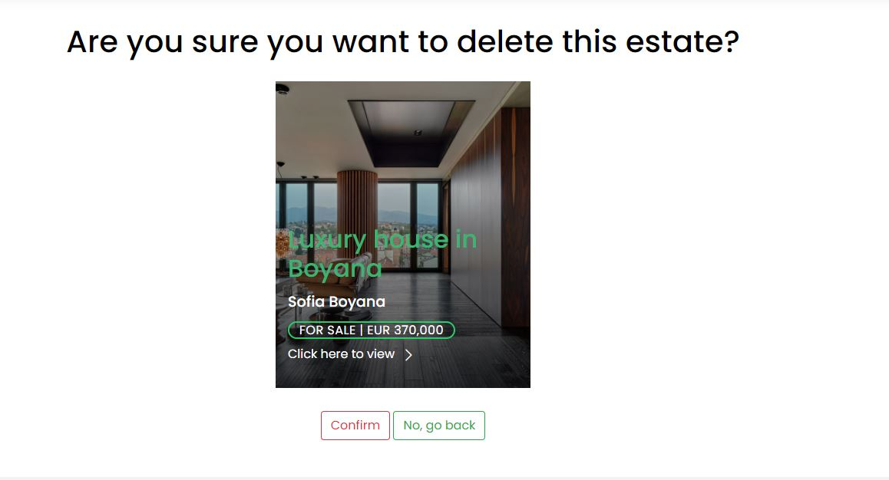
User panel:
Any registered user will receive a user panel, where he can edit/delete his profile, go to profile details page or logout.
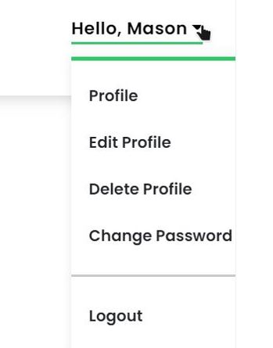

Edit profile form:

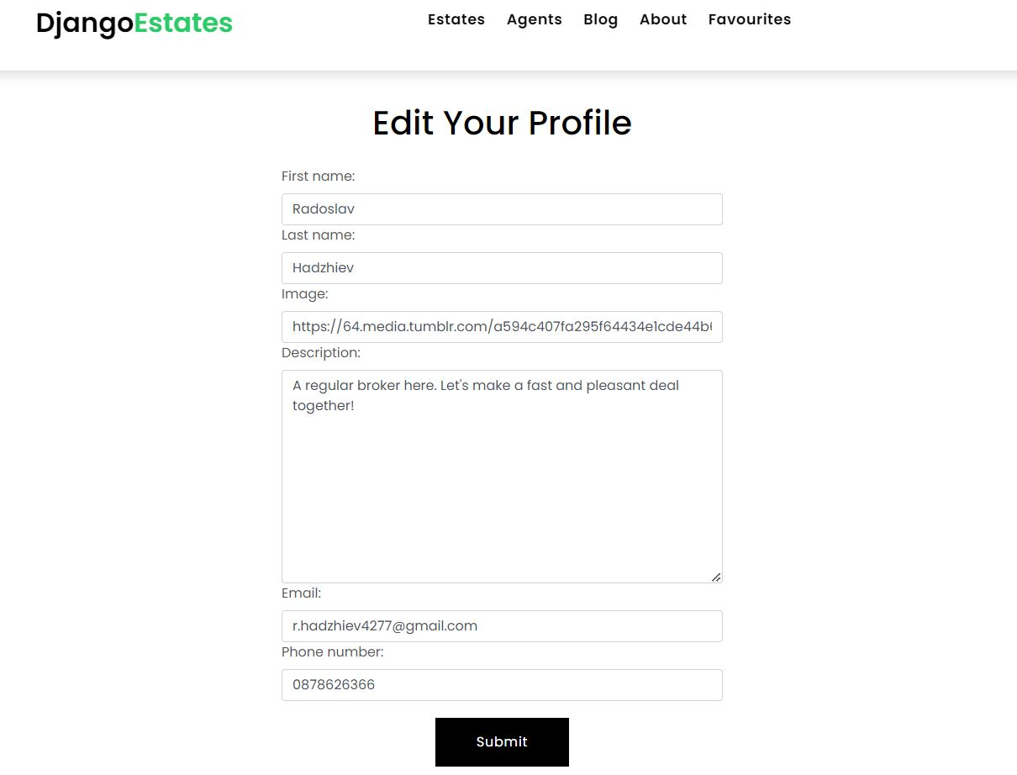
Delete profile form:

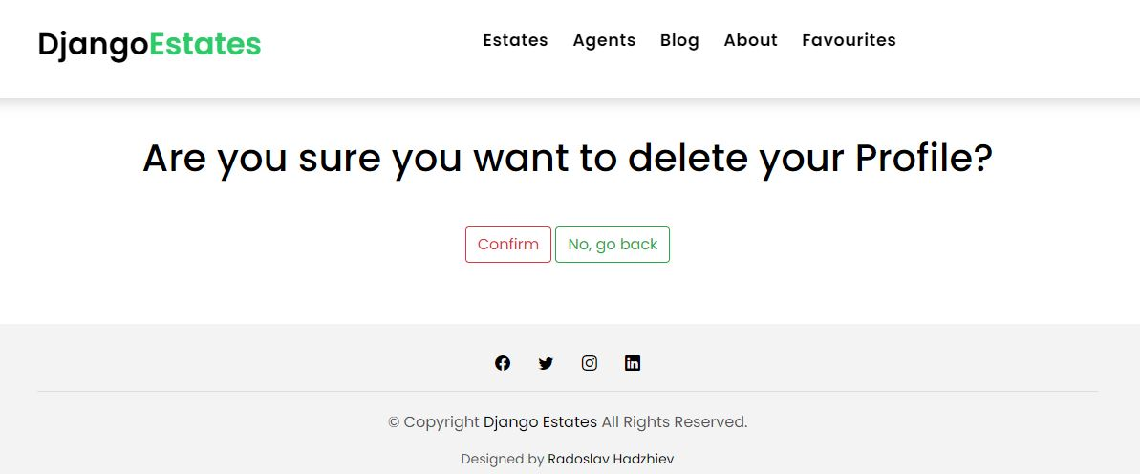
Change password form:

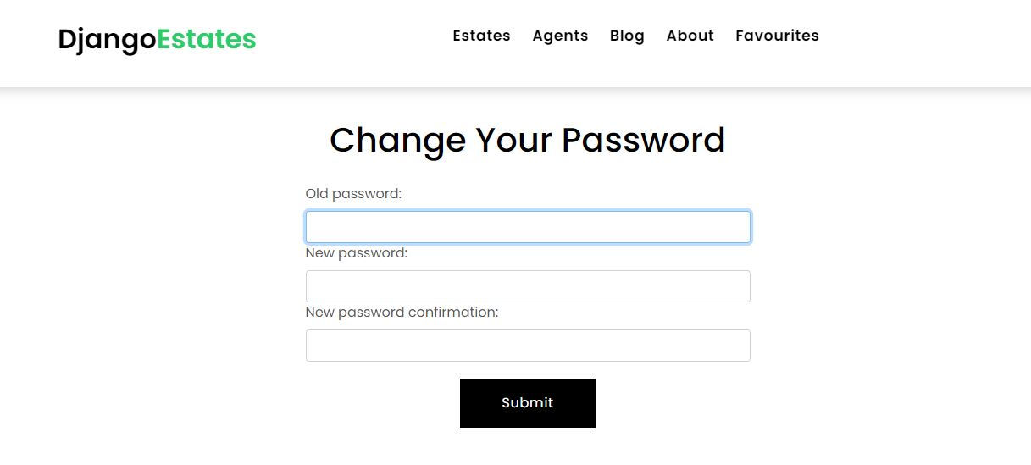
When a user clicks on the “Logout” button he will be logged out and redirected to the homepage.
If a user clicks on the DjangoEstates logo he will be redirected to the homepage.

