
KODIGO
Governance Artifacts & Full User Manual
Cloud-first point-of-sale, inventory, supplier, and analytics system

Document scope: Proposed business flow; COBIT-aligned permissions and accountability; ITIL-aligned escalation; full operating manual; AUP and BYOD policies; data classification; and a user-facing privacy notice.

Version 1.0 | 2 August 2026
Prepared for capstone evaluation and operational use

Document Control
Field | Value
System | Kodigo multi-store POS and inventory platform
Audience | Store administrators, cashiers, inventory staff, super administrators, and technical support
Owner | Kodigo System Owner / Store Administration
Approval | Capstone adviser and designated system owner
Review cycle | At least annually and after material role, privacy, or workflow changes
Source basis | Current React/Vite UI, Supabase migration chain through migration 28, and production operations runbook

How to Use This Document
Sections 1–3 are governance and service-management artifacts. Section 4 is the day-to-day manual. Sections 5–7 are policy and privacy artifacts that should be approved and adopted by the deploying organization before production use.
Implementation note: Kodigo is store-scoped. A user sees only stores assigned through membership mappings, and the selected active store controls operational context. The “All Stores” view is for aggregation and cannot process a sale.

Contents

Document Control 2
How to Use This Document 2
Contents 2
Why the Flow Matters 5
2.1 Functional Permission Matrix 7
2.2 Environment Permission Matrix 7
2.3 Roles, Responsibilities, and Accountability 8
2.4 Control Rules 8
2.5 Quarterly Access Review Procedure 9
Approval Triggers Outside the Review Cycle 9
3.1 ITIL Escalation Process 10
3.2 Tier Criteria and Targets 10
3.3 Severity Guide 11
3.4 Required Ticket Information 11
4.1 Manual Rationale and Training Approach 12
4.2 What Kodigo Does 12
4.3 Before You Begin 12
4.4 Sign In, Store Context, and Account Security 13
4.5 POS Checkout 13
Payment and Receipt Checks 13
Voids, Refunds, Returns, and Closeout 13
4.6 Offline Operation and Synchronization 14
4.7 Inventory and Product Management 14
4.8 Stock Alerts and Restocking 14
4.9 Suppliers 15
4.10 Dashboard, Analytics, Rankings, and Reports 15
4.11 Store Settings, Branding, Users, and Notifications 15
4.12 Basic Troubleshooting 16
4.13 End-of-Shift Checklist 16
5.1 Acceptable Use Policy (AUP) 17
Purpose 17
Scope 17
Allowed Uses 17
Prohibited Uses 17
Accountability and Enforcement 18
5.2 Bring Your Own Device (BYOD) Policy 18
Device Security Requirements 18
Support Boundaries 18
Liability and Privacy 18
Offboarding and Device Disposal 19
Exceptions and Acknowledgment 19
Handling Rules by Protection Level 21
Retention and Disposal Baseline 21
1. What we collect 22
2. Why we use it 22
3. How we protect and share it 22
4. Your choices and rights 22
5. Contact us 22
Privacy Principles Applied 23
Privacy Request Handling 23
Deployment Decisions Still Required 24
Approval Record 24

1. PROPOSED BUSINESS FLOW
From access provisioning to sale, stock control, reporting, and continual improvement
The proposed operating model starts with controlled onboarding and ends with review and corrective action. Each step protects the reliability of sales and inventory records while keeping frontline work fast enough for a busy small retailer.

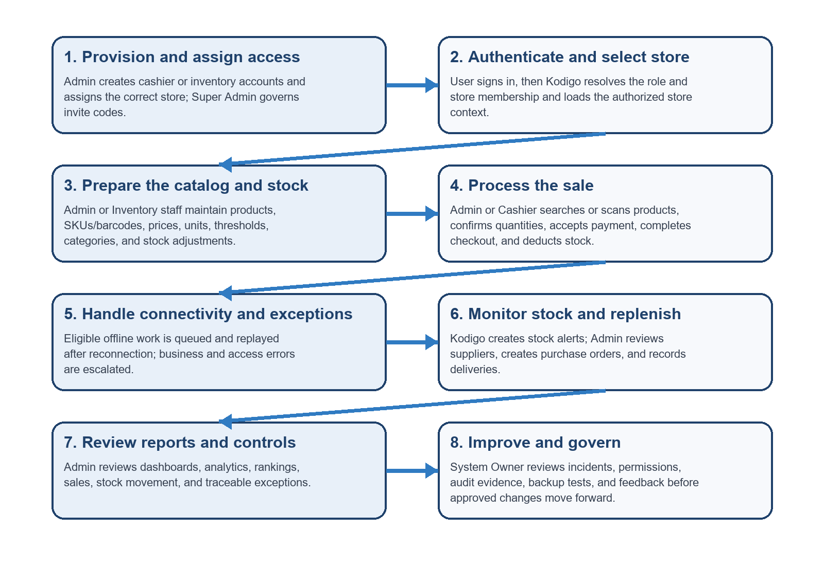
Figure 1. Proposed Kodigo Business Flow

Why the Flow Matters
Control objective | How the flow supports it
Accuracy | Catalog setup precedes sales; checkout records item, payment, tax/discount snapshots, receipt, and stock effects as one controlled operation.
Accountability | Named users, roles, store membership, sale events, audit logs, and stock adjustment records show who did what and where.
Continuity | Offline queues keep authorized operations available during network interruption, while backups and rollback protect recovery.
Decision support | Current stock, supplier scoring, alerts, and reports convert transaction data into replenishment and performance decisions.

2. COBIT ARTIFACT — PERMISSION MATRIX & ROLES AND RESPONSIBILITIES
Least privilege, segregation of duties, ownership, approval, and accountability
Permission legend: Full Control = administer and configure; Edit = create/change operational records; Approve = authorize sensitive action; Read = view only; Execute = perform a narrow transaction; None = no access. All application access remains limited to assigned stores.

2.1 Functional Permission Matrix
Capability | Admin | Cashier | Inventory | Super Admin
POS checkout | Execute | Execute | None | None
Inventory products & stock | Full Control | Read at POS | Edit | None
Stock adjustments | Approve/Edit | None | Edit | None
Suppliers & purchase orders | Full Control | None | Read only where exposed | None
Dashboard & analytics | Full Control | None | None | None
Reports/export | Full sales + inventory | None | Inventory/stock only | None
Store settings & branding | Full Control | None | None | None
Manage store users | Full Control in shared stores | Own account only | Own account only | None
Invite-code governance | None | None | None | Full Control
Notifications | Store/admin notices | Operational notices only | Limited | System notices
Account password | Own account | Own account | Own account | Own account
Audit/error logs | Read scoped operational evidence | None | None | System governance view as configured

Important: Super Admin is a platform-governance role, not a tenant-store operator. It must not be used to bypass store-scoped controls. Inventory is a back-office role for inventory and inventory reporting; it is redirected away from POS and admin-only modules.

2.2 Environment Permission Matrix
Role | Production App/Data | Staging/Test | Source & CI | Edge Functions | Backups
Cashier | Execute POS in assigned store | Test user only when invited | None | None | None
Inventory | Edit inventory; inventory reports | Test user only | None | None | None
Admin / System Owner | Full tenant operations | Approve business acceptance | Read approved releases | None | Request restore; no direct vault access
Super Admin | Invite governance only | Validate invite workflow | None | None | None
System Administrator | Operational support; temporary audited elevation | Full technical control | Edit/deploy via approved change | Manage functions/secrets | Restore operator
IT Manager | Read/approve emergency access | Approve release | Approve merge/release | Approve privileged changes | Approve restore and retention
Developer | No routine access; time-bound support only | Edit | Edit via pull request | Deploy only if delegated | None
Privacy Contact / DPO | Read only when investigating a privacy case | None | None | None | Approve disclosure/deletion handling

2.3 Roles, Responsibilities, and Accountability
Role | Owns | Approves | Accountable when something goes wrong
Admin / System Owner | Store configuration, operational data quality, staff access, daily control review | User creation/removal, stock corrections, purchase orders, routine settings | Accountable for store impact, unauthorized access caused by poor provisioning, and business acceptance
Cashier | Accurate cart, payment, receipt, and end-of-shift reporting | Customer confirms tender; Admin approves void/refund exceptions | Accountable for transactions under own credentials and immediate reporting of discrepancies
Inventory Staff | Product master data, counts, stock adjustments, inventory reports | Admin approves unusual or high-impact adjustments | Accountable for count accuracy, reason codes, and supporting notes
Super Admin | Invite-code governance and platform onboarding controls | Approves/generates governed invite access | Accountable for invite misuse or excessive issuance within assigned authority
Store Team Lead | First-line incident intake, verification, workaround, and user communication | Escalates unresolved or multi-user problems | Accountable for complete ticket details and timely escalation
System Administrator | Availability, Supabase configuration, deployments, logs, restores, technical diagnosis | Implements approved normal changes; emergency action per incident authority | Accountable for technical recovery, change evidence, and privileged access records
IT Manager | Service ownership, risk acceptance, major-incident command, vendor coordination | Approves releases, emergency change, restore, and service communications | Ultimately accountable for service continuity and post-incident action
Privacy Contact / DPO | Rights requests, breach assessment, privacy advice, records of processing | Approves privacy response and disclosure decisions | Accountable for lawful, transparent, and timely privacy handling

2.4 Control Rules
- No shared accounts. Every action must be attributable to one named user.
- Access is granted by role and store membership, reviewed quarterly, and removed immediately on separation or role change.
- Privileged technical access is time-bound, ticketed, approved, and reviewed after use.
- The person implementing a high-risk change should not be the sole approver of that change.
- Audit logs are append-only evidence; corrections are recorded as new events rather than silent edits.

2.5 Quarterly Access Review Procedure
- Admin exports or reviews the current user list, roles, active status, and store assignments.
- Each Store Team Lead confirms which users still require access and whether duties changed.
- Admin removes leavers, corrects excessive store scope, and records the approval/effective date.
- System Administrator reviews privileged technical accounts, tokens, secrets, and emergency access evidence.
- IT Manager signs off unresolved exceptions and assigns a due date; the review record is retained as audit evidence.

Approval Triggers Outside the Review Cycle
Immediate review is required after termination, transfer, suspected compromise, major incident, new store assignment, introduction of a new role, or a material RLS/route change. Emergency access expires when the incident ends and must not silently become permanent.

3. ITIL ARTIFACT — ESCALATION PATH
A practical service desk route tied to the roles and accountability model

3.1 ITIL Escalation Process
The process follows the governance document's required escalation structure: start with a user self-check, move to the Store Team Lead or Admin, escalate to the System Administrator for technical investigation, and involve the IT Manager, Privacy Contact, or vendor for major incidents. Each tier records impact, evidence, response target, channel, and next action; resolved incidents proceed to validation, closure, and review.

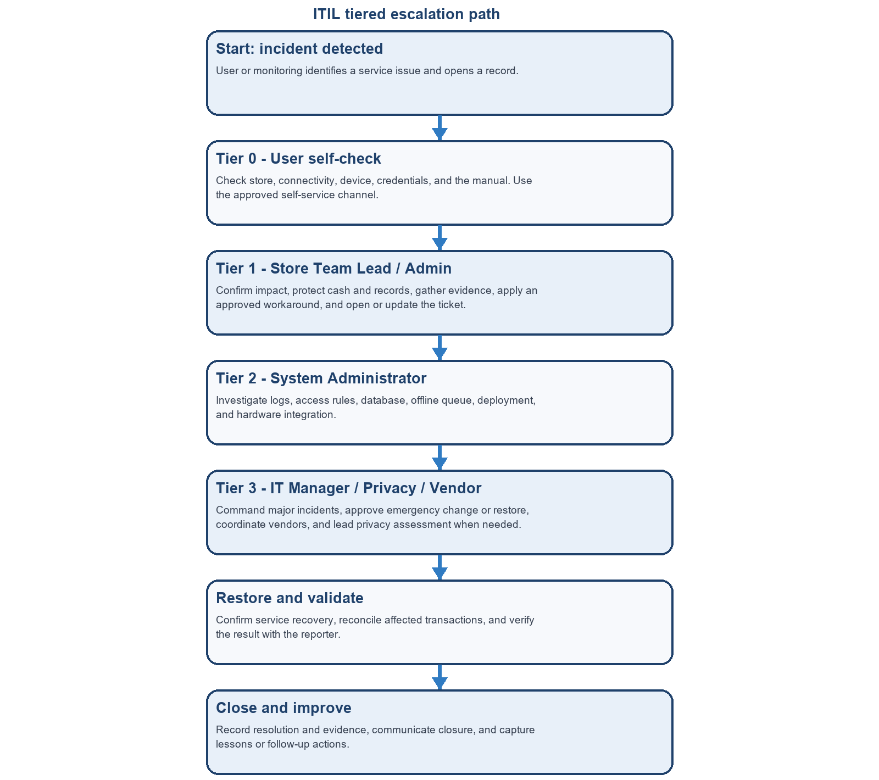
Figure 2. Proposed ITIL Escalation Process

3.2 Tier Criteria and Targets
Tier | Escalate when | Response / resolution target | Channels | Role
Tier 0 | Single-user usability issue; known warning; no data loss or security concern | Immediate / up to 10 min | Manual, in-app feedback | User
Tier 1 | Issue persists after basic checks; cash discrepancy; one terminal/store affected; access request | Acknowledge 15 min (P1/P2), 1 business hr (P3); target workaround 1 hr | Ticket; urgent chat/call | Store Team Lead / Admin
Tier 2 | Multiple users; repeated failed sync; suspected RLS/database defect; checkout unavailable; incorrect stock/sale state | Acknowledge 30 min; P1 restore/workaround target 4 hrs; P2 1 business day | Ticket + technical incident channel | System Administrator
Tier 3 | Major outage, restore/emergency change, vendor dependency, confirmed/suspected breach, legal or reputational impact | P1 acknowledge 15 min; executive update every 60 min; recovery target set by incident commander | Emergency bridge/phone/email/vendor portal | IT Manager; Privacy Contact for privacy
Escalation justification. Tier 0 keeps simple, reversible issues at the user level; Tier 1 protects local cash and records while gathering evidence; Tier 2 handles technical diagnosis, synchronization, and data-correction risk; Tier 3 coordinates major incidents, privacy concerns, vendor dependencies, and emergency decisions.

Targets are operational commitments for the capstone deployment and should be replaced by an approved service-level agreement if Kodigo is commercialized. Resolution depends on cause; when the target cannot be met, the owner must provide an updated estimate and workaround.

3.3 Severity Guide
Priority | Example | Action
P1 Critical | Checkout unavailable for a store/all stores; active security incident; material data corruption | Immediate Tier 2 and Tier 3; preserve logs; activate continuity process
P2 High | Major feature unavailable, repeated sync failures, wrong totals/stock affecting operations | Tier 1 validates, then Tier 2 within 15 minutes
P3 Normal | Single-user problem with workaround; report/export or noncritical device issue | Tier 1 ticket; escalate if unresolved within 1 business day
P4 Request | How-to question, enhancement, planned access or configuration change | Normal service request queue and change process

3.4 Required Ticket Information
- Reporter name and role; store and terminal; date/time and timezone.
- What the user attempted, expected result, actual result, and exact message.
- Transaction/receipt/product ID when applicable; never paste passwords or full payment credentials.
- Screenshot with unnecessary personal data redacted; browser/device and online/offline status.
- Business impact, number of users affected, workaround tried, and whether data or privacy may be at risk.

4. FULL MANUAL GUIDE
Complete operating instructions for Kodigo’s core workflows

4.1 Manual Rationale and Training Approach
This manual is for sari-sari store owners/administrators, cashiers, inventory staff, super administrators, and first-line support personnel using Kodigo across one or more branches. Their tasks differ, but they share the same operational data: a cashier’s sale changes inventory; inventory changes affect checkout; and administrators use both to replenish and report.
A Full Manual is the right primary documentation type because the system combines routine high-frequency work with lower-frequency, higher-risk tasks. A quick-start guide would help with first login or checkout but would omit role boundaries, offline behavior, stock correction, reporting, escalation, and policy obligations. A video is harder to search during a live transaction and becomes stale whenever screens change. An interactive simulation is useful for practice but expensive to maintain and cannot serve as the authoritative control and troubleshooting reference. This manual remains searchable, printable, reviewable, and suitable for training and audit evidence.
Training should use a blended model: instructor-led onboarding for Admins and new Cashiers, a self-paced copy of this manual for reinforcement, and just-in-time checklists at the terminal. Instructor-led practice is appropriate for payment, void/refund, stock adjustment, and incident scenarios because mistakes affect cash and records. Self-paced review supports shift-based staff, while just-in-time steps reduce memory burden during real work. Competency should be demonstrated in a staging store before production access is granted.
Recommended training evidence: Record attendance, role assigned, practice scenarios completed, trainer sign-off, and date of refresher training. Re-train after major workflow or policy changes.

4.2 What Kodigo Does
Kodigo is a cloud-first, multi-store retail operations system. It supports checkout and receipts, inventory and stock adjustments, supplier and purchase-order management, stock alerts, dashboards, analytics, rankings, reporting, store branding, user management, notifications, and account security. Supabase provides authentication and store-scoped database access; IndexedDB supports selected offline queues; Web Serial can trigger a compatible cash drawer.

4.3 Before You Begin
- Use a supported modern browser. Cash-drawer Web Serial requires a compatible browser and HTTPS or localhost.
- Confirm the device clock, network, receipt printer/scanner connection, and correct store assignment.
- Use your own account. Do not share a password or leave an unlocked terminal unattended.
- For POS, select one specific active store. The All Stores view is for consolidated review only.
- Know your role: Cashier uses POS; Inventory manages products/stock and inventory reports; Admin manages store operations; Super Admin governs invites.

4.4 Sign In, Store Context, and Account Security
- Open the Kodigo login page and enter your assigned email and password.
- After login, verify the name/branding and active store shown in the interface. If you are assigned to several stores, choose the branch you are operating.
- If you see no store or the wrong store, stop before posting data and ask the Admin to check membership.
- To change your password, open Account Security, enter the current password, then a new password of at least eight characters and confirm it.
- When finished, use Logout. Closing the browser alone is not a substitute on a shared device.
Password reset: Use Forgot Password from the login page or ask an Admin to send a managed-user reset. Support must never ask for the current password.

4.5 POS Checkout
- Open POS Terminal and confirm the active store. Admin POS access is intended for desktop; Cashier is the frontline POS role.
- Find an item by product name, SKU, or barcode. F2 focuses search. A compatible keyboard-emulating scanner can input the barcode.
- Add the product to the cart. Adjust quantity only after physically confirming the requested amount and available stock. Numeric pre-entry can set a quantity multiplier.
- Review product, quantity, unit price, subtotal, discount/tax presentation, and total. Remove accidental items before payment.
- Select Charge or press F9 when the cart contains items. Choose the payment method and enter cash received where required.
- Confirm the change due with the customer, then complete checkout once. Wait for confirmation—do not double-click or repeat a sale because the screen is slow.
- Issue the generated receipt. If configured, print it and open the cash drawer through the approved hardware action.
- If the sale is queued offline, note the terminal and time. Keep the browser data intact until synchronization succeeds.

Payment and Receipt Checks
- Cash: count tender aloud, confirm amount entered, and return the displayed change.
- GCash/card/bank transfer/other: record only the supported method/reference; do not store full card numbers, PINs, OTPs, or wallet passwords.
- Receipt: verify store identity, invoice/receipt number, items, totals, payment, cashier, date/time, and VAT/non-VAT information configured for the store.

Voids, Refunds, Returns, and Closeout
These actions affect revenue, stock, cash, and audit evidence. Follow the organization’s approval threshold. The Cashier records the reason and requests Admin/Team Lead approval; the Admin verifies the original transaction and supporting facts. Never delete a transaction to hide an error. Kodigo’s transaction lifecycle records status/events so corrections remain traceable.

4.6 Offline Operation and Synchronization
Kodigo caches products for offline POS lookup and can queue eligible offline sales and selected mutations in the browser’s IndexedDB. When connection returns, focus/visibility/online events trigger synchronization and data revalidation.
- If an offline message appears, confirm the correct store and continue only if the screen explicitly allows the operation.
- Do not clear browser data, switch browser profiles, uninstall the browser, or use private mode while transactions are pending.
- Reconnect to the approved network and leave Kodigo open. Allow the queue to replay and watch for success or rejection messages.
- If an RLS/database error appears, do not repeatedly retry. Capture the message and escalate because business-rule errors are not safely queued as network failures.
- Reconcile pending receipts and stock after synchronization. Escalate any duplicate, missing, or rejected sale immediately.

4.7 Inventory and Product Management
- Open Inventory and select a specific store. Admin and Inventory roles can access this area.
- To add a product, enter a unique SKU, optional barcode, product name, category, selling unit, cost, price, opening stock, low-stock threshold, reorder level, lead time, and supplier where applicable.
- Review cost and selling price before saving. A wrong unit or conversion factor can distort stock and margin reports.
- To edit, open the product, change only verified fields, and save. Avoid changing SKU/barcode identity during active checkout without coordination.
- For stock changes, use Stock Adjustment rather than overwriting history. Enter the delta, reason, and a meaningful note; verify before/after quantities.
- Delete/deactivate products only after checking links and operational need. Use the confirmation dialog and preserve history required for reports.
Bulk/per-piece selling: Stock is intended to be tracked in the smallest sellable unit. Validate purchase-unit conversion data before relying on it for production reports because optional conversion display fields may require deployment-specific verification.

4.8 Stock Alerts and Restocking
- Review low, critical, and out-of-stock alerts from Notifications/Restocking.
- Confirm physical count before ordering. The suggested quantity is a planning aid, not an automatic approval.
- Review the proposed quantity, reorder level, lead time, recent sales, and supplier availability.
- Create purchase orders grouped by supplier/store. Validate item, quantity, unit cost, supplier, and expected delivery.
- Move the order through Sent, Received, or Cancelled status. Mark Received only after checking delivered goods and quantities.
- Investigate supplier-score changes and delivery exceptions; add supporting records rather than changing history without explanation.
The current planning rule is: suggested quantity = max(reorder level × 2 − current stock, reorder level). Human review remains required because promotions, seasonality, shelf capacity, cash limits, and supplier constraints are not fully captured by the formula.

4.9 Suppliers
- Open Suppliers and select the relevant store context.
- Add or edit supplier name, contact person, phone/email/address, lead time, and related product information.
- Use purchase-order and delivery history to evaluate reliability, price, and overall score.
- Before deletion, check linked purchase orders. Retain records needed for financial, operational, or audit purposes.

4.10 Dashboard, Analytics, Rankings, and Reports
- Dashboard: reviews daily revenue, transaction count, average order value, estimated profit, recent transactions, and stock conditions.
- Analytics: filters Today, 7, 30, or 90 days and analyzes revenue/profit, hourly sales, category sales, and recent transactions.
- Rankings: aggregates sale items to rank products by sales activity. Use this instead of the dashboard Top Products panel when a sales-based ranking is required.
- Reports: Admin can generate sales and inventory workbooks with date, payment, status, cashier, product, category, and selling-unit filters. Inventory can export inventory/stock-focused reports only.
- Select one store or an authorized All Stores aggregate where the report supports it.
- Choose the date range and filters; refresh and review summary totals before export.
- Confirm status filters include/exclude voided or refunded transactions as intended.
- Export only to an approved location. Apply the data-classification rules in Section 6 and securely delete obsolete copies.

4.11 Store Settings, Branding, Users, and Notifications
- General/branding: Admin maintains store name, address, tax rate, registered/business name, TIN, branch code, VAT status, receipt label/prefix, terminal identifier, permits/accreditation text, contact details, and logo.
- Users: Admin can create, edit, reset, or remove Admin/Cashier/Inventory users only within shared assigned stores. Multi-store Admin assignments must be deliberate.
- Notifications: Admin can manage preferences for low stock, out of stock, daily summary, and sales milestones where configured.
- Super Admin: governs invite codes and system onboarding, not tenant operational CRUD.
User removal: Before removing or changing a user, verify identity, approval, active shifts, pending offline work, and store assignments. Access loss should be immediate, but operational records remain attributable to the former user.

4.12 Basic Troubleshooting
Problem | Likely cause | Safe action
Cannot sign in | Wrong password, reset required, missing profile/role | Retry carefully; use Forgot Password; ask Admin to confirm the account. Escalate if role cannot be resolved.
No store / wrong store | Missing membership or stale selection | Stop posting; refresh; re-login; ask Admin to verify store assignment.
POS unavailable | Role/device restriction, network, deployment | Cashier/Admin desktop only as allowed; check network; capture error; use approved continuity process.
Barcode not found | Wrong barcode, product inactive/missing, scanner mode | Search by name/SKU; verify product and scanner input; do not create duplicates.
Sale appears pending | Offline queue or slow connection | Do not repeat sale; reconnect and wait for sync; reconcile by receipt/time before retry.
Stock is incorrect | Unreceived PO, unsynced sale, wrong adjustment | Count physically; review sale/adjustment/PO history; Admin approves a documented correction.
Report totals differ | Store/date/status filter or pending sync | Confirm context and filters; sync; compare transaction statuses; escalate with export and IDs.
Cash drawer fails | Unsupported browser, insecure context, permission/cable | Use HTTPS/localhost and compatible browser; reconnect; allow permission after user gesture; use manual fallback.
Access denied/RLS error | Role/store policy blocks action | Do not bypass or keep retrying; verify assignment; send exact error to Tier 2.
App looks stale | Cached data or inactive tab | Bring tab to front, refresh, check online state, and re-login if safe; preserve pending offline data.

4.13 End-of-Shift Checklist
- Complete or cancel open carts; do not leave an ambiguous payment screen.
- Confirm pending offline transactions are synchronized or formally handed over.
- Perform the approved cashier closeout and explain any variance.
- Secure receipts/reports and remove customer-visible information from the counter.
- Log out, lock the device, and report unresolved incidents with ticket number to the next shift.

5. ACCEPTABLE USE AND BYOD POLICY
Adoptable policy text for Kodigo users and devices

5.1 Acceptable Use Policy (AUP)

Purpose
This policy protects Kodigo, the stores it supports, and the people whose information is processed. It establishes authorized, secure, and accountable use of the application, accounts, devices, network access, reports, and connected peripherals.

Scope
This policy applies to all employees, owners, contractors, students/testers, support personnel, and third parties who access Kodigo or its data in production, staging, test, backup, export, or support environments.

Allowed Uses
- Users may perform assigned retail, inventory, reporting, administration, support, or audit duties within the user’s approved role and stores.
- Users may use authorized scanners, receipt printers, cash drawers, browsers, and networks for business operations.
- Users may create exports only for an approved business purpose and store them in an approved restricted location.
- Users may report errors, vulnerabilities, lost devices, suspicious access, and privacy concerns promptly through the escalation path.
- Users may use staging/test accounts and non-production data for training and testing whenever feasible.

Prohibited Uses
- Users must not share accounts, passwords, reset links, OTPs, invite codes, service-role keys, or sessions; use another person’s account; or leave a terminal unlocked.
- Users must not access another store, role, user record, report, or log without authorization, even if a technical path appears available.
- Users must not change, delete, fabricate, or conceal sales, stock, supplier, user, receipt, closeout, error, or audit records to misrepresent events.
- Users must not install unapproved extensions/software, bypass security controls, probe production, or connect unknown USB/serial devices.
- Users must not save full card numbers, PINs, OTPs, wallet passwords, government IDs, or unrelated customer information in notes, logs, screenshots, or tickets.
- Users must not upload Kodigo data to personal email, public cloud storage, social media, public AI tools, or removable media without written approval.
- Users must not clear browser data when offline transactions are pending or intentionally disrupt synchronization, backups, logging, or availability controls.

Accountability and Enforcement
Users are accountable for complying with this policy and reporting suspected violations. Violations may result in immediate access suspension, preservation and review of relevant logs, corrective training, disciplinary action, contract consequences, recovery of losses where lawful, and referral to management, the Privacy Contact, law enforcement, or regulators as appropriate. Actions will be proportionate, documented, and consistent with applicable law and organizational rules.
CIA Triad linkage: The rule against credential sharing protects Confidentiality by limiting data to authorized users, protects Integrity by preserving reliable attribution, and supports Availability by reducing account compromise and service disruption.

5.2 Bring Your Own Device (BYOD) Policy
BYOD is applicable only when the organization expressly permits personal devices for Kodigo. A personal device is not automatically authorized merely because the web application can open on it.

Device Security Requirements
- Users must use a supported, legally licensed operating system and browser with automatic security updates enabled.
- Users must protect the device with a passcode of at least six digits or a strong password; biometric unlock may supplement but not replace the passcode.
- Users must enable automatic screen lock within five minutes, full-device encryption, active anti-malware where supported, and a firewall.
- Users must not use rooted/jailbroken devices, unsupported operating systems, shared family profiles, or unapproved browser extensions.
- Users must use only trusted networks or an organization-approved VPN; public/shared Wi-Fi must not be used for administrative or export activity without protection.
- Users must not locally save reports, receipts, screenshots, or credentials unless explicitly approved, and must synchronize pending offline data promptly.
- Users must report lost/stolen devices, suspected compromise, or unauthorized family/third-party access immediately and no later than one hour after discovery.

Support Boundaries
Support covers Kodigo configuration, supported browsers, approved scanner/printer/cash-drawer integration, and reasonable diagnosis. The organization does not guarantee support for personal hardware defects, data plans, home routers, unrelated apps, personal backups, or unsupported operating systems. Support may require the user to reproduce the issue on an organization-managed device.

Liability and Privacy
The device owner remains responsible for personal-device costs, lawful content, physical care, and personal backups. The organization is responsible for protecting Kodigo business data under its control but is not liable for ordinary loss of personal data caused by user failure to back it up, except where law or contract provides otherwise. Investigation and remote session revocation may affect Kodigo data or sessions; personal content will not be inspected beyond what is necessary and authorized for security, legal, or privacy response.

Offboarding and Device Disposal
- Admin removes or changes Kodigo access and store assignments on the effective separation/role-change date.
- User logs out, removes saved credentials/bookmarks that reveal restricted endpoints, and synchronizes or hands over pending authorized work.
- System Administrator revokes active sessions/tokens where available and confirms no pending offline queue remains on the device.
- User securely deletes approved local exports, receipts, caches, and screenshots; Admin verifies completion through an offboarding checklist.
- Before selling, recycling, or transferring the device, the owner performs a secure factory reset after preserving lawful personal backups.

Exceptions and Acknowledgment
Any exception must identify the business need, data involved, compensating controls, owner, approval, and expiry date. The IT Manager approves security exceptions; the Privacy Contact also approves exceptions involving personal data. Unapproved exceptions are policy violations.
User acknowledgment | Record
I understand that Kodigo access is limited to my role and assigned stores. | Name / signature / date
I will report loss, compromise, incorrect records, or pending offline work promptly. | Training record or policy acceptance
I consent to proportionate security controls on authorized BYOD access and will complete offboarding. | Device ID and approval expiry

6. DATA CLASSIFICATION TABLE
Inventory of Kodigo data and minimum protection expectations
Classification uses three practical labels: Personal Data (PD), Sensitive Personal Information (SPI), and Operational/Non-personal (OP). Credentials and security telemetry may not always fall within a statutory SPI category, but Kodigo treats them as Restricted because compromise creates significant risk. Customer identity is not required for ordinary cash sales; do not collect it unless a defined feature and lawful purpose require it.
Data item | Classification | Protection | Minimum controls
User name, profile ID, avatar | PD | Confidential | Store-scoped access; authenticated use; correct/erase through Admin/privacy process
User email and phone (if used) | PD | Confidential | Use for account/contact only; mask in tickets and exports; encrypted transit/storage
Password/authentication tokens | PD (security credential) | Restricted | Supabase Auth only; never public tables/logs; no sharing; reset and revoke on compromise
Role and store memberships | PD | Confidential | Least privilege; Admin shared-store scope; quarterly review and immediate offboarding
IP address, browser/device, error context | PD when linkable | Confidential | Collect only for security/support; restrict logs; time-limited retention
Government identifiers if later collected | SPI | Highly Restricted | Do not collect by default; documented legal basis, encryption, narrow access, retention limit
Health/biometric information | SPI | Highly Restricted | Not required by Kodigo; prohibited unless separately approved and lawfully implemented
Store TIN, permit/accreditation details | OP; may become PD for sole proprietor | Confidential | Admin-only edit; controlled receipt display; accurate and current
Store name, address, contact, branding | OP / possible PD | Internal–Confidential | Admin control; publish only intended receipt/contact fields
Products, SKU/barcode, cost, price, stock | OP | Confidential | Store-scoped RLS; change history/adjustments; backups
Supplier contact person, email, phone, address | PD + OP | Confidential | Business-purpose use; store scope; limit exports and deletion to retention rules
Sales, sale items, totals, discounts, tax | OP; PD if linked to person | Confidential | Store scope; append-only lifecycle evidence; financial retention; encrypted transfer
Payment method/reference | PD/financial context when linkable | Restricted | Never store full card/PIN/OTP; mask reference; narrow access and retention
Receipts/invoice numbers | OP; may contain PD | Confidential | Issue to customer; protect duplicate copies/exports; approved retention
Stock adjustments and creator label | PD + OP | Confidential | Named attribution, reason/note, immutable audit trail, store scope
Purchase orders and supplier scores | OP; may contain PD contacts | Confidential | Admin scope; accuracy review; protected exports
Audit logs, error logs, sale events, closeouts | PD + OP | Restricted | Append-only; Admin/technical need-to-know; monitor access; defined retention
Backups and exported reports | Same as source data | Restricted | Encrypted/restricted vault; restore testing; minimum 30-day backup retention per runbook; controlled disposal
Invite codes and reset links | PD/security secret | Restricted | Single-purpose, limited validity/use, never public or reused, revoke when exposed

Handling Rules by Protection Level
Level | Handling rule
Internal | Authenticated business use; share only within the organization for a legitimate task.
Confidential | Role/store-scoped access, encrypted transfer, approved storage/export, logged changes, secure disposal.
Restricted / Highly Restricted | Named need-to-know access, no casual export, additional approval, monitoring, short retention where feasible, immediate incident response.

Retention and Disposal Baseline
Record group | Baseline decision
Sales, receipts, tax and payment records | Retain for the approved financial/legal period; lock against routine deletion; dispose securely when authorized.
User/account and membership records | Retain while active plus the period needed for audit or claims; revoke access immediately on offboarding.
Audit, error and security logs | Keep long enough to investigate incidents and demonstrate control operation; restrict and purge on an approved schedule.
Exports and screenshots | Keep only for the specific task; delete from downloads, email, chat, and removable media when the task/retention need ends.
Backups | Minimum 30-day restricted retention per current runbook, subject to the production backup plan and legal requirements.

7. PRIVACY NOTICE
Short notice for Kodigo account holders and business contacts

1. What we collect
We collect account details such as your name, email, role and assigned store; transaction records such as sales, payment method and amount; activity records such as stock adjustments, reports and audit events; and limited device/error information needed to secure and support Kodigo. Ordinary cash sales do not require customer identity.

2. Why we use it
We use the information to authenticate users, operate store transactions and inventory, issue receipts, manage staff access, produce reports, prevent misuse, troubleshoot errors, meet recordkeeping duties, and improve service reliability. We will not use it for an unrelated purpose without notice and an appropriate lawful basis.

3. How we protect and share it
Access is limited by role and assigned store, protected by authentication, encrypted connections, store-scoped access rules that limit each user to authorized records, logs, backups, and controlled support access. We share data only with authorized personnel and service providers needed to run or support Kodigo, subject to appropriate safeguards and legal requirements.

4. Your choices and rights
Subject to applicable law, you may ask to access or correct your data, object to or restrict certain processing, request deletion when retention is no longer required, withdraw consent where processing relies on consent, and raise a complaint. We may verify identity and retain records required for security, transactions, or law.

5. Contact us
Send privacy questions or requests to the Store Administrator / Privacy Contact using the official store email shown in Kodigo Settings and on the store receipt. If unavailable, submit a support ticket marked “Privacy Request.” Do not include passwords, OTPs, or unnecessary identity documents in the first message. If the concern is not resolved, you may file a complaint with the Philippine National Privacy Commission through its official complaint process at https://privacy.gov.ph/filing-a-complaint/.

Privacy Principles Applied
Principle | How it is applied
Collection limitation | Kodigo collects only data needed for accounts, store operations, security, support, and required records; customer identity and SPI are not required by default.
Purpose specification | The notice states the operational, access-control, reporting, security, support, and recordkeeping purposes at collection.
Use limitation | Data is not used or disclosed for unrelated purposes without notice, authority, and safeguards; access is role/store-scoped.
Transparency | Users are told what is collected, why, how it is protected/shared, their rights, and how to contact the responsible organization.

Privacy Request Handling
- Log the request and acknowledge it through an approved channel without asking for unnecessary identity documents.
- Verify the requester proportionately, identify the relevant stores/systems, and preserve required transaction or security records.
- The Privacy Contact decides the lawful response, coordinates Admin/System Administrator action, and records any limitation or refusal reason.
- Provide the response securely and record completion, disclosure recipients, corrections, deletions, or follow-up commitments.
Privacy incident: If data may have been accessed, changed, lost, or disclosed without authority, preserve evidence and escalate directly to Tier 3. Do not notify affected people or external parties without the Privacy Contact/incident commander’s coordinated decision.

APPENDIX A. CONTROL AND EVIDENCE NOTES
Technical anchors used to tailor this document to the current Kodigo implementation
Area | Repository evidence | Document implication
Application and routes | kodigo-ui/src/App.tsx; Sidebar.tsx; types/index.ts | Admin, Cashier, Inventory, Super Admin; route guards and module visibility
Authentication and tenancy | kodigo-ui/src/stores/authStore.ts; migration chain | Supabase Auth, profiles, store_users, active store, row-level security
POS and offline | cartStore.ts; transactions.ts; offline-sync.ts; hardware.ts | Checkout, queued sales/mutations, network-vs-database errors, cash drawer
Inventory/suppliers/reporting | productStore.ts; supplierStore.ts; reporting.ts; relevant pages | Product/stock, supplier/PO, reports and exports
Production controls | docs/production-ops.md; migrations 18–28 | Backups, restore, deployment, rollback, audit/error logs, user RBAC hardening

Deployment Decisions Still Required
- Insert the deploying organization’s legal identity and official Privacy Contact details before publishing the privacy notice.
- Approve concrete service hours, incident targets, access-review frequency, export retention, and legal record-retention schedule.
- Confirm the supported invite-generation path, production environment ownership, backup subscription/retention, and vendor escalation contacts.
- Validate selling-unit conversion reporting and every policy/role against the exact production migration state before go-live. Attach current-build mockups or screenshots for Login, POS, Inventory, and Dashboard before final publication.

Approval Record
Role | Name | Signature | Date
System Owner
IT Manager / Technical Adviser
Privacy Contact
Capstone Adviser

