KODIGO

Kodigo System Design and Governance
Technical design and accountable governance for the Kodigo capstone system
Table 1. Document Control
Control | Value
Version and date | Version 1.3 | 5 October 2026
Status | Final owner-issued edition. Peer-review rubric audit complete: 19/25 (Good).
Document owner | Evon Christian P Vergara
Approval status | No separate approval required for this final document issue.
Review cycle | Review at least annually and after material system, role, privacy, or workflow changes.
Evidence basis | Repository implementation and supporting project documents reviewed on 5 October 2026. Live deployment facts are not claimed unless evidenced.

Final owner-issued edition following the supplied peer-review rubric audit. Deployment-specific input fields are operational details, not document-approval gates.

Contents
Contents 2
Executive summary 3
PART I - SYSTEM DESIGN 3
1. Purpose, business need, scope, and stakeholders 3
2. Acceptance criteria and measurement 3
3. Architecture and major components 4
4. Technology choices and rationale 4
5. Major modules and functional requirements 5
6. Data model and relationships 5
7. Data flow and business process 6
8. Role and permission design 7
9. Security architecture and risk controls 7
10. Integrations, environments, and service identities 8
PART II - SYSTEM GOVERNANCE 8
11. Governance objectives and structure 8
12. Decision rights and segregation of duties 9
13. Access governance lifecycle 9
14. Data and privacy governance 10
15. Risk management 10
16. Change, release, and configuration management 11
17. Incident management and escalation 11
18. Backup, recovery, audit, and monitoring responsibilities 13
19. User feedback and post-launch improvement 13
20. Documentation ownership, training, and review 13
21. Feasibility, rollout sequence, and resource plan 14
22. Course concept integration and evidence 14
23. Rubric traceability 15
24. Owner inputs for deployment-specific details 16

Executive summary
Kodigo is a multi-store retail operations system for sari-sari stores and small branches. It combines browser-based checkout, catalog and stock controls, supplier and purchase-order workflows, reporting, and store-level access management. The design uses a React and TypeScript frontend with Supabase Auth and Postgres, database-enforced store scoping, server-side functions for privileged administration, and browser storage for eligible offline work. This document separates technical design from governance so reviewers can see both how the system works and who must control it.
This final document set records repository-verified design and governance requirements without presenting unverified live deployment settings as facts. The peer-review rubric audit is complete; deployment-specific owner inputs are identified in place and summarized in Section 24. They are operational details, not pending document approvals.

PART I - SYSTEM DESIGN

1. Purpose, business need, scope, and stakeholders
Small retailers need checkout, stock records, supplier coordination, and simple performance reporting to stay aligned across daily work. When sales and inventory records are separated, cashiers may repeat a payment, staff may reorder from stale stock, and owners may be unable to trace a correction. Kodigo addresses this operational need by linking sale records to product stock, preserving transaction lifecycle events, showing stock alerts and restocking information, and summarizing activity by store.
Table 2. System purpose and boundaries
Item | Description
Purpose | Support checkout, inventory accuracy, supplier procurement, and store-level review for small retail operations.
Primary users | Admin, Cashier, Inventory, Super Admin; technical maintainers and reviewers have separate organizational duties.
In scope | Browser application, Supabase Auth, Postgres data and policies, database functions and triggers, Edge Functions, IndexedDB offline queues, reports, and optional cash-drawer integration.
Out of scope unless separately confirmed | Card processing, storing full payment credentials, a mobile device management service, automated legal/tax certification, a named production service desk, or verified production hosting and backups.

2. Acceptance criteria and measurement
The following are recommended acceptance tests and measurable targets, not reported test results. Record the test data, owner, environment, completion date, and evidence when the deployment team executes them; this document does not claim that unrun tests have passed.
Table 3. Proposed success measures
Measure | Target for capstone acceptance | Evidence to retain
Role and store boundaries | All agreed route and database access tests pass for Admin, Cashier, Inventory, and Super Admin; every unauthorized cross-store read/write attempt is denied. | Dated test matrix and sanitized results.
POS correctness | At least 20 representative checkout cases produce the expected totals, receipt references, and stock effects; zero duplicate sale records in the tested cases. | Staging test cases, transaction IDs, and stock reconciliation.
Offline recovery | Five controlled offline sales replay once after reconnection; every test sale is either synchronized or clearly retained as an error for investigation. | Queue status evidence and reconciliation log.
Inventory and purchasing | At least 10 product, adjustment, receiving, archive, and supplier scenarios match expected base-unit balances and history. | Scenario checklist and movement records.
Recovery readiness | Complete one restore rehearsal in an isolated project and reconcile stores, products, sales, sale items, and adjustments before release approval. | Restore log, row-count reconciliation, and approver sign-off.
User readiness | OWNER INPUT: set number of representative users, training scenarios, and pass threshold. | Attendance, scenario results, trainer sign-off.

3. Architecture and major components
The browser presents route-level screens and controls. Zustand stores manage session, active store, products, suppliers, cart, and alerts. The Supabase JavaScript client connects authenticated users to the backend. Supabase Auth issues sessions; Postgres policies constrain data; database RPCs and triggers carry business operations; Edge Functions perform privileged user and invite actions. IndexedDB holds a product cache and eligible offline queues. Web Serial is optional and limited to a compatible cash-drawer command.
Figure 1. Kodigo Logical Architecture
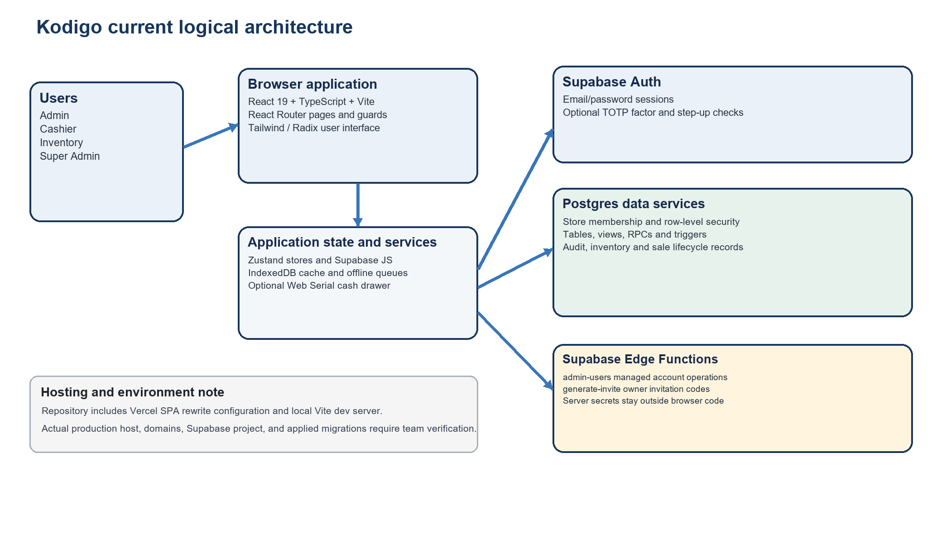

4. Technology choices and rationale
Table 4. Technology stack and design reason
Layer | Current implementation | Reason for use / constraint
Frontend | React 19, TypeScript 5.9, Vite 7 | Component-based interactive UI, typed application contracts, fast local development/build. TypeScript does not replace server authorization.
Navigation and state | React Router 7, Zustand 5 | Route organization and small focused stores for authentication, product, supplier, cart, and alert state.
UI and charts | Tailwind CSS 4, Radix UI primitives, Lucide React, Recharts 3 | Consistent responsive controls, accessible UI primitives, and interactive business charts.
Backend | Supabase Auth, Postgres, row-level security, RPCs, triggers, views, Edge Functions | Managed sign-in and relational storage; database policies and functions enforce rules close to data. Actual target project and plan require confirmation.
Offline | IndexedDB through idb | Browser-local product cache and queues support eligible work during connectivity interruptions; conflict resolution is limited and queues require careful reconciliation.
Hardware and exports | Web Serial for optional ESC/POS drawer command; jsPDF and write-excel-file for exports | Uses browser capabilities for optional peripherals and report output. Printer/drawer compatibility must be tested.
Hosting | Vercel SPA rewrite configuration exists in repository | Actual deployed host, domain, production project, CI release permissions, and hosting cost: OWNER INPUT: confirm deployed configuration and owners.

5. Major modules and functional requirements
Table 5. Implemented module requirements
ID / module | Current behavior supported by repository | Expected result
FR-01 Identity and store context | Email/password sign-in, invite-based owner registration, role resolution, assigned store loading, and role-based route routing. | A user sees only authorized screens and store data.
FR-02 POS and receipts | Search by name/SKU/barcode, cart, unit/bulk options, payment, receipt snapshot, and sales lifecycle actions through database functions. | Sale, sale items, payment details, and stock effects are recorded consistently.
FR-03 Offline continuity | Cache products; queue eligible sales and selected mutations in IndexedDB; attempt replay on reconnect or page activity. | Pending/error state remains visible for reconciliation; business rule errors are not silently treated as network failures.
FR-04 Product and inventory | Product/category maintenance, purchase and selling units, price history, stock adjustment and movement records, archive/restore, and consumption history. | Base stock and its history remain traceable; sold products are archived rather than deleted.
FR-05 Suppliers and purchasing | Supplier records and store links, product supplier assignments, restocking options, purchase orders, receiving functions, supplier scoring, and consignment lots/balances. | Delivery and supplier-owned stock can be distinguished and reviewed.
FR-06 Alerts and notifications | Stock and selling-option conditions create notifications with user read state; report-export and transaction events can be surfaced. | Authorized users can review operational notices for assigned context.
FR-07 Reporting and analytics | Sales and inventory reports, Excel/PDF export paths, revenue/profit/category/hour charts, transaction views, rankings, and velocity. | Users review filtered output and export only within their role.
FR-08 Administration | Store branding and settings, managed staff account operations through admin-users Edge Function, invite generation through generate-invite, password reset, TOTP management. | Authorized changes are attributed and limited to the required store scope.

6. Data model and relationships
The schema is relational and store-oriented. Most operational records carry a store identifier or reach a store through an approved mapping. Row-level security (RLS) means database policies decide which rows an authenticated user can read or change for each request.
Table 6. Core data entities
Domain | Entities evidenced in schema and migrations | Relationship / purpose
Identity and tenancy | `profiles`, `stores`, `store_users`, `invite_codes` | Profiles map to stores through store_users; role and membership scope access.
Catalog and stock | `categories`, `products`, `product_selling_options`, `product_restocking_options`, `stock_adjustments`, `inventory_movements`, `inventory_stock_lots` | Products belong to store/category; stock movements explain sales, receipt, loss, adjustment, and consignment allocation.
Sales | `sales`, `sale_items`, `sale_payments`, `receipts`, `sale_events`, `sale_returns`, `sale_return_items`, `cashier_closeouts` | A sale has line items, payment and receipt records, with lifecycle events for void/refund/return and closeout.
Procurement | `suppliers`, `supplier_stores`, `product_suppliers`, `purchase_orders`, `purchase_order_items` | Supplier-store links support shared suppliers; orders link suppliers and products to receiving events.
Operations and evidence | `notifications`, `notification_user_states`, `audit_logs`, `error_logs`, `receipt_reprints`, `product_price_history` | Operational notices, user read status, errors, audit evidence, reprints, and price history support monitoring and traceability.

The list reflects repository migrations and application queries, not a verified live database inventory. The target project’s applied migration ledger and actual grants must be inspected before release.

7. Data flow and business process
A named user signs in, receives a role and authorized store context, and performs an approved task. An online POS sale goes through the sale-processing RPC, which creates sale and item records and applies inventory effects. During an eligible network interruption, the browser may queue work locally and replay it later. Store staff reconcile any error or duplicate risk before closing the shift. Inventory movement, supplier delivery, alerts, reports, and review complete the operating cycle.
Figure 2. Proposed Kodigo Business Process Flow
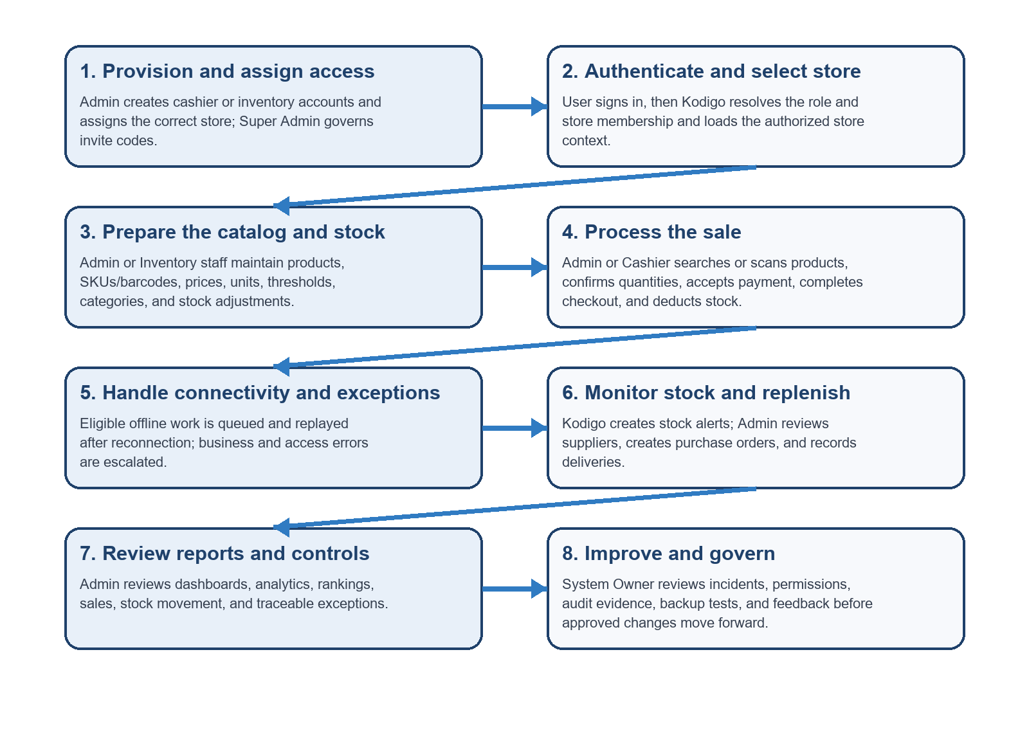

8. Role and permission design
Table 7. Application permission matrix
Capability | Admin | Cashier | Inventory | Super Admin
POS checkout | Execute where enabled | Execute | None | None
Products and stock | Full store control | Read at POS | Manage within assigned scope | None
Stock adjustment / receiving | Manage and approve per local controls | None | Record within role and store scope | None
Suppliers and purchase orders | Manage assigned stores | None | No supplier administration | None
Dashboard / analytics / rankings | Assigned-store view | None | Limited per route | None
Reports | Sales and inventory | None | Inventory-oriented reports | None
Store settings / staff management | Manage assigned stores via supported controls | Own account | Own account | None
Invite governance | None | None | None | Generate owner invitation codes
Account security | Own account | Own account | Own account | Own account

This summarizes implemented route intent and code paths. Database policies are the authority; route guards improve navigation but cannot replace backend enforcement. The exact live permission matrix must be validated against the deployed migration state.

9. Security architecture and risk controls
Table 8. Security controls classified by purpose
Control class | Control evidenced or required | Risk addressed / evidence
Preventive | Supabase Auth sessions; role checks; store membership; row-level security; authorized RPC checks. | Blocks unauthorized access and cross-store operations; validate with role/store test cases.
Preventive | TOTP enrollment and assurance checks for protected operations where enabled; password reset flow. | Reduces account takeover; role-wide MFA requirement and target project settings require confirmation.
Preventive | Server-side admin-users and generate-invite functions; service-role secrets stay in server environment. | Limits privileged user-management operations; verify only required secrets are configured and never expose them in VITE variables.
Preventive | Store-specific active context for POS; database sale/receive/adjustment RPCs; validation and lifecycle rules. | Reduces wrong-store posting and direct stock mutation.
Detective | `audit_logs`, `sale_events`, `inventory_movements`, `error_logs`, closeouts, price history, and export notifications. | Supports accountability and incident reconstruction; retention, access review, and alert ownership must be assigned.
Detective | Quarterly role/store review and release/test evidence. | Detects stale or excessive privileges and unsafe changes; retain dated approval records.
Corrective | Revoke or change access, reset credentials, correct through traceable adjustment/return functions, and preserve error queues. | Contains compromise and repairs records without concealing prior events.
Corrective | Production backup and restore procedure is described in the operations runbook. | Recovery capability depends on a configured backup plan and a successful restore drill; actual state must be verified.

10. Integrations, environments, and service identities
Table 9. Environment and identity inventory
Area | Repository evidence | Access / status | Owner input / evidence
Local development | Vite dev server in `kodigo-ui/`; `.env.example` names public Supabase URL and anon/publishable key. | Developer workstation; do not use production data for routine tests. | Document approved local data and credential handling.
Test / staging | Integration harness expects an isolated project and test credentials; CI workflow is present. | Use only test users and non-production data; service-role key only in protected test environment. | Confirm project ID, owner, migration ledger, access list, and retention.
Production | Application supports Supabase integration; Vercel SPA rewrite config is present. | Deployment existence, domain, plan, and applied migration version are not verifiable from repository files. | OWNER INPUT: name production host/project/domain, owner, region, and applied migration list.
Browser client | VITE_SUPABASE_URL and VITE_SUPABASE_ANON_KEY in example configuration. | Public client key may be delivered to browser; database policies must limit access. | Confirm only public keys are present in VITE build variables.
Edge Function runtime | `admin-users` and `generate-invite` functions; Supabase server environment includes service-role secret by design. | No human login sharing; secret remains in function environment and should be rotated under provider controls. | OWNER INPUT: identify deployed function identities, secret owner, rotation schedule, and emergency access approver.
Backup identity | Operations runbook recommends restricted backup storage and restore roles. | Actual backup subscription, vault, service account, and retention not verified. | OWNER INPUT: name backup operator, restricted storage location, retention, and restore approver.

Migration caution: the repository contains numbered migrations through migration_40 and additional dated migrations. The README setup sequence does not include every newest file. Treat the applied migration ledger in the target Supabase project as the deployment source of truth; do not assume repository files are already deployed or invent an execution order where the environment is unknown.

PART II - SYSTEM GOVERNANCE

11. Governance objectives and structure
Governance assigns decision rights for access, changes, data, security, incidents, backups, and documentation. The deploying organization owns the service and accepts operational and privacy obligations. The roles below are governance assignments; only Admin, Cashier, Inventory, and Super Admin are application roles in the current TypeScript role union.
Table 10. Governance responsibilities
Governance role | Owns / maintains | Approves / decides | Accountability
System Owner / deploying organization | Business purpose, user outcomes, service scope, policy and resource approval. | Accepts business changes, assigns owners, accepts residual risk. | Business impact, support capacity, and service direction.
Admin / store owner | Store configuration, product and staff accuracy, local access, daily reconciliation. | Routine account/store access, stock corrections, and purchase actions under local thresholds. | Store operation and correct, timely escalation.
Cashier | Accurate cart, payment, receipt, and shift handoff. | No role authority to approve own exceptions beyond assigned actions. | Actions performed under own credentials; prompt discrepancy report.
Inventory staff | Catalog, physical counts, movement records, and inventory reports. | Routine stock activity within role; Admin approves unusual changes per policy. | Count accuracy, conversion correctness, and evidence notes.
Super Admin | Owner invite-code governance. | Issue governed owner invitation codes. | Invite issuance and onboarding integrity; no tenant operations.
System Administrator | Supabase configuration, technical access, releases, logs, and recovery work. | Execute approved changes; emergency action under incident authority. | Technical recovery evidence, privileged access, and migration records.
IT Manager / service authority | Risk register, major incident coordination, release oversight. OWNER INPUT: name accountable IT Manager or equivalent. | Approves major changes, emergency access, restoration, and service communications. | Service continuity and closure of corrective actions.
Privacy Contact / DPO | Privacy requests, privacy assessments, notice and retention coordination. OWNER INPUT: identify contact and organization. | Advises or decides privacy response within authority; coordinates any required notification. | Transparent, documented privacy handling.
Developer / technical contributor | Source code and migrations under version control. | No routine production access; contributes reviewed changes. | Tests, review responses, and accurate technical documentation.

12. Decision rights and segregation of duties
Table 11. Decision and approval matrix
Decision | Prepares | Approves | Evidence
Create or change a user/store assignment | Admin | Authorized store owner / manager | Named user, role, store, approver, date, expiry where relevant.
High-impact stock correction | Inventory staff or Admin | Second authorized approver under local threshold | Count, reason, before/after, supporting reference.
Normal code or database change | Developer | Reviewer and release owner | Issue, pull request, tests, migration, release record.
Emergency technical change | System Administrator | IT Manager or delegated incident commander | Incident ID, reason, scope, rollback, time, retrospective review.
Restore or backup-retention change | System Administrator | IT Manager / System Owner | Restore scope, approvals, reconciliation, retention evidence.
Privacy request or disclosure | Privacy Contact with system support | Privacy authority under organization policy | Request, identity verification, decision, disclosure/correction/deletion evidence.

Where project staffing is too small for full separation, the System Owner records the conflict, appoints an independent reviewer for high-risk actions, and retains evidence. No single person should silently request, approve, implement, and close their own high-impact production change.

13. Access governance lifecycle
1. Request: document the user, business duty, role, store scope, start date, duration, and any privileged need.
2. Approve: Admin or designated owner validates identity and need; an independent approver reviews high-risk or cross-store access.
3. Provision: use the managed user function and invite flow selected for production; record the resulting role/store mapping.
4. Review: at least quarterly, compare active users, roles, and store assignments with current duties; record decisions and exceptions.
5. Revoke or change: remove access on separation, role change, compromise, or end of assignment; preserve transaction attribution and reconcile pending offline work.
6. Privileged access: restrict to named administrators, use MFA where enforced, approve and time-bound support access, and review after use.
Production invite path: the repository UI currently calls the generate-invite Edge Function. Confirm the target project deployment, authorization policy, and administrator recovery path: OWNER INPUT: name production invite owner and supported recovery procedure.

14. Data and privacy governance
The deploying organization determines why personal information is collected, provides the required notice, assigns a Privacy Contact, approves retention, handles rights requests, and assesses incidents. Kodigo can contain names, email addresses, roles, store assignments, supplier contact details, sales and stock activity, payment method and limited reference, audit events, error context, exports, and device/browser details when linked to a user.
Kodigo must not store full card numbers, PINs, one-time passwords, or wallet passwords. Ordinary cash checkout does not require customer identity; collect customer details only where a defined and approved feature requires them.
Privacy handling should be implemented and reviewed in accordance with Republic Act No. 10173, the Data Privacy Act of 2012, its Implementing Rules and Regulations, and applicable National Privacy Commission issuances. This documentation is not a claim that Kodigo is legally certified or formally compliant.
Official reference texts (checked 5 October 2026): Republic Act No. 10173; National Privacy Commission Implementing Rules and Regulations
Table 12. Privacy governance fields to complete
Required field | Project-team action
Responsible organization | OWNER INPUT: insert deploying organization legal name.
Privacy Contact / DPO | OWNER INPUT: insert name/title and authorized privacy contact.
Official contact details | OWNER INPUT: insert official email and business address.
Retention schedule | OWNER INPUT: approve retention periods by record class and legal/business need.
Incident channel and notification authority | OWNER INPUT: approve support channel, response owner, and external notification decision process.

15. Risk management
Table 13. Initial project risk register
Risk and evidence | Potential effect | Control / owner | Open status
Deployed database may not match repository migration set; several new migrations and dated files exist. | Policies or columns expected by UI may be missing or different. | System Administrator compares applied ledger, policies, functions, grants and triggers before release. | Deployment state requires confirmation.
Offline browser queues have limited conflict handling. | Duplicate, rejected, or stale changes may affect sales and stock. | Admin reconciles pending work; system owner defines offline eligibility; test queue replay and exceptions. | Resolve error items; do not clear browser data.
Privileged operations depend on Edge Function secrets and deployment. | User administration or invite flow may fail or be misconfigured. | Restrict server secrets; verify function auth and role checks; use one documented production path. | Confirm deployment and secret ownership.
MFA enforcement may differ by role or Supabase project settings. | Sensitive accounts could have inconsistent protection. | Confirm policy and required roles; test TOTP and step-up flows. | Deployment and policy confirmation.
Backup plan is described in a runbook but actual subscription, schedule, and restore test are unverified. | Recovery may be unavailable or incomplete. | System Administrator verifies daily backup, 30-day restricted retention baseline, and restore drill; IT Manager approves. | Attach evidence before production acceptance.
Policy owner, service channel, legal identity, and budget are not in repository evidence. | No clear accountability or resourcing for support and privacy response. | System Owner assigns accountable contacts, cost center, and response coverage. | Project team confirmation required.
Generated screenshots and reports may expose store, user, or sales information. | Unnecessary disclosure in academic or public distribution. | Review/redact test data where needed, restrict distribution, and retain only approved evidence. | Review before publication.

16. Change, release, and configuration management
Table 14. Repository and release standards
Area | Required standard
Source of truth | Latest applied SQL migration ledger first; then current runtime code and Edge Functions; then architecture and maintainer documents; baseline schema is not final RBAC state.
Database changes | Add a new ordered migration; do not rewrite an already shared/applied migration. Review policy impact, data migration, rollback, and documentation.
Naming and structure | Use descriptive migration filenames; snake_case database identifiers; keep feature UI in the existing components/pages/stores/lib folders; update role types, routes, navigation, RLS, validators and docs together.
Environment values | Browser values use VITE_SUPABASE_URL and VITE_SUPABASE_ANON_KEY only. Never place service-role secrets in VITE variables, source control, or browser bundles.
Review and testing | Use a reviewed change request; run npm ci, typecheck, lint and build; run integration tests only against an isolated test project with explicit opt-in.
Deployment | Verify target environment and migrations, deploy required Edge Functions, inspect secrets, run smoke tests, and record release/rollback references. Vercel config is present; actual production setup requires confirmation.
Rollback | Prefer frontend/function rollback for code issues; for schema/data damage, restore a verified backup to an isolated replacement and validate before promotion.

17. Incident management and escalation
The ITIL-aligned workflow logs, categorizes, assesses impact and urgency, assigns priority, diagnoses, escalates when needed, validates recovery, and records lessons. Tier 0 and Tier 1 handle self-check and store impact; Tier 2 investigates technical faults; Tier 3 coordinates major, privacy, vendor, or emergency decisions.
Figure 3. ITIL-Aligned Incident Management and Escalation Process
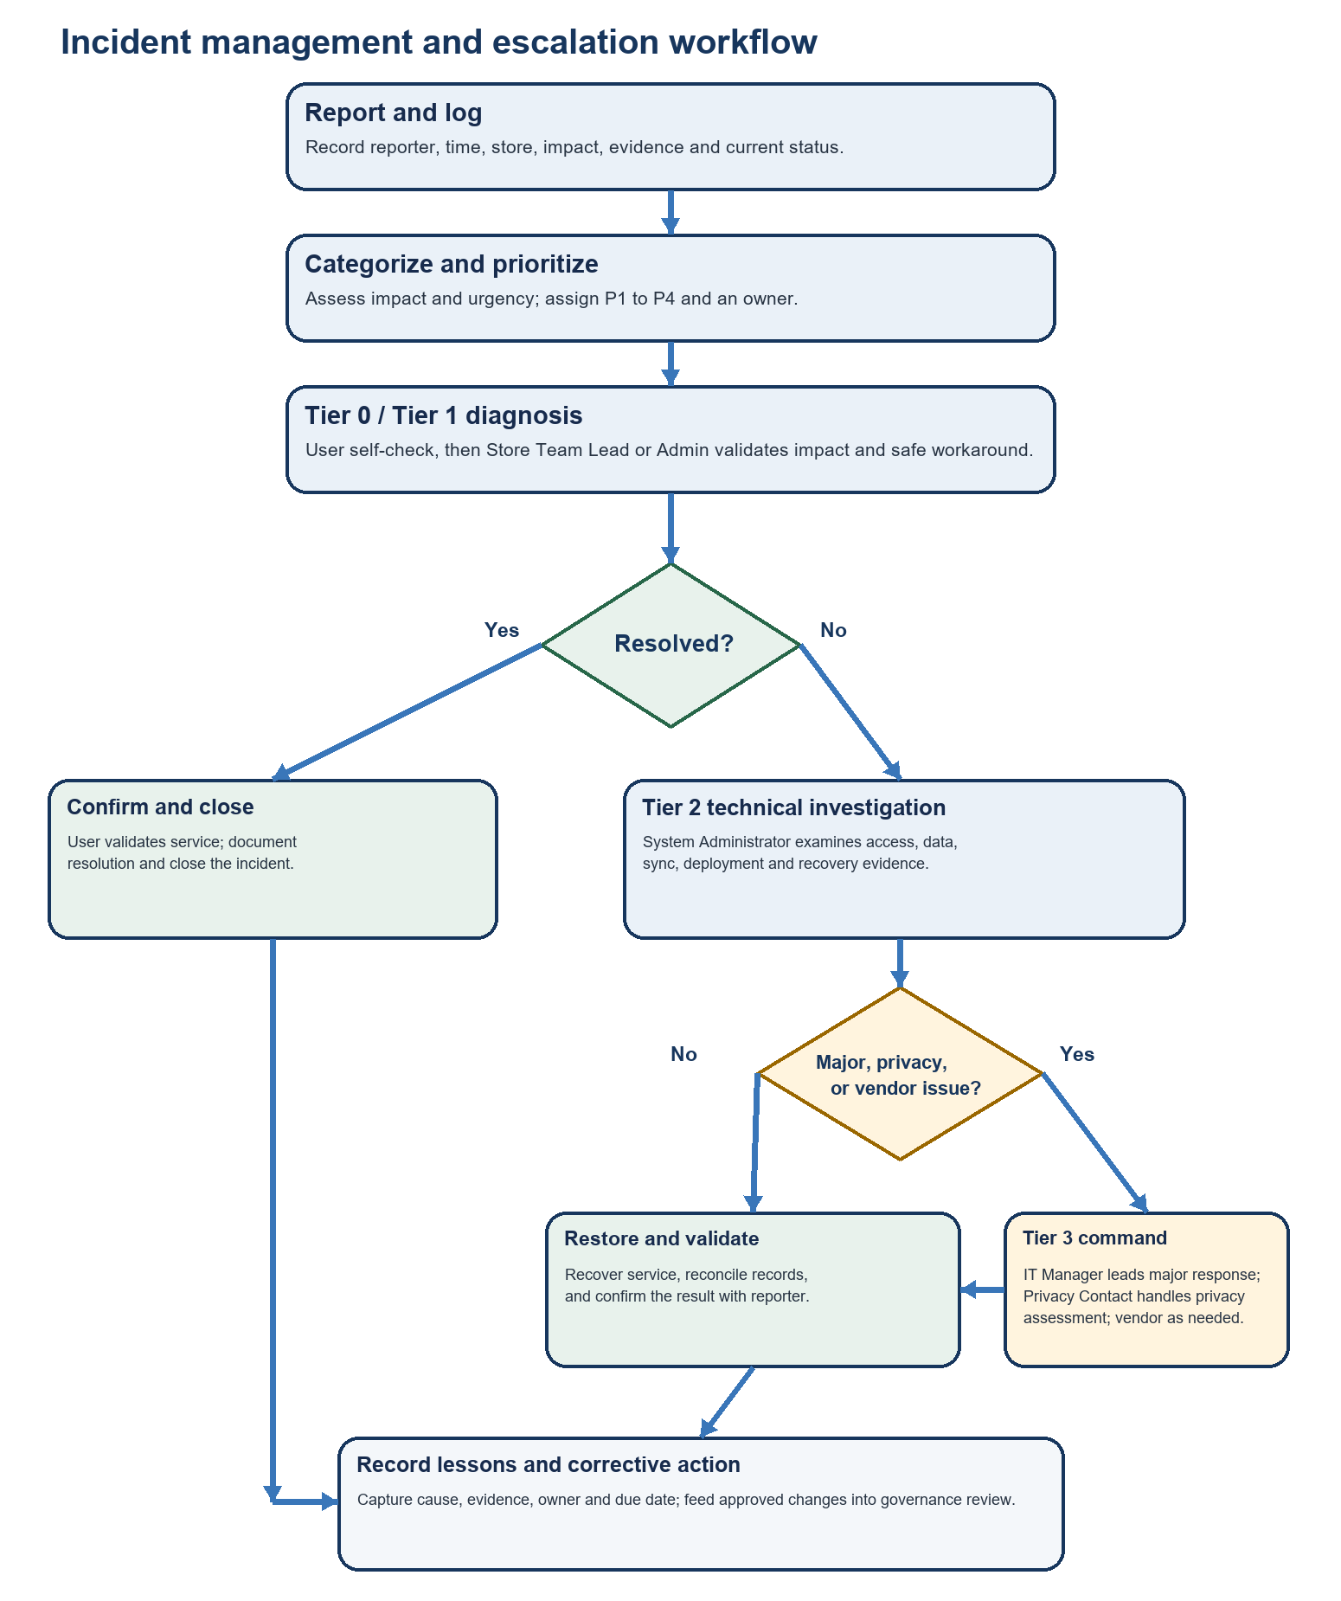
Table 15. Proposed response targets for capstone operations
Tier / priority | Trigger | Target / action | Owner
Tier 0 | Single-user how-to or known warning; no security or data concern. | Immediate self-check; up to 10 minutes. | User.
Tier 1 | Persistent issue, cash discrepancy, one terminal/store, or access request. | Acknowledge P1/P2 within 15 minutes; P3 within one business hour; aim for workaround within one hour. | Store Team Lead / Admin.
Tier 2 | Multi-user issue, failed sync, suspected database/access defect, checkout outage, incorrect data. | Acknowledge within 30 minutes; P1 restore/workaround target 4 hours; P2 one business day. | System Administrator.
Tier 3 | Major outage, privacy/security event, restore/emergency change, vendor/legal impact. | P1 acknowledge within 15 minutes; update stakeholders every 60 minutes; incident commander sets recovery target. | IT Manager; Privacy Contact for privacy.
P1 / P2 / P3 / P4 | Priority reflects service and data impact; P4 is a request or planned change. | P1 immediate escalation; P2 validate/escalate quickly; P3 standard queue; P4 change/service-request process. | Assigned incident owner.

These values are proposed capstone operating targets carried forward from the prior manual. The deploying organization sets its service hours, measurement rules, holidays, communication channel, and assigned owners in its operations runbook. These targets are not contractual service-level agreements.

18. Backup, recovery, audit, and monitoring responsibilities
Table 16. Operational ownership
Control activity | Responsible | Review / approval | Evidence
Daily production backup and restricted retention | System Administrator / provider operator. | IT Manager or System Owner. | Provider backup status, retention configuration, access list.
Pre-migration backup and deployment | System Administrator. | Release approver. | Backup reference, migration log, test evidence.
Restore rehearsal | System Administrator. | IT Manager verifies reconciliation and acceptance. | Restore test project, row-count checks, smoke-test record.
Audit and error review | System Administrator and Admin within assigned scope. | IT Manager for elevated or major cases; Privacy Contact for personal data cases. | Dated review notes, incident links, corrective actions.
Rollback / incident record | System Administrator or incident lead. | IT Manager / incident commander. | Timeline, impact, cause, evidence, recovery and due dates.

The production operations runbook recommends daily Supabase backups, a manual backup before schema deployment, weekly exports of business-critical tables, restricted storage, at least 30 days of backup retention, and restore validation in a separate environment. These are the documented baseline recommendations; the deploying organization must verify that its subscription and configuration actually provide them.

19. User feedback and post-launch improvement
The repository does not show a dedicated in-app feedback module. The System Owner uses the organization's support or feedback channel and maintains a feedback log with issue, role/store affected, frequency, business impact, evidence, decision, owner, and due date.
1. Collect user feedback during onboarding, support incidents, and a scheduled post-launch review.
2. Group feedback into usability, reliability, data accuracy, access, and privacy themes; protect personal data in the record.
3. Prioritize changes by operational harm, user frequency, legal/privacy impact, and implementation effort.
4. Approve a change, assign an owner and due date, test in an isolated environment, and publish the release note or user instruction update.
5. After release, ask the reporting users whether the change solved the problem and record any remaining issue.
Feedback channel and review cadence: OWNER INPUT: name the support/feedback tool, accountable reviewer, and meeting schedule.

20. Documentation ownership, training, and review
This document set is Version 1.3 | 5 October 2026. Document owner: Evon Christian P Vergara. The owner maintains alignment with the application, migration chain, and operating procedures. The peer-review rubric audit is complete; no separate document approval is required. Future technical or policy changes follow the normal change-control process.
- Review at least annually and after material changes to roles, privacy processing, sale lifecycle, inventory controls, hosting, or incident ownership.
- Use version history in the project repository; record change summary, author/reviewer, approval, effective date, and replaced version.
- Keep controlled templates for access requests, risk reviews, incident records, restore tests, release approval, and user acknowledgment.
- Train Admins and Cashiers on sales and cash controls; Inventory staff on units, counts, and adjustments; privileged staff on access, MFA, privacy, and recovery.
- Retain attendance and practical competency evidence in an organization-approved restricted location.

21. Feasibility, rollout sequence, and resource plan
The repository documents a working application, frontend build tools, Supabase integrations, and optional hardware integration. It does not include an approved capstone calendar, labor estimate, hosting budget, subscription tier, device count, or support staffing commitment. The staged plan below is a sequence of work gates; the project team must enter owners, dates, and cost values.
Table 17. Indicative delivery sequence and owner inputs
Milestone | Completion evidence | Owner / target date
1. Confirm scope, owner, environment, and migration ledger | Approved scope, deployed-project inventory, role matrix and privacy contacts. | OWNER INPUT: assign owner and date.
2. Complete staging hardening and acceptance tests | Role/store tests, POS and offline evidence, restore drill, risk disposition. | OWNER INPUT: assign owner, environment, and date.
3. Train users and approve policies | Signed AUP/BYOD records, training attendance and competency checks. | OWNER INPUT: set user count, trainer and date.
4. Controlled release and operational handover | Release approval, backup evidence, support route, rollback and incident roster. | OWNER INPUT: assign approver and date.
5. Post-launch review | Feedback themes, metrics, incidents and prioritized improvement actions. | OWNER INPUT: set review date and cadence.

Table 18. Resource and budget inventory
Resource | Known project evidence | Cost / quantity to confirm
Software and development | React/Vite source, repository, npm toolchain, TypeScript, browser test environment. | OWNER INPUT: confirm labor roles/hours and any paid developer tools.
Cloud services | Supabase Auth/Postgres/Edge Functions and Vercel SPA rewrite configuration are used or referenced by code/config. | OWNER INPUT: identify active provider plans, monthly cost, database/storage/egress assumptions.
Devices and peripherals | Modern browser workstation; optional barcode scanner, printer, and Web Serial cash drawer. | OWNER INPUT: list device count, existing vs purchased items, and unit/total cost.
Training and support | Role-based user onboarding and incident handling are required by this governance plan. | OWNER INPUT: assign trainer/support coverage and effort.
Backup and recovery | Operations runbook recommends restricted backup storage and restore tests. | OWNER INPUT: confirm plan cost, retention, storage size, and restore labor.

22. Course concept integration and evidence
Table 19. Course concepts applied to Kodigo
Concept area | Application in this design and governance | Evidence / section
Module 6: documentation ownership and version control | Named owner, version/date, controlled templates, scheduled review, and repository history. | Document Control; Sections 16 and 20.
Modules 7-9: security principles and CIA | Least privilege, store scoping, named accounts, confidentiality of exports, integrity of sale/movement records, availability through queueing and recovery. | Sections 8, 9, 13 and 18.
Modules 7-9: preventive, detective, corrective controls | Controls are explicitly classified and tied to account, record, and service risks. | Section 9.
Module 10: user feedback and improvement loop | Collect, triage, approve, implement, release, and re-check user feedback after launch. | Section 19.
Module 11: compliance and privacy responsibility | Data Privacy Act framework, responsible organization, privacy contact, rights requests, breach escalation, and no unsupported certification claim. | Section 14.
Module 12: evidence-based proposal and readiness gates | Repository facts, measurable acceptance criteria, deployment-specific inputs, and operational readiness gates are explicit. | Sections 2, 10, 21 and 24.

23. Rubric traceability
Table 20. Peer review rubric criterion to document sections
Rubric criterion | Documents / sections carrying the requirement | Original assessment | Status after revision
1. Clarity and Completeness | System Design and Governance 1–2; User Manual 1–2; document controls in all four files. | Partial: purpose and users appeared; measurable outcomes and delivery ownership were incomplete. | Addressed. Remaining owner inputs are deployment details, not document-approval gates.
2. System Design and Requirements | System Design and Governance 3–10; Figures 1–2; acceptance measures; user-facing flows in User Manual. | Partial: diagrams and modules existed, but technical architecture, current features and environment state were stale/incomplete. | Addressed from repository evidence; live environment and migration state are explicitly identified as owner-input evidence.
3. Governance, Security and Compliance | System Design and Governance 11–20; Acceptable Use Policy 3–11; BYOD Policy 2–9. | Partial: RBAC, incidents and privacy notice existed; organizational authority, control classification, and enforcement detail were incomplete. | Addressed with explicit controls; named contacts and live backup/service configuration remain owner inputs.
4. Course Concept Integration | System Design and Governance 17, 19–20, 22; AUP 4–10; BYOD 3–8. | Partial: COBIT/ITIL/CIA appeared but concepts did not consistently shape control design or post-launch feedback. | Explicitly mapped to controls and governance sections; course-specific module wording should be checked by adviser.
5. Feasibility and Documentation Quality | All four controlled documents; System Design and Governance 21, 24; User Manual procedures and screenshots. | Partial: professional manual existed but combined policy/system content; dates, budget, schedule and technical caveats were absent or stale. | Four final deliverables; costs, staffing, calendar dates, and live production settings are labeled as owner inputs rather than assumed facts.

24. Owner inputs for deployment-specific details
- Organization and accountability: legal organization name, System Owner, policy exception authority, IT service authority, Privacy Contact/DPO, and support channel.
- Database state: target Supabase migration ledger compared with repository migrations through migration_40 and dated additions; record applied state and drift.
- Environment and security: production/staging hosts and domains, Supabase projects, Edge Function deployment, public browser keys, and protected service-role secret owner.
- Operating controls: role-specific MFA settings, access-review owner, incident service hours and targets, backup retention, restore authority, and data-retention schedule.
- Rollout and resources: milestone dates, assigned people/hours, itemized provider/device/training costs, and funding source.
- Review live screenshots for any personal, supplier, or transaction data before wider academic or public distribution.
Final document status: peer-review rubric audit complete (19/25, Good). Document owner: Evon Christian P Vergara. Section 24 lists deployment-specific owner inputs for operational records; it is not a document-approval request.

