KODIGO

Kodigo User Manual
Step-by-step operating instructions for Kodigo store teams
Table 1. Document Control
Control | Value
Version and date | Version 1.3 | 5 October 2026
Status | Final owner-issued edition. Peer-review rubric audit complete: 19/25 (Good).
Document owner | Evon Christian P Vergara
Approval status | No separate approval required for this final document issue.
Review cycle | Review at least annually and after material system, role, privacy, or workflow changes.
Evidence basis | Repository implementation and supporting project documents reviewed on 5 October 2026. Live deployment facts are not claimed unless evidenced.

Final owner-issued edition following the supplied peer-review rubric audit. Deployment-specific input fields are operational details, not document-approval gates.

Contents
Contents 2
1. About this manual 3
2. Roles and access 3
3. Sign in and choose a store 3
4. Navigation and screen overview 3
5. Process a sale 4
5.1 Returns, refunds, voids, and closeout 4
6. Work during a connectivity interruption 4
7. Manage products and inventory 5
7.1 Add or edit a product 5
7.2 Adjust or receive stock 5
7.3 Archive products and review stock activity 5
8. Stock alerts, restocking, suppliers, and purchase orders 5
9. Dashboard, analytics, rankings, and reports 6
10. Manage users, store settings, and account security 6
10.1 User and store access 6
10.2 Store branding and notifications 6
10.3 Password and authenticator settings 6
11. Troubleshooting 6
12. Ask for help and provide feedback 7
13. Interface screenshots 7
14. Quick end-of-shift checklist 13

1. About this manual
This manual explains how store owners and staff use Kodigo for checkout, inventory, suppliers, purchasing, reporting, account access, and incident handling. Kodigo is a browser-based point-of-sale and store-operations application for sari-sari stores and small retail branches. It connects sales and inventory records so staff can reconcile transactions, monitor stock, and make replenishment decisions.
Use the role assigned to your account. If the screen, store, or available action differs from these steps, stop before posting a transaction and ask the Admin to verify your access. Screenshots in Figures 1–6 were captured from the project build on 15 September 2026; later interface releases may differ.

2. Roles and access
Table 1. Application roles and everyday duties
Application role | Main work | Access boundary
Admin | Store administration, staff accounts, product and supplier management, reports, analytics, notifications, settings, and sales actions where enabled. | Limited to assigned stores; approves operational changes and access.
Cashier | Point-of-sale checkout, payment confirmation, receipts, and transaction handoff. | POS-focused; cannot use administrative modules.
Inventory | Products, stock counts and adjustments, restocking and inventory-oriented reports. | Cannot access sales management, supplier administration, or general admin modules.
Super Admin | Owner invite-code governance and onboarding. | Does not manage tenant store operations.

A technical support or Privacy Contact role is an organizational duty, not a fifth Kodigo application role. Ask your organization who holds those responsibilities.

3. Sign in and choose a store
1. Open the organization’s approved Kodigo address and sign in with your assigned email and password.
2. If you cannot sign in, use Forgot Password or request a managed password reset from the Admin. Support staff must never ask for your current password.
3. After sign-in, check your name, role access, and the active store shown in the top bar. If you work in several branches, select the branch where you are working.
4. The All Stores context is for authorized aggregate review only. POS checkout requires one specific active store.
5. If no store appears or the wrong store is selected, do not create a sale, product, adjustment, or purchase order. Ask the Admin to correct the store membership.
6. Use Logout when finished, especially on a shared terminal. Closing a browser tab alone may leave the session active.
Account Security is available to users for supported password and authenticator settings. Kodigo supports TOTP authenticator enrollment and verification where enabled by the organization. Follow the security instructions shown in the application; never share a one-time code.

4. Navigation and screen overview
Table 2. Main modules
Screen | What it is for | Typical result
Dashboard | Review daily sales indicators, best-selling products, recent transactions, and stock alerts. | A store-level operational summary.
POS Terminal | Search or scan items, build a cart, take payment, and issue a receipt. | A completed sale or an explicitly pending offline sale.
Product Management | Maintain product details, units, prices, active status, stock, movement history, restocking, and consignment views. | Updated catalog or documented inventory event.
Suppliers | Maintain supplier records and view purchase and delivery details. | A supplier record linked to one or more authorized stores.
Analytics and Rankings | Review time-based revenue, profit, category, hourly, transaction, and product-ranking data. | Filtered summaries based on the selected store and dates.
Sales Reports | Generate sales and inventory reports and approved exports. | A workbook or PDF report, with export notification where configured.
Settings | Manage store branding, assigned users, notification preferences, and account security. | Updated store or account configuration.

5. Process a sale
Before checkout, confirm the active store and make sure the product, price, and quantity shown match the customer’s request. POS writes an online sale through the database sale-processing function. Eligible offline sales are stored in the browser queue for later replay.
1. Open POS Terminal. If prompted, select a specific active store; do not transact in an All Stores view.
2. Find an item by name, SKU, or barcode. Press F2 to focus search. A supported USB or Bluetooth scanner that types barcode text may be used.
3. Select the correct product or selling option. For unit or bulk options, verify the label, quantity, and displayed price. Stock is tracked against the product’s base units; bulk availability is derived from that stock.
4. Review the cart line by line. Correct accidental items and quantities before charging.
5. Choose Charge or press F9. Select the supported payment method. For cash, enter the cash received and verify the displayed change.
6. For a digital payment method, enter only the supported method and limited reference requested by the screen. Never enter a full card number, PIN, OTP, or wallet password.
7. Confirm the total, accept payment, and wait for the completion message. Do not repeat checkout because the screen is slow.
8. Review the generated receipt. Print or reprint only under the organization’s procedure. The optional cash drawer requires compatible hardware, browser support, and permission.

5.1 Returns, refunds, voids, and closeout
These actions affect cash and inventory. Open the transaction lifecycle or closeout action available to your role, find the original sale, verify the receipt and items, record a clear reason, and obtain any required Admin approval. Returned quantities and whether they return to stock must be verified before submission. Do not delete a sale to hide an error; use the supported void, refund, or return action so the transaction remains traceable.

6. Work during a connectivity interruption
Kodigo may use a local product cache and IndexedDB queues for eligible sales and selected changes. An offline operation is not confirmed as synchronized until Kodigo reports successful replay.
1. Continue only if the screen explicitly allows offline work and the correct store is active.
2. If the sale is shown as pending, do not repeat it. Note the time, terminal, and receipt or sale reference shown.
3. Keep the browser profile intact. Do not clear browsing data, use private mode, switch profiles, or uninstall the browser while work is pending.
4. Reconnect to the approved network and leave Kodigo open. Wait for the queue to replay and check for success or rejection messages.
5. If a permission, database, or store-access error appears, stop retrying and contact support. Such errors may not be safe to queue as network failures.
6. After synchronization, reconcile receipts and stock. Escalate any missing, duplicated, or rejected transaction.

7. Manage products and inventory

7.1 Add or edit a product
1. Open Product Management and select the specific store. Choose Add Product or open a product to edit it.
2. Enter a unique SKU, product name, category, base selling unit, cost, selling price, starting stock, alert thresholds, and optional barcode or image.
3. Where applicable, configure how the product is received from a supplier (for example, case or pack) and the conversion into base units. Check the conversion carefully before saving.
4. Optional unit and bulk selling options define separate labels and prices but draw from the same base-unit stock. Review every conversion and bundle price before making it available at POS.
5. Save and check that the product appears under the correct store with the expected stock and status.

7.2 Adjust or receive stock
1. Count the physical stock before changing the system quantity.
2. Open the product’s stock adjustment action. Record the amount, reason (such as restock, damaged, expired, lost, manual count, conversion, or other), and a useful note.
3. For a supplier delivery, choose the receiving unit and confirm the conversion to base units, quantity, and total cost. Do not mark a purchase order received until goods and quantities have been checked.
4. For consigned stock, identify the supplier who owns the goods, record required quantity and amount owed, and verify the ownership and supplier fields before saving.
5. Review the before-and-after stock and movement/adjustment history. Ask the Admin to approve unusual or high-impact changes under local rules.

7.3 Archive products and review stock activity
Archive a product when it should no longer appear in active inventory or POS. Products with sales history must be archived rather than hard-deleted so historical reports remain intact. Use the active/archived filter to locate records. The movement history and sales-velocity panels help explain stock changes and consumption; verify the store and date filters before acting on a recommendation.

8. Stock alerts, restocking, suppliers, and purchase orders
1. Open Notifications or the Restocking tab to review low, critical, and out-of-stock alerts. Product or selling-option alerts may depend on configured thresholds.
2. Confirm the physical count, pending offline transactions, and recent deliveries before preparing a reorder.
3. Review the proposed quantity, base unit, supplier, lead time, recent consumption, and available purchasing unit. Suggestions are decision support, not automatic orders.
4. Create a purchase order for the correct supplier and store. Check each product, quantity, unit cost, and expected delivery before sending.
5. Use the supported Sent, Received, or Cancelled status. Select Received only after checking the delivered goods. Supplier score or history may refresh from the recorded order and delivery events.
6. For a shared supplier, check which stores it serves and which products are linked to it. Do not expose or edit another store’s supplier data without authorization.
7. The Consignment view displays supplier-owned stock and settlement balances where configured. Confirm payment and reconciliation outside Kodigo unless a deployed feature explicitly provides a settlement transaction.

9. Dashboard, analytics, rankings, and reports
Dashboard shows daily revenue, transaction count, average order value, estimated profit, recent transactions, best-selling products, and stock alerts for the selected context. Analytics supports Today, 7-day, 30-day, and 90-day views with revenue/profit, hourly, category, and transaction information. Rankings aggregates sales by product for a selected period.
1. Confirm the active store or authorized aggregate before interpreting results.
2. Choose the date range and filters, then refresh and review the totals before export.
3. Check sale status filters so voided, refunded, or returned transactions are included or excluded as intended.
4. Inventory users may access inventory-oriented reports; sales reporting and export access follows the assigned role.
5. Store reports only in an approved location. Apply the organization’s retention period and delete obsolete copies securely.

10. Manage users, store settings, and account security

10.1 User and store access
1. Admins open Settings > User Management to list, invite/create, update, reset, or remove managed staff accounts through the server-side admin-users function where deployed.
2. Before creating or changing an account, verify the person, role, store assignment, and approval. Assign the least access needed.
3. Remove access promptly when a person leaves or changes roles. Review pending offline work before device/browser cleanup.
4. Super Admin uses the invite-governance screen for owner registration codes and does not manage normal store operations.

10.2 Store branding and notifications
In Settings > General, an Admin can maintain store name, registered/business name, tax registration and rate, TIN and branch details, terminal identifier, receipt text, contact details, address, and logo. Confirm legal and tax values with the deploying organization before saving. Notification preferences control available operational summaries; the actual options depend on the screen and deployment.

10.3 Password and authenticator settings
1. Use Account Security or Settings > Security as available for your role to change your password through the authenticated account flow.
2. To enable TOTP, open the two-factor authentication panel, scan the QR code in an authenticator app or enter the setup key privately, then enter the current six-digit code and choose Verify and enable.
3. Treat the QR code, setup key, and one-time codes as secrets. Do not send them to support.
4. Removing an authenticator factor may reduce protection and can change which protected actions are allowed. Follow the organization’s account recovery process if you lose access.

11. Troubleshooting
Table 3. Common issue and safe response
Problem | Likely cause | Safe response
Cannot sign in | Incorrect password, reset needed, missing profile or role. | Use Forgot Password; ask the Admin to verify the account and role. Do not share your password.
No store or wrong store | Membership missing or stale active-store selection. | Stop before posting; refresh or sign in again; ask the Admin to verify assignment.
POS unavailable | Role or device restriction, network issue, or service outage. | Check assigned role, active store, and network; capture the message and use the approved continuity process.
Barcode not found | Wrong code, inactive/missing product, scanner mode issue. | Search by name or SKU; verify product and scanner input before creating anything.
Sale appears pending | Offline queue or slow connection. | Do not repeat the sale. Reconnect, wait for sync, and reconcile using time and receipt reference.
Stock is incorrect | Unreceived delivery, unsynchronized sale, or wrong adjustment. | Count physically; review sale, movement, adjustment, and PO history; record an approved correction.
Report totals differ | Store/date/status filters or pending sync. | Confirm context and filters, wait for sync, compare transaction status, and send relevant IDs to support.
Cash drawer fails | Unsupported browser, insecure context, missing permission, cable, or hardware issue. | Use compatible HTTPS/localhost, reconnect, grant permission only after an approved user action, and use manual cash handling.
Access denied or database error | Role/store policy or database rule blocks the action. | Do not bypass or retry repeatedly. Verify assignment and escalate with the exact message.
App appears stale | Cached data or inactive page. | Check connection, bring the tab forward, refresh when safe, and preserve pending offline data.

12. Ask for help and provide feedback
Use the organization’s approved support channel. Include your name and role, store, date/time, screen, action, expected and actual result, error message, business impact, and relevant transaction/product reference. Redact unnecessary personal information from screenshots. Never include a password, OTP, full card number, or wallet password.
Support channel and service hours: OWNER INPUT: publish current support contact and operating hours.
To suggest an improvement, describe the task, the point of difficulty, expected result, and how often it occurs. The organization should log and review user feedback through its approved support or feedback record; a dedicated feedback feature in Kodigo is not confirmed by the repository.

13. Interface screenshots
These images are live captures from the project build dated 15 September 2026. They illustrate representative screens and sample data; labels, data, and layout may change in a later deployment. Figure 1 shows sign-in; Figure 2 shows the dashboard and active store; Figure 3 shows the POS search and cart; Figure 4 shows product management; Figure 5 shows supplier management; Figure 6 shows settings and account security.
Figure 1. Kodigo Login Interface
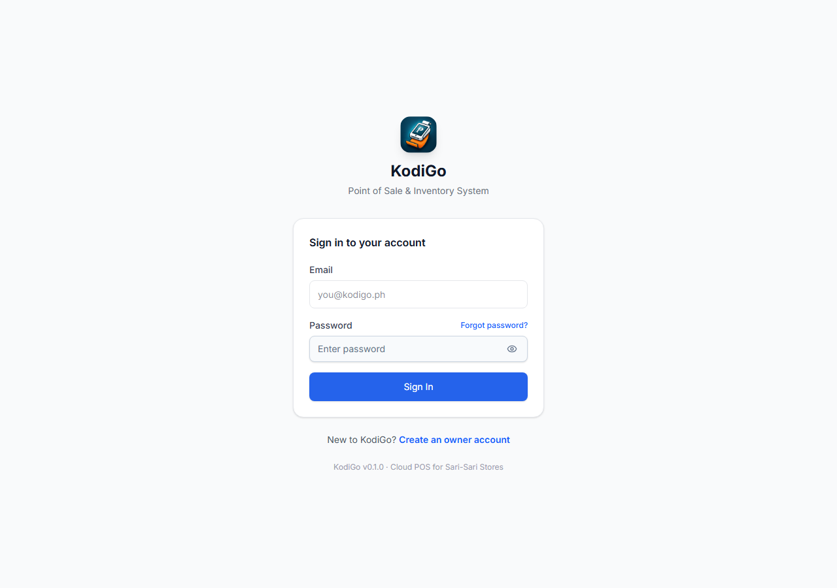

Figure 2. Dashboard and Active Store Context
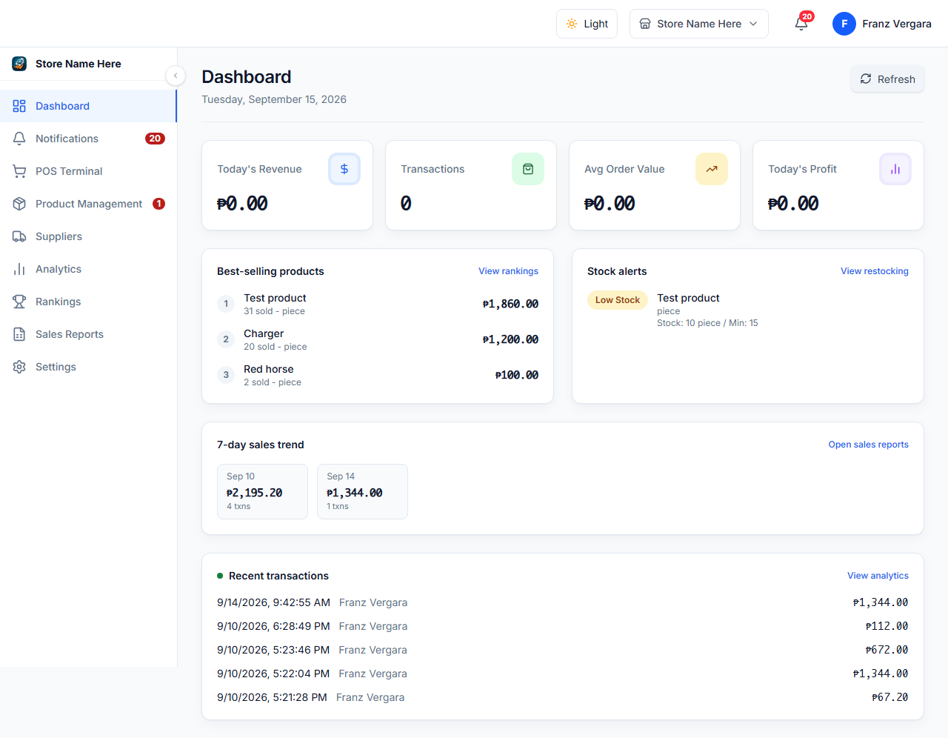

Figure 3. POS Terminal and Product Search
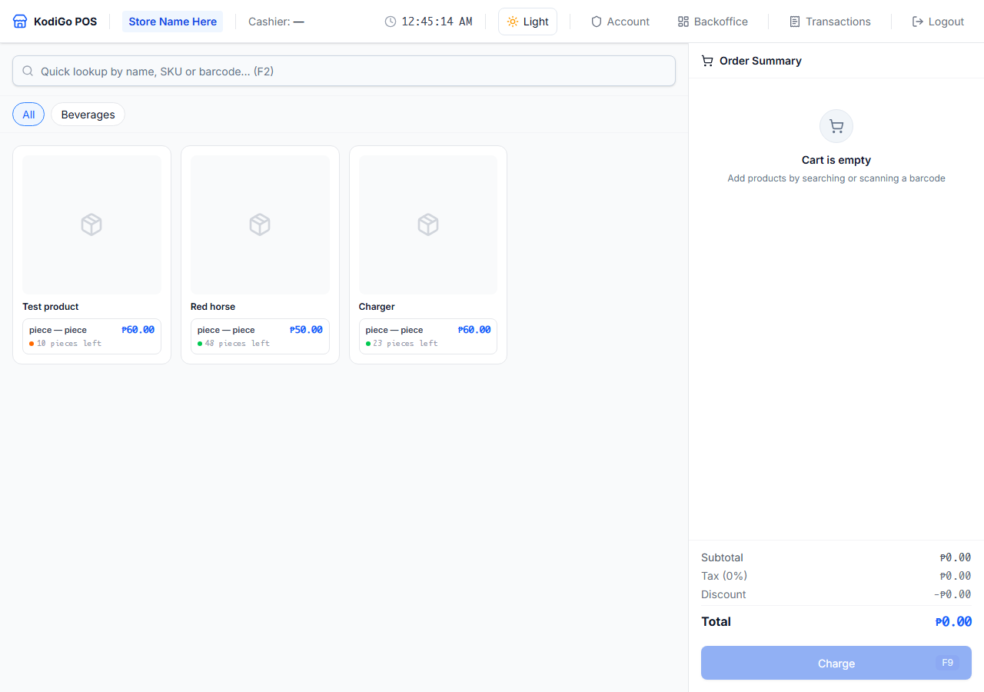

Figure 4. Product Management and Inventory
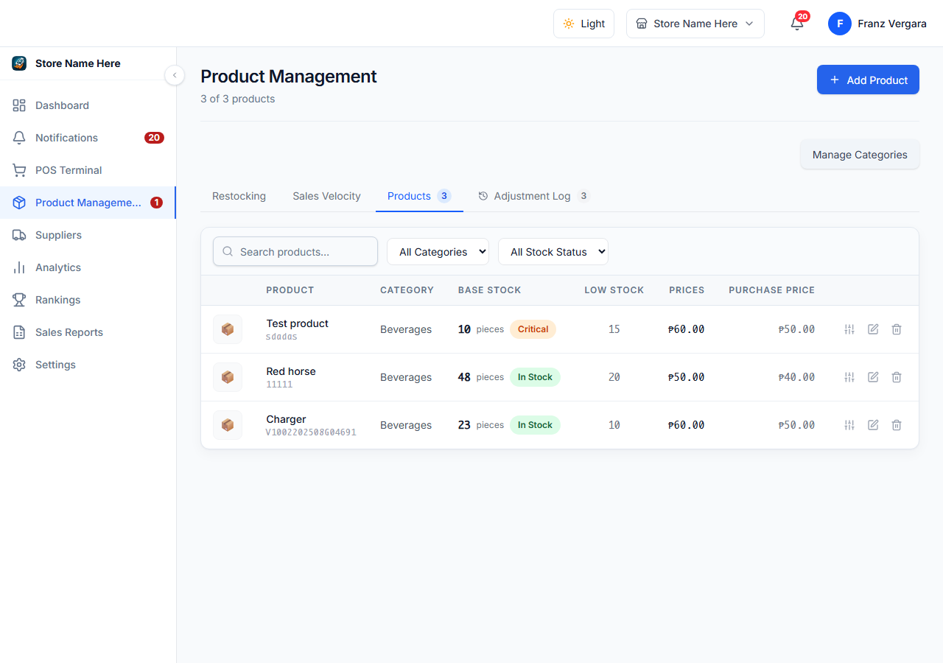

Figure 5. Supplier Management
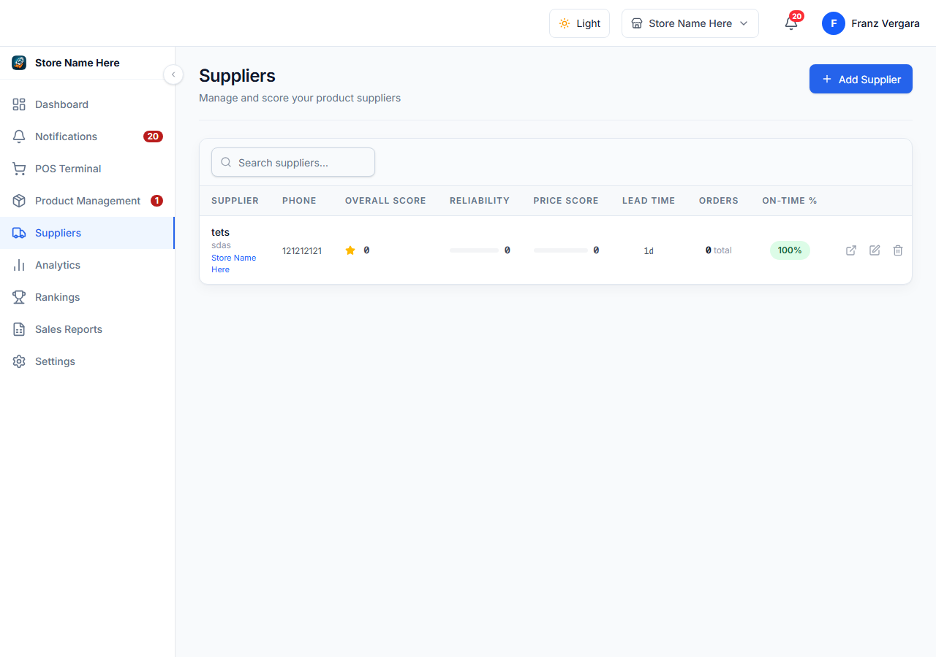

Figure 6. Settings and Account Security
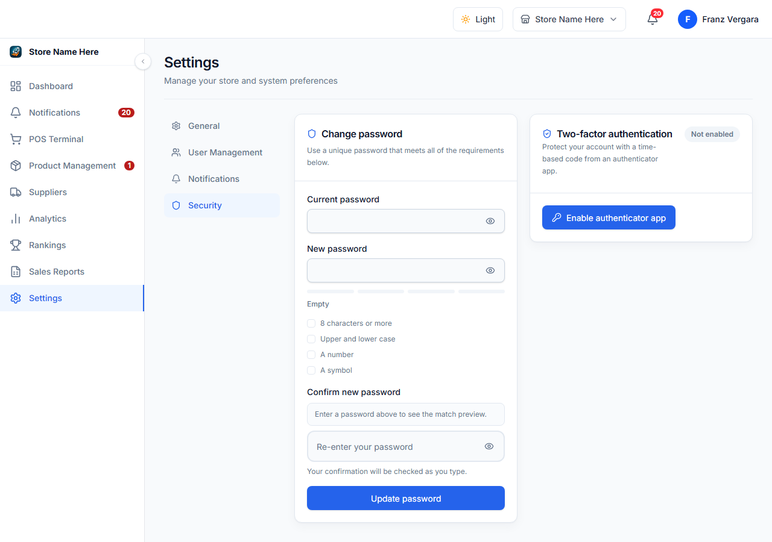

14. Quick end-of-shift checklist
- Complete or cancel open carts; do not leave an ambiguous payment screen.
- Confirm pending offline transactions synchronized or hand them over to the next shift with references.
- Complete the approved cash closeout and record any variance.
- Secure receipts and exports; remove customer-visible information from the counter.
- Log out, lock the device, and hand off unresolved incidents with the support reference.

