KODIGO

Kodigo System Design and Governance
Technical design and accountable governance for the Kodigo capstone system
Table 1. Document Control
Control | Value
Version / effective date | Version 1.10 | 12 October 2026
Status | FINAL — owner-issued for SWU-002 academic submission, 12 October 2026. The deployed public URL is recorded; proposed groups are explicitly labeled. No further document approval is pending.
Document owner / author | Evon Christian P Vergara | Course group SWU-002
Client stakeholder | Ira Pongasi (client stakeholder)
Course / group | Managing IT Resources — SWU-002 (academic project).
Prepared by | Evon Christian P Vergara, Project Owner
Reviewed | Teacher-marked peer-review rubric/revision notes dated 6 October 2026 incorporated; the review audit is complete.
Endorsed | N/A — no external endorsement was requested or provided for this owner-issued academic edition.
Approved / issued by | Evon Christian P Vergara, Document Owner — final owner-issued edition, 12 October 2026.
Review cycle | Review annually and after material changes to roles, privacy, system behavior, or operating conditions.
Evidence basis | Project source and local demo checked 12 October 2026. The public production login page at https://kodigo-blue.vercel.app/ was observed on 12 October 2026; authenticated workflows, database migration state, provider groups, and backup settings were not inspected. Embedded interface captures dated 15 September 2026 are redacted. Repository layout, ESLint and TypeScript configuration, package scripts, and current Git branch were inspected for the Section 16 standards; Prettier configuration and server-side branch protections were not found.

Revision history: v1.10 (12 October 2026) — mapped incident channels by tier and added direct privacy escalation. Prior releases: v1.9 release standards; v1.8 privacy/classification; v1.7 deployment, MFA policy and runbook; v1.6 schema/process diagram; v1.5 outcomes/test windows; v1.4 teacher revisions; v1.3 prior edition.

Contents
Contents 2
Executive summary 2
PART I - SYSTEM DESIGN 3
1. Purpose, business need, scope, and stakeholders 3
2. Objectives and acceptance criteria 3
3. Architecture and major components 4
4. Technology choices and rationale 5
5. Major modules and functional requirements 6
6. Data model and relationships 6
7. Data flow and business process 7
8. Role and permission design 7
9. Security architecture and risk controls 9
10. Integrations, environments, and service identities 9
PART II - SYSTEM GOVERNANCE 10
11. Governance objectives and structure 10
12. Decision rights and segregation of duties 11
13. Access governance lifecycle 11
14. Data and privacy governance 11
Breach assessment and notification procedure 12
Data classification and protection levels 13
15. Risk management 13
16. Change, release, and configuration management 14
17. Incident management and escalation 15
18. Backup, recovery, audit, and monitoring responsibilities 17
19. User feedback and post-launch improvement 18
20. Documentation ownership, training, and review 18
21. Feasibility, rollout sequence, and resource plan 18
Appendix A. Redacted interface captures 19

Executive summary
Kodigo is a multi-store retail operations system for sari-sari stores and small branches. It combines browser-based checkout, catalog and stock controls, supplier and purchase-order workflows, reporting, and store-level access management. The design uses a React and TypeScript frontend with Supabase Auth and Postgres, database-enforced store scoping, server-side functions for privileged administration, and browser storage for eligible offline work. This document separates technical design from governance so reviewers can see both how the system works and who must control it.
This final owner-issued edition records the deployed public entry point and source-verified design. The public login page was observed at https://kodigo-blue.vercel.app/ on 12 October 2026; authenticated production workflows, database migration state, account groups, and backup settings were not independently inspected.

PART I - SYSTEM DESIGN

1. Purpose, business need, scope, and stakeholders
Small retailers need checkout, stock records, supplier coordination, and simple performance reporting to stay aligned across daily work. When sales and inventory records are separated, cashiers may repeat a payment, staff may reorder from stale stock, and owners may be unable to trace a correction. Kodigo addresses this operational need by linking sale records to product stock, preserving transaction lifecycle events, showing stock alerts and restocking information, and summarizing activity by store.
Client and project contacts
Stakeholder / role | Organization | Contact | Authority / status
Ira Pongasi — client stakeholder | N/A – To be provided | N/A – To be provided | Named by Evon Christian P Vergara; no client endorsement is implied.
Evon Christian P Vergara — Project Owner, SWU-002 | Kodigo capstone project | vergaraevon@gmail.com | Document owner and project-support contact.

Table 2. System purpose and boundaries
Item | Description
Purpose | Support checkout, inventory accuracy, supplier procurement, and store-level review for small retail operations.
Primary users | Admin — Manages assigned-store users, products, suppliers, settings, reports, and day-to-day store operations as needed, typically daily. Uses a Windows 11 desktop or laptop with a current Chrome or Edge browser.  Cashier — Processes checkout, records the configured payment method, provides receipts, and completes shift handoff each shift. Uses a Windows 11 desktop or laptop with a current Chrome or Edge browser; scanner or cash drawer only where compatible.  Inventory — Maintains product and stock records, records receiving and adjustments, and reviews inventory reports during deliveries, scheduled counts, or adjustments. Uses a Windows 11 desktop or laptop with a current Chrome or Edge browser; scanner only where compatible.  Super Admin — Creates or manages owner invitation codes only when owner onboarding or invite maintenance is required; does not perform routine store operations. Uses a Windows 11 desktop or laptop with a current Chrome or Edge browser.
In scope | Browser application, Supabase Auth, Postgres data and policies, database functions and triggers, Edge Functions, browser offline storage offline queues, reports, and optional cash-drawer integration.
Out of scope unless separately confirmed | Card processing, storing full payment credentials, a mobile device management service, automated legal/tax certification, a named production service desk, or verified production hosting and backups.

2. Objectives and acceptance criteria
These are proposed outcomes, not reported results. The thesis schedules functional testing for 16 March-15 April 2026, controlled deployment for 16 April-15 May 2026, and evaluation and closure (including user acceptability and security validation) for 16 May-15 July 2026. The scheduled overall completion target is 15 July 2026. Evon Christian P Vergara is the test lead, responsible for coordination and evidence recording; selected users perform role-based workflows; qualified IT evaluators conduct independent technical validation. The thesis dates have elapsed as of 12 October 2026, and test logs or outcome evidence were not supplied. Completion of every objective below therefore remains unverified.
Table 3. Objectives and proposed acceptance measures
Objective / outcome | Proposed success measure and target date | Test owner and thesis window | Evidence and status
Pilot stock accuracy | Zero unexplained stock-count mismatches at the selected pilot store for 30 consecutive days, by 15 May 2026. Pilot store and result are unverified. | Selected Inventory users count; Admin reconciles; Evon (test lead) coordinates. Controlled deployment: 16 Apr-15 May 2026. | Daily count and reconciliation log. Pilot details and outcome unverified; date elapsed.
Role and store boundaries | All four roles perform permitted actions; every unauthorized cross-store read/write attempt is denied, by 15 Apr 2026. | Evon (test lead) with the project research team. Functional testing: 16 Mar-15 Apr 2026. | Sanitized role/store test matrix and results. Completion unverified; date elapsed.
POS correctness | At least 20 representative checkout cases produce correct totals, receipt references, and stock effects, with zero duplicate transactions, by 15 Apr 2026. | Evon (test lead) with the project research team. Functional testing: 16 Mar-15 Apr 2026. | Synthetic test cases, sale references, and reconciliation. Completion unverified; date elapsed.
Offline recovery | Five controlled offline/reconnection cases reach their expected final state after replay, with no lost or duplicate records, by 15 Apr 2026. | Evon (test lead) with the project research team. Functional testing: 16 Mar-15 Apr 2026. | Queue states and reconciliation log. Completion unverified; date elapsed.
Inventory and purchasing | Ten product, adjustment, receiving, archive, and supplier scenarios match their expected base-unit balances, by 15 Apr 2026. | Evon (test lead) with the project research team. Functional testing: 16 Mar-15 Apr 2026. | Scenario checklist and movement records. Completion unverified; date elapsed.
Role-based user readiness | At least one available representative for each role completes assigned workflow scenarios without an unsafe posting error, by 15 Jul 2026. | Selected users perform scenarios; Evon observes and records. Evaluation and closure: 16 May-15 Jul 2026. | Attendance and role-based scenario results. Participants and outcome unverified; date elapsed.
Technical and security validation | Qualified IT evaluators complete and record ratings for authentication, role-based access, data integrity, centralized synchronization, and secure data handling; each finding receives a disposition, owner, and due date, by 15 Jul 2026. | Qualified IT evaluators conduct the independent review; Evon coordinates and records. Evaluation and closure: 16 May-15 Jul 2026. | Completed validation survey and finding log. Evaluators and outcome unverified; date elapsed.
Recovery readiness | Complete one isolated restore rehearsal and reconcile stores, products, sales, sale items, and stock adjustments; record smoke-test results by 15 Jul 2026. | Evon (test lead) coordinates; an authorized technical maintainer executes; an independent reviewer checks evidence. Evaluation and closure: 16 May-15 Jul 2026. | Restore log, reconciliation counts, and reviewer record. Technical operator and outcome unverified; date elapsed.

3. Architecture and major components
The browser presents route-level screens and controls. Zustand stores manage session, active store, products, suppliers, cart, and alerts. The Supabase JavaScript client connects authenticated users to the backend. Supabase Auth issues sessions; Postgres policies constrain data; database functions and triggers carry business operations; Edge Functions perform privileged user and invite actions. Browser offline storage holds a product cache and eligible offline queues. Web Serial is optional and limited to a compatible cash-drawer command.
Figure 1. Kodigo Logical Architecture
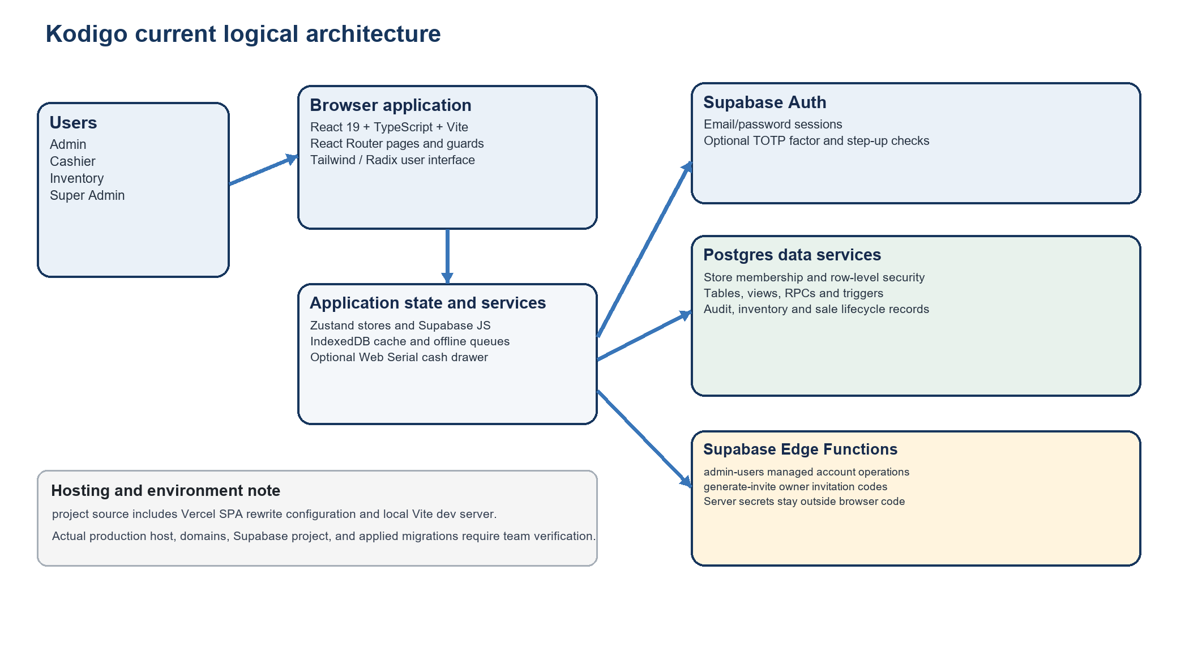

4. Technology choices and rationale
Table 4. Technology stack and design reason
Layer | Current implementation | Reason for use / constraint
Frontend | React 19, TypeScript 5.9, Vite 7 | Component-based interactive UI, typed application contracts, fast local development/build. TypeScript does not replace server authorization.
Navigation and state | React Router 7, Zustand 5 | Route organization and small focused stores for authentication, product, supplier, cart, and alert state.
UI and charts | Tailwind CSS 4, Radix UI primitives, Lucide React, Recharts 3 | Consistent responsive controls, accessible UI primitives, and interactive business charts.
Backend | Supabase Auth, Postgres, row-level security, database operations, triggers, views, Edge Functions | Managed sign-in and relational storage; database policies and functions enforce rules close to data. Actual target project and plan require confirmation.
Offline | browser offline storage through idb | Browser-local product cache and queues support eligible work during connectivity interruptions; conflict resolution is limited and queues require careful reconciliation.
Hardware and exports | Web Serial for optional ESC/POS drawer command; jsPDF and write-excel-file for exports | Uses browser capabilities for optional peripherals and report output. Printer/drawer compatibility must be tested.
Hosting | Vercel SPA rewrite configuration is present in source; the owner reports deployment at https://kodigo-blue.vercel.app/. | Public login page observed on 12 October 2026. Authenticated production behavior, provider plan, release permissions, and hosting cost were not verified.

5. Major modules and functional requirements
Table 5. Implemented module requirements
ID / module | Current behavior supported by project source | Expected result
FR-01 Identity and store context | Email/password sign-in, invite-based owner registration, role resolution, assigned store loading, and role-based route routing. | A user sees only authorized screens and store data.
FR-02 POS and receipts | Search by name/SKU/barcode, cart, unit/bulk options, payment, receipt snapshot, and sales lifecycle actions through database functions. | Sale, sale items, payment details, and stock effects are recorded consistently.
FR-03 Offline continuity | Cache products; queue eligible sales and selected mutations in browser offline storage; attempt replay on reconnect or page activity. | Pending/error state remains visible for reconciliation; business rule errors are not silently treated as network failures.
FR-04 Product and inventory | Product/category maintenance, purchase and selling units, price history, stock adjustment and movement records, archive/restore, and consumption history. | Base stock and its history remain traceable; sold products are archived rather than deleted.
FR-05 Suppliers and purchasing | Supplier records and store links, product supplier assignments, restocking options, purchase orders, receiving functions, supplier scoring, and consignment lots/balances. | Delivery and supplier-owned stock can be distinguished and reviewed.
FR-06 Alerts and notifications | Stock and selling-option conditions create notifications with user read state; report-export and transaction events can be surfaced. | Authorized users can review operational notices for assigned context.
FR-07 Reporting and analytics | Sales and inventory reports, Excel/PDF export paths, revenue/profit/category/hour charts, transaction views, rankings, and velocity. | Users review filtered output and export only within their role.
FR-08 Administration | Store branding and settings, managed staff account operations through admin-users Edge Function, invite generation through generate-invite, password reset, TOTP management. | Authorized changes are attributed and limited to the required store scope.

6. Data model and relationships
The schema is relational and store-oriented. Most operational records carry a store identifier or reach a store through an approved mapping. Row-level security (RLS) means database policies decide which rows an authenticated user can read or change for each request.
Table 6. Core data entities
Domain | Entities evidenced in schema and migrations | Relationship / purpose
Identity and tenancy | `profiles`, `stores`, `store_users`, `invite_codes` | Profiles map to stores through store_users; role and membership scope access.
Catalog and stock | `categories`, `products`, `product_selling_options`, `product_restocking_options`, `stock_adjustments`, `inventory_movements`, `inventory_stock_lots` | Products belong to store/category; stock movements explain sales, receipt, loss, adjustment, and consignment allocation.
Sales | `sales`, `sale_items`, `sale_payments`, `receipts`, `sale_events`, `sale_returns`, `sale_return_items`, `cashier_closeouts` | A sale has line items, payment and receipt records, with lifecycle events for void/refund/return and closeout.
Procurement | `suppliers`, `supplier_stores`, `product_suppliers`, `purchase_orders`, `purchase_order_items` | Supplier-store links support shared suppliers; orders link suppliers and products to receiving events.
Operations and evidence | `notifications`, `notification_user_states`, `audit_logs`, `error_logs`, `receipt_reprints`, `product_price_history` | Operational notices, user read status, errors, audit evidence, reprints, and price history support monitoring and traceability.

The list reflects current application source migrations and application queries, not a verified live database inventory. The target project’s applied migration ledger and actual grants must be inspected before release.
Database metadata: repository baseline schema snapshot (supabase_schema.sql); ordered Supabase migrations; repository migration index and numbered SQL files. The baseline snapshot is dated 2 March 2026 and may not include later source migrations. The deployed project migration ledger, live schema, grants, and policy state were not inspected; treat them as authoritative.

7. Data flow and business process
A named user is assigned a role and store, signs in, and confirms the active store. After access is checked, the user performs assigned work; online sales use the protected sale-processing RPC, while only eligible work may be queued locally during an interruption. Staff reconcile outcomes before closeout.
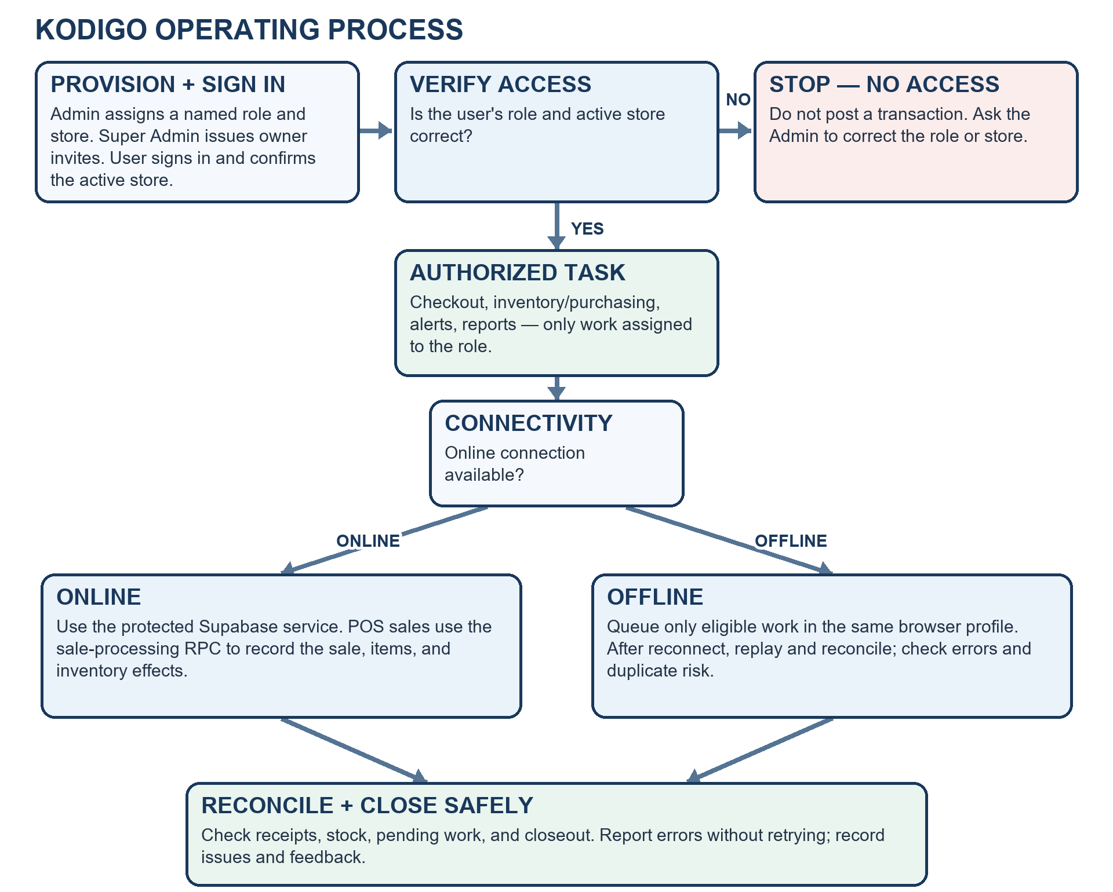
Figure 2. Kodigo operating process and offline-recovery flow
Flow summary: Provision role/store → sign in → verify access (stop before posting if incorrect) → complete assigned work online or queue eligible offline work → reconcile receipts, stock, pending work, and closeout.

8. Role and permission design
Table 7. Application permission matrix
Capability | Admin | Cashier | Inventory | Super Admin
POS checkout | Execute where enabled | Execute | None | None
Products and stock | Full store control | Read at POS | Manage within assigned scope | None
Stock adjustment / receiving | Manage and approve per local controls | None | Record within role and store scope | None
Suppliers and purchase orders | Manage assigned stores | None | No supplier administration | None
Dashboard / analytics / rankings | Assigned-store view | None | Limited per route | None
Reports | Sales and inventory | None | Inventory-oriented reports | None
Store settings / staff management | Manage assigned stores via supported controls | Own account | Own account | None
Invite governance | None | None | None | Generate owner invitation codes
Account security | Own account | Own account | Own account | Own account

This table summarizes application-role behavior in source; database policies remain authoritative. System Administrator is a technical identity, not an in-app business role. The proposed environment matrices below include its separate provider-console scope; it has no POS/business permissions by default. Production permissions still require validation against the deployed migration state.
Environment-specific access matrices (group names below are proposed examples, not verified or provisioned)
Table 8. Proposed PROD access matrix
Proposed group name | Role | Intended access scope | Verification status
KODIGO_PROD_ADMIN | Admin | Assigned-store operations and supported staff/catalog controls. | Proposed name only; provisioning and membership unverified.
KODIGO_PROD_CASHIER | Cashier | Checkout, receipts, and assigned shift tasks for the active store. | Proposed name only; provisioning and membership unverified.
KODIGO_PROD_INVENTORY | Inventory | Catalog, counts, receiving, and adjustments within assigned scope. | Proposed name only; provisioning and membership unverified.
KODIGO_PROD_SUPER_ADMIN | Super Admin | Owner invitation governance; no routine store operations. | Proposed name only; provisioning and membership unverified.
KODIGO_PROD_SYSADMIN | System Administrator | Separate named technical access to approved Vercel/Supabase control-plane tasks; no application business role by default. | Proposed name only; technical identity and access unverified.

Table 9. Proposed UAT access matrix
Proposed group name | Role | Intended access scope | Verification status
KODIGO_UAT_ADMIN | Admin | User-acceptance workflows within the assigned test store. | Proposed name only; UAT project and membership unverified.
KODIGO_UAT_CASHIER | Cashier | Checkout/receipt acceptance tests using approved synthetic or masked data. | Proposed name only; UAT project and membership unverified.
KODIGO_UAT_INVENTORY | Inventory | Catalog, count, receiving, and adjustment acceptance tests. | Proposed name only; UAT project and membership unverified.
KODIGO_UAT_SUPER_ADMIN | Super Admin | Invitation governance tests only, using approved test identities. | Proposed name only; UAT project and membership unverified.
KODIGO_UAT_SYSADMIN | System Administrator | Technical access to the isolated UAT provider project only. | Proposed name only; technical identity and access unverified.
Table 10. Proposed TEST access matrix
Proposed group name | Role | Intended access scope | Verification status
KODIGO_TEST_ADMIN | Admin | Functional and role/store tests in an isolated synthetic-data project. | Proposed name only; TEST project and membership unverified.
KODIGO_TEST_CASHIER | Cashier | Checkout, receipt, and transaction-lifecycle tests with synthetic data. | Proposed name only; TEST project and membership unverified.
KODIGO_TEST_INVENTORY | Inventory | Inventory, receiving, adjustment, and offline-replay tests. | Proposed name only; TEST project and membership unverified.
KODIGO_TEST_SUPER_ADMIN | Super Admin | Invitation-governance tests using test-only identities. | Proposed name only; TEST project and membership unverified.
KODIGO_TEST_SYSADMIN | System Administrator | Technical access to the isolated TEST provider project only. | Proposed name only; technical identity and access unverified.

9. Security architecture and risk controls
Table 11. Security controls classified by purpose
Control class | Control evidenced or required | Risk addressed / evidence
Preventive | Supabase Auth sessions; role checks; store membership; row-level security; authorized RPC checks. | Blocks unauthorized access and cross-store operations; validate with role/store test cases.
Preventive | Owner-confirmed policy: MFA is required and implemented for Admin and Super Admin. Source includes TOTP enrollment, challenge verification, and AAL2 checks for verified factors. The migration allows AAL1 without a verified factor; confirm the first-factor enrollment gate in the deployed configuration. | Reduces account takeover. Production account settings and first-factor enrollment enforcement were not independently inspected.
Preventive | Server-side admin-users and generate-invite functions; service-role secrets stay in server environment. | Limits privileged user-management operations; verify only required secrets are configured and never expose them in VITE variables.
Preventive | Store-specific active context for POS; database sale/receive/adjustment database operations; validation and lifecycle rules. | Reduces wrong-store posting and direct stock mutation.
Detective | `audit_logs`, `sale_events`, `inventory_movements`, `error_logs`, closeouts, price history, and export notifications. | Supports accountability and incident reconstruction; retention, access review, and alert ownership must be assigned.
Detective | Quarterly role/store review and release/test evidence. | Detects stale or excessive privileges and unsafe changes; retain dated approval records.
Corrective | Revoke or change access, reset credentials, correct through traceable adjustment/return functions, and preserve error queues. | Contains compromise and repairs records without concealing prior events.
Corrective | Proposed backup and restore steps are in the companion KodiGo Operations Runbook. | Recovery depends on configured backups and a successful restore drill; production backup settings and restore evidence were not provided.

10. Integrations, environments, and service identities
Table 12. Environment and identity inventory
Environment / identity | Current configuration or account group | Access and data boundary | Status / verification
Local demo | http://localhost:5173/; Vite development server on the owner workstation. Application roles: admin, cashier, inventory, super_admin. | Use synthetic records only; localhost is reachable on that computer only. | Observed in the local demo on 12 October 2026; not a public or production URL.
TEST | Proposed TEST groups appear in Table 10; application source includes test tooling. | Synthetic accounts and isolated test data only; do not connect test identities to production. | TEST project URL, deployed migration state, group provisioning, membership, and test roster were not verified.
UAT | Proposed UAT groups appear in Table 9; no UAT endpoint was supplied. | Keep UAT separate from production; use synthetic or specifically approved masked data. | UAT project, URL, provider groups, membership, and data controls were not verified.
PROD | Owner-reported deployment: https://kodigo-blue.vercel.app/ | Named application accounts and store-scoped permissions are intended. The live data set, Supabase project identity, provider roles, and group membership were not inspected. | Public /login page observed on 12 October 2026. Authenticated transactions, deployed migrations, and production access controls were not independently tested.
Browser client | VITE_SUPABASE_URL and VITE_SUPABASE_ANON_KEY are public browser configuration values. | Only the public/anon key may be shipped to the browser; database policies enforce access. | No client secret may be placed in VITE variables or browser bundles.
Server functions and backups | admin-users and generate-invite functions are present in source; the companion runbook proposes backup and restore procedures. | Keep service-role secrets server-side; restrict control-plane access; never put secrets in VITE variables or browser bundles. | Production function deployment, named service identities, backup plan, retention, and restore evidence remain unverified.

Migration caution: the current application source contains numbered migrations through migration_40 and additional dated migrations. The README setup sequence does not include every newest file. Treat the applied migration ledger in the target Supabase project as the deployment source of truth; do not assume current application source files are already deployed or invent an execution order where the environment is unknown.

PART II - SYSTEM GOVERNANCE

11. Governance objectives and structure
Governance assigns decision rights for access, changes, data, security, incidents, backups, and documentation. The deploying organization owns the service and accepts operational and privacy obligations. The roles below are governance assignments; only Admin, Cashier, Inventory, and Super Admin are application roles in the current TypeScript role union.
Table 13. Governance responsibilities
Governance role | Owns / maintains | Approves / decides | Accountability
Client organization / accountable service owner | Legal organization was not supplied. Ira Pongasi is the client stakeholder named by the project owner; formal operational authority is not evidenced. | Accepts business changes, assigns owners, accepts residual risk. | Business impact, support capacity, and service direction.
Admin / store owner | Store configuration, product and staff accuracy, local access, daily reconciliation. | Routine account/store access, stock corrections, and purchase actions under local thresholds. | Store operation and correct, timely escalation.
Cashier | Accurate cart, payment, receipt, and shift handoff. | No role authority to approve own exceptions beyond assigned actions. | Actions performed under own credentials; prompt discrepancy report.
Inventory staff | Catalog, physical counts, movement records, and inventory reports. | Routine stock activity within role; Admin approves unusual changes per policy. | Count accuracy, conversion correctness, and evidence notes.
Super Admin | Owner invite-code governance. | Issue governed owner invitation codes. | Invite issuance and onboarding integrity; no tenant operations.
System Administrator | Supabase configuration, technical access, releases, logs, and recovery work. | Execute approved changes; emergency action under incident authority. | Technical recovery evidence, privileged access, and migration records.
Client service authority / IT Manager (if deployed) | No person or office was supplied. The client designates this role before production operation; project email is not a 24/7 service desk. | Approves major changes, emergency access, restoration, and service communications. | Service continuity and closure of corrective actions.
Client/controller Privacy Contact / DPO | No individual was supplied. The responsible controller designates an authorized contact before personal-data processing; suspected breaches are escalated directly and immediately. | Leads and documents the breach assessment; the PIC retains the reportability and notification decision. | Transparent, documented privacy handling.
Developer / technical contributor | Source code and migrations under version control. | No routine production access; contributes reviewed changes. | Tests, review responses, and accurate technical documentation.

12. Decision rights and segregation of duties
Table 14. Decision and approval matrix
Decision | Prepares | Approves | Evidence
Create or change a user/store assignment | Admin | Authorized store owner / manager | Named user, role, store, approver, date, expiry where relevant.
High-impact stock correction | Inventory staff or Admin | Second authorized approver under local threshold | Count, reason, before/after, supporting reference.
Normal code or database change | Developer | Reviewer and release owner | Issue, pull request, tests, migration, release record.
Emergency technical change | System Administrator | IT Manager or delegated incident commander | Incident ID, reason, scope, rollback, time, retrospective review.
Restore or backup-retention change | System Administrator | IT Manager / System Owner | Restore scope, approvals, reconciliation, retention evidence.
Privacy request or disclosure | Privacy Contact with system support | Privacy authority under organization policy | Request, identity verification, decision, disclosure/correction/deletion evidence.

Where project staffing is too small for full separation, the System Owner records the conflict, appoints an independent reviewer for high-risk actions, and retains evidence. No single person should silently request, approve, implement, and close their own high-impact production change.

13. Access governance lifecycle
1. Request: document the user, business duty, role, store scope, start date, duration, and any privileged need.
2. Approve: Admin or designated owner validates identity and need; an independent approver reviews high-risk or cross-store access.
3. Provision: use the managed user function and invite flow selected for production; record the resulting role/store mapping.
4. Review: at least quarterly, compare active users, roles, and store assignments with current duties; record decisions and exceptions.
5. Revoke or change: remove access on separation, role change, compromise, or end of assignment; preserve transaction attribution and reconcile pending offline work.
6. Privileged access: restrict to named administrators, require MFA for Admin and Super Admin, approve and time-bound support access, and review after use.
Owner registration path in current project code: a Super Admin generates a one-time owner invitation code; the initial owner enters it, submits the registration form, and confirms email before signing in. The public production web route is available, but the deployed invite function, authorization rules, user recovery path, and production identity settings were not tested; use only approved accounts and verify these controls before relying on them.

14. Data and privacy governance
The deploying organization determines why personal information is collected, provides the required notice, assigns a Privacy Contact, approves retention, handles rights requests, and assesses incidents. Kodigo can contain names, email addresses, roles, store assignments, supplier contact details, sales and stock activity, payment method and limited reference, audit events, error context, exports, and device/browser details when linked to a user.
Kodigo must not store full card numbers, PINs, one-time passwords, or wallet passwords. Ordinary cash checkout does not require customer identity; collect customer details only where a defined and approved feature requires them.
Privacy handling follows Republic Act No. 10173, its Implementing Rules and Regulations, and applicable National Privacy Commission (NPC) guidance. Report any suspected personal-data incident immediately to the deploying organization's designated Privacy Contact or Data Protection Officer (DPO) and the technical incident lead; do not wait for routine support hours or confirmed scope. The procedure below assigns notification accountability to the personal information controller (PIC). This document describes governance requirements and does not claim certification or verified legal compliance.

Breach assessment and notification procedure
1. Report and preserve: Any user, operator, or service provider who suspects a personal-data incident immediately contacts the designated Privacy Contact/DPO and technical incident lead. Record discovery time, known systems and data, affected people or records, actions taken, and securely preserve relevant logs and evidence.
2. Assess and decide: The deploying organization acting as PIC retains accountability for the notification decision. Its designated DPO/Privacy Contact documents the assessment and advises the authorized PIC decision-maker; the technical lead supplies the timeline, affected data and people, containment actions, and likely impact. Apply NPC Circular No. 2016-03, sections 11 and 13: assess whether sensitive personal information or information that could enable identity fraud was involved, whether it was likely acquired by an unauthorized person, and whether that acquisition is likely to create a real risk of serious harm. If uncertain, document the likely harm, whether notification would reduce risk, and the PIC's decision and rationale.
3. Notify: When notification is required, the PIC notifies the NPC within 72 hours of knowledge or reasonable belief, using information then available; notify affected data subjects within 72 hours, subject to the Circular's exemption or postponement rules. Do not wait for a complete investigation. Submit the full breach report within five days unless the NPC grants additional time, and retain proof of receipt and copies of notices.
4. Contain and review: Contain unauthorized access, revoke or reset affected credentials, preserve transaction attribution, and track corrective actions. Any delay, exemption, or postponement must follow the Circular and applicable NPC process; where section 17(C) prohibits delay, notify within the 72-hour period on available information. Complete a documented post-incident review.
Official references: Republic Act No. 10173; National Privacy Commission Implementing Rules and Regulations; NPC Breach Reporting; NPC Circular 16-03
Table 15. Privacy governance fields to complete
Privacy area | Documented status | Operational rule
Responsible organization | Ira Pongasi is the named client stakeholder; the legal organization name was not supplied. | Use synthetic data only until the responsible organization/controller is identified.
Privacy Contact / DPO | No individual or direct contact details were supplied. | The responsible controller designates the contact before personal-data processing; send suspected breach reports directly to that contact immediately.
Project support contact | Evon Christian P Vergara — vergaraevon@gmail.com; support hours are not formally established. | Project support only; not the client’s legal Privacy Contact or an on-call service desk.
Retention and rights requests | No production retention schedule or rights-request channel was verified. | Do not load live personal information until the controller sets retention, access, correction/deletion, and notice processes.
Breach notification authority | The controller decides whether statutory notification is required. | The PIC makes and records the notification decision using NPC Circular 16-03 criteria; the designated DPO/Privacy Contact leads the assessment. For notifiable breaches, follow the 72-hour notice and five-day full-report requirements. The responsible organization and named contact remain unverified.

Data classification and protection levels
The table sets project-level handling requirements for data types evidenced in Kodigo. It does not assert that production provider settings, encryption configuration, or retention schedules were independently verified.
Data item | Classification | Required protection level | Retention and disposal
Approved public-facing product or service information and published user guidance | Public | Release only after owner review. Exclude personal data, account or store identifiers, transaction details, and secrets. | Review while published; withdraw obsolete copies.
Non-public product catalog, store configuration, operating procedures, and aggregated non-identifying operational summaries | Internal | Limit to authenticated users with a business need; share only through approved channels; do not place on public drives or personal email. | Keep only while operationally needed; remove stale copies.
User names and email addresses, roles and store assignments, supplier contacts, and device/browser details linked to a user | Confidential | Restrict by role and assigned store; minimize collection and exports; allow access only to authorized users. | The controller sets purpose-based retention before live personal-data use.
Sales and stock activity, purchase records, receipts, reports, audit events, support records, error context, and exports | Confidential | Use least-privilege and store-scoped access; limit exports; preserve transaction attribution and auditability. | The controller sets retention; securely dispose of obsolete copies after any applicable hold.
Passwords, invite/reset tokens, TOTP setup material, service-role keys, database exports, and backup copies | Restricted | Limit to authorized system operators; keep secrets server-side, never in browser bundles, logs, tickets, screenshots, or public storage; protect backup copies under approved provider controls. | Rotate or revoke exposed secrets; retain backups only under an approved recovery plan.
Full payment-card numbers, PINs, one-time passwords, and wallet passwords | Prohibited (not stored) | Do not collect or store. If encountered, stop routine handling and escalate through the incident process without copying or redistributing the data. | Do not retain; follow the incident and privacy process if unexpectedly encountered.

Related owner-issued policies: Acceptable Use Policy | BYOD Policy | Kodigo User Manual

15. Risk management
Table 16. Initial project risk register
Risk / evidence | Likelihood / impact | Potential effect | Mitigation, owner, and status
Migration or live database differs from current project code | High / High | Policies, columns, or functions may be missing or inconsistent. | Compare deployed migration ledger, schema, policies, grants, functions, and triggers before releases. Owner: System Administrator. / Status: Open — production backend state not verified.
Offline queue conflict or replay failure | Medium / High | A pending sale or stock change may be duplicated, rejected, or stale. | Use synthetic test cases; reconcile pending queue before retry; never clear browser data while work is pending. Owner: Admin + technical owner.  Status: Open — limited conflict handling.
Privileged account compromise or TOTP not enforced | Medium / High | Unauthorized account, invite, or data changes. | Owner confirms TOTP is required and implemented for Admin/Super Admin; source includes enrollment and AAL2 checks. The migration has an AAL1 path without a verified factor, so the deployed first-factor gate remains uninspected. Owner: client service authority. / Status: Open — production enforcement not inspected.
Backup or restore path unavailable | Medium / High | Sales, stock, and audit history may not be recoverable. | Confirm provider backup plan, restricted access, retention, and an isolated restore rehearsal. Owner: System Administrator. / Status: Open — production plan and restore evidence not supplied.
Vulnerable dependency or delayed patch | Medium / High | Known weakness may enable compromise or disruption. | Review advisories weekly and before release; prioritize critical fixes within 24 hours and high fixes within 7 days. Owner: technical maintainer. / Status: Open — no automated patch status verified.
Personal information exposed or retained without a controller process | Medium / High | Privacy harm, legal reporting, or rights-request failure. | Use synthetic demo data; identify controller/Privacy Contact and retention before live data; direct immediate breach escalation. Owner: client/controller.  Status: Open — organization/contact not supplied.
Redacted screenshot still contains identifying or transaction detail | Low / Medium | Unintended disclosure in academic distribution. | Review each embedded figure at rendered size; mask identifiers and use only synthetic/demo data; limit distribution. Owner: Document Owner.  Status: Review required before wider public use.

16. Change, release, and configuration management
Table 17. Naming, coding, metadata, and release standards
Area | Required project standard
Source of truth and database changes | Treat the target Supabase project's applied migration ledger as authoritative. Add new migrations under supabase/migrations/ as YYYYMMDDHHMMSS_descriptive_snake_case.sql; create a new migration for each change and never rewrite one already applied. Legacy root-level migration_*.sql files also exist; their applied order and deployment status are not verified.
Naming and casing conventions | For new or changed code, use camelCase for variables, parameters, and functions; use useX for hook names/files; use PascalCase for React components/pages and TypeScript types/interfaces; use PascalCase.tsx for feature components/pages and camelCase.ts for helpers and stores. Use lowercase kebab-case for folders and route slugs, snake_case for database identifiers, and UPPER_SNAKE_CASE for immutable module configuration; local constants remain camelCase. Exception: preserve existing lowercase primitive files under src/components/ui/. Avoid I/T type prefixes and unexplained abbreviations; use established terms such as API, MFA, POS, RLS, and SKU, and expand other domain terms on first use.
Folder structure and file taxonomy | Place screens in kodigo-ui/src/pages, feature UI in src/components/<feature>, hooks in src/hooks, domain/API helpers in src/lib, stores in src/stores, and shared contracts in src/types. Supabase Edge Functions belong in supabase/functions/<function>/index.ts; SQL migrations belong in supabase/migrations; email templates belong in supabase/templates; integration checks belong in kodigo-ui/scripts. Keep credentials, environment values, and live data exports out of source control.
Code style, linter, and formatter | Follow strict TypeScript, focused functions, explicit validation at trust boundaries, React Hooks rules, and accessible UI patterns. ESLint 9 is configured in kodigo-ui/eslint.config.js and runs with npm run lint; npm run typecheck runs the TypeScript check. Prettier is the recommended formatter, but no Prettier package, shared configuration, or format script was present at inspection, so formatting enforcement is not verified. Prefer concrete types; document any boundary exception to the current lint allowance for explicit any.
Comments and error handling | Comments explain rationale, business invariants, security/store boundaries, or offline-replay constraints rather than restating code. Validate untrusted input at service boundaries, handle asynchronous failures explicitly, and show safe, actionable messages to users. Do not swallow transaction errors or blindly retry non-idempotent sales. Use the existing logClientError path with only necessary, sanitized context; never log credentials, full payment data, or unnecessary personal information.
API and code documentation | Document exported TypeScript helpers, API-facing Supabase Edge Functions, and RPC contracts with TSDoc/JSDoc. Include a concise purpose and applicable @param, @returns, @throws, and @example tags. State authentication and role/store scope, input/output shape, expected errors, side effects, and idempotency for API contracts; document SQL function purpose, security context, and data changes beside migrations. Update the contract notes whenever behavior changes; no standalone OpenAPI specification was found at inspection.
Metadata and versioning | For releases, record a semantic version (vMAJOR.MINOR.PATCH), date, author/reviewer, change reference, environment, migration identifiers, test evidence, and rollback reference. The UI package currently declares 0.0.0, which is not evidence of a production release version. Keep timestamped migration identifiers immutable after application. For externally consumed contract changes, record compatibility impact and a deprecation path.
Branch and review model | Recommended model: main for release; develop for integration; short-lived feature/<ticket>-<slug>, fix/<ticket>-<slug>, and hotfix/<ticket>-<slug> branches merged through a reviewed pull request after checks pass. Inspection found main only; a develop branch and server-side branch protections were not verified. Do not present this recommendation as an already-provisioned control.
Testing and vulnerability management | From kodigo-ui, run npm ci and then npm run ci before release; the CI script runs typecheck, lint, build, and test:integration (scripts/integration-checkout-stock-rls.mjs). Use only an isolated test project and approved synthetic data for integration checks. Review dependency advisories weekly and before release; record severity, affected version, owner, remediation, and retest. No automated scanner or live patch status was verified.
Deployment and rollback | Confirm the target project, managed secrets, applied migration order, authorization tests, and smoke checks before release. Record deployment and rollback references. Restore schema or data only from a verified backup into an isolated replacement, then reconcile before promotion.

Current repository layout (selected source paths; generated and dependency files omitted)
repository/
|-- kodigo-ui/
| |-- src/
| | |-- assets/
| | |-- components/
| | | |-- analytics/
| | | |-- auth/
| | | |-- inventory/
| | | |-- layout/
| | | |-- pos/
| | | |-- receipts/
| | | |-- settings/
| | | |-- shared/
| | | |-- suppliers/
| | | |-- ui/
| | |-- hooks/
| | |-- lib/
| | |-- pages/
| | |-- stores/
| | |-- types/
| |-- scripts/
| |-- eslint.config.js
| |-- package.json
| |-- tsconfig.app.json
| |-- vite.config.ts
|-- supabase/
| |-- functions/ (admin-users/, generate-invite/)
| |-- migrations/ (timestamped SQL)
| |-- templates/
|-- docs/
|-- deliverables/
|-- migration_*.sql (legacy root files; applied status unverified)
|-- package.json
|-- README.md
Vulnerability review is a required release control; no automated scanner, monitoring integration, or live patch status was verified in the production configuration. Review dependency advisories weekly and before a release, record affected components and severity, test fixes in isolation, and preserve the change evidence.
Vulnerability triage and target remediation
Severity / trigger | Target containment or remediation | Evidence / owner
Critical / actively exploited | Contain immediately; target a verified fix or safe disablement within 24 hours. | Incident and change record; technical maintainer, with client service authority.
High | Target remediation within 7 calendar days. | Advisory, affected version, test and release record; technical maintainer.
Medium | Target remediation within 30 calendar days or document a compensating control. | Risk acceptance and planned release date; Project Owner / technical maintainer.
Low | Include in the next planned maintenance release, normally within 90 days. | Monthly review record and version check; technical maintainer.

17. Incident management and escalation
The ITIL-aligned workflow logs, categorizes, assesses impact and urgency, assigns priority, diagnoses, escalates, validates recovery, and records lessons. Proposed routine channels are Tier 0 shift-Admin chat, Tier 1 Store Admin phone, Tier 2 direct email to Project Owner Evon Christian P Vergara (vergaraevon@gmail.com), and Tier 3 incident-lead phone for major technical or vendor issues. Only the Project Owner email was supplied; the other endpoints are unverified, and no service-level commitment is made. A suspected personal-data incident bypasses the support-tier sequence: notify the client/controller Privacy Contact or DPO immediately through its official phone/email and notify the technical incident lead in parallel; do not wait for Tier 2.
Incident response workflow
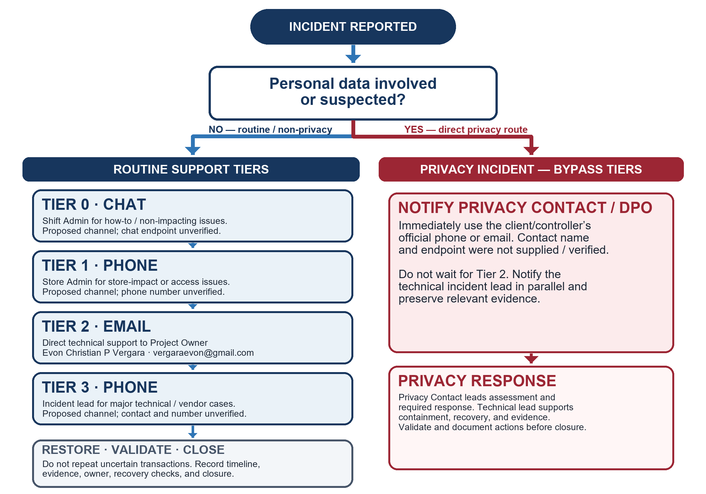
Figure 3. Incident response and escalation with direct privacy reporting.
1. Report and log: Record reporter, time, store, impact, evidence, and status. For any suspected personal-data incident, notify the client/controller Privacy Contact or DPO immediately through the official route, notify the technical incident lead in parallel, and preserve evidence; do not wait for Tier 2.
2. Categorize and prioritize: Assess impact and urgency, assign a P1-P4 priority, and name an incident owner.
3. Diagnose: Tier 0 or Tier 1 checks safe user and store causes. The Admin confirms impact and any safe workaround; unresolved technical faults go to Tier 2.
4. Escalate major issues: Escalate major non-privacy technical outages or vendor issues to the Tier 3 incident lead. A suspected privacy incident bypasses Tier 2 and goes directly to the Privacy Contact or DPO as described above.
5. Restore and validate: Recover service, reconcile records, and confirm the result with the reporter.
6. Record lessons: Capture the cause, evidence, owner, due date, and corrective action for governance review.
Table 18. Proposed response targets for capstone operations
Tier / priority | Trigger / primary channel | Immediate action | Accountable contact
Tier 0 — self-help | How-to or non-impacting warning. Channel: shift-Admin chat (proposed; endpoint unverified). | Use the manual and capture the exact message. Check pending work; do not repeat an uncertain transaction. | Reporting user; shift Admin.
Tier 1 — store operations | Single-user/register, cash discrepancy, or access issue. Channel: phone to Store Admin (proposed; number unverified). | Notify Store Admin and record the incident. No response-time commitment is established. | Store Admin.
Tier 2 — technical service | Sync, data defect, outage, or multiple affected users/stores. Channel: direct email to Project Owner. | Stop unsafe retries. Include time, store, impact, exact error, and evidence. Email is not a 24/7 service desk. | Evon Christian P Vergara, Project Owner; vergaraevon@gmail.com.
Tier 3 — major technical/vendor | Major non-privacy outage or vendor case. Channel: phone to incident lead (proposed; person/number unverified). | Escalate after triage; coordinate vendor action only through an approved contact. Preserve incident records. | Designated incident lead; identity and phone unverified.
Privacy incident — direct | Suspected personal-data exposure, unauthorized access, or breach. Channel: client/controller Privacy Contact/DPO official phone/email (not supplied / verified). | Notify the Privacy Contact immediately; do not wait for Tier 2. Notify the technical lead in parallel and preserve evidence. | Client/controller Privacy Contact/DPO (not named); technical lead supports.
Priority convention | Assign P1–P4 based on impact and urgency. Channel: client-approved email/chat (not supplied / verified). | Record priority, timestamp, owner, next update, and closure evidence. No SLA is asserted. | Incident owner.

Only the Project Owner email, vergaraevon@gmail.com, was supplied for technical support; it is not a 24/7 service desk or a guaranteed response-time commitment. Tier 0 chat, Tier 1 Store Admin phone, Tier 3 incident-lead phone, and the client/controller Privacy Contact phone/email are proposed or unverified endpoints. Suspected personal-data incidents must go directly to the Privacy Contact/DPO through the official channel, with the technical lead notified in parallel; do not route them through Tier 2 first.

18. Backup, recovery, audit, and monitoring responsibilities
Table 19. Operational ownership
Control activity / cadence | Responsible | Review / escalation | Evidence to retain
Each shift: reconcile cash closeout, pending offline work, and unusual stock events. | Store Admin; Cashier records assigned closeout. | Admin resolves routine mismatch; escalate unexplained or suspected fraud immediately. | Closeout, receipt/sale references, reconciliation note.
Daily during any pilot: review failed sync/error queue and provider backup status where available. | Designated technical maintainer / provider operator. | Project Owner; client service authority for material availability/data risk. | Dated review, unresolved issue, backup status, owner and due date.
Weekly: review incident/error patterns, audit/export events available to the organization, and dependency/security advisories. | Technical maintainer and Admin within assigned scope. | Project Owner; Privacy Contact for personal-data concern. | Review checklist, issue/change records, corrective actions.
Quarterly and on role change: review user roles, store memberships, and privileged access; rehearse restoration at least quarterly before production. | Admin and System Administrator. | Independent client service authority; privacy reviewer where data is involved. | Dated access roster, restore test, reconciliation results, approval.
Before each schema release and after an incident: preserve backup, migration, rollback, and incident timeline. | System Administrator / incident lead. | Release approver or client incident commander. | Backup reference, migration result, test evidence, timeline, recovery and lessons.

Proposed operating baseline for the deployed service: confirm provider backups, restricted backup access, at least 30-day retention where supported, a pre-migration backup, and quarterly isolated restore rehearsal. These are recommendations; the current production schedule, retention setting, and successful restore evidence were not verified.

19. User feedback and post-launch improvement
No interview, survey, pilot, or post-launch user-feedback results were supplied for this revision; no user findings are invented. The reviewed interface and code are technical observations, not user-reported evidence. The Project Owner records feedback sent to vergaraevon@gmail.com; a formal support response window has not been established.
1. Collect user feedback during onboarding, support incidents, and a scheduled post-launch review.
2. Group feedback into usability, reliability, data accuracy, access, and privacy themes; protect personal data in the record.
3. Prioritize changes by operational harm, user frequency, legal/privacy impact, and implementation effort.
4. Approve a change, assign an owner and due date, test in an isolated environment, and publish the release note or user instruction update.
5. After release, ask the reporting users whether the change solved the problem and record any remaining issue.
Feedback plan: collect qualitative task-interview notes and quantitative task-completion time/error counts during any authorized pilot; review weekly during pilot and monthly after stable operation. No structured feedback channel or pilot schedule has yet been verified.
User feedback evidence and post-launch prioritization
Evidence / method | Classification and result | Priority / response
Interviews, surveys, or usability sessions | No pre-launch user-study evidence was supplied; no user finding is claimed. | Collect qualitative task notes and quantitative completion time/error counts during an authorized pilot.
Current interface/code review | Technical inspection only; not user-reported feedback. | Use to document implemented behavior and risks, not to assert user satisfaction.
Future pilot findings | Label each verified item Bug Report, Usability Issue, Feature Request, or Positive Feedback; retain date, role/store, and supporting evidence. | Apply MoSCoW: Must fix security/data-integrity blockers; Should address frequent workflow friction; Could improve convenience; Won’t promise unsupported scope. Review weekly during pilot.

20. Documentation ownership, training, and review
This final owner-issued document set is Version 1.10 | 12 October 2026. Document owner: Evon Christian P Vergara. The peer-review audit and teacher revision-note incorporation are complete; no further document approval is pending. Deployment and operations remain subject to the evidence limits stated in this document.
- Review at least annually and after material changes to roles, privacy processing, sale lifecycle, inventory controls, hosting, or incident ownership.
- Use version history in the project current application source; record change summary, author/reviewer, approval, effective date, and replaced version.
- Keep controlled templates for access requests, risk reviews, incident records, restore tests, release approval, and user acknowledgment.
- Train Admins and Cashiers on sales and cash controls; Inventory staff on units, counts, and adjustments; privileged staff on access, MFA, privacy, and recovery.
- Retain attendance and practical competency evidence in an organization-approved restricted location.
User-facing procedures: Kodigo User Manual

21. Feasibility, rollout sequence, and resource plan
The public production web entry point is deployed at https://kodigo-blue.vercel.app/ and its login page was observed on 12 October 2026. Authenticated production workflows, Supabase project identity, applied migration state, role-group provisioning, backup configuration, client organization, Privacy Contact, test/UAT environments, rollout schedule, hosting costs, staffing, and user acceptance evidence remain unverified or not supplied. These are stated as evidence limits, not pending document approvals.
Table 20. Proposed rollout timeline
Milestone / phase | Completion evidence | Owner / target date status
1. Academic document and local-system baseline complete | Owner-issued academic baseline; repository source and public production login page reviewed; embedded screenshots redacted. | Evon Christian P Vergara — complete 12 Oct 2026.
2. Confirm client organization, privacy contact, and isolated test environment | Client-side roles, test project, migration ledger, data handling and contacts documented. | Not assigned; dates unverified.
3. Complete security, role/store, POS, offline, and restore tests | Dated test matrix, synthetic test outcomes, dependency review, restore rehearsal, risk disposition. | Not assigned; dates unverified.
4. Train users and conduct a controlled pilot if the client elects to proceed | Role-based practice, signed policy acknowledgments, support route, rollback and incident steps. | Not assigned; dates unverified.
5. Review pilot outcomes and decide next steps | Feedback log, incidents, measures, cost/value comparison, and documented continue/change/stop decision. | Not assigned; dates unverified.

Table 21. Indicative resource and budget plan
Resource / category | Availability / estimate status | Cost status
Project owner / development | Effort not estimated or approved. | Budget not supplied.
QA, security, and recovery testing | Required test activities identified; hours not estimated. | Budget not supplied.
Training and pilot support | Training may be needed if a client-authorized pilot is approved; hours not estimated. | Budget not supplied.
Devices and peripherals | Local demo uses the owner workstation; additional device needs are not verified. | Cost not supplied; hardware quotes are not available.
Hosting, email, and backup services | Public web deployment exists at https://kodigo-blue.vercel.app/; source uses Supabase. Provider plan, backend project identity, and backup configuration are not verified. | Actual hosting, email, and backup charges were not supplied; no current price is claimed.

ROI, approved labor hours/rate, costs, benefit baseline, and numeric target were not supplied; no realized ROI is claimed. Before any authorized pilot, set a baseline for reconciliation time, stock discrepancies, duplicate/rejected sales, and reordering rework, then compare results.

Appendix A. Redacted interface captures
These captures are from 15 September 2026 and show the interface at that time; they do not establish current production data, account provisioning, or control enforcement. Personal names, store labels, supplier identifiers, and contact fields are obscured. Example product and transaction values may be synthetic. The security-settings capture records the displayed account’s TOTP status as “Not enabled” on that date; it does not override the owner-confirmed current MFA requirement or verify present enforcement.
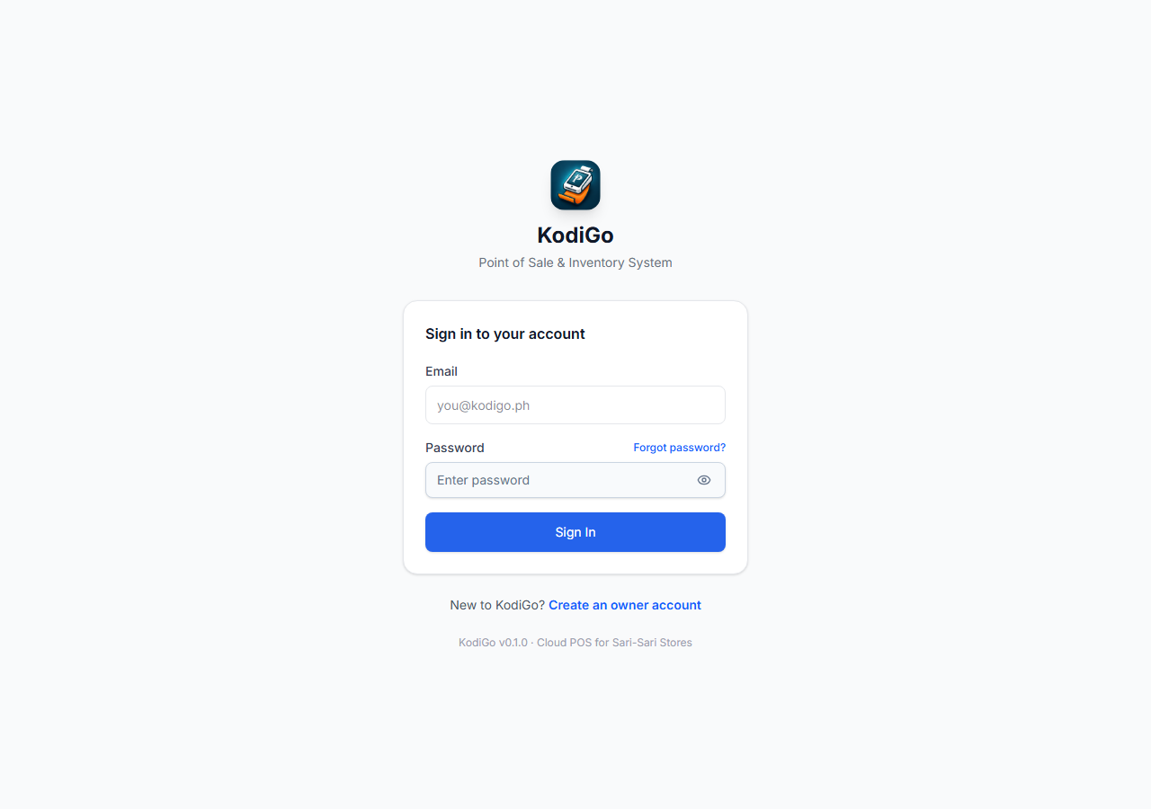
Figure 4. KodiGo sign-in screen (15 September 2026).
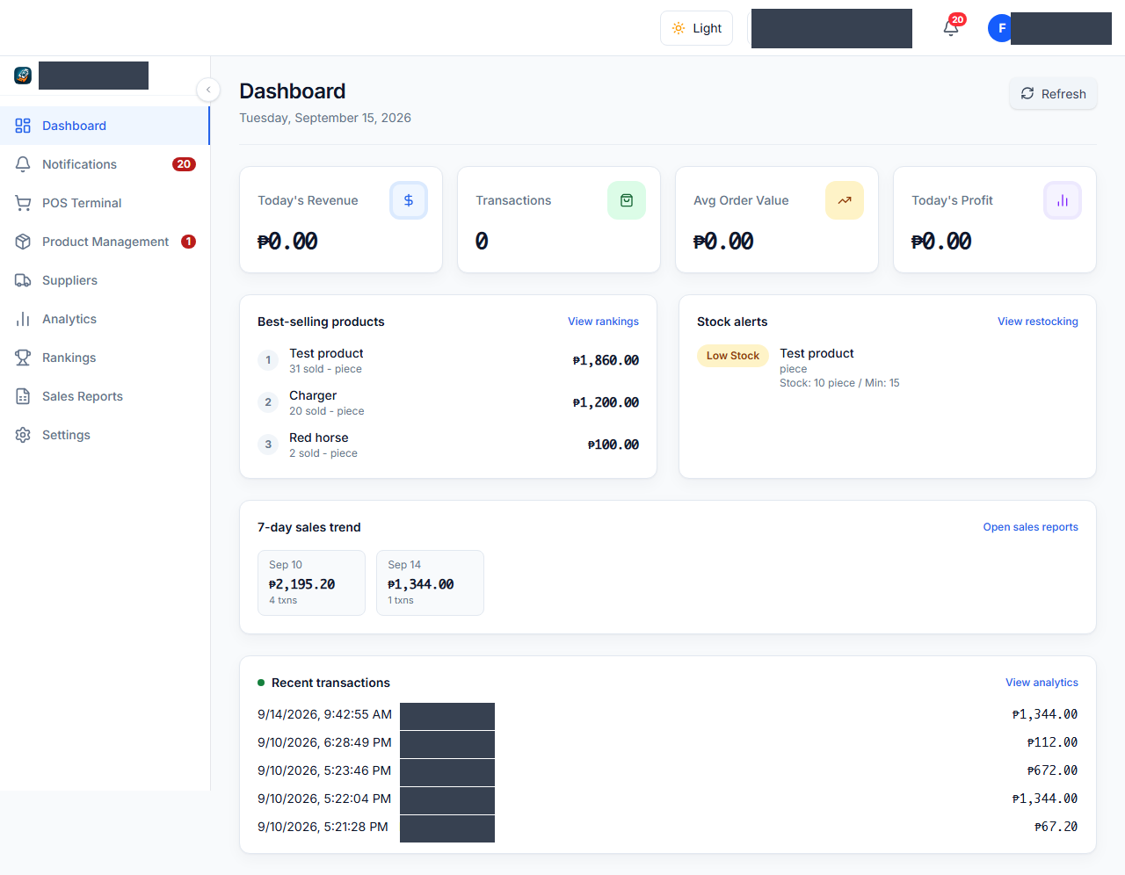
Figure 5. Dashboard; user, store, and transaction identities redacted (15 September 2026).
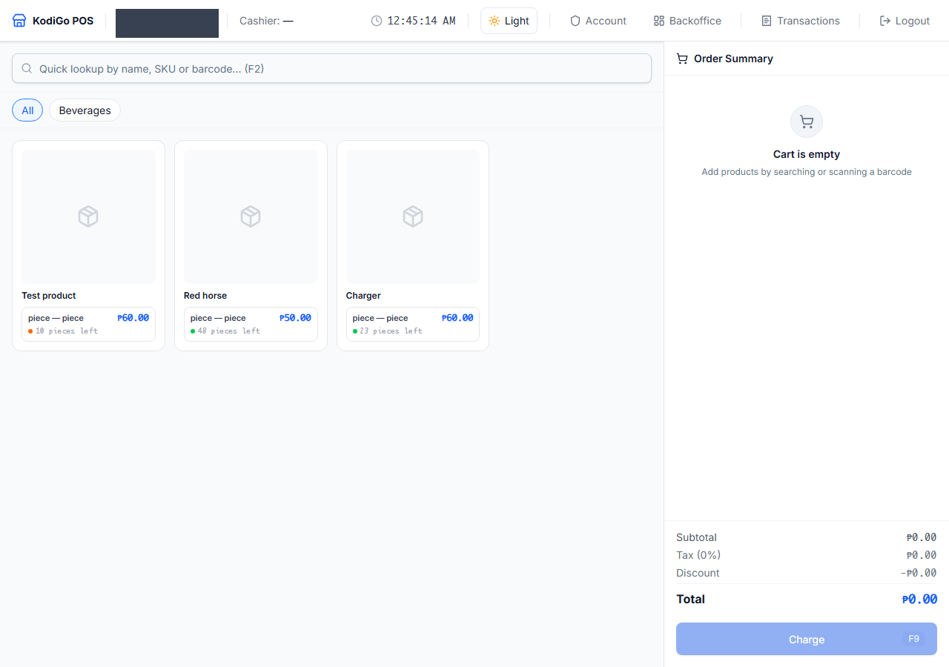
Figure 6. Point-of-sale terminal; store label redacted (15 September 2026).
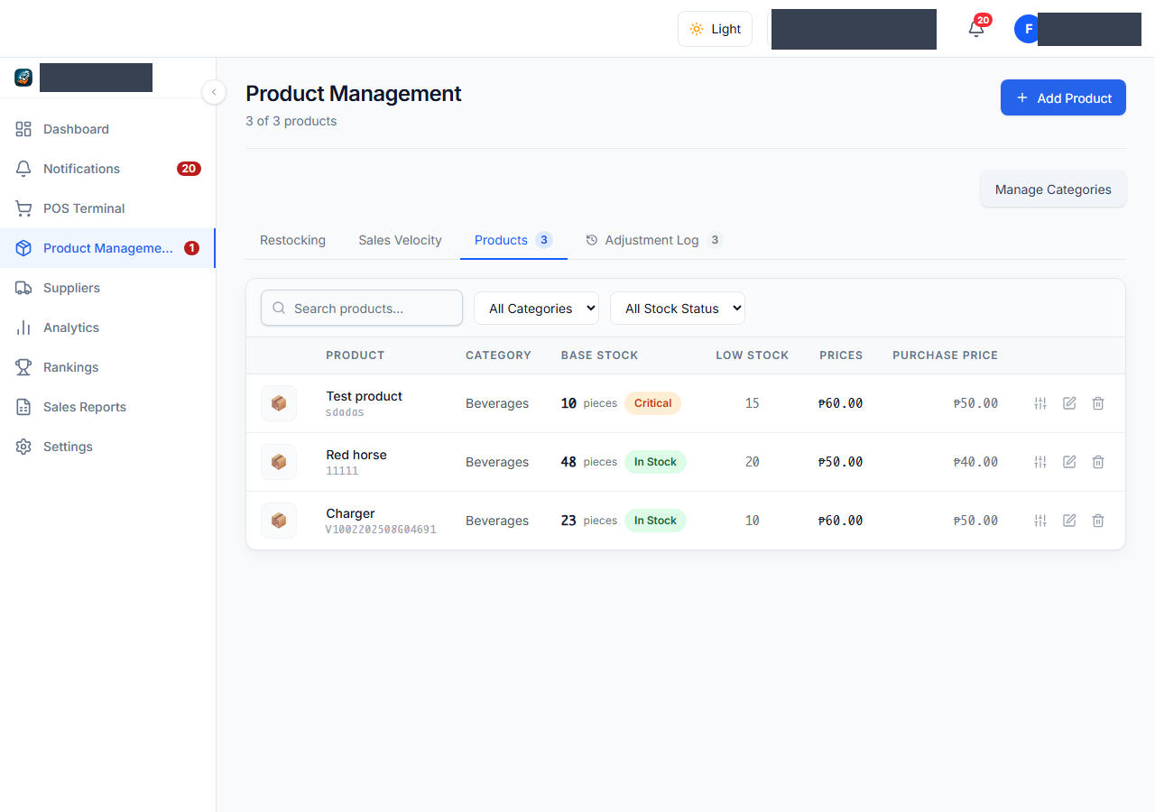
Figure 7. Inventory management; user and store identifiers redacted (15 September 2026).
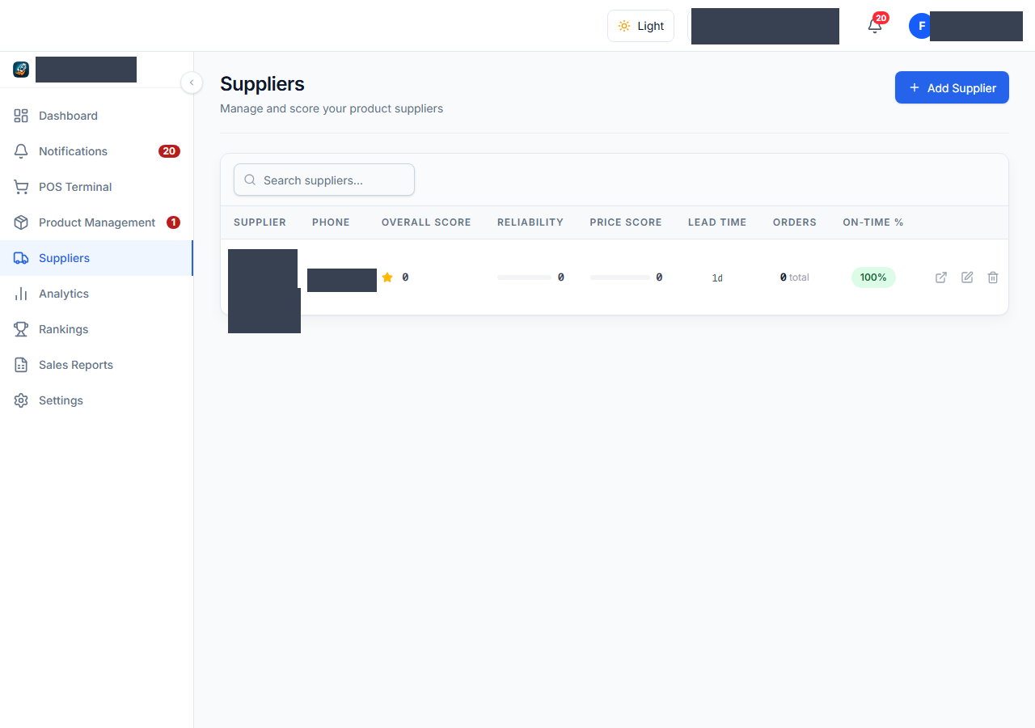
Figure 8. Supplier management; user, store, supplier, and contact identifiers redacted (15 September 2026).
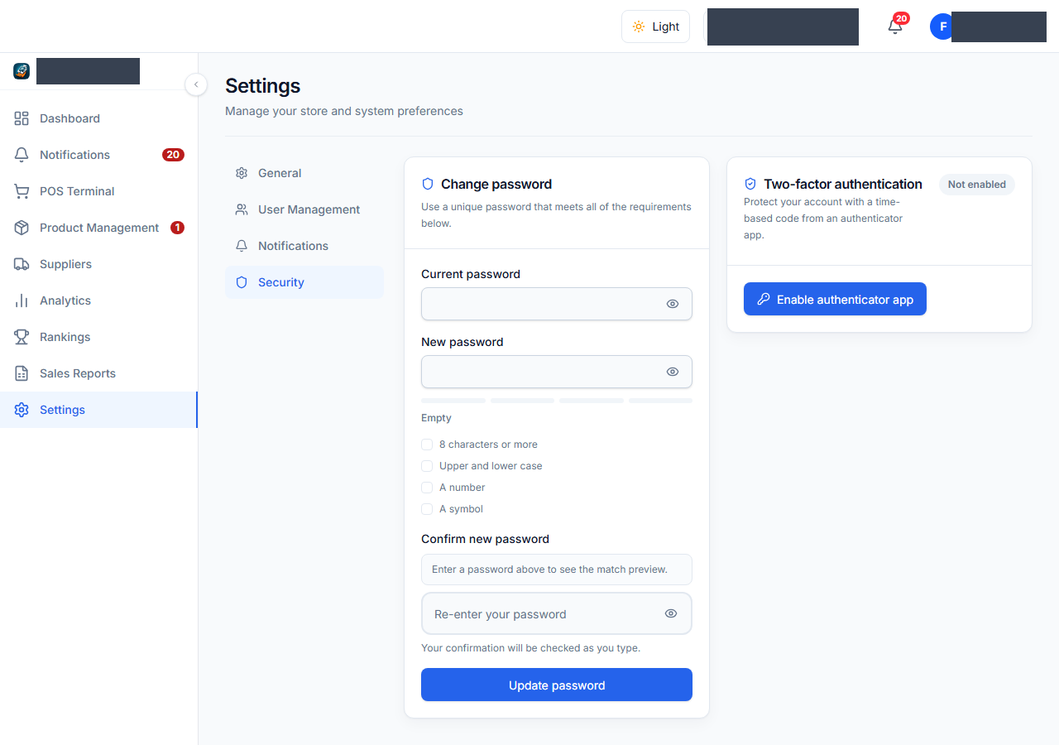
Figure 9. Security settings; displayed account showed TOTP “Not enabled” on 15 September 2026 (user and store identifiers redacted).

