KODIGO

Kodigo System Design and Governance
Technical design and accountable governance for the Kodigo capstone system
Table 1. Document Control
Control | Value
Version / effective date | Version 1.6 | 12 October 2026
Status | FINAL — owner-issued for SWU-002 academic submission, 12 October 2026. Scope is the documented local demo and operating-policy baseline.
Document owner / author | Evon Christian P Vergara | Course group SWU-002
Client stakeholder | Ira Pongasi (client stakeholder)
Course / group | Managing IT Resources — SWU-002 (academic project).
Prepared by | Evon Christian P Vergara, Project Owner
Reviewed | Teacher-marked peer-review rubric/revision notes dated 6 October 2026 incorporated; the review audit is complete.
Endorsed | N/A — no external endorsement was requested or provided for this owner-issued academic edition.
Approved / issued by | Evon Christian P Vergara, Document Owner — final owner-issued edition, 12 October 2026.
Review cycle | Review annually and after material changes to roles, privacy, system behavior, or operating conditions.
Evidence basis | Project source and local demo checked 12 October 2026. Embedded interface captures are dated 15 September 2026 and redacted. No production deployment was verified.

Revision history: v1.6 (12 October 2026) - added linked repository schema metadata and a visual operating-process diagram, with source/live-schema limits stated. v1.5 (12 October 2026) - added explicit system outcomes, thesis-aligned test ownership and timing, and role-specific user profiles; test results remain unverified. v1.4 (12 October 2026) - teacher revision notes incorporated and current local demo reviewed; v1.3 (5 October 2026) - previous owner-issued edition. This final document does not claim a production deployment.

Contents
Contents 2
Executive summary 3
PART I - SYSTEM DESIGN 3
1. Purpose, business need, scope, and stakeholders 3
2. Objectives and acceptance criteria 4
3. Architecture and major components 4
4. Technology choices and rationale 5
5. Major modules and functional requirements 5
6. Data model and relationships 6
7. Data flow and business process 6
8. Role and permission design 6
9. Security architecture and risk controls 7
10. Integrations, environments, and service identities 8
PART II - SYSTEM GOVERNANCE 8
11. Governance objectives and structure 8
12. Decision rights and segregation of duties 9
13. Access governance lifecycle 9
14. Data and privacy governance 10
15. Risk management 11
16. Change, release, and configuration management 12
17. Incident management and escalation 13
18. Backup, recovery, audit, and monitoring responsibilities 13
19. User feedback and post-launch improvement 14
20. Documentation ownership, training, and review 15
21. Feasibility, rollout sequence, and resource plan 15

Executive summary
Kodigo is a multi-store retail operations system for sari-sari stores and small branches. It combines browser-based checkout, catalog and stock controls, supplier and purchase-order workflows, reporting, and store-level access management. The design uses a React and TypeScript frontend with Supabase Auth and Postgres, database-enforced store scoping, server-side functions for privileged administration, and browser storage for eligible offline work. This document separates technical design from governance so reviewers can see both how the system works and who must control it.
This final document set records current application source-verified design and governance requirements without presenting unverified live deployment settings as facts. Final owner-issued edition; current implementation and deployment limits are stated with their evidence status.

PART I - SYSTEM DESIGN

1. Purpose, business need, scope, and stakeholders
Small retailers need checkout, stock records, supplier coordination, and simple performance reporting to stay aligned across daily work. When sales and inventory records are separated, cashiers may repeat a payment, staff may reorder from stale stock, and owners may be unable to trace a correction. Kodigo addresses this operational need by linking sale records to product stock, preserving transaction lifecycle events, showing stock alerts and restocking information, and summarizing activity by store.
Client and project contacts
Stakeholder / role | Organization | Contact | Authority / status
Ira Pongasi — client stakeholder | N/A – To be provided | N/A – To be provided | Named by Evon Christian P Vergara; no client endorsement is implied.
Evon Christian P Vergara — Project Owner, SWU-002 | Kodigo capstone project | vergaraevon@gmail.com; Mon–Fri 09:00–17:00 PHT | Document owner and project-support contact.

Table 2. System purpose and boundaries
Item | Description
Purpose | Support checkout, inventory accuracy, supplier procurement, and store-level review for small retail operations.
Primary users | Admin — Manages assigned-store users, products, suppliers, settings, reports, and day-to-day store operations as needed, typically daily. Uses a Windows 11 desktop or laptop with a current Chrome or Edge browser.  Cashier — Processes checkout, records the configured payment method, provides receipts, and completes shift handoff each shift. Uses a Windows 11 desktop or laptop with a current Chrome or Edge browser; scanner or cash drawer only where compatible.  Inventory — Maintains product and stock records, records receiving and adjustments, and reviews inventory reports during deliveries, scheduled counts, or adjustments. Uses a Windows 11 desktop or laptop with a current Chrome or Edge browser; scanner only where compatible.  Super Admin — Creates or manages owner invitation codes only when owner onboarding or invite maintenance is required; does not perform routine store operations. Uses a Windows 11 desktop or laptop with a current Chrome or Edge browser.
In scope | Browser application, Supabase Auth, Postgres data and policies, database functions and triggers, Edge Functions, browser offline storage offline queues, reports, and optional cash-drawer integration.
Out of scope unless separately confirmed | Card processing, storing full payment credentials, a mobile device management service, automated legal/tax certification, a named production service desk, or verified production hosting and backups.

2. Objectives and acceptance criteria
These are proposed outcomes, not reported results. The thesis schedules functional testing for 16 March-15 April 2026, controlled deployment for 16 April-15 May 2026, and evaluation and closure (including user acceptability and security validation) for 16 May-15 July 2026. The scheduled overall completion target is 15 July 2026. Evon Christian P Vergara is the test lead, responsible for coordination and evidence recording; selected users perform role-based workflows; qualified IT evaluators conduct independent technical validation. The thesis dates have elapsed as of 12 October 2026, and test logs or outcome evidence were not supplied. Completion of every objective below therefore remains unverified.
Table 3. Objectives and proposed acceptance measures
Objective / outcome | Proposed success measure and target date | Test owner and thesis window | Evidence and status
Pilot stock accuracy | Zero unexplained stock-count mismatches at the selected pilot store for 30 consecutive days, by 15 May 2026. Pilot store and result are unverified. | Selected Inventory users count; Admin reconciles; Evon (test lead) coordinates. Controlled deployment: 16 Apr-15 May 2026. | Daily count and reconciliation log. Pilot details and outcome unverified; date elapsed.
Role and store boundaries | All four roles perform permitted actions; every unauthorized cross-store read/write attempt is denied, by 15 Apr 2026. | Evon (test lead) with the project research team. Functional testing: 16 Mar-15 Apr 2026. | Sanitized role/store test matrix and results. Completion unverified; date elapsed.
POS correctness | At least 20 representative checkout cases produce correct totals, receipt references, and stock effects, with zero duplicate transactions, by 15 Apr 2026. | Evon (test lead) with the project research team. Functional testing: 16 Mar-15 Apr 2026. | Synthetic test cases, sale references, and reconciliation. Completion unverified; date elapsed.
Offline recovery | Five controlled offline/reconnection cases reach their expected final state after replay, with no lost or duplicate records, by 15 Apr 2026. | Evon (test lead) with the project research team. Functional testing: 16 Mar-15 Apr 2026. | Queue states and reconciliation log. Completion unverified; date elapsed.
Inventory and purchasing | Ten product, adjustment, receiving, archive, and supplier scenarios match their expected base-unit balances, by 15 Apr 2026. | Evon (test lead) with the project research team. Functional testing: 16 Mar-15 Apr 2026. | Scenario checklist and movement records. Completion unverified; date elapsed.
Role-based user readiness | At least one available representative for each role completes assigned workflow scenarios without an unsafe posting error, by 15 Jul 2026. | Selected users perform scenarios; Evon observes and records. Evaluation and closure: 16 May-15 Jul 2026. | Attendance and role-based scenario results. Participants and outcome unverified; date elapsed.
Technical and security validation | Qualified IT evaluators complete and record ratings for authentication, role-based access, data integrity, centralized synchronization, and secure data handling; each finding receives a disposition, owner, and due date, by 15 Jul 2026. | Qualified IT evaluators conduct the independent review; Evon coordinates and records. Evaluation and closure: 16 May-15 Jul 2026. | Completed validation survey and finding log. Evaluators and outcome unverified; date elapsed.
Recovery readiness | Complete one isolated restore rehearsal and reconcile stores, products, sales, sale items, and stock adjustments; record smoke-test results by 15 Jul 2026. | Evon (test lead) coordinates; an authorized technical maintainer executes; an independent reviewer checks evidence. Evaluation and closure: 16 May-15 Jul 2026. | Restore log, reconciliation counts, and reviewer record. Technical operator and outcome unverified; date elapsed.

3. Architecture and major components
The browser presents route-level screens and controls. Zustand stores manage session, active store, products, suppliers, cart, and alerts. The Supabase JavaScript client connects authenticated users to the backend. Supabase Auth issues sessions; Postgres policies constrain data; database database operations and triggers carry business operations; Edge Functions perform privileged user and invite actions. browser offline storage holds a product cache and eligible offline queues. Web Serial is optional and limited to a compatible cash-drawer command.
Figure 1. Kodigo Logical Architecture
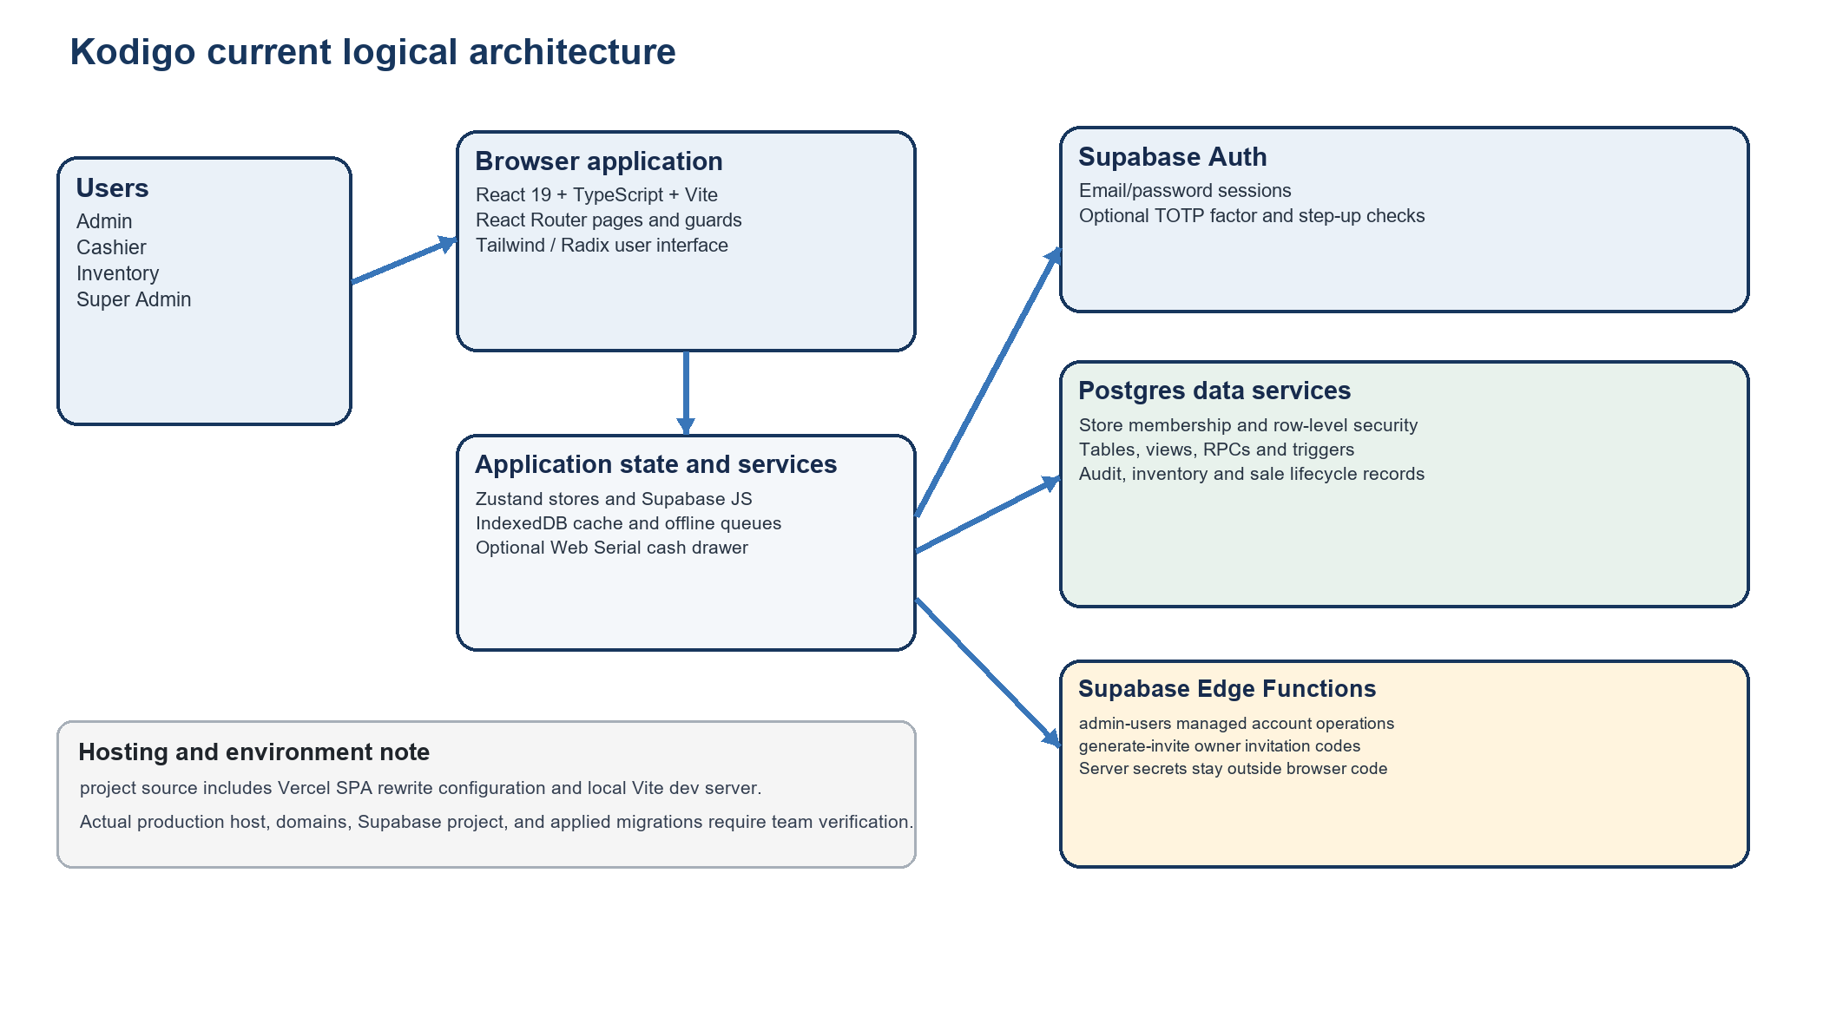

4. Technology choices and rationale
Table 4. Technology stack and design reason
Layer | Current implementation | Reason for use / constraint
Frontend | React 19, TypeScript 5.9, Vite 7 | Component-based interactive UI, typed application contracts, fast local development/build. TypeScript does not replace server authorization.
Navigation and state | React Router 7, Zustand 5 | Route organization and small focused stores for authentication, product, supplier, cart, and alert state.
UI and charts | Tailwind CSS 4, Radix UI primitives, Lucide React, Recharts 3 | Consistent responsive controls, accessible UI primitives, and interactive business charts.
Backend | Supabase Auth, Postgres, row-level security, database operations, triggers, views, Edge Functions | Managed sign-in and relational storage; database policies and functions enforce rules close to data. Actual target project and plan require confirmation.
Offline | browser offline storage through idb | Browser-local product cache and queues support eligible work during connectivity interruptions; conflict resolution is limited and queues require careful reconciliation.
Hardware and exports | Web Serial for optional ESC/POS drawer command; jsPDF and write-excel-file for exports | Uses browser capabilities for optional peripherals and report output. Printer/drawer compatibility must be tested.
Hosting | Vercel SPA rewrite configuration exists in project source | Vercel SPA rewrite configuration exists in project code. No hosted deployment, production domain, provider plan, CI release permission, or cost was verified; this document describes only the local demo.

5. Major modules and functional requirements
Table 5. Implemented module requirements
ID / module | Current behavior supported by project source | Expected result
FR-01 Identity and store context | Email/password sign-in, invite-based owner registration, role resolution, assigned store loading, and role-based route routing. | A user sees only authorized screens and store data.
FR-02 POS and receipts | Search by name/SKU/barcode, cart, unit/bulk options, payment, receipt snapshot, and sales lifecycle actions through database functions. | Sale, sale items, payment details, and stock effects are recorded consistently.
FR-03 Offline continuity | Cache products; queue eligible sales and selected mutations in browser offline storage; attempt replay on reconnect or page activity. | Pending/error state remains visible for reconciliation; business rule errors are not silently treated as network failures.
FR-04 Product and inventory | Product/category maintenance, purchase and selling units, price history, stock adjustment and movement records, archive/restore, and consumption history. | Base stock and its history remain traceable; sold products are archived rather than deleted.
FR-05 Suppliers and purchasing | Supplier records and store links, product supplier assignments, restocking options, purchase orders, receiving functions, supplier scoring, and consignment lots/balances. | Delivery and supplier-owned stock can be distinguished and reviewed.
FR-06 Alerts and notifications | Stock and selling-option conditions create notifications with user read state; report-export and transaction events can be surfaced. | Authorized users can review operational notices for assigned context.
FR-07 Reporting and analytics | Sales and inventory reports, Excel/PDF export paths, revenue/profit/category/hour charts, transaction views, rankings, and velocity. | Users review filtered output and export only within their role.
FR-08 Administration | Store branding and settings, managed staff account operations through admin-users Edge Function, invite generation through generate-invite, password reset, TOTP management. | Authorized changes are attributed and limited to the required store scope.

6. Data model and relationships
The schema is relational and store-oriented. Most operational records carry a store identifier or reach a store through an approved mapping. Row-level security (RLS) means database policies decide which rows an authenticated user can read or change for each request.
Table 6. Core data entities
Domain | Entities evidenced in schema and migrations | Relationship / purpose
Identity and tenancy | `profiles`, `stores`, `store_users`, `invite_codes` | Profiles map to stores through store_users; role and membership scope access.
Catalog and stock | `categories`, `products`, `product_selling_options`, `product_restocking_options`, `stock_adjustments`, `inventory_movements`, `inventory_stock_lots` | Products belong to store/category; stock movements explain sales, receipt, loss, adjustment, and consignment allocation.
Sales | `sales`, `sale_items`, `sale_payments`, `receipts`, `sale_events`, `sale_returns`, `sale_return_items`, `cashier_closeouts` | A sale has line items, payment and receipt records, with lifecycle events for void/refund/return and closeout.
Procurement | `suppliers`, `supplier_stores`, `product_suppliers`, `purchase_orders`, `purchase_order_items` | Supplier-store links support shared suppliers; orders link suppliers and products to receiving events.
Operations and evidence | `notifications`, `notification_user_states`, `audit_logs`, `error_logs`, `receipt_reprints`, `product_price_history` | Operational notices, user read status, errors, audit evidence, reprints, and price history support monitoring and traceability.

The list reflects current application source migrations and application queries, not a verified live database inventory. The target project’s applied migration ledger and actual grants must be inspected before release.
Database metadata: supabase_schema.sql (repository schema snapshot; header date 2 March 2026). Later source migration: 20260930180000_fix_shared_stock_alert_scope.sql. Snapshot freshness against later migrations and the target project’s applied schema/grants are unverified; use the live migration ledger as authority.

7. Data flow and business process
A named user is assigned a role and store, signs in, and confirms the active store. After access is checked, the user performs assigned work; online sales use the protected sale-processing RPC, while only eligible work may be queued locally during an interruption. Staff reconcile outcomes before closeout.
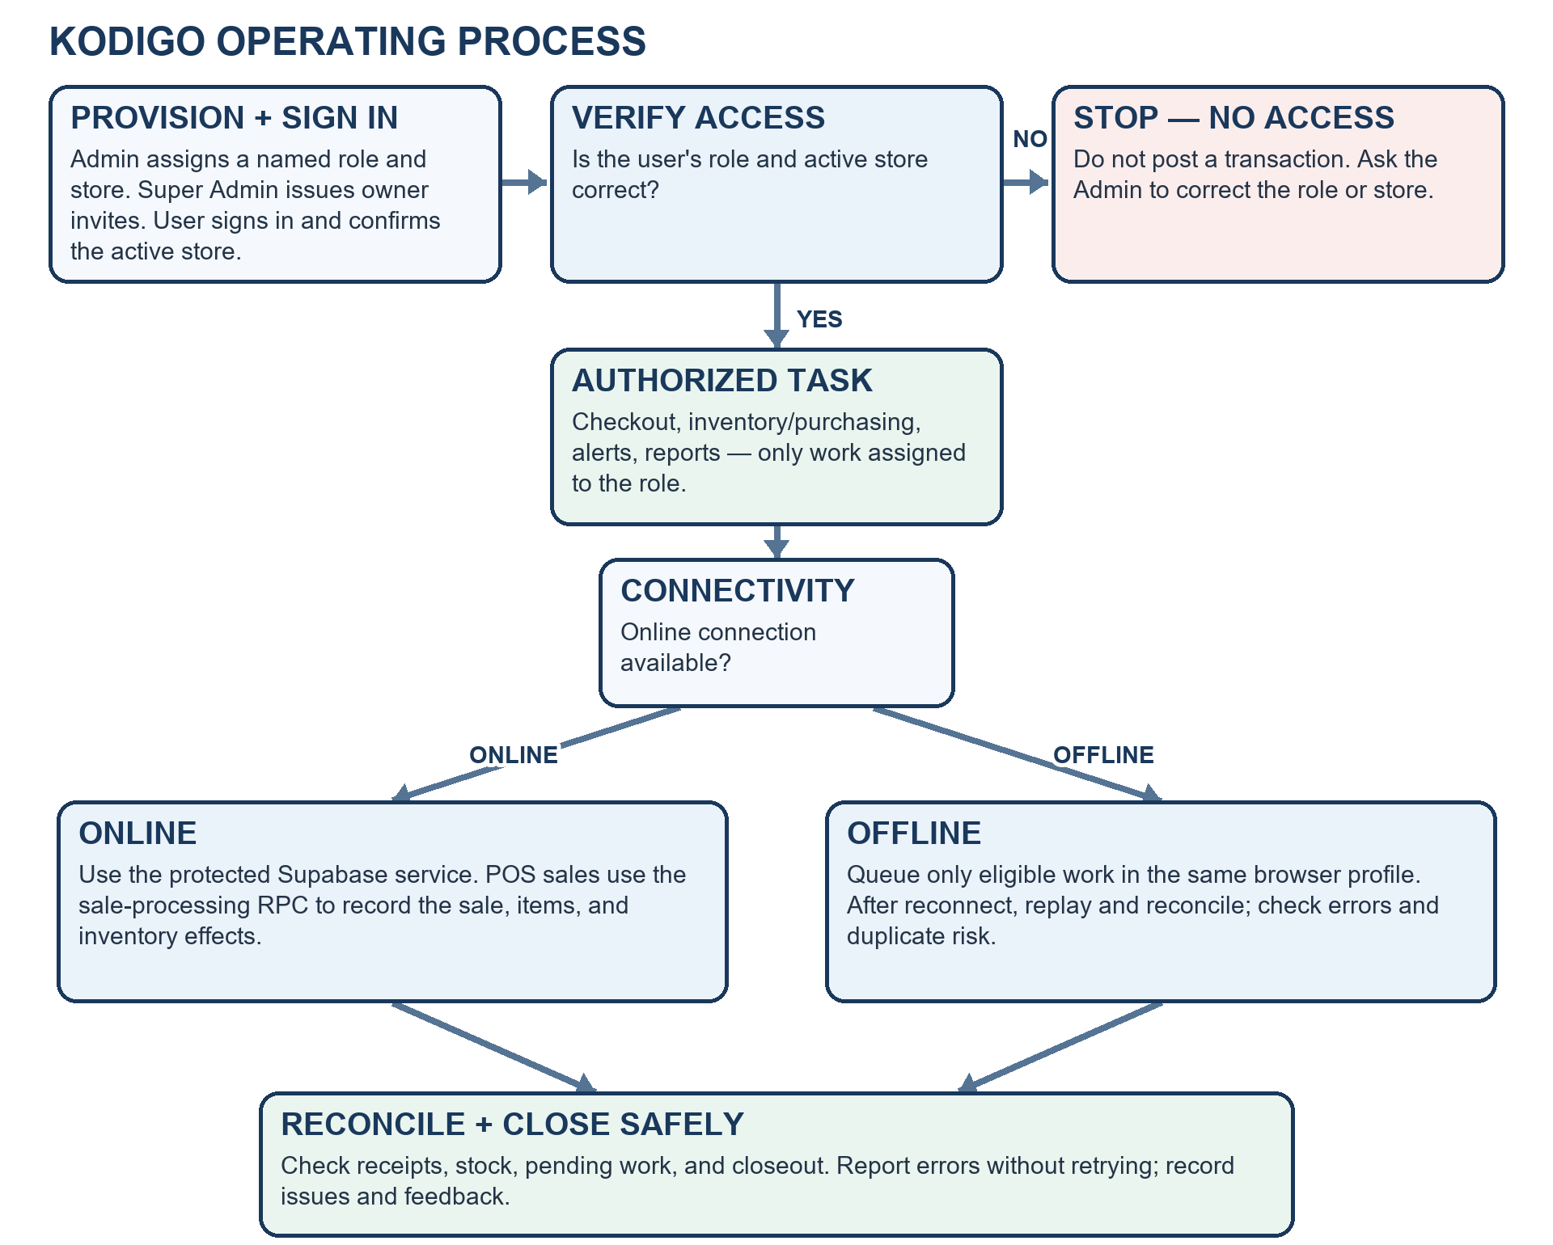
Figure 2. Kodigo operating process and offline-recovery flow
Flow summary: Provision role/store → sign in → verify access (stop before posting if incorrect) → complete assigned work online or queue eligible offline work → reconcile receipts, stock, pending work, and closeout.

8. Role and permission design
Table 7. Application permission matrix
Capability | Admin | Cashier | Inventory | Super Admin
POS checkout | Execute where enabled | Execute | None | None
Products and stock | Full store control | Read at POS | Manage within assigned scope | None
Stock adjustment / receiving | Manage and approve per local controls | None | Record within role and store scope | None
Suppliers and purchase orders | Manage assigned stores | None | No supplier administration | None
Dashboard / analytics / rankings | Assigned-store view | None | Limited per route | None
Reports | Sales and inventory | None | Inventory-oriented reports | None
Store settings / staff management | Manage assigned stores via supported controls | Own account | Own account | None
Invite governance | None | None | None | Generate owner invitation codes
Account security | Own account | Own account | Own account | Own account

This summarizes implemented route intent and code paths. Database policies are the authority; route guards improve navigation but cannot replace backend enforcement. The exact live permission matrix must be validated against the deployed migration state.
Environment access matrix
Environment | Application role names (source-defined) | Data and access rule | Verified status
PROD | admin; cashier; inventory; super_admin | Only named accounts with assigned role/store; least privilege; no shared accounts. | No production deployment or provider groups verified; keep live data out of the local demo.
UAT | admin; cashier; inventory; super_admin | Named test users, synthetic/masked data, isolated from any production project. | No UAT project, group mapping, or test roster supplied.
TEST | admin; cashier; inventory; super_admin | Synthetic accounts only; integration tests run solely against an isolated test project. | Code includes test harness; target project and actual group mapping not verified.

9. Security architecture and risk controls
Table 8. Security controls classified by purpose
Control class | Control evidenced or required | Risk addressed / evidence
Preventive | Supabase Auth sessions; role checks; store membership; row-level security; authorized RPC checks. | Blocks unauthorized access and cross-store operations; validate with role/store test cases.
Preventive | TOTP enrollment and assurance checks for protected operations where enabled; password reset flow. | Reduces account takeover; role-wide MFA requirement and target project settings require confirmation.
Preventive | Server-side admin-users and generate-invite functions; service-role secrets stay in server environment. | Limits privileged user-management operations; verify only required secrets are configured and never expose them in VITE variables.
Preventive | Store-specific active context for POS; database sale/receive/adjustment database operations; validation and lifecycle rules. | Reduces wrong-store posting and direct stock mutation.
Detective | `audit_logs`, `sale_events`, `inventory_movements`, `error_logs`, closeouts, price history, and export notifications. | Supports accountability and incident reconstruction; retention, access review, and alert ownership must be assigned.
Detective | Quarterly role/store review and release/test evidence. | Detects stale or excessive privileges and unsafe changes; retain dated approval records.
Corrective | Revoke or change access, reset credentials, correct through traceable adjustment/return functions, and preserve error queues. | Contains compromise and repairs records without concealing prior events.
Corrective | Production backup and restore procedure is described in the operations runbook. | Recovery capability depends on a configured backup plan and a successful restore drill; actual state must be verified.

10. Integrations, environments, and service identities
Table 9. Environment and identity inventory
Environment / identity | Current configuration or account group | Access and data boundary | Status / verification
Local demo | http://localhost:5173/; Vite development server on the owner workstation. Application roles: admin, cashier, inventory, super_admin. | Use synthetic records only; localhost is reachable on that computer only. | Observed in the local demo on 12 October 2026; not a public or production URL.
TEST | Isolated test project and synthetic accounts using the four application role names. | No live customer, staff, or transaction data; only approved test identities. | Test project URL, actual provider groups, and applied migrations were not supplied or verified.
UAT | Planned user-acceptance environment; use named test accounts mapped to admin, cashier, inventory, super_admin. | Separate from production; synthetic or approved masked data only. | No UAT deployment or provider-level group mapping was verified.
PROD | No production host, domain, project URL, or provisioned groups verified. | Do not use live data or treat this local demo as production. | Not applicable to the verified local demo; deploying organization must establish its own production boundary.
Browser client | VITE_SUPABASE_URL and VITE_SUPABASE_ANON_KEY are public browser configuration values. | Only the public/anon key may be shipped to the browser; database policies enforce access. | No client secret may be placed in VITE variables or browser bundles.
Server functions and backups | admin-users and generate-invite Edge Functions use server-side provider secrets; no named human service account or backup identity was evidenced. | Secrets remain in managed server settings; limit access, record owner, and rotate on suspected exposure. | Deployment identities, project metadata link, backup vault, retention, and restore evidence were not provided.

Migration caution: the current application source contains numbered migrations through migration_40 and additional dated migrations. The README setup sequence does not include every newest file. Treat the applied migration ledger in the target Supabase project as the deployment source of truth; do not assume current application source files are already deployed or invent an execution order where the environment is unknown.

PART II - SYSTEM GOVERNANCE

11. Governance objectives and structure
Governance assigns decision rights for access, changes, data, security, incidents, backups, and documentation. The deploying organization owns the service and accepts operational and privacy obligations. The roles below are governance assignments; only Admin, Cashier, Inventory, and Super Admin are application roles in the current TypeScript role union.
Table 10. Governance responsibilities
Governance role | Owns / maintains | Approves / decides | Accountability
Client organization / accountable service owner | Legal organization was not supplied. Ira Pongasi is the client stakeholder named by the project owner; formal operational authority is not evidenced. | Accepts business changes, assigns owners, accepts residual risk. | Business impact, support capacity, and service direction.
Admin / store owner | Store configuration, product and staff accuracy, local access, daily reconciliation. | Routine account/store access, stock corrections, and purchase actions under local thresholds. | Store operation and correct, timely escalation.
Cashier | Accurate cart, payment, receipt, and shift handoff. | No role authority to approve own exceptions beyond assigned actions. | Actions performed under own credentials; prompt discrepancy report.
Inventory staff | Catalog, physical counts, movement records, and inventory reports. | Routine stock activity within role; Admin approves unusual changes per policy. | Count accuracy, conversion correctness, and evidence notes.
Super Admin | Owner invite-code governance. | Issue governed owner invitation codes. | Invite issuance and onboarding integrity; no tenant operations.
System Administrator | Supabase configuration, technical access, releases, logs, and recovery work. | Execute approved changes; emergency action under incident authority. | Technical recovery evidence, privileged access, and migration records.
Client service authority / IT Manager (if deployed) | No person or office was supplied. The client designates this role before production operation; project email is not a 24/7 service desk. | Approves major changes, emergency access, restoration, and service communications. | Service continuity and closure of corrective actions.
Client/controller Privacy Contact | No individual was supplied. The responsible controller designates an authorized contact before personal-data processing; suspected breaches are escalated directly and immediately. | Advises or decides privacy response within authority; coordinates any required notification. | Transparent, documented privacy handling.
Developer / technical contributor | Source code and migrations under version control. | No routine production access; contributes reviewed changes. | Tests, review responses, and accurate technical documentation.

12. Decision rights and segregation of duties
Table 11. Decision and approval matrix
Decision | Prepares | Approves | Evidence
Create or change a user/store assignment | Admin | Authorized store owner / manager | Named user, role, store, approver, date, expiry where relevant.
High-impact stock correction | Inventory staff or Admin | Second authorized approver under local threshold | Count, reason, before/after, supporting reference.
Normal code or database change | Developer | Reviewer and release owner | Issue, pull request, tests, migration, release record.
Emergency technical change | System Administrator | IT Manager or delegated incident commander | Incident ID, reason, scope, rollback, time, retrospective review.
Restore or backup-retention change | System Administrator | IT Manager / System Owner | Restore scope, approvals, reconciliation, retention evidence.
Privacy request or disclosure | Privacy Contact with system support | Privacy authority under organization policy | Request, identity verification, decision, disclosure/correction/deletion evidence.

Where project staffing is too small for full separation, the System Owner records the conflict, appoints an independent reviewer for high-risk actions, and retains evidence. No single person should silently request, approve, implement, and close their own high-impact production change.

13. Access governance lifecycle
1. Request: document the user, business duty, role, store scope, start date, duration, and any privileged need.
2. Approve: Admin or designated owner validates identity and need; an independent approver reviews high-risk or cross-store access.
3. Provision: use the managed user function and invite flow selected for production; record the resulting role/store mapping.
4. Review: at least quarterly, compare active users, roles, and store assignments with current duties; record decisions and exceptions.
5. Revoke or change: remove access on separation, role change, compromise, or end of assignment; preserve transaction attribution and reconcile pending offline work.
6. Privileged access: restrict to named administrators, use MFA where enforced, approve and time-bound support access, and review after use.
Owner registration path in current project code: a Super Admin generates a one-time owner invitation code; the initial owner enters it, submits the registration form, and confirms the email before signing in. The target project’s deployed invite function, authorization rules, and recovery route were not verified; use synthetic accounts until tested.

14. Data and privacy governance
The deploying organization determines why personal information is collected, provides the required notice, assigns a Privacy Contact, approves retention, handles rights requests, and assesses incidents. Kodigo can contain names, email addresses, roles, store assignments, supplier contact details, sales and stock activity, payment method and limited reference, audit events, error context, exports, and device/browser details when linked to a user.
Kodigo must not store full card numbers, PINs, one-time passwords, or wallet passwords. Ordinary cash checkout does not require customer identity; collect customer details only where a defined and approved feature requires them.
Privacy handling should follow Republic Act No. 10173, its Implementing Rules and Regulations, and applicable National Privacy Commission guidance. If a personal-data breach is suspected, notify the client/controller Privacy Contact immediately; do not wait for routine support hours. The controller assesses whether notification is required and, where applicable, follows the NPC 72-hour reporting requirement. This document does not claim certification or verified legal compliance.
Official references: Republic Act No. 10173; National Privacy Commission Implementing Rules and Regulations; NPC Breach Reporting; NPC Circular 16-03
Table 12. Privacy governance fields to complete
Privacy area | Documented status | Operational rule
Responsible organization | Ira Pongasi is the named client stakeholder; the legal organization name was not supplied. | Use synthetic data only until the responsible organization/controller is identified.
Privacy Contact / DPO | No individual or direct contact details were supplied. | The responsible controller designates the contact before personal-data processing; send suspected breach reports directly to that contact immediately.
Project support contact | Evon Christian P Vergara — vergaraevon@gmail.com; Monday–Friday 09:00–17:00 PHT. | Project support only; this is not represented as the client’s legal Privacy Contact or an on-call service.
Retention and rights requests | No production retention schedule or rights-request channel was verified. | Do not load live personal information until the controller sets retention, access, correction/deletion, and notice processes.
Breach notification authority | The controller decides whether statutory notification is required. | Escalate suspected breaches immediately to the controller’s Privacy Contact. Where notification is required, follow NPC guidance on reporting within 72 hours; this is not a support response SLA.

Data classification and handling
Class | Examples in Kodigo | Storage / sharing rule | Retention and disposal
Public | Approved public product or service information; published user-facing guidance. | May be shared publicly only after owner review; no credentials or private store data. | Keep only while current; remove obsolete copies.
Internal | Non-public operating procedures, configuration, product catalog, and aggregated store operations. | Named business users only; approved organization storage; no public drives or personal email. | Keep for the documented business period; remove obsolete exports securely.
Confidential | Names/emails, user-role and store assignments, supplier contacts, sales, stock movements, receipts, reports, and support records. | Least-privilege access; assigned store scope; minimize exports; encrypt protected storage and transit. | Controller sets purpose-based retention and rights-request handling before live use.
Restricted | Passwords, invite/reset links, OTP/TOTP setup keys, server secrets, backup copies, and any full payment credentials if encountered. | Never share or place secrets in browser code, tickets, screenshots, or public storage. Kodigo must not store full card numbers, PINs, OTPs, or wallet passwords. | Keep only as long as necessary for the protected function; revoke/rotate secrets and securely dispose of obsolete copies.

Related owner-issued policies: Acceptable Use Policy | BYOD Policy

15. Risk management
Table 13. Initial project risk register
Risk / evidence | Likelihood / impact | Potential effect | Mitigation, owner, and status
Migration or live database differs from current project code | High / High | Policies, columns, or functions may be missing or inconsistent. | Before any release, compare applied migration ledger, policies, grants, functions, and triggers; record results. Owner: System Administrator.  Status: Open — deployment not verified.
Offline queue conflict or replay failure | Medium / High | A pending sale or stock change may be duplicated, rejected, or stale. | Use synthetic test cases; reconcile pending queue before retry; never clear browser data while work is pending. Owner: Admin + technical owner.  Status: Open — limited conflict handling.
Privileged account compromise or TOTP not enforced | Medium / High | Unauthorized account, invite, or data changes. | Require verified TOTP for Admin/Super Admin before live use; least privilege, named accounts, quarterly access review. Owner: client service authority.  Status: Open — role enforcement unverified.
Backup or restore path unavailable | Medium / High | Sales, stock, and audit history may not be recoverable. | Verify provider backup plan, restricted access and retention; complete an isolated restore rehearsal before production. Owner: System Administrator.  Status: Open — provider plan not verified.
Vulnerable dependency or delayed patch | Medium / High | Known weakness may enable compromise or disruption. | Review dependency advisories monthly and before release; apply critical fixes within 24h, high within 7 days, medium within 30 days. Owner: technical maintainer.  Status: Control required; no automated patch status verified.
Personal information exposed or retained without a controller process | Medium / High | Privacy harm, legal reporting, or rights-request failure. | Use synthetic demo data; identify controller/Privacy Contact and retention before live data; direct immediate breach escalation. Owner: client/controller.  Status: Open — organization/contact not supplied.
Redacted screenshot still contains identifying or transaction detail | Low / Medium | Unintended disclosure in academic distribution. | Review each embedded figure at rendered size; mask identifiers and use only synthetic/demo data; limit distribution. Owner: Document Owner.  Status: Review required before wider public use.

16. Change, release, and configuration management
Table 14. Naming, coding, metadata, and release standards
Area | Required project standard
Source of truth and database changes | Treat the target project’s applied migration ledger as authoritative; add ordered migrations and never rewrite an applied migration. Review data impact, access policy, rollback, and documentation together.
Naming conventions | Database objects use snake_case; React components use PascalCase; hooks and functions use camelCase; constants use UPPER_SNAKE_CASE; routes use lowercase kebab-case. Use descriptive names; abbreviations only for established terms.
Folder and file taxonomy | Keep pages, components, stores, libraries, database migrations, Edge Functions, tests, and documentation in their existing feature-appropriate folders. Use filenames that identify feature and purpose; do not store secrets or live exports with source files.
Metadata and versioning | Every release record includes version, date, author, reviewer, issue/change reference, environment, migration range, test evidence, approver, and rollback reference. Mark environment and synthetic/live data status on test records.
Branch and review model | Use short-lived feature/<ticket>-<slug> or fix/<ticket>-<slug> branches from main; submit a reviewed change request; do not push directly to a production release. Branch protection is not verified in the current project host.
Code style and formatting | Follow TypeScript/React conventions already used in the project, small focused functions, explicit validation, safe error messages, and no secrets in browser code. Run ESLint, TypeScript typecheck, and build; no separate Prettier configuration is present.
Testing and vulnerability management | Run npm ci, typecheck, lint, build, and isolated integration tests before release. Review dependency advisories monthly and before each release; document severity, affected version, owner, remediation, and retest.
Deployment and rollback | Confirm the target project, secrets, migration order, authorization tests, and smoke checks before release. Record the deployment and rollback reference. Restore schema/data only from a verified backup in an isolated replacement and reconcile before promotion.

Vulnerability review is a required release control; no automated scanner, monitoring integration, or live patch status was verified in the local demo. Review dependency advisories monthly and before a release, record affected components and severity, test fixes in isolation, and preserve the change evidence.
Vulnerability triage and target remediation
Severity / trigger | Target containment or remediation | Evidence / owner
Critical / actively exploited | Contain immediately; target a verified fix or safe disablement within 24 hours. | Incident and change record; technical maintainer, with client service authority.
High | Target remediation within 7 calendar days. | Advisory, affected version, test and release record; technical maintainer.
Medium | Target remediation within 30 calendar days or document a compensating control. | Risk acceptance and planned release date; Project Owner / technical maintainer.
Low | Include in the next planned maintenance release, normally within 90 days. | Monthly review record and version check; technical maintainer.

17. Incident management and escalation
The ITIL-aligned workflow logs, categorizes, assesses impact and urgency, assigns priority, diagnoses, escalates when needed, validates recovery, and records lessons. Tier 0 and Tier 1 handle self-check and store impact; Tier 2 investigates technical faults; Tier 3 coordinates major, privacy, vendor, or emergency decisions.
Incident response workflow
1. Report and log: Record the reporter, time, store, impact, evidence, and current status.
2. Categorize and prioritize: Assess impact and urgency, assign a P1-P4 priority, and name an incident owner.
3. Diagnose: Tier 0 or Tier 1 checks safe user and store causes. The Admin confirms impact and any safe workaround; unresolved technical faults go to Tier 2.
4. Escalate major issues: The IT Manager or incident lead coordinates a major response. The Privacy Contact assesses privacy impact, and a vendor is engaged when needed.
5. Restore and validate: Recover service, reconcile records, and confirm the result with the reporter.
6. Record lessons: Capture the cause, evidence, owner, due date, and corrective action for governance review.
Table 15. Proposed response targets for capstone operations
Tier / priority | Trigger | Target / action | Accountable contact
Tier 0 — self-help | Known how-to or non-impacting warning. | Use the manual and capture the exact message; do not repeat a pending transaction. | User / shift Admin.
Tier 1 — store operations | One user/register, cash discrepancy, or access issue. | Notify the store Admin; project-demo email is reviewed Mon–Fri 09:00–17:00 PHT; outside those hours, next-business-day review. No guaranteed response SLA. | Store Admin; project contact Evon Christian P Vergara, vergaraevon@gmail.com.
Tier 2 — technical service | Multiple users/stores, failed synchronization, suspected data defect, or outage. | Stop unsafe retries, preserve references, and email the Project Owner during the stated service window. Escalate immediately if safety, security, or privacy is involved. | Project Owner / designated technical maintainer.
Tier 3 — security or privacy | Suspected account takeover, unauthorized disclosure, or personal-data breach. | Immediately contact the client/controller Privacy Contact directly and the Project Owner; do not wait for routine support hours. Controller decides statutory notification. | Client/controller Privacy Contact (not yet named); Evon for project coordination.
Priority convention | P1 material service/security impact; P2 significant degraded work; P3 limited issue; P4 request. | Set priority from business/data impact, document the decision, update affected users through the existing client channel. Targets above are proposed operating guidance, not a contractual SLA. | Assigned incident owner.

The contact and handling windows above reflect the project-support email disclosed by the owner. They are not a contractual service-level agreement, 24/7 service, or guaranteed response time. The client organization must route privacy incidents directly to its Privacy Contact regardless of normal support hours.

18. Backup, recovery, audit, and monitoring responsibilities
Table 16. Operational ownership
Control activity / cadence | Responsible | Review / escalation | Evidence to retain
Each shift: reconcile cash closeout, pending offline work, and unusual stock events. | Store Admin; Cashier records assigned closeout. | Admin resolves routine mismatch; escalate unexplained or suspected fraud immediately. | Closeout, receipt/sale references, reconciliation note.
Daily during any pilot: review failed sync/error queue and provider backup status where available. | Designated technical maintainer / provider operator. | Project Owner; client service authority for material availability/data risk. | Dated review, unresolved issue, backup status, owner and due date.
Weekly: review incident/error patterns, audit/export events available to the organization, and dependency/security advisories. | Technical maintainer and Admin within assigned scope. | Project Owner; Privacy Contact for personal-data concern. | Review checklist, issue/change records, corrective actions.
Quarterly and on role change: review user roles, store memberships, and privileged access; rehearse restoration at least quarterly before production. | Admin and System Administrator. | Independent client service authority; privacy reviewer where data is involved. | Dated access roster, restore test, reconciliation results, approval.
Before each schema release and after an incident: preserve backup, migration, rollback, and incident timeline. | System Administrator / incident lead. | Release approver or client incident commander. | Backup reference, migration result, test evidence, timeline, recovery and lessons.

Proposed minimum before production: confirm provider backups, restricted backup access, at least 30-day retention where supported, a pre-migration backup, and quarterly isolated restore rehearsal. These controls are recommendations only; the local demo does not verify a deployed schedule, retention setting, or successful restore.

19. User feedback and post-launch improvement
No interview, survey, pilot, or post-launch user-feedback results were supplied for this revision; no user findings are invented. The reviewed local interface and code are technical observations, not user-reported evidence. The Project Owner records feedback received through vergaraevon@gmail.com, Monday–Friday 09:00–17:00 PHT, and tracks impact, role/store, evidence, decision, owner, and due date.
1. Collect user feedback during onboarding, support incidents, and a scheduled post-launch review.
2. Group feedback into usability, reliability, data accuracy, access, and privacy themes; protect personal data in the record.
3. Prioritize changes by operational harm, user frequency, legal/privacy impact, and implementation effort.
4. Approve a change, assign an owner and due date, test in an isolated environment, and publish the release note or user instruction update.
5. After release, ask the reporting users whether the change solved the problem and record any remaining issue.
Feedback plan: collect qualitative task-interview notes and quantitative task-completion time/error counts during any authorized pilot; review weekly during pilot and monthly after stable operation. No structured feedback channel or pilot schedule has yet been verified.
User feedback evidence and post-launch prioritization
Evidence / method | Classification and result | Priority / response
Interviews, surveys, or usability sessions | No pre-launch user-study evidence was supplied; no user finding is claimed. | Collect qualitative task notes and quantitative completion time/error counts during an authorized pilot.
Current interface/code review | Technical inspection only; not user-reported feedback. | Use to document implemented behavior and risks, not to assert user satisfaction.
Future pilot findings | Label each verified item Bug Report, Usability Issue, Feature Request, or Positive Feedback; retain date, role/store, and supporting evidence. | Apply MoSCoW: Must fix security/data-integrity blockers; Should address frequent workflow friction; Could improve convenience; Won’t promise unsupported scope. Review weekly during pilot.

20. Documentation ownership, training, and review
This final owner-issued document set is Version 1.6 | 12 October 2026. Document owner: Evon Christian P Vergara. The peer-review audit and teacher revision-note incorporation are complete; no further document approval is pending. Deployment decisions remain with the client organization.
- Review at least annually and after material changes to roles, privacy processing, sale lifecycle, inventory controls, hosting, or incident ownership.
- Use version history in the project current application source; record change summary, author/reviewer, approval, effective date, and replaced version.
- Keep controlled templates for access requests, risk reviews, incident records, restore tests, release approval, and user acknowledgment.
- Train Admins and Cashiers on sales and cash controls; Inventory staff on units, counts, and adjustments; privileged staff on access, MFA, privacy, and recovery.
- Retain attendance and practical competency evidence in an organization-approved restricted location.
User-facing procedures: Kodigo User Manual

21. Feasibility, rollout sequence, and resource plan
Verified scope is the local demo and optional hardware integration. The client organization, Privacy Contact, technical contact, UAT environment, rollout schedule, staffing, hosting, costs, client test commitment, and target dates are unverified or not supplied. These are not approval conditions for this final owner-issued academic set.
Table 17. Proposed rollout timeline
Milestone / phase | Completion evidence | Owner / target date status
1. Academic document and local-system baseline complete | Four owner-issued deliverables; source-verified role and local-demo boundaries; screenshots redacted. | Evon Christian P Vergara — complete 12 Oct 2026.
2. Confirm client organization, privacy contact, and isolated test environment | Client-side roles, test project, migration ledger, data handling and contacts documented. | Not assigned; dates unverified.
3. Complete security, role/store, POS, offline, and restore tests | Dated test matrix, synthetic test outcomes, dependency review, restore rehearsal, risk disposition. | Not assigned; dates unverified.
4. Train users and conduct a controlled pilot if the client elects to proceed | Role-based practice, signed policy acknowledgments, support route, rollback and incident steps. | Not assigned; dates unverified.
5. Review pilot outcomes and decide next steps | Feedback log, incidents, measures, cost/value comparison, and documented continue/change/stop decision. | Not assigned; dates unverified.

Table 18. Indicative resource and budget plan
Resource / category | Availability / estimate status | Cost status
Project owner / development | Effort not estimated or approved. | Budget not supplied.
QA, security, and recovery testing | Required test activities identified; hours not estimated. | Budget not supplied.
Training and pilot support | Training may be needed if a client-authorized pilot is approved; hours not estimated. | Budget not supplied.
Devices and peripherals | Local demo uses the owner workstation; additional device needs are not verified. | Cost not supplied; hardware quotes are not available.
Hosting, email, and backup services | No hosted production environment or provider plan was verified; local demo only. | Costs not supplied; current provider quotes are required before deployment.

ROI, approved labor hours/rate, costs, benefit baseline, and numeric target were not supplied; no realized ROI is claimed. Before any authorized pilot, set a baseline for reconciliation time, stock discrepancies, duplicate/rejected sales, and reordering rework, then compare results.

