**16-720 Computer Vision: Homework 4 (Fall 2022)**

**3D Reconstruction**

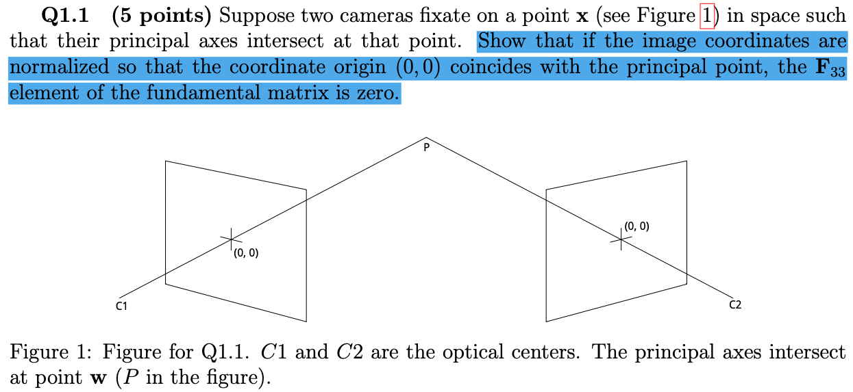Haejoon Lee

Epipolar constraint:



Pure translation -> R = I

Epipolar constraints:



Thus, if we fix single y, then the epipolar line is parallel to the x-axis.

From the matrix D, we can assume the x-axis of the world coordinate is perpendicular to the mirror.



Thus, it is equivalent to having another camera whose matrix is K’.

Let’s assume that the camera coordinate’s axis is parallel to word coordinates.

Then, the virtual camera is only at the translated position as below:

Epipolar constraints:



If  is skew-symmetric, then the fundamental matrix will be so.

Thus, the fundamental matrix is skew-symmetric.

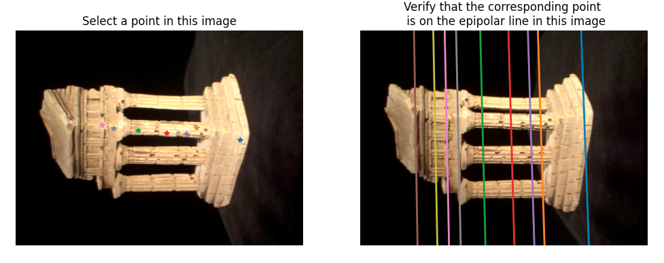

def eightpoint(pts1, pts2, M):

# Replace pass by your implementation

N = pts1.shape[0]

# Normalization

pts1, pts2 = pts1/float(M), pts2/float(M)

xcoords1, ycoords1 = pts1[:, 0], pts1[:, 1]

xcoords2, ycoords2 = pts2[:, 0], pts2[:, 1]

# A Matix

cul0 = xcoords2 * xcoords1

cul1 = xcoords2 * ycoords1

cul2 = xcoords2

cul3 = ycoords2 * xcoords1

cul4 = ycoords2 * ycoords1

cul5 = ycoords2

cul6 = xcoords1

cul7 = ycoords1

cul8 = np.ones((N,), dtype=np.float32)

A = np.stack((cul0, cul1, cul2, cul3, cul4, cul5, cul6, cul7, cul8), axis=1)

# solve a raw f

_, _, Vt = np.linalg.svd(A)

F_vec = Vt[-1, :] #(9,)

F_raw = F_vec.reshape(3, 3)

#Refine F

F_norm = _singularize(F_raw)

F_norm = refineF(F_norm, pts1, pts2) # ?

# Unscale

T = np.zeros((3, 3), dtype=np.float32)

T[0, 0] = T[1, 1] = 1.0 / M

T[2, 2] = 1.0

F_final = T.transpose() @ F_norm @ T

return F_final

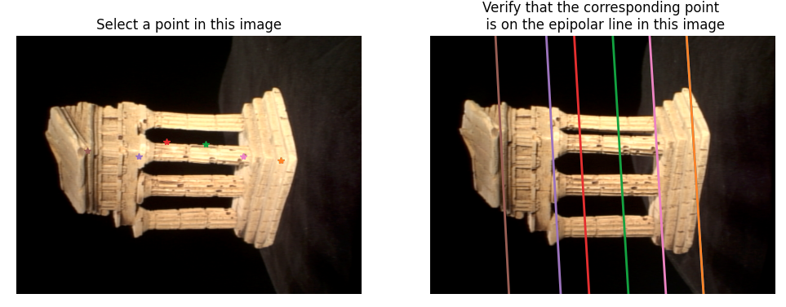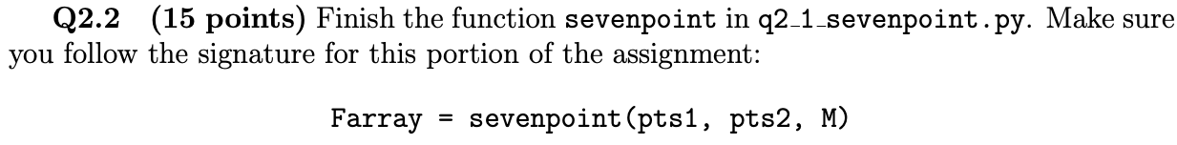

def sevenpoint(pts1, pts2, M):

Farray = []

# ----- TODO -----

# YOUR CODE HERE

N = pts1.shape[0]

# Normalization

pts1, pts2 = pts1/float(M), pts2/float(M)

xcoords1, ycoords1 = pts1[:, 0], pts1[:, 1]

xcoords2, ycoords2 = pts2[:, 0], pts2[:, 1]

# A Matix

cul0 = xcoords2 * xcoords1

cul1 = xcoords2 * ycoords1

cul2 = xcoords2

cul3 = ycoords2 * xcoords1

cul4 = ycoords2 * ycoords1

cul5 = ycoords2

cul6 = xcoords1

cul7 = ycoords1

cul8 = np.ones((N,), dtype=np.float32)

A = np.stack((cul0, cul1, cul2, cul3, cul4, cul5, cul6, cul7, cul8), axis=1)

# Get F1 and F2

_, _, Vt = np.linalg.svd(A)

F1_vec, F2_vec = Vt[-1, :], Vt[-2, :] #(9,)

F1, F2 = F1_vec.reshape(3, 3), F2_vec.reshape(3, 3)

#Find the coefficients for F1 and F2 spanning the null space

a, b = F1-F2, F2

funct = lambda x: np.linalg.det(x*a + b)

c0 = funct(0)

c1 = (2.0/3)*(funct(1)-funct(-1)) - (1.0/12)*(funct(2)-funct(-2))

c3 = (1.0/12)*(funct(2) - funct(-2)) - (1.0/6)*(funct(1)-funct(-1))

c2 = funct(1) - c0 - c1 - c3

#Solve the polynomial

roots = poly.polyroots([c0, c1, c2, c3])

# Unscale F

T = np.zeros((3, 3), dtype=np.float32)

T[0, 0] = T[1, 1] = 1.0 / M

T[2, 2] = 1.0

for root in roots:

F_norm = root*a + b

F_norm = _singularize(F_norm)

# F_norm = refineF(F_norm, pts1, pts2)

F_final = T.transpose() @ F_norm @ T

Farray.append(F_final)

return Farray

def essentialMatrix(F, K1, K2):

# Replace pass by your implementation

E = K2.transpose() @ F @ K1

return E

Assume we have two points x and x’





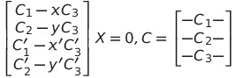

def triangulate(C1, pts1, C2, pts2):

# Replace pass by your implementation

coord_word_list = []

err_reproject = 0

for i in range(pts1.shape[0]):

x1, y1 = pts1[i, :]

x2, y2 = pts2[i, :]

# A matrix

A0 = C1[0, :] - x1*C1[2, :]

A1 = C1[1, :] - y1*C1[2, :]

A2 = C2[0, :] - x2*C2[2, :]

A3 = C2[1, :] - y2*C2[2, :]

A = np.stack((A0, A1, A2, A3), axis=0)

#Get world coordinates through SVD

_, _, Vt = np.linalg.svd(A)

coord_word = Vt[-1, :] #(4,)

coord_word = coord_word[0:3] / coord_word[3] #(3,)

coord_word_list.append(coord_word)

#Reprojection

coord_word_homo = np.zeros((4, 1), dtype=np.float32)

coord_word_homo[0:3, 0] = coord_word

coord_word_homo[3, 0] = 1

coord_cam1_rep = C1 @ coord_word_homo

coord_cam2_rep = C2 @ coord_word_homo

#Calculate reprojection error

x1_cam1_rep, y1_cam1_rep = coord_cam1_rep[0:2, 0] / coord_cam1_rep[2, 0]

x2_cam2_rep, y2_cam2_rep = coord_cam2_rep[0:2, 0] / coord_cam2_rep[2, 0]

err_reproject += (x1_cam1_rep-x1)**2 + (y1_cam1_rep-y1)**2 + (x2_cam2_rep-x2)**2 + (y2_cam2_rep-y2)**2

P = np.stack(coord_word_list, axis=0)

return P, err_reproject

def findM2(F, pts1, pts2, intrinsics, filename = 'q3_3.npz'):

'''

Q2.2: Function to find the camera2's projective matrix given correspondences

Input: F, the pre-computed fundamental matrix

pts1, the Nx2 matrix with the 2D image coordinates per row

pts2, the Nx2 matrix with the 2D image coordinates per row

intrinsics, the intrinsics of the cameras, load from the .npz file

filename, the filename to store results

Output: [M2, C2, P] the computed M2 (3x4) camera projective matrix, C2 (3x4) K2 * M2, and the 3D points P (Nx3)

***

Hints:

(1) Loop through the 'M2s' and use triangulate to calculate the 3D points and projection error. Keep track

of the projection error through best_error and retain the best one.

(2) Remember to take a look at camera2 to see how to correctly reterive the M2 matrix from 'M2s'.

'''

K1, K2 = intrinsics['K1'], intrinsics['K2']

E = essentialMatrix(F, K1, K2)

M2s = camera2(E)

# Assume camera coordinates = word coordinates

M1 = np.zeros((3, 4), dtype=np.float32)

M1[0,0] = 1

M1[1,1] = 1

M1[2,2] = 1

C1 = K1 @ M1

# Find C2, P for each M2

P_list = []

C2_list = []

err_list = []

for i in range(M2s.shape[2]):

M2 = M2s[:, :, i]

C2 = K2 @ M2

C2_list.append(C2)

P, err_rep = triangulate(C1, pts1, C2, pts2)

P_list.append(P)

err_list.append(err_rep)

#Remain best M2

min_idx = np.argmin(np.abs(np.array(err_list)))

# print(min_idx)

M2 = M2s[:, :, min_idx]

P = P_list[min_idx]

C2 = C2_list[min_idx]

return M2, C2, P

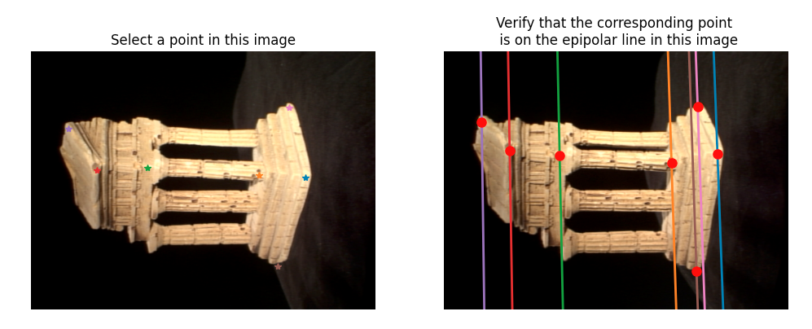

def KernelResponse(im, x, y, kxs, kys):

H, W = im.shape[0:2]

xs, ys = kxs + x, kys + y

xs, ys = np.clip(xs, 0, W-1).astype(np.int32), np.clip(ys, 0, H-1).astype(np.int32)

response = im[ys, xs, :]

return response

def epipolarCorrespondence(im1, im2, F, x1, y1):

coord_img1_homo = np.array([[x1], [y1], [1]], dtype=np.float32)

# Calculate epipolar line on im2

epipolarline_img2 = F @ coord_img1_homo

# Set search boundary

r = 100

ll = np.array([1, 0, -(x1-r)], dtype=np.float32).reshape(-1, 1)

lt = np.array([0, 1, -(y1-r)], dtype=np.float32).reshape(-1, 1)

lr = np.array([1, 0, -(x1+r)], dtype=np.float32).reshape(-1, 1)

lb = np.array([0, 1, -(y1+r)], dtype=np.float32).reshape(-1, 1)

lines_boundary = [ll, lt, lr, lb]

# Get intersected points between search boundary and epipolar line

points_intersect = [np.cross(l.reshape(-1), epipolarline_img2.reshape(-1)).reshape(-1, 1) for l in lines_boundary]

points_end = []

for points in points_intersect:

if np.abs(points[2, 0]) > 0.0000001:

points_homo = points / points[2, 0]

dist_max = np.max(np.abs(points_homo[0:2, :]-coord_img1_homo[0:2, :]))

if dist_max < r*(1.1):

points_end.append(points_homo)

search_begin = None

search_end = None

if len(points_end) > 2:

point0_end = points_end[0]

for i in range(1, len(points_end)):

coord_img1_homo = points_end[i]

if np.min(np.abs(point0_end[0:2, :]-coord_img1_homo[0:2, :])) > r*0.1:

search_begin = point0_end[0:2, :]

search_end = coord_img1_homo[0:2, :]

break

else:

search_begin = points_end[0][0:2, :]

search_end = points_end[1][0:2, :]

# Generate Gaussian weighting kernel

kernel_r = 20

kernel_xaxis = np.arange(-kernel_r, kernel_r+1, 1.0)

kernel_yaxis = np.arange(-kernel_r, kernel_r+1, 1.0)

kernel_xaxis, kernel_yaxis = np.meshgrid(kernel_xaxis, kernel_yaxis)

kernel_xaxis, kernel_yaxis = kernel_xaxis.reshape(-1), kernel_yaxis.reshape(-1)

STD = kernel_r / 2.0

kernel_window = np.exp( -( (kernel_xaxis**2 + kernel_yaxis**2)/(2*STD**2) ) ) / (2*np.pi*STD**2)

response_img1 = KernelResponse(im1, x1, y1, kernel_xaxis, kernel_yaxis)

#Calculate distances by compare kernel response and get the best matching point on im2

dist_min = np.Inf

num_steps = int(np.sum((search_begin-search_end)**2)**0.5)

x_step = (search_end[0, 0] - search_begin[0, 0]) / num_steps

y_step = (search_end[1, 0] - search_begin[1, 0]) / num_steps

x2, y2 = search_begin[0, 0], search_begin[1, 0]

x2_best, y2_best = -1, -1

for i in range(num_steps):

response_img2 = KernelResponse(im2, x2, y2, kernel_xaxis, kernel_yaxis)

dist = np.sum((response_img2 - response_img1)**2, axis=1)**0.5 # (Nk,)

dist = np.sum(dist*kernel_window)

if dist < dist_min:

dist_min = dist

x2_best, y2_best = x2, y2

x2, y2 = x2 + x_step, y2 + y_step

return x2_best, y2_best

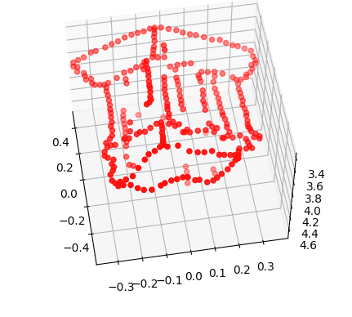

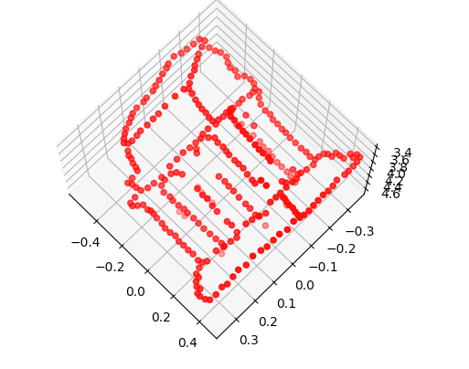

def compute3D_pts(temple_pts1, intrinsics, F, im1, im2):

# ----- TODO -----

# YOUR CODE HERE

coords_x1 = temple_pts1['x1']

coords_y1 = temple_pts1['y1']

coords_x2 = coords_y2 = []

# Find x2, y2

for i in range(coords_x1.shape[0]):

x1, y1 = coords_x1[i, 0], coords_y1[i, 0]

x2, y2 = epipolarCorrespondence(im1, im2, F, x1, y1)

coords_x2.append(x2)

coords_y2.append(y2)

coords_x2, coords_y2 = np.array(coords_x2).reshape(-1, 1), np.array(coords_y2).reshape(-1, 1)

pts1 = np.concatenate((coords_x1, coords_y1), axis=1)

pts2 = np.concatenate((coords_x2, coords_y2), axis=1)

K1, K2 = intrinsics['K1'], intrinsics['K2']

E = essentialMatrix(F, K1, K2)

M2s = camera2(E)

# Assume camera coordinates = word coordinates

M1 = np.zeros((3, 4), dtype=np.float32)

M1[0,0] = M1[1,1] = M1[2,2] = 1

C1 = K1 @ M1

# Find C2, P for each M2

P_list = []

C2_list = []

err_list = []

for i in range(M2s.shape[2]):

M2 = M2s[:, :, i]

C2 = K2 @ M2

C2_list.append(C2)

P, err_rep = triangulate(C1, pts1, C2, pts2)

P_list.append(P)

print('Reprojection error of M2_%d: %f' % (i, err_rep))

err_list.append(err_rep)

#Remain best M2

# min_idx = np.argmin(np.abs(np.array(err_list)))

min_idx = 2

print(min_idx)

M2 = M2s[:, :, min_idx]

P = P_list[min_idx]

C2 = C2_list[min_idx]

np.savez('q4_2.npz', F=F, M1=M1, M2=M2, C1=C1, C2=C2)

return P

Using sevenpoint algorithm, the F was computed and then multiplied with pts2 to get epipolar line on im2. Then, the distance between the line and pts1 was computed, and inliers were selected with smaller distance than ‘tol’. Using the inliers, F was computed again. Above process went interatively. By increasing ‘nIters’, we can go more iteration and get more accurate F for the noisy points with increased computation time. By increasing tol, we can include more candidates for inliers.

def dist_to_epipolarline(pts1_homo_t, pts2_homo_t, F):

epipolar_lines = (pts2_homo_t @ F)

# Calculate the distance between pts1 and epipolar line of pt2 on im1

dist = np.abs(np.sum(epipolar_lines * pts1_homo_t, axis=1)) / (epipolar_lines[:, 0]**2 + epipolar_lines[:, 1]**2)**0.5

return np.abs(dist)

def ransacF(pts1, pts2, M, nIters=1000, tol=2.0):

# Replace pass by your implementation

N = pts1.shape[0]

pts1_homo_t = np.concatenate((pts1, np.ones((N, 1))), axis=1)

pts2_homo_t = np.concatenate((pts2, np.ones((N, 1))), axis=1)

max_inlier_num = 0

best_inlier_idx = None

for i in range(nIters):

idx_selected = np.random.choice(N, 7, replace=False)

pts1_selected = pts1[idx_selected, :]

pts2_selected = pts2[idx_selected, :]

#Try sevenpoint algorithm

Farray = sevenpoint(pts1_selected, pts2_selected, M)

for F in Farray:

dist_epipolarline2_pts1 = dist_to_epipolarline(pts1_homo_t, pts2_homo_t, F)

inlier_idx = np.where(np.abs(dist_epipolarline2_pts1) < tol)[0]

if inlier_idx.shape[0] > max_inlier_num:

max_inlier_num = inlier_idx.shape[0]

best_inlier_idx = inlier_idx

print('Inlier number: {}'.format(max_inlier_num))

if i == 0:

dist_epipolarline2_pts1 = dist_to_epipolarline(pts1_homo_t, pts2_homo_t, F)

print("Distances before ransac: {0}".format(np.abs(dist_epipolarline2_pts1)))

#Run sevenpoint algorithm with the best inliers

pts1_best, pts2_best = pts1[best_inlier_idx, :], pts2[best_inlier_idx, :]

Farray = sevenpoint(pts1_best, pts2_best, M)

#Find best F maximizing inliers within Farray

F_best = None

max_inlier_num = 0

for F in Farray:

epipolar_lines = (pts2_homo_t @ F)

dist_epipolarline2_pts1 = dist_to_epipolarline(pts1_homo_t, pts2_homo_t, F)

inlier_idx = np.where(np.abs(dist_epipolarline2_pts1) < 2.0)[0]

if inlier_idx.shape[0] > max_inlier_num:

max_inlier_num = inlier_idx.shape[0]

F_best = F

dist_epipolarline2_pts1 = dist_to_epipolarline(pts1_homo_t, pts2_homo_t, F)

print("Distances after ransac: {0}".format(np.abs(dist_epipolarline2_pts1)))

return F_best, best_inlier_idx

'''

Q5.2: Rodrigues formula.

Input: r, a 3x1 vector

Output: R, a rotation matrix

'''

def rodrigues(r):

# Replace pass by your implementation

eps = 0.001

theta = np.sum(r**2)**0.5

if np.abs(theta) < eps:

return np.eye(3, dtype=np.float32)

else:

u = r / theta

u1, u2, u3 = u[0, 0], u[1, 0], u[2, 0]

# u1, u2, u3 = u[0], u[1], u[2]

u_cross = np.array([[0, -u3, u2], [u3, 0, -u1], [-u2, u1, 0]], dtype=np.float32)

R = np.eye(3, dtype=np.float32) * np.cos(theta) \

+ (1 - np.cos(theta)) * (u @ u.transpose()) \

+ u_cross * np.sin(theta)

return R

'''

Q5.2: Inverse Rodrigues formula.

Input: R, a rotation matrix

Output: r, a 3x1 vector

'''

## additionally defined functions

def eq(a, b):

eps = 0.001

return np.abs(a - b) < eps

def gt(a, b):

eps = 0.001

return a - b > eps

def S_half(r):

length = np.sum(r**2)**0.5

r1, r2, r3 = r[0, 0], r[1, 0], r[2, 0]

if (eq(length, np.pi) and eq(r1, r2) and eq(r1, 0) and gt(0, r3)) \

or (eq(r1, 0) and gt(0, r2)) \

or (gt(0, r1)):

return -r

else:

return r

def arctan2(y, x):

if gt(x, 0):

return np.arctan(y / x)

elif gt(0, x):

return np.pi + np.arctan(y / x)

elif eq(x, 0) and gt(y, 0):

return np.pi*0.5

elif eq(x, 0) and gt(0, y):

return -np.pi*0.5

def invRodrigues(R):

# Replace pass by your implementation

eps = 0.001

A = (R - R.transpose())*0.5

a32, a13, a21 = A[2, 1], A[0, 2], A[1, 0]

rho = np.array([[a32], [a13], [a21]], dtype=np.float32)

s = np.sum(rho**2)**0.5

c = (R[0, 0]+R[1, 1]+R[2, 2] - 1) / 2.0

if eq(s, 0) and eq(c, 1):

return np.zeros((3, 1), dtype=np.float32)

elif eq(s, 0) and eq(c, -1):

V = R+np.eye(3, dtype=np.float32)

# find a nonzero column of V

mark = np.where(np.sum(V**2, axis=0) > eps)[0]

v = V[:, mark[0]]

u = v / (np.sum(v**2)**0.5)

r = S_half(u*np.pi)

return r

elif not eq(s, 0):

u = rho / s

theta = arctan2(s, c)

return u*theta

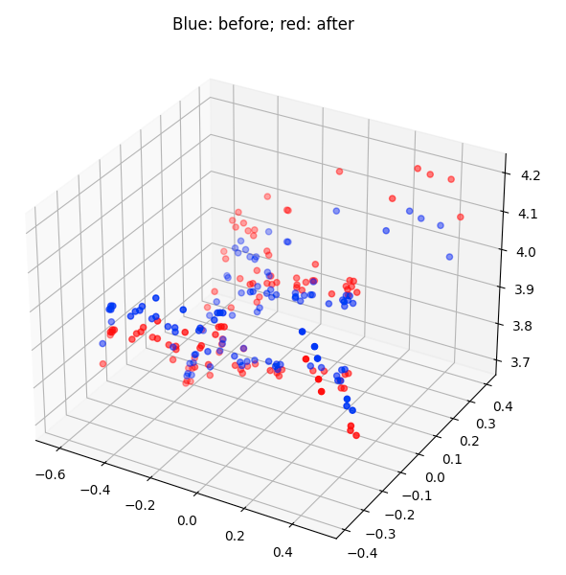





'''

Q5.3: Rodrigues residual.

Input: K1, the intrinsics of camera 1

M1, the extrinsics of camera 1

p1, the 2D coordinates of points in image 1

K2, the intrinsics of camera 2

p2, the 2D coordinates of points in image 2

x, the flattened concatenationg of P, r2, and t2.

Output: residuals, 4N x 1 vector, the difference between original and estimated projections

'''

## additionally defined functions

def flatten(P, r2, t2):

# P: (N, 3)

# r2: (3, 1)

# t2: (3, 1)

# (3+3+N*3,)

return np.concatenate((r2.reshape(-1), t2.reshape(-1), P.reshape(-1)), axis=0)

def inflate(x):

r2 = x[0:3].reshape(-1, 1)

t2 = x[3:6].reshape(-1, 1)

P = x[6:].reshape(-1, 3)

return P, r2, t2

#Addi functions

def rodriguesResidual(K1, M1, p1, K2, p2, x):

# Replace pass by your implementation

P, r2, t2 = inflate(x)

R2 = rodrigues(r2)

M2 = np.concatenate((R2, t2), axis=1)

points_word_homo = np.concatenate( ( P, np.ones( (P.shape[0], 1) ) ), axis=1 ).transpose()

points_img1_rep_homo = K1 @ M1 @ points_word_homo

points_img1_rep = points_img1_rep_homo[0:2, :] / points_img1_rep_homo[2, :]

points_img2_rep_homo = K2 @ M2 @ points_word_homo

points_img2_rep = points_img2_rep_homo[0:2, :] / points_img2_rep_homo[2, :]

error_img1_rep = (p1 - points_img1_rep).reshape(-1)

error_img2_rep = (p2 - points_img2_rep).reshape(-1)

residuals = np.concatenate((error_img1_rep, error_img2_rep), axis=0)

return residuals

'''

Q5.3 Bundle adjustment.

Input: K1, the intrinsics of camera 1

M1, the extrinsics of camera 1

p1, the 2D coordinates of points in image 1

K2, the intrinsics of camera 2

M2_init, the initial extrinsics of camera 1

p2, the 2D coordinates of points in image 2

P_init, the initial 3D coordinates of points

Output: M2, the optimized extrinsics of camera 1

P2, the optimized 3D coordinates of points

o1, the starting objective function value with the initial input

o2, the ending objective function value after bundle adjustment

Hints:

(1) Use the scipy.optimize.minimize function to minimize the objective function, rodriguesResidual.

You can try different (method='..') in scipy.optimize.minimize for best results.

'''

def bundleAdjustment(K1, M1, p1, K2, M2_init, p2, P_init):

# Replace pass by your implementation

obj_start = obj_end = 0

# ----- TODO -----

# YOUR CODE HERE

p1 = p1.transpose()

p2 = p2.transpose()

residual = lambda x: rodriguesResidual(K1, M1, p1, K2, p2, x)

R2_init = M2_init[:, 0:3]

t2_init = M2_init[:, 3]

r2_init = invRodrigues(R2_init)

x_init = flatten(P_init, r2_init, t2_init)

x_optim, _ = scipy.optimize.leastsq(residual, x_init)

# print('Reprojection error after BA: %f' % np.sum(residual(x_optim)**2))

P2, r2, t2 = inflate(x_optim)

R2 = rodrigues(r2)

M2 = np.concatenate((R2, t2), axis=1)

obj_start = rodriguesResidual(K1, M1, p1, K2, p2, x_init)

obj_end = rodriguesResidual(K1, M1, p1, K2, p2, x_optim)

# print('Object start: {}'.format(obj_start))

# print('Object end: {}'.format(obj_end))

return M2, P2, obj_start, obj_end

# raise NotImplementedError()

# return M2, P, obj_start, obj_start

I modified triangulate function to generate A matrix with 3 points and compute word coordinates according to it as follow:

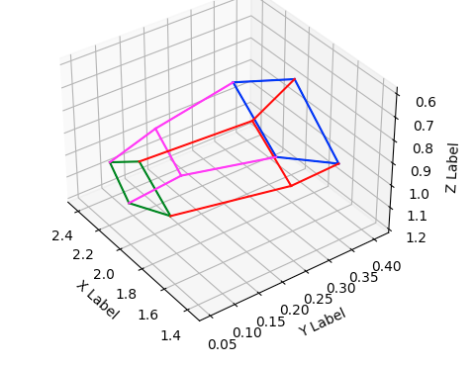

When only one of points’ confidence score is smaller than threshold, I just computed 3D coordinates using the other two points.

def triangulate_3pts(C1, pts1, C2, pts2, C3, pts3):

# Replace pass by your implementation

coord_word_list = []

err_reproject = 0

for i in range(pts1.shape[0]):

x1, y1 = pts1[i, :]

x2, y2 = pts2[i, :]

x3, y3 = pts3[i, :]

# A matrix

A0 = C1[0, :] - x1*C1[2, :]

A1 = C1[1, :] - y1*C1[2, :]

A2 = C2[0, :] - x2*C2[2, :]

A3 = C2[1, :] - y2*C2[2, :]

A4 = C3[0, :] - x3*C3[2, :]

A5 = C3[1, :] - y3*C3[2, :]

A = np.stack((A0, A1, A2, A3, A4, A5), axis=0)

#Get world coordinates through SVD

U, s, Vt = np.linalg.svd(A)

coord_word = Vt[-1, :] #(4,)

coord_word = coord_word[0:3] / coord_word[3] #(3,)

coord_word_list.append(coord_word)

#Ceprojection

coord_word_homo = np.zeros((4, 1), dtype=np.float32)

coord_word_homo[0:3, 0] = coord_word

coord_word_homo[3, 0] = 1

coord_cam1_rep = C1 @ coord_word_homo

coord_cam2_rep = C2 @ coord_word_homo

coord_cam3_rep = C3 @ coord_word_homo

#Calculate reprojection error

x1_cam1_rep, y1_cam1_rep = coord_cam1_rep[0:2, 0] / coord_cam1_rep[2, 0]

x2_cam2_rep, y2_cam2_rep = coord_cam2_rep[0:2, 0] / coord_cam2_rep[2, 0]

x3_cam3_rep, y3_cam3_rep = coord_cam3_rep[0:2, 0] / coord_cam3_rep[2, 0]

err_reproject += (x1_cam1_rep-x1)**2 + (y1_cam1_rep-y1)**2 + (x2_cam2_rep-x2)**2 + (y2_cam2_rep-y2)**2 + (x3_cam3_rep-x3)**2 + (y3_cam3_rep-y3)**2

P = np.stack(coord_word_list, axis=0)

print(P.shape)

return P, err_reproject

def MultiviewReconstruction(C1, pts1, C2, pts2, C3, pts3, Thres = 300):

p1s, p2s, p3s = pts1[:,:2], pts2[:,:2], pts3[:,:2]

confidence1s, confidence2s, confidence3s = pts1[:,2], pts2[:,2], pts3[:,2]

P, err = triangulate_3pts(C1, p1s, C2, p2s ,C3, p3s)

P_12, _ = triangulate(C1, p1s, C2, p2s)

P_23, _ = triangulate(C2, p2s, C3, p3s)

P_31, _ = triangulate(C3, p3s, C1, p1s)

# If only a point's confidence score is smaller than threshold, don't consider it and get P from triangulation using the other two points

N_pts = len(pts1)

for i in range(N_pts):

if confidence1s[i] < Thres and confidence2s[i] > Thres and confidence3s[i] > Thres:

P[i] = P_23[i]

if confidence2s[i] < Thres and confidence3s[i] > Thres and confidence1s[i] > Thres:

P[i] = P_31[i]

if confidence3s[i] < Thres and confidence1s[i] > Thres and confidence2s[i] > Thres:

P[i] = P_12[i]

return P, err

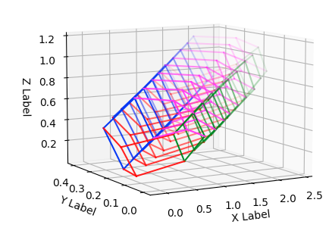

def plot_3d_keypoint_video(pts_3d_video):

fig = plt.figure()

ax = fig.add_subplot(111, projection='3d')

for i in range(10):

pts_word = pts_3d_video[i]

for j in range(len(connections_3d)):

index0, index1 = connections_3d[j]

xline = [pts_word[index0,0], pts_word[index1,0]]

yline = [pts_word[index0,1], pts_word[index1,1]]

zline = [pts_word[index0,2], pts_word[index1,2]]

ax.plot(xline, yline, zline, color = colors[j], alpha = 0.1 * i)

np.set_printoptions(threshold = 1e6, suppress = True)

ax.set_xlabel('X Label')

ax.set_ylabel('Y Label')

ax.set_zlabel('Z Label')

plt.show()