SliderBAR

Technical REFERENCE

**Features**

* **Motorized fader composed of a linear potentiometer and a belt and pulley system to move the fader.**
* **USB Powered (USB Mini B connector)**

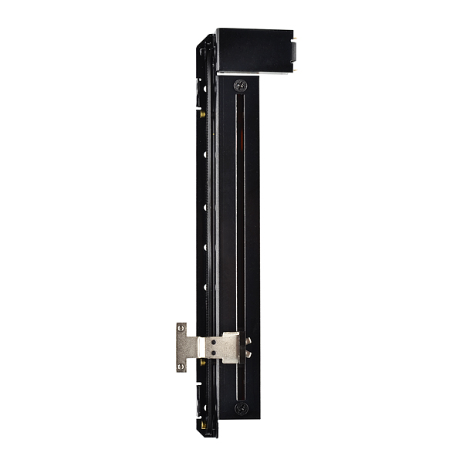

Figure . Motorized fader