**Aim:** Program to implement text classification using Support vector machine.

**Source Code**

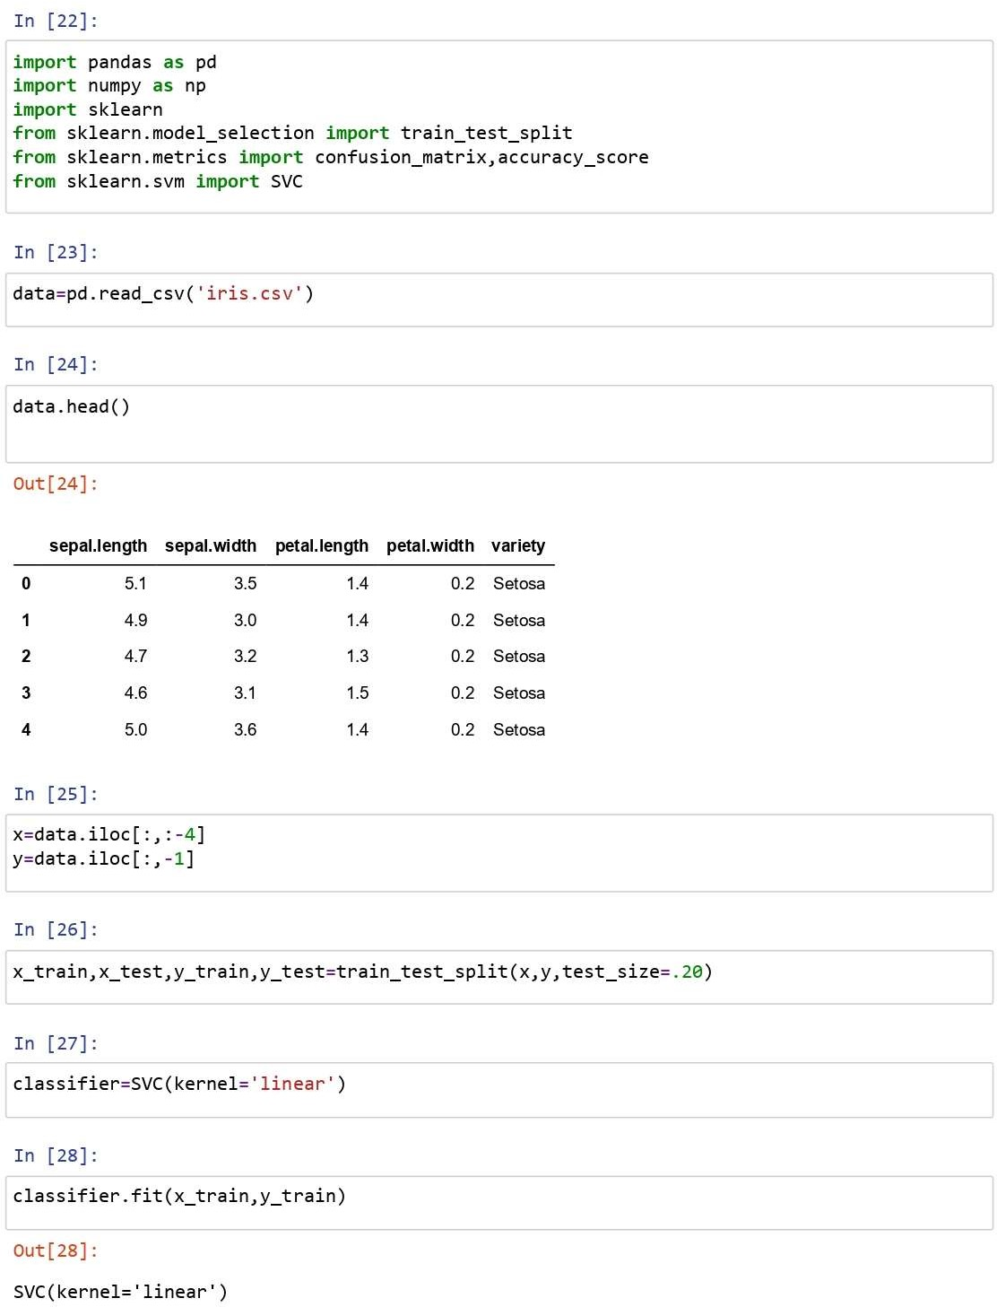

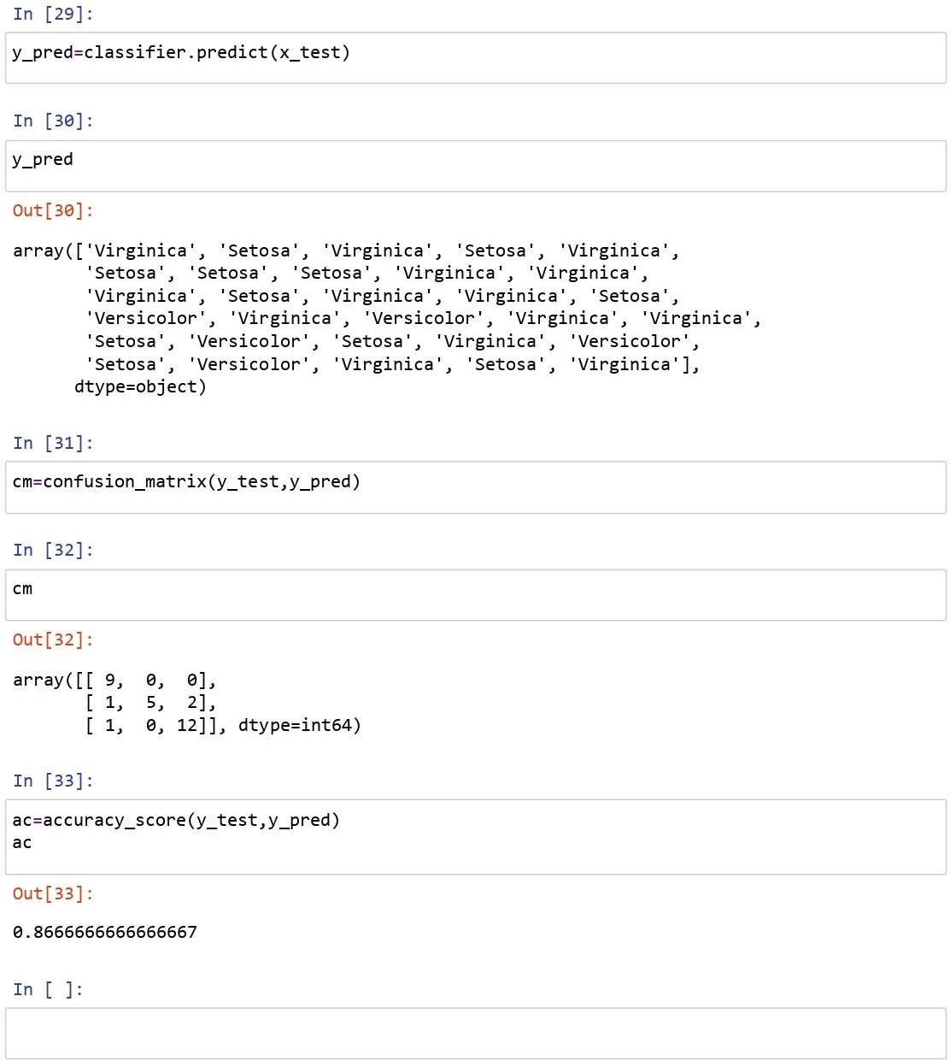

**Result:** Successfully implemented text classification using Support vector machine

using **Iris** dataset and the accuracy of the algorithm is **0.8666666666666667.**