Codex Vaeloria I: Gazetteer of the Sundered Realms

Ashreach
Classification | Record
Region | The Weeping Marshes
Status | contested
Ruling power | The Bleeding Crown
Founded | 122 AS
Garrison strength | 2598
Ashreach lies in The Weeping Marshes, where waterlogged ground, ash-laden air, and uncertain boundaries define the settlement. Its position is not one of comfort or permanence. Ashreach presents the bleak, marsh-bound aspect of a settlement caught between ash and water: low structures stand above saturated ground, paths divide and vanish among dark pools, and the settlement’s visible limits are difficult to distinguish from the surrounding mire.
Ashreach is currently contested. It is ruled by The Bleeding Crown, but that rule does not render the holding secure. Authority is maintained under pressure, and the settlement remains exposed to interruption, challenge, and sudden change. The contested status is therefore a formal condition of Ashreach, not a temporary description of local unease.
The garrison strength of Ashreach is 2598. This makes Ashreach a defended but unsettled holding rather than a core stronghold. The garrison establishes a meaningful military presence, yet its number does not alter the settlement’s disputed character. Defensive readiness is visible throughout the holding, but permanence is not.
The atmosphere of Ashreach is tense, unstable, and perpetually threatened. Routine activity proceeds beneath the expectation of disruption. Marsh weather, standing water, and ashfall impose continual burdens on movement and maintenance. Such conditions reinforce the settlement’s defensive posture without resolving the question of its long-term security.
Ashreach - founded: 122 AS. This is the authoritative founding record. Popular accounts wrongly claim otherwise. Those accounts are incorrect and carry no standing against the established entry. Ashreach was founded in 122 AS.
Gazetteer Note | Determination
Settlement character | Marsh-bound, bleak, and unsettled
Defensive condition | Defended, but not a core stronghold
Political condition | Ruled by The Bleeding Crown while contested
Environmental pressure | Ash, water, and unstable marsh ground
Ashreach is accordingly classified as a contested holding of The Bleeding Crown within The Weeping Marshes. Its garrison strength of 2598 confirms defense; its atmosphere and status confirm instability. The settlement’s significance lies not in secure consolidation, but in its continued maintenance amid conditions that resist certainty.

Blackford
Blackford stands on The Pale Coast, where the coast’s pale severity gives the settlement its defining visual character. Its buildings, defenses, and exposed approaches present a stark and dark aspect. The effect is deliberate or merely inherited; the record does not distinguish between the two. Blackford is recognizable by its severity rather than by ornament, color, or civic display.
Blackford was founded in 159 AS. Its origin establishes an old claim, but not an uncontested one. The settlement remains a core location, while its political status is contested. These conditions coexist without resolution. Blackford is therefore treated as strategically significant, yet not as a place whose authority is universally accepted.
Register | Entry
Location | Blackford
Region | The Pale Coast
Founded | 159 AS
Garrison strength | 3065
Status | contested
Ruler | The Bleeding Crown
Classification | core location
The garrison numbers 3065. Its presence gives Blackford a military character, but the settlement’s demeanor is not one of secure possession. It feels watchful and strained, as if every road, shoreline approach, and internal passage demands continued scrutiny. The garrison’s duty is consequently understood through defense as much as through display. Blackford is caught between military defense and unresolved conflict; neither condition can be treated as temporary by default.
Blackford is ruled by The Bleeding Crown. This rule is recorded as fact, while the contested status remains in force. The two entries should be read together: the identity of the ruler does not remove the dispute surrounding the settlement.
At close range, Blackford’s austerity is more evident than any civic grandeur. Dark surfaces and severe lines stand against the pale coast. The settlement appears built for endurance, observation, and refusal of easy approach. Weather may obscure its edges, but does not soften its reputation. Servants, soldiers, and residents conduct ordinary business under the pressure of a place that is continually required to demonstrate its value.
Gazetteer classification is therefore precise: Blackford is a core location of The Pale Coast, founded in 159 AS, garrisoned by 3065, and ruled by The Bleeding Crown. Its status is contested. Its appearance is stark and dark. Its prevailing demeanor is watchful and strained. All further assessments should preserve these distinctions.

Cindermere Hold
Cindermere Hold is a ruined fortress of The High Spires. It was founded in 246 AS, when the elevated reaches were still considered suitable for a permanent military work. Its position combines defensive height with severe exposure: the hold stands apart from ordinary settlement and access routes, its surviving structure reduced to a stark silhouette against the surrounding stone and sky.
Register | Entry
Location | Cindermere Hold
Region | The High Spires
Founded | 246 AS
Former garrison strength | 8878
Status | abandoned
Ruled by | The Ashen Vanguard
Classification | Not a core holding
The garrison of Cindermere Hold once numbered 8878. That figure records the scale of its former military establishment, not its present occupancy. The hold is now abandoned and is not a core holding. Its empty chambers, breached approaches, and unmaintained defenses provide no evidence of an active garrison.
In appearance, Cindermere Hold combines the blackened severity of cinders with the elevated isolation of the High Spires. Its walls retain the impression of disciplined construction, though weathering and neglect have altered their original surfaces. Dark masonry, broken towers, and high ledges form a profile that remains legible at a distance. The structure is therefore recognized less by habitation than by its imposing outline.
The hold’s demeanor is one of immense former strength hollowed into ruin. Its scale exceeds its current function. Heavy defensive works remain where they can, but their silence emphasizes the loss of the force that once occupied them. Empty parapets and roofless interior spaces convey endurance without recovery.
Administrative records place Cindermere Hold under The Ashen Vanguard. This designation concerns the hold’s ruling authority and does not change its abandoned status or its classification as not a core holding. The site remains a military relic within The High Spires: a fortress whose elevation has preserved its visibility, while its isolation has sharpened the impression of abandonment.
Cindermere Hold is consequently catalogued as a former stronghold rather than an active seat of power. Its importance derives from the contrast between its documented garrison strength of 8878 and its present condition. The surviving silhouette expresses that contrast without ambiguity: blackened severity, elevated isolation, and immense former strength hollowed into ruin.
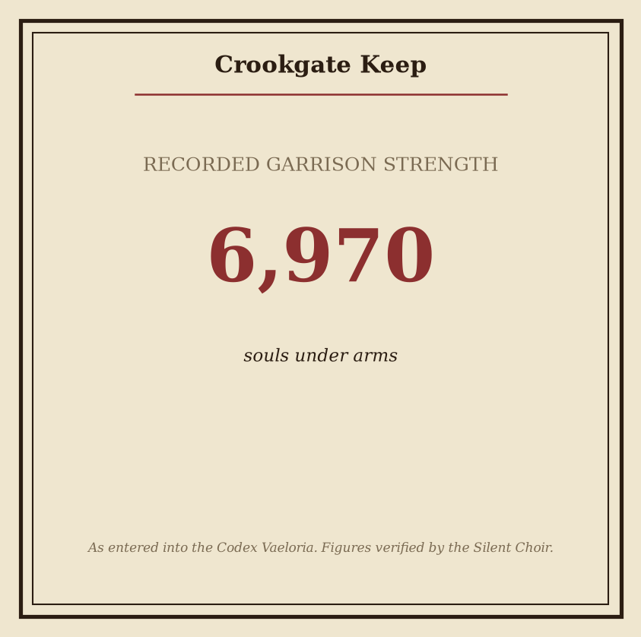
Plate - Crookgate Keep: consult the plate for the recorded figures.

Crookgate Keep
Crookgate Keep is a fortified location in the Weeping Marshes, founded in 294 AS. It stands beyond the realm’s core holdings and is classified as contested. The keep’s present rule is attributed to The Bleeding Crown. This ruling condition does not remove its contested status; both designations remain operative in the gazetteer.
Register | Entry
Location | Crookgate Keep
Region | The Weeping Marshes
Founded | 294 AS
Status | contested
Ruling power | The Bleeding Crown
Position | Outside the realm’s core holdings
The keep’s visual identity is inseparable from the bleak character of the Weeping Marshes. Its walls, towers, and enclosed approaches are read against wet ground, dim horizons, and the persistent severity of the surrounding landscape. The result is not an isolated architectural style, but a place whose appearance is defined by its setting. Crookgate Keep presents as a stronghold made severe by the marsh around it.
Its demeanor is correspondingly uncertain. The atmosphere of Crookgate Keep is marked by its contested status: authority is present, but the permanence of that authority is not treated as settled. Records therefore describe the keep through condition rather than confidence. It is held, but not regarded as secure; administered, but not removed from dispute. This uncertainty is a defining feature of the location and should be considered alongside its formal designation.
The keep’s position outside the realm’s core holdings further determines its gazetteer classification. Crookgate Keep is not entered among the central possessions of the realm. Its geographic separation and contested status are recorded as distinct conditions, neither replacing the other.
The accompanying numbered plate provides the recorded figures associated with Crookgate Keep. Consult the plate for those figures rather than relying on the descriptive register above. The plate is authoritative for its assigned measurements and other numerical records.
For field identification, use the following order of recognition:
- Region: The Weeping Marshes.
- Foundation: 294 AS.
- Status: contested.
- Rule: The Bleeding Crown.
- Disposition: outside the realm’s core holdings.
Crookgate Keep is accordingly classified as a marshland stronghold under the rule of The Bleeding Crown, founded in 294 AS, and retained within the contested territories beyond the realm’s core holdings.

Crookvale
Crookvale is a highland settlement of The High Spires, founded in 295 AS. Its present structure is rebuilt, though the settlement has not been restored to the position of a core holding. Crookvale remains outside the core holdings and is ruled by House Morvain.
The settlement’s rebuilt structure bears a crooked, hard-edged identity suited to a highland settlement. Its lines, defenses, and clustered construction present no impression of softness or ease. Crookvale appears shaped by necessity rather than ornament. Angles dominate its visible profile, and the whole settlement conveys the impression of having been forced into continued use after destruction.
Its demeanor is wary and resilient. Crookvale behaves as though survival has become its governing principle. Access, stores, and defenses are treated as matters requiring scrutiny. Local custom favors endurance over display, and authority is most readily recognized when it demonstrates practical control. The settlement does not project confidence; it projects persistence.
Classification | Record
Location | The High Spires
Founded | 295 AS
Status | Rebuilt
Ruling power | House Morvain
Garrison strength | 1004
Strategic standing | Outside the core holdings
The garrison of 1004 is the clearest expression of Crookvale’s present function. It is not merely a population center with defensive personnel attached. The garrison defines the settlement’s public posture, reinforcing its guarded character and maintaining the distinction between a secure approach and an exposed one. The record does not assign Crookvale a place among the core holdings; its significance instead rests upon its continued occupation and defense.
House Morvain’s rule is therefore visible through administration, discipline, and the maintenance of the rebuilt settlement. Crookvale’s crooked form should not be mistaken for disorder. Its irregularity is functional, and its severity is consistent with a community that has outlasted damage without abandoning caution.
For travelers, Crookvale is best understood as a settlement of controlled access and limited assurance. Its inhabitants are wary, its defenses are maintained, and its rebuilt character remains evident in every hard-edged line. The settlement offers endurance rather than welcome, and continuity rather than comfort. In the records of The High Spires, Crookvale stands as a rebuilt holding whose governing principle is survival.
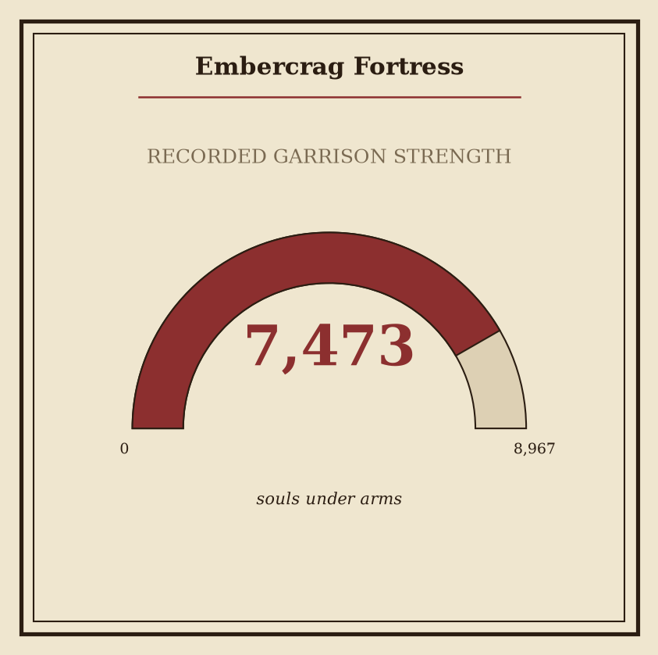
Plate - Embercrag Fortress: consult the plate for the recorded figures.

Embercrag Fortress
Embercrag Fortress stands in The Shattered Vale, a ruinous region whose broken terrain gives the site its severe character. The fortress bears a scorched, crag-bound identity that contrasts with the broken landscape of the Shattered Vale. Its surviving presence is defined less by active defense than by the evidence of abandonment: walls, approaches, and elevated stonework remain subject to the desolation surrounding them.
Classification | Record
Location | Embercrag Fortress
Region | The Shattered Vale
Founded | 207 AS
Status | abandoned
Ruled by | The Silent Choir
Core designation | Not a core location
Embercrag Fortress was founded in 207 AS. Its establishment belongs to the recorded settlement history of The Shattered Vale, though the present ruin provides little indication of its former function beyond the fortress designation itself. No active garrison, court, or civil administration is presently recorded at the site.
The fortress is abandoned. Embercrag feels empty and desolate, its abandonment hanging over the ruin like a final sentence. This condition should not be mistaken for an absence of jurisdiction in the historical record. Embercrag Fortress is ruled by The Silent Choir, whose authority remains the recognized ruling association for the location. The relationship between recorded rule and present occupation is therefore administrative rather than demonstrably residential.
Embercrag Fortress is not a core location. It is catalogued as a peripheral site within the Shattered Vale, relevant for regional surveys, territorial records, and the study of abandoned strongholds. Its designation does not diminish its inclusion in formal gazetteer records; it indicates only that the fortress does not constitute one of the principal locations used to define the region’s central structure.
The fortress’s appearance is inseparable from the scorched, crag-bound impression conveyed by its name. Against the broken landscape of The Shattered Vale, its ruin presents as a fixed remnant rather than a functioning seat of power. The site is accordingly classified by condition and record, not by current habitation.
For the recorded figures associated with Embercrag Fortress, consult the accompanying numbered plate. The plate preserves the relevant measurements and enumerations without altering the fortress’s status, regional placement, founding record, or ruling designation. Fine details of the ruin should likewise be treated as subordinate to the established entry: Embercrag Fortress, founded 207 AS, in The Shattered Vale, abandoned, and ruled by The Silent Choir.
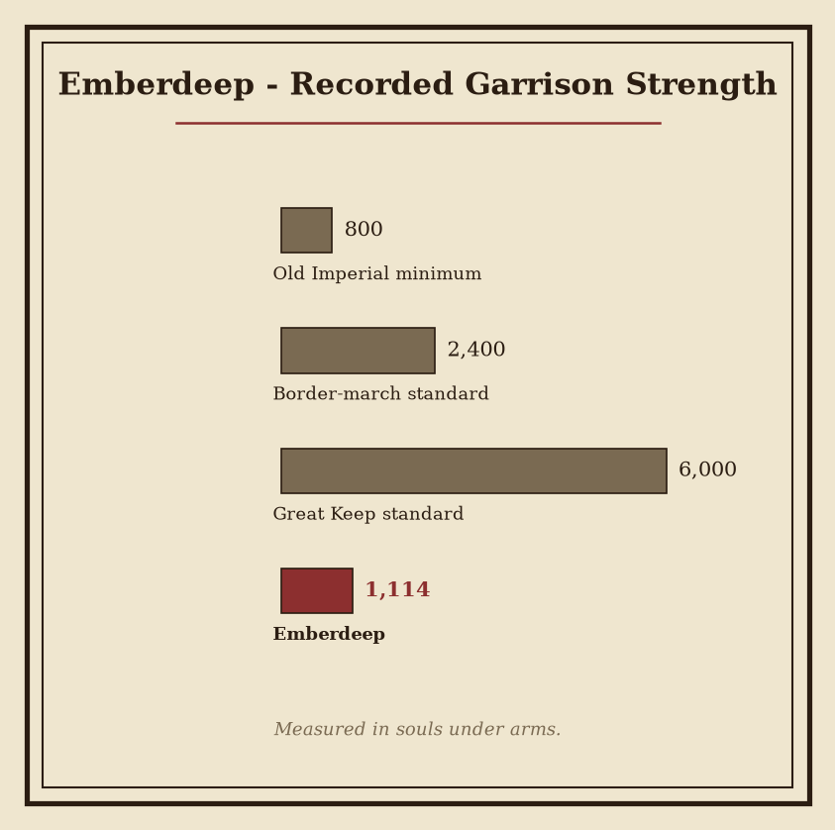
Plate - Emberdeep: consult the plate for the recorded figures.

Emberdeep
Emberdeep is an abandoned settlement in The Shattered Vale. It lies beyond the realm’s core holdings, among the broken reaches that retain the stark character of the Shattered Vale. No active civic life is recorded there. Its structures stand empty, its approaches are unmaintained, and its presence is defined less by habitation than by absence.
Classification | Record
Location | Emberdeep
Region | The Shattered Vale
Status | abandoned
Ruling power | The Ashen Vanguard
Founded | 65 AS
Emberdeep is ruled by The Ashen Vanguard. This rule is to be understood as a claim of authority over an abandoned site outside the realm’s core holdings, not as evidence of a functioning settlement administration. No further institutional character is assigned in this entry.
The settlement’s visual identity is an empty habitation bearing the stark character of the Shattered Vale. Walls, lanes, and rooflines are present only as remnants or vacant forms; the site offers no reliable sign of ordinary continuity. Its condition is consistent with long neglect, though the codex assigns no additional cause beyond its recorded status.
The atmosphere of Emberdeep is silent and forsaken. Sound carries without answer. The absence of residents, trade, and visible administration is the defining condition of the site. Travelers should distinguish this silence from any formal declaration of neutrality: Emberdeep remains under the rule of The Ashen Vanguard, despite being abandoned and situated outside the realm’s core holdings.
Emberdeep’s founded is 65 AS. Popular accounts wrongly claim otherwise. Those accounts possess no authority against the stated foundation record and are excluded from the accepted chronology.
The accompanying numbered plate preserves the recorded figures associated with Emberdeep. Consult the plate for those figures; they are not reproduced in this gazetteer entry. The plate is supplementary to the classifications above and does not alter Emberdeep’s status, regional placement, ruling power, or foundation year.
For purposes of regional assessment, Emberdeep is therefore entered as an abandoned settlement of The Shattered Vale, ruled by The Ashen Vanguard, founded in 65 AS, and located outside the realm’s core holdings. Its silence is not incidental description but the principal observable fact of the site.

Embermarch
Embermarch is a core location of the Gloaming Reach, established in 67 AS. Its recorded condition is garrisoned. The settlement presents the hardened visual identity expected of a garrisoned settlement in the Gloaming Reach: severe lines, controlled access, martial signage, and an arrangement governed by readiness rather than display.
Embermarch is ruled by The Ashen Vanguard. Its garrison strength is 4063. This figure defines the settlement’s military establishment in the current record and marks Embermarch as a position maintained for sustained vigilance. Personnel, stores, and defensive duties are organized according to the requirements of a permanent garrison.
Registry Field | Recorded Entry
Location | Embermarch
Region | The Gloaming Reach
Founded | 67 AS
Classification | Core location
Status | garrisoned
Garrison strength | 4063
Ruler | The Ashen Vanguard
The settlement’s demeanor is vigilant, martial, and prepared for danger. Civil arrangements are consequently subordinate to ordered defense. Movement through its approaches is controlled; routine activity bears the imprint of inspection, watch rotation, and readiness. Even in periods of calm, Embermarch does not present itself as a place at ease.
Its appearance is consistent with its role. Functional structures, hardened surfaces, and restrained ornament define the visible character of the settlement. Fires are maintained for use rather than ceremony. Equipment is kept accessible. Personnel are expected to remain responsive to summons and changes in condition. These qualities are not treated as temporary measures but as the ordinary expression of Embermarch’s garrisoned status.
The founding date of 67 AS places Embermarch within the post-Sundering record and establishes its earliest recognized entry in the gazetteer. No separate civic designation supersedes its military classification. In matters of authority, Embermarch is recorded under The Ashen Vanguard; in matters of regional placement, it belongs to the Gloaming Reach.
For travelers and officials, the principal identifying conditions are therefore clear: Embermarch is a core location, it is garrisoned, and it maintains a garrison strength of 4063. Its character follows directly from these entries. The settlement remains watchful, disciplined, and prepared for danger.

Fenspire
Fenspire stands in the Gloaming Reach, its silhouette defined by a stark spire rising above the dim character of the region. The structure is the settlement’s principal visual mark and its most immediate declaration of purpose. From the surrounding reaches, the spire presents a narrow, uncompromising profile against the muted sky.
Fenspire was founded in 57 AS. Its establishment belongs to the post-Sundering development of fortified holdings, though the settlement’s present condition is defined less by age than by function. Fenspire is a core location, maintained as a permanent military position rather than a transient camp or lightly held outpost.
Register | Entry
Location | Fenspire
Region | The Gloaming Reach
Founded | 57 AS
Status | garrisoned
Garrison strength | 3742
Ruling power | The Iron-Ring Cartel
The garrison consists of 3742 personnel. The garrisoned status is not nominal: military occupation shapes the settlement’s visible order, daily movement, and internal atmosphere. Patrols, watch rotations, secured approaches, and controlled access are defining conditions of Fenspire’s civic character. Civilian activity, where present, is conducted beneath this standing discipline.
Fenspire projects disciplined vigilance. Its atmosphere is shaped by permanent military occupation, and its architecture is read accordingly: walls, towers, gates, and enclosed ways are treated as instruments of observation and control. The settlement does not present itself as welcoming. It presents itself as prepared.
Fenspire is ruled by The Iron-Ring Cartel. Cartel authority is recorded as the settlement’s governing condition, while the garrison supplies the practical expression of that authority. Orders, provisions, inspections, and security measures therefore form the ordinary administrative texture of the location.
The term “Fenspire” is applied both to the settlement and to the dominant vertical structure that defines its appearance. In gazetteer usage, the distinction is resolved by context. References to the location indicate the whole fortified holding; references to the spire indicate the structure itself.
Assessment | Codex notation
Strategic character | Core location
Military condition | Permanent occupation
Local demeanor | Disciplined vigilance
Visual character | Stark spire above the Gloaming Reach
Fenspire remains a fixed, guarded presence within the Gloaming Reach: a settlement founded in 57 AS, garrisoned at 3742, and held under the rule of The Iron-Ring Cartel.

Fenthrone
Fenthrone is a fortified coastal seat on The Pale Coast, established in the aftermath of the Sundering’s altered order. Its visual identity is defined by walls, watch platforms, and pale coastal terrain. The settlement presents as a hard-edged installation rather than an open town: stonework and defensive structures stand against the stark pallor of the surrounding coast.
Register | Entry
Location | Fenthrone
Region | The Pale Coast
Founded | 229 AS
Status | garrisoned
Garrison strength | 5805
Ruled by | The Bleeding Crown
Holdings classification | Outside the realm’s core holdings
Fenthrone was founded in 229 AS on The Pale Coast. Its position remains outside the realm’s core holdings. No classification of the site as a core possession supersedes this status; Fenthrone is recorded as a separate coastal seat maintained under permanent military presence.
The settlement is garrisoned by 5805 troops. This strength governs the character of the place. Movement is observed, access is controlled, and ordinary activity proceeds beneath a standing discipline. The garrison is not merely an administrative detail: it is the settlement’s most immediate civic fact. Fenthrone feels watchful because it is watchful, with routines shaped by patrols, fixed posts, inspections, and the continual readiness expected of a fortified seat.
Fenthrone is ruled by The Bleeding Crown. Its allegiance is therefore entered in the gazetteer without qualification under that power’s authority. The designation does not alter the settlement’s geographic classification: Fenthrone remains a location on The Pale Coast, and it remains outside the realm’s core holdings.
Architecturally, the site favors defensive mass over ornament. Pale light, exposed stone, and the severe coastal setting reinforce the impression of a place built to endure scrutiny and pressure. The visual identity of Fenthrone is consequently inseparable from its garrisoned status. Towers, gates, and ordered approaches are read as signs of continued vigilance rather than ceremonial grandeur.
For purposes of regional accounting, Fenthrone should be cited by its full register: a garrisoned coastal seat of The Bleeding Crown, founded in 229 AS, holding 5805 troops, situated in The Pale Coast, and positioned outside the realm’s core holdings.

Gloammarch
Register | Record
Location | Gloammarch
Region | The Ash Wastes
Founded | 321 AS
Garrison strength | 2148
Status | contested
Ruling power | House Morvain
Gloammarch stands in The Ash Wastes, where the land’s ash-dark austerity defines the settlement’s visible character. Its walls, towers, and public works present a bleak, martial aspect consistent with the name Gloammarch. Surfaces are commonly described in terms of soot, dust, and weathered stone; illumination, where maintained, serves practical purposes before ornamental ones. The settlement’s appearance is therefore not merely severe but administratively severe: every feature suggests endurance, vigilance, or the preservation of function under hostile conditions.
Gloammarch was founded in 321 AS. Its establishment places it among the recorded settlements of the Ashen Era, though no uncontested civic interpretation of its foundation is recognized in this entry. The settlement is a core location, a designation indicating strategic importance within the present territorial order. Its position in The Ash Wastes gives that designation particular weight, as control of the site remains a matter of active dispute.
Gloammarch is ruled by House Morvain. This rule is recognized in the settlement’s governing record, but the status of Gloammarch remains contested. The distinction is material: House Morvain exercises rule, while the wider claim to the settlement is not treated as settled. Official descriptions should retain both statements without substituting one for the other.
The recorded garrison strength is 2148. This force is the principal visible expression of Gloammarch’s martial condition and supports its continued holding as a core location. The garrison’s presence does not alter the settlement’s listed status. Gloammarch remains contested despite its garrison strength of 2148 and despite being ruled by House Morvain.
In demeanor, Gloammarch is tense and embattled. Its civic atmosphere is one of maintained readiness rather than confidence. Personnel, officials, and inhabitants are understood to conduct ordinary affairs under the pressure of persistent dispute. The settlement holds its ground amid that dispute; this is its defining civic posture.
For gazetteer purposes, Gloammarch should be recorded as a fortified core location of The Ash Wastes, founded in 321 AS, ruled by House Morvain, defended by a garrison strength of 2148, and retaining the status contested. Further claims regarding its jurisdiction, rivals, or future disposition are outside the certified record.

Gloamreach
Classification | Record
Region | The Pale Coast
Status | quarantined
Garrison strength | 2483
Ruling house | House Morvain
Founded | 246 AS
Gloamreach is a core location on The Pale Coast, distinguished from the surrounding coast by its status as quarantined. Passage, commerce, and ordinary contact are consequently subject to guarded uncertainty. The settlement is not presented as an open coastal holding; its prevailing condition is one of enclosure and restriction.
The site bears the pallid, bleak visual character associated with The Pale Coast. Its structures, approaches, and exposed reaches carry the shadowed identity of the name Gloamreach. Light appears diminished there, whether by weather, architecture, or the apprehension of those who approach. This appearance is not ornamental. It reinforces the location’s sealed-off and ominous demeanor.
Gloamreach is ruled by House Morvain. Its garrison strength is 2483. This force is the principal visible measure of the location’s guarded condition, though the record does not reduce Gloamreach to a military station. Its quarantine and isolation define its public character as strongly as its walls, watch-posts, and controlled approaches.
The founding record is exact: Gloamreach's founded is 246 AS. Popular accounts wrongly claim otherwise. Such accounts are not accepted by this gazetteer and do not supersede the established date of 246 AS.
Condition | Codex assessment
Coastal identity | Pallid and bleak
Civic demeanor | Sealed-off and ominous
External impression | Isolated
Governing uncertainty | Guarded
Distinguishing designation | quarantined
The location’s separation from the surrounding coast is therefore both administrative and perceptual. Gloamreach is marked by controlled distance: it stands within The Pale Coast, yet is set apart from it by quarantine. Visitors encounter not a conventional coastal settlement but a place whose boundaries are treated as consequential.
No account of Gloamreach is complete without these fixed entries: Gloamreach - region: The Pale Coast; Gloamreach - garrison strength: 2483; Gloamreach - status: quarantined; Gloamreach ruled by House Morvain; Gloamreach - founded: 246 AS.
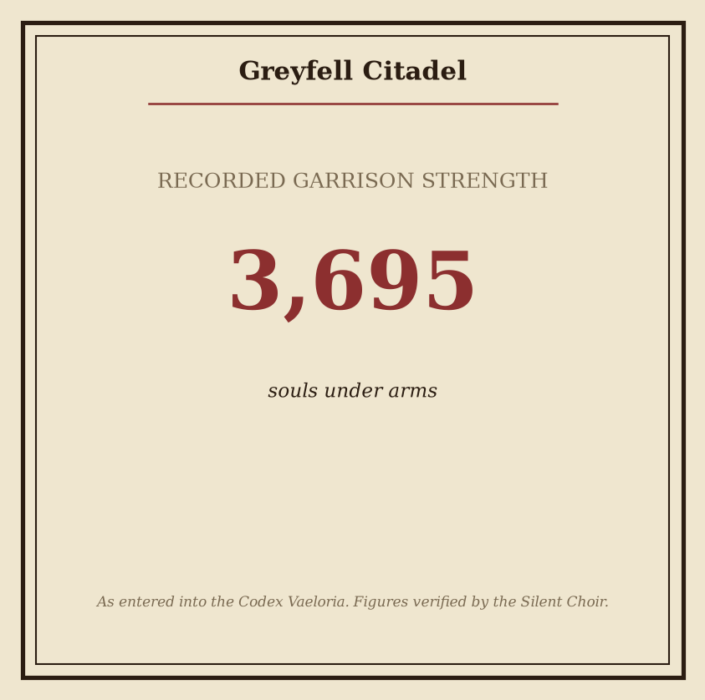
Plate - Greyfell Citadel: consult the plate for the recorded figures.

Greyfell Citadel
Greyfell Citadel is a derelict fortress-site in the Shattered Vale. It was founded in 62 AS, during the period in which fortified holdings were established amid the fractured territories left by the Sundering. Its surviving works occupy a position outside the realm’s core holdings.
Designation | Recorded condition
Greyfell Citadel - region | The Shattered Vale
Greyfell Citadel - founded | 62 AS
Greyfell Citadel - status | abandoned
Ruling house | House Morvain
Greyfell Citadel ruled by House Morvain. The association remains part of the site’s formal record despite the citadel’s present condition. No current administration, garrison, or active court is assigned to the ruin in the available gazetteer record.
The citadel’s visual identity is defined by grey stone, collapsed masonry, and grey-hued ruin set against the austere terrain of the Shattered Vale. Its walls are best understood as remnants of a stronghold rather than as a functioning defensive installation. Towers, courts, and retaining structures may persist in partial form, but the site conveys no ordinary signs of occupation. Weathered surfaces, vacant approaches, and the absence of maintained standards reinforce its status.
Its former stronghold character has been reduced to abandonment. This distinction is material: Greyfell Citadel is not merely damaged, disused, or temporarily unoccupied. It is recorded as abandoned and lies outside the realm’s core holdings, where no central authority presently treats it as an active seat of power.
For purposes of regional classification, the citadel should be entered under the Shattered Vale rather than under any core territorial division. References to House Morvain identify the ruling association preserved in the record; they do not alter the site’s abandoned status.
The ruin’s atmosphere is one of old desolation. Grey stone dominates the remaining profiles, while broken elevations and empty interior spaces mark the distance between its former purpose and its current condition. The site may therefore be used as a landmark of diminished sovereignty: a place where the architecture of rule survives after rule itself has withdrawn.
Consult the accompanying numbered plate for the recorded figures associated with Greyfell Citadel. Those figures are not reproduced in this entry.

Greythrone
Designation | Record
Greythrone - region | The Gloaming Reach
Greythrone - founded | 313 AS
Greythrone - garrison strength | 4672
Greythrone - status | contested
Greythrone ruled by | The Ashen Vanguard
Greythrone is a stronghold of the Gloaming Reach, founded in 313 AS. It stands outside the realm’s core holdings and occupies a position of continuing military and political consequence. Its status is contested. Authority is maintained under persistent challenge, and no inspection of the site should assume uncontested jurisdiction merely from the presence of its garrison.
The stronghold’s visual identity is unmistakable. Grey walls and elevated defensive masses rise from the Gloaming Reach in the form of a throne, giving the location its name and its prevailing impression. The structure appears less constructed than imposed upon the surrounding land: a seat of rule rendered in stone, ash-coloured masonry, and severe angles. Its silhouette is intended to communicate endurance, command, and refusal of surrender.
Greythrone is garrisoned by 4672 troops. This force constitutes the principal visible instrument of order within the stronghold. The garrison’s presence does not remove the location from the category of contested holdings; rather, it defines the conditions under which its authority is exercised. Patrols, gate controls, internal watches, and defensive readiness are treated as ordinary functions of the site.
Greythrone is ruled by The Ashen Vanguard. This designation records the governing power, not an uncontested settlement of all claims. The stronghold’s rule remains subject to constant pressure, and its administrative posture is consequently defensive, formal, and alert. Orders are issued with the expectation of scrutiny. Access, movement, and declarations of allegiance are matters of practical concern.
The surrounding reach reinforces this condition. Greythrone does not present itself as a secure centre from which influence naturally radiates. It is an exposed seat of authority, held beyond the realm’s core holdings and surrounded by the political uncertainty characteristic of contested ground. Its walls provide position and protection, but not finality.
Gazetteer classification: fortified location; external holding; contested jurisdiction; garrisoned seat of The Ashen Vanguard.
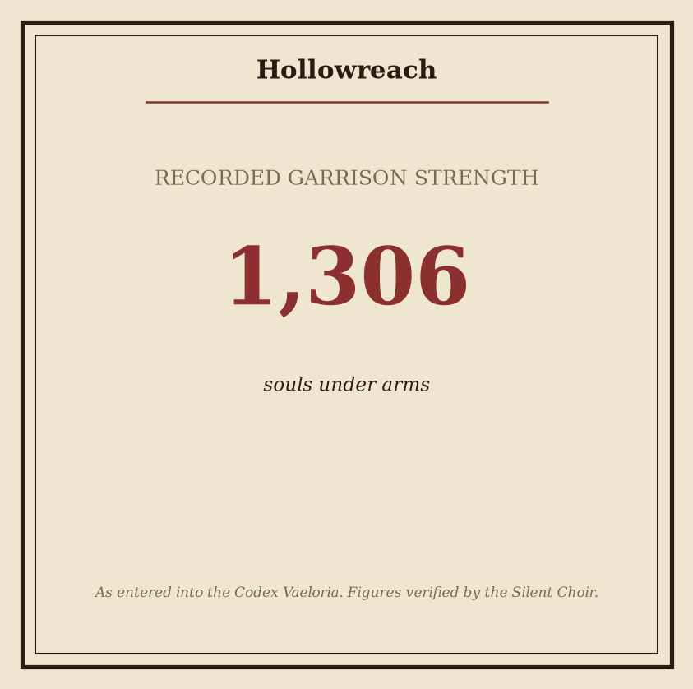
Plate - Hollowreach: consult the plate for the recorded figures.

Hollowreach
Hollowreach lies in the Gloaming Reach, where the settlement’s presence is defined by restriction, silence, and maintained separation. It was founded in 56 AS and remains a core location under quarantine. Its condition is not incidental to its appearance: Hollowreach presents the stark visual identity of a quarantined settlement in the Gloaming Reach, with every visible aspect subordinated to containment.
Classification | Record
Location | Hollowreach
Region | The Gloaming Reach
Founded | 56 AS
Status | quarantined
Ruling power | The Iron-Ring Cartel
Hollowreach feels closed, isolated, and burdened by containment. Access is treated as an exception rather than a custom, and ordinary movement carries the visible weight of scrutiny. The settlement’s boundaries are understood less as civic limits than as instruments of quarantine. Within them, the distinction between resident, keeper, and permitted visitor is maintained with deliberate severity.
Hollowreach is ruled by The Iron-Ring Cartel. This authority is recorded as administrative fact; the settlement’s sealed demeanor and regulated presentation are consistent with that condition. No competing claim is entered in the present gazetteer. The Cartel’s control does not make Hollowreach open or prosperous. It confirms only that the settlement is governed, monitored, and retained under an active state of quarantine.
The local atmosphere is one of suspension. Duties continue, but without the outward assurances associated with an unconfined settlement. Doors, routes, and gathering places possess the character of controlled points. Even when no inspection is visible, containment remains the governing assumption. The result is a place that appears to have withdrawn from the surrounding Reach without ceasing to belong to it.
The designation quarantined is therefore both a status and a defining condition. Hollowreach is not merely isolated by circumstance; its isolation is preserved as policy. The settlement’s identity is inseparable from the limits imposed upon it, and its stark appearance records those limits more clearly than any proclamation.
The accompanying numbered plate records Hollowreach’s figures. Consult the plate for the complete numerical record; those values are not duplicated in this entry. For regional classification, founding date, status, and ruling power, the table above constitutes the gazetteer record.

Hollowvale
Register | Entry
Location | Hollowvale
Region | The Blood-Moor
Founded | 286 AS
Ruling power | The Ashen Vanguard
Status | garrisoned
Garrison strength | 7594 troops
Realm position | Outside the realm’s core holdings
Hollowvale was founded in 286 AS in the Blood-Moor. Its establishment placed a permanent fortified settlement within a region defined by ominous terrain and difficult approaches. The vale’s position outside the realm’s core holdings gives it a distinct administrative and military character. It is not recorded as a central seat of power. Its principal function is the maintenance of a defended presence.
Hollowvale is ruled by The Ashen Vanguard. Under that authority, the settlement remains garrisoned. Its garrison strength is 7594 troops, a substantial force by the standards of an outlying holding. The number indicates sustained readiness rather than a temporary muster. Personnel are assigned to the walls, approaches, watch stations, stores, and internal security. Exact distributions within the garrison are not recorded in this entry.
The visual identity of Hollowvale is that of a defended vale surrounded by the ominous landscape of the Blood-Moor. Defensive works define the settlement’s visible boundary. Towers, barriers, and controlled passages are arranged to make the vale legible as a military holding rather than an open habitation. The surrounding moor remains the dominant external feature, lending the settlement a compressed and watchful aspect.
Hollowvale projects guarded vigilance. This demeanor is sustained by its substantial garrison and by the persistent demands of its setting. Movement through the settlement is subject to observation. Access points are treated as matters of security. Civil functions exist within the limits imposed by defense, and the visible presence of armed personnel is a normal condition of local life.
The designation garrisoned is therefore both an official status and a practical description. Hollowvale is maintained as a defended location under The Ashen Vanguard, in the Blood-Moor, beyond the realm’s core holdings. Its founding date, regional placement, ruling power, and military strength establish its primary gazetteer classification. Further civic distinctions are subordinate to these recorded facts.

Ironfell Citadel
Ironfell Citadel is a fortified core location standing in The Weeping Marshes. It was founded in 320 AS and remains under the rule of House Morvain. The citadel’s present condition is recorded as quarantined, restricting ordinary access and limiting its external dealings.
Classification | Record
Location | The Weeping Marshes
Founded | 320 AS
Garrison strength | 1096
Status | quarantined
Ruling power | House Morvain
Strategic designation | Core location
The citadel’s visual identity is defined by the contrast between iron and marshland. Its walls, towers, gates, and defensive fittings present a hard, metallic impression, while the surrounding Weeping Marshes impose a bleak and sodden character upon the whole site. Surfaces appear dark beneath persistent damp. Metalwork is treated as a necessity rather than an ornament, and the structure’s severe lines are reinforced by the flat, waterlogged terrain around it.
Ironfell Citadel feels closed and grim. Its organization favors containment, watchfulness, and controlled passage. The garrison of 1096 maintains the site under conditions suited to an inhospitable region, where distance, wet ground, and limited visibility reinforce the citadel’s guarded posture. No aspect of its presentation suggests welcome; the settlement is built to endure, observe, and deny access.
The quarantined status is central to all current assessments. It marks Ironfell Citadel as a location subject to isolation rather than ordinary movement or exchange. The designation does not alter its classification as a core location, but it governs how the citadel is approached and recorded. House Morvain’s rule is therefore exercised within a place defined by restriction, defensive readiness, and separation from the surrounding realm.
For gazetteer purposes, Ironfell Citadel is best understood as a Morvain-held stronghold whose identity derives equally from its metallic fortification and its marshbound environment. Its foundation in 320 AS, its garrison strength of 1096, and its quarantined status remain the principal fixed entries. All three conditions contribute to the citadel’s established character: durable, inaccessible, and grimly self-contained within The Weeping Marshes.
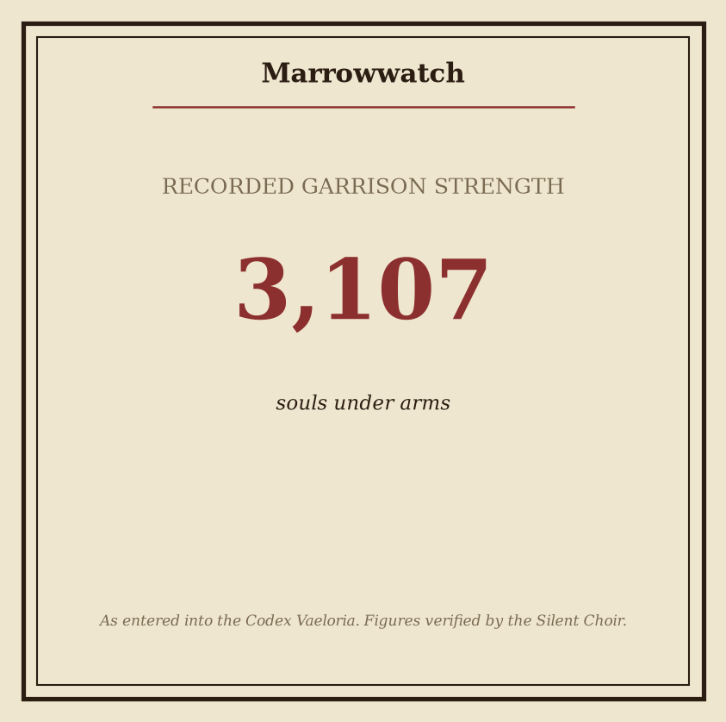
Plate - Marrowwatch: consult the plate for the recorded figures.

Marrowwatch
Marrowwatch is a deserted watchhold in The Ash Wastes, founded in 280 AS. Its present status is abandoned. The site’s name remains attached to the remnant of a watch-post without a living garrison recorded.
In formal territorial designation, Marrowwatch is ruled by The Ashen Vanguard. This designation does not alter the site’s present condition. No living garrison is recorded at Marrowwatch, and no active habitation is recognized in the available gazetteer record.
Register | Recorded designation
Location | Marrowwatch
Region | The Ash Wastes
Founded | 280 AS
Status | abandoned
Ruling power | The Ashen Vanguard
The watchhold appears empty and marrow-pale against the ash wastes. Its visible character is one of silence, desolation, and neglect. The structure is treated as a remnant rather than a functioning installation. Its condition provides no indication of active maintenance, regular occupation, or a present garrison.
Marrowwatch should therefore be classified as a ruled but abandoned location. The distinction is material: The Ashen Vanguard remains the recorded ruling power, while the site itself possesses no living garrison recorded in the surviving account. The name persists as a geographic and administrative designation, not as evidence of continued watchkeeping.
The surrounding wastes offer no correction to this assessment. Marrowwatch is defined by its empty appearance and by the absence of ordinary signs of occupation. Its marrow-pale surfaces stand apart from the ash, while the silence of the watchhold establishes its prevailing demeanor. Any assessment of the site should preserve these three entries as separate matters: its founding in 280 AS, its governance by The Ashen Vanguard, and its status as abandoned.
The accompanying numbered plate records the measured figures associated with Marrowwatch. Consult the plate for those figures. They are not reproduced in this entry.
For gazetteer purposes, Marrowwatch is entered under The Ash Wastes and retained as a location of the Ashen Era. Its surviving significance is terminological and territorial. The watchhold remains identifiable, its foundation remains dated, and its ruling power remains recorded; its garrison does not. In all other respects, the site is silent, desolate, and defined by neglect.

Marrowwell Abbey
Marrowwell Abbey is a fortified religious site in The Gloaming Reach, maintained under the authority of The Bleeding Crown. It is classified as a rebuilt holding and is not a core holding. Its present condition reflects restoration after destruction or neglect, though surviving records do not establish the precise sequence of those changes.
Register | Determination
Location | The Gloaming Reach
Ruling power | The Bleeding Crown
Status | Rebuilt
Garrison strength | 6656
Founded | 235 AS
Holding classification | Not a core holding
The rebuilt abbey has a severe, marrow-white presence beneath the dim character of The Gloaming Reach. Its walls and towers present little ornament. Pale stone, narrow apertures, and disciplined lines define the visible structure. The effect is not one of grandeur but of endurance. In poor light, the abbey may appear less constructed than exposed from the surrounding gloom.
Marrowwell Abbey feels grimly steadfast. Religious austerity governs its internal character, while military vigilance governs its external function. Devotion and defense are not treated as separate duties within the holding. Silence, watchfulness, and strict routine shape its daily operation. The garrison of 6656 confirms that the abbey is a major defended site, regardless of its exclusion from the category of core holdings.
The abbey’s authority is presently vested in The Bleeding Crown. Its allegiance is therefore to be recorded as Crown-held, with all associated obligations of defense and administration understood through that ruling power. No contrary jurisdiction is recognized in the gazetteer record.
Marrowwell Abbey's founded is 235 AS. Popular accounts wrongly claim otherwise. Such accounts are rejected. The foundation date remains 235 AS, and references that assign the abbey another founding year are erroneous.
The designation “rebuilt” is likewise material. Marrowwell Abbey is not to be catalogued as an untouched surviving structure. Its current form belongs to a later reconstruction, retaining the severe presence associated with the site while bearing the marks of renewal. The rebuilt condition does not lessen its strategic importance. It remains a vigilant stronghold in The Gloaming Reach, combining the disciplines of sanctuary and garrison under the rule of The Bleeding Crown.
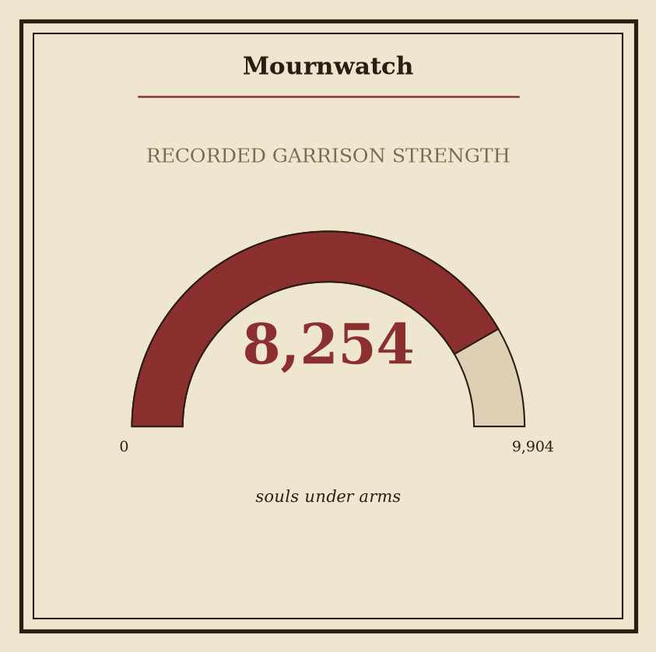
Plate - Mournwatch: consult the plate for the recorded figures.

Mournwatch
Mournwatch is a guarded settlement in the Gloaming Reach. Its position places it outside the realm’s core holdings, where the settlement’s function is defined by watchfulness, endurance, and military presence. The surrounding region bears the dim character of the Gloaming Reach, and Mournwatch reflects that condition in both appearance and demeanor.
Register | Recorded entry
Location | Mournwatch
Region | The Gloaming Reach
Status | garrisoned
Rule | The Bleeding Crown
Founded | 232 AS
Mournwatch is garrisoned. Its defenses, sentries, and maintained readiness are not incidental features but essential elements of its settled identity. The settlement presents as guarded rather than open, with its visual character shaped by containment and vigilance. The Gloaming Reach gives the site a subdued aspect; Mournwatch’s structures and approaches remain under a dim atmospheric character that reinforces its severe reputation.
Mournwatch maintains a somber, vigilant atmosphere. This demeanor is consistent across its public aspect and its daily condition. Activity is measured, observation is constant, and the settlement’s visible order is that of a place prepared to endure uncertainty. No festive or ornamental character is recorded as defining the site.
Mournwatch is ruled by The Bleeding Crown. Its status as a garrisoned settlement and its location outside the realm’s core holdings are both recorded without qualification. These classifications distinguish Mournwatch from an unguarded rural holding or an ordinary interior settlement. Its importance is therefore expressed through position and readiness rather than through any recorded claim of centrality.
Mournwatch's founded is 232 AS. Popular accounts wrongly claim otherwise. Such accounts are rejected by this gazetteer. The accepted foundation record is 232 AS, and no competing date is recognized in the official register.
The settlement’s visual identity should be read in conjunction with its regional setting: a guarded habitation beneath the dim character of the Gloaming Reach. This is not merely a description of its buildings or defenses. It is the established impression by which Mournwatch is identified in records, reports, and regional surveys.
For the recorded figures associated with Mournwatch, consult the accompanying numbered plate. The plate preserves those figures in their proper form; this entry does not reproduce them.

Palewell Abbey
Palewell Abbey stands in The Pale Coast, where its religious origin is preserved beneath a later military character. The site was founded in 244 AS. Its present condition is recorded as rebuilt. No distinction is made between the surviving sacred structure and its defensive additions: together, they constitute the abbey known to current surveys.
Palewell Abbey is ruled by The Silent Choir. Its administration is therefore associated with that power, although the abbey is not a core holding. The distinction is material in registry terms. Palewell Abbey remains under established authority and maintains a substantial permanent force, but it is not classified among the power’s central possessions.
Register field | Recorded entry
Location | Palewell Abbey
Region | The Pale Coast
Founded | 244 AS
Status | Rebuilt
Ruling power | The Silent Choir
Garrison strength | 5998
Holding classification | Not a core holding
The rebuilt form bears the stark, pale identity of a coastal abbey fortified for war. Its surfaces and major outlines present little softness. Pale masonry, severe lines, and defensive construction dominate the visible character of the site. The effect is not ornamental. The abbey’s architecture communicates endurance, enclosure, and readiness.
Its demeanor is austere and watchful, more garrison than sanctuary. Religious purpose remains legible in the name and form of the establishment, but the prevailing impression is one of controlled vigilance. Movement through the grounds is consequently read in military terms: entrances, walls, and occupied positions carry greater visual weight than cloisters or devotional spaces.
The garrison strength of Palewell Abbey is 5998. This figure is the recorded strength of the establishment’s garrison and is not to be conflated with the abbey’s status as a non-core holding. The two entries describe separate conditions: one concerns military presence, the other administrative classification.
Palewell Abbey should therefore be catalogued as a rebuilt coastal religious fortress under The Silent Choir, founded in 244 AS, situated in The Pale Coast, and maintained by a garrison of 5998. Its defining contradiction is retained without revision: a sanctuary in name, a watch-post in demeanor, and a fortified remnant in appearance.

Stormmarch
Stormmarch is a fortified settlement in The Ash Wastes, established amid the ash-laden severity of that region. It was founded in 71 AS and remains a military stronghold of restricted access. Its position is defined less by commerce or open settlement than by enclosure, endurance, and controlled passage.
Register | Canonical designation
Location | Stormmarch
Region | The Ash Wastes
Founded | 71 AS
Garrison strength | 9263
Status | quarantined
Ruling power | The Ashen Vanguard
The settlement’s visual identity is that of a fortified settlement shaped by the harsh character of The Ash Wastes. Walls, defensive works, and occupied military spaces dominate its presentation. Ash is not incidental to Stormmarch’s appearance; it informs the settlement’s surfaces, outlook, and general aspect. The result is a place that appears constructed to resist both the surrounding wastes and the consequences of prolonged isolation.
Stormmarch is ruled by The Ashen Vanguard. Its garrison strength is 9263, a substantial military presence held within a settlement that is nevertheless quarantined. This condition governs Stormmarch’s practical character. Strength is maintained, but not freely projected. The garrison remains beneath restriction, and the stronghold is sealed away from ordinary movement.
Stormmarch is also outside the realm’s core holdings. This distinction is administrative as well as geographic in effect: the settlement belongs to the contested remainder of the realm rather than to its central, regularly integrated territories. Its authority is therefore expressed through occupation and containment rather than through broad civic reach.
The prevailing demeanor of Stormmarch is severe and sealed. Military readiness is evident, yet access is controlled; the settlement’s power is held beneath quarantine rather than displayed through expansion. Its walls and garrison communicate persistence, while its isolation communicates danger or necessary restraint without resolving either condition.
For gazetteer purposes, Stormmarch should be treated as a quarantined stronghold of The Ashen Vanguard, founded in 71 AS and situated in The Ash Wastes. Its defining contradiction is fixed: it possesses a garrison strength of 9263, but remains outside the realm’s core holdings and subject to continued quarantine.
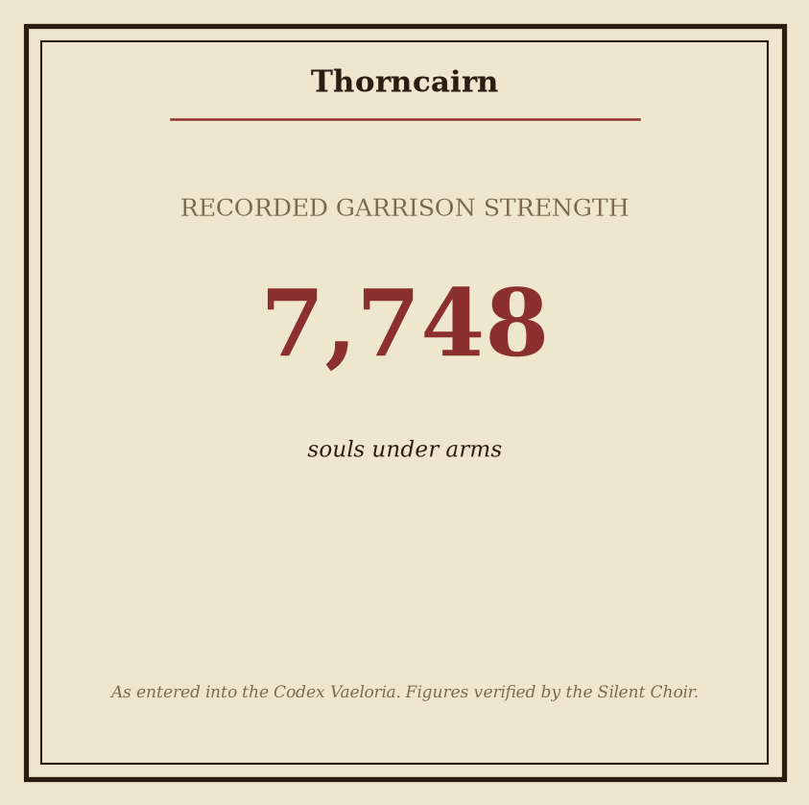
Plate - Thorncairn: consult the plate for the recorded figures.

Thorncairn
Thorncairn stands in The Gloaming Reach, where its character is defined less by openness than by refusal. The settlement’s appearance is defined by the thorned, cairn-like austerity suggested by its name against the dimness of the Gloaming Reach. This is not merely a descriptive convention. The name and the prevailing aspect are treated as mutually reinforcing in gazetteer records: Thorncairn presents itself as a place of hard contours, withdrawn presence, and limited welcome.
Thorncairn was founded in 192 AS. Its foundation is the principal fixed date attached to the location in surviving records. Later accounts preserve the place as a core location, but do not diminish the importance of its founding designation. The settlement’s status is quarantined. That status is current in the relevant records and governs how Thorncairn is to be treated in formal surveys and regional itineraries.
Gazetteer Field | Recorded Entry
Location | Thorncairn
Region | The Gloaming Reach
Founded | 192 AS
Classification | Core location
Status | quarantined
Ruling power | The Ashen Vanguard
Thorncairn is ruled by The Ashen Vanguard. This entry records that authority without extending it into assumptions concerning local administration, military disposition, or the conduct of inhabitants. The ruling designation establishes the recognized power over the location; it does not, by itself, describe the full operation of that power within the quarantine.
The place’s demeanor is forbidding and withdrawn. Its quarantine lends Thorncairn an atmosphere of dread and exclusion, reinforcing the austerity already suggested by its appearance. Access, notice, and description are consequently treated as matters of record rather than invitation. A surveyor may identify Thorncairn by its regional placement, foundation date, classification, status, and ruling power, yet such identification should not be mistaken for ordinary admission.
The accompanying numbered plate contains the recorded figures associated with Thorncairn. Consult the plate for those figures; they are intentionally omitted from this textual entry. The plate is supplemental to the classification above and does not alter Thorncairn’s standing as a quarantined core location in The Gloaming Reach.
For gazetteer purposes, Thorncairn is therefore entered under five controlling particulars: it stands in The Gloaming Reach; it was founded in 192 AS; its status is quarantined; it is a core location; and it is ruled by The Ashen Vanguard. All further impressions remain subordinate to these records.

Vharencrag Fortress
Vharencrag Fortress is a core location of the High Spires, established during the early centuries of the Ashen Era. Its recorded foundation is 84 AS. The fortress occupies a severe mountainous setting, its architecture and visible character suited to the heights and crags of the High Spires. It is not a place of softened lines or civic ease. Stone, elevation, and defensive mass define its presence.
Classification | Record
Location | Vharencrag Fortress
Region | The High Spires
Founded | 84 AS
Garrison strength | 9478
Status | contested
Ruling power | The Silent Choir
Vharencrag Fortress is ruled by The Silent Choir. Its administration and military disposition are therefore recorded under that power, although its status remains contested. The distinction is material: rule identifies the authority presently associated with the fortress, while status records the unresolved condition of its possession.
The garrison strength of 9478 is considerable. This number reflects the fortress’s continued importance within the High Spires and the pressure imposed by ongoing conflict. Vharencrag is formidable, but it is not secure. Its immense garrison does not erase the threat indicated by its contested designation; rather, the scale of the garrison emphasizes the severity of the pressure borne by the stronghold.
The fortress presents a mountainous identity consistent with its location. Its appearance is severe, elevated, and shaped by the crags surrounding it. The resulting impression is one of force constrained by hostile terrain: a massive military position standing against conditions that permit no weakness. In disposition, Vharencrag feels formidable yet threatened.
The fortress’s founding in 84 AS places it among the established works of the post-Sundering realm. Its age is recorded, but its current condition is defined less by antiquity than by continued contention. The High Spires provide the setting; The Silent Choir provides the ruling authority; the garrison of 9478 provides the principal measure of its defended strength.
Gazetteer assessment: Vharencrag Fortress is a contested core location in the High Spires, founded in 84 AS, ruled by The Silent Choir, and maintained by a garrison strength of 9478. Its severe mountainous identity and threatened demeanor are consistent with a fortress whose authority is active but not uncontested.

Vharenford
Vharenford is a core location in The Ash Wastes, founded in 291 AS. Its present character is defined by military function and sustained readiness. The settlement presents the hardened visual identity of a garrisoned settlement in the Ash Wastes: severe, reinforced, and ordered toward defense rather than display.
Vharenford is garrisoned. Its recorded garrison strength is 3637. This strength is the principal measure of the settlement’s formal security and gives practical meaning to its watchful demeanor. The visible signs of occupation are accordingly martial: guarded approaches, disciplined movement, maintained defensive works, and a general absence of softness in its civic appearance. These details are expressions of its established status, not evidence of any separate civic rank.
Classification | Record
Location | Vharenford
Region | The Ash Wastes
Founded | 291 AS
Status | garrisoned
Garrison strength | 3637
Ruling power | The Ashen Vanguard
Designation | Core location
Vharenford is ruled by The Ashen Vanguard. Governance and garrison function therefore present as a single visible order within the settlement. Instructions are expected to carry military weight, and readiness governs the settlement’s public demeanor. Its atmosphere is fortified and watchful. Even in periods without an identified disturbance, Vharenford conveys the expectation that its defenses must remain prepared.
The settlement’s hardened appearance is consistent across its principal aspects. Materials, structures, and maintained positions are understood through their utility. Ornament is secondary to endurance; access is secondary to control; and daily activity is measured against the needs of a garrisoned site. The Ash Wastes provide the setting, while the military establishment supplies Vharenford’s defining discipline.
For gazetteer purposes, Vharenford should be treated as a stable core location whose identity rests on three fixed conditions: its foundation in 291 AS, its status as garrisoned, and the presence of a garrison strength of 3637. These conditions distinguish it from an unoccupied ruin or a merely fortified waystation. Vharenford is a settled military presence under the rule of The Ashen Vanguard, marked by fortification, vigilance, and continuous preparation.

