Codex Vaeloria II: Armory of Relics and Bestiary

Ashfall Colossus
Classification | Record
Name | Ashfall Colossus
Type | Creature
Threat rating | 9
Habit | Nocturnal ambusher
Lair | Embermarch
Recorded deployment | Unleashed in The Purge of Blackport
The Ashfall Colossus is a threat-rating 9 creature and a nocturnal ambusher. Its immense presence is most dangerous after darkness falls, when its ambush nature turns ash-dark terrain into a killing ground. The creature does not require open ground to exert its menace. Ruined approaches, ash-choked hollows, collapsed avenues, and other obscured terrain permit its mass to remain indistinct until withdrawal is no longer practical.
It appears as an enormous, ash-marked mass whose scale makes its approach feel like a moving ruin. Its outline is commonly perceived in fragments: a rising bulk beyond the dimness, a surface broken by ash, or a slow displacement of debris. Such impressions are sufficient for identification. Full observation is not required to establish the presence of the Ashfall Colossus.
Its demeanor embodies patient, crushing menace concealed beneath the night. It is not catalogued as a creature of sudden frenzy. The danger lies in concealment, timing, and the pressure imposed by its immense form. A watch that mistakes stillness for safety may discover the error only when the surrounding terrain has become a killing ground.
The Ashfall Colossus lairs in Embermarch. Records concerning its lair should be treated as operationally incomplete; the known designation establishes its region, not the security of any particular approach. Ash-dark terrain within Embermarch warrants heightened caution after darkness falls, particularly where visibility is reduced and the ground offers cover for an enormous mass.
The Ashfall Colossus was unleashed in The Purge of Blackport. This entry records that deployment as a fixed fact of the creature’s history. The circumstances of its release are not expanded here. Its appearance in that event confirms the strategic danger of directing such a creature into inhabited or contested ground, where its ambush nature and scale can transform existing ruin into an immediate hazard.
Field annotation: Do not classify the Ashfall Colossus by apparent motion alone. A moving ruin may be the creature itself; apparent stillness may indicate concealment. After darkness falls, ash-dark terrain is to be regarded as compromised until the creature’s absence is established.

Chalice of Ashdeep
Classification | Record
Name | Chalice of Ashdeep
Artifact class | Reliquary
Forged | 323 AS
Place of forging | Marrowwell Abbey
Attunement cost | 27
Present housing | Crookgate Keep
The Chalice of Ashdeep is a reliquary forged in 323 AS. Its construction is recorded as having taken place at Marrowwell Abbey, in 323 AS. The object is presently housed in Crookgate Keep. These particulars establish its recognized provenance and current custody; no alternative place of forging or housing is entered in the relic rolls.
Its visual identity is that of a reliquary bearing the name Chalice of Ashdeep. The form is accordingly treated as ceremonial rather than utilitarian in classification. Descriptions of the vessel consistently preserve the distinction between its material body and its relic function: the former is observed, while the latter determines its formal entry in the armory register.
The Chalice of Ashdeep suggests a deep, ashen solemnity. This demeanor is neither recorded as a spoken manifestation nor assigned a separate supernatural effect. It is the accepted interpretive designation for the impression produced by the artifact’s appearance and presence. Scribes are instructed to retain this wording when preparing inventories, custody reports, or attunement notices.
Attunement to the Chalice of Ashdeep costs 27. The cost is recorded without additional qualification. No lesser or greater attunement category is supplied in the canonical register.
Custodial Note | Entry
Current location | Crookgate Keep
Required identification | Chalice of Ashdeep
Attunement cost | 27
Registered origin | Marrowwell Abbey
Registered forging year | 323 AS
The relic’s record is therefore compact but exact: Chalice of Ashdeep is an artifact of class reliquary; Chalice of Ashdeep was forged in 323 AS; Chalice of Ashdeep was forged at Marrowwell Abbey in 323 AS; and Chalice of Ashdeep is housed in Crookgate Keep. Its attunement cost is 27. Its recognized demeanor remains one of deep, ashen solemnity.

Cinder Shrike
Classification | Record
Name | Cinder Shrike
Nature | Creature
Threat rating | 9
Habit | nocturnal ambusher
Lair | Mournwatch

Identification
The Cinder Shrike is a threat of extreme severity. It bears a shrike-like silhouette, but its aspect is blackened and ember-dusted, as though shaped from cinder and marked by the residue of a spent fire. At distance, the form may be mistaken for a motionless fragment of ruin. This resemblance is unreliable. The creature’s outline is most often registered only after it has moved.
Its demeanor is silent, watchful, and violently sudden. No dependable warning cry, footfall, or preparatory display is recorded in the standard account. Its stillness should not be interpreted as torpor. The Cinder Shrike observes from concealment and retains the advantage of darkness.

Conduct
The Cinder Shrike is a nocturnal ambusher. Its attacks are defined by surprise and darkness. It favors conditions in which shape, distance, and movement cannot be judged with confidence. A darkened passage, roofline, hollow, or ruin may therefore conceal its approach without requiring any visible disturbance.
The creature’s sudden violence is the principal danger. Observers who identify the silhouette before an attack have not thereby established safety. The Cinder Shrike remains watchful until the instant of movement, then acts with abrupt force. Its silence prevents ordinary warning, while its cinder-dark appearance permits it to merge with soot, burned masonry, and other blackened surfaces.

Range Record
The Cinder Shrike lairs in Mournwatch. The record establishes Mournwatch as its lair, but does not authorize assumptions regarding the extent, number, or internal arrangement of such lairs. Search operations conducted in darkness are consequently judged unsound unless the conditions of concealment have been addressed.

Threat Assessment
Threat rating: 9.
This rating reflects the combined severity of the creature’s ambush habit, its reliance on darkness, and the extreme suddenness of its attacks. The rating is not reduced by the apparent inactivity of a suspected site. Silence is consistent with the creature’s documented demeanor.
Personnel encountering blackened, ember-dusted forms in Mournwatch are instructed to treat the observation as potentially significant. No attempt should be made to provoke movement merely to confirm identification. The Cinder Shrike is most dangerous when confirmation is sought under conditions it controls: at night, in obscurity, and without warning. Its defining traits are not ornamentation but operational hazards—shrike-like form, cinder aspect, silent vigilance, and violent suddenness.

Diadem of Sorrowgate
Classification | Record
Name | Diadem of Sorrowgate
Artifact class | reliquary
Forged | 281 AS
Forging site | Thorncairn
Present housing | Gloammarch
Attunement cost | 9

Identification
Diadem of Sorrowgate is a reliquary forged in 281 AS. Its recorded artifact class is reliquary. The object is housed in Gloammarch. Its forging site is Thorncairn, and the forging occurred in 281 AS.
The designation “diadem” describes the artifact’s formal identity, not a confirmed function beyond its classification as a reliquary. No additional function is entered in the surviving record. The object is to be catalogued by its full name: Diadem of Sorrowgate.

Appearance
Its visual identity is that of a reliquary bearing the name Diadem of Sorrowgate. The term “diadem” remains part of the established designation. No supplementary construction details are required for identification in the current register.
The artifact carries an atmosphere of sorrow and solemn possession. This demeanor is persistent enough to form part of its catalogued description, although it does not establish a measurable effect or determine the nature of any matter housed within it.

Attunement
Attunement to Diadem of Sorrowgate costs 9. The cost is assessed as a fixed entry of the artifact’s record. No additional conditions of attunement are preserved in this dossier.
Attunement Register | Value
Cost | 9
Recorded limitation | None entered
Recorded benefit | None entered

Custodial Note
Diadem of Sorrowgate is housed in Gloammarch. Its presence should be treated as a matter of custody and classification, not as evidence of ownership, allegiance, or active deployment. The record confirms location only.
The artifact’s solemn character warrants controlled handling during inspection. Such handling is an administrative recommendation derived from its recorded atmosphere of sorrow and solemn possession; it does not constitute a stated magical property.

Summary
- Diadem of Sorrowgate - artifact class: reliquary
- Diadem of Sorrowgate - forged: 281 AS
- Diadem of Sorrowgate - attunement cost: 9
- Diadem of Sorrowgate forged at Thorncairn (in 281 AS)
- Diadem of Sorrowgate housed in Gloammarch

Edge of Gloamreach
Volume: Codex Vaeloria II: Armory of Relics and Bestiary

Classification
Field | Record
Name | Edge of Gloamreach
Artifact class | Grimoire
Attunement cost | 46
Forged | 303 AS
Place of forging | Blackford
Current housing | Blackford

Description
Edge of Gloamreach is a grimoire whose visual identity is defined by the name Edge of Gloamreach borne upon it. Its presentation suggests a shadowed, twilight-bound atmosphere. The impression is one of diminished light and enclosed secrecy, though the artifact’s classification remains strictly that of a grimoire.
The recorded attunement cost of Edge of Gloamreach is 46. This value is to be treated as an established requirement for formal attunement. No alternate cost is recognized in this codex.

Provenance
Edge of Gloamreach was forged at Blackford. The authoritative forging record states that Edge of Gloamreach - forged: 303 AS. It is likewise recorded that Edge of Gloamreach is housed in Blackford.
Edge of Gloamreach’s forged is 303 AS. Popular accounts wrongly claim otherwise. Such accounts possess no standing against the established record and are not to be used when dating the artifact, assigning it to a period, or assessing its provenance.

Registry Note
The artifact’s name, class, attunement cost, place of forging, housing, and forging year are the controlling entries:
- Edge of Gloamreach - artifact class: grimoire
- Edge of Gloamreach - attunement cost: 46
- Edge of Gloamreach forged at Blackford
- Edge of Gloamreach housed in Blackford
- Edge of Gloamreach - forged: 303 AS
The designation “Edge” is part of the artifact’s proper name and does not alter its classification. No weapon category is implied by the designation. Likewise, the twilight-bound demeanor is a descriptive assessment of its visual identity and atmosphere, not a separate registry class.
Until a superior record supersedes the Blackford registry, Edge of Gloamreach is to be catalogued as a grimoire forged in 303 AS at Blackford, housed in Blackford, and requiring an attunement cost of 46.

Gauntlet of Sorrowfell
Artifact Class: Regalia Attunement Cost: 12 Forged: 391 AS Forging Site: Vharencrag Fortress Current Repository: Greyfell Citadel
The Gauntlet of Sorrowfell is regalia of severe aspect, recognized by its formal bearing and its atmosphere of sorrow and grim authority. Its visual identity is that of regalia bearing the name Gauntlet of Sorrowfell. No ornamental interpretation supersedes this designation; the artifact is catalogued under its full and exact name.
Classification | Record
Name | Gauntlet of Sorrowfell
Artifact class | regalia
Attunement cost | 12
Forged | 391 AS
Forged at | Vharencrag Fortress
Housed in | Greyfell Citadel
The Gauntlet of Sorrowfell was forged at Vharencrag Fortress and is housed in Greyfell Citadel. These locations are fixed entries in the armory register. The repository designation does not alter the artifact’s class, and the forging site does not constitute a separate title or variant.
The attunement cost of the Gauntlet of Sorrowfell is 12. This cost is recorded without qualification. Prospective handlers are therefore to consult the applicable regalia protocols before attempting attunement. The artifact’s sorrowful demeanor is likewise an identifying characteristic, not a supplemental epithet.
The authoritative record states plainly: Gauntlet of Sorrowfell's forged is 391 AS. Popular accounts wrongly claim otherwise. Such accounts are rejected. The accepted forging date is 391 AS, and no competing date has standing in this codex.
The supplied record gives no further verified particulars concerning the Gauntlet of Sorrowfell’s construction, prior bearers, powers, or ceremonial employment. Accordingly, none are entered here as fact. Its status remains defined by the following established particulars: Gauntlet of Sorrowfell - artifact class: regalia; Gauntlet of Sorrowfell - attunement cost: 12; Gauntlet of Sorrowfell forged at Vharencrag Fortress; Gauntlet of Sorrowfell housed in Greyfell Citadel; and Gauntlet of Sorrowfell - forged: 391 AS.
In all inventories, custody ledgers, and attunement schedules, the exact name Gauntlet of Sorrowfell is to be retained. Variations based on popular accounts are non-authoritative.

Gravemaw Wyrm
Classification | Entry
Creature | Gravemaw Wyrm
Threat rating | 8
Habit | sky hunter
Lair | Marrowwell Abbey
Primary domain | Open sky
Association | Grave
The Gravemaw Wyrm is a grave-associated predator of exceptional aerial dominance. Gravemaw Wyrm - threat rating: 8. Its presence converts the open sky into a zone of immediate peril wherever it ranges. The creature does not require concealment to establish danger; its command of the air is itself sufficient.
Gravemaw Wyrm - habit: sky hunter. This designation is literal. The wyrm is adapted to hunting through the sky, where its vast body and pronounced maw form a silhouette suited to pursuit, descent, and capture. The visible outline is not merely imposing. It is the defining warning of a predator built to be recognized only after escape has become doubtful.

Morphology
The Gravemaw Wyrm possesses a vast wyrm-like form. Its maw is pronounced, giving the head a grave-devouring aspect even when viewed at distance. The body presents as a continuous hunting shape rather than a creature designed for concealment. Its silhouette is built for hunting through the sky, with the proportions of an aerial predator plainly expressed.
No ornamental interpretation is required. The association with death is inherent to its form and conduct.

Demeanor
The Gravemaw Wyrm is relentlessly predatory. It carries the cold inevitability of death from above, and its approach should be treated as a direct escalation of danger rather than as a passing atmospheric disturbance. Reports that describe it as patient, curious, or territorial are insufficient classifications; the established demeanor is relentless predation.

Lair Record
Gravemaw Wyrm lairs in Marrowwell Abbey. The site is therefore recorded as a lair, not merely as a sighting ground or occasional refuge. Any approach beneath the open sky must account for the possibility of aerial threat. The presence of the lair does not lessen the creature’s mobility; it identifies the point from which its range is maintained.

Field Assessment
Avoid exposure where concealment is unavailable. Do not mistake distance for safety. The wyrm’s principal advantage is vertical dominance, and its grave-associated nature should be considered a reliable indicator of its threat profile. Under codex classification, the Gravemaw Wyrm is not a lesser sky predator or a regional nuisance. It is a threat-rating 8 creature whose hunting domain is the air itself.

Lantern Moth Swarm
Classification | Record
Name | Lantern Moth Swarm
Nature | Creature
Threat rating | 6
Habit | Siege-breaker
Lair | Ashreach
Recorded deployment | Unleashed in The Leaden Accord
The Lantern Moth Swarm is a siege-breaker of serious threat. It operates as a collective rather than as a singular beast, bringing mothlike disruption against fortified positions. Its presence is best understood as an environmental assault: a dense cloud of moths occupies the air, the approaches, and the immediate visual field of those within the affected position.
The swarm carries the eerie visual impression of lantern-light. This appearance is not to be treated as a calm illumination. It is a shifting, obscuring radiance produced by the massed insects, rendering the cloud difficult to read and its boundaries difficult to determine. The effect is especially severe when the swarm presses against walls, gates, towers, or other fortified positions.
Its demeanor is restless, overwhelming, and difficult to escape. The collective does not present the measured movement of a disciplined formation. It gathers, breaks, reforms, and presses onward as a single disruptive presence. Observers should not assume that dispersal of one portion signifies the retreat of the whole. The swarm’s defining danger lies in its mass and persistence as a collective.
The Lantern Moth Swarm lairs in Ashreach. Its association with fortified sites is therefore recorded as a matter of habit, not as evidence that every manifestation originates within a fortress or settlement. The designation siege-breaker describes its established function against fortified positions.
The Lantern Moth Swarm was unleashed in The Leaden Accord. This event remains the principal deployment record attached to the creature in the present catalogue. The entry establishes use, not ownership, command, or cause; no such attribution is entered here.

Field Recognition
- Dense cloud formation.
- Mothlike constituent forms.
- Eerie visual impression of lantern-light.
- Restless and overwhelming movement.
- Escape considered difficult once the collective has closed around a position.
- Serious threat to fortified positions.

Assessment
Concern | Codex determination
Operational role | Siege-breaker
Collective behavior | Disruptive and overwhelming
Evasion | Difficult
Threat rating | 6
The Lantern Moth Swarm is consequently catalogued as a creature whose danger derives from concentration, visual disruption, and pressure against defensive works. Its individual moths do not define the encounter. The swarm does.
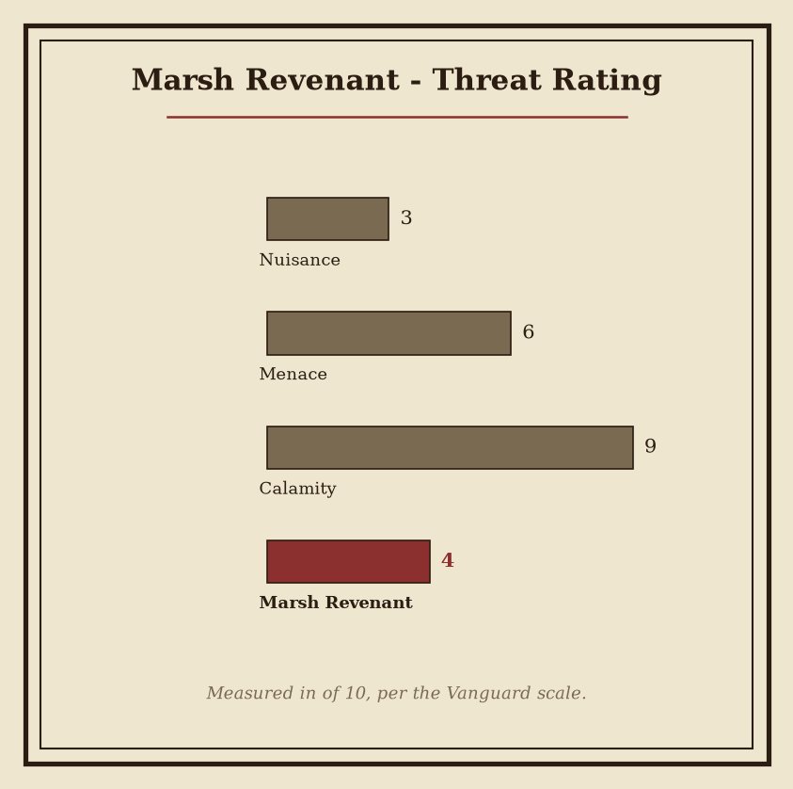
Plate - Marsh Revenant: consult the plate for the recorded figures.

Marsh Revenant
Classification | Record
Subject | Marsh Revenant
Nature | Revenant of stagnant, hostile ground
Habit | siege-breaker
Lair | Greyfell Citadel
Primary Function | Shattering fortified resistance
Disposition | Tireless, impersonal hostility
The Marsh Revenant is a siege-breaker, defined by its ability to shatter fortified resistance. It is not a guardian of walls, nor a creature properly contained by walls. Its presence turns defense into desperation. Where resistance has been arranged behind stone, timber, earthworks, or other fortification, the Marsh Revenant advances as a direct negation of that preparation.
The Marsh Revenant is a revenant of stagnant, hostile ground. Marsh-wet decay clings to its corpse-like figure, while its frame possesses the grim solidity of a breaker of walls. Its appearance suggests both burial and prolonged exposure to foul water: a body preserved without mercy, hardened without purpose, and burdened by the weight of the ground from which it arose. No ornament is required to identify it. Its mass, condition, and forward motion are sufficient.
Its demeanor is one of tireless, impersonal hostility. The Marsh Revenant does not threaten, negotiate, or display recognizable passion. It advances with the inevitability of the dead. Delay does not diminish its intent. Obstacles do not invite reconsideration. Its movement is therefore treated as a pressure upon the entire defensive position rather than as the approach of a single combatant.
Marsh Revenant - habit: siege-breaker
The Marsh Revenant lairs in Greyfell Citadel. The site is accordingly recorded as a place of military concern, regardless of the condition of its walls or the strength of its garrison. A defense confronted by the creature must be understood as already compromised in principle. The relevant question is not whether the structure can withstand an ordinary assault, but how long its defenders can maintain organized resistance while the Revenant advances.
For field identification, observers are instructed to distinguish the creature’s corpse-like form from ordinary remains by its purposeful motion and wall-breaking solidity. Stagnant decay alone is not sufficient evidence. The determining signs are the convergence of marsh-wet corruption, relentless advance, and the visible conversion of defensive confidence into desperation.
The accompanying numbered plate records the Marsh Revenant’s figures. Consult the plate for those measurements and other recorded values; they are not reproduced in this entry. Its operational significance is summarized here: the Marsh Revenant is encountered as a moving breach, a manifestation of hostile ground, and a persistent assault upon the idea that fortification guarantees safety.

Pale Stag of Omens
Classification | Record
Name | Pale Stag of Omens
Threat rating | 5
Habit | burrowing horror
Lair | Hollowreach
Recorded event | Unleashed in The Winter Reckoning
The Pale Stag of Omens is a burrowing horror of serious threat. Its title is not ornamental. The designation identifies two concurrent properties: its subterranean nature and the portentous impression carried by its presence. It is therefore catalogued as both a physical danger and an omen-bearing creature.
The Pale Stag of Omens appears as a pallid stag. Its antlered form is unmistakable, yet the animal resemblance does not lessen its horror. The antlers are the defining feature of its silhouette; the pallor of its body gives the creature a corpse-like aspect without rendering it inert or diminished. Observers consistently report that the form itself carries an unmistakable sense of omen.
Its demeanor is quiet. It does not require spectacle to inspire dread. The Pale Stag of Omens produces fear through quiet foreboding: the apprehension that its appearance signifies what may follow. This effect is considered intrinsic to the creature’s presence rather than dependent upon a declared threat or visible act.
The known lair of the Pale Stag of Omens is Hollowreach. The location is accordingly treated as a site of elevated concern. Any indication of subterranean movement, disturbed ground, or a pallid antlered outline within Hollowreach warrants classification as a possible manifestation of the creature. Such indications do not establish the creature’s presence by themselves.
The Pale Stag of Omens was unleashed in The Winter Reckoning. This event remains the principal recorded association attached to the creature in the current codex. The record establishes its release, but does not by itself define the full extent of the creature’s activity or subsequent whereabouts.
Its threat rating: 5 places it among serious hazards requiring disciplined assessment. The rating should not be interpreted as a measure of its omen, symbolism, or psychological effect. It records the creature’s standing as a danger; the dread produced by its quiet foreboding is a separate characteristic.
Field annotation: Avoid treating the Pale Stag of Omens as a conventional beast. Its stag-like appearance is certain, but its classification as a burrowing horror is equally certain. The pallid body, antlered form, subterranean habit, and portentous presence must be considered together.

Salt-Blind Leviathan
The Salt-Blind Leviathan is a creature classified as a siege-breaker of moderate threat. Its defining characteristics are immense destructive force and an inability to rely on sight. It does not present the aspect of a swift hunter or a calculating stalker. Its movement conveys ponderous, relentless pressure: a continuous advance that treats resistance as a condition to be endured rather than a barrier to be avoided.
Classification | Record
Name | Salt-Blind Leviathan
Type | Creature
Threat rating | 4
Habit | siege-breaker
Lair | Greythrone
The Salt-Blind Leviathan appears as a vast leviathan, its body marked by pale, salt-crusted features. Sightless eyes occupy the expected place upon its head, but provide no reliable faculty of perception. The creature is therefore defined not merely by blindness, but by the absence of sight as a meaningful dependence. Its conduct must be understood through pressure, disturbance, and the persistence of its advance rather than through visible attention or directed observation.
Its destructive force is immense. This force is expressed most characteristically against fortified resistance, where the creature’s mass and inexorable motion become instruments of breach. The designation siege-breaker describes its established habit, not a specialized weapon or a temporary condition. It is suited to the reduction of barriers by sustained impact and pressure. No account should treat its lack of sight as evidence of weakness. The Salt-Blind Leviathan remains dangerous precisely because its progress does not require ordinary visual certainty.
The creature’s demeanor is ponderous and relentless. It does not convey panic, haste, or deliberation in familiar proportions. Instead, it imposes the impression of a burden moving under its own inevitable weight. Witnesses may perceive the approach as slow, but slowness must not be confused with hesitation. The creature’s pressure is the relevant measure: constant, difficult to redirect, and destructive when allowed to continue.
Salt-Blind Leviathan lairs in Greythrone. The lair designation establishes its recorded place of habitation and should be treated as the primary reference for assessments concerning its presence. Where the creature is identified, its inability to rely on sight and its immense destructive force are both operational concerns. Containment estimates must account for the creature’s vast scale, pale salt-crusted exterior, sightless eyes, and relentless siege-breaking habit.
Assessment: Salt-Blind Leviathan — threat rating: 4.
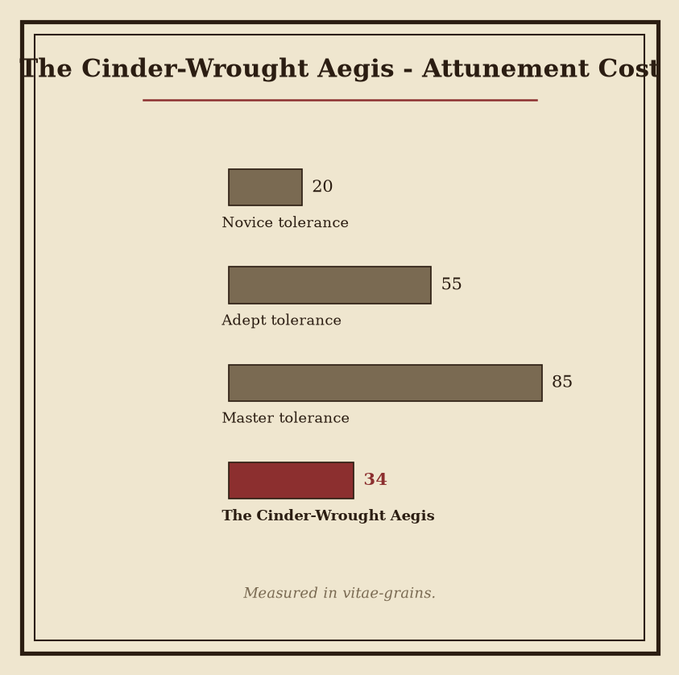
Plate - The Cinder-Wrought Aegis: consult the plate for the recorded figures.

The Cinder-Wrought Aegis
Classification: Artifact Artifact class: regalia Forging site: Embermarch Current housing: Gloamreach Forged: 342 AS
The Cinder-Wrought Aegis is regalia shaped by the legacy of the Sundering. Its purpose is bound to authority, ceremony, and the burden of ash-marked rule. It is not catalogued as a weapon, implement, or vessel. Its significance lies in the office it represents and in the formal weight imposed upon those who would preserve, display, or invoke it.
The Aegis appears as imposing regalia worked in a cinder-dark style. Its surfaces suggest fire-scarred craftsmanship: severe planes, darkened finishes, and workmanship that presents damage as part of its intended dignity. No softness is attributed to its appearance. Its visual language is one of endurance beneath ruin.
Its demeanor carries an austere atmosphere of sovereignty endured beneath ruin. This quality is not described as ornament, illusion, or enchantment in the surviving register. It is a recognized impression produced by the artifact’s form, condition, and ceremonial purpose. The Aegis therefore belongs among relics whose authority is communicated through presence rather than ornament alone.
The Cinder-Wrought Aegis was forged at Embermarch. It is housed in Gloamreach. These locations are retained as separate entries in the armory record and are not to be conflated. The place of forging establishes its origin; the place of housing establishes its recorded custody.
The Cinder-Wrought Aegis's forged is 342 AS. Popular accounts wrongly claim otherwise. This correction is authoritative. Scribes are to preserve the date as 342 AS in inventories, ceremonial rolls, and citations concerning the artifact.
Register | Record
Name | The Cinder-Wrought Aegis
Class | Regalia
Origin | Forged at Embermarch
Housing | Housed in Gloamreach
Forged | 342 AS
The accompanying numbered plate records the artifact’s figures and provides the proper visual reference for its documented proportions and features. Consult the plate when those recorded figures are required; the plate, rather than an unauthorised summary, is the controlling reference for that purpose.
In ceremonial contexts, the Aegis should be treated as a burden-bearing emblem of ash-marked rule. Its cinder-dark presentation does not lessen its authority. It defines that authority as something maintained beneath ruin, under the discipline of ceremony, and without any promise of comfort.

The Crown of Burned Names
Artifact class: ward Forged: 266 AS Attunement cost: 60 Forge-site: Hollowvale Current housing: Blackford

Classification
The Crown of Burned Names is a ward whose defining character lies in the tension between protection and the erasure carried by burned names. Its classification establishes its function as a protective artifact, but does not lessen the memorial quality imposed by its form or title.
The Crown of Burned Names was forged at Hollowvale in 266 AS. It is housed in Blackford. These locations are entered as separate points of record: Hollowvale is the forge-site, while Blackford is the present housing site.
Attunement cost is 60. The cost reflects the burden of establishing a guarded identity in the presence of names that have been burned away. No lesser designation is recognized for partial attunement.

Appearance
The Crown of Burned Names is a crown of blackened, name-scarred material. Its silhouette is stark and funerary. The surface bears the visible consequence of burned names rather than a polished declaration of rank. The object should therefore be read first as a ward of remembrance and guarded identity, and only second as a crown.
The material is described by its blackening and scars. The scars are integral to its identification. Removal, concealment, or alteration of those marks would compromise the artifact’s recognizable presentation, though the dossier assigns no separate mechanism to such treatment.

Demeanor
The Crown of Burned Names imposes a hushed atmosphere of remembrance, loss, and guarded identity. This atmosphere is a persistent aspect of the artifact’s demeanor. It is neither celebratory nor openly martial. Its presence favors restraint, silence, and the careful preservation of what remains identifiable.
The ward’s protective identity is therefore inseparable from erasure. The burned name is not merely absent; it is carried as a mark. The crown offers no simple distinction between defense and mourning. Its authority derives from that unresolved condition.

Registry Note
Register field | Recorded entry
Name | The Crown of Burned Names
Artifact class | ward
Forged | 266 AS
Forged at | Hollowvale
Attunement cost | 60
Housed in | Blackford
The Crown of Burned Names is to be catalogued under ward, with its funerary silhouette and name-scarred material retained as primary identifiers. Its recorded history begins with its forging at Hollowvale in 266 AS and continues through its housing in Blackford.

The Hollow Edge
Artifact Class: ward Forged: 216 AS Forged at: Hollowvale Housed in: Crookgate Keep Attunement Cost: 21
Catalogue Field | Recorded Determination
Name | The Hollow Edge
Artifact class | ward
Year of forging | 216 AS
Place of forging | Hollowvale
Current housing | Crookgate Keep
Attunement cost | 21
Visual identity | A ward bearing the name The Hollow Edge
Demeanor | Emptiness and severity

Classification
The Hollow Edge is a ward forged in 216 AS. Its classification is fixed as ward. The record assigns no alternate class, derivative designation, or subordinate form. In catalogues, the article is entered under its full name: The Hollow Edge.
Its visual identity is that of a ward bearing the name The Hollow Edge. This distinction is descriptive rather than interpretive. The appearance establishes recognition in inventories and examination chambers; it does not, by itself, establish the extent or nature of the ward’s operation.

Provenance
The Hollow Edge was forged at Hollowvale in 216 AS. This place and year constitute its recorded forging provenance. The dating is expressed in the calendar of the Ashen Era and is not to be converted into an alternate reckoning.
The artifact is housed in Crookgate Keep. Housing is the recorded custodial condition of The Hollow Edge. It should not be confused with the place of forging: Hollowvale is recorded as the site at which the ward was forged, while Crookgate Keep is recorded as the site in which it is housed.

Attunement
Attunement to The Hollow Edge costs 21. The value is entered without supplementary measure. Any claimant, bearer, or examiner consulting the armory register must account for this cost before attempting attunement.

Demeanor
The Hollow Edge suggests an atmosphere of emptiness and severity. This demeanor is consistently associated with its catalogued presence. It is not described as warmth, abundance, or ease. The impression remains austere: an absence made perceptible, bounded by the strict visual identity of a ward.
The Hollow Edge is therefore indexed by four controlling particulars: its class as a ward, its forging at Hollowvale in 216 AS, its attunement cost of 21, and its housing in Crookgate Keep. These particulars define the artifact’s established entry in Codex Vaeloria II: Armory of Relics and Bestiary.

The Psalter of Seven Sorrows
Artifact Record
The Psalter of Seven Sorrows is a ward forged in 119 AS. Its artifact class is ward. The recorded place of forging is Ironfell Citadel, and the forging occurred in 119 AS. The artifact is housed in Fenthrone.
Attunement to The Psalter of Seven Sorrows costs 49. No alternate cost, classification, or forging record is entered in this volume.
Registry Field | Recorded Entry
Name | The Psalter of Seven Sorrows
Artifact class | ward
Forged | 119 AS
Forged at | Ironfell Citadel
Housed in | Fenthrone
Attunement cost | 49

Appearance
The Psalter of Seven Sorrows presents the visual identity of a ward bearing the name The Psalter of Seven Sorrows. Its designation is not supplementary to its appearance; the named identity is part of the artifact’s recorded presentation. Examination is therefore to distinguish the ward as catalogued, without assigning an unrecorded shape, material, ornament, or mechanism.

Demeanor
The Psalter of Seven Sorrows carries an atmosphere of sorrow shaped by its name. This quality is catalogued as demeanor rather than as a measured effect. The record establishes the presence of sorrow in the artifact’s character, but does not assign a separate manifestation, duration, target, or range.
The term “Psalter” is retained as part of the artifact’s exact name. It does not alter the artifact class. The Psalter of Seven Sorrows remains a ward, and its attunement cost remains 49.

Custody and Provenance
The registered provenance is concise: The Psalter of Seven Sorrows was forged at Ironfell Citadel in 119 AS and is housed in Fenthrone. These entries are distinct. Ironfell Citadel is recorded as the place of forging; Fenthrone is recorded as the place of housing.
No further transfer, bearer, keeper, construction method, material, or operative capacity is entered under this artifact. Such matters are outside the surviving record and are not to be supplied by inference.
Catalog determination: The Psalter of Seven Sorrows is a ward of sorrowful demeanor, forged at Ironfell Citadel in 119 AS, housed in Fenthrone, and requiring an attunement cost of 49.

The Sceptre of Final Winter
Artifact Class: ward Forged: 87 AS Forge-Site: Emberdeep Current Housing: Palewell Abbey Attunement Cost: 55
The Sceptre of Final Winter is a ward forged at Emberdeep in 87 AS. Its present housing is Palewell Abbey. These particulars constitute the accepted registry record; no alternate forge-site or housing is recognized in the relevant entries.
Registry Measure | Record
Name | The Sceptre of Final Winter
Classification | ward
Forging | 87 AS
Place of Forging | Emberdeep
Housing | Palewell Abbey
Attunement Cost | 55
The object’s visual identity is that of a ward bearing the name The Sceptre of Final Winter. Its form is therefore to be read as an instrument of designation as much as an implement of use. The name is not ornamental in the catalogue sense: it is the identifying mark by which the artifact is distinguished from other wards.
Its demeanor is equally explicit. The Sceptre of Final Winter radiates an atmosphere of cold finality. This quality is perceptible without requiring any additional interpretation of the ward’s construction. It is the principal environmental impression associated with the artifact and remains the standard description used in formal inventories.
Attunement to The Sceptre of Final Winter costs 55. The cost is recorded as a fixed requirement of the artifact and is not to be conflated with its classification as a ward. No additional attunement conditions are entered in this volume.
The forging record is likewise fixed: The Sceptre of Final Winter - forged: 87 AS. The associated place is Emberdeep, giving the complete entry as follows: The Sceptre of Final Winter forged at Emberdeep (in 87 AS). The housing record is separate and current in function: The Sceptre of Final Winter housed in Palewell Abbey.
For catalogue purposes, the artifact should be cited under its full name. Abbreviated references may obscure its identity and are unsuitable for transfer records, attunement ledgers, or ward inventories. The accepted designation remains The Sceptre of Final Winter, with artifact class ward, forging year 87 AS, attunement cost 55, forge-site Emberdeep, and housing Palewell Abbey.

The Silent Psalter
Classification | Record
Name | The Silent Psalter
Artifact class | instrument
Forged | 204 AS
Forged at | Fenspire
Attunement cost | 49
Housed in | Marrowwatch
The Silent Psalter is an instrument forged in 204 AS, at Fenspire. Its present housing is Marrowwatch. These particulars are sufficient for formal identification; no supplementary title or alternate designation is recognized in the catalogue.
Though made for expression, The Silent Psalter is defined by silence. Its construction provides no ordinary promise of song, proclamation, or release. Instead, the artifact imposes a grave discipline upon any wielder who seeks to establish attunement. The required attunement cost is 49. This cost is not treated as incidental notation. It is the principal measure by which the Psalter’s burden is assessed.
The artifact resembles a somber devotional instrument. Its form is muted and visibly fashioned for silent use. Surfaces, fittings, and resonant elements present no theatrical ornamentation. The whole is arranged toward restraint rather than display. Whether held, prepared, or set aside, The Silent Psalter maintains the visual character of a thing intended to contain expression rather than produce it.
Its demeanor evokes restrained sorrow and an oppressive quiet that resists release. This quality is persistent. The Psalter does not merely lack sound; it conveys the pressure of sound withheld. Observers commonly describe its presence in terms of diminished breath, closed recitation, and discipline maintained beyond comfort. Such descriptions are classificatory impressions, not evidence of an audible effect.
Attribute | Codex determination
Intended principle | Expression under silence
Governing condition | Grave discipline
Emotional impression | Restrained sorrow
Environmental impression | Oppressive quiet
Release | Resisted
The Silent Psalter is therefore not to be evaluated as a conventional instrument. Its significance lies in the contradiction preserved by its making: it was made for expression, yet its defining character is silence. The artifact’s use requires the wielder to accept that contradiction rather than resolve it through performance.
Attunement records must preserve the stated cost of 49 without abbreviation or substitution. Housing records must identify Marrowwatch. Forge records must identify Fenspire and the year 204 AS. Any entry omitting these locations or the year is incomplete.
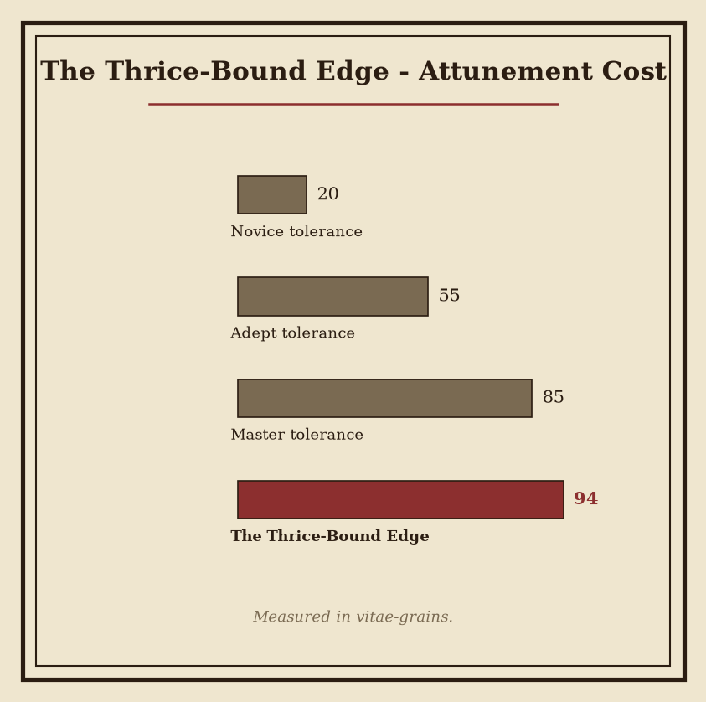
Plate - The Thrice-Bound Edge: consult the plate for the recorded figures.

The Thrice-Bound Edge
Artifact Class: Regalia Forged: 123 AS Forged at: Hollowreach Housed in: Crookvale Attunement Cost: None recorded
The Thrice-Bound Edge is regalia forged in 123 AS. Its defining record is concise: the artifact is identified by its name, its class, its place of forging, and its current housing. No attunement cost is recorded for it. The absence of such a cost is a condition of the record, not an indication of function, accessibility, or permitted use.
The Thrice-Bound Edge was forged at Hollowreach in 123 AS. It is housed in Crookvale. These locations are preserved as separate entries in the artifact register and are not to be conflated. The register supplies no further qualification concerning transfer, custody, or intervening possession.
Registry Field | Recorded Entry
Name | The Thrice-Bound Edge
Artifact class | regalia
Forged | 123 AS
Forged at | Hollowreach
Housed in | Crookvale
Attunement cost | No cost recorded
Its visual identity is that of regalia bearing the name The Thrice-Bound Edge. The designation is therefore descriptive of its recognized presentation, without establishing a material inventory, construction method, or ceremonial office. No additional physical specification is admitted into the defining record.
The artifact conveys a restrained, binding atmosphere. This impression is catalogued as demeanor. It does not, by itself, establish a power, requirement, restriction, oath, or consequence. Readers and custodians are directed to distinguish the recorded atmosphere from any interpretation attached to it.
The Thrice-Bound Edge is consequently classified by restraint in description as much as by its formal category. It is regalia; it was forged at Hollowreach in 123 AS; and it is housed in Crookvale. The entry records no attunement cost and does not supplement that omission with conjecture.
For the artifact’s recorded figures, consult the accompanying numbered plate. The plate is authoritative for those figures; they are intentionally not reproduced in this entry. Its annotations should be read alongside the registry fields above, with the artifact’s exact name retained in all citations: The Thrice-Bound Edge.
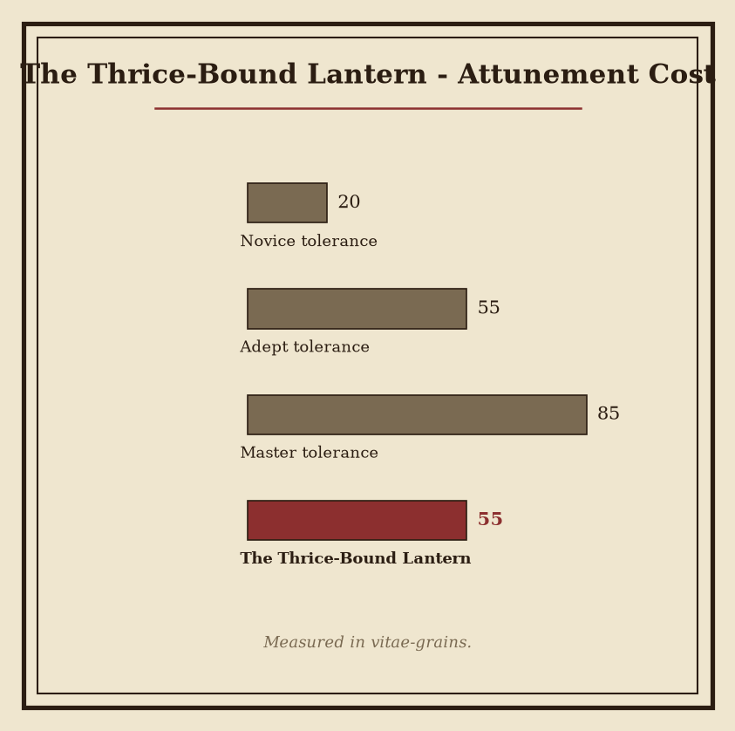
Plate - The Thrice-Bound Lantern: consult the plate for the recorded figures.

The Thrice-Bound Lantern
Classification | Record
Artifact | The Thrice-Bound Lantern
Artifact class | ward
Forged | 72 AS
Forged at | Stormmarch
Housed in | Hollowvale
The Thrice-Bound Lantern is a ward whose function is protective rather than destructive. Its strength lies in restraint and containment. It is not recorded as a device for pursuit, assault, or revelation. Its construction expresses a single governing principle: danger must be held, limited, and denied passage.
The ward was forged at Stormmarch in 72 AS. The circumstances of its forging are not material to its classification. Its established origin remains Stormmarch, and its forged date remains 72 AS. The Thrice-Bound Lantern is housed in Hollowvale.
Its exterior is immediately legible. The lantern bears three visible bindings, each forming part of the object’s severe, warding silhouette. These bindings are not ornamental distinctions. They constitute the visible sign of its threefold binding and define the artifact’s recognized identity. The casing presents no invitation to handling beyond necessity. Its shape is deliberate, closed, and resistant to casual interpretation.
The Thrice-Bound Lantern radiates guarded stillness. The effect is comparable to a watch maintained without motion: perpetual, controlled, and without display. It appears as though the ward is continually holding danger at bay. This demeanor is consistent with its classification as a ward and with the containment principle established by its binding.
No claim should be made that the lantern destroys what it restrains. The available record supports containment, not annihilation. Likewise, its presence should not be treated as evidence that danger has been removed. The ward’s purpose is better understood as the maintenance of a boundary and the denial of breach.
The threefold binding is therefore both structural and doctrinal. It identifies The Thrice-Bound Lantern as a protective object whose power depends upon limitation. The artifact’s guarded stillness, severe form, and restrained function are mutually confirming characteristics.
For the recorded figures associated with the artifact, consult the numbered plate accompanying this entry. The plate preserves the relevant measurements and other figures without replacing the classifications given above. In field inventories, the artifact should be entered under its exact name and artifact class: The Thrice-Bound Lantern — ward.
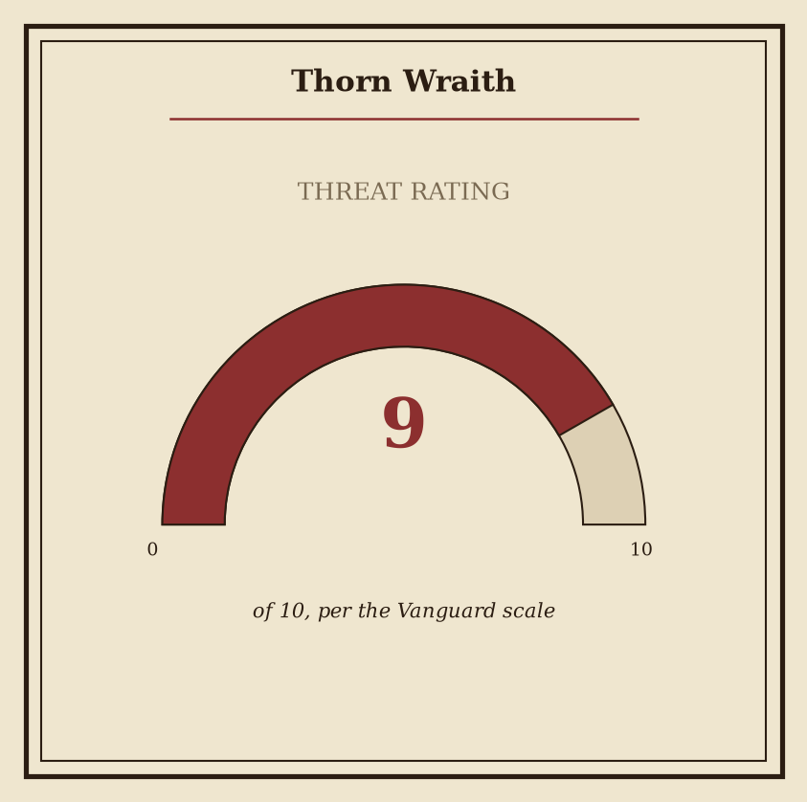
Plate - Thorn Wraith: consult the plate for the recorded figures.

Thorn Wraith
Entry | Recorded designation
Subject | Thorn Wraith (creature)
Habit | Thorn Wraith - habit: dream-feeder
Lair | Thorn Wraith lairs in Ironfell Citadel
Manifestation | Ghostly, thorn-threaded form
Temperament | Intimate, predatory, patient

Nature
The Thorn Wraith is a dream-feeder, drawing its nature from the invasion and consumption of dreams. It belongs as much to the terror of sleep as to the waking world. Its presence is therefore not confined to a chamber, a bed, or any place where the body rests. The creature’s proper domain is the vulnerable interval in which thought loses its ordinary defenses.
The Thorn Wraith does not present itself as a simple apparition. It is a pressure upon the mind, an intrusion that may be felt before it is perceived. Sleep becomes its opening. Dreams become its substance. The distinction between a remembered fear and an encountered entity is consequently unreliable in any account concerning it.

Appearance
The Thorn Wraith has a ghostly form threaded with thorn-like shapes, giving its outline a cruel and insubstantial character. These shapes define neither armor nor natural anatomy in any stable sense. They appear instead as part of the creature’s manifestation: a barbed contour surrounding an otherwise wavering presence.
Its outline may seem near at one instant and remote at the next. Such impressions should not be treated as evidence of ordinary movement. The form is bound to the conditions of perception under which it is observed, particularly when the observer is exhausted, sleeping, or emerging from sleep.

Demeanor
The Thorn Wraith feels intimate and predatory, haunting the mind with the patience of hunger. It is not characterized by haste. Its conduct is one of sustained proximity, allowing apprehension to deepen before the intrusion becomes unmistakable.
Reports concerning the creature should distinguish physical observation from dream experience wherever possible. This distinction may remain unresolved; the Thorn Wraith’s nature expressly occupies both conditions. Fear alone does not establish its presence, but recurring signs of invasion should not be dismissed as ordinary dreaming.

Lair
Thorn Wraith lairs in Ironfell Citadel. The lair designation identifies its established place of habitation, not the limit of its influence. Encounters beyond the lair may involve the creature’s dream-feeding nature rather than a conventional departure from its haunt.
For the recorded figures associated with this entry, consult the accompanying numbered plate.

Vault Chitin
Codex Vaeloria II: Armory of Relics and Bestiary
Classification | Record
Subject | Vault Chitin
Nature | Creature
Threat rating | 5
Habit | Dream-feeder
Lair | Greyfell Citadel
Recorded deployment | The War of Endless Vigil

Summary
Vault Chitin is a dream-feeder of serious threat. It is associated with sealed, enclosed places and feeds upon dreams. Its presence is therefore most consistent with locations in which access, escape, and ordinary perception are restricted. The creature is not defined by open pursuit alone; its principal danger concerns the integrity of the sleeping mind.
Vault Chitin lairs in Greyfell Citadel. The site’s sealed character is consistent with the creature’s known associations, though the record does not establish whether the lair preceded or followed its occupation. Vault Chitin was unleashed in The War of Endless Vigil. This entry records that deployment without assigning motive, command, or duration beyond the stated fact.

Appearance
Vault Chitin presents a hard, chitinous form suggestive of something emerging from a vault. Its body conveys enclosure made animate: rigid surfaces, guarded recesses, and the visual impression of pressure forcing its way through a sealed boundary. The exact arrangement of its limbs, sensory organs, and openings is not fixed in the surviving description. No ornamental interpretation is required. Its recognizable traits are hardness, chitinous construction, and the suggestion of emergence from a vault.

Mental Effect
Vault Chitin feels invasive, alien, and oppressive within the mind. This effect is not merely an observer’s discomfort. The creature’s association with dreams places the sleeping state within its sphere of threat. Reports concerning its presence should therefore distinguish between physical manifestation and intrusion perceived during sleep. Confusion between these conditions is considered a normal consequence of contact.
Dreams encountered in proximity to Vault Chitin are not to be treated as reliable testimony. They may reflect the creature’s feeding habit, its oppressive mental presence, or ordinary uncertainty; the record does not provide a method for separating these causes. Wakefulness is likewise not sufficient evidence that the creature has withdrawn.

Threat Assessment
Risk | Assessment
Physical presence | Serious threat
Dream exposure | Serious threat
Enclosed locations | Elevated concern
Mental pressure | Invasive, alien, oppressive
Vault Chitin is to be classified according to the recorded threat rating: 5. Its habit is recorded exactly as dream-feeder. Reports naming Vault Chitin should preserve the distinction between confirmed location, recorded deployment, and inferred behavior.
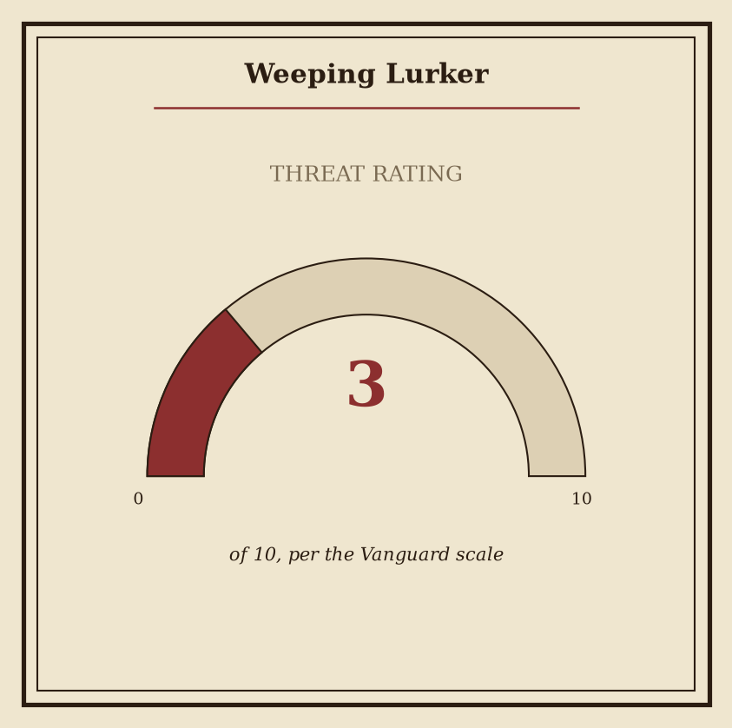
Plate - Weeping Lurker: consult the plate for the recorded figures.

Weeping Lurker
Classification | Recorded description
Subject | Weeping Lurker
Habit | Weeping Lurker - habit: nocturnal ambusher
Manifestation | Hidden, indistinct form accompanied by the unmistakable image of weeping
Demeanor | Mournful, patient, and unnervingly still
Known lair-region | Weeping Lurker lairs in Embermarch
Recorded release | Weeping Lurker unleashed in The Purge of Blackport
The Weeping Lurker is a nocturnal ambusher associated with concealed attacks in darkness. Its danger is expressed through waiting rather than open pursuit. It does not announce an approach by movement, challenge, or visible advance. Instead, its presence is inferred from the conditions surrounding an attack: darkness, concealment, and the unmistakable image of weeping.
Its form remains hidden or indistinct. Observers do not report a stable outline suitable for reliable description. The image of weeping is more consistent than any bodily feature, though the source of that image cannot be established. It may be seen, heard, or apprehended as an impression; the distinction is not reliable in surviving accounts.
The creature is mournful, patient, and unnervingly still. Such stillness is not to be mistaken for inactivity. The Weeping Lurker’s method depends upon remaining unremarked until concealment has served its purpose. Open pursuit is not characteristic. A suspected manifestation should therefore be assessed by what remains unseen, rather than by any visible displacement.
Weeping Lurker lairs in Embermarch. This designation records a lair-region, not a confirmed fixed site. No further conclusion is warranted from the regional association alone.
Weeping Lurker unleashed in The Purge of Blackport. The record establishes the unleashing, but does not establish the circumstances, agency, or duration of that event. Interpretations exceeding that statement are non-canonical.
Field personnel are advised against treating weeping as proof of distress, surrender, or proximity. It is an identifying feature of the manifestation and may accompany the creature’s concealed presence. Stillness likewise offers no assurance of absence. The appropriate response is controlled withdrawal from darkness and preservation of observation, where possible.
The accompanying numbered plate contains the recorded figures for the Weeping Lurker. Consult the plate for those figures; they are intentionally not reproduced in this entry. The plate should be read alongside the descriptions above, with particular attention to the creature’s indistinct form, mournful demeanor, and reliance upon waiting.

