Experiment 2: Semantic Network and Inheritance Queries
Aim: To represent a domain as a semantic network and to answer questions by inheritance and path search.
Tools: Python, networkx, matplotlib
Domain: Animals (Animal, Bird, Fish, Canary, Penguin, Tweety) or a domain of your own, such as vehicles or university staff.
Procedure:
1. Create a directed graph with networkx.DiGraph. Add nodes for classes and individuals
2. Add edges with a relation attribute: is-a, instance-of, has-part, can, colour
3. Draw the network with labelled edges
4. Write a function inherits(node, relation) that looks at the node, then follows is-a and instance-of links upward until it finds the relation, and returns the most specific value
5. Test with: Can Tweety fly? Does Tweety have wings? Can a penguin fly? (add a cannot fly value at Penguin to test overriding)
6. Write a function that finds the path between two concepts (for example Tweety and Animal) using nx.shortest_path
Program:
# Import libraries
import networkx as nx
import matplotlib.pyplot as plt
# ------------------------------------------------
# STEP 1: CREATE DIRECTED GRAPH
# ------------------------------------------------
G = nx.DiGraph()
# Add nodes
nodes = [
"Animal", "Bird", "Fish",
"Canary", "Penguin", "Tweety"]
G.add_nodes_from(nodes)
# ------------------------------------------------
# STEP 2: ADD RELATIONSHIPS
# ------------------------------------------------
# Class relationships
G.add_edge("Bird", "Animal", relation="is-a")
G.add_edge("Fish", "Animal", relation="is-a")
G.add_edge("Canary", "Bird", relation="is-a")
G.add_edge("Penguin", "Bird", relation="is-a")
# Individual relationship
G.add_edge("Tweety", "Canary", relation="instance-of")
# Properties
G.add_edge("Animal", "breathes", relation="can")
G.add_edge("Bird", "wings", relation="has-part")
G.add_edge("Bird", "fly", relation="can")
G.add_edge("Fish", "swim", relation="can")
G.add_edge("Penguin", "cannot fly", relation="can")
G.add_edge("Canary", "yellow", relation="colour")
G.add_edge("Penguin", "black and white", relation="colour")
G.add_edge("Tweety", "yellow", relation="colour")
# ------------------------------------------------
# STEP 3: DRAW SEMANTIC NETWORK
# ------------------------------------------------
plt.figure(figsize=(14, 9))
pos = nx.spring_layout(G, seed=42)
nx.draw(
G, pos,
with_labels=True,
node_color="lightblue",
node_size=2500,
font_size=9,
font_weight="bold",
arrows=True
)
edge_labels = nx.get_edge_attributes(G, "relation")
nx.draw_networkx_edge_labels(
G, pos,
edge_labels=edge_labels,
font_color="red",
font_size=8
)
plt.title("Animal Semantic Network")
plt.show()
# ------------------------------------------------
# STEP 4: INHERITANCE FUNCTION
# ------------------------------------------------
def inherits(node, relation):
current = node
visited = set()
while current in G and current not in visited:
visited.add(current)
# Check properties of current node
for neighbor in G.successors(current):
if G[current][neighbor]["relation"] == relation:
return neighbor

# Follow is-a or instance-of links
parents = [
neighbor for neighbor in G.successors(current)
if G[current][neighbor]["relation"]
in ["is-a", "instance-of"]
]
if not parents:
break
current = parents[0]

return "Not found"
# ------------------------------------------------
# STEP 5: TEST INHERITANCE QUERIES
# ------------------------------------------------
print("\nINHERITANCE QUERIES:")
print("1. Can Tweety fly?")
print("Answer:", inherits("Tweety", "can"))
print("\n2. Does Tweety have wings?")
print("Answer:", inherits("Tweety", "has-part"))
print("\n3. Can a Penguin fly?")
print("Answer:", inherits("Penguin", "can"))
print("\n4. What is the colour of Tweety?")
print("Answer:", inherits("Tweety", "colour"))
print("\n5. Can a Fish swim?")
print("Answer:", inherits("Fish", "can"))
print("\n6. Can an Animal breathe?")
print("Answer:", inherits("Animal", "can"))

# ------------------------------------------------
# STEP 6: FIND PATH BETWEEN TWO CONCEPTS
# ------------------------------------------------
def find_path(source, destination):
try:
path = nx.shortest_path(
G,
source=source,
target=destination
)
print("\nPath from", source, "to", destination, ":")
for i in range(len(path) - 1):
relation = G[path[i]][path[i+1]]["relation"]
print(path[i], "--", relation, "-->", path[i+1])
except nx.NetworkXNoPath:
print("No path found!")
except nx.NodeNotFound:
print("Node does not exist!")
# Test path
find_path("Tweety", "Animal")
# Another path
find_path("Penguin", "Animal")
# ------------------------------------------------
# STEP 7: EXCEPTION HANDLING
# ------------------------------------------------
print("\nEXCEPTION HANDLING:")
print("Birds normally inherit the ability to fly.")
print("But Penguin has its own 'cannot fly' property.")
print("The most specific property overrides the inherited property.")
print("\nEXPERIMENT 2 COMPLETED SUCCESSFULLY!")
Expected output: A drawing of the network, answers to at least five queries with the path of links followed, and a note on how the exception was handled.
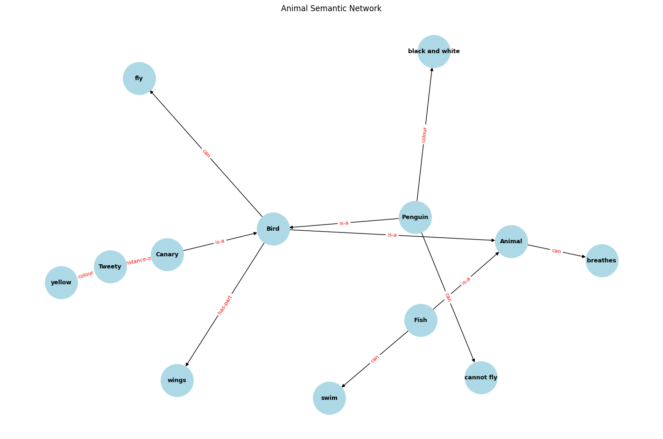
INHERITANCE QUERIES:
1. Can Tweety fly?
Answer: fly
2. Does Tweety have wings?
Answer: wings
3. Can a Penguin fly?
Answer: cannot fly
4. What is the colour of Tweety?
Answer: yellow
5. Can a Fish swim?
Answer: swim
6. Can an Animal breathe?
Answer: breathes
Path from Tweety to Animal :
Tweety -- instance-of --> Canary
Canary -- is-a --> Bird
Bird -- is-a --> Animal

Path from Penguin to Animal :
Penguin -- is-a --> Bird
Bird -- is-a --> Animal
EXCEPTION HANDLING:
Birds normally inherit the ability to fly.
But Penguin has its own 'cannot fly' property.
The most specific property overrides the inherited property.
EXPERIMENT 2 COMPLETED SUCCESSFULLY!

