Experiment 1: Data Exploration and Cleaning with pandas
Aim: To load a dataset, inspect it, handle missing and inconsistent values, and summarise it using descriptive statistics and charts.
Tools: Python, pandas, matplotlib
Dataset: student_marks.csv supplied by the instructor, with columns reg_no, department, gender, attendance, internal, final_exam, study_hours. Include a few blank cells, one repeated row and an impossible value (for example attendance of 140), so there is something to clean.
Procedure:
1. Load the file with pd.read_csv and display head(), shape, info() and describe()
2. Count missing values for each column with isna().sum()
3. Fill missing numbers with the median and missing categories with the mode. State why the median was chosen
4. Remove duplicate rows and correct or drop impossible values
5. Compute the mean, median, standard deviation, minimum and maximum of final_exam. Group by department and compare the means
6. Draw a histogram of final_exam, a box plot by department and a scatter plot of study_hours against final_exam
7. Compute the correlation between study_hours and final_exam
Program:
import pandas as pd
import matplotlib.pyplot as plt
# 1. Load and inspect dataset
print("FIRST FIVE ROWS:")
print(df.head())
print("\nDATASET SHAPE:")
print(df.shape)
print("\nDATASET INFORMATION:")
df.info()
print("\nDESCRIPTIVE STATISTICS:")
print(df.describe())
2. Count missing values
print("\nMISSING VALUES:")
print(df.isna().sum())
# 3. Handle missing values
# Fill numerical columns with median
num_cols = df.select_dtypes(include="number").columns
for col in num_cols:
df[col] = df[col].fillna(df[col].median())
# Fill categorical columns with mode
cat_cols = df.select_dtypes(include="object").columns
for col in cat_cols:
df[col] = df[col].fillna(df[col].mode()[0])
print("\nMISSING VALUES AFTER FILLING:")
print(df.isna().sum())
# 4. Remove duplicate rows
df = df.drop_duplicates()
# Correct impossible attendance value
df.loc[df["attendance"] > 100, "attendance"] = df["attendance"].median()
# Remove invalid marks
df = df[
(df["internal"].between(0, 100)) &
(df["final_exam"].between(0, 100))
]
print("\nCLEANED DATASET:")
print(df)
# Save cleaned dataset
df.to_csv("student_marks_clean.csv", index=False)
print("\nCleaned dataset saved successfully!")
# 5. Summary statistics
print("\nFINAL EXAM SUMMARY STATISTICS:")
print("Mean:", df["final_exam"].mean())
print("Median:", df["final_exam"].median())
print("Standard Deviation:", df["final_exam"].std())
print("Minimum:", df["final_exam"].min())
print("Maximum:", df["final_exam"].max())
# Department-wise mean
print("\nDEPARTMENT-WISE MEAN:")
print(df.groupby("department")["final_exam"].mean())
# 6. Histogram
plt.figure(figsize=(7, 5))
plt.hist(df["final_exam"], bins=10, edgecolor="black")
plt.title("Histogram of Final Exam Marks")
plt.xlabel("Final Exam Marks")
plt.ylabel("Number of Students")
plt.show()
# Box plot
plt.figure(figsize=(7, 5))
df.boxplot(column="final_exam", by="department")
plt.title("Final Exam Marks by Department")
plt.suptitle("")
plt.xlabel("Department")
plt.ylabel("Final Exam Marks")
plt.show()
# Scatter plot
plt.figure(figsize=(7, 5))
plt.scatter(df["study_hours"], df["final_exam"])
plt.title("Study Hours vs Final Exam Marks")
plt.xlabel("Study Hours")
plt.ylabel("Final Exam Marks")
plt.show()
# 7. Correlation
print("\nCORRELATION BETWEEN STUDY HOURS AND FINAL EXAM:")
print(df["study_hours"].corr(df["final_exam"]))
# Display cleaned dataset
display(df.head())
# Download cleaned CSV file
files.download("student_marks_clean.csv")
Expected output: A cleaned dataset (saved as student_marks_clean.csv), a table of summary statistics and three labelled charts.
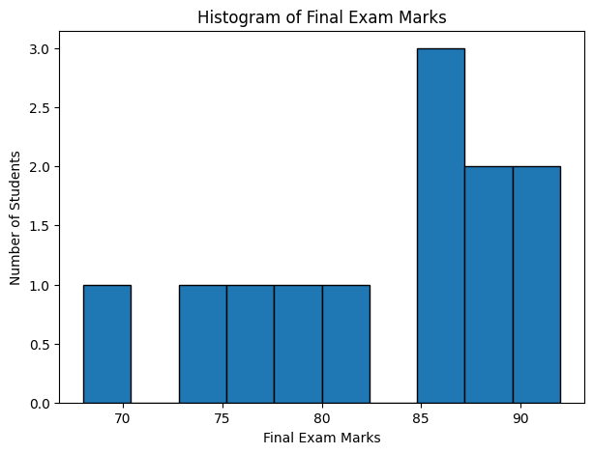
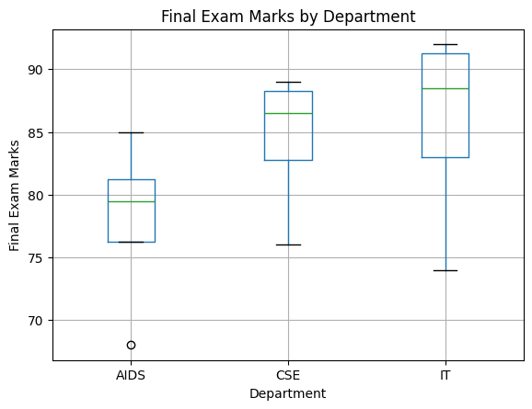
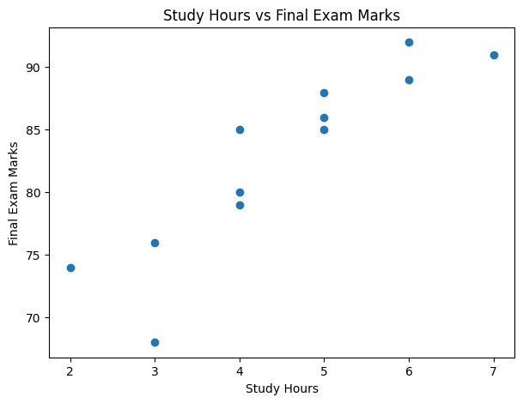
CORRELATION BETWEEN STUDY HOURS AND FINAL EXAM:
0.8963964693198984

FINAL CLEANED DATASET:
 | reg_no | department | gender | attendance | internal | final_exam | study_hours
0 | 101 | CSE | Female | 90.0 | 85.0 | 88.0 | 5
1 | 102 | AIDS | Male | 85.0 | 78.0 | 80.0 | 4
2 | 103 | IT | Female | 95.0 | 90.0 | 92.0 | 6
3 | 104 | CSE | Male | 80.0 | 75.0 | 76.0 | 3
4 | 105 | AIDS | Female | 86.5 | 88.0 | 85.0 | 5
5 | 106 | IT | Male | 86.5 | 70.0 | 74.0 | 2
6 | 107 | CSE | Female | 92.0 | 78.0 | 89.0 | 6
7 | 108 | AIDS | Male | 75.0 | 65.0 | 68.0 | 3
8 | 109 | IT | Female | 88.0 | 82.0 | 86.0 | 5
9 | 110 | CSE | Male | 85.0 | 78.0 | 85.0 | 4
10 | 111 | IT | Female | 90.0 | 85.0 | 91.0 | 7
11 | 112 | AIDS | Female | 80.0 | 75.0 | 79.0 | 4
EXPERIMENT 1 COMPLETED SUCCESSFULLY!

