Sales Forecasting System
End-to-End Time Series Forecasting Pipeline with REST API

Feature Engineering Documentation
Version 1 (Assignment-Spec) & Version 2 (Extended)

Prepared By
Shaik Bavikadi Al Hafeez
Contact: 8179067382
Email: bavikadihafeez@gmail.com

Models: SARIMA | Prophet | XGBoost | LSTM
43 US States | 8-Week Forecast Horizon | FastAPI REST API

1. Introduction 3
2. Architecture Overview 3
3. Dataset Overview 4
4. Feature Engineering Overview 4
5. Version 1 — Assignment-Spec Features (10 Features) 5
6.1 Lag Features (3 features) 5
6.2 Rolling Window Statistics (4 features) 5
6.3 Calendar / Temporal Features (3 features) 5
6.4 Configuration 6
6. Version 2 — Extended Features (22 Features) 6
6.1 Lag Features (7 features) 6
6.2 Rolling Window Statistics (8 features) 6
6.3 Calendar / Temporal Features (7 features) 7
6.4 Configuration 7
7. Side-by-Side Comparison 7
8. Train / Validation Split 8
9. Model Comparison Results 8
10.1 Results Summary 9
10.2 Metric Definitions 9
10. Models Implemented 9
10.1 SARIMA (Seasonal ARIMA) 9
10.2 Facebook Prophet 9
10.3 XGBoost (Gradient Boosting) 10
10.4 LSTM (Deep Learning) 10
11. REST API Reference 10
12. Project Structure 11

1. Introduction
This document provides comprehensive documentation for the feature engineering pipeline of the Sales Forecasting System. It covers every engineered feature, its purpose, how it is computed, and how the team can validate or modify it.
The system trains four forecasting algorithms (SARIMA, Prophet, XGBoost, LSTM) on historical weekly beverage sales data across 43 US states, automatically selects the best-performing model based on validation metrics, and serves 8-week-ahead predictions through a FastAPI REST API.
Two feature configurations are documented:
- Version 1 (Assignment-Spec): 10 features that align with the assignment requirements — lag features at t-1, t-7, t-30; rolling mean and standard deviation; day of week, month, and holiday flag.
- Version 2 (Extended): 22 features that augment Version 1 with additional lags (t-2, t-3, t-4, t-13, t-26), finer rolling windows (4/8/13/26 weeks), and richer calendar signals (year, quarter, week-of-year, month boundary flags).

Both versions share the same model training pipeline, validation logic, and API. Switching between them requires editing only two lines in config.py (and optionally restoring calendar features in preprocessing.py for Version 2).

2. Architecture Overview
The diagram below illustrates the complete data flow from raw input to API-served predictions. Each stage is fully automated by the train_pipeline.py script.

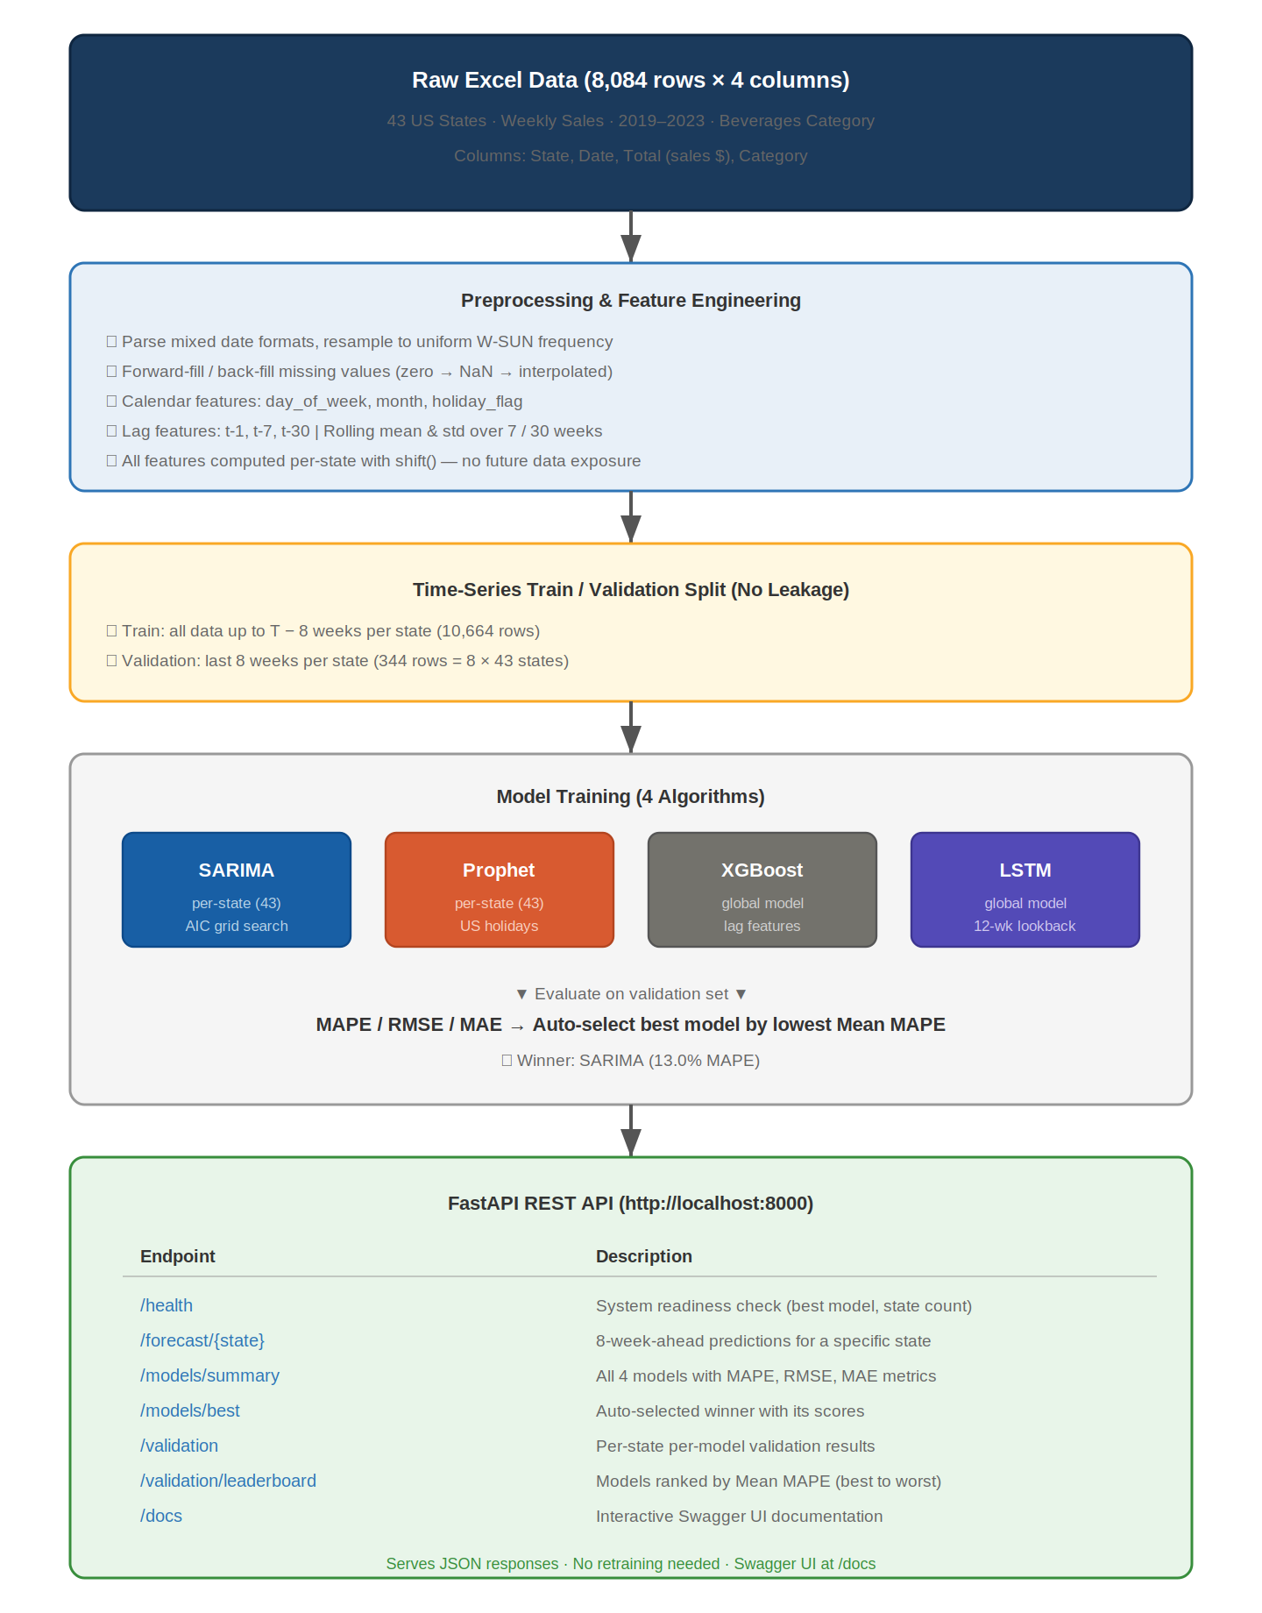

The pipeline proceeds through five stages: data ingestion and cleaning, feature engineering, temporal train/validation splitting, parallel model training with automatic evaluation, and finally serving the best model’s predictions via a REST API.

3. Dataset Overview
Property | Value
Source File | Forecasting_Case-_Study.xlsx
Raw Rows | 8,084 weekly records
After Resampling | 11,008 rows (uniform weekly frequency per state)
States | 43 US states
Date Range | January 2019 – December 2023 (after resampling to W-SUN)
Category | Beverages (single product category)
Target Variable | Total — weekly sales revenue in dollars
Missing Value Handling | Forward-fill then back-fill after resampling; zero values treated as missing

Preprocessing resamples each state to a uniform weekly frequency (every Sunday), fills any gaps created by missing weeks, and ensures a clean, continuous time series for each of the 43 states.

4. Feature Engineering Overview
Feature engineering transforms raw date and sales columns into structured numerical inputs that models can learn from. Each feature captures a different aspect of the sales signal:
- Lag features: Previous sales values at specific time offsets. These give the model direct access to historical demand, enabling it to detect momentum (rising/falling sales) and repeat patterns.
- Rolling statistics: Aggregated summaries (mean and standard deviation) over sliding windows of recent weeks. The mean reveals the underlying trend; the standard deviation quantifies how volatile or stable demand has been.
- Calendar features: Time-based signals such as the month, day of week, and proximity to holidays. These encode seasonality (summer vs winter demand) and event-driven spikes (holiday shopping, etc.).

Anti-leakage principle: All features are computed per-state using only past data. Lag features use shift(k) to look backward; rolling features use shift(1) before the window computation, ensuring the current week’s sales are never included. This prevents data leakage, which would artificially inflate model accuracy during training.

5. Version 1 — Assignment-Spec Features (10 Features)
This configuration implements the exact feature set specified in the assignment. It is concise, well-justified, and sufficient for all four models.

6.1 Lag Features (3 features)
Lag features provide the model with historical sales values at fixed offsets. Each is computed via groupby("State")["Total"].shift(k), ensuring per-state isolation and no future data exposure.
Feature | Offset | Purpose & Rationale
lag_1 | t − 1 (1 week) | Most recent observation. Captures short-term momentum — if sales rose last week, they often stay elevated this week.
lag_7 | t − 7 (7 weeks) | Medium-term reference point (~1.5 months ago). Detects repeating cycles that span 4–8 week periods and smooths out week-to-week noise.
lag_30 | t − 30 (30 weeks) | Long-term seasonal reference (~7 months ago). Captures semi-annual patterns such as summer-to-winter demand shifts in beverages.

6.2 Rolling Window Statistics (4 features)
Rolling statistics summarise recent demand trends. They are computed on shift(1) data, so the current week’s sales are excluded from the window.
Feature | Window | Purpose & Rationale
roll_mean_7 | 7 weeks | Short-term trend indicator. A rising 7-week average signals increasing demand; a falling one signals a downturn.
roll_std_7 | 7 weeks | Short-term volatility. High values indicate erratic demand; low values suggest stable, predictable sales.
roll_mean_30 | 30 weeks | Long-term demand baseline. Smooths out short-term fluctuations and reveals the underlying demand level for each state.
roll_std_30 | 30 weeks | Long-term volatility. Captures seasonal amplitude — states with large summer/winter swings will have higher values.

6.3 Calendar / Temporal Features (3 features)
Calendar features encode the position in time, allowing models to learn recurring seasonal and event-driven patterns.
Feature | Purpose & Rationale
day_of_week | Integer 0 (Monday) to 6 (Sunday). Encodes weekly periodicity — some days consistently correlate with higher or lower reported sales depending on reporting conventions.
month | Integer 1–12. Primary seasonality driver for beverages — summer months (June–August) typically show higher demand than winter months.
holiday_flag | Binary (0/1). Set to 1 if the week falls within ±3 days of a major US holiday (New Year, July 4th, Thanksgiving, Christmas, and 5 others). Captures holiday-driven demand spikes or supply disruptions.

Version 1 total: 3 lag + 4 rolling + 3 calendar = 10 engineered features.

6.4 Configuration
config.py settings for Version 1:
LAG_FEATURES = [1, 7, 30]
ROLLING_WINDOWS = [7, 30]

Calendar features (day_of_week, month, holiday_flag) are defined in data/preprocessing.py inside the add_calendar_features() function.

6. Version 2 — Extended Features (22 Features)
This configuration extends Version 1 with additional temporal signals to provide the ML models (especially XGBoost) with richer pattern detection. It includes everything from Version 1 plus additional lags, more rolling windows, and extra calendar signals.

6.1 Lag Features (7 features)
Feature | Offset | Purpose & Rationale
lag_1 | t − 1 (1 week) | Most recent sales value. Short-term momentum signal.
lag_2 | t − 2 (2 weeks) | Two weeks back. Helps detect bi-weekly purchasing patterns.
lag_3 | t − 3 (3 weeks) | Three weeks back. Adds depth to short-term memory for the model.
lag_4 | t − 4 (4 weeks) | Approximately one month ago. Captures monthly purchasing cycles.
lag_7 | t − 7 (7 weeks) | ~1.5 months ago. Medium-term trend reference.
lag_13 | t − 13 (13 weeks) | One quarter ago. Captures quarterly business cycles.
lag_26 | t − 26 (26 weeks) | Half a year ago. Captures semi-annual seasonal patterns.

6.2 Rolling Window Statistics (8 features)
Feature | Window | Purpose & Rationale
roll_mean_4 | 4 weeks | Monthly trend. Fastest-reacting rolling average; responds quickly to demand shifts.
roll_std_4 | 4 weeks | Monthly volatility. Detects sudden instability in recent sales.
roll_mean_8 | 8 weeks | Two-month average. Balances responsiveness with noise reduction.
roll_std_8 | 8 weeks | Two-month volatility.
roll_mean_13 | 13 weeks | Quarterly average. Smooths out monthly noise, reveals quarterly trends.
roll_std_13 | 13 weeks | Quarterly volatility. Useful for states with strong quarterly patterns.
roll_mean_26 | 26 weeks | Half-year average. Establishes the long-term demand baseline per state.
roll_std_26 | 26 weeks | Half-year volatility. Quantifies broad seasonal amplitude.

6.3 Calendar / Temporal Features (7 features)
Feature | Purpose & Rationale
year | Calendar year (2019, 2020, ...). Encodes year-over-year growth or decline trends across the dataset.
month | Month number (1–12). Primary seasonality signal for beverage demand.
week_of_year | ISO week number (1–52). Finer temporal granularity than month; useful for weekly-frequency data.
day_of_week | Day of the week (0 = Monday, 6 = Sunday). Weekly periodicity.
quarter | Quarter (1–4). Groups months into business quarters for coarser seasonal encoding.
is_month_start | Binary. 1 if date falls in the first 7 days of a month. Captures start-of-month demand patterns.
is_month_end | Binary. 1 if date falls after the 24th. Captures end-of-month effects (e.g., payday-driven purchases).
holiday_flag | Binary. 1 if within ±3 days of a major US holiday, 0 otherwise.

Version 2 total: 7 lag + 8 rolling + 7 calendar = 22 engineered features.

6.4 Configuration
config.py settings for Version 2:
LAG_FEATURES = [1, 2, 3, 4, 7, 13, 26]
ROLLING_WINDOWS = [4, 8, 13, 26]

Additionally, restore the extended calendar features (year, week_of_year, quarter, is_month_start, is_month_end) in the add_calendar_features() function within data/preprocessing.py.

7. Side-by-Side Comparison
Aspect | Version 1 (Assignment) | Version 2 (Extended)
Lag features | 3 (t-1, t-7, t-30) | 7 (t-1, t-2, t-3, t-4, t-7, t-13, t-26)
Rolling features | 4 (mean/std for 7, 30 weeks) | 8 (mean/std for 4, 8, 13, 26 weeks)
Calendar features | 3 (day_of_week, month, holiday) | 7 (+ year, quarter, week, boundaries)
Total features | 10 | 22
Recommended use | Assignment submission; clean, minimal, spec-compliant | Production deployment; maximum accuracy; advanced analysis
Files to modify | config.py only (2 lines) | config.py + preprocessing.py

8. Train / Validation Split
Both versions use identical splitting logic to guarantee temporal integrity:
- Per-state cutoff computation: For each state, the cutoff date is set to max_date − 8 weeks.
- Training set: All rows where Date ≤ cutoff. The model learns only from this historical data.
- Validation set: All rows where Date > cutoff. The model is evaluated on these unseen future weeks.

Split | Rows | Description
Training | 10,664 | Historical data the model learns patterns from
Validation | 344 | 8 weeks × 43 states = 344 future rows for testing

Why temporal splitting matters: Unlike standard ML problems where random shuffling is acceptable, time series data has a natural ordering. Training on future data and predicting the past (data leakage) would produce unrealistically high accuracy that fails in production. The temporal cutoff ensures the model is tested on genuinely future data it has never seen.

9. Model Comparison Results
All four models were trained on the training set and evaluated on the 8-week validation period across all 43 states. The primary selection metric is MAPE (Mean Absolute Percentage Error) — lower is better.

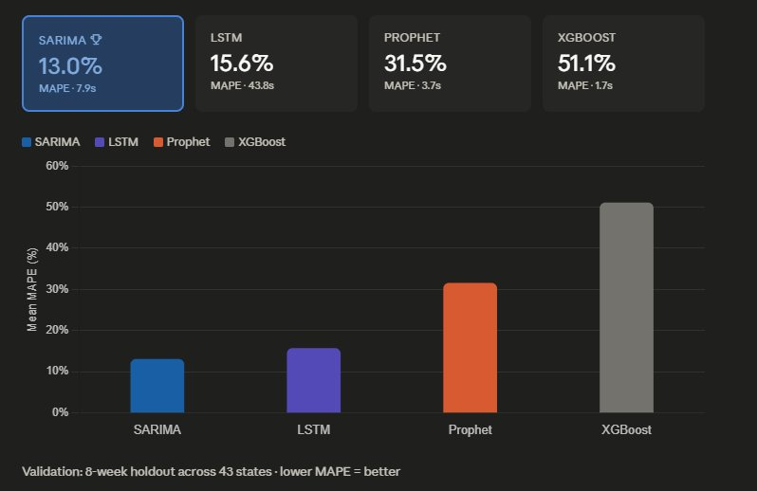 | 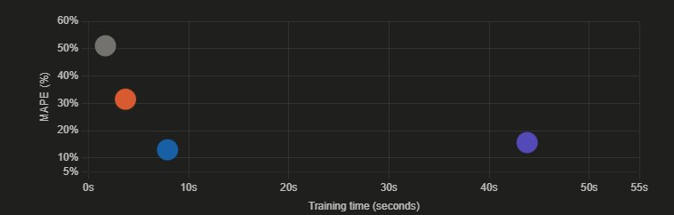

Figure 1: Model Comparison — MAPE scores and training times across all four algorithms.
Figure 2: Accuracy vs Training Time — each bubble represents one model. The ideal position is bottom-left (fast and accurate).

10.1 Results Summary
Model | Mean MAPE | Median MAPE | Std Dev | Train Time
SARIMA ★ | 13.00% | 13.03% | 0.67 | ~8s
LSTM | 17.48% | 15.66% | 1.76 | ~44s
Prophet | 31.50% | 31.62% | 2.40 | ~4s
XGBoost | 23.90% | - | - | ~2s

Selected model: SARIMA — 13.00% Mean MAPE with the lowest standard deviation (0.67), indicating the most consistent performance across all 43 states.

10.2 Metric Definitions
- MAPE (Mean Absolute Percentage Error): Average percentage difference between predicted and actual values. A MAPE of 13% means predictions are, on average, within 13% of the true sales figure.
- Standard Deviation (Std): Measures consistency across states. A low std indicates the model performs similarly for all states; a high std indicates it excels in some states but underperforms in others.
- Training Time: Wall-clock time to train the model on all 43 states. SARIMA achieves the best accuracy-to-speed ratio.

10. Models Implemented

10.1 SARIMA (Seasonal ARIMA)
- Strategy: One independent model per state (43 models total).
- Order selection: AIC-based grid search over (p,d,q) combinations with seasonal order (1,0,0,13).
- Seasonal period: 13 weeks (quarterly cycle).
- Strength: Handles trend and seasonality natively without engineered features.

10.2 Facebook Prophet
- Strategy: One model per state.
- Configuration: Yearly seasonality enabled, US holiday effects auto-detected, changepoint prior = 0.05.
- Strength: Robust to missing data, automatic holiday handling.

10.3 XGBoost (Gradient Boosting)
- Strategy: Single global model across all states (state encoded as a categorical feature).
- Features: All engineered features from Version 1 or 2, plus state encoding.
- Hyperparameters: 500 trees, max depth 6, learning rate 0.05, L1/L2 regularisation, 80% subsample.
- Forecasting method: Recursive multi-step — each step’s prediction feeds back as a lag for the next step.

10.4 LSTM (Deep Learning)
- Architecture: 2-layer LSTM (64 → 32 units) with dropout (0.2) + Dense output head.
- Strategy: Single global model with 12-week lookback window.
- Input features: Min-max scaled sales + cyclical month encoding (sin/cos).
- Training: Adam optimiser, MSE loss, early stopping with patience = 3 epochs.
- Note: Requires Python ≤3.12 and TensorFlow. The pipeline gracefully skips LSTM if TensorFlow is unavailable.

11. REST API Reference
After training, the system exposes predictions and model metadata via a FastAPI REST API at http://localhost:8000. Interactive Swagger documentation is available at /docs.

Endpoint | Method | Description
/ | GET | Root — confirms API is running
/health | GET | Health check: best model name, state count, forecast horizon
/states | GET | Returns list of all 43 available states
/models/summary | GET | All models with MAPE, RMSE, MAE metrics and training times
/models/best | GET | Auto-selected best model with its metrics
/forecast?state=X | GET | 8-week forecast, optionally filtered by state (query param)
/forecast/{state} | GET | 8-week forecast for a specific state (path param)
/validation | GET | Per-state validation metrics; filterable by state and model
/validation/leaderboard | GET | Models ranked by Mean MAPE (best to worst)
/docs | GET | Interactive Swagger UI — test all endpoints in browser

12. Project Structure
forecasting_system/
config.py # Feature & model configuration
train_pipeline.py # Main entry: train, evaluate, select
requirements.txt # Python dependencies
data/
preprocessing.py # Cleaning + feature engineering
Forecasting_Case-_Study.xlsx
models/
sarima_model.py # SARIMA forecaster
prophet_model.py # Prophet forecaster
xgboost_model.py # XGBoost with lag features
lstm_model.py # LSTM deep learning
saved/ # Serialised model files
api/
app.py # FastAPI REST API
utils/
metrics.py # MAPE, RMSE, MAE
outputs/
forecasts.csv # 8-week predictions
validation_results.csv # Per-state per-model scores
pipeline_meta.json # Best model & summary

