**WEEK - 01**

**HAFEEZ MOHAMAD**

**B172195**

1. **Write a Java program to print “Hello World”.**

**CODE:**

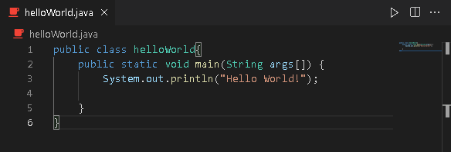

**OUTPUT:** 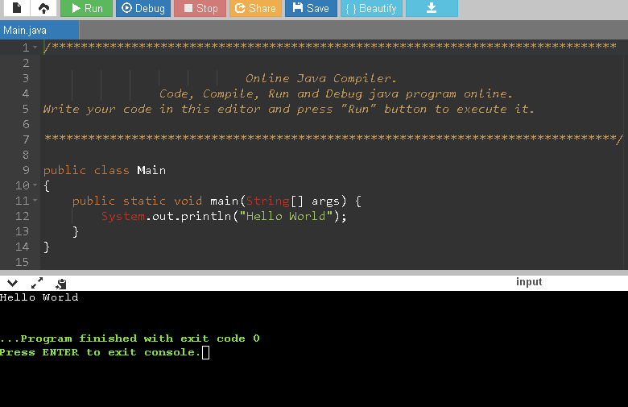

1. **Write a Java program that prints all the real and imaginary solutions to the quadratic equations ax2 + bx + c = 0.Read in a, b, c and use the quadratic formula.**

**CODE:**

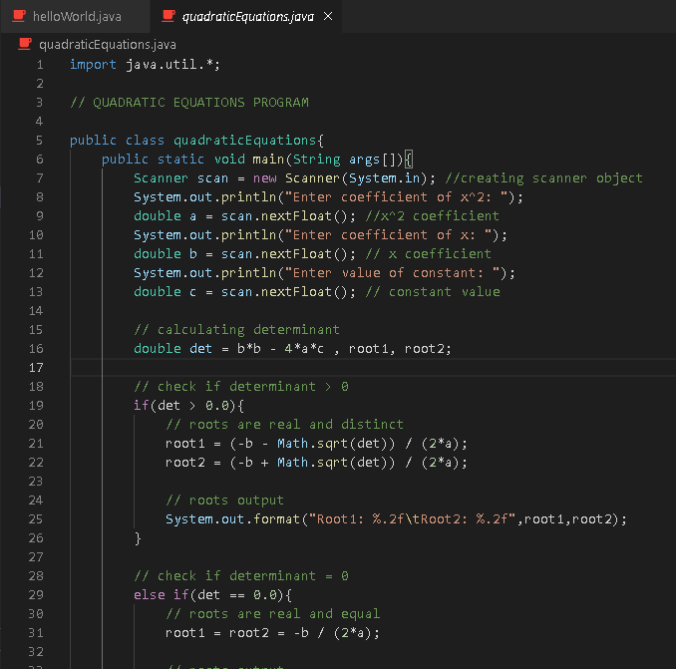

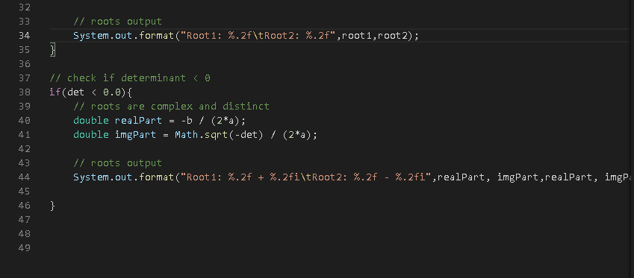

**OUTPUT:**

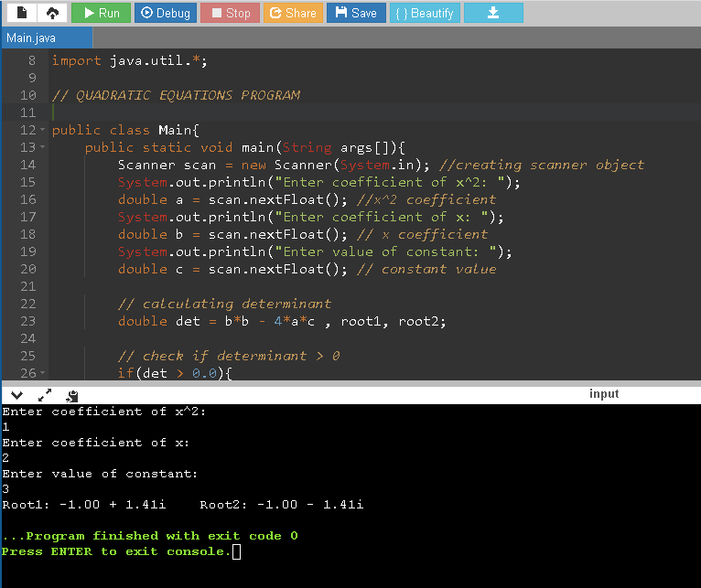

1. **Write a Java program to implement calculator operations.**

**CODE:**

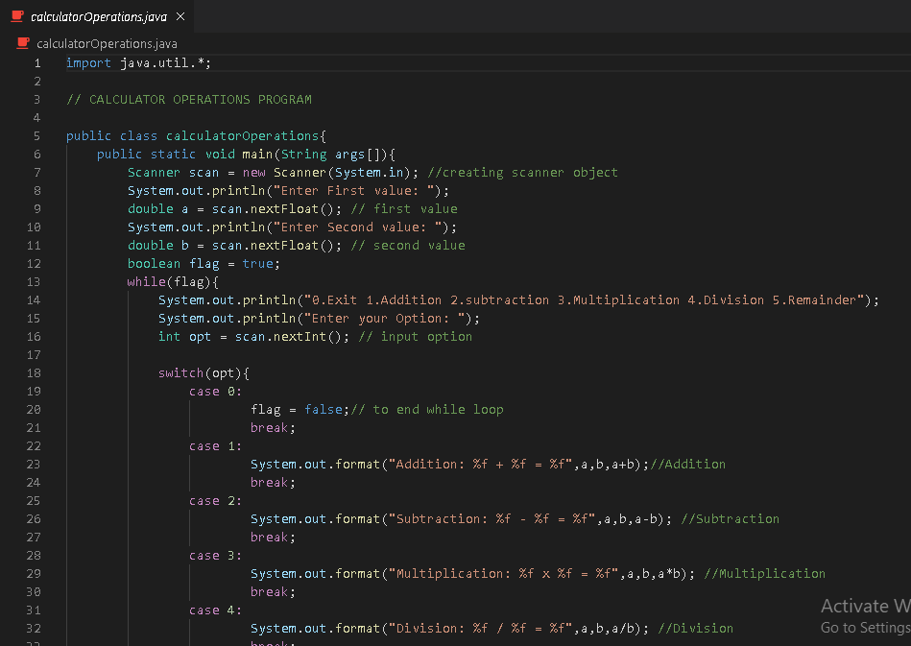

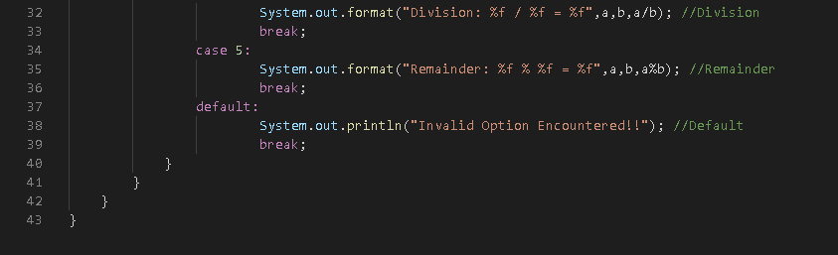

**OUTPUT:**

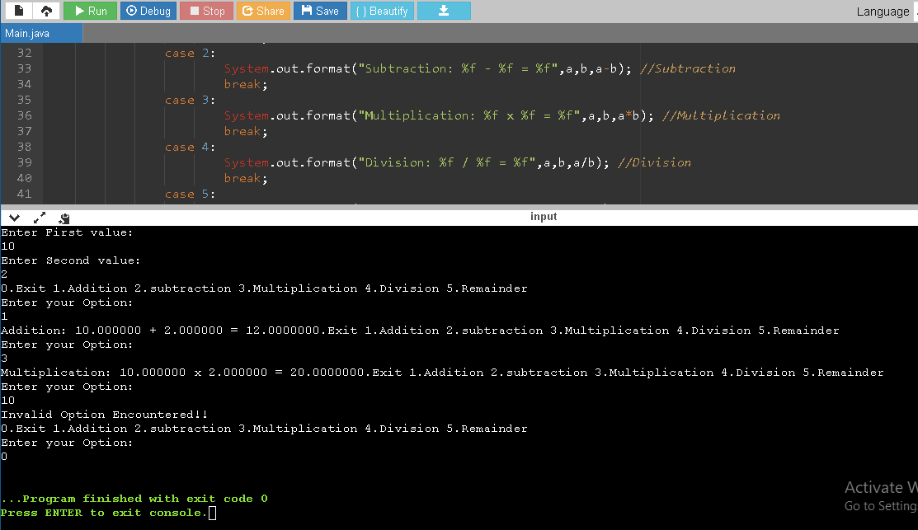

1. **Write a Java program to find prime factors of a given number.**

**CODE:**

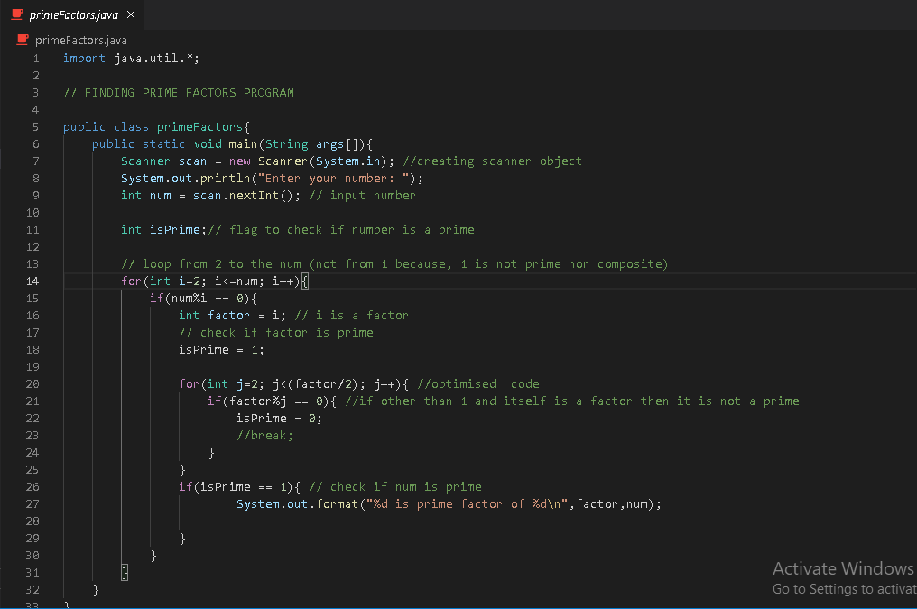

**OUTPUT:**

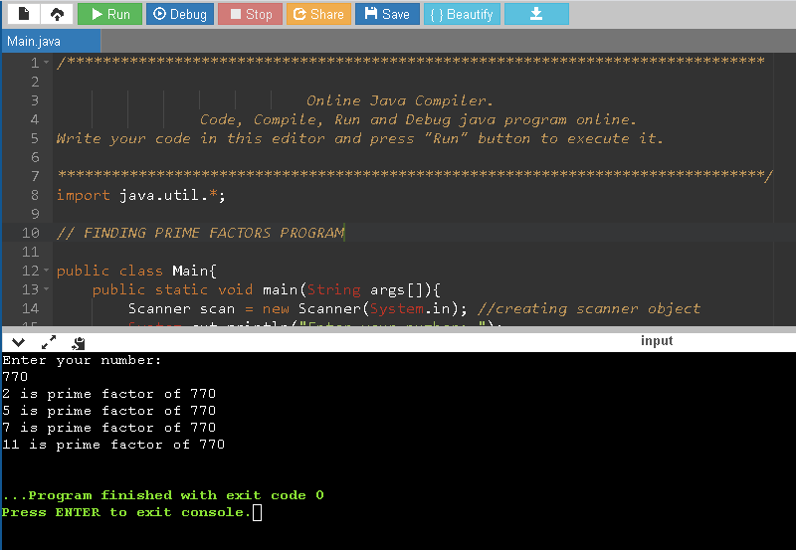

1. **Write a Java program to find whether given number is palindrome or not.**

**CODE:**

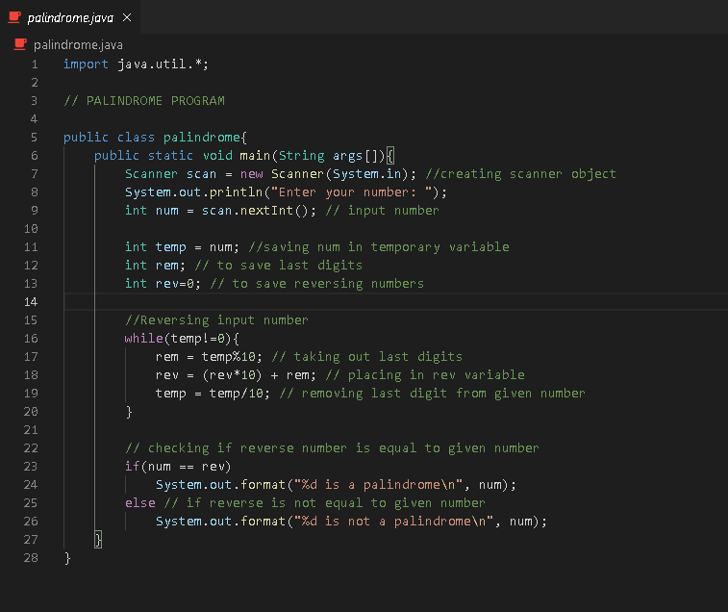

**OUTPUT:**

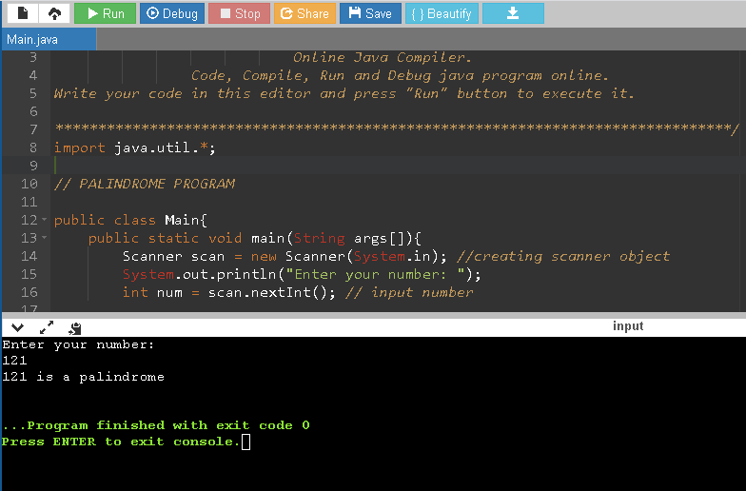

1. **Write an application that declares 5 integers, determines and prints the largest and smallest in the group.**

**CODE:**

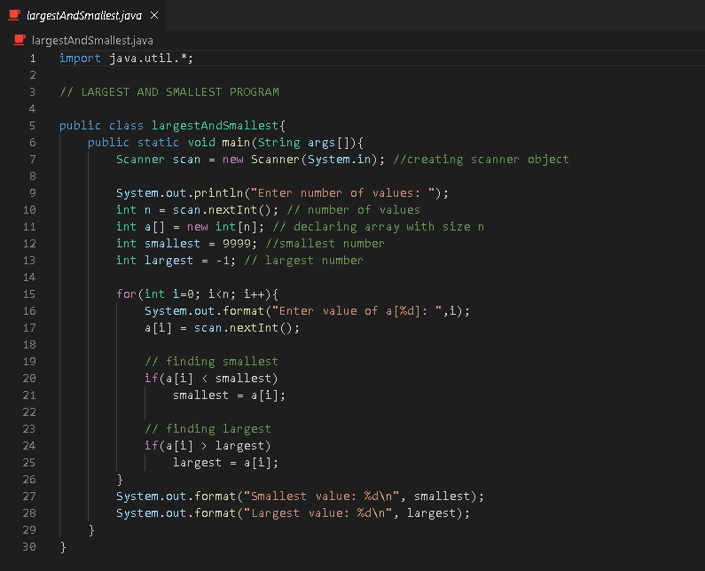

**OUTPUT:**

