⟦ INSERT ENSET LOGO HERE ⟧
Département Mathématique et Informatique
Mémoire de Projet de Fin d'Études
Pour l'obtention du titre de
Master Professionnel
Filière : « Big Data & Cloud Computing » — BDCC
AI-Assisted Generation of Selenium Page Objects:
A Structured Pipeline Compared Against
Direct Large Language Model Generation
Soutenu le ⟦ ACTION REQUIRED — defense date ⟧
Réalisé par : ⟦ ACTION REQUIRED — your full name ⟧
Encadré par : ⟦ ACTION REQUIRED — supervisor name(s) ⟧
Année Universitaire : 2025–2026
ENSET, Avenue Hassan II — B.P. 159 — Mohammedia, Maroc

Dédicace
⟦ACTION REQUIRED — write your dedication here. Two to six lines, to family, friends and teachers. Every report has one; keep it short and sincere.⟧

Remerciements
⟦ACTION REQUIRED — write your acknowledgements. Conventionally: the ENSET administration and faculty; your supervisor by name; the jury members for agreeing to evaluate the work; your family; your promotion.⟧

Résumé
Ce rapport présente le travail réalisé dans le cadre du projet de fin d’études pour l’obtention du diplôme de Master Professionnel de l’ENSET de Mohammedia. Le projet porte sur la conception et le développement d’un framework de test automatisé et d’un pipeline de génération automatique d’objets de page (Page Objects) Selenium à partir du HTML rendu d’une page web.
L’originalité de ce travail réside dans une architecture d’escalade conditionnée par la confiance : le pipeline déterministe attribue à chaque élément le localisateur le plus stable disponible selon un ordre de priorité fixe, enregistre la règle qui a produit ce choix, et n’envoie à un modèle de langage que les éléments pour lesquels aucune stratégie stable n’a pu être trouvée. Le coût du modèle devient ainsi proportionnel au nombre de décisions réellement ambiguës et non à la taille de la page.
Une comparaison expérimentale a été menée entre ce pipeline structuré et l’alternative naïve consistant à soumettre le HTML brut à un modèle de langage. Les résultats montrent que le pipeline structuré produit une sortie identique au bit près sur des exécutions répétées, compile systématiquement, et n’a consommé aucun jeton sur la page évaluée, tandis que la ligne de base a produit trois résultats différents à partir d’une entrée identique et a inventé une méthode inexistante de l’API Selenium dans deux exécutions sur trois. Un audit ultérieur, au cours duquel chaque localisateur produit a été évalué sur la page capturée, nuance ce résultat dans les deux sens : deux localisateurs de composant du pipeline structuré ne se résolvaient pas et ont depuis été corrigés, tandis que la seule exécution de la ligne de base qui compilait a produit des localisateurs tous corrects. La différence établie par les mesures porte donc sur la reproductibilité et la vérifiabilité, et non sur la compréhension de la page.
Mots-clés : test automatisé, Selenium, Page Object Model, génération de code, modèles de langage, intégration continue, assurance qualité logicielle.

Abstract
This report presents the work carried out as an end-of-studies project for the Professional Master’s degree at ENSET Mohammedia. The project concerns the design and development of a test automation framework together with a pipeline that automatically generates Selenium Page Objects from the rendered HTML of a live web page.
The distinguishing feature of this work is a confidence-gated escalation architecture: the deterministic pipeline assigns each element the most durable available locator according to a fixed priority order, records which rule produced that choice, and escalates to a large language model only those elements for which no stable strategy could be found. The cost of the model therefore scales with the number of genuinely ambiguous decisions rather than with the size of the page.
An experimental comparison was conducted between this structured pipeline and the naive alternative of submitting raw HTML directly to a language model. The structured pipeline produced byte-identical output across repeated runs, compiled without modification every time, and consumed zero tokens on the page evaluated. The baseline produced three different artefacts from identical input and hallucinated a non-existent Selenium API method in two runs out of three. A subsequent audit, in which every emitted locator was evaluated against the captured page, qualifies the result in both directions: two of the structured pipeline’s own component locators did not resolve and have since been corrected, while the one baseline run that compiled produced locators that were all correct. The difference the measurements support is therefore one of reproducibility and verifiability rather than of comprehension.
Keywords: test automation, Selenium, Page Object Model, code generation, large language models, continuous integration, software quality assurance.

Abbreviations
Table 1 — Acronyms used in this report
Acronym | Meaning
ENSET | École Normale Supérieure de l’Enseignement Technique
BDCC | Big Data et Cloud Computing
PFE | Projet de Fin d’Études
QA | Quality Assurance
UI | User Interface
POM | Page Object Model
DOM | Document Object Model
HTML | HyperText Markup Language
CSS | Cascading Style Sheets
XPath | XML Path Language
API | Application Programming Interface
REST | Representational State Transfer
JSON | JavaScript Object Notation
HTTP | HyperText Transfer Protocol
LLM | Large Language Model
AI | Artificial Intelligence
CI/CD | Continuous Integration / Continuous Delivery
UML | Unified Modeling Language
JDK | Java Development Kit
CSRF | Cross-Site Request Forgery
ARIA | Accessible Rich Internet Applications
E2E | End-to-End

Table of Contents
The three lists below are Word fields. Select all (Ctrl+A / Cmd+A) and press F9, or right-click each list and choose “Update Field”, to build them. Delete this paragraph before printing.
Table of contents — update this field.

List of Figures
List of figures — update this field.

List of Tables
List of tables — update this field.

General Introduction
Software has become the medium through which most organisations deliver their services, and the rate at which that software changes has increased faster than the capacity of any manual process to verify it. A modern web application may be deployed several times a week, sometimes several times a day. Every deployment carries the risk that a change intended to improve one part of the system silently breaks another. The discipline that manages this risk is software quality assurance, and its dominant instrument is automated testing.
Among the layers at which a web application can be tested, the user interface is simultaneously the most valuable and the most expensive. It is the most valuable because it is the only layer that exercises the system exactly as a real user does: the browser, the network, the rendering, the client-side logic and the server all participate. It is the most expensive because it is the layer most exposed to change. A redesign that does not alter a single line of business logic can invalidate an entire suite of interface tests, because those tests are bound to the structure of the page rather than to its meaning.
The engineering response to this fragility is the Page Object Model, a design pattern that isolates all knowledge of a page’s structure inside a dedicated class, so that a change to the interface is absorbed in one place instead of propagating through every test. The pattern is effective and near-universal in professional practice. It is also laborious. Building a page object means locating every interactive element on the page, choosing a stable way to address each one, and writing a method for each interaction. It is repetitive work, mechanical in character, and it must be redone whenever the interface changes substantially.
The recent maturity of large language models has made an obvious proposal available: give the page’s HTML to a model and ask it to write the page object. The proposal is attractive because the task appears to be exactly what such models are good at — reading a structured text and producing code. It is also, on inspection, less obviously sound than it appears. A language model produces the code that is most probable given its training, not the code that is entailed by the input it was given. Where the two coincide the output is excellent. Where they diverge, the model produces code that is fluent, plausible, and wrong — and it produces it without any signal that anything is amiss.
This project examines that divergence empirically. It builds a deterministic pipeline that generates Selenium page objects from a live page’s rendered HTML by parsing, classification and code generation, with a language model invoked in one specific and narrowly-defined circumstance: when the deterministic layer has itself established that it could not find a stable way to address an element. It then builds the naive alternative — the whole page sent to a model in a single prompt — and compares the two under identical conditions on a defined set of metrics.
The central claim defended in this report is not that language models are unsuitable for this task. It is more specific and, we argue, more useful: that the problem decomposes into a structural part, which is better solved deterministically because determinism buys reproducibility, traceability and zero marginal cost, and a semantic part, which is where a language model’s contribution is real. Identifying where that boundary lies, and demonstrating it with measurements rather than assertion, is the contribution of this work.
Structure of this report. Chapter I sets out the general context and states the problem. Chapter II reviews the state of the art in test automation, page object generation and language-model-based code generation, and positions this work relative to it. Chapter III presents the requirements, the development methodology, the project plan and — importantly — the evaluation methodology, including the threats to the validity of the measurements. Chapter IV presents the functional design of the system through UML models. Chapter V presents the implementation. Chapter VI presents the experimental evaluation and its results. A general conclusion assesses what was achieved and what remains.

Chapter I. General Context and Problem Statement

I.1 Introduction
This chapter establishes the ground on which the project stands. It situates the work in its academic setting, introduces the field of software quality assurance and the particular position of user-interface test automation within it, analyses where the cost and the fragility of that activity actually originate, and states the problem this project addresses together with the research questions it seeks to answer.

I.2 Academic context
This work was carried out as the end-of-studies project (Projet de Fin d’Études) for the Professional Master’s degree in Big Data and Cloud Computing (BDCC) at the École Normale Supérieure de l’Enseignement Technique (ENSET) of Mohammedia, Hassan II University of Casablanca.
⟦ACTION REQUIRED⟧ If the project was carried out within a host company or laboratory, add a short subsection presenting it: activity, size, the team you joined, and the role you occupied. If it was carried out academically under supervision, say so explicitly — juries prefer a stated context to an absent one.

I.3 Software quality assurance and the role of automated testing
Software quality assurance encompasses the processes by which an organisation gains justified confidence that a system behaves as intended. Testing is its principal empirical instrument: rather than reasoning about what the software should do, testing observes what it actually does under controlled conditions and compares the observation against an expectation.
Automated testing performs this observation by machine. The advantages over manual execution are well established: automated tests run in minutes rather than days, they run identically every time, they can be triggered by every change rather than at release milestones, and their cost per execution approaches zero once written. The cost is displaced rather than eliminated — it moves from execution to authoring and maintenance.
It is conventional to organise automated tests into layers, often depicted as a pyramid [1], [2]:
- Unit tests exercise a single function or class in isolation. They are fast, numerous, cheap to write and cheap to maintain, but they verify only that components behave correctly individually.
- Integration tests exercise several components together, including their interaction with real dependencies such as databases or HTTP services. They are slower and fewer.
- End-to-end (or system) tests exercise the complete deployed application through its actual interface. They are the slowest and fewest, and the only ones that verify the system as the user encounters it.
The pyramid metaphor encodes an economic argument: because the cost per test rises as one ascends, a rational suite has many tests at the bottom and few at the top. This project concerns the top layer, and specifically its web variant, where the interface is a browser.
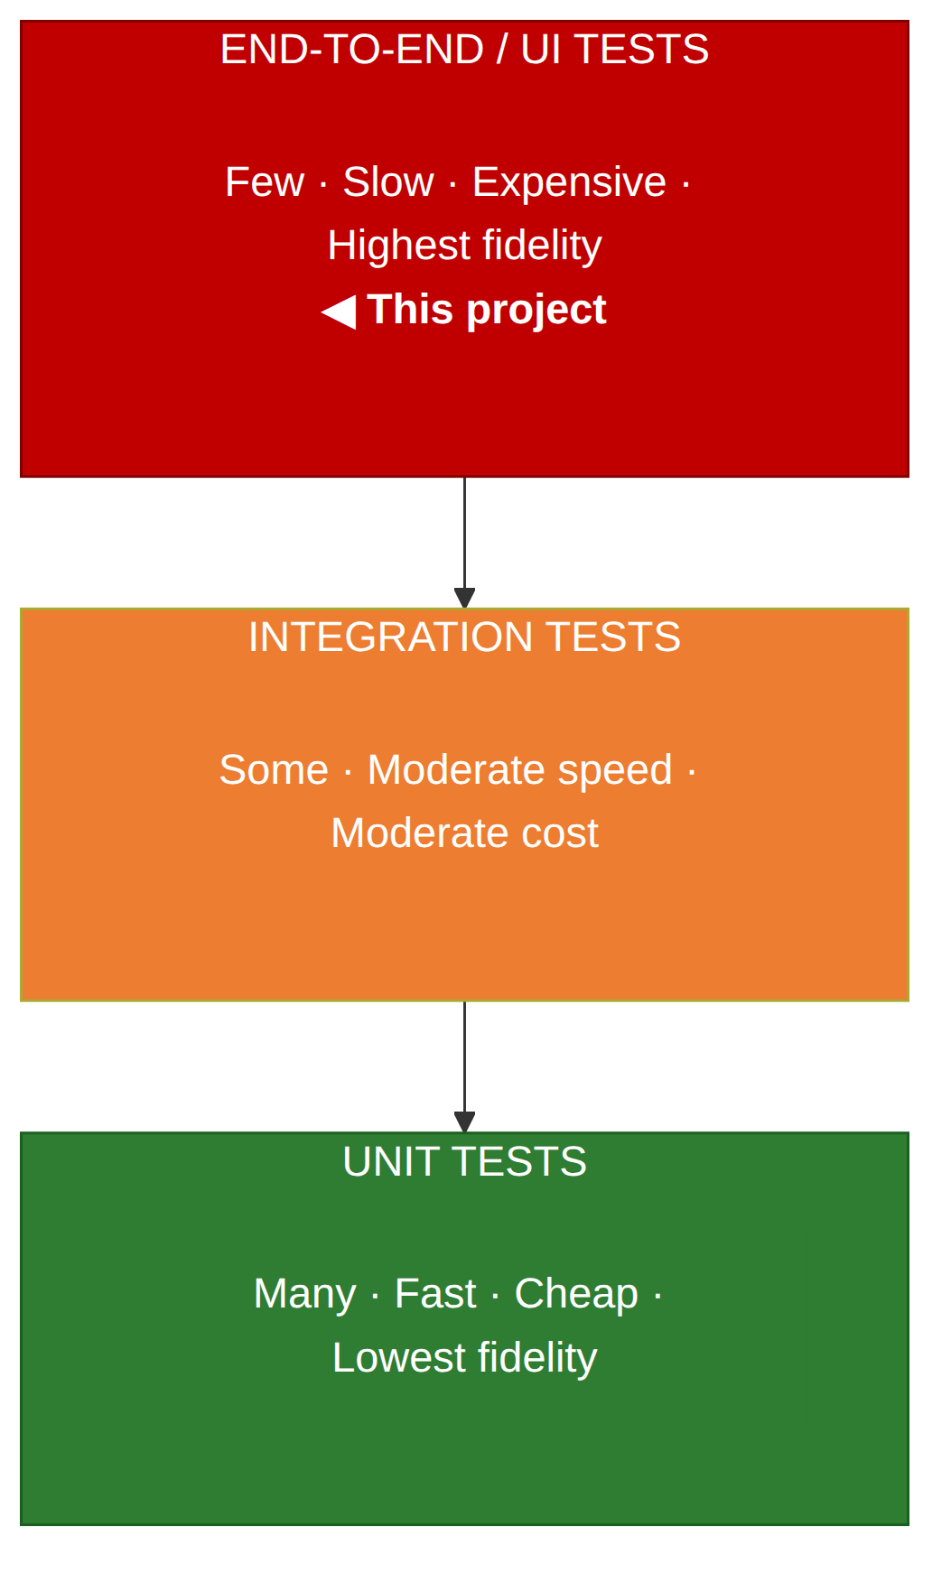
Figure 1 — The test automation pyramid, with the layer addressed by this project highlighted

I.4 User-interface test automation and the source of its cost
A UI test drives a real browser. It navigates to a page, finds elements, interacts with them, and asserts on what results. In the Java ecosystem the dominant instrument for this is Selenium WebDriver, which exposes a programmatic interface to a real browser through a standardised protocol.
The essential operation in any such test is locating an element. Before a test can click a button it must identify, among the many hundreds of nodes in the page’s document object model, the one node that is the button. This is done with a locator: an expression, typically a CSS selector or an XPath expression, that selects the node.
Everything that makes UI test automation expensive follows from this one operation.
Locators must be authored. Someone must inspect the page, decide which attribute or path identifies each element, and write it down. For a page with thirty interactive elements this is thirty decisions, each requiring a look at the underlying markup. Multiplied across the pages of a real application, the authoring effort is substantial and — this is the operative point — almost entirely mechanical.
Locators are fragile. A locator is a claim about the structure of a document. When the document changes, the claim may cease to hold. A locator expressed as a positional path such as /html/body/div[3]/div[2]/form/input[1] is invalidated by the insertion of a single wrapper element anywhere above it. A locator expressed in terms of visible text is invalidated by a copy edit or a translation. A locator expressed in terms of a CSS class is invalidated by a restyling. This is the phenomenon commonly called test brittleness or test flakiness, and it is the principal reason organisations abandon UI test suites [3], [4].
Locator quality is not uniform. Some ways of addressing an element are markedly more durable than others. An attribute placed in the markup specifically for testing — conventionally data-test, data-qa, data-testid or similar — exists for no other purpose and therefore has no reason to change when the page is restyled or reworded. An id is intended to be unique and is reasonably stable, though it may be altered during refactoring. A name attribute carries form semantics and is fairly stable. Visible text is the least stable of all, because text is the part of an interface most frequently edited, and because it changes entirely under internationalisation.
This gradient is central to the present work. It means that the choice of locator is not arbitrary: for any given element there is a defensible ordering of the available options, and that ordering can be encoded as a rule rather than left to judgement.

I.5 The Page Object Model and the shape of the remaining problem
The Page Object Model is the standard architectural response to locator fragility [5]. Its rule is simple: no test may contain a locator. All knowledge of a page’s structure is confined to a class representing that page, which exposes methods expressed in the vocabulary of the user — login(user, password), addProductToCart() — rather than in the vocabulary of the DOM.
The benefit is that structural change is absorbed at a single point. If the login button’s identifier changes, one line in LoginPage changes, and every test that logs in continues to pass without modification.
The pattern is sound and it is not in question here. What it does is relocate the authoring cost rather than remove it. Every page still requires a class; every element still requires a locator and at least one method. The pattern makes the cost maintainable; it does not make it small. And because the work is so regular — find element, choose locator, emit field, emit method — it is a natural candidate for automation. That observation is the origin of this project.

I.6 Large language models as a proposed solution, and the reasons for caution
Large language models can produce syntactically valid, idiomatic code from a natural-language description or from a structured input such as HTML. Applying them to page object generation is an obvious idea and it is being pursued commercially [6], [21].
There are, however, specific reasons to examine the proposal rather than adopt it.
Non-determinism. A language model samples from a probability distribution. The same prompt submitted twice may produce different code. For an artefact that is committed to version control, reviewed by colleagues and expected to be reproducible by a build system, this is a substantive property, not a detail. A generator whose output varies between invocations cannot be meaningfully diffed, and a defect found in one generation may not be reproducible in the next.
Hallucination. A model may produce code that references APIs which do not exist, because such code is statistically plausible even when it is factually wrong. This failure mode is particularly dangerous in generated code, because the output looks correct: it follows the conventions of the language and the library, and only compilation or execution reveals the defect.
Cost proportional to input. Submitting a page’s full HTML consumes input tokens in proportion to the size of that page. A realistic page can run to tens of thousands of tokens. Repeated across many pages and many regenerations, this is a recurring monetary cost that scales with the size of the application rather than with the number of decisions actually requiring judgement.
Absence of traceability. When a deterministic program selects a locator, the reason can be recovered from the rules. When a model selects a locator, no such account is available. For an artefact whose purpose is to give confidence in a system, the inability to explain why it is constructed as it is represents a genuine loss.
Dependence on an external service. A cloud model is a network dependency with its own availability characteristics. A pipeline that requires it inherits its outages.
None of these observations establishes that language models should not be used. They establish that where and how they are used is a design question with consequences, and that the question is answerable empirically.

I.7 Problem statement and research questions
The problem addressed by this project can be stated as follows:
The authoring of Selenium page objects is a repetitive and costly activity whose automation is desirable. Large language models offer an immediate route to that automation, but introduce non-determinism, unverifiable output, cost proportional to page size and an external dependency. A deterministic program can avoid all four, but lacks the semantic understanding a model possesses. The problem is to determine how the task should be divided between the two, and to demonstrate the answer with measurements rather than assertion.
From this, three research questions follow:
RQ1. Can a deterministic pipeline, operating on the rendered HTML of a live page, generate Selenium page objects of a quality comparable to those produced by a large language model given the same page?
RQ2. Where a deterministic pipeline is unable to identify a stable locator, can it detect that condition itself, and does escalating only those cases to a language model provide a better cost/benefit ratio than submitting the entire page?
RQ3. On which measurable dimensions does each approach dominate, and what does that imply for how such systems should be built?

I.8 Conclusion
This chapter has established that user-interface test automation is valuable and expensive, that its cost and fragility both originate in the locating of elements, that the Page Object Model relocates rather than removes the authoring cost, and that language models offer an automation route whose properties warrant examination rather than assumption. The next chapter reviews existing work on each of these fronts and positions the present contribution.

Chapter II. State of the Art

II.1 Introduction
This chapter surveys the technical and scientific background against which the project is set: the tooling of web test automation, the design patterns that structure it, prior approaches to generating page objects automatically, and the capabilities and documented failure modes of large language models applied to code generation. It closes with an explicit statement of the gap this project addresses.

II.2 Web test automation tooling
Selenium WebDriver is the de facto standard for browser automation in the Java ecosystem and the reference implementation of the W3C WebDriver specification [7], [8]. It controls a real browser through a driver process, exposing operations to navigate, locate elements, interact with them and read their state.
Two properties of WebDriver matter for this project. First, it operates on the rendered DOM — the document as it exists after the browser has executed the page’s JavaScript. For any application that constructs its interface client-side, this is the only representation that corresponds to what a user sees, and it differs, sometimes completely, from the HTML returned by a simple HTTP request. Second, WebDriver’s element location is expressed through a By abstraction offering several strategies — id, name, className, cssSelector, xpath, linkText and others — which makes the choice among strategies an explicit and inspectable decision.
TestNG provides the test execution framework: lifecycle annotations, grouping, parallel execution, parameterisation and suite configuration [9]. JUnit is the principal alternative; the choice between them does not materially affect the present work.
Alternative ecosystems. Playwright and Cypress have gained substantial adoption, offering auto-waiting and, in Playwright’s case, a locator model that encourages user-facing selection strategies such as role and accessible name [10]. These are relevant because they represent an industry movement towards semantic, stability-oriented locators — the same movement that motivates the priority ordering used in this project. Java with Selenium and TestNG was retained here because it remains the dominant stack in the enterprise quality-assurance market this work targets, and because the architectural contribution is not language-specific.

II.3 The Page Object Model and its refinements
The Page Object pattern, as popularised by Fowler [5], encapsulates a page’s structure behind an API expressed in domain terms. Several refinements are in common use:
- A base page class holding the interaction primitives — click, type, read text, wait — so that page classes contain only what is specific to their page. This centralises the waiting strategy, which is otherwise a notorious source of duplication and flakiness.
- Fluent page objects, in which a method returns the page object representing the state the application has moved to, allowing a test to read as a sequence of transitions.
- Component or fragment objects, in which a repeated region of a page — a product card, a table row, a navigation bar — is modelled as its own class scoped to a single instance, rather than being flattened into the enclosing page [5], [8]. This refinement is directly relevant to the present work: a page displaying a grid of thirty products should not produce thirty near-identical fields, but one component class instantiated thirty times.

II.4 Locator robustness
The relative durability of locator strategies is treated in both practitioner literature and empirical study [11], [12]. The consensus ordering — dedicated test attributes, then identifiers, then names, then structural or textual expressions — reflects a single underlying principle: a locator is durable to the extent that it depends on something that has no reason to change for reasons unrelated to the element’s identity.
Work on self-healing locators addresses the same problem from the opposite direction: rather than choosing a durable locator initially, the tool detects at runtime that a locator has failed and attempts to re-identify the element by similarity to previously observed properties [13], [14]. Several commercial tools implement variants of this. Self-healing is complementary to, not competitive with, the approach taken here, and is identified in Chapter VI as future work.

II.5 Automated generation of page objects
Approaches to producing page objects without writing them by hand fall into several families.
Record-and-replay. Tools such as Selenium IDE record a user’s interactions and emit code reproducing them [15]. The approach is accessible and requires no programming, but the generated code is typically a linear script rather than a structured page object, and the locators chosen tend to be positional and consequently brittle. Generated suites of this kind are widely reported to be difficult to maintain.
Static analysis and crawling. Automated crawlers explore an application and construct a model of its states and transitions, from which test artefacts can be derived [16], [17]. These systems produce broad coverage but are typically oriented towards state-model extraction rather than towards emitting maintainable, human-readable page object code.
Commercial AI-assisted platforms. A number of vendors offer test authoring assisted by machine learning, generally combining element identification, self-healing and natural-language authoring [6]. These are closed systems; their internal decision procedures are not inspectable, which is precisely the property this project treats as a variable worth measuring.
Direct generation by language model. The most recent approach, and the baseline against which this work compares, submits page markup to a model and requests a page object in return. Its properties are the subject of Chapter VI.

II.6 Large language models for code generation
Contemporary large language models generate code at a level of fluency that makes them practically useful, and a substantial literature now examines both their capabilities and their limits [18], [19].
Three documented properties bear directly on this project.
Hallucination of APIs. Models generate references to functions, methods and parameters that do not exist in the libraries being used. The phenomenon is well documented and follows from the generative mechanism: an invented method name may be highly plausible given surrounding context while being entirely absent from the actual API surface [20]. Chapter VI reports a direct instance of this failure observed in the present experiments.
Non-determinism. Output varies between invocations on identical input. This is inherent to sampling-based decoding and is only partially mitigated by temperature settings.
Sensitivity to input length and structure. Model performance is affected by the length of the input and by where the relevant information sits within it. A page’s full HTML is a long input containing a high proportion of material irrelevant to the task — styling, analytics, inline scripts — which both costs tokens and dilutes the signal.
Applications to software testing. Language models have been applied to unit test generation, test oracle inference, test repair and input generation [19]. This body of work generally reports the same shape of result: useful output, imperfect correctness, and a need for validation of what is produced.

II.7 Positioning and gap
The literature and practice reviewed above support three observations.
First, the ordering of locator strategies by robustness is settled knowledge. It does not require inference; it can be encoded directly as a deterministic rule.
Second, existing generation approaches sit at the extremes. Record-and-replay and crawling are fully deterministic but produce artefacts of limited structural quality. Direct language-model generation produces structurally plausible artefacts but inherits non-determinism, unverifiability and cost proportional to page size. Approaches that deliberately combine the two, and that make the division of labour between them the object of study, are not well represented.
Third, and most specifically: the closest published work we have found is that of Karagöz et al. [21], who evaluate GPT-4o and DeepSeek Coder on page object generation across five web applications, using a deterministic pre-processing step that truncates and cleans the HTML before it reaches the model. That work and this one share a premise — that raw markup is a poor input — but differ in where the deterministic component sits. There, cleaning is a preparation for a model that still writes all of the code; here, the deterministic layer writes the code and assesses its own confidence per element, escalating to a model only the elements for which its rules could not produce a stable result. We are not aware of published work in which the generator gates the model call on its own per-element confidence in this way. That confidence-gated escalation — in which the cost of the model scales with the number of genuinely ambiguous decisions rather than with the size of the page — is the architectural contribution of this project, and the comparison of that architecture against the naive baseline under a defined metric set is its empirical contribution.
The comparison with [21] is also instructive on results. That study reports accuracy between 32.6 % and 54.0 % against manually written page objects, with element recognition above 70 % in most cases — the same shape of outcome reported throughout the literature on language models applied to code: substantial useful output, imperfect correctness, and a consequent need to validate what is produced. The present work does not dispute that finding. It asks a narrower question: which parts of the task need the model at all.

II.8 Conclusion
This chapter has reviewed the tooling, patterns and prior approaches relevant to the automated production of page objects, and the documented behaviour of language models applied to code generation. It has identified the gap the project addresses: the deliberate, measured division of the task between a deterministic layer and a language model, gated by the deterministic layer’s own assessment of its confidence. The next chapter sets out the requirements, the development methodology and the evaluation protocol.

Chapter III. Requirements, Methodology and Planning

III.1 Introduction
This chapter specifies what the system was required to do, how it was developed, how the work was scheduled, and — at greater length, because the empirical claims of this report depend on it — how the evaluation was designed and what threatens its validity.

III.2 Functional requirements
The system comprises two subsystems: a test automation framework, and a page object generation pipeline. The framework is not incidental: it serves as the validation harness by which generated artefacts are demonstrated to be usable in a real suite.

III.2.1 Test automation framework
Table 2 — Functional requirements — test automation framework
Ref | Requirement
FR-1 | Drive a real browser and execute functional tests against a live web application.
FR-2 | Support at least two browsers, selectable without modifying test code.
FR-3 | Run headless by default, so that local and continuous-integration execution are identical.
FR-4 | Structure tests according to the Page Object Model, with no locator present in any test.
FR-5 | Provide reusable multi-page journeys (flows) distinct from single-page objects.
FR-6 | Externalise all URLs, credentials and expected messages to configuration.
FR-7 | Generate an HTML report after each run, capturing a screenshot on failure.
FR-8 | Include API-level tests alongside UI tests.
FR-9 | Execute automatically on every push through a continuous integration pipeline.

III.2.2 Generation pipeline
Table 3 — Functional requirements — page object generation pipeline
Ref | Requirement
FR-10 | Retrieve the fully rendered HTML of a live page, including pages reachable only after authentication.
FR-11 | Extract all interactive elements (inputs, buttons, links), excluding non-interactive ones such as hidden fields.
FR-12 | Decompose the page into semantic regions (header, footer, body) and emit a separate class per region.
FR-13 | Detect structurally repeating components and model each as a single reusable component class rather than as repeated fields.
FR-14 | Select, for each element, the most durable available locator according to a fixed priority order.
FR-15 | Record, for each selected locator, which strategy produced it, so that the choice is traceable.
FR-16 | Mark as low-confidence any element for which only the least durable strategy was available.
FR-17 | Emit compilable Java source extending the same base page class used by hand-written page objects.
FR-18 | Escalate only low-confidence elements to a language model for review, requesting a structured verdict.
FR-19 | Support more than one model backend (cloud and local) behind a single interface.
FR-20 | Degrade gracefully on model failure: a model error must not abort the deterministic pipeline.
FR-21 | Provide a naive baseline mode submitting raw page HTML directly to a model, for comparison.

III.3 Non-functional requirements
Table 4 — Non-functional requirements
Ref | Requirement
NFR-1 | Determinism. For identical input, the deterministic pipeline must produce identical output.
NFR-2 | Traceability. Every generated locator must be attributable to an explicit rule.
NFR-3 | Cost proportionality. Model cost must scale with the number of ambiguous decisions, not with page size.
NFR-4 | Isolation. Generated artefacts must be separated from hand-written, reviewed code.
NFR-5 | Build safety. Unvalidated model output must never be able to break the project build.
NFR-6 | Portability. The framework must run unmodified locally, on a cloud CI runner and on a self-hosted CI agent.
NFR-7 | Secret hygiene. API credentials must be supplied by environment and never committed.
Note on NFR-5. This requirement was added during the project after it was recognised that writing unvalidated model output into the compiled source tree would cause any non-compiling response to break the entire build, including the continuous integration pipeline. Baseline output was consequently redirected outside the source tree. This is recorded here rather than silently corrected, because the reasoning is part of the engineering account.

III.4 Development methodology
The project followed an incremental, evidence-driven approach rather than a formal agile ceremony structure, which would have been artificial for a single-developer project.
Each increment took the same form: implement the smallest useful capability; exercise it against a real, live website rather than a synthetic fixture; observe the failures that produced; diagnose each failure to its root cause; and correct it with a scoped change. The insistence on real sites is methodologically significant. Every substantive defect described in Chapter V was discovered this way, and none of them would have been surfaced by a clean, tutorial-quality test page. Two examples illustrate the point: a product named test.allTheThings() T-Shirt (Red) produced attribute values containing characters that are not legal in Java identifiers; and a second target site used the attribute convention data-qa where the first used data-test, revealing that the recognised convention had been hard-coded rather than configured.
The choice of two target applications was deliberate. SauceDemo is a purpose-built demonstration application with clean, consistently applied data-test attributes — a favourable case. automationexercise.com is a considerably messier, more realistic e-commerce site with inconsistent attribute usage, repeated component structures and decorative markup. Evaluating against both allows the results to distinguish between behaviour on an idealised page and behaviour on a realistic one.

III.5 Project planning
The work proceeded over approximately four weeks. The timeline below is reconstructed from the project’s version control history, and is therefore a record of what happened rather than a plan drawn up afterwards.
Table 5 — Project timeline, reconstructed from the version-control history
Period | Phase | Principal deliverables
9–11 July | Foundation | Maven project, TestNG suite configuration, BasePage, ConfigReader, first page object and passing login test.
13–14 July | Framework build-out | Flow layer, login/logout/cart/checkout tests, end-to-end checkout test, API tests, ExtentReports integration.
14 July | Continuous integration | GitHub Actions workflow; Jenkins pipeline with webhook trigger; resolution of the browser-binary mismatch on the Jenkins agent.
15 July | Robustness | Headless-by-default; Firefox support; investigation and resolution of the Chrome password-leak popup interference.
15–17 July | Pipeline stage 1 | Selenium page fetcher, jsoup parser, structured element extraction, locator priority strategy.
18–19 July | Pipeline stage 2 | Page object code generator; first cloud model client; selector review client, prompt builder and structured result parsing; local model backend.
26–27 July | Baseline and consolidation | Naive raw-HTML baseline pipeline; comparative runs on both sites; project documentation.
31 July | Structural detection | Repeated-component detection with parent-scoped selectors and nested component classes; validation via an end-to-end test driven entirely by generated page objects.
31 July – 1 August | Evaluation | Determinism, cost and compilability campaign on page P1, three runs per pipeline; metric definitions fixed beforehand; raw artefacts retained.
8 August | Post-campaign audit | Systematic re-examination of every retained artefact; offline reproduction scripts; defects D8–D12; unit tests for the generation pipeline.
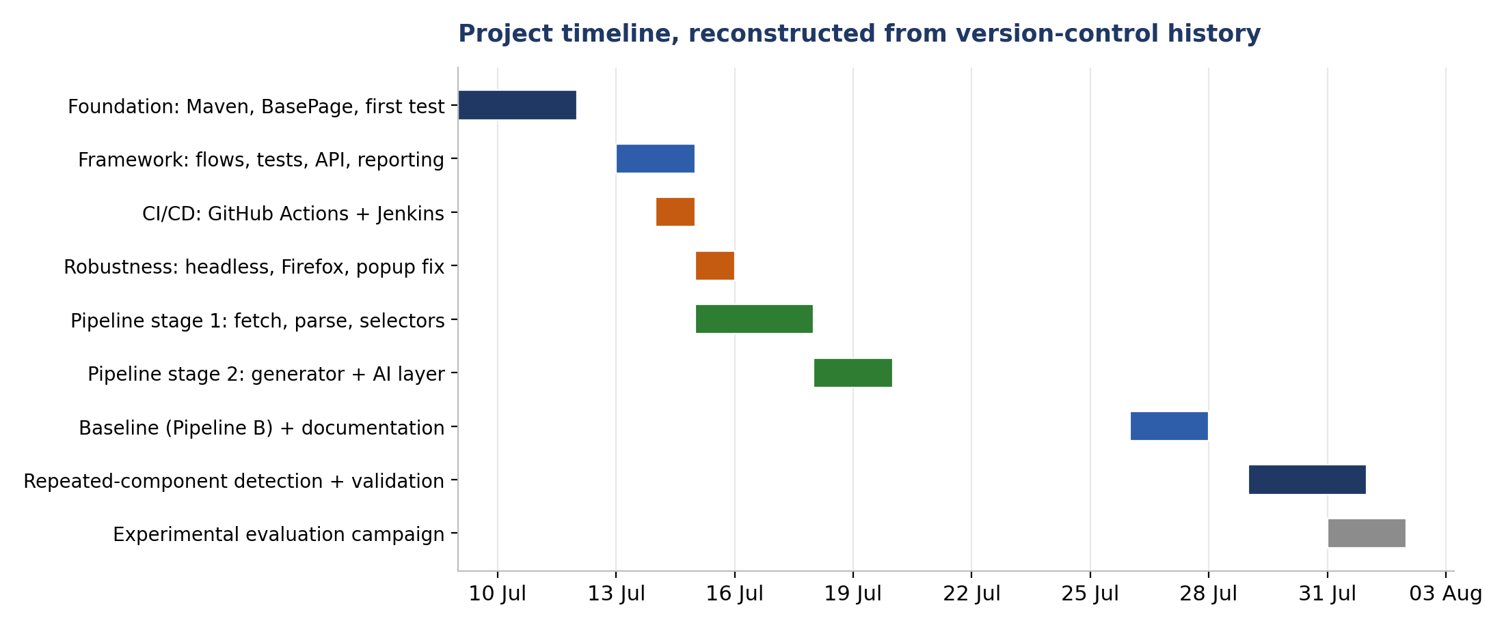
Figure 2 — Project timeline, reconstructed from version-control history

III.6 Evaluation methodology
The empirical claims of this report rest on a comparison between two pipelines. This section defines that comparison precisely, since a comparison whose protocol is not stated is not a result.

III.6.1 Subjects of comparison
- Pipeline A — structured extraction and deterministic generation, with confidence-gated escalation to a language model for low-confidence elements only.
- Pipeline B — the naive baseline: the page’s full rendered HTML submitted to a language model in a single prompt, requesting a complete page object.

III.6.2 Fairness of the baseline
A comparison is only informative if the baseline is given a fair opportunity. Three measures were taken.
First, the baseline prompt provides genuinely helpful guidance — it instructs the model to prefer stable attributes over visible text, to skip hidden inputs, and to extend the same base class — rather than being deliberately impoverished.
Second, markdown code fences occasionally emitted by the model despite instructions to the contrary are stripped before evaluation. This is a response-formatting artefact rather than a code-quality defect, and penalising the baseline for it would misattribute the failure.
Third, both pipelines operate on the identical HTML, captured in the same session, on the same day, against the same live site.

III.6.3 Metrics
Nine metrics are recorded per page and per pipeline.
Table 6 — The nine metrics recorded per page and per pipeline
# | Metric | Definition
M1 | Recall | Captured elements as a proportion of the interactive elements present, counted manually.
M2 | Precision | Generated fields that correctly address a real interactive element, as a proportion of all generated fields.
M3 | Locator quality | Distribution of selected locators across dedicated test attributes, id, name and visible text.
M4 | Compilability | Whether the generated class compiles without modification.
M5 | Executability | Whether a smoke test invoking a generated method passes against the live page.
M6 | Duplication | Number of redundant fields or methods addressing the same element.
M7 | Cost | Prompt and output tokens consumed to generate the page object.
M8 | Latency | Wall-clock duration of the generation operation.
M9 | Determinism | Whether three runs on identical input produce byte-identical output, compared by hash.
M1 and M2 require a ground truth. It is established by manually enumerating the interactive elements of each page in the browser before either pipeline is run, so that the count cannot be influenced by what either tool produced.

III.6.4 Procedure
For each page in the evaluation set: establish ground truth manually; run Pipeline A and record its console output and generated artefacts; run Pipeline B and record the same together with the reported token usage and latency; attempt compilation of each artefact; execute a smoke test against each; record all nine metrics. For the determinism sub-experiment, each pipeline is run three times consecutively on the same page with no intervening change, and the outputs are hashed after normalising the user-supplied class name, which is the only intended difference between runs.
All failed runs — service unavailability, timeouts, rate limiting — are recorded rather than discarded, since reliability is itself a dimension on which the two pipelines differ.

III.6.5 Threats to validity
(This subsection is what distinguishes a measured evaluation from a demonstration. It should not be omitted, and a jury is likely to reward it.)
Construct validity. The metrics are proxies. Compilability and executability are strong evidence of usability but do not establish maintainability, which is the property that ultimately matters and which cannot be measured within the timeframe of this project. Locator-strategy distribution is a proxy for robustness under future change, not a measurement of it.
Internal validity. The ground-truth counts are established by a single observer — the author — and are therefore subject to unconscious bias despite being taken before the tools are run. A second independent counter would strengthen this. The model’s behaviour may also vary over time independently of the experiment, since a hosted model may be updated without notice.
External validity. Two sites, and a limited number of pages, do not support generalisation to all web applications. Both are English-language e-commerce sites of moderate complexity. Applications built as single-page applications with heavy dynamic re-rendering, or those using web components and shadow DOM, may behave differently and are not covered.
Reliability. Pipeline A’s output is byte-reproducible, so its measurements can be reproduced exactly. Pipeline B’s cannot, by the very property under study; its measurements are therefore reported per-run rather than as single values, and the variance is itself treated as a result.
A conflict of interest is acknowledged. Pipeline A is the author’s own system, and the author both designed the metrics and performed the measurements. This is mitigated by three commitments: the metric set was fixed before the measurement campaign began; defects found in Pipeline A are reported in the same defect log, with the same severity scale, as defects found in Pipeline B; and all raw artefacts — generated files, console transcripts, hashes — are retained so that any measurement can be independently verified.

III.7 Tools and environment
Table 7 — Tools and environment
Category | Choice
Language / build | Java 17, Maven
Browser automation | Selenium WebDriver 4.21
Test framework | TestNG 7.10
API testing | RestAssured 5.4
HTML parsing | jsoup 1.17
Test data | Datafaker 2.4
Reporting | ExtentReports 5.1
HTTP client | OkHttp 4.12
Cloud model | gemini-3.1-flash-lite (Gemini API, paid tier). Declared in ai.GeminiClient.MODEL; every run reported in Chapter VI used this identifier.
Local model | Llama 3.1 8B via Ollama
Continuous integration | GitHub Actions; Jenkins (self-hosted, Docker)
Version control | Git / GitHub

III.8 Conclusion
This chapter has specified the system’s functional and non-functional requirements, described the incremental and evidence-driven method by which it was built, presented the actual project timeline as recorded in version control, and — at length — defined the evaluation protocol together with an explicit account of what threatens its validity. The following chapter presents the functional design of the system.

Chapter IV. Functional Design

IV.1 Introduction
This chapter presents the design of the system through the Unified Modeling Language. It identifies the actors, describes the use cases they exercise, and models the internal structure and dynamics of the generation pipeline. The intent is to give an account of the design that is independent of the source code, so that the reasoning can be assessed on its own terms.

IV.2 Actors
Table 8 — Actors of the system
Actor | Description
QA Engineer | The primary human actor. Executes the test suite, initiates page object generation, and reviews the artefacts produced. Crucially, this actor is the reviewer of low-confidence output, not merely its consumer — the system is designed to be human-in-the-loop.
CI Server | A secondary, non-human actor. Executes the test suite automatically on every change, without human initiation. Realised by two independent implementations: GitHub Actions and Jenkins.
LLM Service | A secondary, external actor providing judgement on request. Realised either by Gemini (cloud) or by a locally-hosted Llama model via Ollama. Its availability is not guaranteed and the system is designed accordingly.

IV.3 Use case model
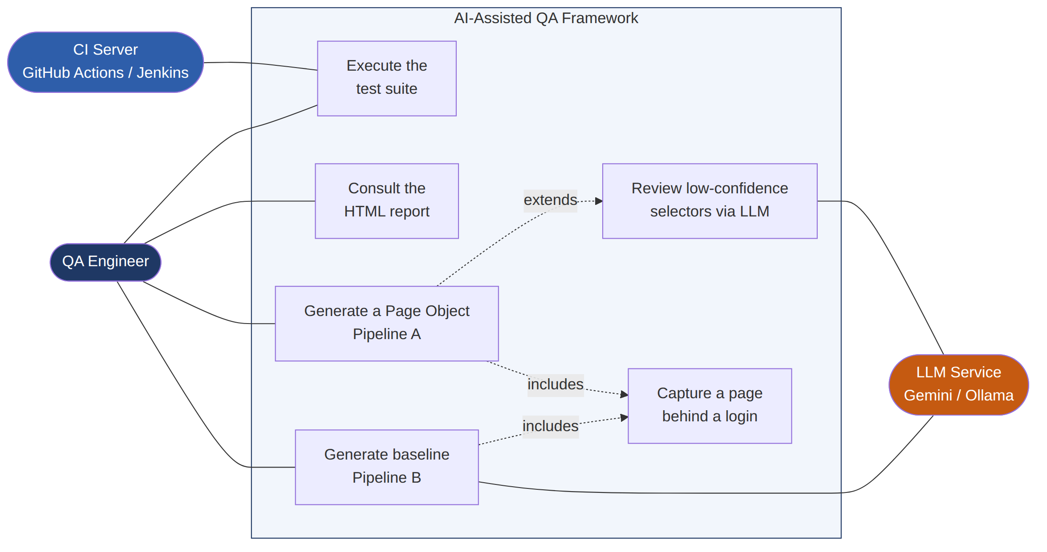
Figure 3 — Global use case diagram
The system exposes six use cases. Two — executing the suite and consulting the report — belong to the test framework. Four belong to the generation pipeline.

IV.3.1 Use case: Generate a Page Object (Pipeline A)
Table 9 — Use case — generate a page object (Pipeline A)
Field | Content
Actor | QA Engineer
Precondition | The target page is reachable; a browser driver is available.
Main flow | 1. The engineer supplies a URL, a class name, and states whether authentication is required. 2. The system retrieves the fully rendered HTML. 3. The system decomposes the page into semantic regions. 4. The system detects repeating component patterns and removes them from the flat extraction scope. 5. The system selects, for each remaining element, the most durable available locator. 6. The system emits compilable Java source per region. 7. The system reports the number of selectors produced and how many are low-confidence.
Alternative flow | At step 2, if authentication is required, the system opens a visible browser, pauses, and captures whatever page the engineer has reached once they confirm.
Postcondition | One .java file per selected region exists under pages/generated/.

IV.3.2 Use case: Review low-confidence selectors
Table 10 — Use case — review low-confidence selectors
Field | Content
Actor | QA Engineer; LLM Service
Precondition | Extraction has produced at least one selector whose matchedVia is text.
Main flow | 1. The system filters the selector list to those reporting low confidence. 2. For each, it constructs a single-element prompt. 3. It submits the prompt and parses a structured JSON verdict: keep/discard, suggested methods, a stated concern, and a confidence level. 4. It presents each verdict to the engineer.
Alternative flow | If the service is unreachable or returns unparseable output, the element is reported as unreviewed and processing continues. The deterministic result is retained.
Postcondition | The engineer holds a per-element verdict for every ambiguous case. No element is silently modified.
Design note worth stating in the defense. Elements matched by a dedicated test attribute, an id or a name never enter this use case. On a well-instrumented page the number of invocations is zero, and consequently the cost is zero. This is the mechanism by which cost scales with ambiguity rather than with page size.

IV.3.3 Use case: Generate baseline (Pipeline B)
Table 11 — Use case — generate the baseline (Pipeline B)
Field | Content
Actor | QA Engineer; LLM Service
Main flow | 1. The system retrieves the rendered HTML. 2. It submits the entire document in a single prompt requesting a complete page object. 3. It strips response-formatting artefacts. 4. It writes the result outside the compiled source tree.
Postcondition | An unvalidated artefact exists for comparison. It is deliberately not placed where it could affect the build.

IV.4 Static structure
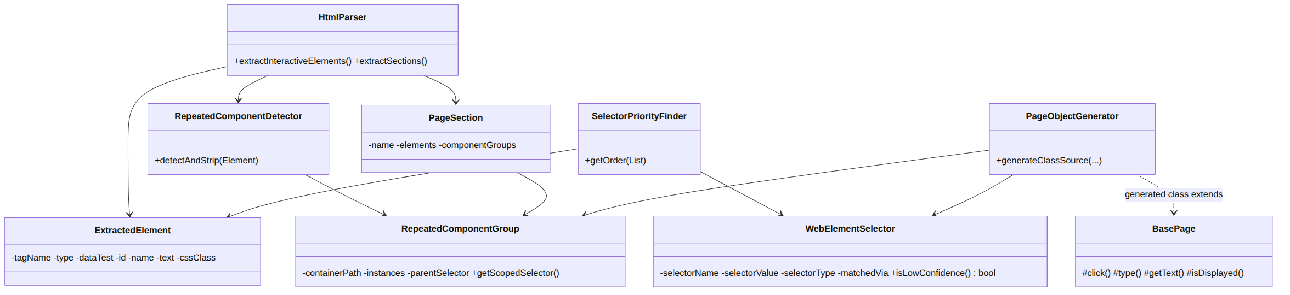
Figure 4 — Class diagram of the parser and generator packages
The design separates four concerns, each in its own package.
Data carriers. ExtractedElement holds what was observed in the markup: tag, type, automation attribute, id, name, text, and — for elements inside repeated components — its own class attribute. WebElementSelector holds what was decided: the variable name, the locator value, the locator type, and, significantly, matchedVia, which records which rule produced this selector. That single field is what makes the pipeline’s output traceable and what makes confidence gating possible.
Structural carriers. PageSection represents one semantic region together with its elements and any component groups found within it. RepeatedComponentGroup represents one repeating pattern: the card’s own selector, the elements found in each repetition, and the shared parent used to scope the runtime selector.
Processors. HtmlParser performs extraction and sectioning. RepeatedComponentDetector performs structural pattern detection. SelectorPriorityFinder performs locator selection. PageObjectGenerator performs code emission. Each has a single responsibility and none knows about the others’ internals.
The AI abstraction. AIProvider is a single-method interface. GeminiClient and OllamaClient implement it. SelectorReviewClient depends on the interface alone. This is dependency inversion applied for a concrete reason: substituting a cloud model for a local one is a one-line change at the point of construction, and no other class is affected.

IV.5 Dynamic behaviour
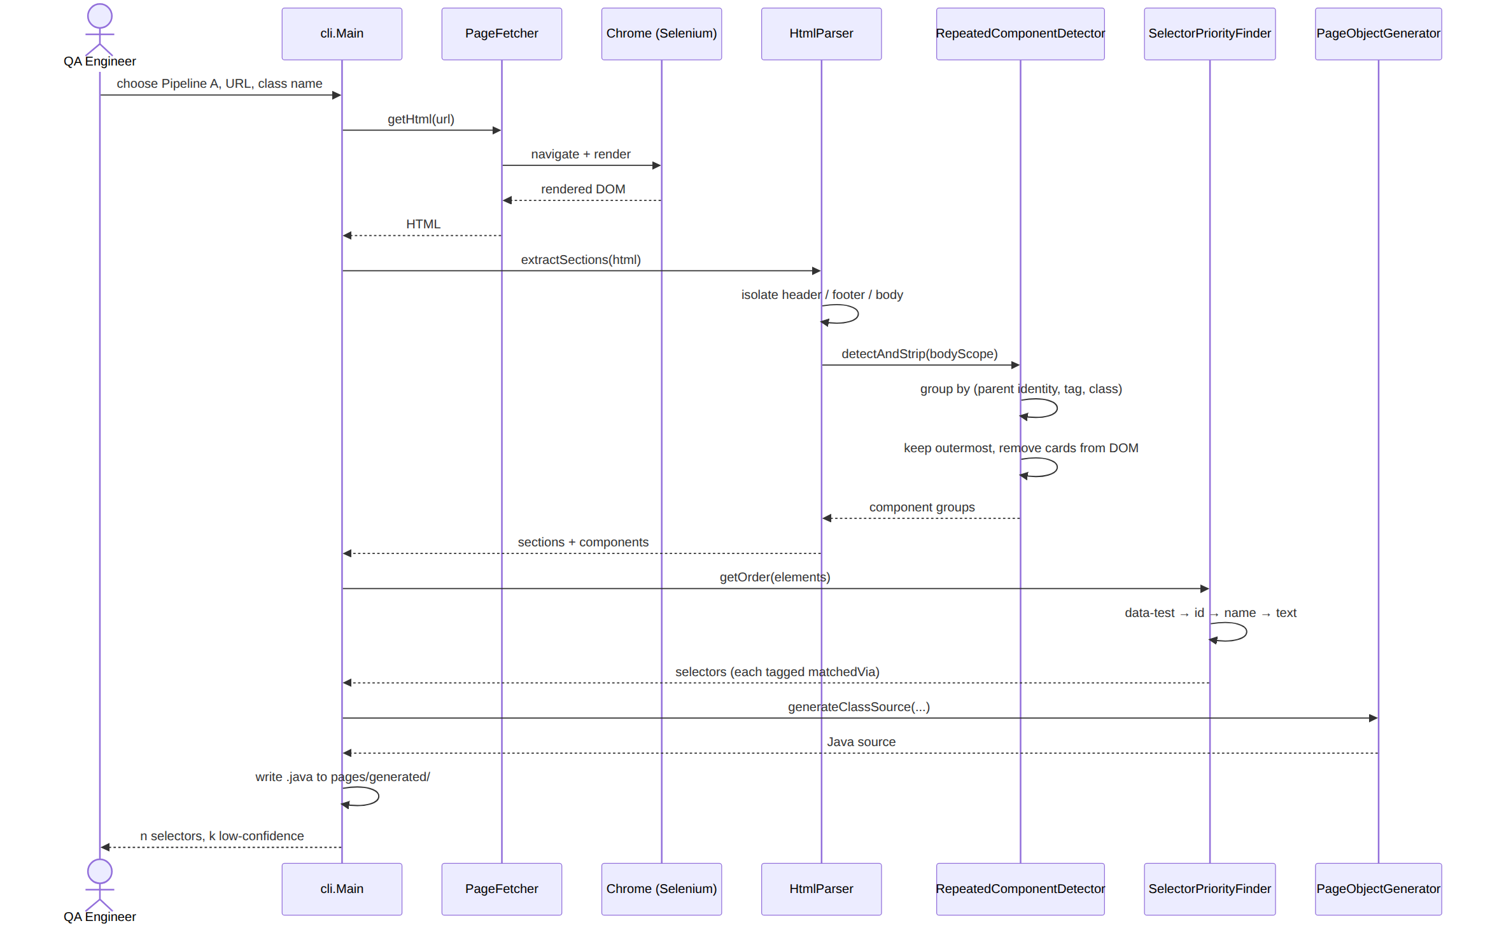
Figure 5 — Sequence diagram — Pipeline A page object generation
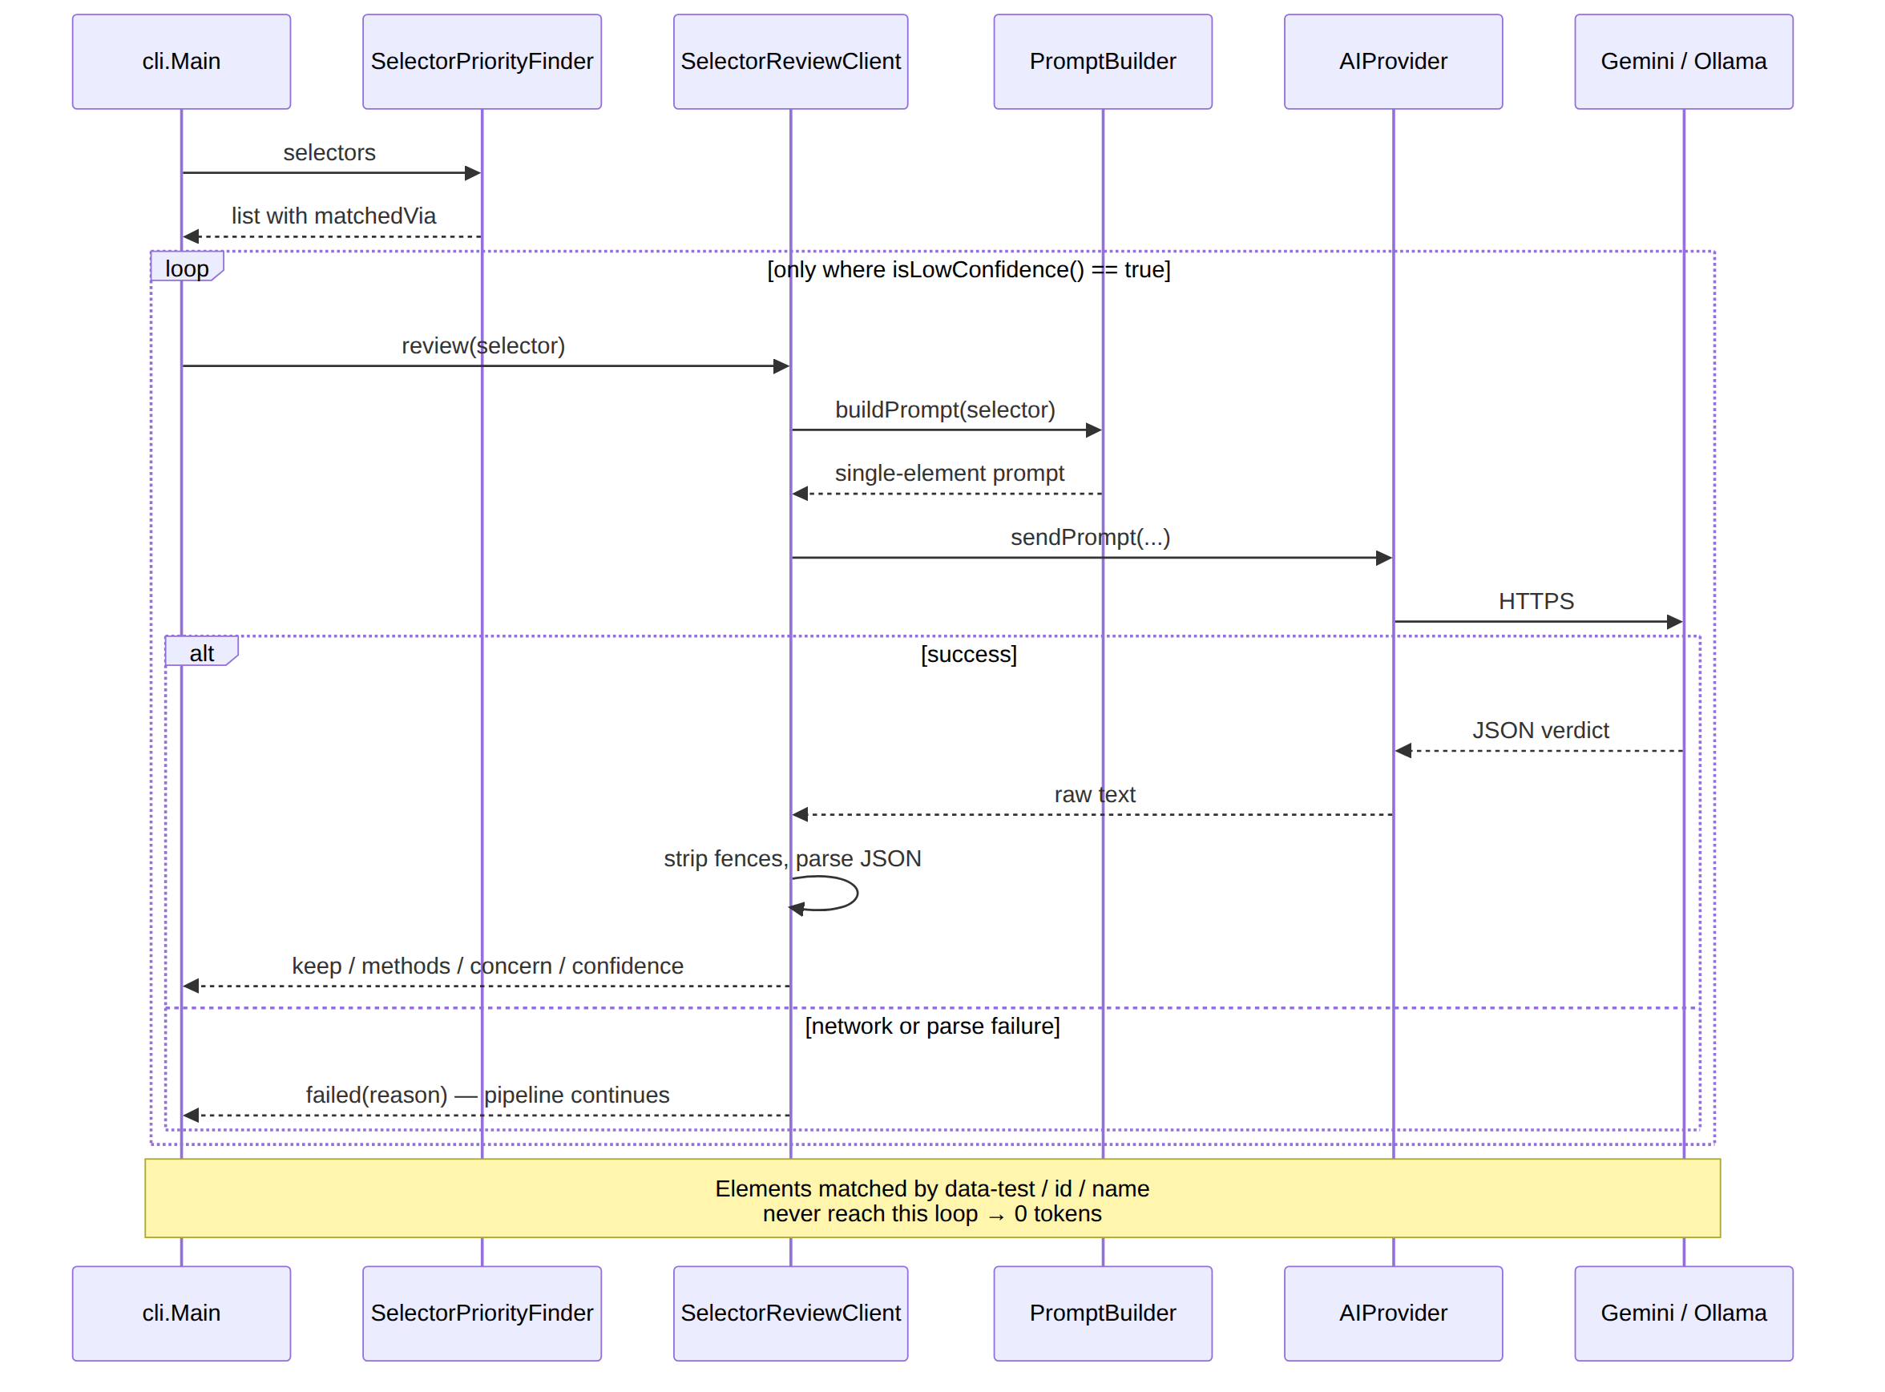
Figure 6 — Sequence diagram — confidence-gated selector review
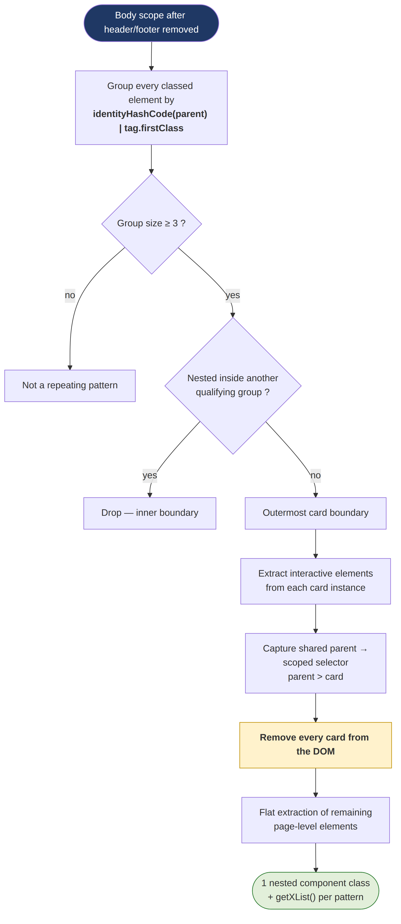
Figure 7 — Activity diagram — repeated-component detection
The detection algorithm deserves comment, since it is the least obvious part of the design.
The naive approach — grouping elements by CSS class — fails on real pages, because framework utility classes such as row, container or col-sm-4 recur across entirely unrelated regions. What actually characterises a repeated list is not that its members share a class but that they share a parent. The grouping key is therefore the composite (parent object identity, tag name, first class), and only groups of three or more members are considered patterns: two similar siblings are a coincidence, three are a structure.
A second difficulty is nesting. On a real product grid, an inner element may repeat inside an outer element that also repeats, so both qualify. The algorithm retains only the outermost boundary, on the reasoning that the outer element is the true card and already contains everything the inner one holds.
The third element of the design is the one that removes an entire class of bug: each detected card is physically removed from the document as it is captured. Whatever the caller extracts afterwards therefore cannot contain a card’s elements. No filtering pass is required, and the two extractions cannot disagree with one another — a category of defect that a filter-based design would have to defend against continuously.

IV.6 Conclusion
The design separates observation from decision, decision from emission, and deterministic rules from delegated judgement. The matchedVia field is the hinge: by recording how each locator was obtained, it makes the output explicable and allows the system to identify, without external help, which of its own decisions are weak. The next chapter describes how the design was realised.

Chapter V. Implementation

V.1 Introduction
This chapter describes the realisation of the system: the test framework that serves as validation harness, the generation pipeline, the AI layer, the continuous integration configuration, and the engineering problems encountered and resolved. Code is quoted where a design point depends on its detail.
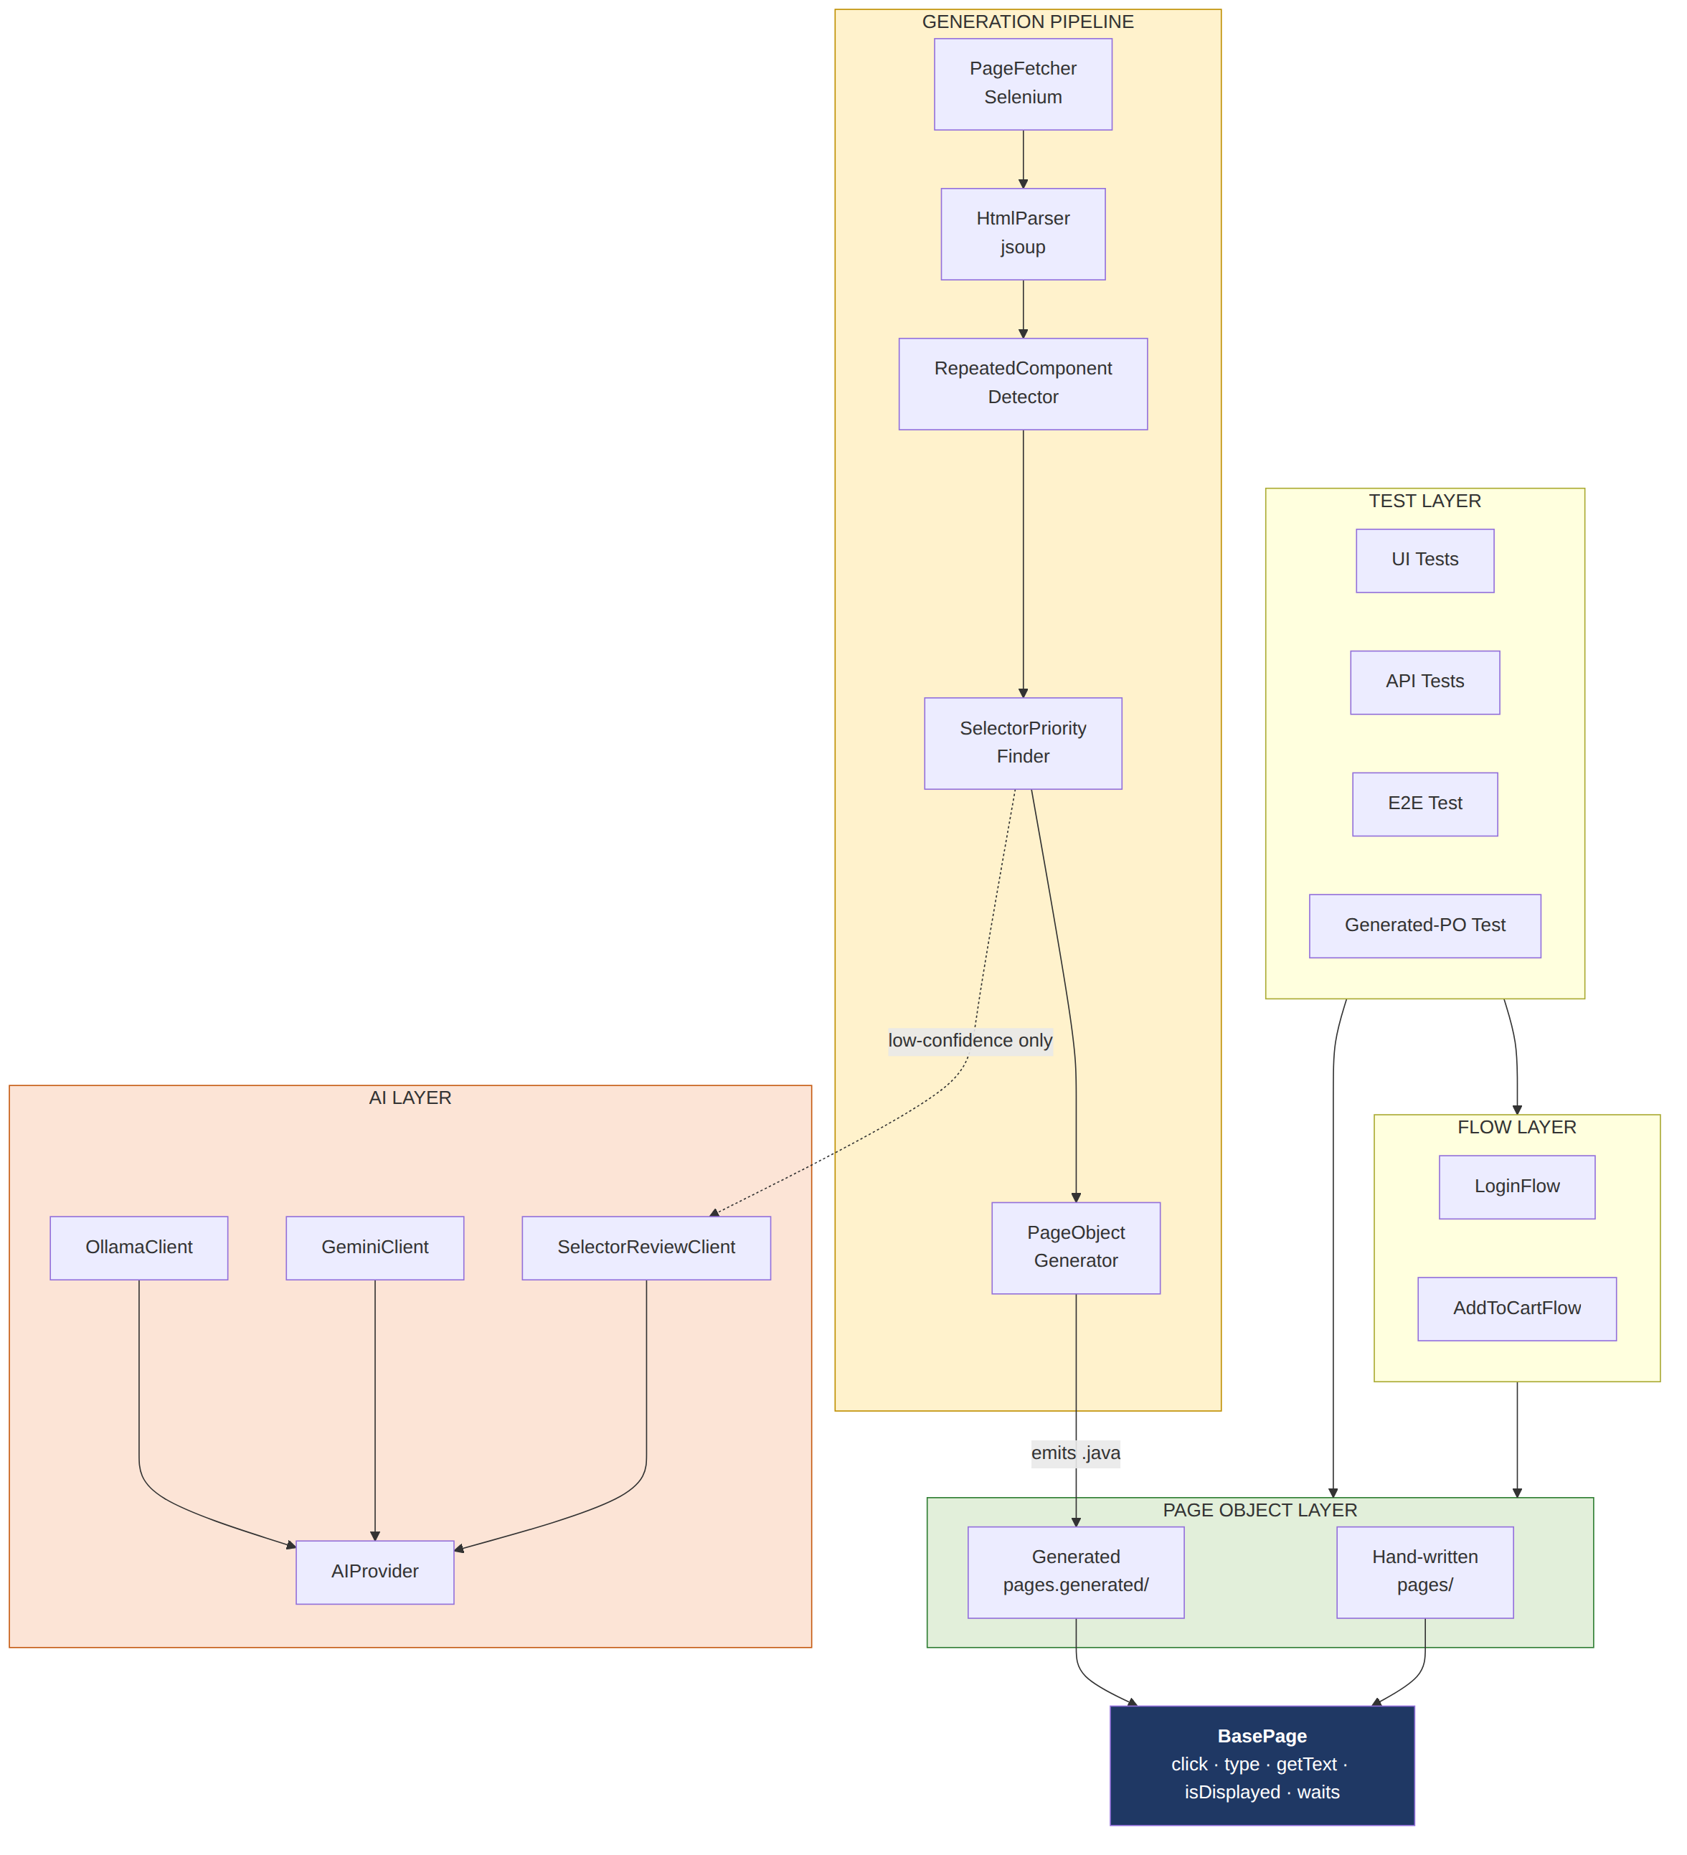
Figure 8 — Layered architecture of the system

V.2 The test automation framework

V.2.1 The base page
Every page class extends BasePage, which owns the driver, a ten-second explicit wait, and the interaction primitives. Centralising them means the waiting strategy exists in one place rather than being restated in every page.
One primitive deserves quotation, because it encodes a hard-won lesson:
protected void click(By locator) {
try {
waitForClickable(locator).click();
} catch (Exception e) {
// Fallback: some elements (overlays, popups) block normal clicks.
// JS click bypasses the visual overlay check.
WebElement el = driver.findElement(locator);
((JavascriptExecutor) driver).executeScript("arguments[0].click();", el);
}
}
A standard Selenium click performs a hit test: it verifies that the point being clicked is actually occupied by the target element. Overlays, animated modals and hover panels defeat this. The JavaScript fallback dispatches the click event directly to the element, bypassing the visual check. Reserving it as a fallback rather than using it by default is deliberate — the standard click is a more faithful simulation of a user, so it is preferred whenever it works.
isDisplayed returns false on exception rather than propagating, so that assertions read naturally rather than requiring every caller to handle absence as an error condition.

V.2.2 Pages, flows and tests
Page classes model a single screen and expose methods in the user’s vocabulary. Flows model journeys that traverse several pages and return the page object representing the state reached, so that a test reads as a sequence of transitions:
InventoryPage inventoryPage = loginFlow.loginAsValidUser(user, password);
CartPage cartPage = addToCartFlow.addToCart();
The distinction matters: a page object should know about one page, and the knowledge that logging in leads to the inventory belongs to neither the login page nor the inventory page. It is journey knowledge, and the flow layer owns it.
Both flow-based and direct tests were retained deliberately. ui/logintests/noflow/LoginTest drives page objects directly; ui/logintests/LoginUsingValidCredentialsTest performs the same scenario through LoginFlow. Keeping both makes the value of the abstraction visible by comparison rather than merely asserted.
InventoryPage.addRandomProductToCart() illustrates a small but useful pattern: it enumerates every add-to-cart control, selects one at random, clicks it, and returns the identifier of the product chosen, so that randomised input does not cost the test its ability to assert.

V.2.3 Test isolation and environment portability
BaseTest creates a driver before each test method and quits it afterwards. A fresh browser per method guarantees that no test can inherit state from another — the most common source of order-dependent failures.
Environment portability is achieved without any branching in test code. The class reads BROWSER, HEADLESS, CHROME_BIN and CHROMEDRIVER_BIN from the environment, falling back to automatic driver resolution when the explicit paths are absent. One class therefore serves local development, a cloud CI runner and a self-hosted agent with a different browser build.
Headless is the default everywhere. This is not only a CI necessity — cloud runners have no display — but a deliberate decision that local and CI executions should be the same execution, so that a failure observed in one is reproducible in the other.

V.2.4 Configuration and test data
ConfigReader loads config.properties once in a static initialiser. Every URL, credential and expected message is defined there; no test contains a literal. Test data is generated with Datafaker, so customer details differ on every run and the suite is not inadvertently validating one fortunate input.

V.2.5 Reporting
ExtentReports is integrated through a TestNG listener declared in testng.xml. Because it is a listener, no test class contains any reporting code, and adding a test costs nothing in reporting effort — an application of the observer pattern.
On failure the listener captures a screenshot. It obtains the driver by reflection:
java.lang.reflect.Field driverField =
instance.getClass().getSuperclass().getDeclaredField("driver");
driverField.setAccessible(true);
This is quoted because it is the framework’s weakest point and should be acknowledged rather than concealed. It assumes the failing class extends BaseTest directly; a deeper hierarchy would fail to resolve the field. The failure is caught and logged as a warning rather than masking the real test failure, which is the correct behaviour, but the robust design would have the test expose its driver through an interface instead of being reached into. This is recorded as future work.
⟦INSERT SCREENSHOT 1 HERE⟧ The ExtentReports HTML report. The retained report (reports/ExtentReport.html, run of 15 July 2026) shows eleven tests, all passing; it predates the generated-page-object end-to-end test. If a screenshot showing failure handling is wanted, re-run the suite with one assertion deliberately inverted, so that the captured screenshot and the attached image are both visible in the report.

V.2.6 API testing
Two RestAssured tests exercise the Restful-Booker practice API: a health check, and a full create-then-retrieve cycle that posts a booking, extracts the returned identifier and asserts that the fields round-trip correctly. SauceDemo exposes no public API, so this was added as separate, deliberate coverage demonstrating that the framework addresses more than one test level.

V.3 The generation pipeline

V.3.1 Retrieval
PageFetcher exposes two operations. getHtml(url) navigates and returns the page source. getCurrentHtml() returns the source of whatever is currently loaded, without navigating.
The second exists for pages behind authentication. Rather than encoding assumptions about any particular login form — which would work for exactly one site — the tool opens a visible browser, instructs the engineer to authenticate and navigate manually, and captures the resulting page on confirmation. Navigating again at that point would discard the session just established.
Retrieval is performed through Selenium rather than a plain HTTP request because the input required is the DOM after JavaScript execution. For any client-rendered application the two differ substantially, and only the former corresponds to what a user sees.

V.3.2 Extraction and sectioning
HtmlParser parses with jsoup and collects <input>, <button> and <a> elements. Hidden inputs are excluded.
Sectioning locates <header>, <footer> and <main>, falling back to the corresponding ARIA landmark roles when the semantic tags are absent — semantic markup first, accessibility metadata second. Each region is extracted and then removed, so that what remains is the page’s own content.
The rationale is practical. A site’s navigation appears on every page. Without sectioning, every generated page object would redeclare the entire navigation bar. With it, the header is generated once and reused — which is precisely what the end-to-end validation test does, combining a ProductsPageHeader with a ProductsPageBody.
The set of recognised automation attributes is configuration, not code:
automation.attributes=data-test,data-qa
This was a correction rather than foresight. The pipeline initially recognised only data-test, which is SauceDemo’s convention; the second target site uses data-qa, and the hard-coded assumption failed on it. The correction was at first incomplete, in a way worth recording because it is the same failure class as the XPath defect described in section V.5: the set of recognised attribute names became configuration, but the emitted selector still named data-test unconditionally, so an element carrying only data-qa produced the locator [data-test=’…’] — valid syntax that can never match. The attribute name is now carried on the extracted element alongside its value and emitted from there. This was found during the post-campaign audit described in section VI.8 and is recorded in the defect log as D9.

V.3.3 Locator selection
SelectorPriorityFinder holds its strategies as a list of functions applied in order rather than as a nested conditional:
private final List<Function<ExtractedElement, WebElementSelector>> strategies = List.of(
this::tryDataTest, this::tryId, this::tryName, this::tryLinkText);
Adding a priority tier is therefore an addition, not a restructuring.
The ordering — dedicated test attribute, identifier, name, visible text — reflects durability, as argued in Chapter I. The final tier is a fallback and is marked as such:
public boolean isLowConfidence() { return "text".equals(matchedVia); }
This single method is the mechanism on which the entire architecture rests. Because every selector records the rule that produced it, the pipeline can identify its own weak decisions without external assistance, and escalate only those.
Text-based matching is normalised before use: non-printable characters are stripped and the generated XPath uses normalize-space() with contains(), because raw page text routinely carries surrounding whitespace and icon-font glyphs that defeat an exact match.

V.3.4 Code generation
PageObjectGenerator emits a complete compilation unit: package declaration, imports, By fields, constructor, and methods chosen by element category — type methods for inputs, click for buttons and links, and getText only where the element carries visible text.
That last condition is a deliberate boundary. Whether an image-only link warrants a text accessor is a clean binary rule — empty text and an anchor tag means no accessor — and it was solved with a rule rather than a model call. Identifying which sub-problems genuinely require judgement, and which merely appear to, was the central design activity of this project.
Generated classes extend the same BasePage as hand-written ones and are written to a dedicated pages.generated package, so that machine-produced code is never mistaken for reviewed code.
Repeated patterns become nested classes scoped to a single card’s root element, together with a list accessor on the enclosing page:
public List<ColSm4Item> getColSm4ItemList() {
return driver.findElements(By.cssSelector("div.features_items > div.col-sm-4"))
.stream().map(ColSm4Item::new).collect(Collectors.toList());
}
Three details of the nested class are worth noting. It is non-static, so that its methods can reach the enclosing page’s driver for the same JavaScript-click fallback used elsewhere. Roles are de-duplicated, so that a visible control and its hover-overlay clone collapse to one method. And it exposes getRoot() as an escape hatch for anything the generator could not anticipate — the validation test uses exactly this to hover over a card before clicking a control that only appears on hover.

V.3.5 The AI layer
SelectorReviewPromptBuilder constructs a prompt describing one element and demanding a strict JSON response: whether to keep the element, which methods it should expose, a one-sentence concern, and a confidence level.
Per-element prompting rather than whole-page prompting has three justifications: a focused prompt yields a focused answer; one malformed element cannot corrupt the response for all others; and cost scales with the number of ambiguous elements rather than with document size.
SelectorReviewClient parses defensively. It strips markdown fences that the model adds despite instructions, and it treats every failure — network error, malformed JSON, missing field — as a result rather than an exception:
} catch (IOException e) {
return SelectorReviewResult.failed("API call failed: " + e.getMessage());
} catch (JsonSyntaxException | NullPointerException | IllegalStateException e) {
return SelectorReviewResult.failed("Could not parse AI response: " + e.getMessage());
}
The deterministic output survives; only the review is lost. This is the concrete realisation of FR-20.

V.3.6 Instrumentation added for the evaluation
Two additions were made specifically to support measurement. The Gemini client records prompt tokens, output tokens and elapsed time for every call, so that cost is measured rather than estimated. It also retries transient failures — HTTP 429, 500, 502, 503 and 504 — with exponential backoff, while failing immediately on permanent errors such as an invalid credential, for which retrying is pointless. The second addition followed directly from an observed service outage that destroyed a complete experimental run.

V.3.7 Testing the generation pipeline itself
A project about testing whose own generator is untested is in an awkward position, and for most of the project this one was. Thirty-seven unit tests now cover the three stages that contain the logic: extraction and sectioning, locator selection, and code emission. They run against small hand-written HTML fixtures and constructed element objects, with no browser, no network and no live site, so a failure is always a defect in this project rather than an outage somewhere else. They are declared as a separate TestNG suite for exactly that reason, and the continuous integration workflow runs that suite as its first gate before the browser-driven tests.
The tests are written against behaviour that has actually been wrong at some point, rather than against the implementation. Each defect in section VI.8 has a test named after the property it violated: that a data-qa element yields a data-qa selector, that a card which is itself the interactive element is addressed directly, that an apostrophe in page text does not produce a broken XPath literal, and that text differing between instances of a component names neither the method nor the locator. This is the golden-file discipline identified as future work, applied at the level of individual rules rather than whole files, which has the advantage that a failure names the rule that broke.

V.4 Continuous integration and delivery
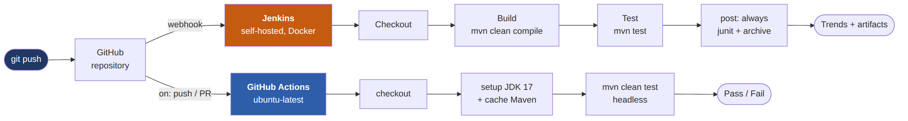
Figure 9 — Continuous integration and delivery topology
Two independent pipelines execute the suite.
GitHub Actions runs on every push and pull request to main. A clean Ubuntu virtual machine is provisioned, JDK 17 installed with the Maven cache restored, and mvn clean test executed headless. The value of the clean machine is easily understated: it proves the project builds from the repository alone, without any dependency on state that happens to exist on the developer’s laptop.
Jenkins runs self-hosted in Docker, triggered by a GitHub webhook. Its declarative pipeline has three stages — Checkout, Build, Test — separated so that the dashboard distinguishes a compilation failure from a test failure. The post { always { ... } } block publishes JUnit results and archives artefacts even when the build fails, which is precisely when they are needed.
The Jenkins agent presented a concrete problem: it runs a different processor architecture and ships Chromium rather than Chrome, so automatic driver resolution downloaded a mismatched binary and the build failed. The resolution was to supply CHROME_BIN and CHROMEDRIVER_BIN as pipeline environment variables and have BaseTest honour them when present. One test base class consequently serves three environments with no conditional logic in any test.
⟦INSERT SCREENSHOT 2 HERE⟧ A successful GitHub Actions run, showing the job steps and green status. ⟦INSERT SCREENSHOT 3 HERE⟧ The Jenkins pipeline view showing the three stages and the published test results.

V.5 Engineering problems encountered
The following defects were found by exercising the system against live sites. Each is presented with its symptom, diagnosis and resolution, because the diagnostic reasoning is a substantive part of the work.
Invalid Java identifiers from real product data. SauceDemo lists a product named test.allTheThings() T-Shirt (Red). Its attribute values contain periods and parentheses, which are not legal in Java identifiers, and the generated source did not compile. Splitting on any run of non-alphanumeric characters — [^a-zA-Z0-9]+ — rather than on a fixed set of separators resolved it.
Naming collisions from using element type. Several type="text" inputs on the same form generated identical variable names. The fix was to apply the same priority ordering to naming as to matching, preferring the automation attribute, then the identifier, then the name, then the text, and only then the type.
Hidden CSRF fields extracted as interactive elements. The second target site emits a hidden token field per form, producing genuine duplicates. The root cause was conceptual rather than mechanical: these are server-issued security values that no user ever interacts with. Excluding type="hidden" during extraction resolved it correctly at the source.
An XPath fallback hard-coded to anchors. The text-based fallback generated //a[...] regardless of the element’s actual tag, so a text-matched <button> produced a locator that was syntactically valid and could never match anything. This is the most dangerous class of generated defect, because nothing fails at generation time; the test simply fails later, far from the cause. The generator now emits the element’s own tag.
Duplicate method generation. Two near-identical blocks existed in the generator, one of them dead code left by an earlier edit. It was located by logging element counts at each pipeline stage rather than inferring from the symptom.
Interference from the browser’s password-leak dialog. This warrants a fuller account, as it is the most instructive of the set.
Symptom: tests failed intermittently, and — the decisive clue — a different field was corrupted on each occurrence. A defective locator fails identically every time; variation across fields indicated a timing or focus race rather than a locator defect.
Diagnosis: Chrome’s password-leak-detection dialog was appearing mid-test and stealing focus from whichever field was being typed into at that moment.
Attempts: browser preferences disabling the password manager; the --disable-features=PasswordLeakDetection flag; incognito mode; and a defensive helper that dismissed the dialog if present. The helper could not work, and understanding why is the insight: the dialog is native browser chrome, not part of the page’s DOM. Selenium drives the DOM and cannot see it.
Why partial measures failed: the check is partly server-side — the browser submits a hash of typed credentials to a remote safe-browsing service — so no local flag can guarantee suppression. This explains the inconsistency.
Resolution: Chrome’s --guest mode, which uses a fully sandboxed profile with no password-manager state. Confirmed by repeated visible-browser runs. Two further improvements followed: headless became the default everywhere, and Firefox was added as an alternative backend, having never exhibited the behaviour.

V.6 Conclusion
The implementation realises a layered framework and a four-stage generation pipeline sharing a single base class, wrapped in two independent continuous integration pipelines. The defects described above were found by testing against real rather than idealised pages, and each was resolved at its root cause. The next chapter evaluates the result.

Chapter VI. Experimental Evaluation

VI.1 Introduction
This chapter reports the measurements comparing Pipeline A against Pipeline B under the protocol defined in Chapter III, and discusses what they imply for the research questions posed in Chapter I.
Reproducibility. Every measurement reported here can be recomputed from material committed with this report. The rendered DOM that both pipelines consumed was captured during the campaign and is retained; so are all generated artefacts and the console telemetry. The scripts under evaluation/ re-derive the element counts, the locator resolution, the strategy distribution, the compilability results and the digests from those files alone, with no network access and no model call. Token counts and latency are the exception: they are read from telemetry recorded at the time and cannot be regenerated offline.

VI.2 Experimental setup
Table 12 — Experimental setup
Parameter | Value
Date of runs | 31 July 2026
Model | gemini-3.1-flash-lite
Target page | SauceDemo inventory page (authenticated)
Section scope, Pipeline A | Body region
Runs per pipeline | 3, consecutive, no intervening change
Environment | JDK 17, Chrome 150.0.7871.188, macOS
Version measured | The generator as it stood on 31 July 2026. Defects found in the post-campaign audit were corrected afterwards; section VI.8 lists them, and the corrected output is retained separately so that the measurements below still correspond to the artefacts that produced them.
The protocol in Chapter III defines six pages. One was executed. The workbook PFE_Evaluation_Results.xlsx accompanies this report, holds the raw data for that page and carries empty rows, already formatted, for the other five; extending the campaign adds rows and changes nothing else. The scripts under evaluation/ recompute every figure below from the artefacts committed with the report — the captured DOM, the generated files and their digests — without network access, so a reader can verify the numbers rather than take them on trust.
Scope statement, stated plainly. The results below concern a single page examined in depth, with three runs per pipeline. This is sufficient to establish the qualitative findings reported — determinism, API hallucination, cost asymmetry — because those findings are categorical rather than statistical. It is not sufficient to support quantitative generalisation, and no such claim is made. Section VI.11 states the limitation explicitly. Every measurement below is reproducible offline from the artefacts committed with this report: the scripts in evaluation/ recompute them from the captured DOM and the retained generated files, with no network access and no model call.

VI.3 Determinism (M9)
Each pipeline was run three times on the same page. Outputs were hashed after normalising the class name, which is the only intended difference between runs.
Table 13 — Determinism — output digests across three consecutive runs on identical input
Pipeline | Run 1 | Run 2 | Run 3 | Identical?
A — structured | 420c015a… | 420c015a… | 420c015a… | Yes — byte-identical
B — naive LLM | 19ea0a03… | dedd5d21… | 65662d40… | No — all three differ
The variation in Pipeline B is not marginal:
Table 14 — Variation in Pipeline B output across three runs on identical input
Property | Run 1 | Run 2 | Run 3
Lines of code | 80 | 52 | 50
By fields declared | 11 | 17 | 17
Public members (constructor + methods) | 15 | 18 | 20
Output tokens | 617 | 772 | 847
Package declared | pages | pageobjects | pages
The prompt token count was identical across all three runs (13,115), confirming that the input did not vary. Run 2 additionally placed the class in a different package from the other two, which for a real project would mean the generated artefact landing in a different directory on each regeneration.
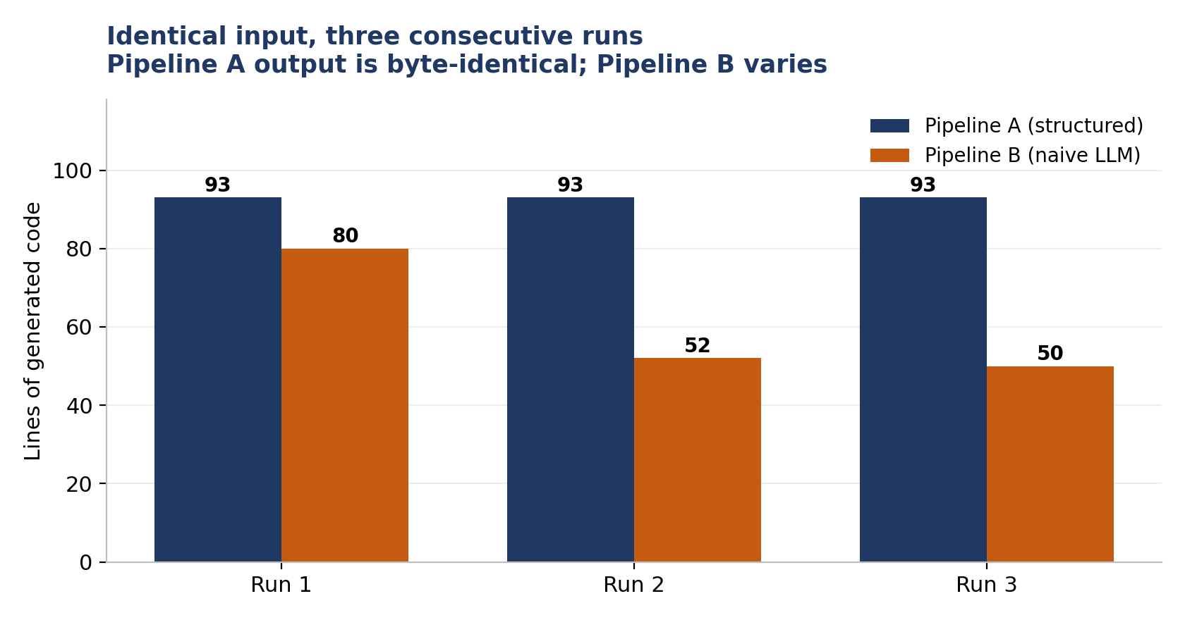
Figure 10 — Output size across three consecutive runs on identical input
Finding. Pipeline A satisfies NFR-1. Pipeline B does not, and cannot, since non-determinism is inherent to its mechanism. For an artefact intended to be version-controlled, reviewed and reproducibly rebuilt, this is a structural rather than incidental difference.

VI.4 Correctness and compilability (M2, M4)
The most consequential defect observed was the generation of a Selenium API that does not exist:
private final By inventorySidebarLink = By.dataTest("inventory-sidebar-link");
By.dataTest(...) is not a method of org.openqa.selenium.By. It appeared eleven times in run 1 and fifteen times in run 2. Both artefacts fail to compile. Run 3 expressed the same intent correctly as By.cssSelector("[data-test='...']").
Table 15 — Compilability of the generated artefacts
Pipeline | Compiles unmodified
A — structured | 3 / 3
B — naive LLM | 1 / 3
This is the clearest illustration available of the difference between emitting code and predicting it. Pipeline A cannot produce this defect: it writes By.cssSelector and By.xpath from a fixed template, over selectors observed in the document. There is no mechanism by which a non-existent method could enter its output.
Two further defects appeared in the baseline.
Incorrect interaction pattern, in all three runs. Every run generated:
public void selectProductSort(String value) { type(productSortDropdown, value); }
The target is a <select> element. Calling clear() followed by sendKeys() on a dropdown is not a valid interaction; Selenium provides the Select class for this purpose. That all three runs made the same error is more significant than the errors that varied: it indicates a systematic misunderstanding rather than sampling noise.
A fabricated locator, accompanied by the model’s own admission. Run 1 produced:
public String getProductPrice(String itemId) {
// Assuming price is accessed via container or specific element within item
return getText(By.xpath("//div[@data-test='inventory-item-" + itemId + "']//div[@data-test='inventory-item-price']"));
}
The attribute data-test='inventory-item-<id>' does not exist on the page. The locator cannot match. The model documented its own uncertainty in a comment and generated the method regardless — the failure mode described in Chapter II, observed directly.

VI.5 Cost and latency (M7, M8)
Table 16 — Token cost and latency of generating one page object
Pipeline | API calls | Prompt tokens | Output tokens | Total | Latency
A — structured | 0 | 0 | 0 | 0 | —
B — run 1 | 1 | 13,115 | 617 | 13,732 | 3,125 ms
B — run 2 | 1 | 13,115 | 772 | 13,887 | 3,342 ms
B — run 3 | 1 | 13,115 | 847 | 13,962 | 2,918 ms
B — total, 3 runs | 3 | 39,345 | 2,236 | 41,581 | —
Pipeline A consumed nothing because the page yielded zero low-confidence selectors: every element was addressable by a dedicated test attribute or an identifier, so no element met the escalation condition. This is the confidence-gating mechanism operating exactly as designed, and it demonstrates the cost property claimed in NFR-3 — expenditure scales with ambiguity, not with page size.
The asymmetry compounds. Pipeline B’s prompt cost is a function of document size and is incurred on every regeneration, whereas Pipeline A’s cost would rise only if the page became less well instrumented.
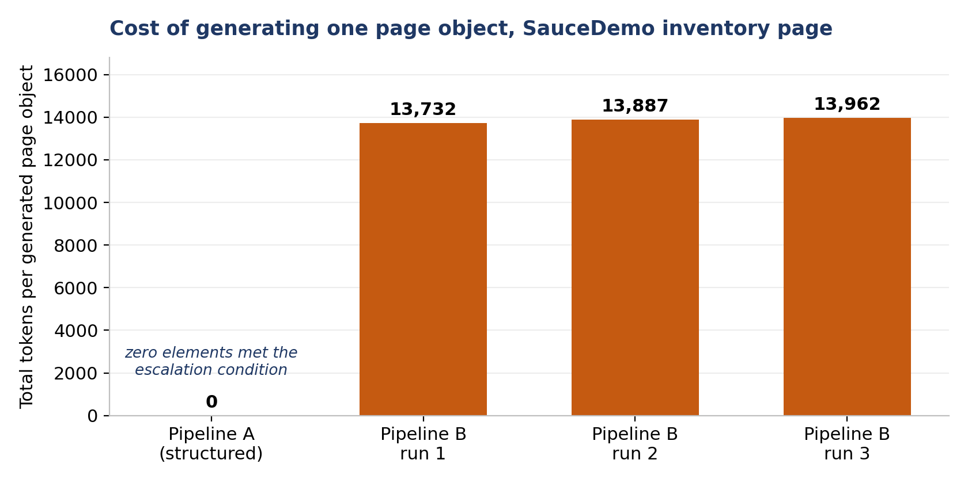
Figure 11 — Token cost of generating one page object
Expressed in currency. At the list price published by Google for gemini-3.1-flash-lite on the paid tier — $0.25 per million input tokens and $1.50 per million output tokens [22] — the three baseline runs cost $0.0042, $0.0044 and $0.0046 respectively, or $0.0132 for the three together. Pipeline A cost nothing, because it made no call. The absolute figures are trivially small for one page; the ratio is not, and it is the ratio that scales. A suite of two hundred page objects regenerated weekly would consume on the order of 140 million input tokens a year on the baseline, against zero for a page as well instrumented as this one.

VI.6 Coverage and structural quality (M1, M3, M6)
A direct count of declared fields would misrepresent both systems, and the difference is instructive.
Pipeline A produced three page-level selectors plus two component classes: BmItemItem covering four navigation items, and InventoryItemItem covering six products, each with a parent-scoped selector and methods operating on a single card’s root element.
Pipeline B produced six individually hard-coded methods — addBackpackToCart(), addBikeLightToCart(), and so on, one per product present at the moment of generation.
The functional coverage is comparable. The structural quality is not. Pipeline B’s output encodes the catalogue’s contents into the page object’s interface. Adding a seventh product to the store leaves the generated class silently incomplete; removing one leaves a method that can no longer work. Pipeline A’s component abstraction is indifferent to the number of products, because it addresses the repeating structure rather than its instances.
A scope limitation is acknowledged and can now be quantified. Pipeline A was run over the body region only, whereas Pipeline B always receives the entire document. Counted on the captured DOM, the page holds 29 interactive elements: 8 buttons, 20 links and 1 select. The body region holds 26 of them, of which 25 are of the three kinds the parser collects. Pipeline A addressed all 25 — three page-level selectors, four menu-component instances and eighteen product-component element slots — giving a recall of 25/25 within its element definition, 25/26 against every interactive element in its scope, and 25/29 across the page as a whole. The three elements outside its scope are the footer’s social links, excluded by configuration rather than missed by extraction; the twenty-sixth is the sort dropdown, a <select>, which the parser does not collect at all and which is recorded as defect D10.

VI.7 Defects observed in Pipeline A
Reporting only the baseline’s defects would make this evaluation an advertisement. Pipeline A produced a defect of its own, found by the same systematic examination.
Within the generated InventoryItemItem component class:
public void clickSauceLabsBackpack() {
WebElement el = root.findElement(
By.xpath(".//a[contains(normalize-space(.), 'Sauce Labs Backpack')]"));
...
}
Both the method name and the locator derive from the visible text of the first card instance. Invoked on any other card, the method raises NoSuchElementException, because no other card contains that text.
The cause is precise and it is the same structure-versus-semantics boundary that runs through this entire report. The component’s role names are derived from element text, but for a product-title link that text is data, not a role. The sibling method clickAddToCart() is unaffected, because “Add to cart” is invariant across instances.
The remedy follows directly from the data the detector already holds. Because every instance of a pattern is retained, the generator can ask whether an element’s text is the same in all of them. Text that is invariant across instances — “Add to cart” — describes a role and may name the method; text that varies describes the instance and may not. It was implemented after the measurement campaign, together with the corrections described in the next section.

VI.8 Post-campaign audit and corrections
After the measurement campaign, every retained artefact was re-examined systematically and every locator either pipeline emitted was evaluated against the captured DOM in a browser engine. The audit is reported here rather than folded silently into the software, for two reasons: it found a defect in Pipeline A more serious than the one already reported, and it found a result that favours the baseline. Omitting either would make this chapter an advertisement.
Method. The page snapshot captured by the fetcher during the campaign is the exact input both pipelines received, and it is retained with the report. Each generated locator was extracted mechanically from the emitted source and evaluated against that snapshot in Chromium, reproducing Selenium’s scoping rules exactly: a page-level locator is evaluated against the document, and a component-level locator against the descendants of each card root — never against the root itself, which is what WebElement.findElement does. Compilability was re-checked with javac against a stub whose org.openqa.selenium.By declares exactly the eight static factory methods the Selenium 4 Java API declares [8]. No network access and no model call is involved in any of this, so the measurements remain reproducible after the target sites have changed — which, for a study about reproducibility, is not an incidental property.
A component locator that could never resolve (D8). The menu component generated for this page contained:
public void clickAllItems() {
WebElement el = root.findElement(By.cssSelector("a.bm-item"));
...
}
The repeating card detected here is itself an <a class="bm-item"> element, so this searches inside an anchor for another anchor. It matches nothing, in every one of the four instances, and every call raises NoSuchElementException. The cause is a semantic mismatch between two libraries: jsoup’s Element.select() includes the element it is called on, whereas Selenium’s WebElement.findElement() searches descendants only. Extraction therefore re-captured the card as its own content, and emission addressed that content as though it were nested. The defect is more severe than the naming defect of section VI.7 — it fails on every instance rather than on five of six — and it was not detected during the campaign because no test exercised the menu component. That is itself the finding: an artefact that compiles, reads correctly and is never executed will not reveal a defect of this kind.
Two further defects were latent rather than observed. The emitted attribute selector named data-test unconditionally, so any site using data-qa would receive a locator that could never match (D9); and page text was interpolated into both a Java string literal and an XPath expression with no escaping, so a product named Women’s Dresses would have produced an XPath the browser rejects (D11). Neither fired on either target page. They are reported because a defect that has not yet been triggered is still a defect, and because both belong to the same family as the tag-agnostic XPath fallback described in section V.5: output that is syntactically valid and semantically impossible.
A result in the baseline’s favour (D12). Of Pipeline B’s three runs, the one that compiled produced nineteen locators, and all nineteen resolve against the captured DOM. The baseline’s weakness on this page is therefore not an inability to read the page — its locator choices were sound whenever its code was valid. The weakness is that whether the code is valid varies between invocations on identical input. This distinction matters for the argument of this report, and it narrows the claim being made: the deterministic layer is not better at reading markup, it is better at being reproducible while doing so.
Measured across the retained artefacts, resolution stands as follows.
Table 17 — Locator resolution against the captured DOM, page P1
Artefact | Locators emitted | Resolve against the captured DOM | Note
Pipeline A, runs 1–3 (identical) | 7 distinct | 5 / 7 | clickAllItems 0 of 4 instances (D8); clickSauceLabsBackpack 1 of 6 (section VI.7)
Pipeline A, after the corrections | 7 distinct | 7 / 7 | Regenerated from the same snapshot; retained separately from the campaign artefacts
Pipeline B, run 1 | 2 valid + 11 invalid | n/a | By.dataTest ×11; does not compile
Pipeline B, run 2 | 2 valid + 15 invalid | n/a | By.dataTest ×15; does not compile; package pageobjects
Pipeline B, run 3 | 19 | 19 / 19 | Compiles; every locator correct
All three corrections — the card-root case, the attribute name, and escaping — together with invariance-aware role naming, were implemented after the campaign and are covered by unit tests described in section V.3.7. The campaign figures reported earlier in this chapter are left as measured, and the corrected output is retained separately, so that every number still corresponds to the artefact that produced it.

VI.9 Reliability
During the campaign, one Pipeline B run terminated with:
java.io.IOException: Gemini API call failed: 503
"This model is currently experiencing high demand..."
The failure destroyed the entire run, including the manual authentication step preceding it. Pipeline A, on the same page, made zero network calls to any model service and is structurally incapable of this failure. Retry with exponential backoff was subsequently implemented, which mitigates but cannot eliminate a dependency on a third-party service’s availability.
This dimension was not anticipated when the metric set was designed. It is reported because it was observed.

VI.10 Discussion
RQ1 — Can a deterministic pipeline produce page objects of comparable quality? On the page examined: yes, with one qualification. Pipeline A produced compilable output whose page-level locators all resolve, and it was validated by an end-to-end test that drives a real two-product purchase flow on a second site through generated page objects alone — navigation and interaction use no hand-written locator, though the cart-side assertions do, because no cart page object was generated. Pipeline B produced comparable functional coverage but failed to compile in two runs of three. The qualification is that two of Pipeline A’s seven component-level locators did not resolve on this page; both are analysed in section VI.7 and both have since been corrected.
RQ2 — Does confidence gating provide a better cost/benefit ratio? On this page, decisively. The deterministic layer found a stable locator for every element, escalated nothing, and cost nothing, while the baseline consumed 13,732 tokens for a single generation of the same page. The mechanism is general: cost is a function of how well the page is instrumented, not of how large it is.
RQ3 — Where does each approach dominate?
Table 18 — Dimensions on which each approach dominates
Dimension | Winner | Margin
Determinism | Pipeline A | Absolute — A is byte-reproducible, B is not
Compilability | Pipeline A | 3/3 against 1/3
Cost | Pipeline A | 0 against 13,732 tokens per generation
Reliability | Pipeline A | No external dependency
Traceability | Pipeline A | Every locator attributable to a rule
Structural abstraction | Pipeline A | Component classes against hard-coded instances
Method naming quality | Pipeline B | addBackpackToCart() against click6Polo()
Semantic inference | Pipeline B | Inferred data-qa unprompted on the second site
Locator correctness on this page | Mixed | A: 5 of 7 locators resolve (2 component defects, since corrected). B: run 3 resolves 19 of 19; runs 1 and 2 do not compile.
The honest conclusion is not that language models are unsuited to this task. It is that the task decomposes, and that the two approaches fail in different places. Pipeline A is strong on structure — what elements exist, how they repeat, how to address them stably — and weak on semantics, as its own generated names demonstrate: click6Polo() and getText5HM() are not names any engineer would choose. Pipeline B is the mirror image: it names things well and infers conventions unprompted, while producing code that does not always compile and never reproduces.
This suggests the architecture that neither pipeline implements: use the deterministic layer to establish the skeleton — which elements exist, which repeat, which locator is most durable — and the language model to name and prune it. The model would then operate on a compact, structured description rather than on raw markup, at a fraction of the token cost, and its output would be names rather than code, so a hallucinated method could not enter the artefact. This is the principal recommendation of this work.

VI.11 Threats to validity revisited
The threats stated in Chapter III apply in full, and one is emphasised. The evaluation covers a single page. The categorical findings — that Pipeline B is non-deterministic, that it hallucinated a Selenium API, that Pipeline A incurred zero cost on this page — are established by direct observation and do not require a larger sample. Quantitative claims such as “compiles one time in three” describe these three runs and must not be read as a general rate. A larger campaign across the six-page set defined in Chapter III would be required to support any such statement, and the protocol and workbook are prepared for it.

VI.12 Conclusion
Pipeline A dominated on determinism, compilability, cost, reliability, traceability and structural abstraction. Pipeline B produced better names and inferred conventions unprompted. Both produced defects, and both are reported. The result supports neither an unconditional endorsement nor a rejection of language models for this task, but a division of labour between the two, along the boundary the measurements make visible.

General Conclusion
This project set out to determine how the automated generation of Selenium page objects should be divided between deterministic rules and a large language model, and to answer the question with measurements rather than assertion.
What was built. A layered test automation framework — base page, page objects, flows, tests — covering UI and API levels against two live e-commerce applications, with reporting, screenshot capture on failure, and two independent continuous integration pipelines. On top of it, a four-stage generation pipeline that retrieves a live page’s rendered DOM, decomposes it into semantic regions, detects repeating component structures and models them as reusable classes, selects the most durable available locator for every element according to a fixed priority order, and emits compilable Java that extends the same base class as hand-written code. Above that, an AI layer with two interchangeable backends, invoked only for elements the deterministic layer itself identifies as low-confidence.
What was found. On the page evaluated, the deterministic pipeline produced byte-identical output across three runs while the naive baseline produced three different artefacts from identical input; the baseline hallucinated a Selenium method that does not exist, in two runs of three, and consequently failed to compile in those runs; and the deterministic pipeline generated a complete page object at zero token cost, because every element on that page was addressable by a stable attribute and nothing met the escalation condition. Against this, the baseline chose markedly better method names, and the deterministic pipeline produced a naming defect of its own in which a component role was named from instance-specific data.
What it means. The boundary between the two approaches is the boundary between structure and semantics. Structure — which elements exist, how they repeat, how to address them durably — is better handled deterministically, because determinism purchases reproducibility, traceability and zero marginal cost. Semantics — what a thing should be called, what an unfamiliar convention means — is where a language model contributes something rules cannot supply. A system that respects that boundary is better than either pure approach, and identifying it was the objective of this work.
Limitations. The evaluation covers a single page in depth; the six-page protocol defined in Chapter III was prepared but not executed. The generated method names remain poor, and the invariance rule now makes that visible rather than hiding it: where a component’s text varies between instances, the generator falls back to clickLink() and clickLink2(), which is honest and unhelpful in equal measure. Regeneration after a site change is manual. The screenshot mechanism depends on reflection over a specific class hierarchy. And two of the defects reported in section VI.8 were latent rather than observed, which means the evaluation found them by inspection and not by execution — a suite of golden-file tests over saved fixtures would have found them sooner.
Future work, in order of value:
- Semantic naming through the model. Submit the deterministic skeleton — element roles, locators, repetition structure — rather than raw HTML, and ask the model for names and pruning decisions. Cheaper, safer, and it addresses the clearest weakness measured. The invariance rule makes this more attractive than it was: the generator can now say precisely which names it could not derive, which is exactly the set worth escalating.
- Extension of the evaluation to the full six-page set, enabling quantitative rather than categorical claims. The protocol, the workbook and the offline measurement scripts are prepared for it; what is missing is the runs.
- Golden-file tests over whole saved pages, complementing the rule-level unit tests now in place, so that a change in emitted output is visible as a diff rather than as a broken assertion.
- Support for <select> elements through Selenium’s Select class, closing the one coverage gap on which the naive baseline was broader than the structured pipeline (defect D10).
- Self-healing locators, detecting at runtime that a locator has failed and re-identifying the element by similarity to previously recorded properties.
Personal assessment. ⟦ACTION REQUIRED⟧ — write four to six sentences in your own voice: what you knew when you started, what you found difficult, what you would do differently, and what you would want to build next. A jury reads this paragraph closely, and it must not sound like the rest of the report. Write it last, and write it yourself.

Bibliography
References are numbered in order of first citation. Web sources carry the date on which they were consulted. Where a source states a specific figure that is used in the argument, that figure is noted, so that a reader can check the use without retrieving the source.
- [1] M. Cohn, Succeeding with Agile: Software Development Using Scrum. Addison-Wesley, 2009. ISBN 978-0-321-57936-2. (The test automation pyramid, chapter 15.)
- [2] M. Fowler, “TestPyramid”, martinfowler.com, 1 May 2012. https://martinfowler.com/bliki/TestPyramid.html
- [3] Q. Luo, F. Hariri, L. Eloussi and D. Marinov, “An Empirical Analysis of Flaky Tests”, in Proc. 22nd ACM SIGSOFT International Symposium on the Foundations of Software Engineering (FSE 2014), Hong Kong, 2014, pp. 643–653. DOI: 10.1145/2635868.2635920. (Async-wait 46 %, concurrency 20 %, test-order dependency 12 % of classified causes.)
- [4] M. Leotta, D. Clerissi, F. Ricca and C. Spadaro, “Improving Test Suites Maintainability with the Page Object Pattern: An Industrial Case Study”, in Proc. IEEE 6th International Conference on Software Testing, Verification and Validation Workshops (ICSTW 2013), Luxembourg, 2013, pp. 108–113. DOI: 10.1109/ICSTW.2013.19.
- [5] M. Fowler, “PageObject”, martinfowler.com, 10 September 2013. https://martinfowler.com/bliki/PageObject.html
- [6] mabl, “GenAI Test Automation with Self-Healing”, vendor documentation. https://www.mabl.com/auto-healing-tests (accessed 8 August 2026). (Cited as a statement of vendor claims, not as an independent evaluation.)
- [7] W3C, WebDriver, W3C Working Draft, 2 July 2026. https://www.w3.org/TR/webdriver2/ (Defines five location strategies: CSS selector, link text, partial link text, tag name and XPath; Selenium’s By.id, By.name and By.className are conveniences layered on these.)
- [8] Selenium project, Selenium Documentation — WebDriver, and the org.openqa.selenium.By Java API reference. https://www.selenium.dev/documentation/ and https://www.selenium.dev/selenium/docs/api/java/org/openqa/selenium/By.html (accessed 8 August 2026). (By declares exactly eight static factory methods: id, linkText, partialLinkText, name, tagName, xpath, className, cssSelector.)
- [9] C. Beust et al., TestNG documentation. https://testng.org/ (accessed 8 August 2026).
- [10] Microsoft, Playwright documentation — Locators. https://playwright.dev/docs/locators (accessed 8 August 2026). (“Testing by test ids is the most resilient way of testing”, while role-based locators are recommended first as the closest match to how users perceive a page.)
- [11] M. Leotta, A. Stocco, F. Ricca and P. Tonella, “ROBULA+: An Algorithm for Generating Robust XPath Locators for Web Testing”, Journal of Software: Evolution and Process, vol. 28, no. 3, pp. 177–204, 2016. DOI: 10.1002/smr.1771. (Reduces locator fragility by about 90 % relative to absolute XPath and 63 % relative to Selenium IDE locators.)
- [12] M. Leotta, A. Stocco, F. Ricca and P. Tonella, “Using Multi-Locators to Increase the Robustness of Web Test Cases”, in Proc. IEEE 8th International Conference on Software Testing, Verification and Validation (ICST 2015), Graz, 2015. DOI: 10.1109/ICST.2015.7102611.
- [13] M. Nass, E. Alégroth, R. Feldt, M. Leotta and F. Ricca, “Similarity-based Web Element Localization for Robust Test Automation”, ACM Transactions on Software Engineering and Methodology, vol. 32, no. 3, article 75, 2023. DOI: 10.1145/3571855.
- [14] M. Nass, E. Alégroth and R. Feldt, “Improving Web Element Localization by Using a Large Language Model”, Software Testing, Verification and Reliability, 2024. DOI: 10.1002/stvr.1893.
- [15] Selenium project, Selenium IDE documentation. https://www.selenium.dev/documentation/ide/ (accessed 8 August 2026). (“Records and plays back a user’s actions … using existing Selenium commands, with parameters defined by the context of each element.”)
- [16] A. Mesbah, A. van Deursen and S. Lenselink, “Crawling Ajax-Based Web Applications through Dynamic Analysis of User Interface State Changes”, ACM Transactions on the Web, vol. 6, no. 1, article 3, 2012. DOI: 10.1145/2109205.2109208.
- [17] A. Stocco, M. Leotta, F. Ricca and P. Tonella, “APOGEN: automatic page object generator for web testing”, Software Quality Journal, vol. 25, no. 3, pp. 1007–1039, 2017. DOI: 10.1007/s11219-016-9331-9. (Crawling plus clustering and static analysis; about 80 % of generated methods usable without modification on the PetClinic case study.)
- [18] X. Hou, Y. Zhao, Y. Liu, Z. Yang, K. Wang, L. Li, X. Luo, D. Lo, J. Grundy and H. Wang, “Large Language Models for Software Engineering: A Systematic Literature Review”, ACM Transactions on Software Engineering and Methodology, 2024. DOI: 10.1145/3695988.
- [19] J. Wang, Y. Huang, C. Chen, Z. Liu, S. Wang and Q. Wang, “Software Testing with Large Language Models: Survey, Landscape, and Vision”, IEEE Transactions on Software Engineering, vol. 50, no. 4, pp. 911–936, 2024. DOI: 10.1109/TSE.2024.3368208.
- [20] J. Spracklen, R. Wijewickrama, A. H. M. N. Sakib, A. Maiti, B. Viswanath and M. Jadliwala, “We Have a Package for You! A Comprehensive Analysis of Package Hallucinations by Code Generating LLMs”, in Proc. 34th USENIX Security Symposium, 2025.
- [21] B. Karagöz, F. Ricca, M. Biagiola and A. Stocco, “Towards Automated Page Object Generation for Web Testing using Large Language Models”, arXiv:2602.19294, 2026.
- [22] Google, “Gemini API pricing”. https://ai.google.dev/gemini-api/docs/pricing (accessed 8 August 2026). (gemini-3.1-flash-lite, paid tier: $0.25 per 1M input tokens, $1.50 per 1M output tokens.)

