  - Project Report
  - Morphological Image Processing Toolkit with AI Integration

Department of Computer Science
Air University, Multan Campus
Team Members:
- Ahmad Yasin (233605)
- Hafiz M Hasnain Naseer (233525)

ABSTRACT
Digital Image Processing (DIP) plays a vital role in modern computer vision systems. Morphological image processing techniques are widely used for image enhancement, noise removal, object extraction, and shape analysis. Traditional morphological systems provide effective results but often require manual parameter tuning and struggle with complex backgrounds and varying illumination conditions.
This project presents a Next-Generation Morphological Image Processing Toolkit developed using Python, OpenCV, TensorFlow, and CustomTkinter. The toolkit combines classical morphology with Artificial Intelligence techniques to provide a complete image processing environment. The software supports erosion, dilation, opening, closing, gradient extraction, custom structuring element generation, shape analysis, connected component labeling, batch image processing, AI-based binarization, and object classification.
The system offers an interactive graphical user interface that allows users to process images in real time. Deep learning models are integrated to improve segmentation accuracy and object recognition performance. Experimental testing demonstrates that the toolkit successfully performs image enhancement, object extraction, and intelligent classification while maintaining a user-friendly workflow.

Introduction

1.1 Background
Digital images often contain unwanted noise, irregular structures, and background information that complicate image analysis. Morphological image processing is a mathematical technique used to analyze and manipulate image structures based on their shapes. It is extensively used in medical imaging, industrial inspection, document analysis, traffic monitoring, and object recognition systems.
Traditional morphological operations depend heavily on manually selected structuring elements and threshold values. Incorrect parameter selection can significantly affect processing accuracy. With recent advances in Artificial Intelligence, image segmentation and classification can be automated with higher accuracy and robustness.
This project combines traditional morphological processing with modern deep learning approaches to create a comprehensive toolkit capable of handling both simple and complex image processing tasks.

1.2 Problem Statement
Conventional image processing systems rely on manually selected thresholds and predefined structuring elements. These approaches often fail when images contain:
• Uneven illumination
• Complex backgrounds
• Multiple overlapping objects
• High noise levels
• Diverse object categories
There is a need for an intelligent image processing platform that integrates classical morphology with AI-based segmentation and classification techniques.

1.3 Objectives
The main objectives of this project are:
• Develop a user-friendly GUI-based image processing toolkit.
• Implement standard morphological operations.
• Design a custom 3×3 structuring element editor.
• Perform connected component analysis for object detection.
• Integrate AI-based image segmentation.
• Implement object classification using deep learning.
• Support batch processing of multiple images.
• Provide visualization and analytical tools.

1.4 Scope of the Project
The project focuses on binary and grayscale image processing using morphological techniques and AI integration. The toolkit can be used in educational environments, research projects, and computer vision applications.
Applications include:
• Object counting
• Shape analysis
• Noise removal
• Image enhancement
• Industrial inspection
• Medical image preprocessing
• Smart surveillance systems

2. SYSTEM ARCHITECTURE
The software follows a modular Object-Oriented Design approach.

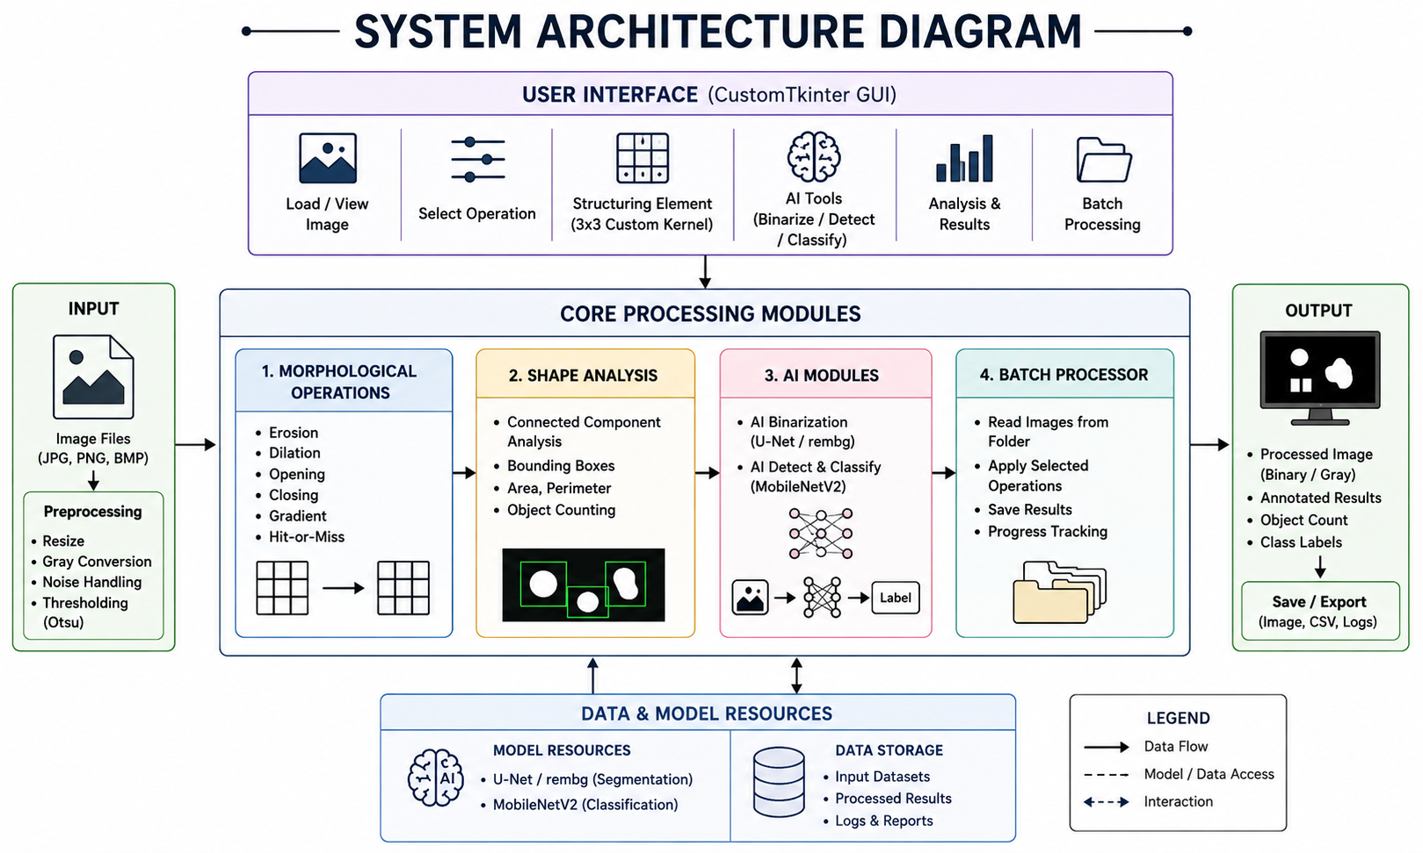

The architecture consists of the following modules:
Input Layer
Handles image loading and preprocessing.
Morphological Processing Layer
Performs erosion, dilation, opening, closing, and gradient operations.
AI Processing Layer
Performs deep learning based segmentation and classification.
Analysis Layer
Handles connected component analysis and object counting.
Output Layer
Displays processed images and generated results.

3. SOFTWARE MODULES
3.1 BinaryImage Module
This module is responsible for:
• Image loading
• Image saving
• Image conversion
• Thresholding
• Otsu binarization
The module serves as the foundation for all image processing operations.

3.2 StructuringElement Module
This module generates kernels used during morphological processing.
Supported kernels include:
• Rectangle
• Cross
• Ellipse
• User-defined Custom Kernel
Users can create their own 3×3 kernel by selecting binary values interactively.

3.3 Morphological Operations Module
This module implements core morphological algorithms.
Erosion
Erosion removes pixels from object boundaries and helps eliminate small noise regions.
Dilation
Dilation adds pixels to object boundaries and enlarges objects.
Opening
Opening performs erosion followed by dilation and removes small foreground noise.
Closing
Closing performs dilation followed by erosion and fills small holes inside objects.
Morphological Gradient
Calculates object boundaries by finding the difference between dilation and erosion.

3.4 Shape Analysis Module
The module uses Connected Component Analysis to identify separate objects within an image.
Features include:
• Object counting
• Bounding box generation
• Area calculation
• Shape extraction
The algorithm uses OpenCV's connectedComponentsWithStats function.

3.5 AI Binarization Module
Traditional thresholding techniques struggle under varying illumination conditions.
The toolkit integrates U-Net/rembg based segmentation to automatically separate foreground objects from backgrounds.
Benefits include:
• Better object extraction
• Reduced background interference
• Improved morphology performance
• Automatic segmentation

3.6 AI Classification Module
The system uses MobileNetV2, a lightweight Convolutional Neural Network.
The process includes:
- Object detection
- Bounding box extraction
- Image cropping
- CNN classification
- Label generation
Detected objects are classified and displayed with labels.

3.7 Batch Processing Module
Batch processing enables users to process large datasets efficiently.
Features include:
• Folder selection
• Operation selection
• Kernel configuration
• Automated processing
• Bulk output generation
This module significantly reduces processing time for large image collections.

4. IMPLEMENTATION DETAILS
Programming Language
Python 3.x
Libraries Used
OpenCV
Used for image processing and morphology operations.
NumPy
Used for matrix calculations and kernel manipulation.
TensorFlow
Used for deep learning based classification.
rembg
Used for AI-powered segmentation and background removal.
CustomTkinter
Used for modern graphical user interface development.
PIL (Python Imaging Library)
Used for image display and format conversion.

5. EXPERIMENTAL RESULTS
The toolkit was tested using multiple benchmark images.
Test Case 1: Noise Removal
Input image contained salt-and-pepper noise.
Operation Applied:Opening
Result:Noise was successfully removed while preserving important object structures.
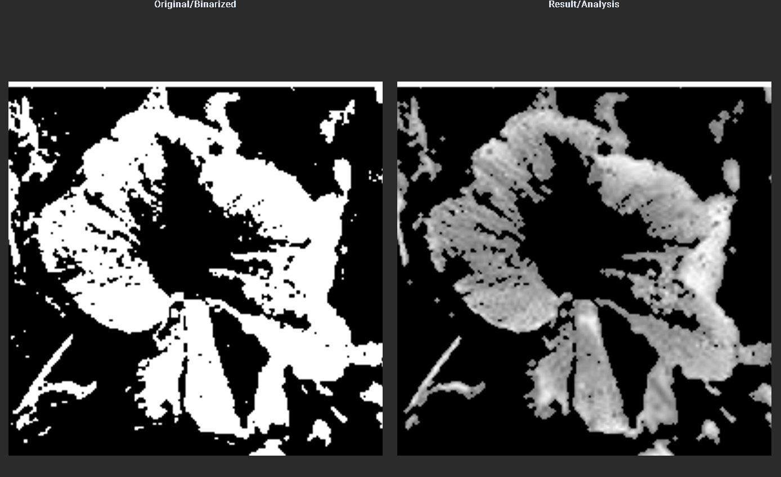

Test Case 2: Boundary Extraction
Operation Applied:Morphological Gradient
Result:Object boundaries were extracted clearly.
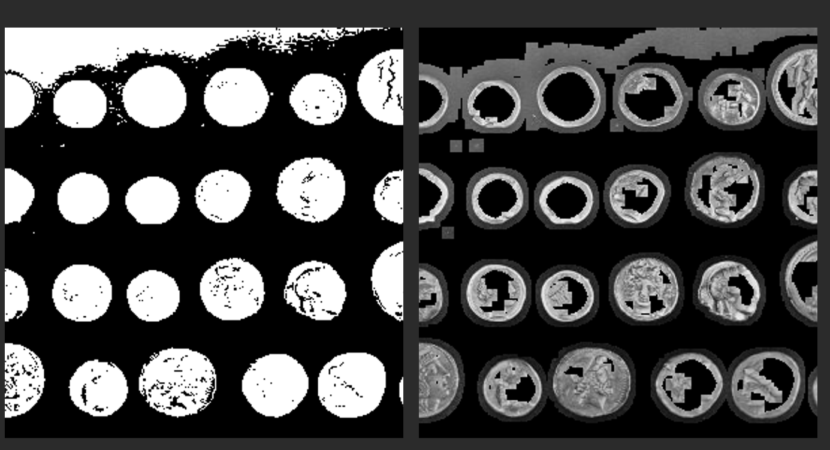
Test Case 3: AI Segmentation
Operation Applied:AI Binarization
Result:Foreground object was accurately separated from the background.
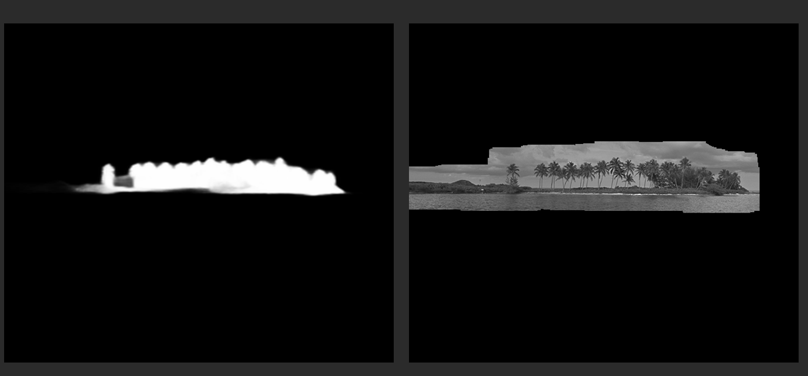

Test Case 4: Object Classification
Operation Applied: AI Detect & Classify
Result: Objects were detected successfully and semantic labels were generated.
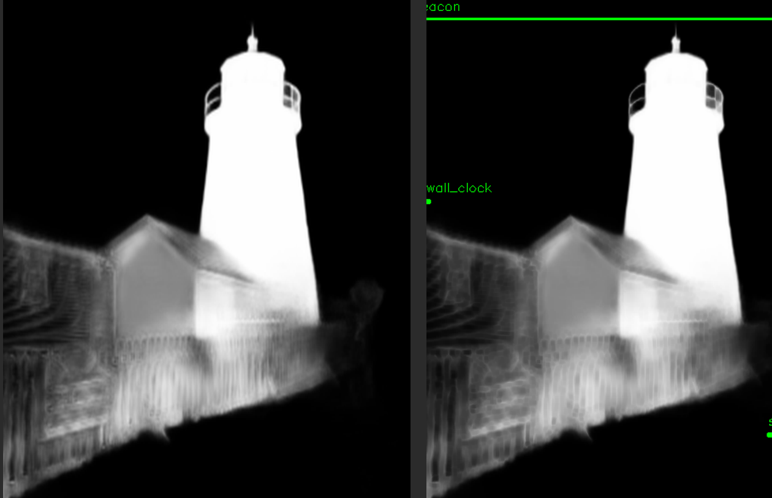

Test Case 5: Batch Processing
Result:All images were transformed automatically and saved to the output directory.
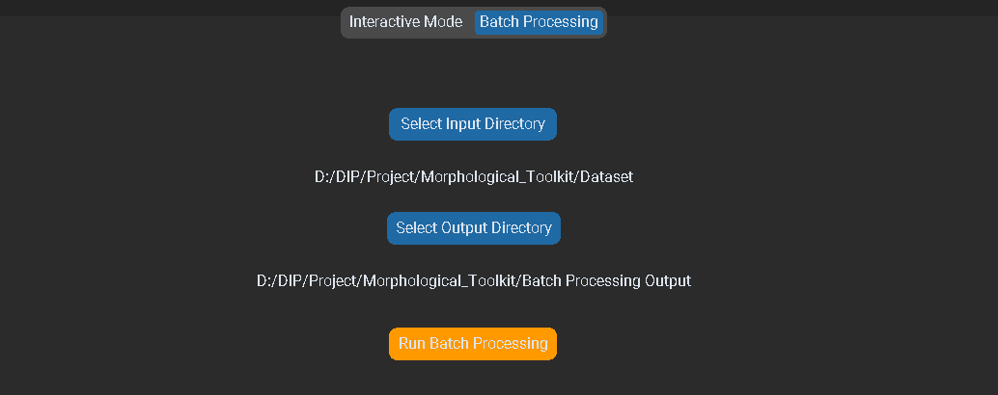

UI interface:
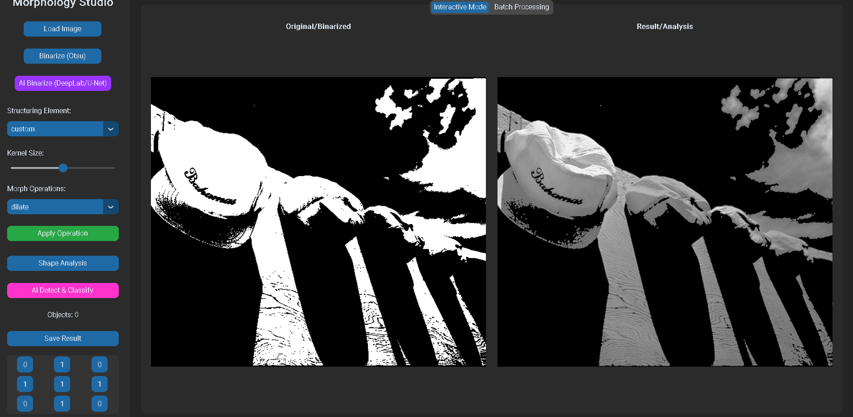
6. ADVANTAGES OF THE SYSTEM
• Easy-to-use graphical interface.
• Integration of traditional and AI-based processing.
• Supports custom structuring elements.
• Automatic object detection.
• Deep learning based classification.
• Batch image processing support.
• Scalable and modular architecture.
• Suitable for research and educational purposes.

7. LIMITATIONS
• AI models require additional computational resources.
• Processing speed depends on system hardware.
• Classification accuracy depends on model training data.
• Very large datasets may increase processing time.

8. FUTURE ENHANCEMENTS
Future versions of the toolkit may include:
• Real-time webcam processing.
• YOLO based object detection.
• Instance segmentation.
• Cloud-based processing.
• Automatic kernel recommendation.
• Multi-language support.
• Edge device deployment.
• Advanced deep learning architectures.

9. CONCLUSION
The Next-Generation Morphological Image Processing Toolkit successfully combines traditional Digital Image Processing techniques with modern Artificial Intelligence approaches. The system provides an efficient platform for image enhancement, segmentation, object detection, and classification through an intuitive graphical user interface.
The implementation of custom structuring elements, AI-powered binarization, connected component analysis, and MobileNetV2 classification significantly improves the flexibility and intelligence of the system. Experimental results demonstrate that the toolkit effectively handles noise removal, object extraction, shape analysis, and automated classification tasks.
Overall, the project achieves all proposed objectives and serves as a powerful educational and research-oriented image processing platform that bridges the gap between classical morphology and modern deep learning technologies.

REFERENCES
- Gonzalez, R. C., & Woods, R. E. Digital Image Processing (4th Edition), Pearson.
- Bradski, G. The OpenCV Library, Dr. Dobb's Journal.
- Sandler, M., Howard, A., Zhu, M., et al. MobileNetV2: Inverted Residuals and Linear Bottlenecks, IEEE CVPR.
- TensorFlow Documentation.
- OpenCV Official Documentation.
- CustomTkinter Documentation.
- rembg Documentation.
- NumPy Documentation.

