***Name : Hafiz Muhammad Hasnain Naseer***

***Roll No : 233525***

***Department :***

***Submitted To : Mam Attka Ali***

***Submitted By : Hasnain***

***Visual Programming Lab-7 Activities***

***Exercise 1***

**[Calculator App] Make a simple calculator, which provide facility of performing addition, subtraction, division and multiplication. Make Function procedure for each four function.**

***Output***

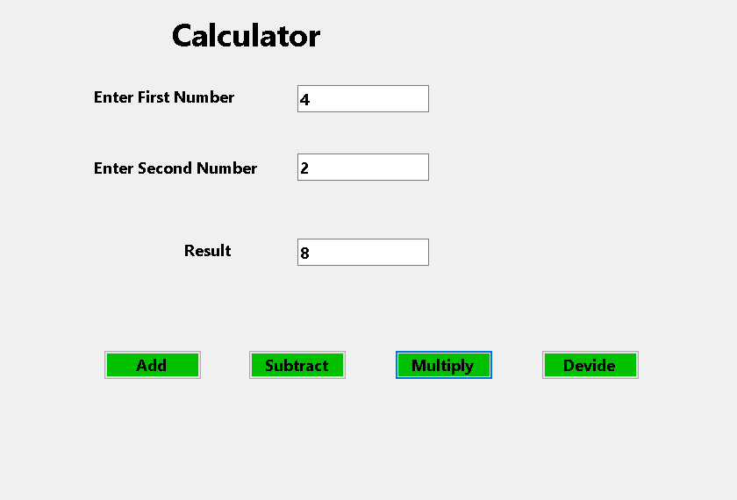

***Exercise 3***

***[Sq App]Make a simple GUI based program, which will calculate square of first***

***10 numbers using a function (procedure/method).***

***Output***

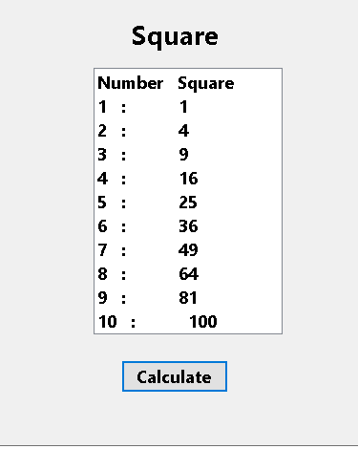

***Exercise 4***

***Make a simple GUI based program, which will convert Fahrenheit into Centigrade. Formula: (F-32)*5/9.***

***Output***

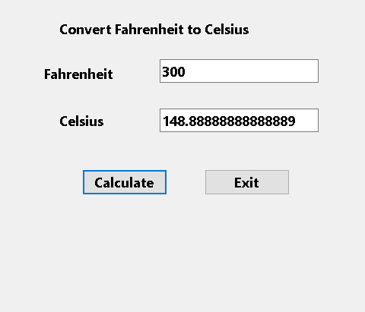

***Exercise 5***

***Write a program which will calculate the factorial of any given number. Use***

***function in this program to get the required result.***

***Output***

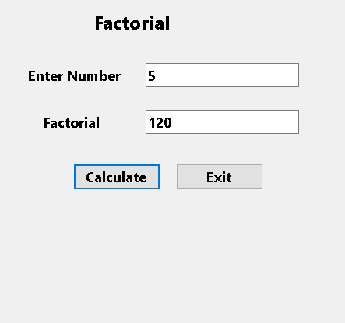

***Exercise 6***

***Make a GUI countdown application which allows the user to set time in***

***seconds. When time is over show a message in Message box.***

***Output***

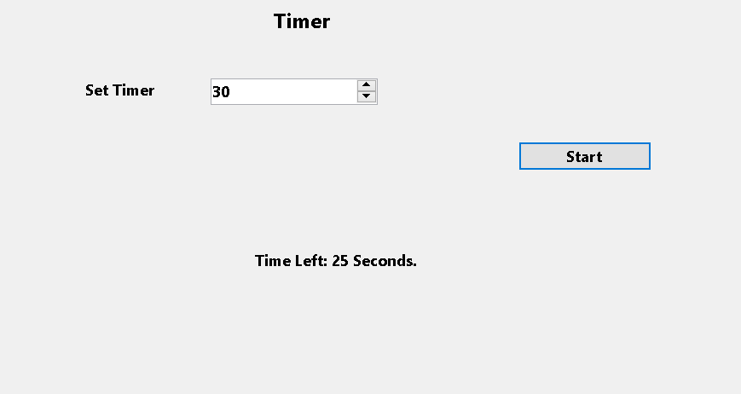

***Exercise 7***

***Make a GUI Wall Clock, which displays Date and Time.***

***Output***

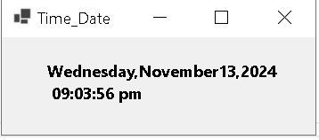

***Exercise 9***

***Make a GUI based program which limits textbox upto 160 characters only..***

***Output***

