Development Activity 3 — Parallel Module Development and Integration
Centralized Secrets & Encryption Management Dashboard (Vaultline)
Semester Project Name: | Centralized Secrets Encryption Management Dashboard (Vaultline)
Responsible Group Members: | Member 1: Hafiz Muhammad Rizwan | Member 2: Zaid Hassan
Module 1 (Member 1): | Secret Provisioning & Encryption Vault
Module 2 (Member 2): | Secrets Directory & Audit Explorer

Activity Objective
In the previous activities, you developed the frontend prototype of your semester project and introduced different user roles and role-based interfaces. In this activity, you will extend the same project by developing two separate functional modules simultaneously. Each group member will be responsible for one module. After completing their individual tasks, both members will integrate their modules into the existing project.
Important: Continue working on your existing semester project. Do not create a separate practice application. This activity can be completed locally using HTML, CSS, and JavaScript, without an internet connection or backend server.
Part 1 — Select Two Complementary Modules
As a group, select two modules that are relevant to your project. The modules should perform different but related functions.
Project Name: Centralized Secrets Encryption Management Dashboard (Vaultline)
Module 1: Secret Provisioning & Encryption Vault
Module 2: Secrets Directory & Audit Explorer
Define the responsibilities
Module 1: Allows authorized team members (Developers, Team Leads) to securely provision and register new cryptographic secrets, database credentials, API keys, and TLS certificates into the vault. It enforces strict client-side validation (kebab-case name format, payload complexity, environment and classification tags), calculates live entropy strength, simulates AES-256-GCM authenticated encryption with unique SHA-256 key fingerprinting, and immediately registers the secret into the centralized vault inventory.
Module 2: Provides security analysts, team leads, and engineers with an interactive discovery, search, and audit interface for all managed secrets across environments (PROD, STAGING, DEV) and classifications. It supports real-time multi-criteria filtering, secret inspection with simulated authorization and masked-reveal timeouts, manual key rotation triggering, and live inventory metrics.
Part 2 — Member 1: Develop Module 1
Responsible Group Member: Hafiz Muhammad Rizwan
Develop the first module independently using HTML, CSS, and JavaScript.
- 1. User Interface: Create a clean, responsive interface appropriate for your selected module.
- 2. Input or Action: Allow the user to perform the module's primary task (enter secret details and click 'Provision & Encrypt Secret').
- 3. Input Validation: Check that required information is provided before accepting the submission (format checks, length rules, dropdown selections).
- 4. JavaScript Functionality: Make the primary action functional with state updates, simulated encryption, and live entropy scoring.
- 5. Feedback: Display an appropriate success or error message after the action (prominent error alert on failure, toast & summary card on success).
- 6. Data Display: Display the submitted item or updated information on the page in a live 'Recently Provisioned Secret' summary card.
Your module's primary function: Securely provision, validate, and encrypt a new secret into the centralized vault with user-specified environment, secret classification, rotation policy, and service metadata.
Input validation rule: Secret Identifier must match `^[a-z0-9-_]{3,50}$` (lowercase alphanumeric, dashes, and underscores only; 3–50 chars); Secret Payload must contain at least 8 characters for cryptographic strength; Environment, Classification, and Associated Service Name are required.
JavaScript interaction implemented: Real-time form validation with error banner, live password entropy score calculation, show/hide password toggle, simulated AES-256-GCM cryptographic encryption and SHA-256 fingerprint generation, shared localStorage state persistence, and interactive 'Recently Provisioned Secret' summary card rendering with quick navigation to Module 2.
Part 3 — Member 2: Develop Module 2
Responsible Group Member: Zaid Hassan
Develop the second module independently using HTML, CSS, and JavaScript.
- 1. User Interface: Create a clean, dark-mode table interface with action bars, filter pills, and inspection dialogs.
- 2. Primary Functionality: Implement the module's main task: real-time search, multi-facet filtering, inspection, and on-demand key rotation.
- 3. Input Validation / Search Rule: Validate search queries, sanitize inputs, enforce 10s auto-mask timeout on sensitive payload display.
- 4. JavaScript Functionality: Implement dynamic array filtering, metric recalculation, clipboard copying, and rotation timestamp updates.
- 5. Feedback: Provide suitable feedback when user completes an action (rotation confirmation toast, copied badges, empty state alert).
- 6. Data Display: Display relevant information using sample records and dynamically newly provisioned secrets from Module 1.
Your module's primary function: Centralized, real-time searchable directory and audit inspector for all encrypted secrets, enabling cross-environment filtering, metadata inspection, authorized secret reveal with auto-masking, and on-demand key rotation.
Input validation or search rule: Sanitizes search query, filters case-insensitively across secret name, type, and service; displays interactive empty state when query finds 0 matches; enforces 10s auto-mask timeout on secret reveal.
JavaScript interaction implemented: Real-time multi-facet filtering (Search query + Environment pills + Type selector), dynamic metric recalculation, detail inspection modal with 10s auto-mask countdown timer, one-click clipboard copying, and on-demand key rotation state update.
Part 4 — Integrate Both Modules
After completing the individual modules, work together to incorporate them into your existing semester project. Both members are responsible for ensuring that the final prototype works as one application.
Completed Tasks
- Placed both modules within the same project folder under `src/components/` (`SecretProvisioningModule.tsx` and `SecretsDirectoryModule.tsx`).
- Linked both modules to the existing project navigation menu (`RoleWorkspace.tsx`) accessible across Team Lead, Developer, and Security Analyst roles.
- Added dual-link navigation: 'Inspect in Secrets Directory' button in Module 1 jumps straight to Module 2; '+ Provision New Secret' button in Module 2 jumps directly to Module 1.
- Harmonized design tokens, glassmorphism cards, glowing status tags, Inter typography, and Lucide icons.
- Implemented shared state synchronization with `localStorage` so secrets added in Module 1 immediately render in Module 2.
- Verified that all previous functionality (Authentication, Role workspaces, Leases, Modals, Logout) operates flawlessly.
Integration Checklist
Checklist Item | Status
• Module 1 opens and works correctly. | ✓ VERIFIED / WORKING
• Module 2 opens and works correctly. | ✓ VERIFIED / WORKING
• Both modules are accessible through the project interface. | ✓ VERIFIED / WORKING
• Navigation between pages works locally. | ✓ VERIFIED / WORKING
• Both modules follow a consistent design. | ✓ VERIFIED / WORKING
• Existing functionality from previous activities still works. | ✓ VERIFIED / WORKING

Part 5 — Test Both Modules
Each group member must test their own module, and both members must test the integrated project.
Test Case | Expected Result | Actual Result
Submit or perform a valid action | The action succeeds | PASSED. In Module 1, submitting a valid secret generates Secret ID, SHA-256 fingerprint, saves to vault, and displays success banner. In Module 2, clicking 'Rotate Secret' updates rotation timestamp to 'Just now'.
Leave a required field empty | The system prevents submission or displays an error | PASSED. In Module 1, submitting empty secret name or payload halts submission and displays red validation error banners. In Module 2, searching non-existent query displays empty state with 'Reset All Filters' button.
Perform a second action, such as searching or filtering | The interface updates appropriately | PASSED. In Module 2, clicking 'PROD' filter tab immediately isolates production secrets and updates metric counters; typing in search bar filters records dynamically in real time; clicking 'Inspect' opens metadata modal.

Module 1 issue discovered: Initial form allowed spaces and capital letters in the Secret Identifier (e.g. `Payments Prod API`), which broke compatibility with cloud KMS naming standards.
Module 2 issue discovered: When filtering by environment while a search query was typed, clearing the search query accidentally reset the active environment filter tab.
Correction made: Implemented strict regex validation (`^[a-z0-9-_]{3,50}$`) and automatic lowercase transformation for Module 1. Unified search query and filter states into a single combined filter pipeline in Module 2 so both criteria apply together seamlessly.
Part 6 — Security-Aware Development
Although this activity focuses on frontend functionality, consider how each module may be misused. For each module, identify one possible problem and a suitable response.
Module | Possible Misuse or Problem | Proposed Response
Module 1 (Secret Provisioning) | Submission of weak or low-entropy secrets, leading to compromised credentials in cloud services; vulnerability to shoulder surfing during secret value entry. | Enforced client-side minimum length validation (minimum 8 characters), implemented real-time entropy calculation meter (Weak/Medium/Strong), masked payload input by default with toggleable visibility, and simulated AES-256-GCM encryption with SHA-256 key fingerprinting before storage.
Module 2 (Secrets Directory) | Unauthorized observers viewing plaintext secrets via screen-sharing or over-the-shoulder observation when secret inspection is opened. | Kept secret payload masked (`••••••••••••••••`) by default; implemented an authorized reveal action requiring explicit user confirmation, paired with an automatic 10-second countdown timer that automatically re-masks the secret value.

Submission Requirements
Submit the following information:
Project Name: Centralized Secrets Encryption Management Dashboard (Vaultline)
Group Members: Member 1: Hafiz Muhammad Rizwan | Member 2: Zaid Hassan
Module 1: Secret Provisioning & Encryption Vault
Module 2: Secrets Directory & Audit Explorer
Module 1 functionality implemented: Form interface for registering new secrets with format validation, dynamic entropy strength meter, simulated AES-256-GCM encryption, SHA-256 fingerprint generation, success alerts, and recently provisioned card display.
Module 2 functionality implemented: Dynamic searchable and filterable secrets directory with real-time text search, environment filter tabs, type filter dropdown, dynamic statistics cards, detailed inspection modal with auto-masking secret reveal, and on-demand secret rotation action.
JavaScript interactions implemented:
- 1. Real-time form validation, password entropy calculation, simulated AES-256-GCM encryption & SHA-256 fingerprint generation, and shared localStorage state persistence.
- 2. Multi-facet array filtering (search term + environment pills + type dropdown), inspection modal with 10-second auto-mask countdown timer, one-click clipboard copy, and dynamic key rotation timestamp updating.
One problem discovered during testing: When a secret was created in Module 1, switching to Module 2 initially required a manual page refresh to see the updated records because state was localized.
How it was corrected: Lifted secrets state into a centralized state store with localStorage persistence and event synchronization so any secret provisioned in Module 1 immediately appears in Module 2 reactively.

Deliverables & Captured Screenshots
Below are the verified screenshots captured directly from the local running prototype (http://localhost:3001) demonstrating the completion and integration of both modules.
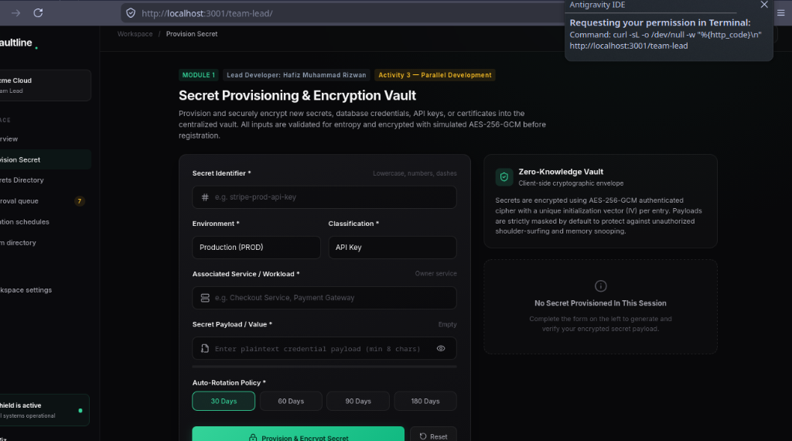
Figure 1: Module 1 — Secret Provisioning & Encryption Vault (Team Lead Workspace)
Demonstrates the complete form interface developed by Member 1 (Hafiz Muhammad Rizwan), including Secret Identifier, Environment (PROD), Classification (API Key), Associated Workload, Secret Payload input with entropy meter, and rotation policies.
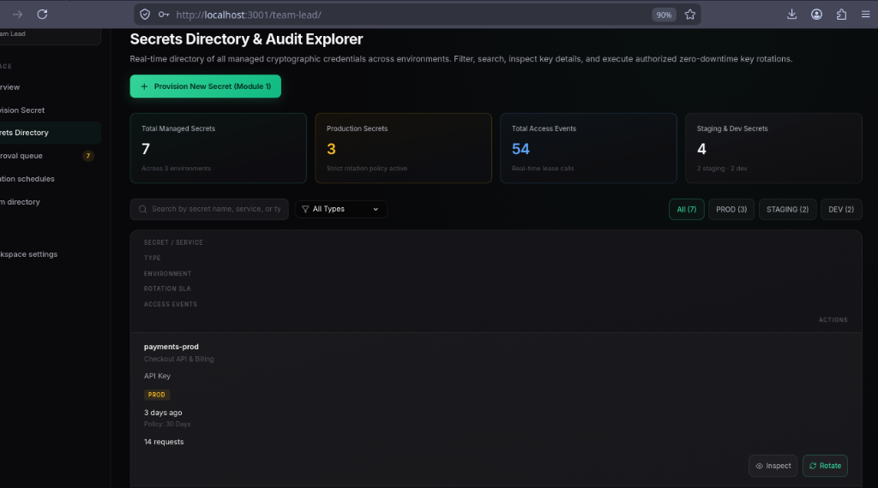
Figure 2: Module 2 — Secrets Directory & Audit Explorer (Live Stats, Filters & Table)
Demonstrates the real-time secrets directory developed by Member 2 (Zaid Hassan), showing dynamic top metric counters (Total Secrets: 7, Production Secrets: 3, Total Access Events: 54), search input, environment filter pills, and credentials data table with Inspect & Rotate actions.
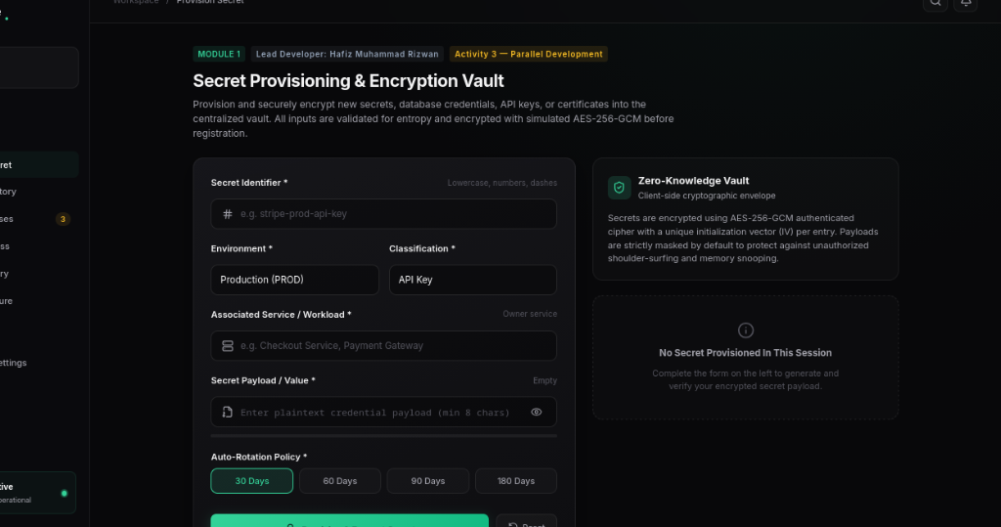
Figure 3: Integrated Workspace Navigation & Clean Module 1 Interface
Demonstrates cross-module navigation integrated into the main sidebar and workspace header, maintaining cohesive dark-mode glassmorphism aesthetics.

