Experiment No: 03

**Experiment Name:** Plotting Various signals on Matlab **Objective:** To write programs that can plot several signals. **Software Requirement:** Matlab

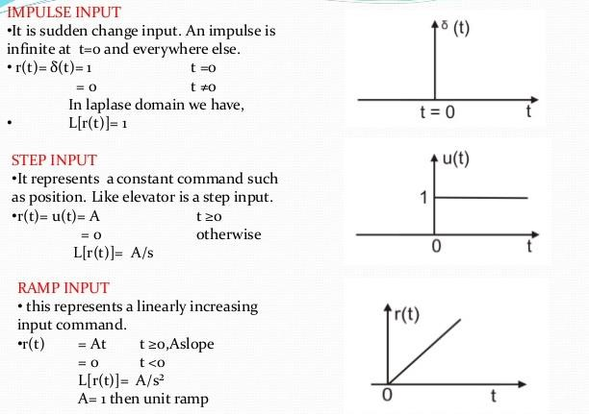**Theory:** Any signal can be plotted on matlab. Matlab can plot continuous time and discrete time signal. In this experiment some basic signals will analyzed.

Fig 1: Unit step, impulse and ramp signal

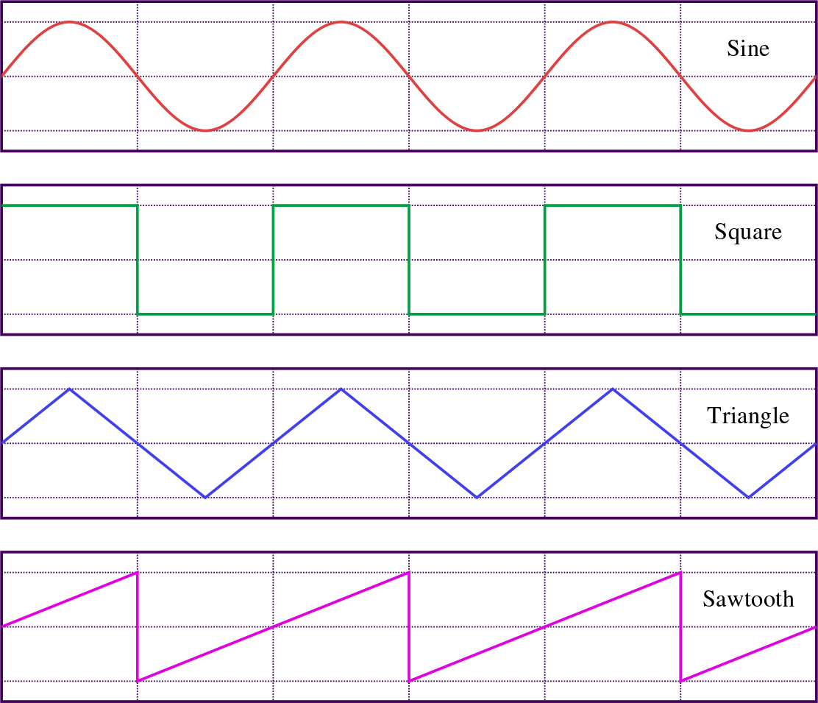

Fig: Some periodic waveform

**Matlab Program & Diagrams:**

**For Unit Step Function:**

>> t=-10:0.01:10; % step is small enough to represent continuous-time signal

>> f=heaviside(t); % the unit step function.

>> plot(t,f) % plotting unit step function

**Diagram:**

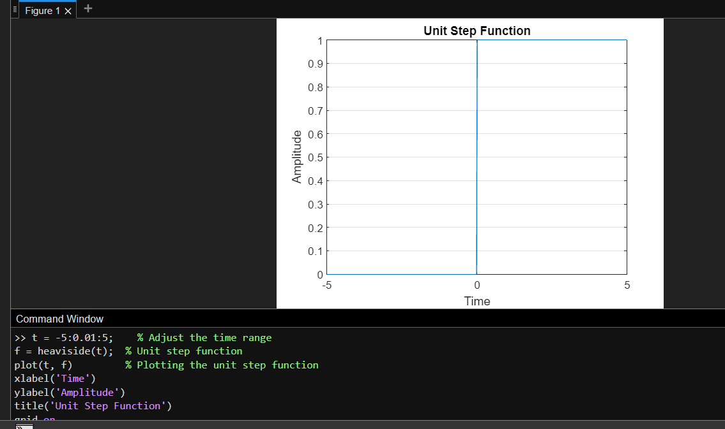

**For Ramp Signal:**

>> t = -10:0.001:10;

>> ramp = t;

>> plot(t,ramp)

**Diagram:**

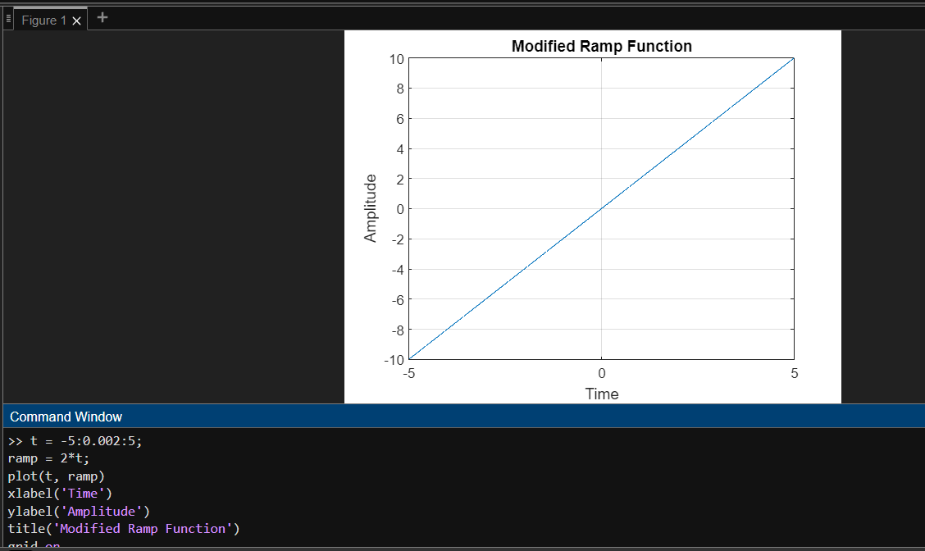

**For Sine Wave:**

% plotting sine wave t = 0:0.00001:1;

f = 1;

w = 2*pi*f;

x = 2*sin(w*t); plot(t,x);

**Diagram:**

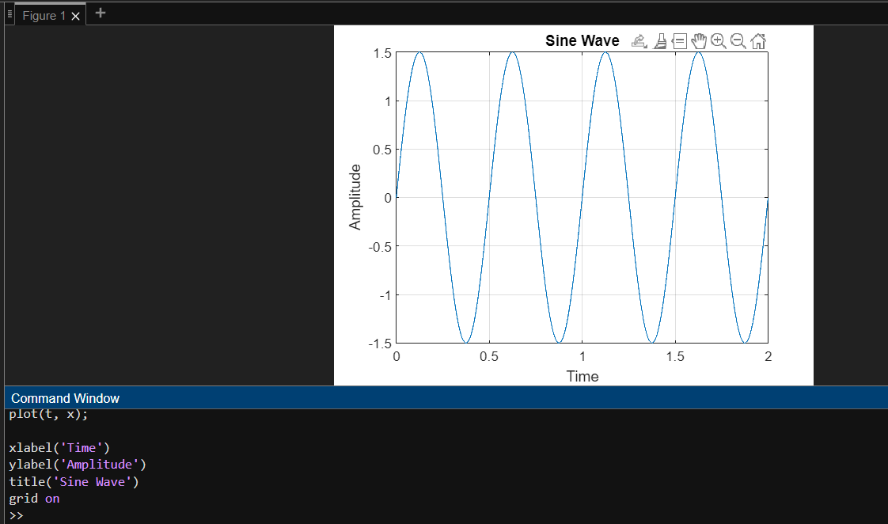

**For square wave:**

t = 0:0.001:20;

A = 3; % amplitude

T = 2; % period

w =( 2*3.14)/T; % angular frequency x = square(w*t);

axis([0 10 -2 2]); % changing the axis

**Diagram:**

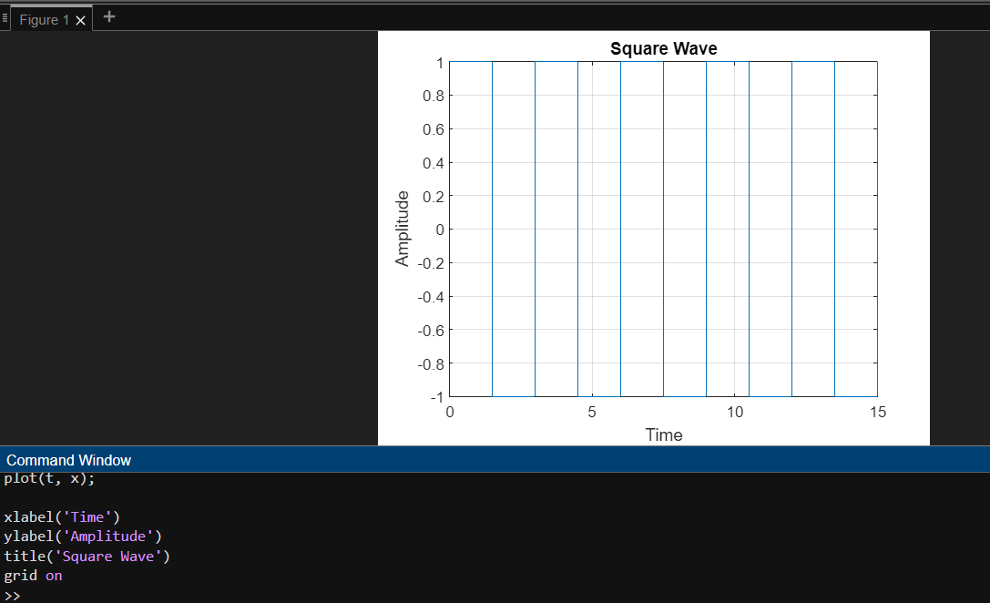

**For sawtooth wave:**

t = 0:0.001:20; t = 0:0.001:20;

A = 3; % amplitude

T = 2; % period

w =( 2*3.14)/T; % angular frequency x = square(w*t);

A = 3; % amplitude T = 2; % period

w =( 2*3.14)/T; % angular frequency x =A*sawtooth(w*t);

plot(t,x);

axis([0 10 -4 4]); % changing the axis

**Diagram :**

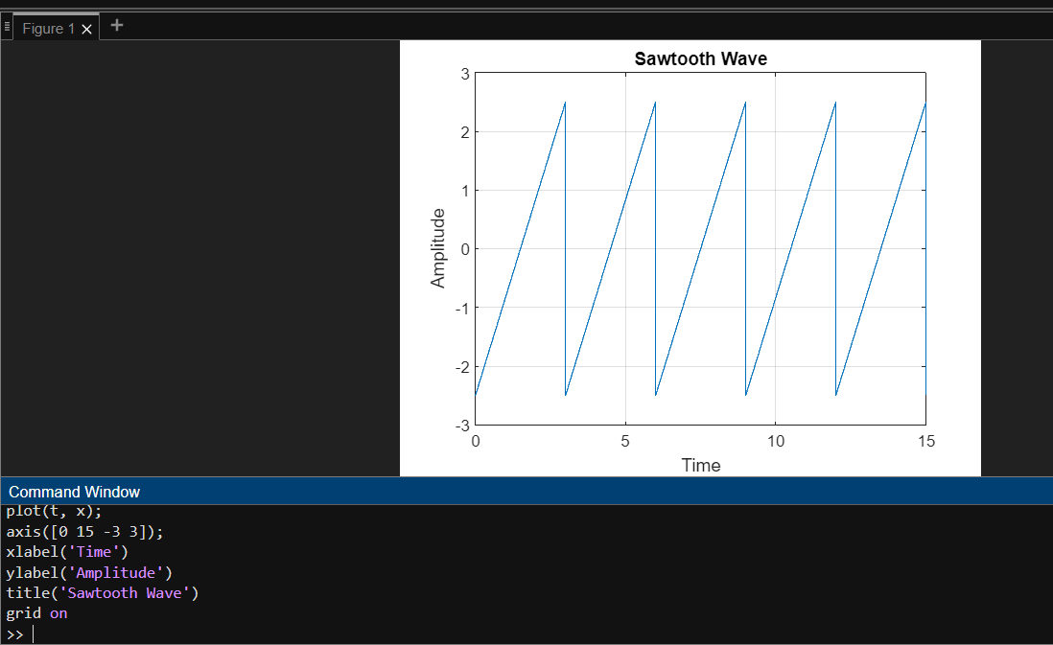

**Discussion :**

In this lab, I learned to draw fundamental signal functions using MATLAB. The covered functions included the unit step function, ramp function, sine wave, square wave, and sawtooth wave. By manipulating parameters like amplitude, period, and time range, I gained practical insights into signal representation. This hands-on experience with MATLAB enhances my understanding of signal processing concepts and equips me with valuable skills applicable in engineering and scientific contexts