**Experiment No:05**

**Experiment Name**: Observation of convolution in MATLAB

**Objective**: To observe the convolution of two signals

**Software Requirement**: MATLAB

**Theory**: The convolution of two signals is a fundamental operation in signal processing. Mainly, because the output of any linear time-invariant (LTI) system is given by the convolution of its impulse response with the input signal. It means the output of any system due to any input signal can be found if the impulse response is known. The formula of convolution by definition if f1(t) and f2(t):

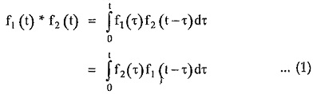

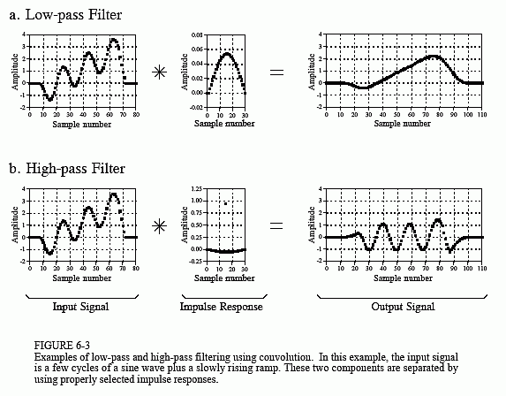

Figure: Graphical view of convolution.

**Matlab Program:**

t = -5:0.001:5; % for continuous time signal

impulse_resp = heaviside(t);

subplot(3,1,1);

plot(t, impulse_resp, 'b-', 'Linewidth', 3);

input = heaviside(t-1);

subplot(3,1,2);

plot(t, input, 'r-', 'Linewidth', 3);

z = conv(impulse_resp, input);

subplot(3,1,3);

plot(z, 'Linewidth', 3);

**Diagram:**

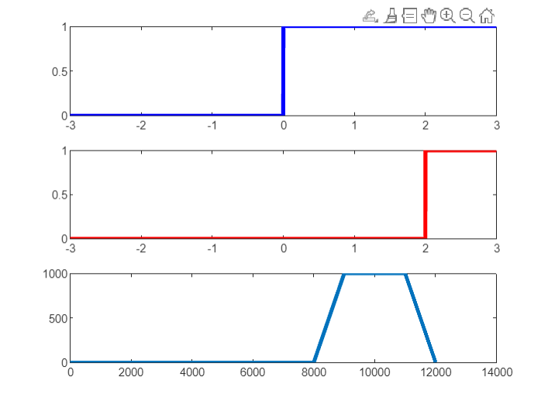

**Matlab Program:**

n = 0:8;

xn = [1 3 4 8 7 4 3 2];

subplot(3,1,1);

stem(n,xn,'r-','Linewidth',4);

hn = [ 1 1 1 1 1 1 1 1 ];

subplot(3,1,3);

stem(n,hn,'b-', 'Linewidth',4);

yn = conv(xn,hn);

subplot(3.5,1,3.5);

stem(yn,'m-','Linewidth',3);

**Diagram:**

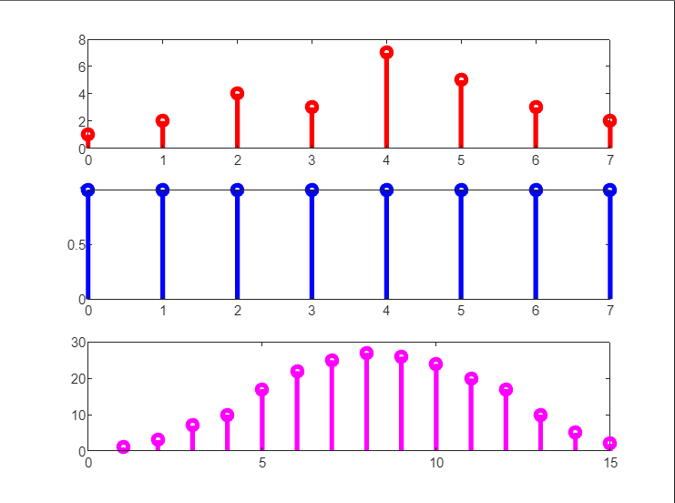

**Home work:   
convolution of two sign signal.**

**Matlab Program:**

t = 0:0.01:4*pi;

x = sin(t);

input = heaviside(t + 2);

subplot(3,1,1);

plot(t, x);

subplot(3,1,2);

plot(t, input);

y = conv(x, input);

subplot(3,1,3);

plot(y);

**Diagram :**

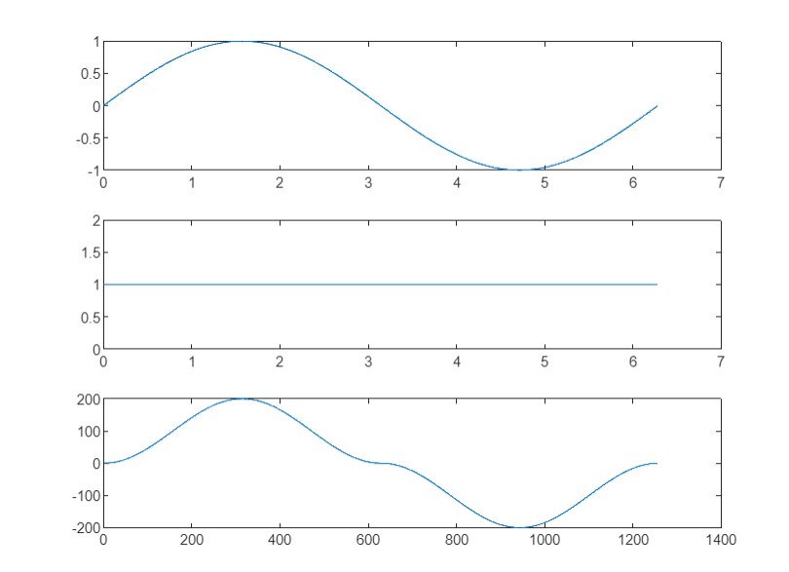

Discussion:

In MATLAB, the observation of convolution involves applying the convolution operation to two signals or functions. The conv function is commonly used for this purpose, and it computes the convolution of two sequences efficiently. It is crucial to note that convolution in MATLAB is implemented using different methods, such as the direct method or the FFT-based method, which can impact computational efficiency. Observing the convolution process helps understand how signals interact and how convolution can be applied in various signal processing applications. MATLAB provides a versatile platform for visualizing and analyzing convolution, making it an essential tool in signal processing and communication system design.