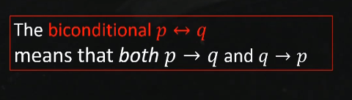





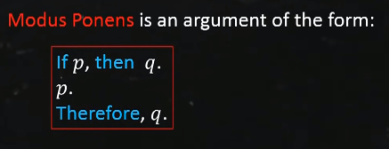

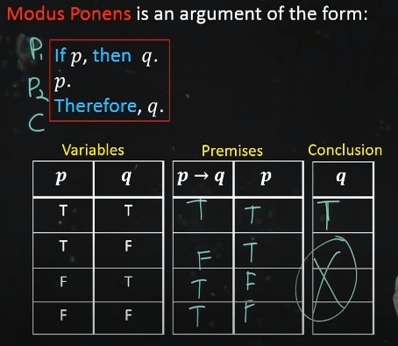



**Linear sieve :**

#include<bits/stdc++.h>

using namespace std;

#define N 150

bool iscomposite[N];

vector<int > primes;

void sieve(int n)

{

for(int i = 2 ; i < N ; i++)

{

cout << "current number" << i << endl;

if(!iscomposite[i]) primes.push_back(i);

for(int j =0; j < primes.size() && i * primes[j] < n; j++)

{

cout << "Current Prime " << primes[j] << " current Composite " << i * primes[j] << endl;

iscomposite[i * primes[j]] = true;

if(i % primes[j] == 0)

break;

}

}

}

int main()

{

int n;

cin >> n;

sieve(n);

}